# TASK 1:

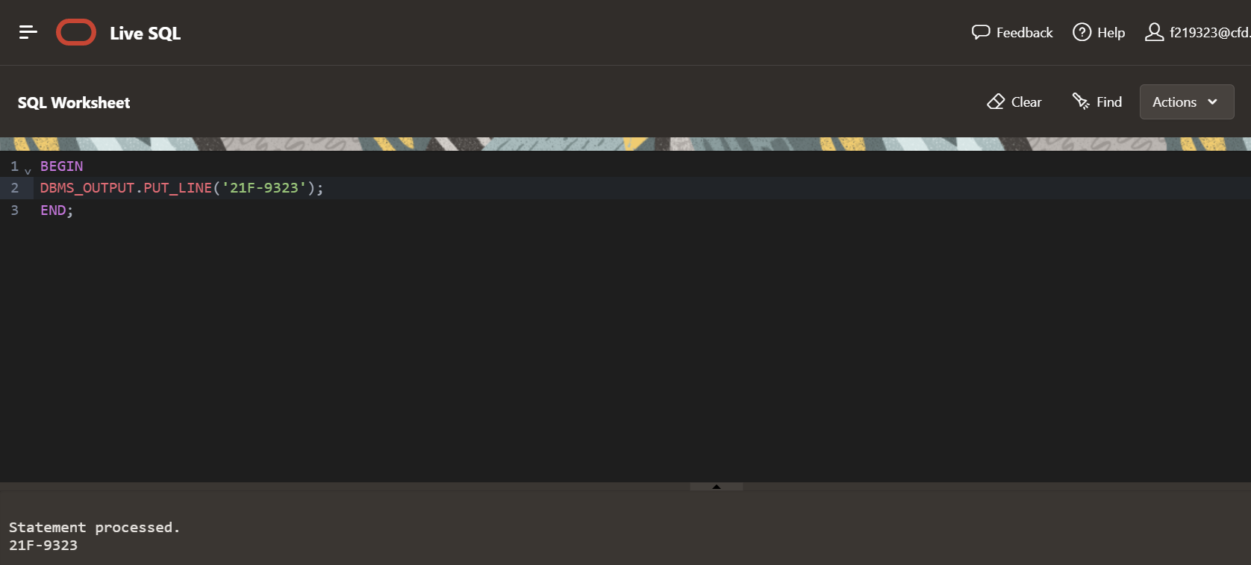

TASK 2:  
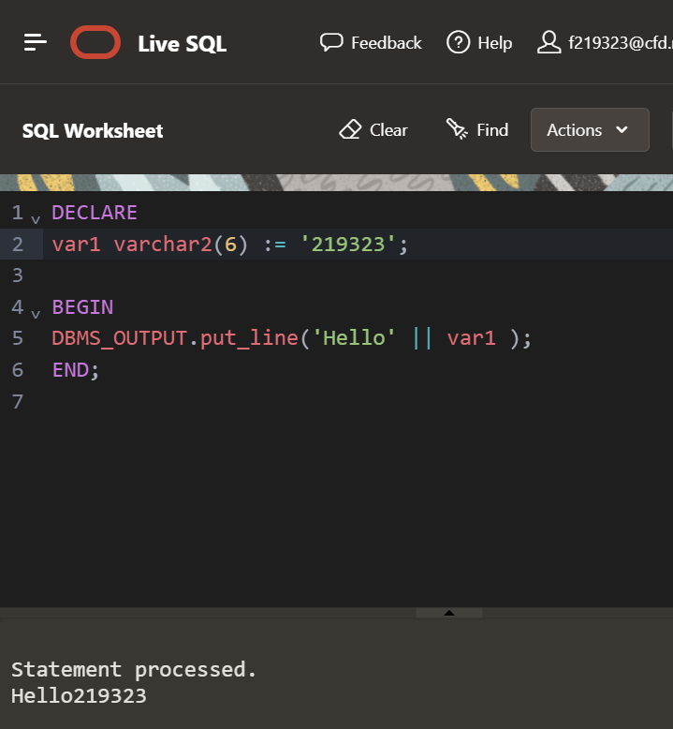

TASK 3:

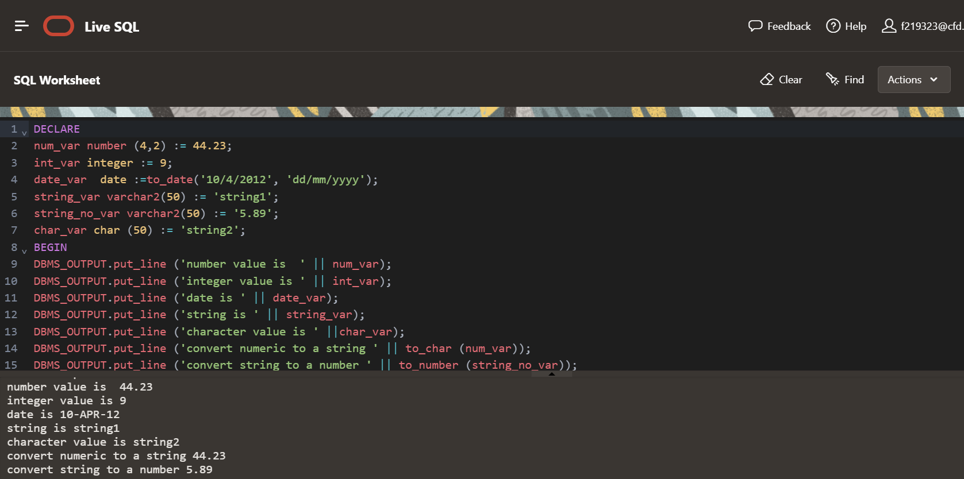

# TASK 4:

# 

# TASK 5:

# TASK 6:

# 

# TASK 7:

# 

# TASK 8:

# TASK 9:

# 

# TASK 10:

# TASK 11:

