# TASK 1:

# TASK 2:

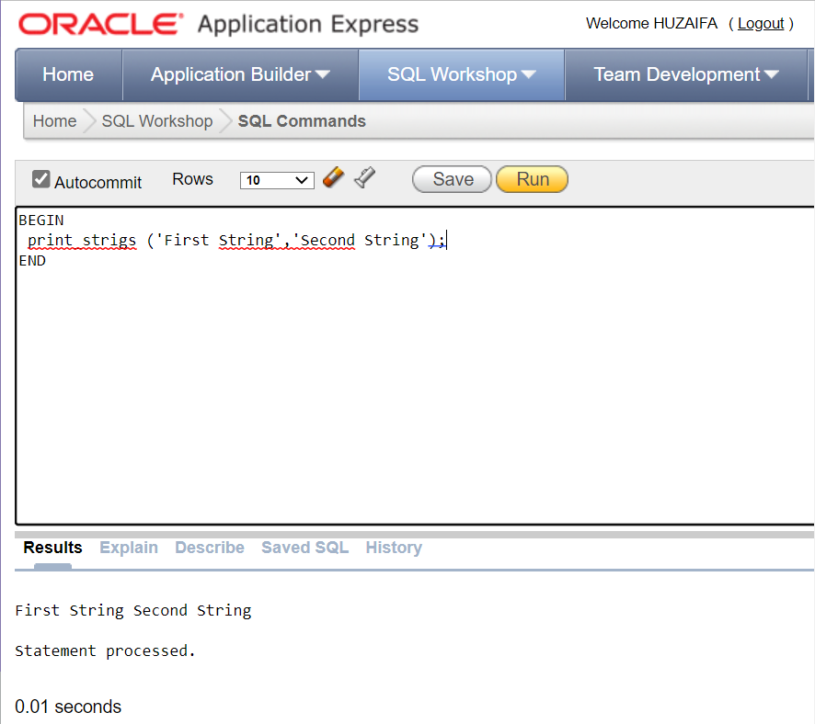

TASK 3:  
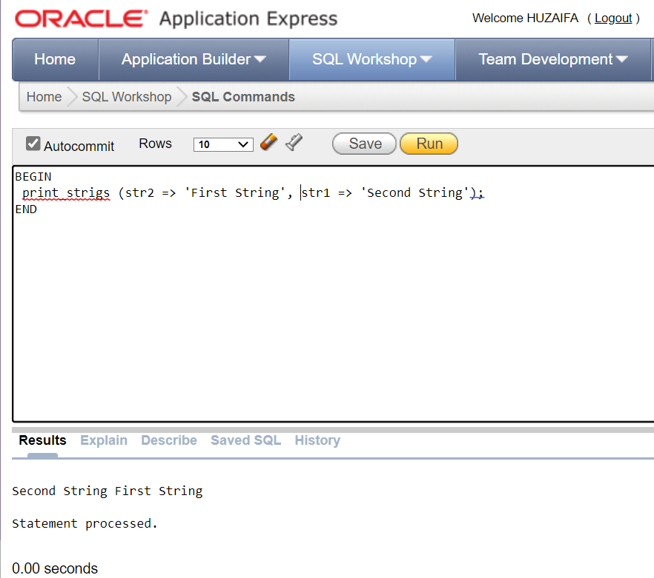

TASK 4:  
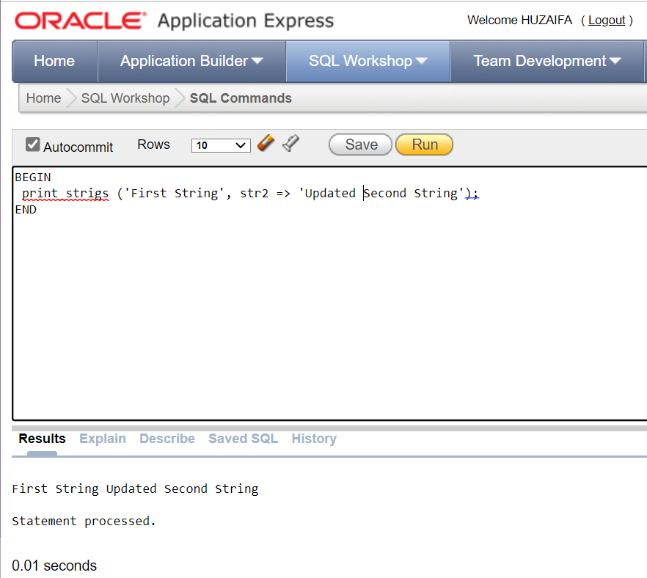

TASK 5:

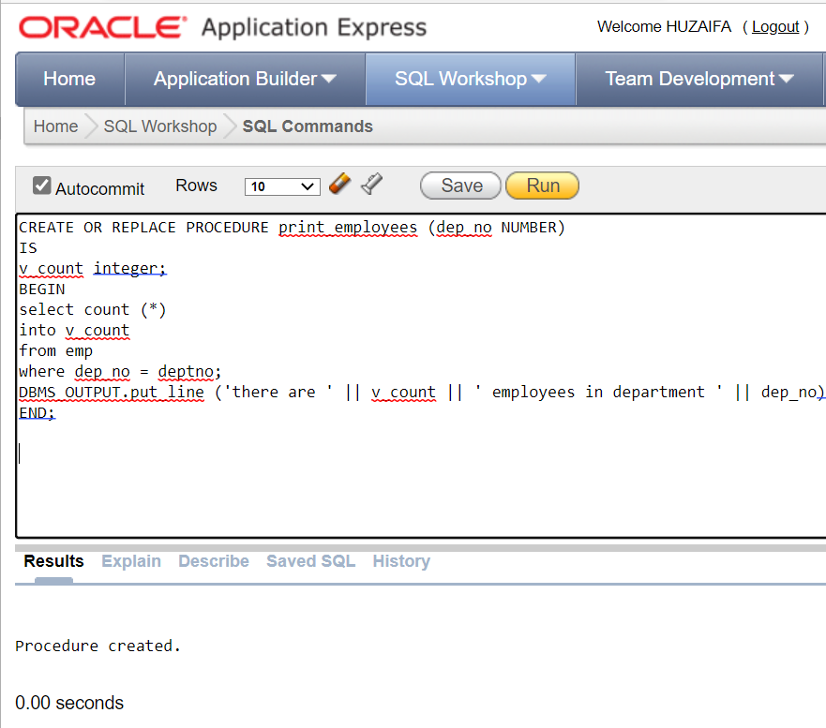

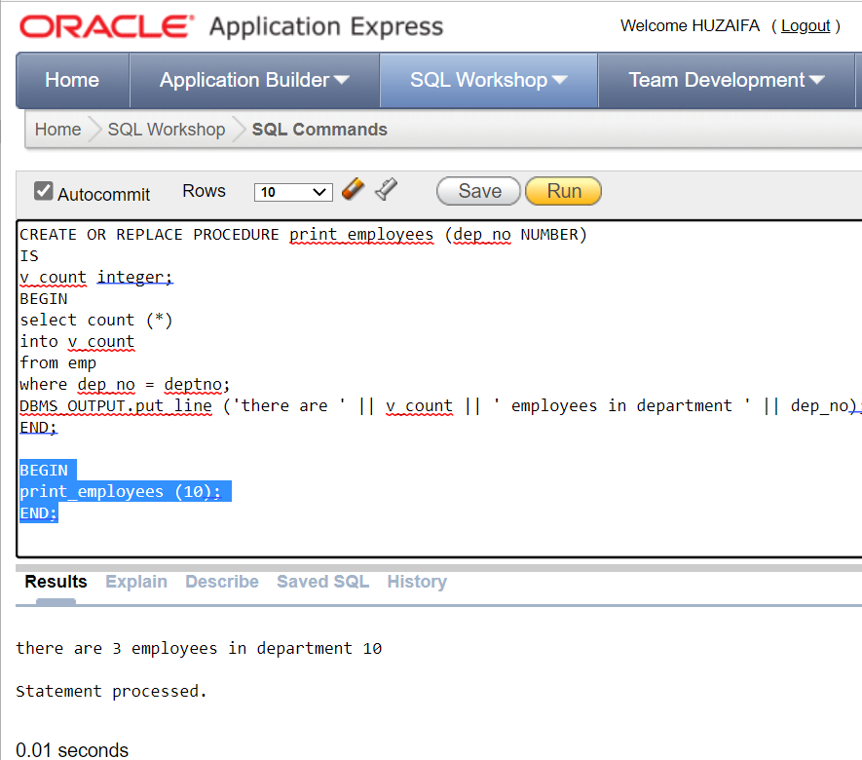

# TASK 6:

# 

# 

# TASK 7:

# 

# 

# TASK 8:

# 

# 