**PACKAGES PRACTICE:**

# TASK 1:

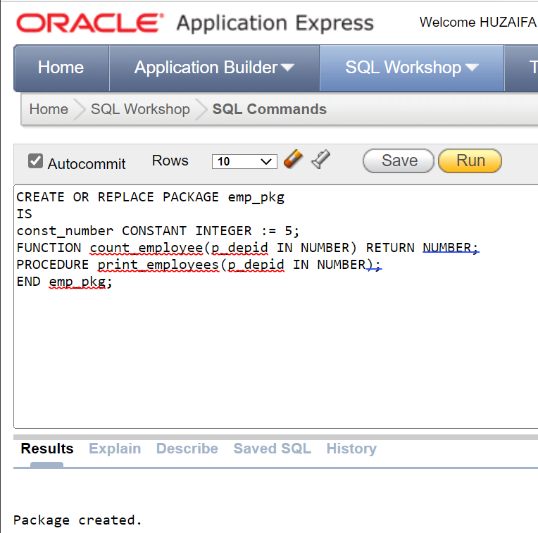

# TASK 2:

# TASK 3:

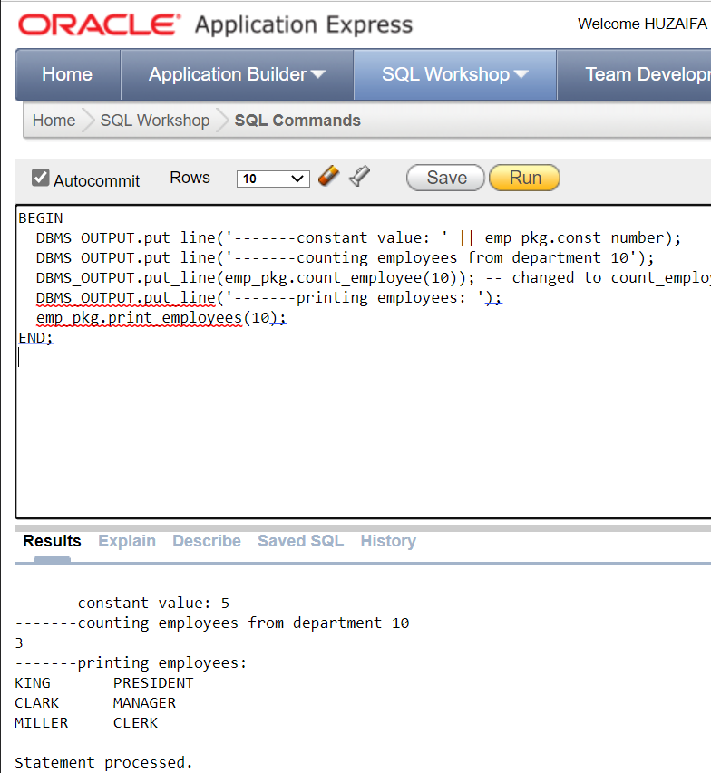

# TASK 4:

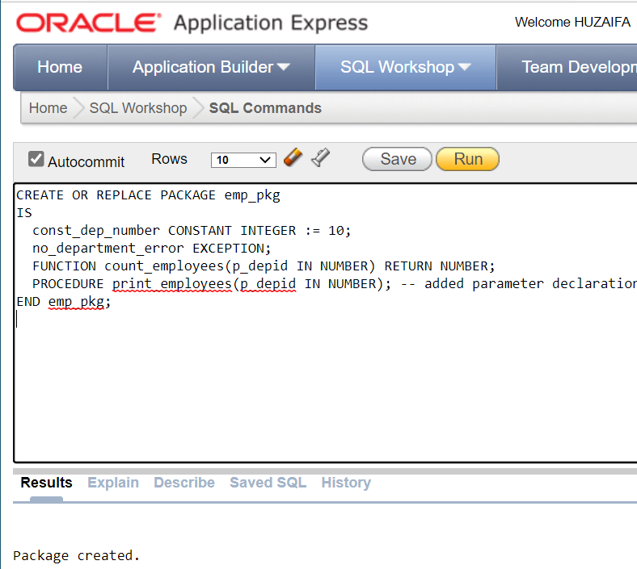

**CURSOR PRACTICE:**

# TASK 1:

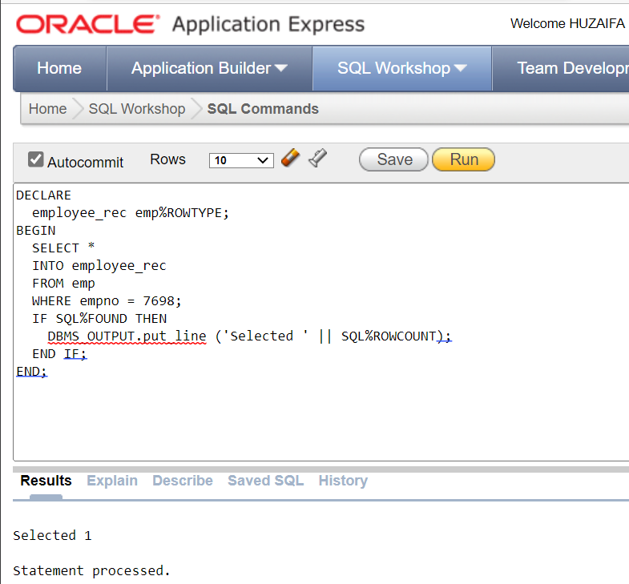

# TASK 2:

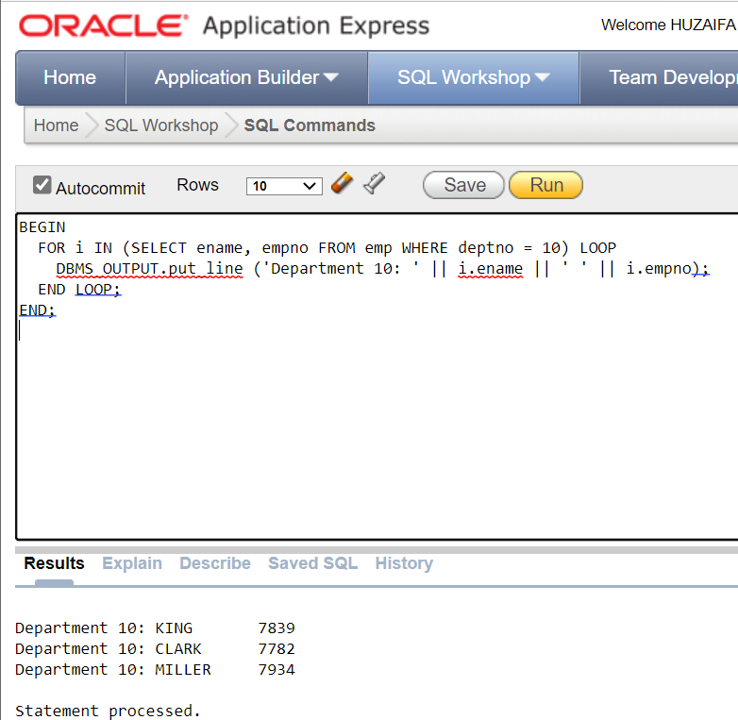

# TASK 3:

# TASK 4: