# TASK 1:

# 

# OUTPUT:

# 

# TASK 2:

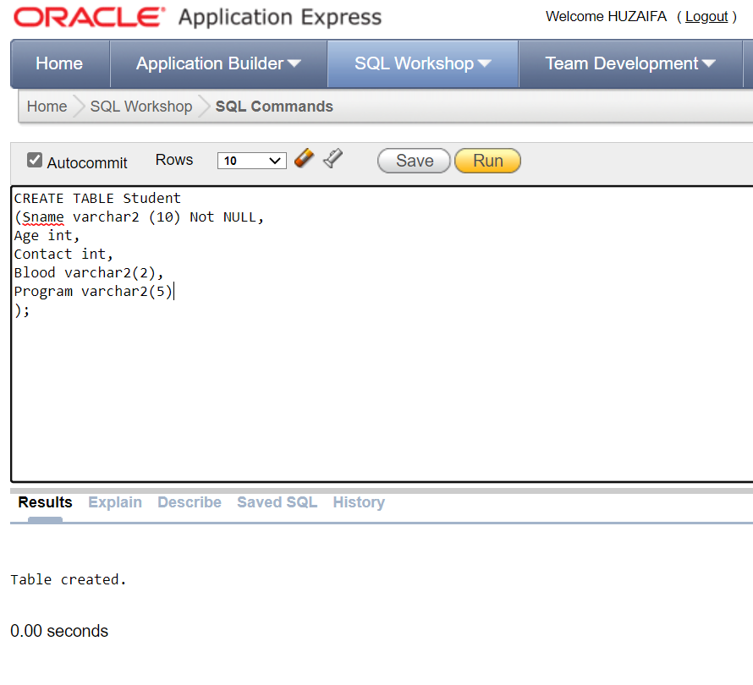

# OUTPUT:

# 