# Task 1:

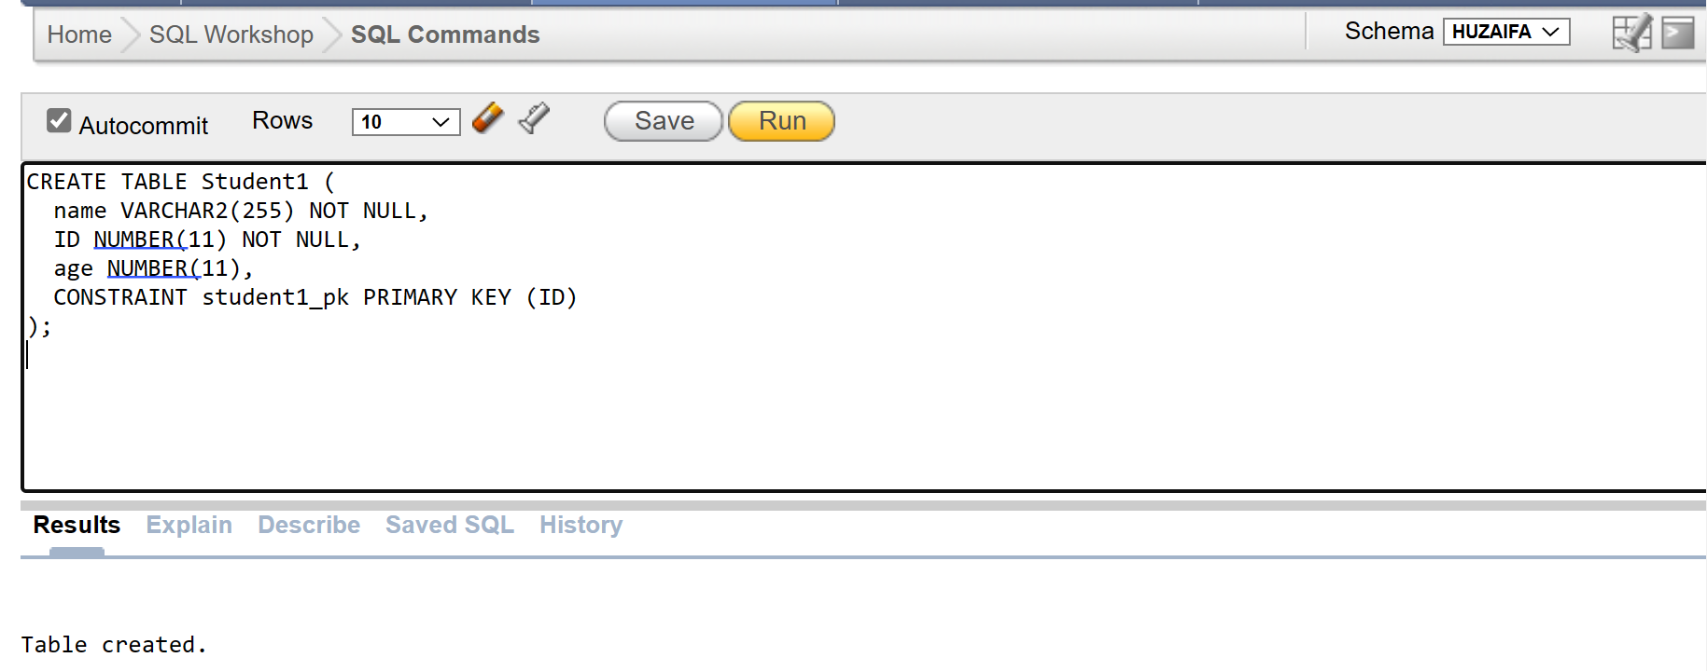

# TASK 2:

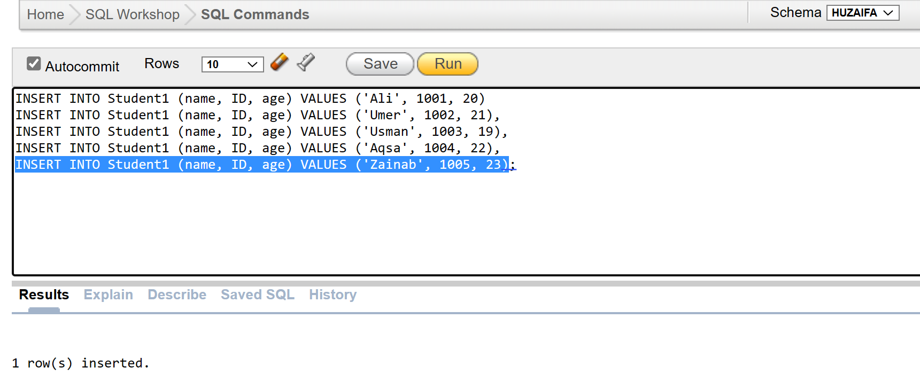

# TASK 3:

# TASK 4:

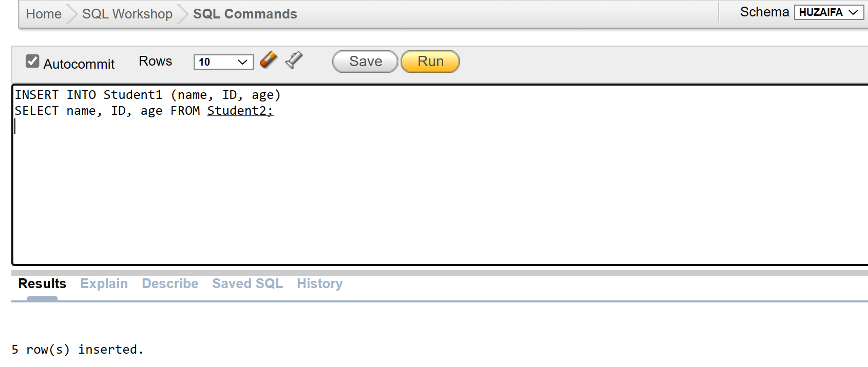

# TASK 5:

# TASK 6:

# TASK 7:

# TASK 8:

# TASK 9:

# TASK 10:

# TASK 11:

# TASK 12:

# TASK 13:

# TASK 14:

# TASK 15:

# 

# 