# TASK 1:

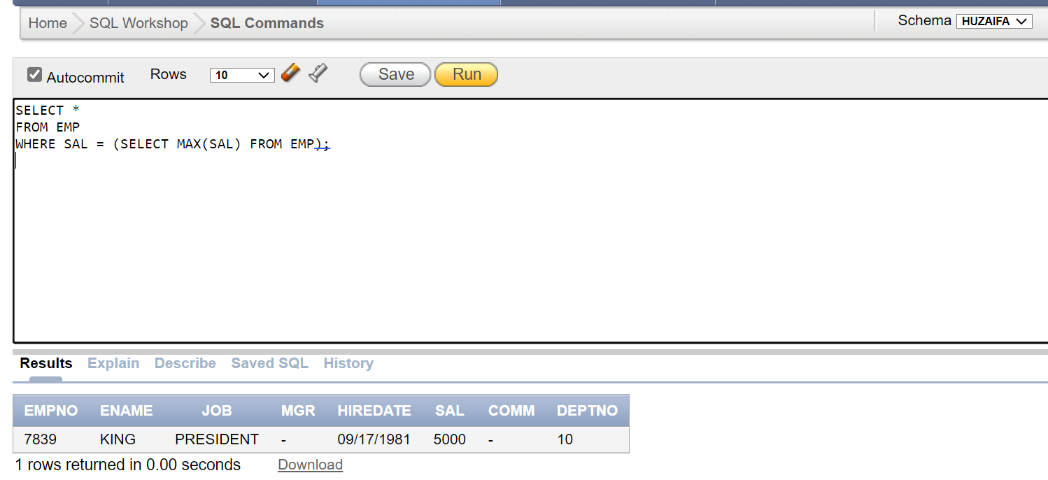

# TASK 2:

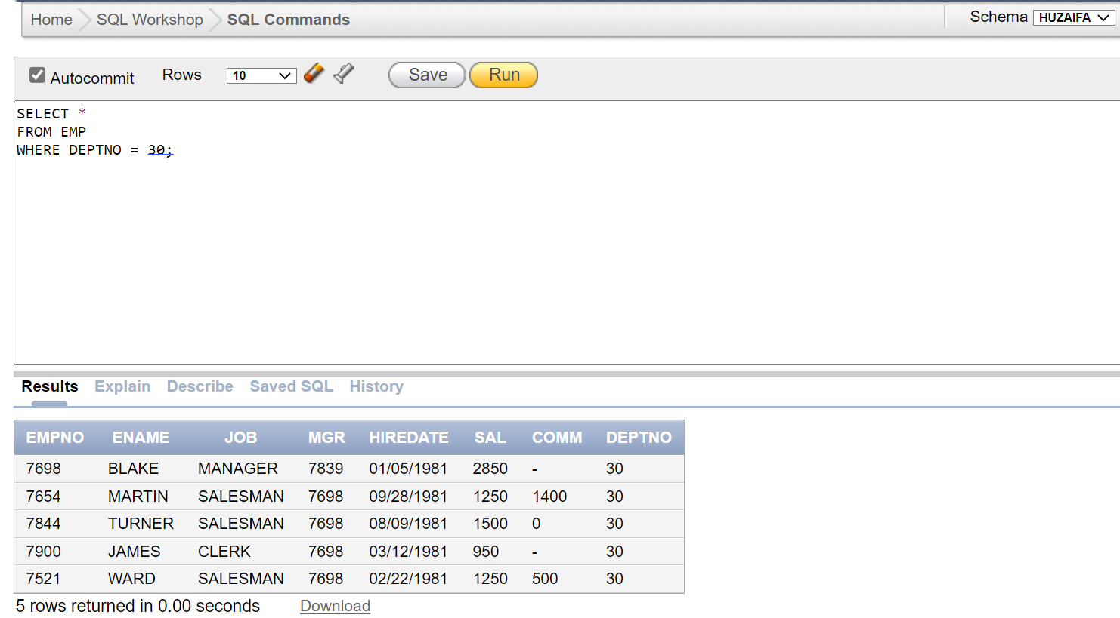

# TASK 3:

# TASK 4:

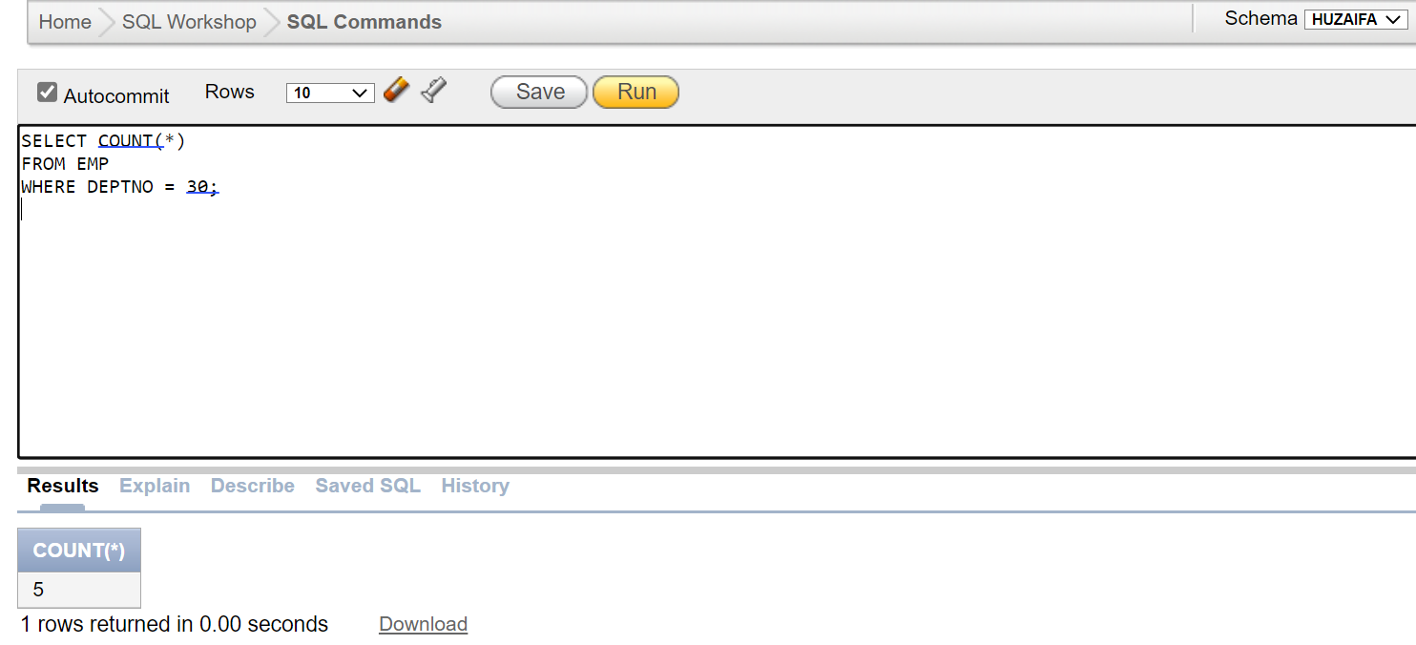

# TASK 5:

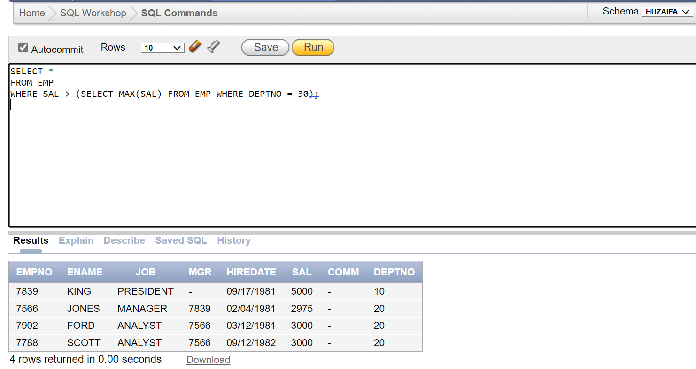

# TASK 6:

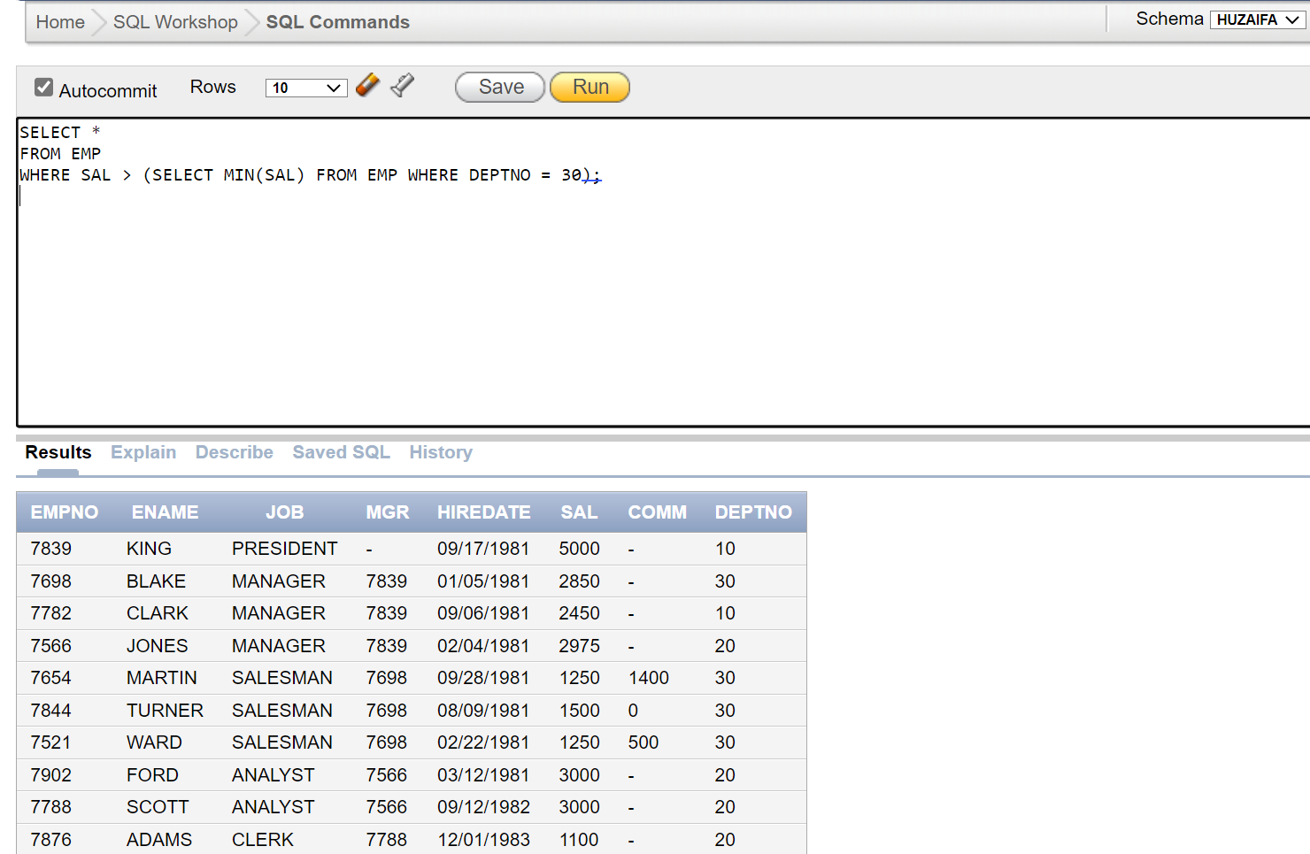

# TASK 7:

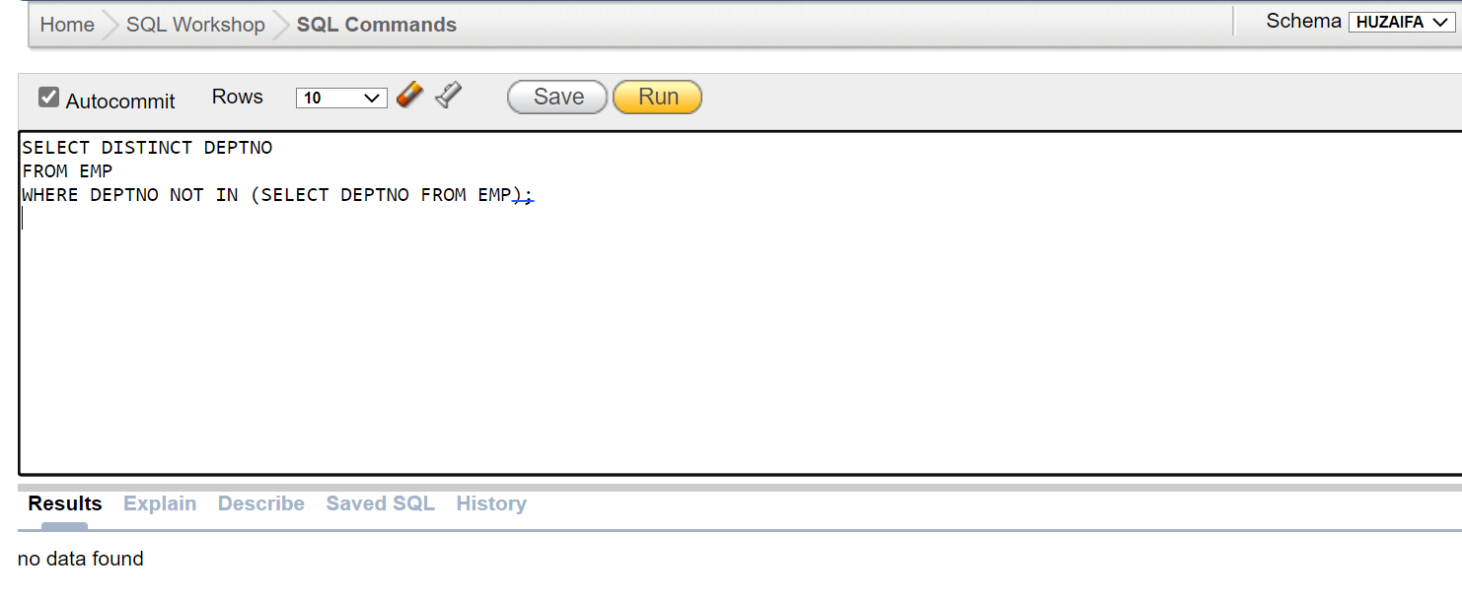

# TASK 8:

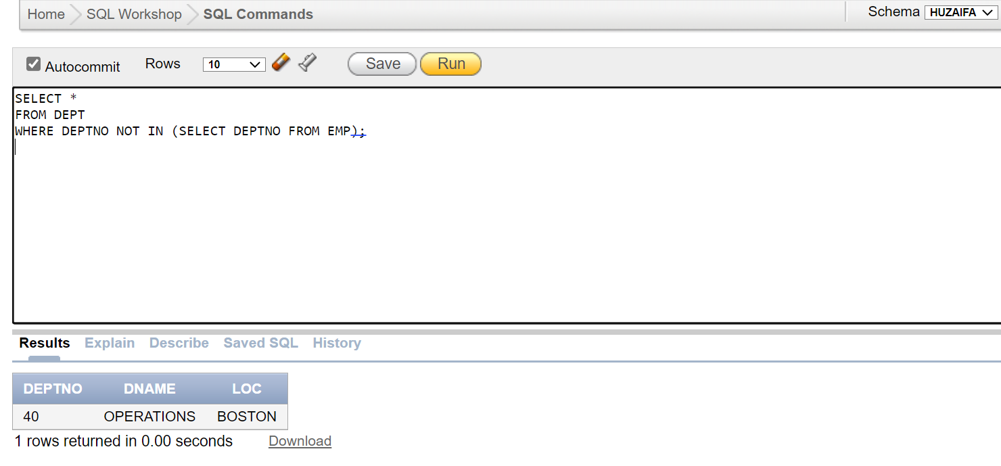

# TASK 9:

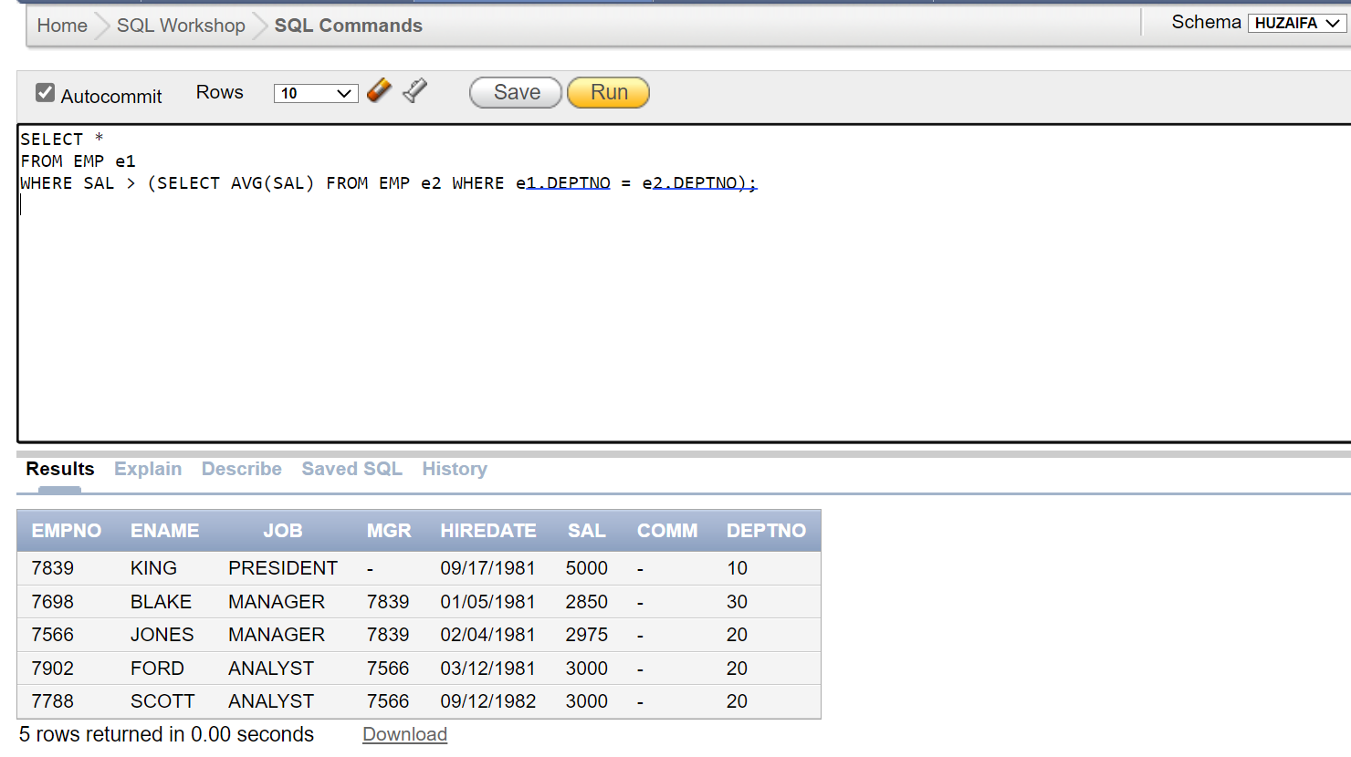

# TASK 10:

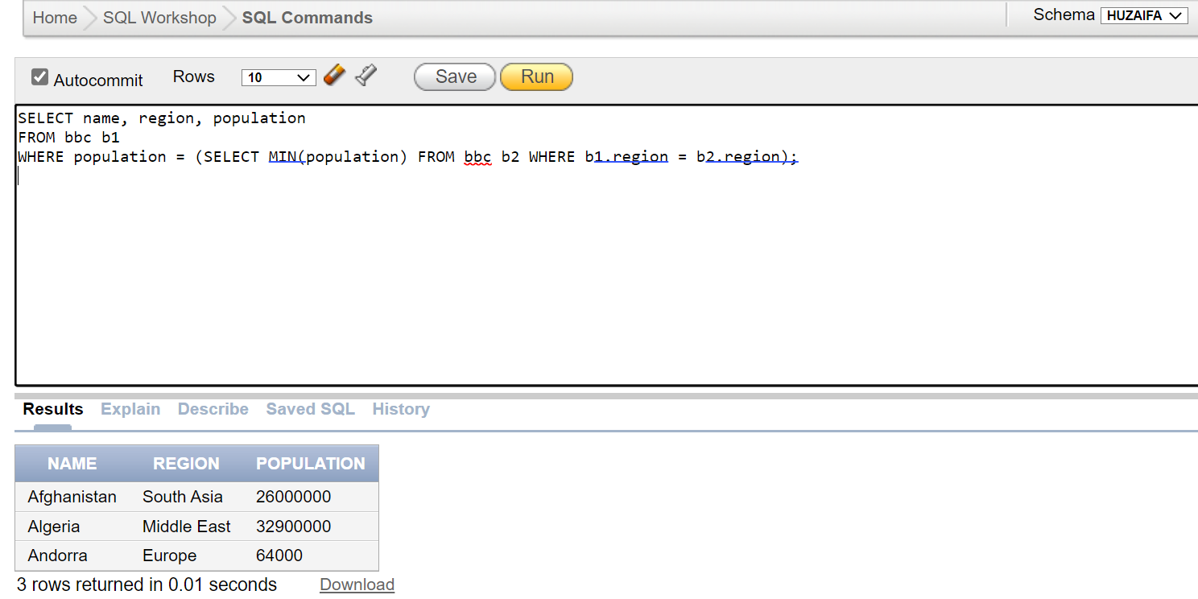

# TASK 11:

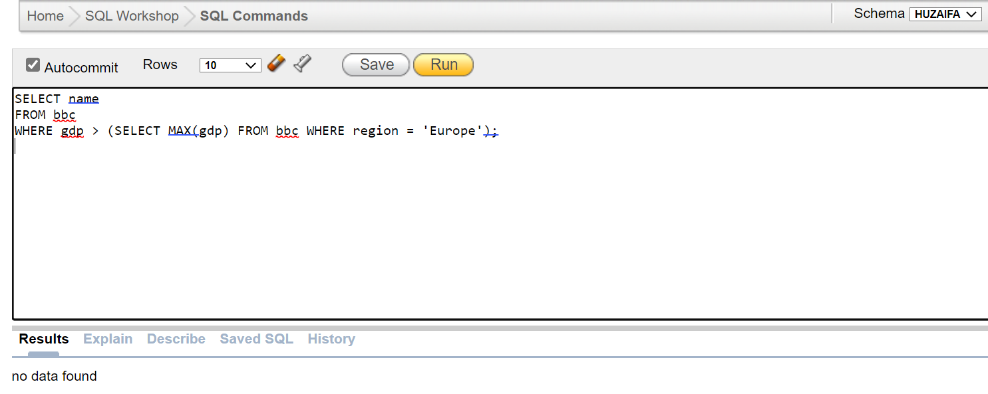

# TASK 12:

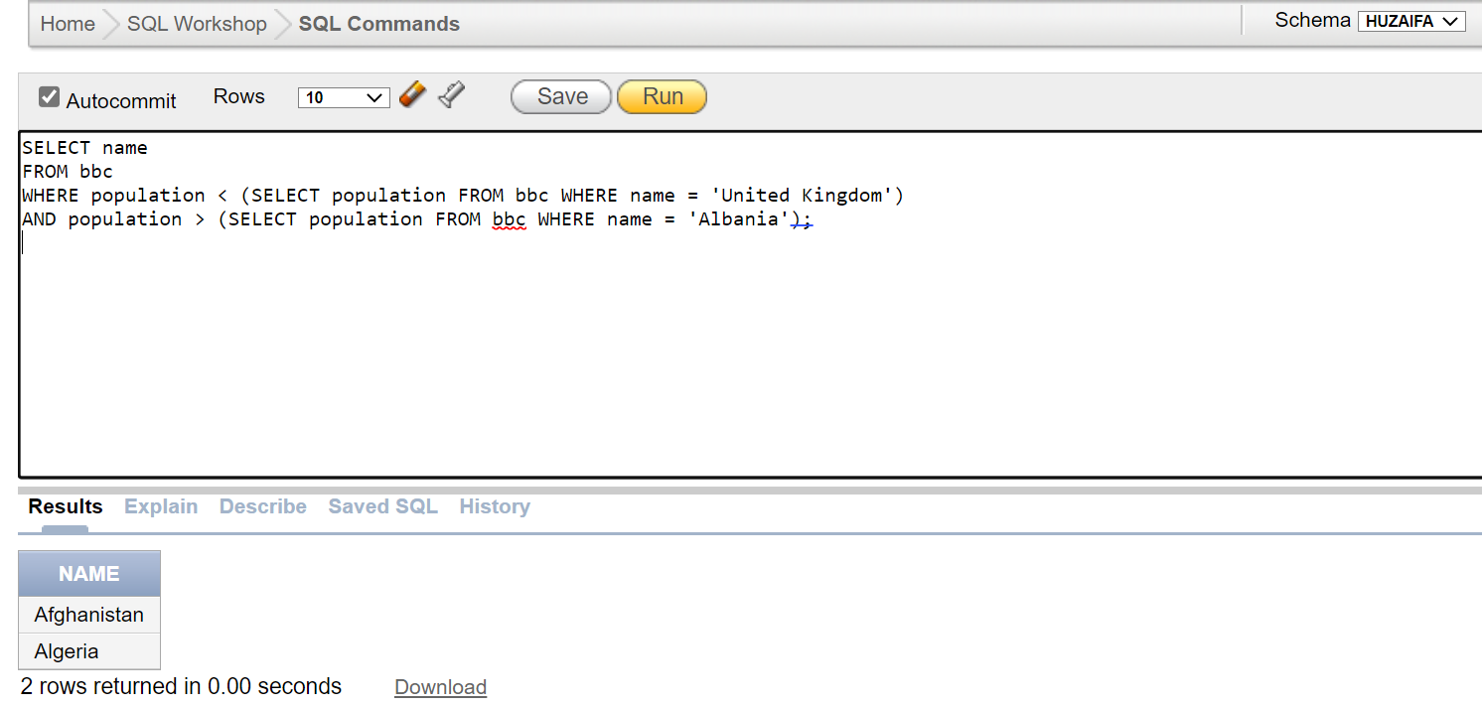

**PART 2:**

# TASK 1:

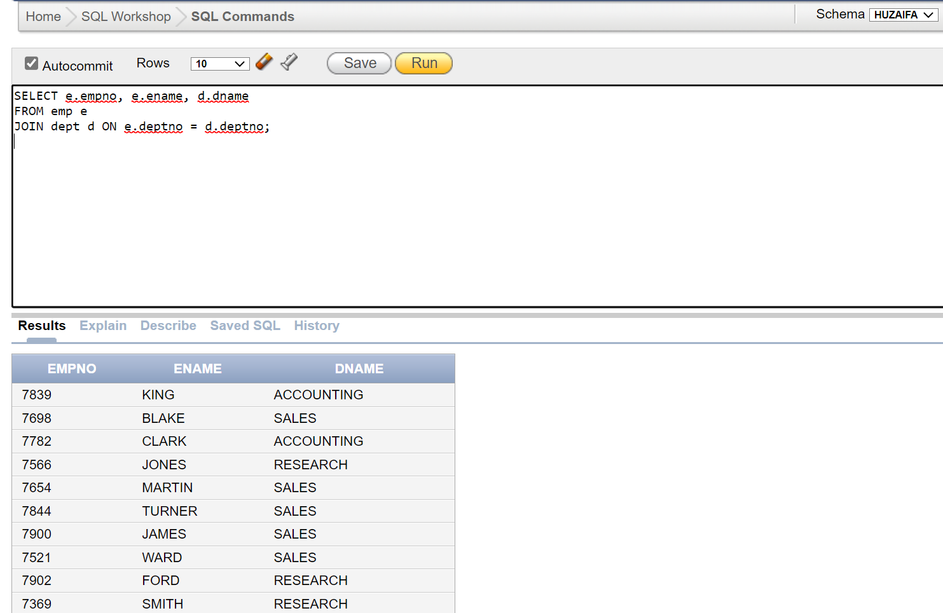

# TASK 2:

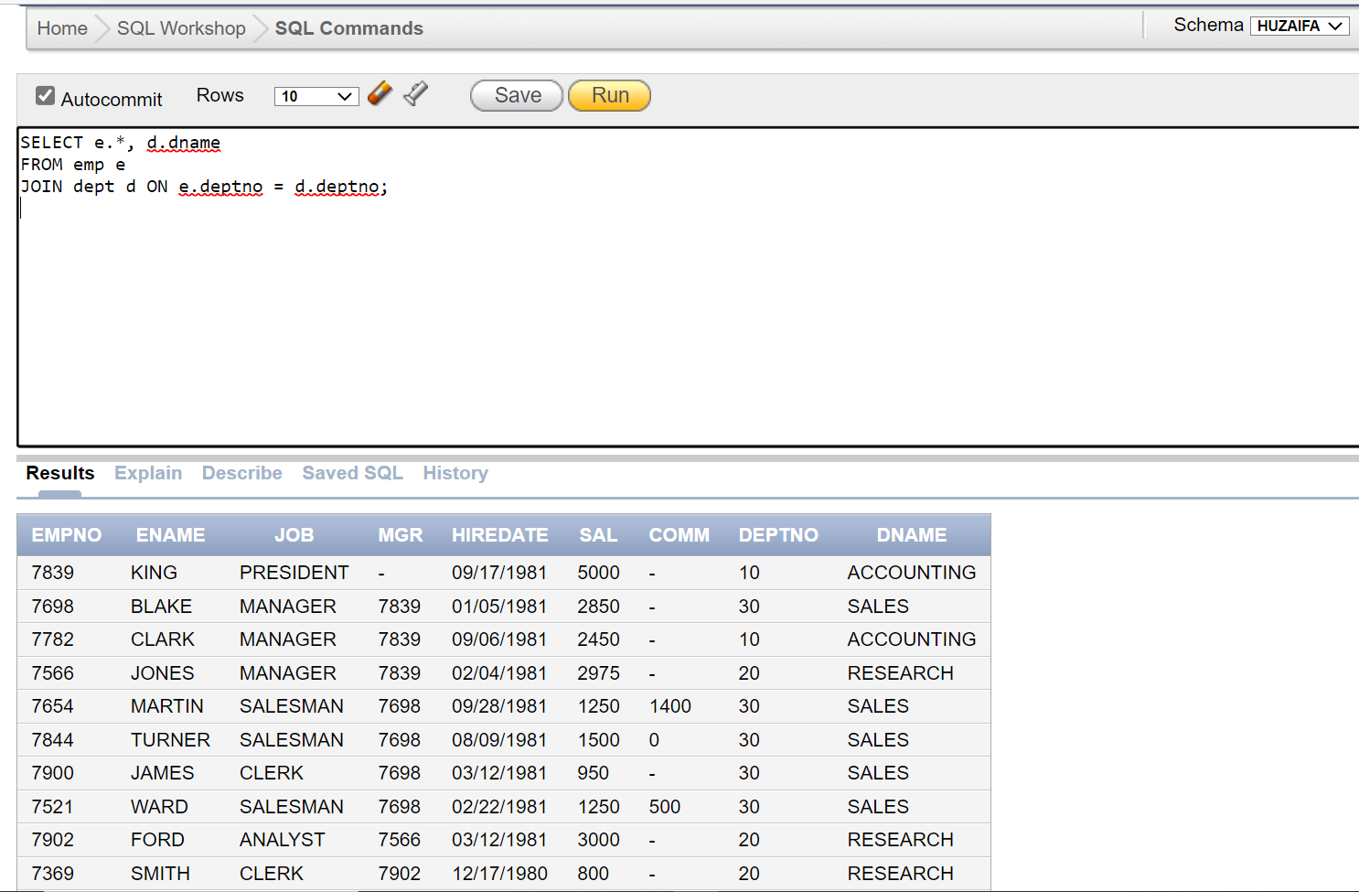

# TASK 3:

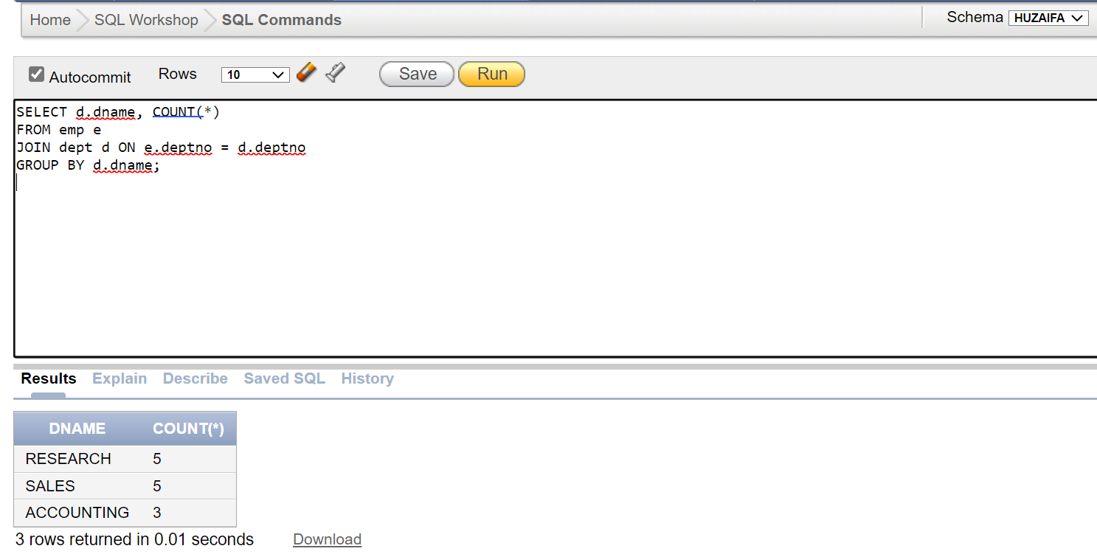

# TASK 4:

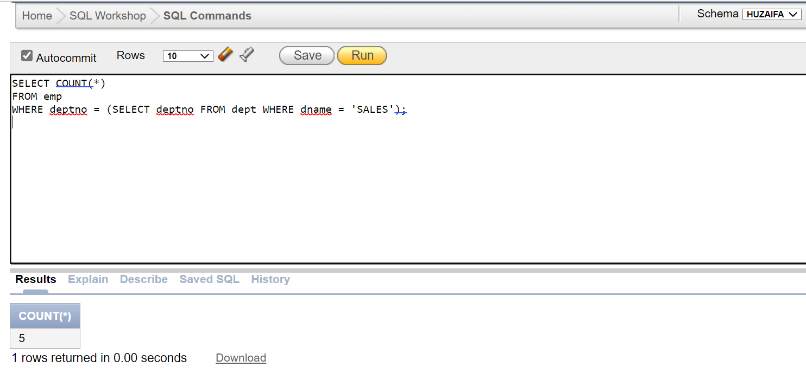

TASK 5:  
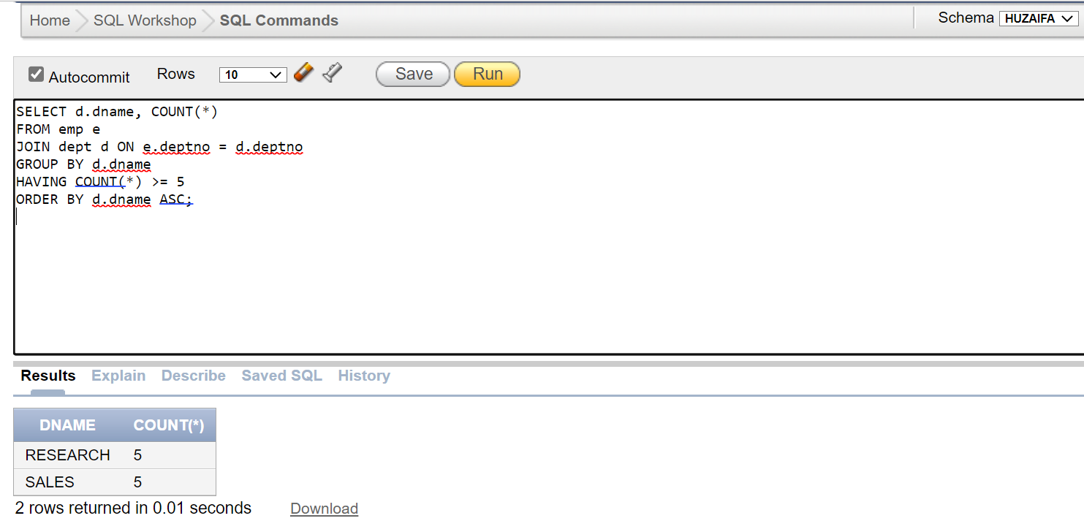

# TASK 6:

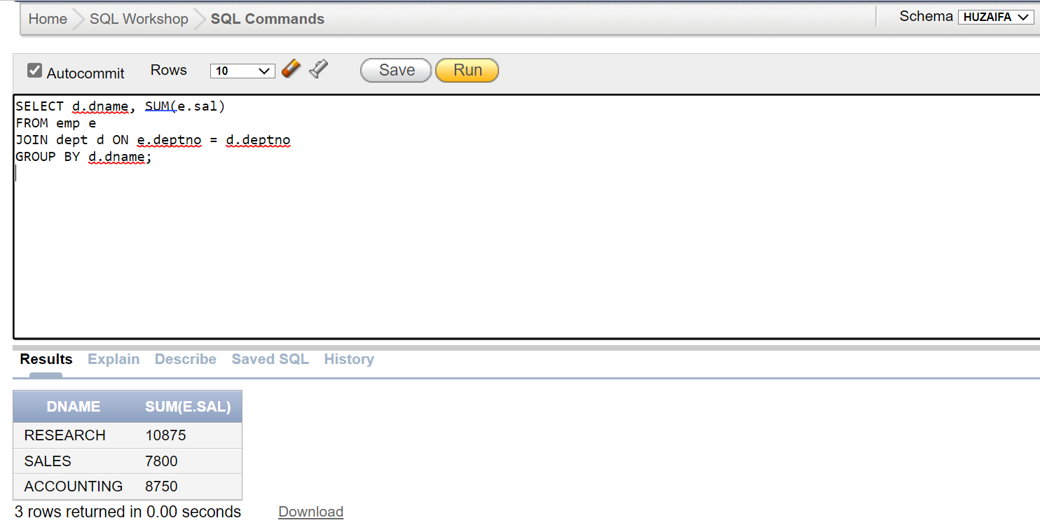

# TASK 7:

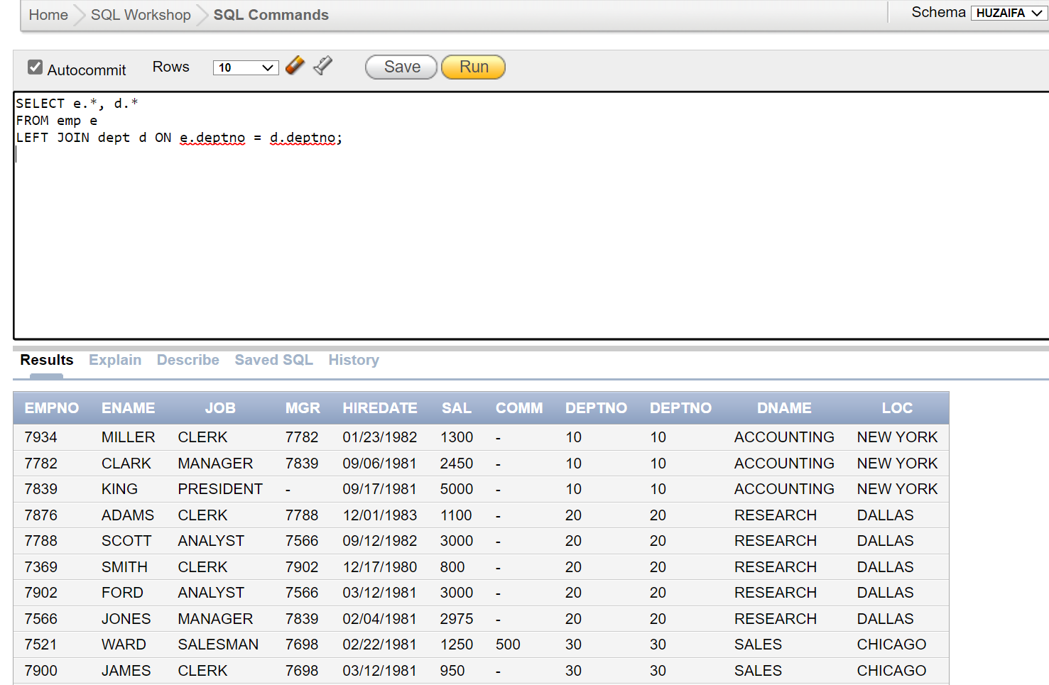

# TASK 8:

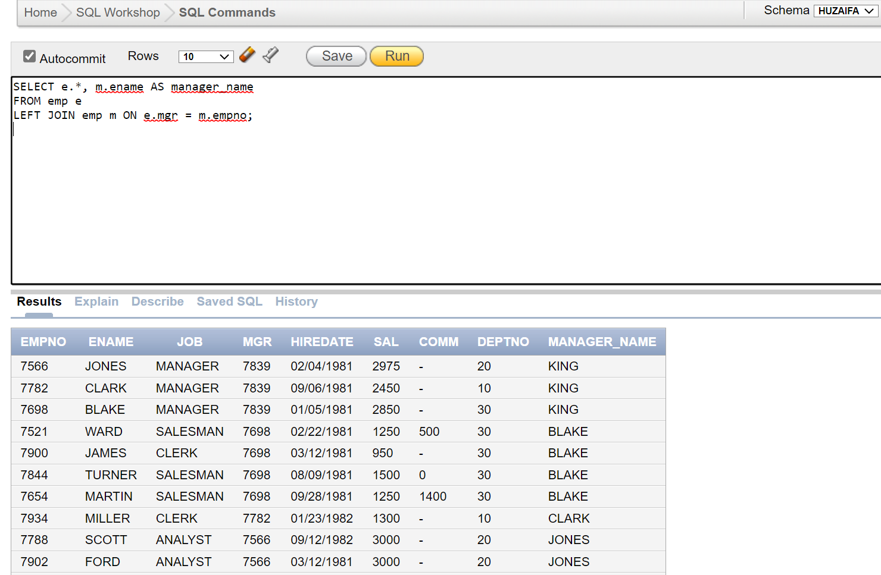

# TASK 9:

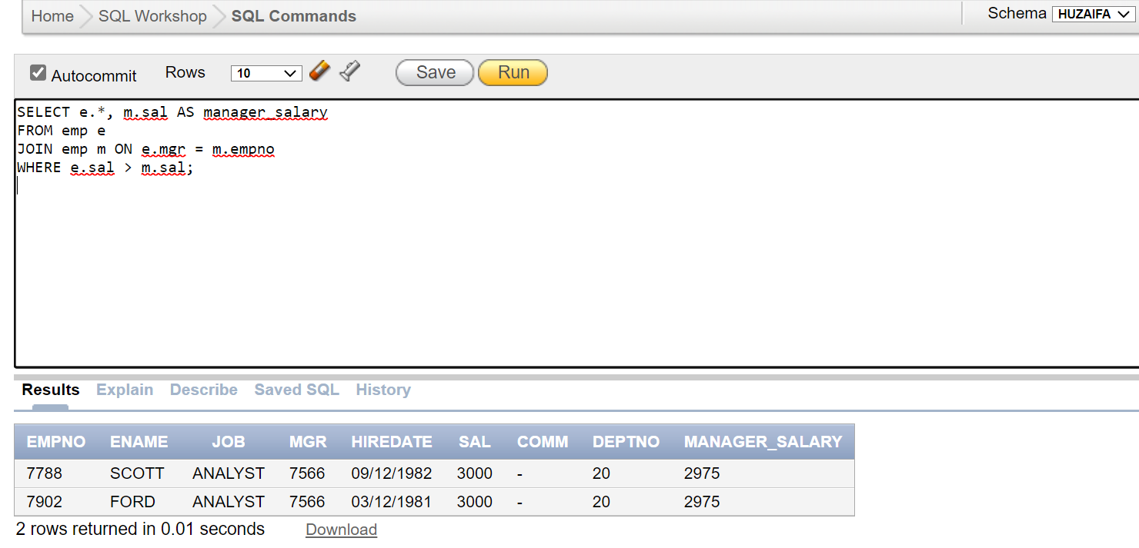

# TASK 10:

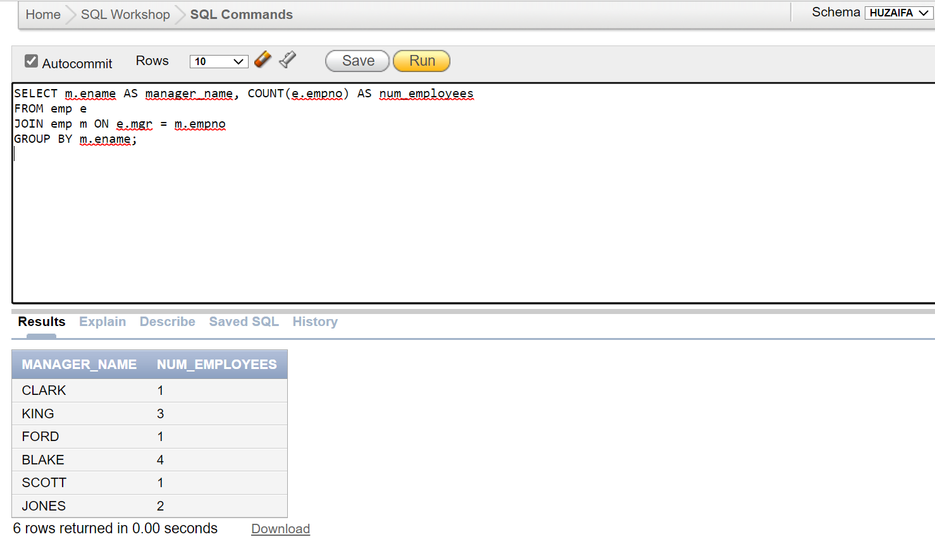

**PART 3:**

# PART A:

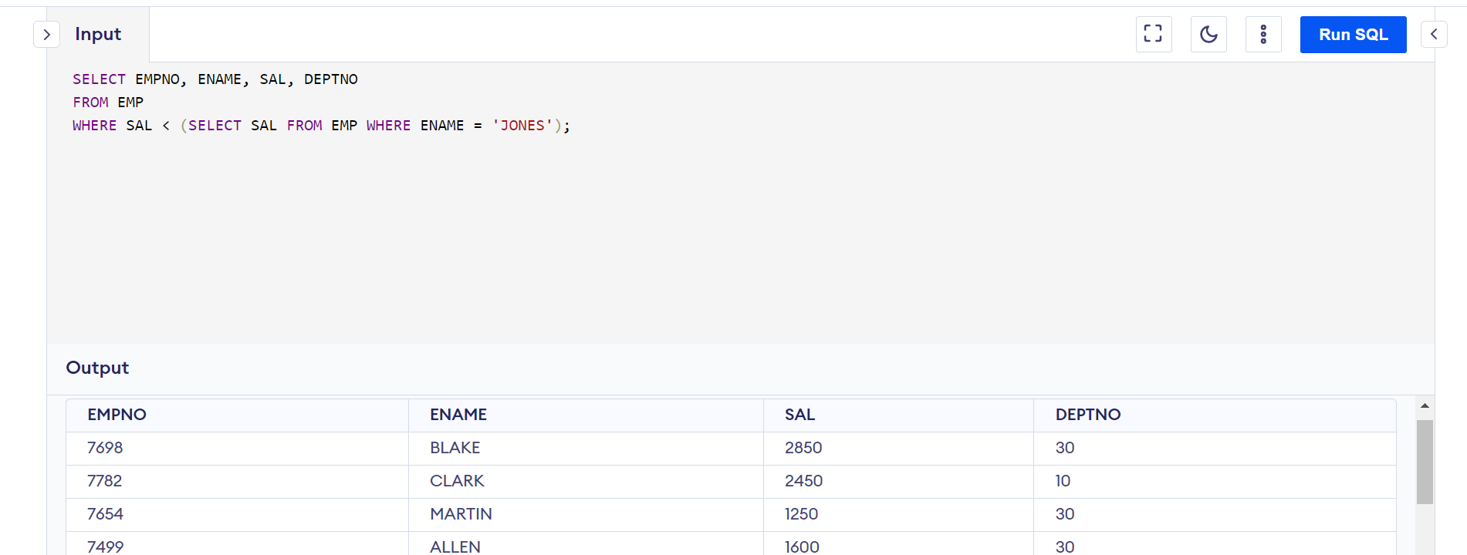

# PART B:

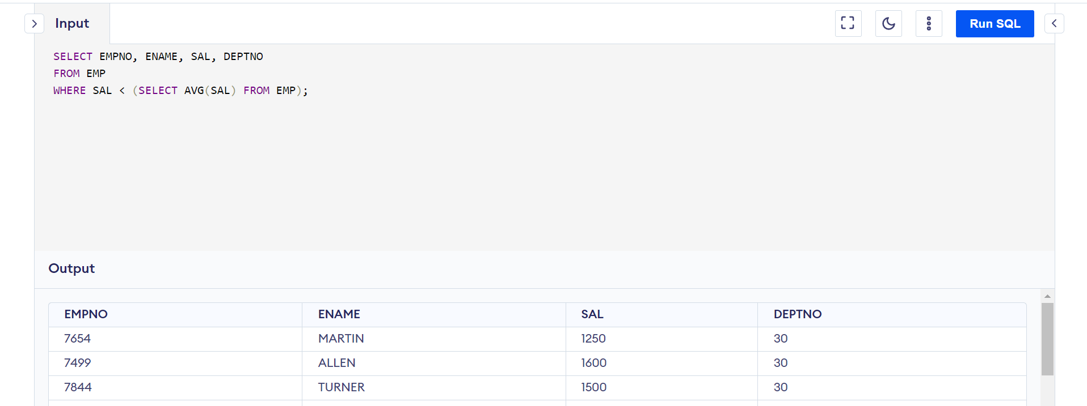

# PART C:

# PART D:

The given query selects the employee number (empno), name (ename), and department number (deptno) from the emp table where the (empno, deptno) combination exists in the result set of the subquery. The subquery returns all combinations of empno and deptno from the emp and dept tables respectively. These combinations are matched with the corresponding values in the emp table using the IN operator. So, the overall effect of the query is to select all employees whose empno and deptno values appear in both the emp and dept tables.

# PART E:

The given query is an example of a correlated subquery. The main query selects the employee number (empno), manager number (mgr), name (ename), and salary (sal) of all employees whose salary is greater than the average salary of all employees in their respective departments. The subquery calculates the average salary of all employees in the same department as the current employee in the outer query. This is done by correlating the subquery with the outer query using the empno column, which is shared between the two tables. The inner query only considers rows where the empno of the inner query matches the empno of the outer query, and then computes the average salary of all employees in the same department as the current employee in the outer query. The main query then uses this average salary as a filter condition, selecting only those employees whose salary is greater than this value.