# TASK 1:

#include <stdio.h>

#include <stdlib.h>

#include <pthread.h>

int n, m, p;

int MAT_A[10][10], MAT_B[10][10], MAT_C[10][10];

pthread_t thread[10];

void* multiply(void* arg)

{

int row = *(int*) arg;

for (int i = 0; i < p; i++)

{

MAT_C[row][i] = 0;

for (int j = 0; j < m; j++)

{

MAT_C[row][i] += MAT_A[row][j] * MAT_B[j][i];

}

}

pthread_exit(NULL);

}

int main()

{

int i, j;

printf("Enter size of matrix A (less than 10, n x m): ");

scanf("%d %d", &n, &m);

printf("Enter size of matrix B (less than 10, m x k): ");

scanf("%d %d", &m, &p);

printf("Enter values for matrix A:\n");

for (int i = 0; i < n; i++)

{

for (int j = 0; j < m; j++)

{

scanf("%d", &MAT_A[i][j]);

}

}

printf("Enter values for matrix B:\n");

for (int i = 0; i < m; i++)

{

for (int j = 0; j < p; j++)

{

scanf("%d", &MAT_B[i][j]);

}

}

for (int i = 0; i < n; i++)

{

pthread_create(&thread[i], NULL, multiply, (void*) &i);

}

for (int i = 0; i < n; i++)

{

pthread_join(thread[i], NULL);

}

printf("\nResultant matrix C:\n");

for (int i = 0; i < n; i++)

{

for (int j = 0; j < p; j++)

{

printf("%d ", MAT_C[i][j]);

}

printf("\n");

}

return 0;

}

# OUTPUT:

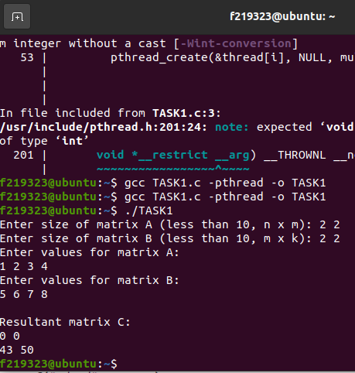

TASK 3:  
#include <stdio.h>

#include <stdlib.h>

#include <pthread.h>

struct Node

{

int data;

struct Node* next;

};

struct Queue

{

struct Node* front;

struct Node* rear;

};

int globalValue;

struct Queue* createQueue()

{

struct Queue* q = (struct Queue*)malloc(sizeof(struct Queue));

q->front = q->rear = NULL;

return q;

}

void enqueue(struct Queue* q, int value)

{

struct Node* newNode = (struct Node*)malloc(sizeof(struct Node));

newNode->data = value;

newNode->next = NULL;

if (q->rear == NULL)

{

q->front = q->rear = newNode;

return;

}

q->rear->next = newNode;

q->rear = newNode;

}

int dequeue(struct Queue* q)

{

if (q->front == NULL)

{

return -1;

}

int value = q->front->data;

struct Node* temp = q->front;

q->front = q->front->next;

if (q->front == NULL)

{

q->rear = NULL;

}

free(temp);

return value;

}

void* readIntegers()

{

FILE* obj = fopen("input.txt", "r");

int value;

while (fscanf(obj, "%d", &value) != EOF)

{

globalValue = value;

}

fclose(obj);

pthread_exit(NULL);

}

void* insertIntoQueue(void* arg)

{

struct Queue* q = (struct Queue*)arg;

while (globalValue != -1)

{

if (globalValue != 0)

{

enqueue(q, globalValue);

globalValue = 0;

}

}

pthread_exit(NULL);

}

int main()

{

struct Queue* q = createQueue();

pthread_t readThread, insertThread;

pthread_create(&readThread, NULL, readIntegers, NULL);

pthread_create(&insertThread, NULL, insertIntoQueue, q);

pthread_join(readThread, NULL);

pthread_join(insertThread, NULL);

struct Node* temp = q->front;

while (temp != NULL)

{

printf("%d ", temp->data);

temp = temp->next;

}

return 0;

}

OUTPUT:  
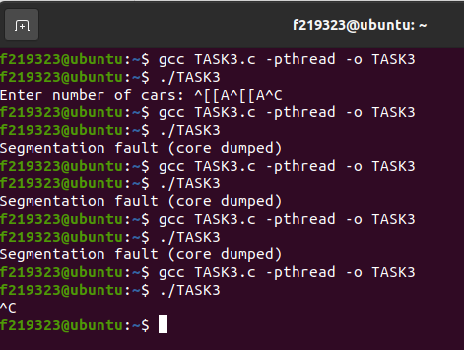

TASK 4:

#include <stdio.h>

#include <stdlib.h>

#include <pthread.h>

#include <time.h>

#define ARRAY_SIZE 1000000

#define CHUNK_SIZE 250000

void generate_integers(int* array, int size)

{

srand(time(NULL));

for (int i = 0; i < size; i++)

{

array[i] = rand() % 10000;

}

}

void print_array_to_file(int* array, int size, char* filename)

{

FILE* obj = fopen(filename, "w");

for (int i = 0; i < size; i++)

{

fprintf(obj, "%d\n", array[i]);

}

fclose(obj);

}

void read_array_from_file(int* array, int size, char* filename)

{

FILE* obj = fopen(filename, "r");

for (int i = 0; i < size; i++)

{

fscanf(obj, "%d", &array[i]);

}

fclose(obj);

}

void print_array(int* array, int size)

{

for (int i = 0; i < size; i++)

{

printf("%d ", array[i]);

}

printf("\n");

}

void merge(int* left, int left_size, int* right, int right_size, int* result)

{

int i = 0, j = 0, k = 0;

while (i < left_size && j < right_size)

{

if (left[i] <= right[j])

{

result[k++] = left[i++];

}

else

{

result[k++] = right[j++];

}

}

while (i < left_size)

{

result[k++] = left[i++];

}

while (j < right_size)

{

result[k++] = right[j++];

}

}

void merge_sort_rec(int* array, int* temp, int left, int right) ;

void* merge_sort(void* arg)

{

int* array = (int*)arg;

int size = CHUNK_SIZE;

int temp[size];

clock_t start = clock();

merge_sort_rec(array, temp, 0, size-1);

clock_t end = clock();

double time_taken = ((double)(end - start))/CLOCKS_PER_SEC;

printf("Merge Sort Thread %lu finished in %lf seconds\n", pthread_self(), time_taken);

pthread_exit(NULL);

}

void merge_sort_rec(int* array, int* temp, int left, int right)

{

if (left < right) {

int mid = (left + right) / 2;

merge_sort_rec(array, temp, left, mid);

merge_sort_rec(array, temp, mid+1, right);

merge(array+left, mid-left+1, array+mid+1, right-mid, temp+left);

for (int i = left; i <= right; i++)

{

array[i] = temp[i];

}

}

}

void selection_sort(int* array, int size)

{

for (int i = 0; i < size-1; i++)

{

for (int j = i+1; j < size; j++)

{

if (array[i] > array[j])

{

int temp = array[i];

array[i] = array[j];

array[j] = temp;

}

}

}

}

int main()

{

int array[ARRAY_SIZE];

generate_integers(array, ARRAY_SIZE);

print_array_to_file(array, ARRAY_SIZE, "array.txt");

pthread_t threads[4];

for (int i = 0; i < 4; i++)

{

int* chunk = &array[i*CHUNK_SIZE];

pthread_create(&threads[i], NULL, merge_sort, chunk);

}

for (int i = 0; i < 4; i++)

{

pthread_join(threads[i], NULL);

}

int temp[ARRAY_SIZE];

for (int i = 0; i < ARRAY_SIZE; i += 2*CHUNK_SIZE)

{

int left_chunk_start = i;

int left_chunk_end = i + CHUNK_SIZE - 1;

int right_chunk_start = i + CHUNK_SIZE;

int right_chunk_end = i + 2*CHUNK_SIZE - 1;

if (right_chunk_end >= ARRAY_SIZE)

{

right_chunk_end = ARRAY_SIZE-1;

}

merge(array+left_chunk_start, CHUNK_SIZE, array+right_chunk_start, right_chunk_end-right_chunk_start+1, temp+left_chunk_start);

}

merge(array, 2*CHUNK_SIZE, array+2*CHUNK_SIZE, 2*CHUNK_SIZE, temp);

print_array_to_file(temp, ARRAY_SIZE, "sorted_array.txt");

printf("Array sorted successfully!\n");

return 0;

}

OUTPUT:

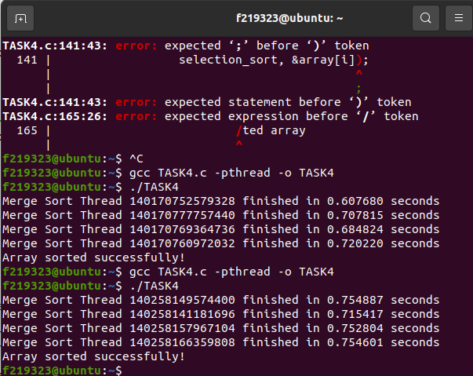

TASK 5:

#include <stdio.h>

#include <stdlib.h>

#include <unistd.h>

#include <time.h>

#include <sys/wait.h>

//READ_END 0

//WRITE_END 1

int main()

{

int arr[10];

int i, left_max, right_max, max;

int left_pipe[2], right_pipe[2];

pid_t left_pid, right_pid;

srand(time(NULL));

for (i = 0; i < 10; i++)

{

arr[i] = rand() % 1000;

}

int left[5], right[5];

for (i = 0; i < 5; i++)

{

left[i] = arr[i];

right[i] = arr[5 + i];

}

pipe(left_pipe);

pipe(right_pipe);

left_pid = fork();

if (left_pid == -1)

{

printf("Error: failed to fork\n");

exit(EXIT_FAILURE);

}

else if (left_pid == 0)

{

close(left_pipe[0]);

left_max = left[0];

for (i = 1; i < 5; i++)

{

if (left[i] > left_max)

{

left_max = left[i];

}

}

write(left_pipe[1], &left_max, sizeof(int));

close(left_pipe[1]);

exit(EXIT_SUCCESS);

}

else

{

right_pid = fork();

if (right_pid == -1)

{

printf("Error: failed to fork\n");

exit(EXIT_FAILURE);

}

else if (right_pid == 0)

{

close(right_pipe[0]);

right_max = right[0];

for (i = 1; i < 5; i++)

{

if (right[i] > right_max)

{

right_max = right[i];

}

}

write(right_pipe[1], &right_max, sizeof(int));

close(right_pipe[1]);

exit(EXIT_SUCCESS);

}

else

{

wait(NULL);

wait(NULL);

close(left_pipe[1]);

close(right_pipe[1]);

read(left_pipe[0], &left_max, sizeof(int));

read(right_pipe[0], &right_max, sizeof(int));

close(left_pipe[0]);

close(right_pipe[0]);

if (left_max > right_max)

{

max = left_max;

}

else

{

max = right_max;

}

printf("Max value: %d\n", max);

}

}

return 0;

}

# OUTPUT:

