# TASK 1:

1. Create a New Virtual Machine and select TYPICAL option.

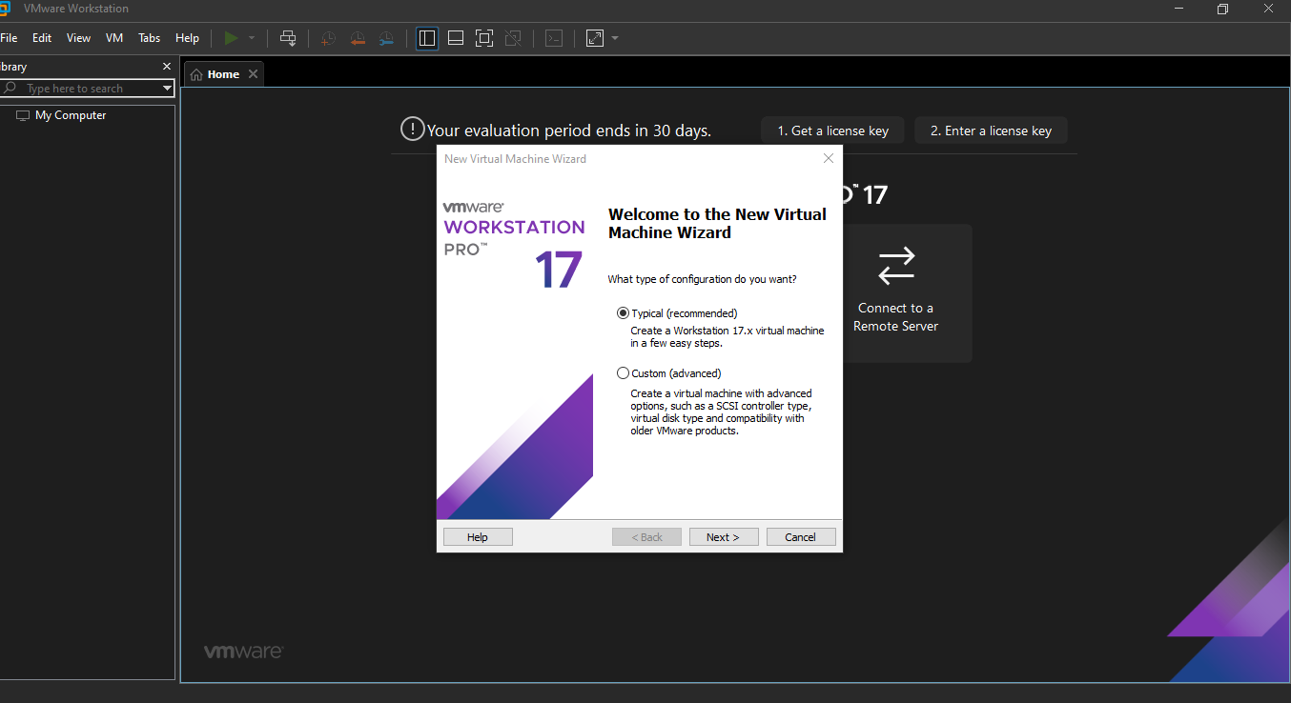

1. Browse the Operating System located in your PC and press next.

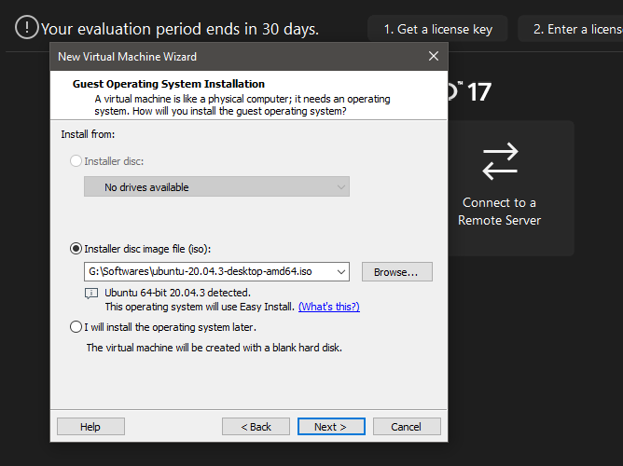

1. Enter name, username, password for your machine.

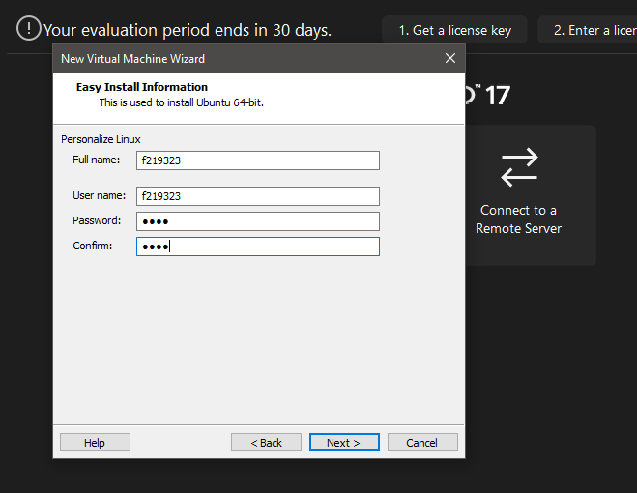

1. Enter your Virtual Machine name.

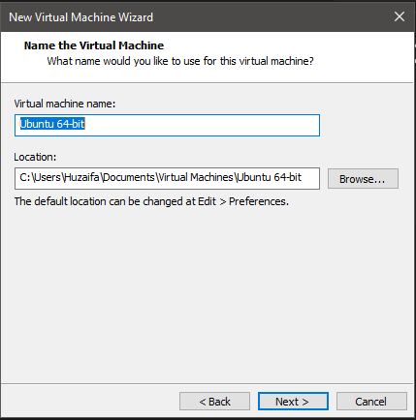

1. Enter disk size you want to allocate to your machine. It should be at least minimum or more.

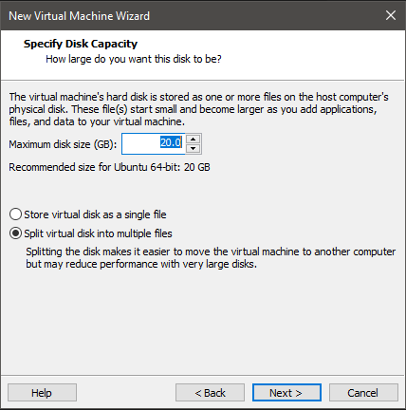

1. Finish the process and then loading screen will pop up and after some time it would be ready to use.

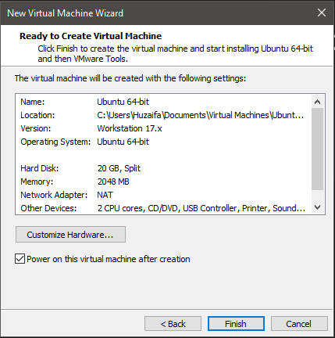

# TASK 2: **CPP:**

#include<iostream>

using namespace std;

int main()

{

int a, b;

cout << "Enter Value of a and b: " << endl;

cin >> a >> b;

cout << "Sum of a and b is: " << a + b << endl;

cout << "Difference of a and b is: " << a - b << endl;

cout << "Multiplication of a and b is: " << a * b << endl;

cout << "Division of a and b is: " << a / b << endl;

return 0;

}

# OUTPUT:

#include<iostream>

using namespace std;

int main()

{

int a, b;

printf("Enter Value of a and b: ");

scanf("%d", &a);

scanf("%d", &b);

printf("Sum of a and b is: \n");

printf("Difference of a and b is: \n");

printf("Multiplication of a and b is: \n");

printf("Division of a and b is: \n");

return 0;

}

