# TASK 1:

#include <pthread.h>

#include <semaphore.h>

#include <stdio.h>

#include <stdlib.h>

#include <unistd.h>

#define NUM 5 //No of philosphers

pthread_t philosophers[NUM];

sem_t chopsticks[NUM];

void* philosopher(void* arg)

{

int id = *((int*)arg);

int left_chopstick = id;

int right_chopstick = (id + 1) % NUM;

while (1)

{

// Try to pick up left chopstick

sem_wait(&chopsticks[left_chopstick]);

// Try to pick up right chopstick

if (sem_trywait(&chopsticks[right_chopstick]) == 0)

{

printf("Philosopher %d is eating.\n", id);

usleep(rand() % 1000);

// Put down right chopstick

sem_post(&chopsticks[right_chopstick]);

}

// Put down left chopstick

sem_post(&chopsticks[left_chopstick]);

printf("Philosopher %d is not eating.\n", id);

usleep(rand() % 1000);

}

return NULL;

}

int main()

{

int id[NUM];

for (int i = 0; i < NUM; i++)

{

sem_init(&chopsticks[i], 0, 1);

}

for (int i = 0; i < NUM; i++)

{

id[i] = i;

pthread_create(&philosophers[i], NULL, philosopher, &id[i]);

}

for (int i = 0; i < NUM; i++)

{

pthread_join(philosophers[i], NULL);

}

for (int i = 0; i < NUM; i++)

{

sem_destroy(&chopsticks[i]);

}

return 0;

}

# OUTPUT:

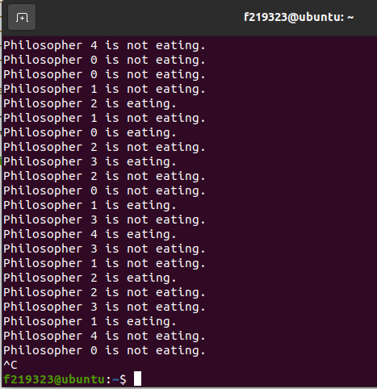

# TASK 2:

#include <stdio.h>

#include <stdlib.h>

#include <string.h>

#define MAX_JOBS 10

typedef struct {

char* text;

} Job;

typedef struct {

Job jobs[MAX_JOBS];

int front;

int rear;

int count;

} PrinterSpooler;

void initialize(PrinterSpooler* spooler) {

spooler->front = 0;

spooler->rear = -1;

spooler->count = 0;

}

void enqueue(PrinterSpooler* spooler, char* text) {

if (spooler->count >= MAX_JOBS) {

printf("Printer spooler is full. Cannot add job.\n");

return;

}

spooler->rear = (spooler->rear + 1) % MAX_JOBS;

Job newJob;

newJob.text = text;

spooler->jobs[spooler->rear] = newJob;

spooler->count++;

}

Job dequeue(PrinterSpooler* spooler) {

if (spooler->count <= 0) {

printf("Printer spooler is empty. Cannot dequeue job.\n");

Job nullJob;

nullJob.text = "";

return nullJob;

}

Job dequeuedJob = spooler->jobs[spooler->front];

spooler->front = (spooler->front + 1) % MAX_JOBS;

spooler->count--;

return dequeuedJob;

}

void printJob(Job job) {

printf("Printing job: %s\n", job.text);

}

int main() {

PrinterSpooler spooler;

initialize(&spooler);

enqueue(&spooler, "Job 1");

enqueue(&spooler, "Job 2");

enqueue(&spooler, "Job 3");

while (spooler.count > 0) {

Job job = dequeue(&spooler);

printJob(job);

}

return 0;

}  
  
OUTPUT:

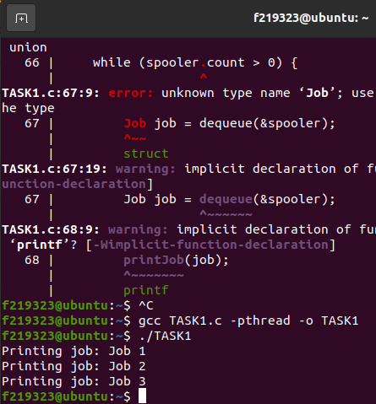

# TASK 3:

#include <pthread.h>

#include <semaphore.h>

#include <stdio.h>

#include <unistd.h>

sem_t mutex, wrt;

int readCount = 0, data = 0;

void* reader(void *arg) {

int id = *(int*)arg;

while (1) {

sem_wait(&mutex);

readCount++;

if (readCount == 1) {

sem_wait(&wrt);

}

sem_post(&mutex);

printf("Reader %d read data: %d\n", id, data);

sem_wait(&mutex);

readCount--;

if (readCount == 0) {

sem_post(&wrt);

}

sem_post(&mutex);

sleep(1);

}

}

void* writer(void *arg) {

int id = *(int*)arg;

while (1) {

sem_wait(&wrt);

data++;

printf("Writer %d wrote data: %d\n", id, data);

sem_post(&wrt);

sleep(1);

}

}

int main() {

pthread_t r1, r2, w1, w2;

sem_init(&mutex, 0, 1);

sem_init(&wrt, 0, 1);

int r1_id = 1, r2_id = 2, w1_id = 1, w2_id = 2;

pthread_create(&r1, NULL, reader, &r1_id);

pthread_create(&r2, NULL, reader, &r2_id);

pthread_create(&w1, NULL, writer, &w1_id);

pthread_create(&w2, NULL, writer, &w2_id);

pthread_join(r1, NULL);

pthread_join(r2, NULL);

pthread_join(w1, NULL);

pthread_join(w2, NULL);

sem_destroy(&mutex);

sem_destroy(&wrt);

return 0;

}

OUTPUT:

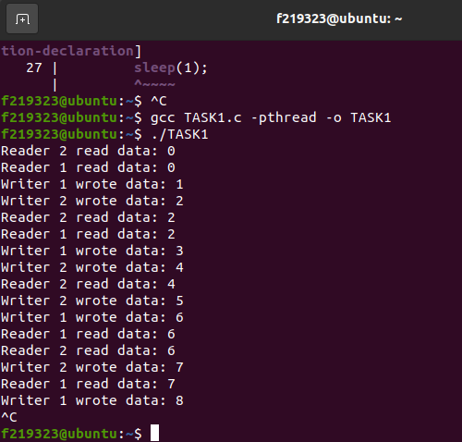

TASK 4:  
#include <stdio.h>

#include <stdbool.h>

#include <pthread.h>

#define NUM_THREADS 2

bool flag[2] = {false, false};

int turn = 0;

void enter_critical_section(int thread_num)

{

int other_thread = 1 - thread_num;

flag[thread_num] = true;

turn = other_thread;

while (flag[other_thread] && turn == other_thread);

}

void leave_critical_section(int thread_num)

{

flag[thread_num] = false;

}

void* thread_function(void* arg)

{

int thread_num = *(int*) arg;

for (int i = 0; i < 10; i++)

{

enter_critical_section(thread_num);

printf("Thread %d is in critical section.\n", thread_num);

leave_critical_section(thread_num);

printf("Thread %d is out of critical section.\n", thread_num);

}

pthread_exit(NULL);

}

int main()

{

pthread_t threads[NUM_THREADS];

int thread_args[NUM_THREADS];

for (int i = 0; i < NUM_THREADS; i++)

{

thread_args[i] = i;

pthread_create(&threads[i], NULL, thread_function, &thread_args[i]);

}

for (int i = 0; i < NUM_THREADS; i++)

{

pthread_join(threads[i], NULL);

}

return 0;

}

# OUTPUT:

