# TASK 1:

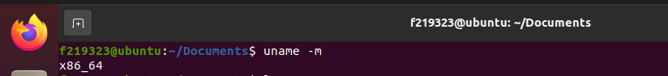

# TASK 2:

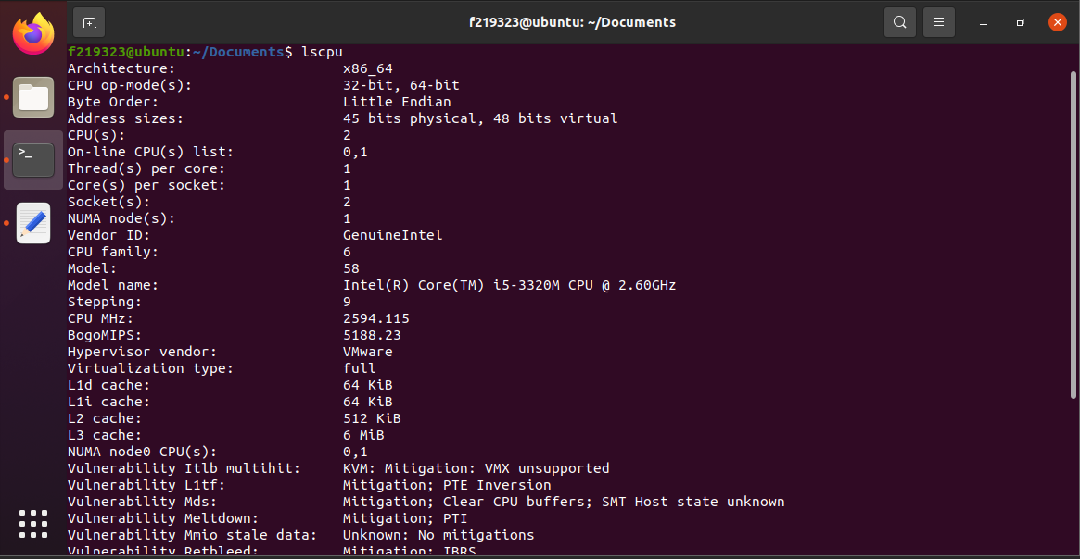

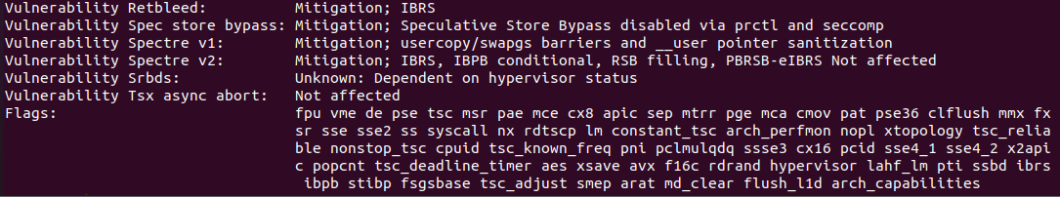

# TASK 3:



# TASK 4:

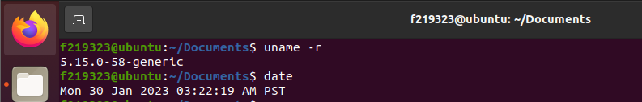

# TASK 5:

# TASK 6:

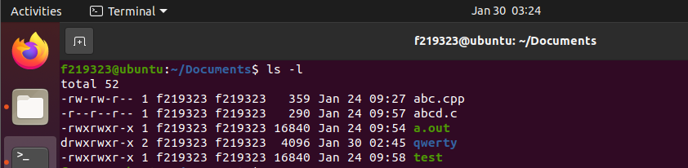

# TASK 7:

# TASK 8:

# TASK 9:

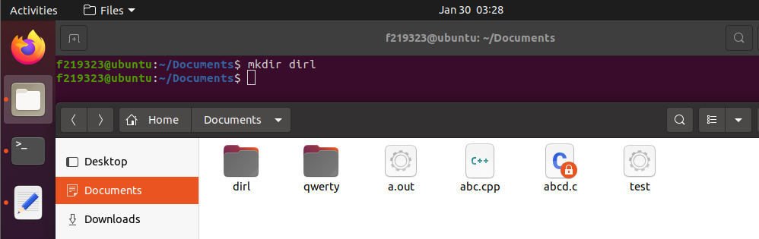

# TASK 10:

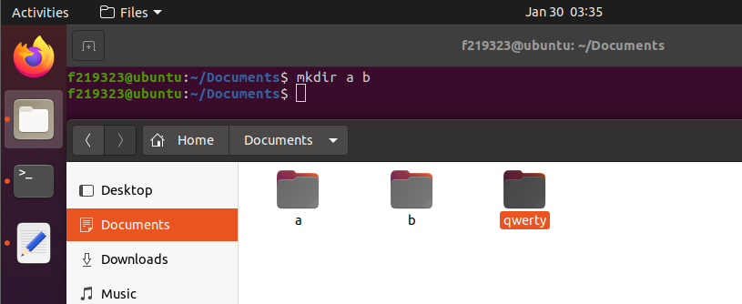

# TASK 11:

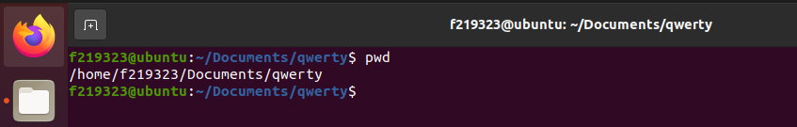

# TASK 12:

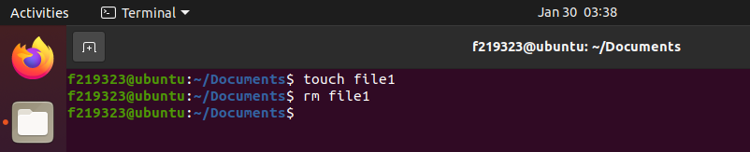

# TASK 13:

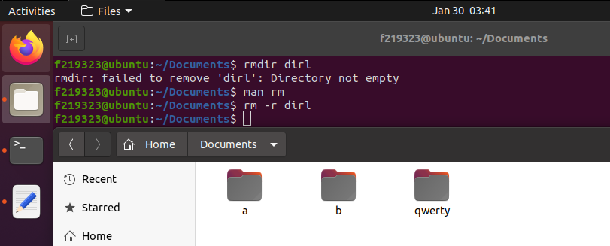

# TASK 14:

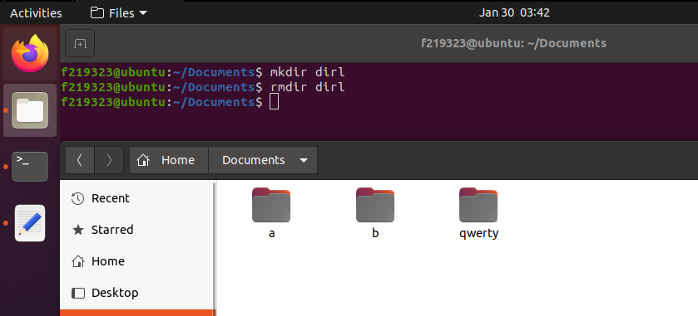

# TASK 15:

# TASK 16:

# TASK 17:

# TASK 18:

# TASK 19: