# CHANGE DIRECTORY : FORWARD

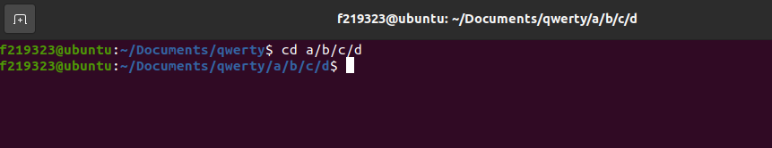

# CHANGE DIRECTORY : BACKWARDS

# PWD:

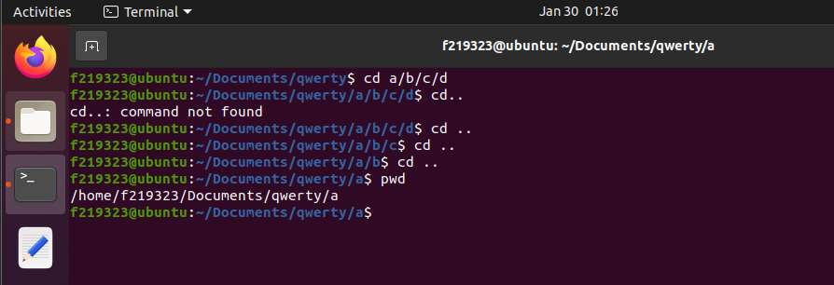

# LIST:

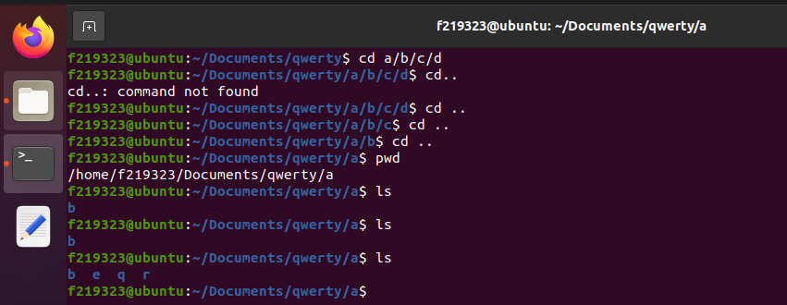

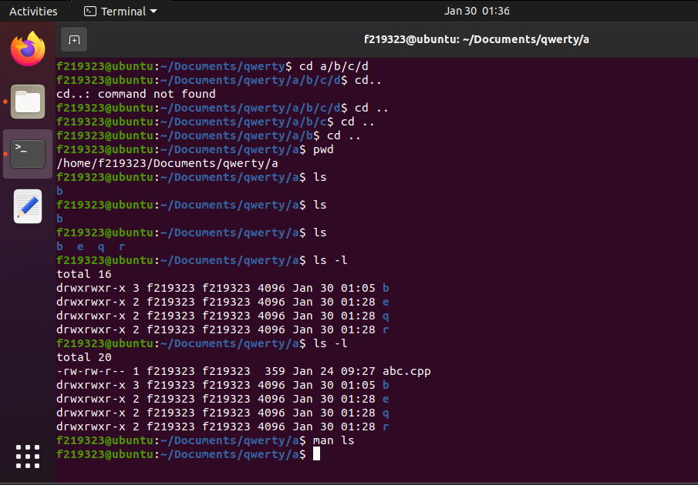

# CREATE FILE/ CREATE AND EDIT FILE:

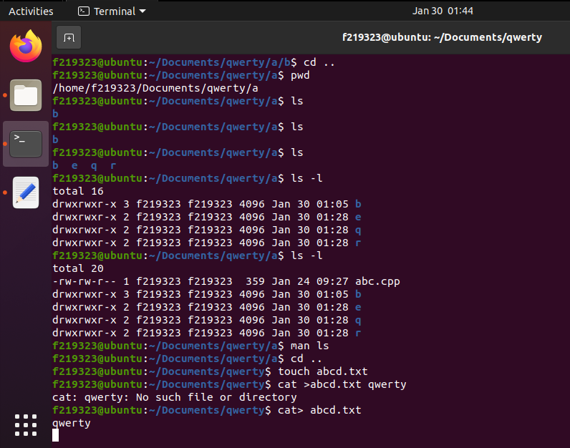

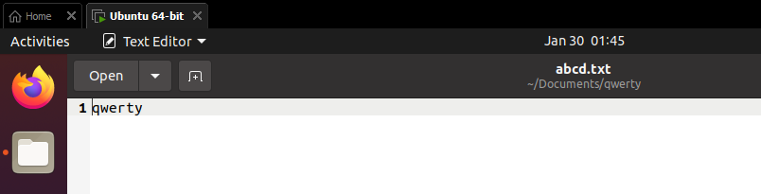

# APPEND:

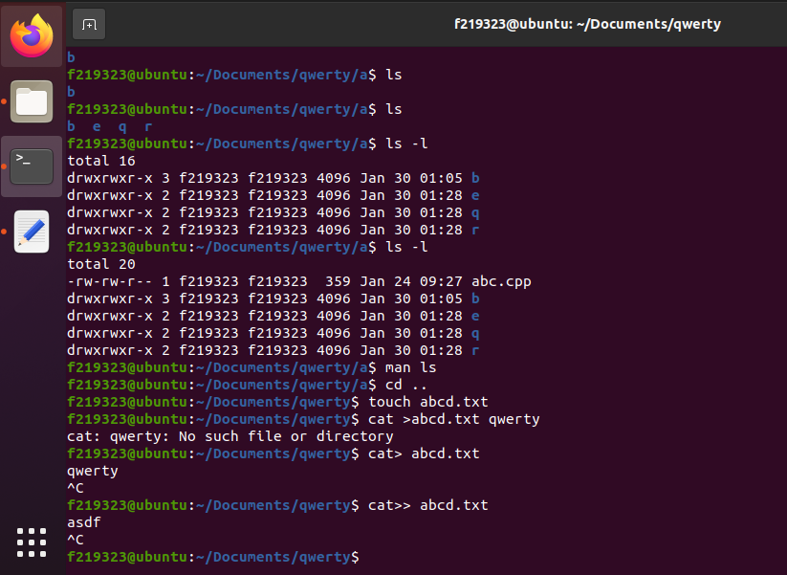

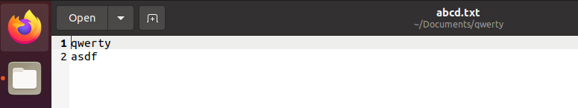

# REMOVE:

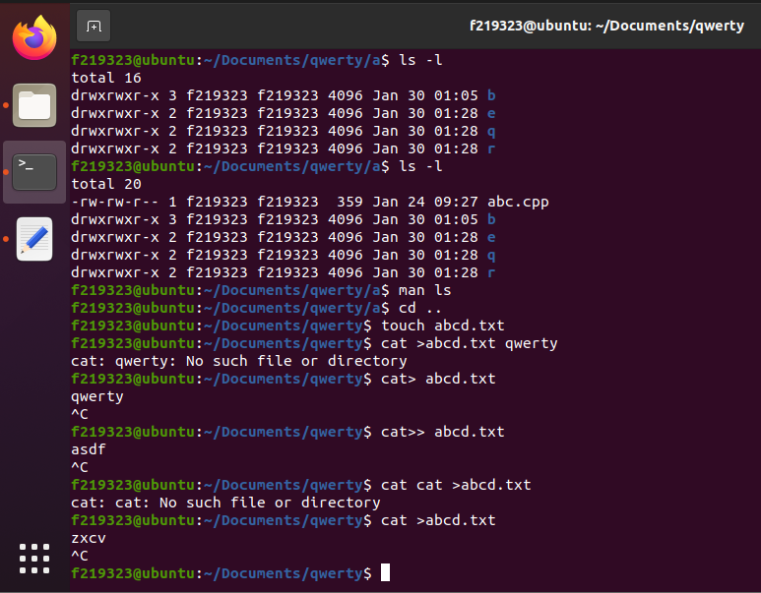

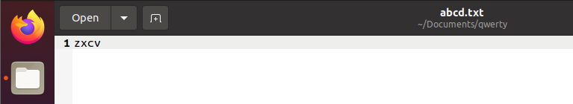

# OUTPUT:

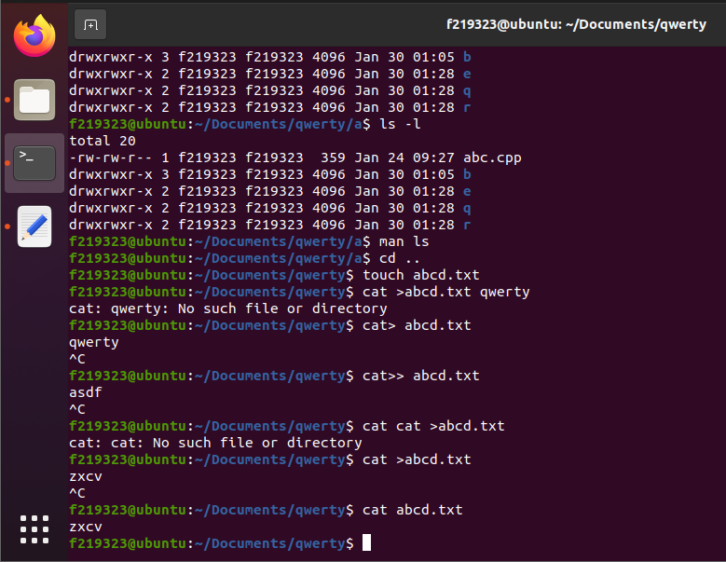

# MAKE DIRECTORY:

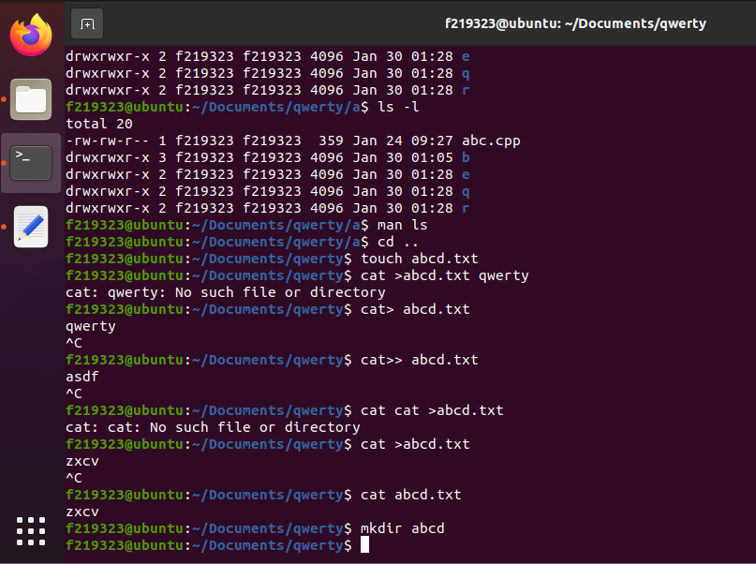

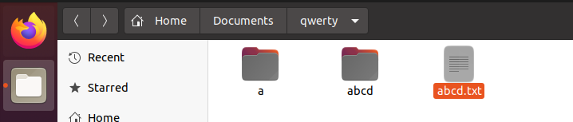

# REMOVE DIRECTORY:

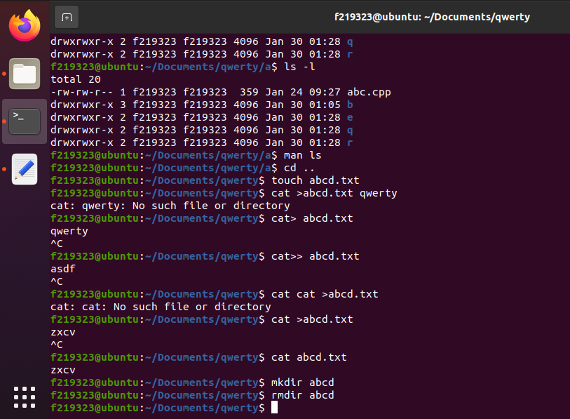

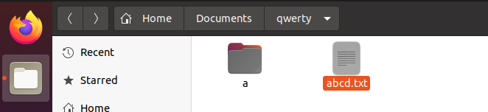

# MERGE FILE:

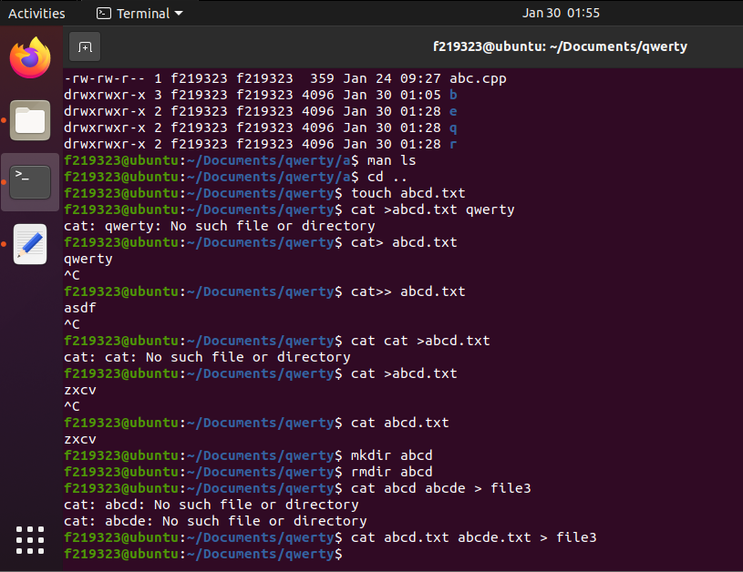

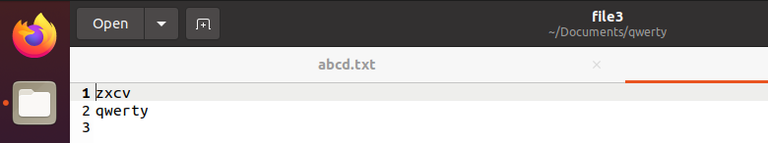

# OUTPUT 2 FILES:

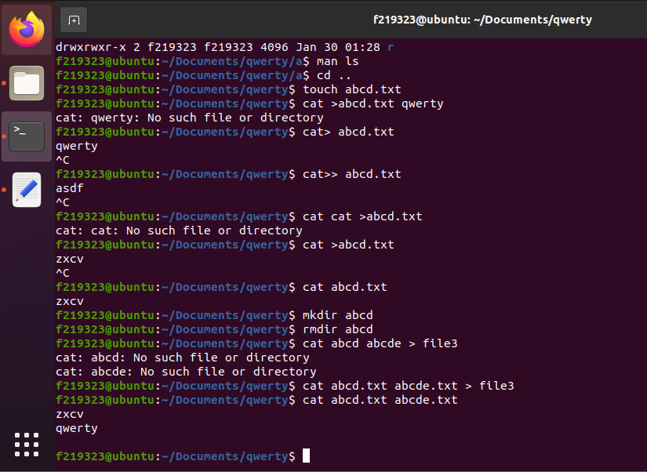

# COPY FILE INTO NEW FILE:

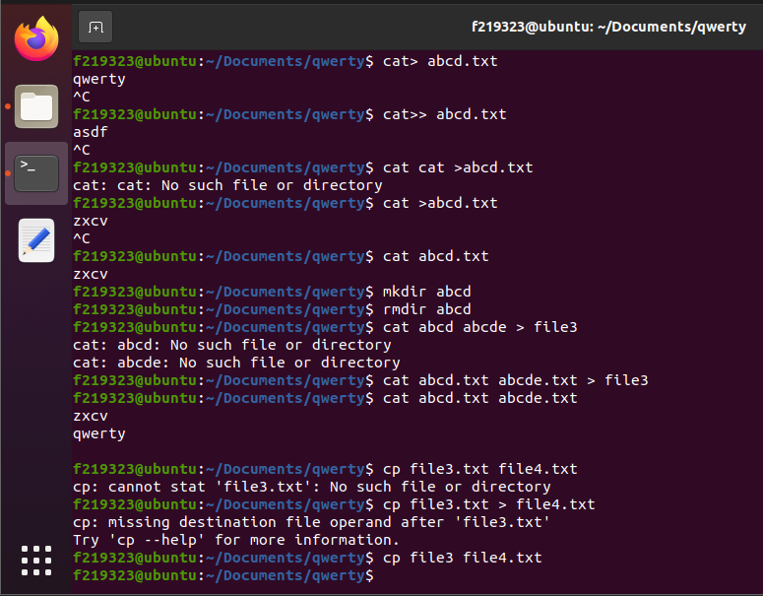

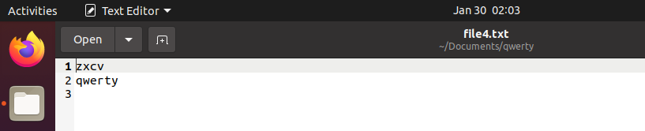

# MOVE FILE :

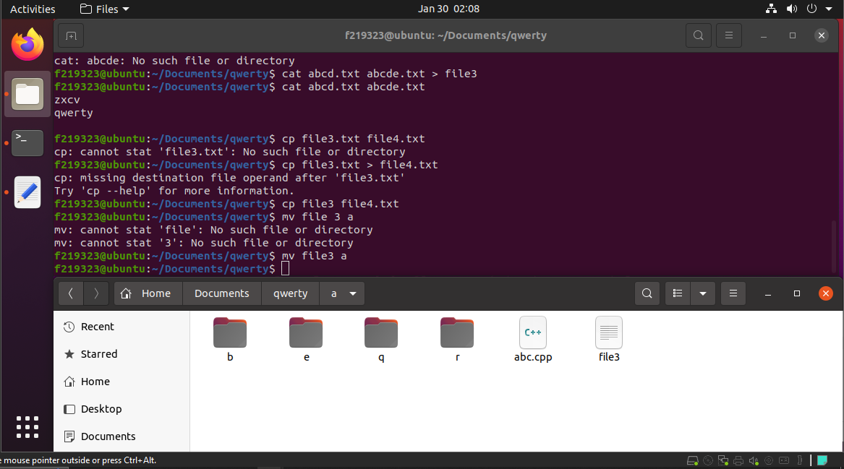

# MOVE TO DIFFERENT DIRECTORY:

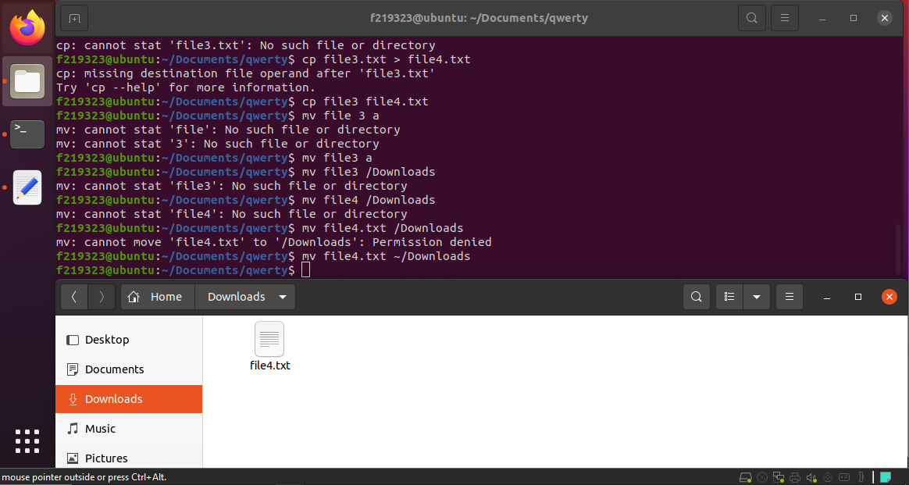

# MOVE FILE FROM SOME DIRECTORY TO ANOTHER DIRECTORY:

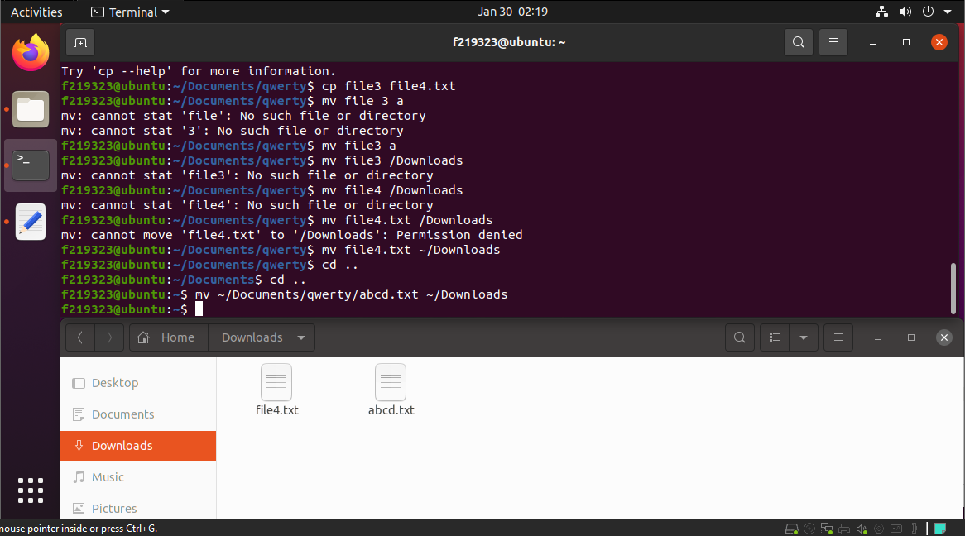

# FINDING STRING:

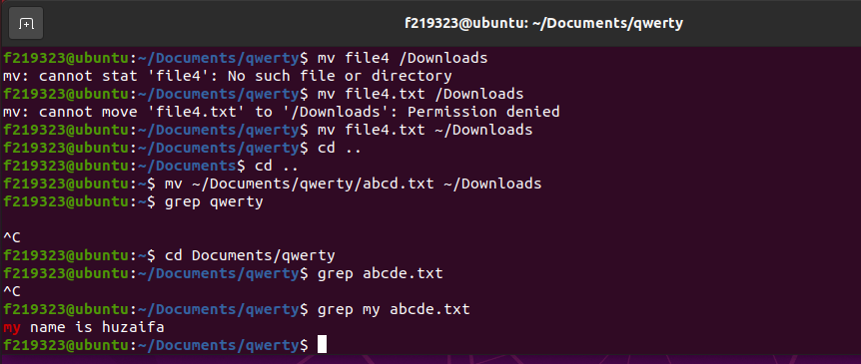

# DELETING NON EMPTY FOLDER:

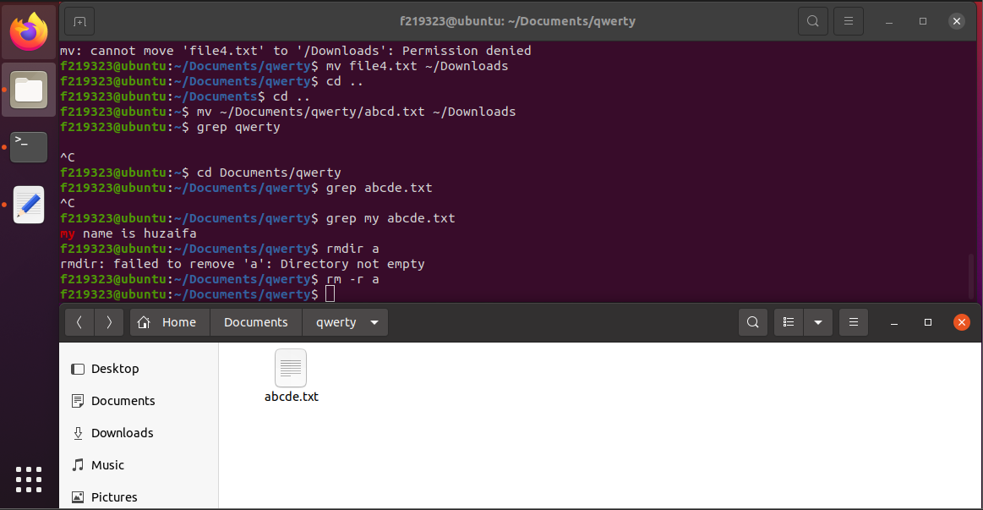

# HEAD/TAIL/SORT:

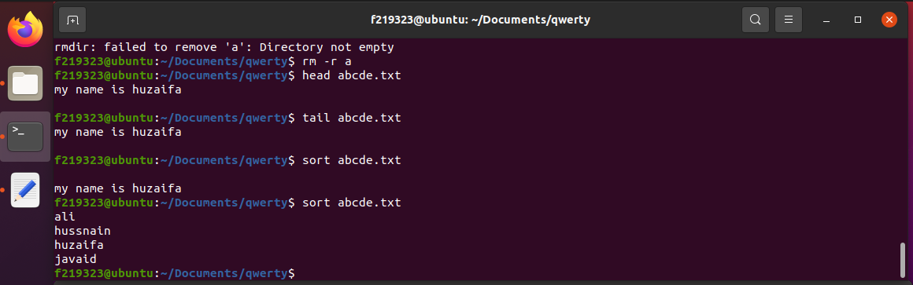

# LS SORT:

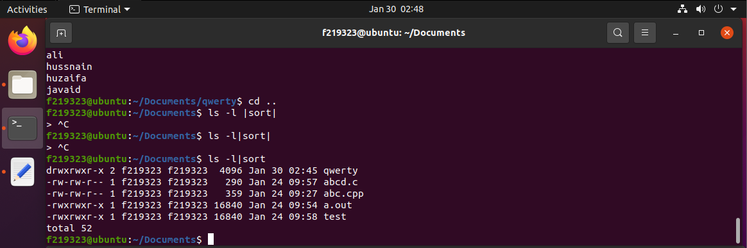

# MORE/LESS:

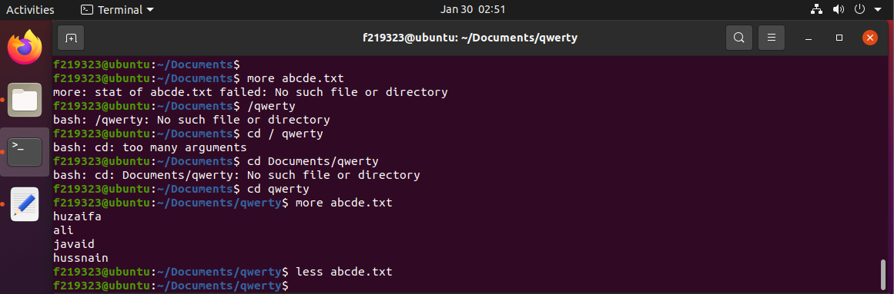

# WHO:

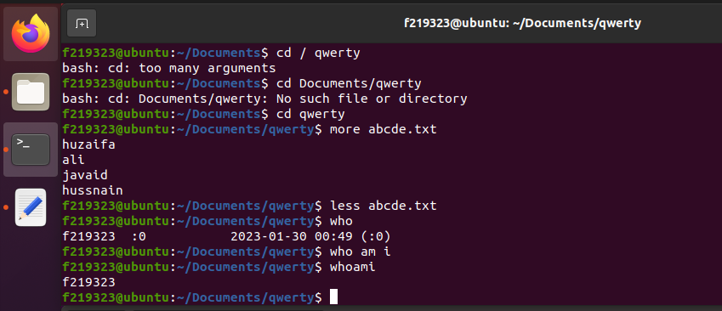

# DATE:

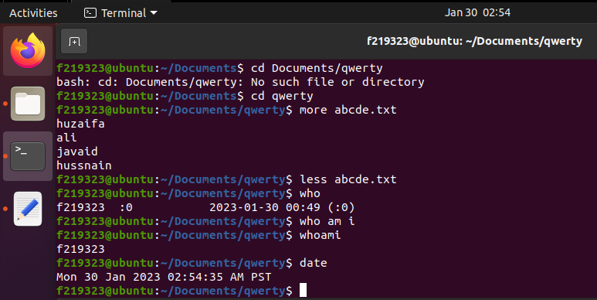

# PS:

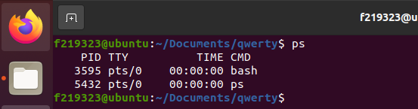

# TOP/KILL:

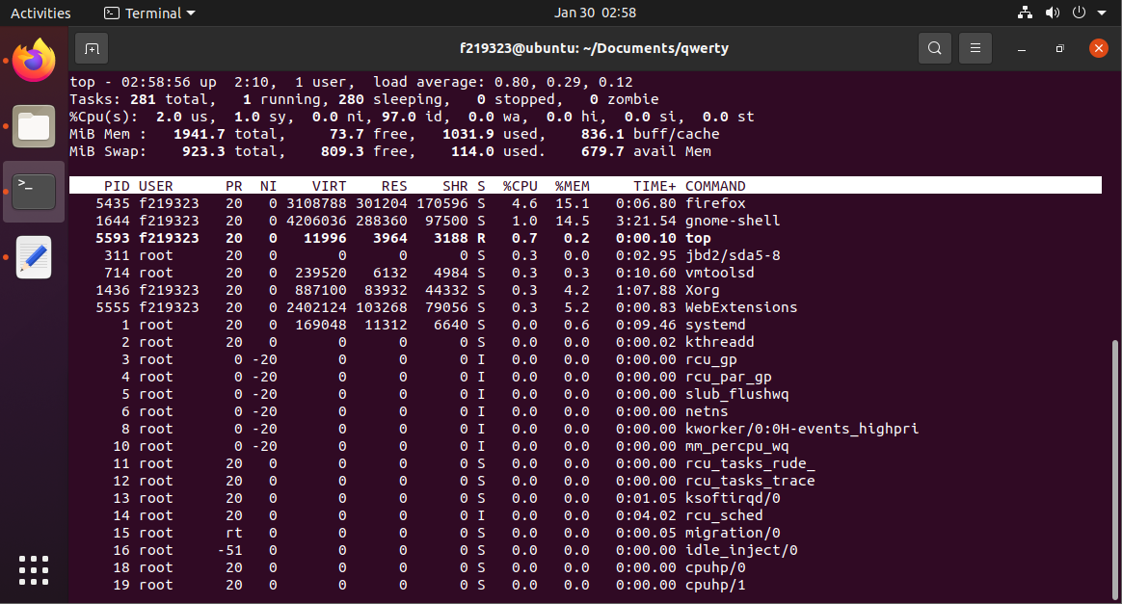

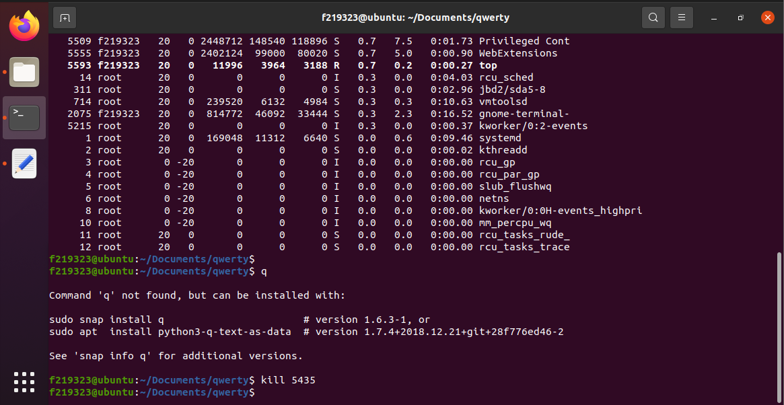

# CHANGE MODE:

