# TASK 1:

#!/bin/bash

echo "Enter a:"

read n1

echo "Enter b:"

read n2

echo "Choose an operation:"

echo "1. add"

echo "2. subtract"

echo "3. multiply"

echo "4. divide"

read operation

if [ $operation = "1" ]

then

echo $((n1+n2))

elif [ $operation = "2" ]

then

echo $((n1-n2))

elif [ $operation = "3" ]

then

echo $((n1*n2))

elif [ $operation = "4" ]

then

echo $((n1/n2))

fi

# OUTPUT:

# 

# TASK 2:

#!/bin/bash

echo "Enter a:"

read n1

echo "Enter b:"

read n2

echo "Choose an operation:"

echo "1. add"

echo "2. subtract"

echo "3. multiply"

echo "4. divide"

read operation

case $operation in

1)res=`echo $a + $b | bc`

;;

2)res=`echo $n1 - $n2 | bc`

;;

3)res=`echo $n1 \* $n2 | bc`

;;

4)res=`echo "scale=2; $n1 / $n2" | bc`

;;

esac

echo "Result : $res"

# OUTPUT:

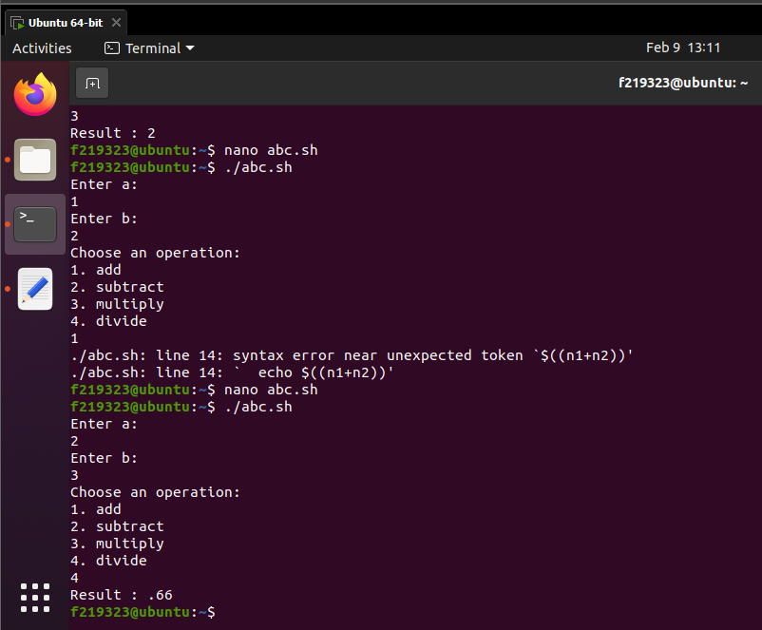

# TASK 3:

#!/bin/bash

echo "Enter a:"

read n1

echo "Enter b:"

read n2

echo "Enter c:"

read n3

if [ $n1 -gt $n2 ] && [ $n1 -gt $n3 ]

then

echo $n1 is the greatest number.

elif [ $n2 -gt $n1 ] && [ $n2 -gt $n3 ]

then

echo $n2 is the greatest number.

else

echo $n3 is the greatest number.

fi

# OUTPUT:

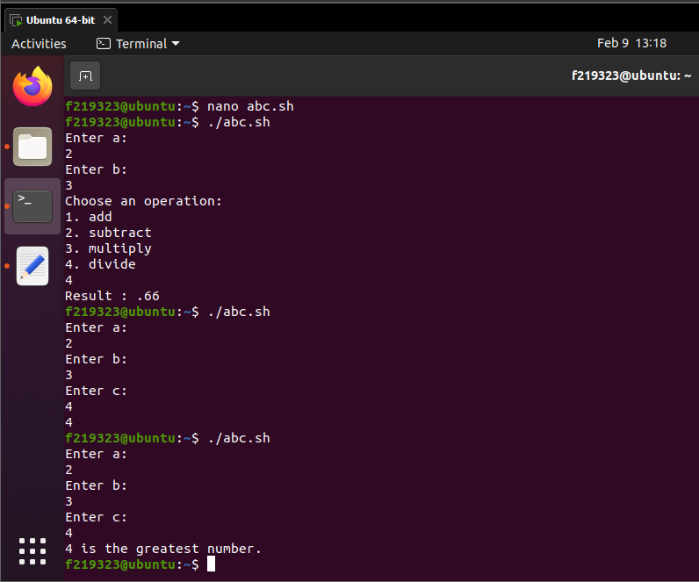

# TASK 4:

#!/bin/bash

echo "Enter a:"

read n1

echo "Enter b:"

read n2

if [ $((n1%2)) -eq 0 ]

then

echo $n1 is even.

else

echo $n1 is odd.

fi

if [ $((n2%2)) -eq 0 ]

then

echo $n2 is even.

else

echo $n2 is odd.

Fi

# OUTPUT:

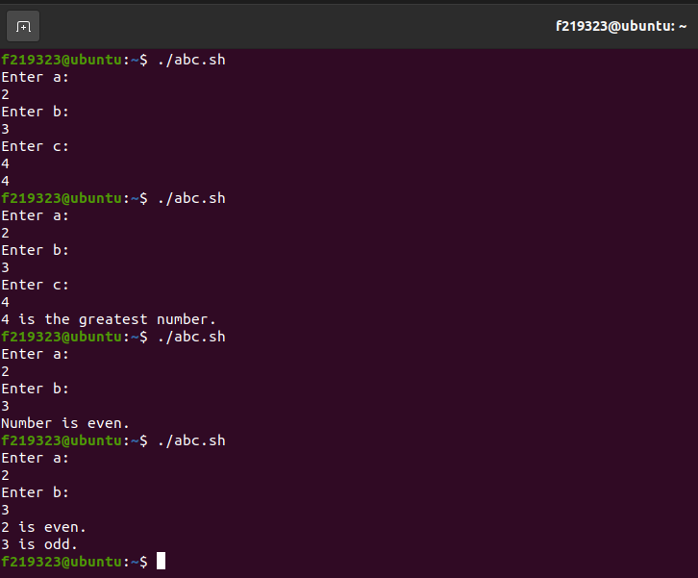

# TASK 5:

#!/bin/bash

echo "Enter string 1:"

read a

echo "Enter string 2:"

read b

a+=$b

echo $a

# OUTPUT:

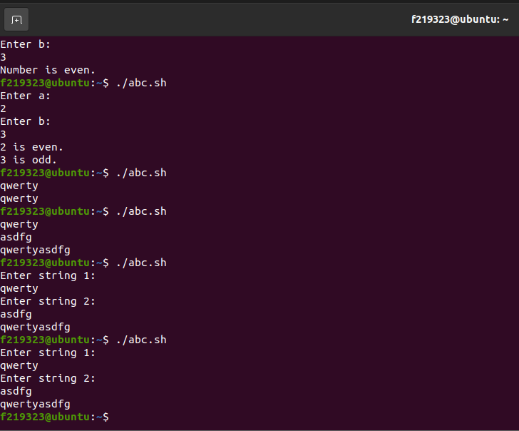

# TASK 6:

#!/bin/bash

echo "Enter string: "

read str

strlen=${#str}

for (( i=$strlen-1; i>=0; i-- ));

do

revstr=$revstr${str:$i:1}

done

echo "Reversed String : $revstr"

# OUTPUT:

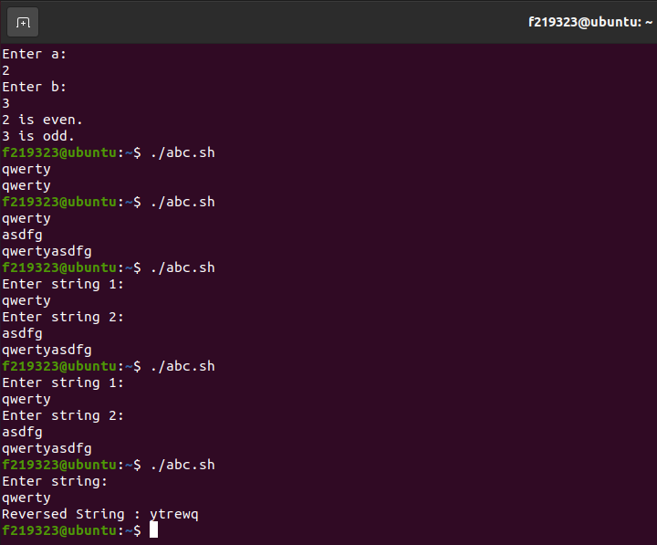

# TASK 7:

#!/bin/bash

echo "Enter a string: "

read string

vowels="aeiouAEIOU"

count=0

for char in $(echo $string | grep -o .); do

if [[ $vowels =~ $char ]]; then

((count++))

fi

done

echo "Number of vowels are: $count"

# OUTPUT:

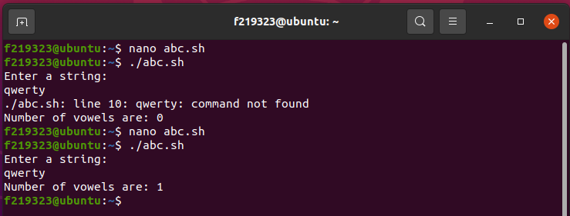

# TASK 8:

#!/bin/bash

echo "1)Monday"

echo "2)Tuesday"

echo "3)Wednesday"

echo "4)Thursday"

echo "5)Friday"

echo "6)Saturday"

echo "7)Sunday"

echo "Enter yout choice"

read n

case $n in

1) echo "Happy day" ;;

2) echo "Sad day" ;;

3) echo "Good day" ;;

4) echo "Exciting day" ;;

5) echo "Blessed day" ;;

6) echo "Game day" ;;

7) echo "Holiday1" ;;

*) echo "enter value between 1 to 7" ;;

Esac

# OUTPUT:

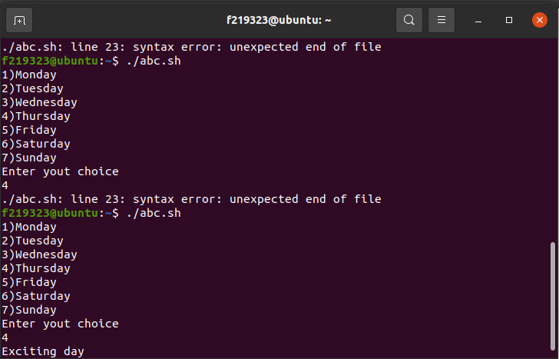

# TASK 9:

#!/bin/bash

echo "Enter First No: "

read n1

echo "Enter Second No:"

read n2

if [ "$n1" -gt 500 ] && [ "$n1" -lt 1000 ] && [ "$n2" -gt 500 ] && [ "$n2" -lt 1000 ]; then

and=$((n1 & n2))

or=$((n1 | n2))

not=$((~ n1))

echo "And: $and"

echo "Or: $or"

echo "Not: $not"

else

echo "Error: Both numbers should be greater than 500 and less than 1000."

fi

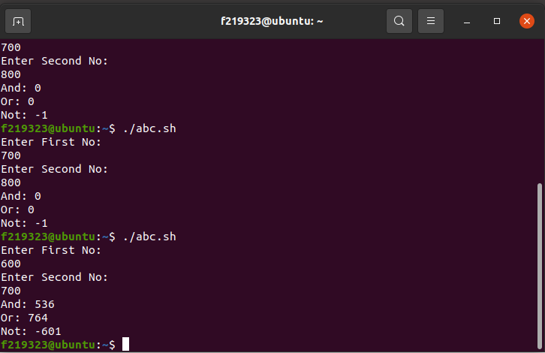

# TASK 10:

#!/bin/bash

echo "Enter string: "

read str

strlen=${#str}

echo "No of characters are: $strlen"

words=$(echo "$str" | wc -w)

echo n"No of words are: $words"

# OUTPUT:

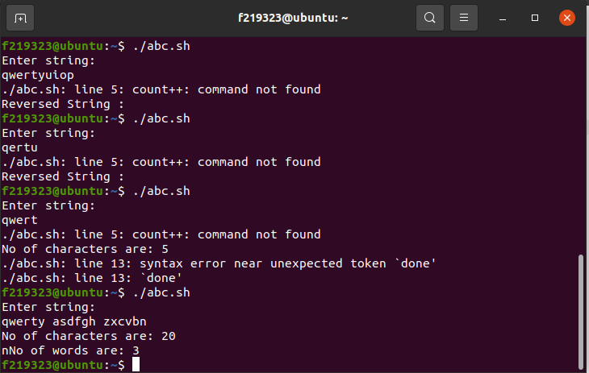

# TASK 11:

#!/bin/bash

echo "Enter the array: "

read -a array

declare -a count

for element in "${array[@]}"; do

count[$element]=$((count[$element]+1))

done

max=0

max_element=0

for element in "${array[@]}"; do

if [ ${count[$element]} -gt $max ]; then

max=${count[$element]}

max_element=$element

fi

done

echo "The most occurring element is: $max_element with $max occurrences."

# OUTPUT:

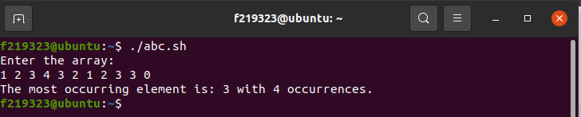

# TASK 12:

#!/bin/bash

echo "Enter the array: "

read -a array

zeros=()

ones=()

for element in "${array[@]}"; do

if [ $element -eq 0 ]; then

zeros+=($element)

else

ones+=($element)

fi

done

echo "Zeros: ${zeros[@]}"

echo "Ones: ${ones[@]}"

# OUTPUT:

# 