TASK 1:

#include<stdio.h>

#include<stdlib.h>

#include<unistd.h>

#include<sys/wait.h>

#include<sys/types.h>

#include<pthread.h>

#include<time.h>

#define BUFFER_SIZE 5

int buffer[BUFFER_SIZE];

int in = 0, out = 0, count = 0;

void *producer()

{

int next_produced = 1;

while (1)

{

while (count == BUFFER_SIZE)

{

sleep(rand()%12);

}

buffer[in] = next_produced;

in = (in + 1) % BUFFER_SIZE;

count++;

printf("Producer: Inserted %d into the buffer\n", next_produced);

next_produced++;

sleep(1);

}

pthread_exit(NULL);

}

void *consumer()

{

int next_consumed=1;

while (1)

{

while (count == 0)

{

sleep(rand()%7);

}

next_consumed = buffer[out];

out = (out + 1) % BUFFER_SIZE;

count--;

printf("Consumer: Removed %d from the buffer\n", next_consumed);

sleep(1);

}

pthread_exit(NULL);

}

int main()

{

srand(time(0));

printf("Producer Consumer in Critical Situation\n");

pthread_t p1,c1;

pthread_create(&p1,NULL,producer,NULL);

pthread_create(&c1,NULL,consumer,NULL);

pthread_join(p1,NULL);

pthread_join(c1,NULL);

return 0;

}

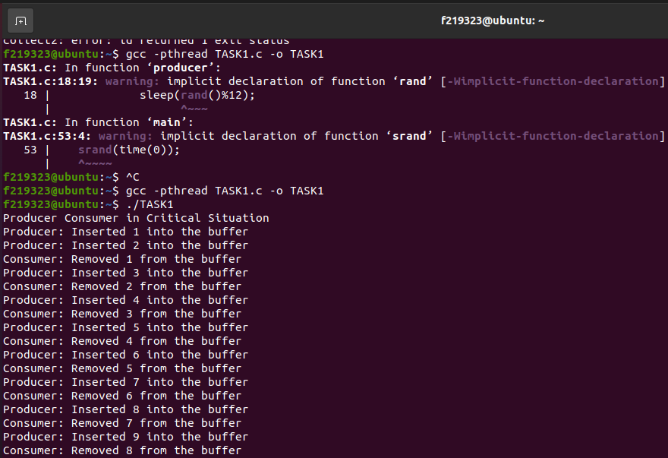

TASK 2:  
#include <stdio.h>

#include <stdlib.h>

#include <pthread.h>

int counter = 0;

void *increment(void *arg)

{

int i;

for(i = 0; i < 100000; i++) {

counter++;

}

pthread_exit(NULL);

}

int main()

{

pthread_t threads[4];

int i;

for(i = 0; i < 4; i++) {

pthread_create(&threads[i], NULL, increment, NULL);

}

for(i = 0; i < 4; i++) {

pthread_join(threads[i], NULL);

}

printf("Final counter value: %d\n", counter);

return 0;

}

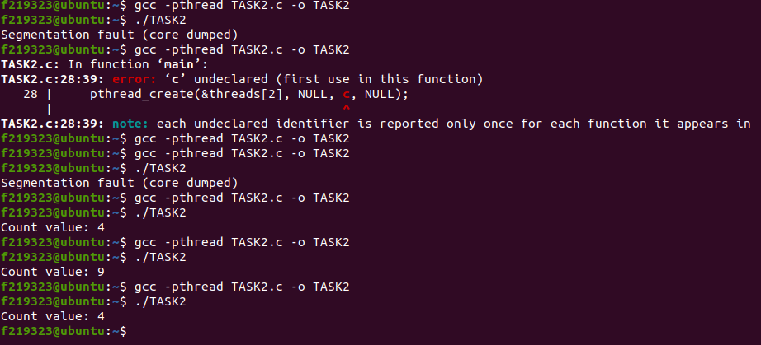

# TASK 3:

#include <stdio.h>

#include <stdbool.h>

#include <pthread.h>

#define NUM_THREADS 2

bool flag[2] = {false, false};

int turn = 0;

void enter_critical_section(int thread_num)

{

int other_thread = 1 - thread_num;

flag[thread_num] = true;

turn = other_thread;

while (flag[other_thread] && turn == other_thread);

}

void leave_critical_section(int thread_num)

{

flag[thread_num] = false;

}

void* thread_function(void* arg)

{

int thread_num = *(int*) arg;

for (int i = 0; i < 10; i++)

{

enter_critical_section(thread_num);

printf("Thread %d is in critical section.\n", thread_num);

leave_critical_section(thread_num);

printf("Thread %d is out of critical section.\n", thread_num);

}

pthread_exit(NULL);

}

int main()

{

pthread_t threads[NUM_THREADS];

int thread_args[NUM_THREADS];

for (int i = 0; i < NUM_THREADS; i++)

{

thread_args[i] = i;

pthread_create(&threads[i], NULL, thread_function, &thread_args[i]);

}

for (int i = 0; i < NUM_THREADS; i++)

{

pthread_join(threads[i], NULL);

}

return 0;

}

