# TASK 1:

# #include <stdio.h>

# #include <stdlib.h>

# #include <pthread.h>

# #include <unistd.h>

# pthread_mutex_t lock;

# int num_cars;

# int num_boats;

# int time_per_car;

# int time_per_boat;

# int bridge_open = 0;

# void* car_thread(void* arg)

# {

# int car_id = *(int*)arg;

# printf("Car %d is waiting to cross the bridge\n", car_id);

# pthread_mutex_lock(&lock);

# while (bridge_open)

# {

# printf("Car %d is waiting for the bridge to close\n", car_id);

# pthread_mutex_unlock(&lock);

# sleep(1);

# pthread_mutex_lock(&lock);

# }

# printf("Car %d is crossing the bridge\n", car_id);

# bridge_open = 1;

# pthread_mutex_unlock(&lock);

# sleep(time_per_car);

# bridge_open = 0;

# printf("Car %d has crossed the bridge\n", car_id);

# pthread_exit(NULL);

# }

# void* boat_thread(void* arg)

# {

# int boat_id = *(int*)arg;

# printf("Boat %d is waiting to cross the bridge\n", boat_id);

# pthread_mutex_lock(&lock);

# while (bridge_open)

# {

# printf("Boat %d is waiting for the bridge to close\n", boat_id);

# pthread_mutex_unlock(&lock);

# sleep(1);

# pthread_mutex_lock(&lock);

# }

# printf("Boat %d is crossing the bridge\n", boat_id);

# bridge_open = 1;

# pthread_mutex_unlock(&lock);

# sleep(time_per_boat);

# bridge_open = 0;

# printf("Boat %d has crossed the bridge\n", boat_id);

# pthread_exit(NULL);

# }

# int main()

# {

# printf("Enter number of cars: ");

# scanf("%d", &num_cars);

# printf("Enter number of boats: ");

# scanf("%d", &num_boats);

# printf("Enter time per car (in seconds): ");

# scanf("%d", &time_per_car);

# printf("Enter time per boat (in seconds): ");

# scanf("%d", &time_per_boat);

# pthread_t car_threads[num_cars];

# pthread_t boat_threads[num_boats];

# int car_ids[num_cars];

# int boat_ids[num_boats];

# pthread_mutex_init(&lock, NULL);

# 

# for (int i = 0; i < num_cars; i++)

# {

# car_ids[i] = i+1;

# pthread_create(&car_threads[i], NULL, car_thread, &car_ids[i]);

# }

# for (int i = 0; i < num_boats; i++)

# {

# boat_ids[i] = i+1;

# pthread_create(&boat_threads[i], NULL, boat_thread, &boat_ids[i]);

# }

# for (int i = 0; i < num_cars; i++)

# {

# pthread_join(car_threads[i], NULL);

# }

# for (int i = 0; i < num_boats; i++)

# {

# pthread_join(boat_threads[i], NULL);

# }

# pthread_mutex_destroy(&lock);

# return 0;

# }

# OUTPUT:

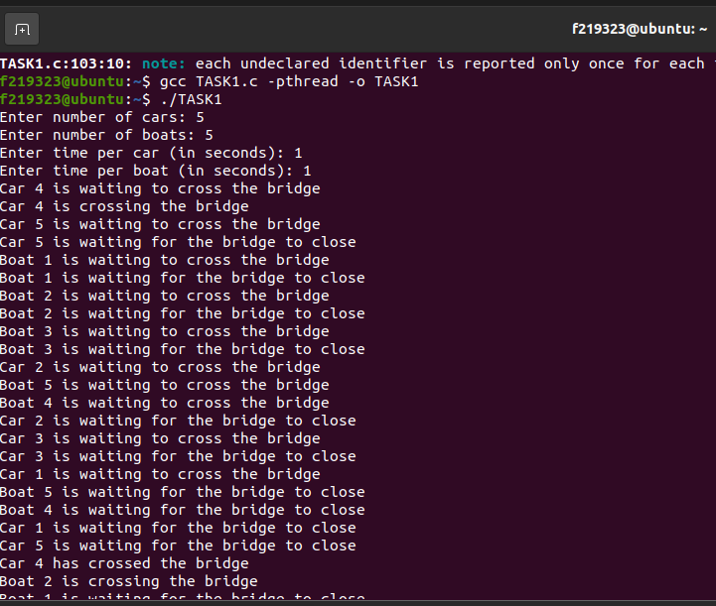

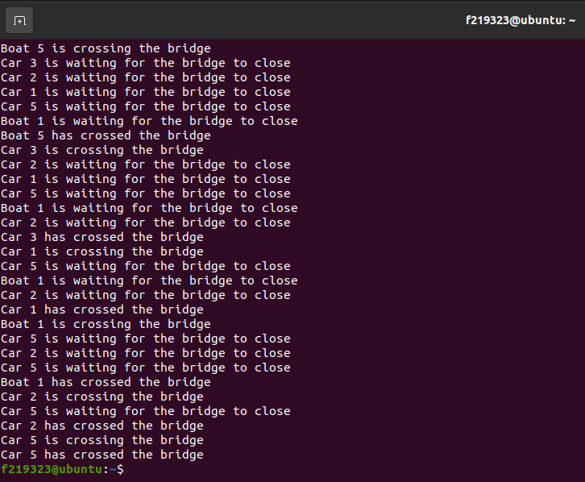

TASK 2:  
#include <stdio.h>

#include <stdlib.h>

#include <pthread.h>

#include <unistd.h>

#include <semaphore.h>

sem_t bridge_sem;

int num_cars;

int num_boats;

int time_per_car;

int time_per_boat;

int bridge_open = 0;

void* car_thread(void* arg)

{

int car_id = *(int*)arg;

printf("Car %d is waiting to cross the bridge\n", car_id);

while (1)

{

sem_wait(&bridge_sem);

if (!bridge_open)

{

printf("Car %d is crossing the bridge\n", car_id);

bridge_open = 1;

sem_post(&bridge_sem);

sleep(time_per_car);

bridge_open = 0;

printf("Car %d has crossed the bridge\n", car_id);

break;

}

else

{

sem_post(&bridge_sem);

printf("Car %d is waiting for the bridge to close\n", car_id);

sleep(1);

}

}

pthread_exit(NULL);

}

void* boat_thread(void* arg)

{

int boat_id = *(int*)arg;

printf("Boat %d is waiting to cross the bridge\n", boat_id);

while (1)

{

sem_wait(&bridge_sem);

if (!bridge_open)

{

printf("Boat %d is crossing the bridge\n", boat_id);

bridge_open = 1;

sem_post(&bridge_sem);

sleep(time_per_boat);

bridge_open = 0;

printf("Boat %d has crossed the bridge\n", boat_id);

break;

}

else

{

sem_post(&bridge_sem);

printf("Boat %d is waiting for the bridge to close\n", boat_id);

sleep(1);

}

}

pthread_exit(NULL);

}

int main()

{

printf("Enter number of cars: ");

scanf("%d", &num_cars);

printf("Enter number of boats: ");

scanf("%d", &num_boats);

printf("Enter time per car (in seconds): ");

scanf("%d", &time_per_car);

printf("Enter time per boat (in seconds): ");

scanf("%d", &time_per_boat);

pthread_t car_threads[num_cars];

pthread_t boat_threads[num_boats];

int car_ids[num_cars];

int boat_ids[num_boats];

sem_init(&bridge_sem, 0, 1);

for (int i = 0; i < num_cars; i++)

{

car_ids[i] = i+1;

pthread_create(&car_threads[i], NULL, car_thread, &car_ids[i]);

}

for (int i = 0; i < num_boats; i++)

{

boat_ids[i] = i+1;

pthread_create(&boat_threads[i], NULL, boat_thread, &boat_ids[i]);

}

for (int i = 0; i < num_cars; i++)

{

pthread_join(car_threads[i], NULL);

}

for (int i = 0; i < num_boats; i++)

{

pthread_join(boat_threads[i], NULL);

}

sem_destroy(&bridge_sem);

return 0;

}

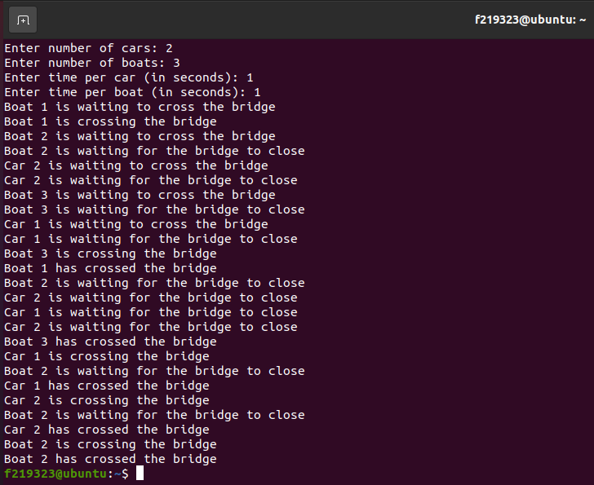

TASK 3:  
#include <stdio.h>

#include <stdlib.h>

#include <pthread.h>

#include <unistd.h>

#include <semaphore.h>

sem_t bridge_sem;

sem_t car_sem;

sem_t boat_sem;

int num_cars;

int num_boats;

int time_per_car;

int time_per_boat;

int bridge_open = 0;

void* car_thread(void* arg)

{

int car_id = *(int*)arg;

printf("Car %d is waiting to cross the bridge\n", car_id);

while (1)

{

sem_wait(&car_sem);

sem_wait(&bridge_sem);

if (!bridge_open)

{

printf("Car %d is crossing the bridge\n", car_id);

bridge_open = 1;

sem_post(&bridge_sem);

sem_post(&car_sem);

sleep(time_per_car);

bridge_open = 0;

printf("Car %d has crossed the bridge\n", car_id);

break;

}

else

{

sem_post(&bridge_sem);

sem_post(&car_sem);

printf("Car %d is waiting for the bridge to close\n", car_id);

sleep(1);

}

}

pthread_exit(NULL);

}

void* boat_thread(void* arg)

{

int boat_id = *(int*)arg;

printf("Boat %d is waiting to cross the bridge\n", boat_id);

while (1)

{

sem_wait(&boat_sem);

sem_wait(&bridge_sem);

if (!bridge_open)

{

printf("Boat %d is crossing the bridge\n", boat_id);

bridge_open = 1;

sem_post(&bridge_sem);

sem_post(&boat_sem);

sleep(time_per_boat);

bridge_open = 0;

printf("Boat %d has crossed the bridge\n", boat_id);

break;

}

else

{

sem_post(&bridge_sem);

sem_post(&boat_sem);

printf("Boat %d is waiting for the bridge to close\n", boat_id);

sleep(1);

}

}

pthread_exit(NULL);

}

int main()

{

printf("Enter number of cars: ");

scanf("%d", &num_cars);

printf("Enter number of boats: ");

scanf("%d", &num_boats);

printf("Enter time per car (in seconds): ");

scanf("%d", &time_per_car);

printf("Enter time per boat (in seconds): ");

scanf("%d", &time_per_boat);

pthread_t car_threads[num_cars];

pthread_t boat_threads[num_boats];

int car_ids[num_cars];

int boat_ids[num_boats];

sem_init(&bridge_sem, 0, 1);

sem_init(&car_sem, 0, 2);

sem_init(&boat_sem, 0, 3);

for (int i = 0; i < num_cars; i++)

{

car_ids[i] = i+1;

pthread_create(&car_threads[i], NULL, car_thread, &car_ids[i]);

}

for (int i = 0; i < num_boats; i++)

{

boat_ids[i] = i+1;

pthread_create(&boat_threads[i], NULL, boat_thread, &boat_ids[i]);

}

for (int i = 0; i < num_cars; i++)

{

pthread_join(car_threads[i], NULL);

}

for (int i = 0; i < num_boats; i++)

{

pthread_join(boat_threads[i], NULL);

}

sem_destroy(&bridge_sem);

return 0;

}

# OUTPUT:

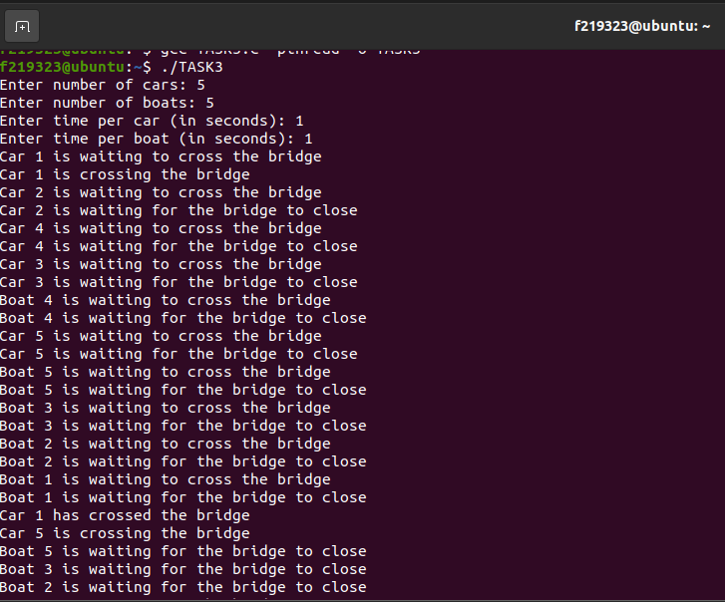

# TASK 4:

#include <stdio.h>

#include <stdlib.h>

#include <unistd.h>

#include <pthread.h>

int fuel_left = 100;

pthread_mutex_t mutex_fuel;

pthread_cond_t cond_fuel_not_empty;

void *fuel_station()

{

while (1)

{

pthread_mutex_lock(&mutex_fuel);

if (fuel_left < 100)

{

fuel_left++;

printf("Fuel Station: Produced 1 liter of fuel, fuel left: %d\n", fuel_left);

pthread_cond_signal(&cond_fuel_not_empty);

}

pthread_mutex_unlock(&mutex_fuel);

usleep(100000);

}

return NULL;

}

void *car()

{

while (1)

{

pthread_mutex_lock(&mutex_fuel);

while (fuel_left < 40)

{

printf("Car: Waiting for fuel, fuel left: %d\n", fuel_left);

pthread_cond_wait(&cond_fuel_not_empty, &mutex_fuel);

}

fuel_left -= 40;

printf("Car: Consumed %d liters of fuel, fuel left: %d\n", 40, fuel_left);

pthread_mutex_unlock(&mutex_fuel);

usleep(500000);

}

return NULL;

}

int main()

{

pthread_t fuel_station_thread, car_thread1, car_thread2;

pthread_mutex_init(&mutex_fuel, NULL);

pthread_cond_init(&cond_fuel_not_empty, NULL);

pthread_create(&fuel_station_thread, NULL, fuel_station, NULL);

pthread_create(&car_thread1, NULL, car, NULL);

pthread_create(&car_thread2, NULL, car, NULL);

pthread_join(fuel_station_thread, NULL);

pthread_join(car_thread1, NULL);

pthread_join(car_thread2, NULL);

pthread_mutex_destroy(&mutex_fuel);

pthread_cond_destroy(&cond_fuel_not_empty);

return 0;

}

OUTPUT:  
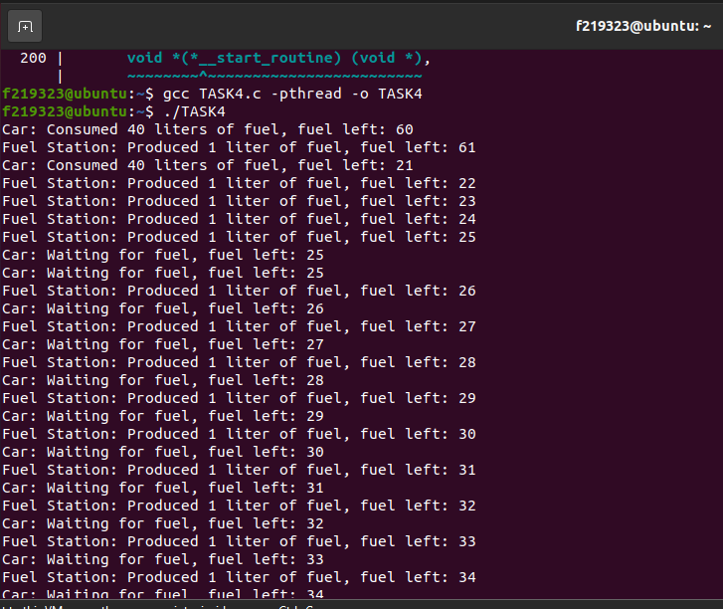

# TASK 5:

#include <stdio.h>

#include <pthread.h>

#include <semaphore.h>

sem_t mutex;

void *job_i()

{

for (int i = 0; i < 5; i++)

{

sem_wait(&mutex);

printf("Job i is running\n");

sem_post(&mutex);

}

return NULL;

}

void *job_j()

{

for (int i = 0; i < 5; i++)

{

sem_wait(&mutex);

printf("Job j is running\n");

sem_post(&mutex);

}

return NULL;

}

int main()

{

pthread_t job_i_thread, job_j_thread;

sem_init(&mutex, 0, 1);

pthread_create(&job_i_thread, NULL, job_i, NULL);

pthread_create(&job_j_thread, NULL, job_j, NULL);

pthread_join(job_i_thread, NULL);

pthread_join(job_j_thread, NULL);

sem_destroy(&mutex);

return 0;

}

OUTPUT:  
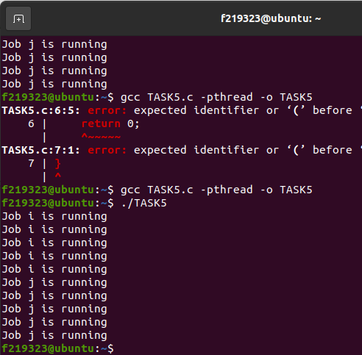

# TASK 6:

#include <stdio.h>

#include <stdlib.h>

#include <pthread.h>

#include <semaphore.h>

#include <unistd.h>

sem_t mutex, full, empty;

int buffer[5];

int in = 0, out = 0;

void* producer()

{

int item;

while (1)

{

printf("Producer is waiting...\n");

sleep(1);

printf("Producer is adding an item to the buffer...\n");

item = rand() % 100;

sem_wait(&empty);

sem_wait(&mutex);

buffer[in] = item;

in = (in + 1) % 5;

printf("Producer added %d to the buffer.\n", item);

sem_post(&mutex);

sem_post(&full);

}

pthread_exit(NULL);

}

void* consumer()

{

int item;

while (1)

{

printf("Consumer is waiting...\n");

sleep(1);

sem_wait(&full);

sem_wait(&mutex);

item = buffer[out];

out = (out + 1) % 5;

printf("Consumer removed %d from the buffer.\n", item);

sem_post(&mutex);

sem_post(&empty);

printf("Consumer is using the item %d...\n", item);

}

pthread_exit(NULL);

}

int main()

{

int choice;

pthread_t tid1, tid2;

sem_init(&mutex, 0, 1);

sem_init(&full, 0, 0);

sem_init(&empty, 0, 5);

printf("Enter 1 for Producer and 2 for Consumer: ");

scanf("%d", &choice);

if (choice == 1)

{

printf("Starting Producer...\n");

pthread_create(&tid1, NULL, producer, NULL);

pthread_join(tid1, NULL);

}

else if (choice == 2)

{

printf("Starting Consumer...\n");

pthread_create(&tid2, NULL, consumer, NULL);

pthread_join(tid2, NULL);

}

else

{

printf("Invalid choice.\n");

}

sem_destroy(&mutex);

sem_destroy(&full);

sem_destroy(&empty);

return 0;

# }

# OUTPUT:

