A Project Report on

**SCHOOL INFORMATION PORTAL**

Submitted by

**HUZAIFA SHAIKH (SS15CO021)**

**ARIF KHAN (SD16CO006)**

**ADITYA SHINDE (SS15CO060)**

**VIJAY SALVE (SS15CO049)**

**In partial fulfillment of the requirements for**

**Diploma in Computer Engineering**

Under the guidance of

**Ms. POOJA S CHAME**



**Department of Computer Engineering**

**Government Polytechnic, Mumbai**

**Mumbai-400051**



**Department of Computer Engineering**

**Government Polytechnic, Mumbai**

Mumbai-400051

**CERTIFICATE**

This is to certify that following students have successfully and satisfactorily completed the project on SCHOOL INFORMATION PORTAL and presented their report in the partial fulfillment of requirement for Diploma in Computer Engineering from Government Polytechnic, Mumbai under the guidance of [POOJA .S. CHAME] in the academic year 2017-2018.

|  |  |
| --- | --- |
| **HUZAIFA SHAIKH** | **SS15CO021** |
| **ARIF KHAN** | **SD16CO006** |
| **ADITYA SHINDE** | **SS15CO060** |
| **VIJAY SALVE** | **SS15CO049** |

|  |  |  |
| --- | --- | --- |
| Project Guide |  | External Examiner |
| Head Of the Department |  | Principal |

**ACKNOWLEDGEMENT**

The satisfaction and euphoria that accompany to successfully completion of any task would be incomplete without the mention of people, who made it possible, whose constant guidance and encouragement crown all effort with success.

I would like to thank our Prof***.* POOJA S CHAME** for giving such kind of opportunity for developing school information portal and sparing him valuable time knowledge including keen interest and guiding us at every stage of this project.

We also great to the helpful extended by our HOD **Prof**. **V.M.ASWAR** and other faculty members who rendered a helping hand in the completion of this project. I am highly obliged to staff member constant encouragement and valuable guidance.

We would also like to thank my friends and all the lab assistants associated with labs who had helped us throughout the academic year of our project.

Our special thanks extended to Principal .**Smt. SWATI..DESHPANDE** and other supporting staff of Government Polytechnic Mumbai.

**­**

**Table of Contents**

Introduction…………………………………………………………………………...1

Literature Review…………………………………………………………………..…..3

Existing System……………………………………………………………….4

Proposed System………………………………………………………………5

Requirement Analysis…………………………………………………………………6

Project planning……………………………………………………………….7

Activity planning………………………………………………………………8

Feasibility Study……………………………………………………………….10

**SYSTEM ANALYSIS AND SPECIFICATIONS………………………………………………………………..13**

Hardware specifications……………………………………………………….13

Software specifications………………………………………………………...13

System Design………………………………………………………………………...14

Design Phase………………………………………………………………….15

Language Description…………………………………………………………16

Flowcharts…………………………………………………………………….18

Algorithms…………………………………………………………………….19

Data Flow Diagrams…………………………………………………………..20

Database Structure……………………………………………………………21

If applicable only……………………………………………...21

Implementation……………………………………………………………………......22

Module wise Description with Coding………………………………………..24

Testing…………………………………………………………………………………46

Software Testing………………………………………………………………..47

Software Testing Objectives…………………………………………………..47

Types of testing……………………………………………………………….48

Black Box Testing Or White Box Testing Whichever applicable…………….50

Unit Testing …………………………………………………………………..51

Integrated Testing…………………………………………………………….51

User Acceptance ……………………………………………………………..51

Output/ Screen shots………………………………………………………………….53

Conclusion……………………………………………………………………………62

Future Scope………………………………………………………………………….63

Bibliography and References…………………………………………………………64

**List of Figures**

Figure 4-1 Class Diagram of Login Module.............................................................................. 18

Figure 4-2 Flow chart of Login Module.................................................................................... 19

Figure 4-3Dataflow Diagram of Login Module........................................................................ 20

Figure 4-4Database Structure................................................................................................... 21

Figure 7-1 Home page............................................................................................................... 54

Figure 7-2 Method of teaching…….......................................................................................... 54

Figure 7-3 Mission And Vision............................................................................................... 55

Figure 7-4Contact .....................................................................................................................55

Figure 7-5Newsletter And Navigation.................... ............................................................... 56

Figure 7-6About Us.......................................................................................... ………….…..56

Figure 7-7Search Engine.......................................................................................................... 57

Figure 7-8Chat Login ............................................................................................................ 57

Figure 7-9Offline Chats......................................................................................................... 58

Figure 7-10Testing ................................................................................................................ 58

Figure 7-11Gallery .................................................................................................. ….…….59

Figure 7-12Time Table.......................................................................................................... 59

Figure 7-13 Documents Up loader........................................................................................... 60

Figure 7-14Developers desk ................................................................................................. 60

Figure 7-15 SMS Page ................................................................................................. 61

**List of Tables:**

Table 3.1: Activity Planning…………………………………………………................…8

Table 3.2: System Requirements …………………………………………………........…13

**ABSTRACT**

A SCHOOL INFORMATION PORTAL is collection of webpage’s which provide users with information and some sort of information about school. Providing information is the major highlight of this project. A person having basic knowledge of suffering on internet can use this portal.

The portal can be viewed on devices that have internet connection. Portal helps the user to gain the required information very easily. This website is developed **in HTML,CSS,JAVA SCRIPT,BOOTSTRAP.** So this made easier to load web pages faster.

The school information portal which respond according to the resolution or the screen size automatically are when we access a portal from two different devices with different screen resolution the portal layout is same as for both the devices.

This led to poor and slow processing of data and makes it uncomfortable or one two browse in a smaller screen whereas in responsive website the website fit to the screen of the website automatically so no problem acquire for browsing in any kind of the screen size. And as media size change and loading the website becomes much easier.

**CHAPTER 1**

**INTRODUCTION**

**1.INTRODUCTION**

**SCHOOL INFORMATION PORTAL** is a collection of Web pages, images, videos and other digital assets that is hosted on one or several Web server ,usually accessible via the Internet, cell phone or LAN.

The pages of PORTAL can usually be accessed from a common root URL called the homepage (i.e.mhurhs.com),and usually reside on the same physical server. The URLs of the pages organize them into a hierarchy, although the hyperlinks between them control how the reader perceives it.

Overall structure and how the traffic low between the different parts of the sites. A portal has attractive design and proper arrangement of links and images, which enables a browser to easily interpret and access the properties of the site. Hence it provides the browser with adequate information and functionality about the organization, community, network etc.

The portal has been developed for school MAHARASHTRA URDU HIGH SCHOOL (MHURHS) in an effort to make it as attractive and dynamic as possible Compared to the existing site a database has been added to our project. The working of the project is as follows.

The first page provides several links. The Home page contains several information about the school like :-

* Establishment
* Aim
* Methods of teaching
* Latest news
* Contact information
* Navigation

Student login module helps the user to login to the result page, latest news by school as well as any announcement from EDUCATION MINISTRY . For that he must type the username and password correctly. The login provision in this page helps the already registered user to directly access the site and there is a link for registration to a user who is new to this site.

Student Registration module helps the new user to register into the site. The information entered by the users is added into the table registration.

A teacher page is also provided for teachers to update marks and attendance of students, and access to that page is through a teacher login user id and password. This prevent inappropriate use of student data.

CHAPTER 2

**LITERATURE REVIEW**

**2 . LITERATURE REVIEW**

A LITERATURE REVIEW is text part of a scholarly paper which includes the current knowledge including substantive findings, as well as theoretical and methodological contribution to our project .

Internet usage has increased tremendously and rapidly in the past decade. Website have became the most important public communication portal for most important public communication.

Well designed portal with high usability has been found to positively influence visitor[1].

Little search has been conducted to define the specific element that constitute effective portal design usability is also determined by download time, navigation, content interactivity

And responsiveness [3]

we have searched for article relating to portal design on :-

* Google Search Engine
* Research Databases
* Academic Journals
* Review Papers and Commentaries

**2.1 EXISTING SYSTEM**

The Existing system have physical interaction between school teachers parents the process is very tedious and time consuming. There is no centralized method which only deals with online portal

**2.2 Disadvantages of Existing System**

* Didn’t have any online portal
* Online notes, Timetable, Resources not Available.
* Students can’t get updated with latest new.
* Didn’t having any SMS facility
* No Newsletter Facility

**2.3 Proposed system**

* Timetable, notes, curriculum, result available 24/7 for Students
* Students will be update with latest news.
* SMS facility available
* Newsletter available

**2.4Hardwarethatwill be required for Web Development**

* NEED A LAPTOP
* PHYSICAL SERVER

**2.5 Software that will be required for Web Development**

* EDITOR
* OPERATING SYSTEM
* WEB SERVER

**2.6 Other Requirements**

* INTERNET

**CHAPTER 3**

**REQUIREMENT ANALYSIS**

**3.REQUIREMENT ANALYSIS**

Requirement Analysis in system engineering and software engineering, encompasses those task that go into determining needs or conditions to meet for a new or altered portal, taking account of the possibly conflicting requirements of the various portals.

Such as beneficiaries or users which is an early stage in the more general activity of requirements engineering which encompasses all activities concern with eliciting, analyzing, documenting, validating and managing software or hardware and any other requirements.

Requirement analysis is critical to the success of a system or software project. We collect required information from existing portals and even from staff members.

Photos where collected, few syllabus, curriculum, school info, students of merits where collected from school.

**3.1 PROJECT PLANNING**

The key role of successful project is the planning. In our project of school information portal website, the planning plays the vital role. Thus we have made a list of to be performed.

The list is as follows:-

* Problem Identification
* Requirement Elicitation
* Problem Modeling
* System Analysis & Specification
* System Design
* Module Implementation & system integration
* System test & Evaluation
* Documentation
* Project management

These activities helps us to complete our project Successfully. Throughout this process of project development we try to follow the above activities

|  |  |  |  |  |  |
| --- | --- | --- | --- | --- | --- |
| **SR**  **No** | **Activity done** | **Start date** | **End date** | **Deviation** | **Result** |
| 1 | Information Gathering | 18-08-2017 | 26-08-2017 | We gathered all information about Website | Task complete |
| 2 | Study of simple html website | 29-08-2017 | 03-09-2017 | We studied limitation of html website | Task complete |
| 3 | Requirement analysis | 19-09-2017 | 29-09-2017 | We analyzed hardware & software requirement to develop a website | Task complete |
| 4 | Modulation of project | 03-10-2017 | 09-10-2017 | We divided out topic into different web page | Task  complete |
| 5 | Preparation | 10-10-2017 | 15-10-2017 | Prepare for the Presentation | Task complete |
| 6 | Preparation | 17-10-2017 | 21-10-2017 | Fully preparation for the presentation | Task complete |
| 7 | System analysis | 14-11-2017 | 20-11-2017 | We actually studied system specification | Task complete |

**3.2 ACTIVITY PLAN**

**Table 3.1 Activity Planning**

|  |  |  |  |  |  |
| --- | --- | --- | --- | --- | --- |
| 8 | Designing software  &Form | 02-01-2018 | 08-01-2018 | We designed the form to interact with the user | Task complete |
| 9 | Coding | 25-01-2018 | 29-01-2018 | We did coding for webpage | Task complete |
| 10 | Testing | 11-02-2018 | 19-02-2018 | We did testing for the code for testing methods | Task complete |
| 11 | Correction | 19-02-2018 | 27-02-2018 | We have fixed all the errors that occurred | Task complete |
| 12 | Black Book | 01-03-2018 | 10-03-2018 | Gathered information about Black-Book | Task complete |
| 13 | Black Book | 02-04-2018 | 09-04-2018 | Black Book soft copy was ready | Task complete |

**3.3 FEASIBILITY STUDY**

**3.3.1 Definition: - What does Feasibility Study mean?**

A feasibility study is a study, usually done by engineers, that establishes whether conditions are right to implement a particular project. Feasibility study can be done for many purposes, and is sometimes done in IT in order to look at feasibility for new hardware and software setups.

**3.3.2 Feasibility Study**

A Feasibility Analysis is a test of a system proposal according to its working ability, impact on the organization, ability to meet the user needs and effective user resources. Feasibility study does not solve the problem, but it defines the scope of the work.

Sometimes a feasibility study is done as part of a system’s development lifecycle, in order to drive precision for the implementation of technologies. Engineers might look at a five point model called **TELOS**.

This includes the following components:

• Technical

• Economic

• Legal

• Operational

• Schedule

**3.3.3 Technical Feasibility**

Technical Feasibility accesses the current resources and technology, which are required to accomplish user requirement in the software within the allocated time.

Technical feasibility performs the following tasks:-

* It analyzes the technical and capabilities of the software development team members.
* It ascertains that technology chosen for software development has large number of user so that can be consulted when problems arise, or when improvements are required.
* Since our project is an example of responsive website there are no technical hind ranches for it to work.

**3.3.4 Economic Feasibility**

Economic Analysis is the most frequently used method for evaluating the effectiveness of candidate system. More commonly known as cost/benefit analysis, the procedure is to determine the benefits and characteristics that are expected from the candidate system and compare them with costs.

If benefit outweigh cost, then the decision is made to design and implement the system . This is an ongoing effort that improves in accuracy at each phase of the system life cycle.

**3.3.5Legal Feasibility**

Legal feasibility study on the introduction of a portal register. Final report produced with the support of the Federal. Environment Agency and with funding from the Federal Ministry for the Environment, Nature Conservation and Nuclear Safety.

• The public procurement law which may be partially Applicable, Especially in search of general contractual and procurement guidelines.

• Legislation referring to foreign investment, property, and labor issues.

• Legislation related to land use planning and environmental laws.

• Sector specific legislation, for example, corrections legislation may regulate whether a prison PPP can be operated by the private sector.

**3.3.6Operational Feasibility**

Operational feasibility accesses the extent to which the required software performs a series of steps to solve business problem and user requirement. This feasibility is dependent on human resources and involves visualizing whether or not the software will operate after it is developed, and used by end user once it is implemented.

Operational feasibility also performs the following tasks:-

* It determines whether the expected system can perform expected operation.
* It determines whether the required system can operate in actual environment.
* Scrollable text has no issue.

**3.3.7Schedule Feasibility**

The process of assessing the degree to which the potential time frame and completion dates for all major activities within a project meet organizational deadlines and constraints for affecting change .Ho/w long a project will run, analyzed by the schedule feasibility.

In general, a feasibility study should cover all of the salient points on whether a project is reasonable, and should have documentation related to any concerns.

**3.4SYSTEM ANALYSIS AND SPECIFICATIONS**

**3.4.1 SYSTEM ANALYSIS**

System analysis is the process of gathering and interpreting facts, diagnosing problems and using the information to recommend improvements on the portal analysis is a problem solving activity that requires intensive communication between the system users and system developers. System analysis or study is an important phase of any system development process.

The system is studied to the minutest detail and analyzed. The system analyst plays the role of an interrogator and dwells deep into the working of the present system. The system is viewed as a whole and the inputs to the system are identified. The outputs from the organization are traced through the various processing that the inputs phase through in the organization.

A detailed study of these processes must be made by various techniques like Interviews, Questionnaires etc. The data collected by these sources must be scrutinized to arrive to a conclusion. The conclusion is an understanding of how the system functions. This system is called the existing system.

Now, the existing system is subjected to close study and the problem areas are identified. The designer now functions as a problem solver and tries to sort out the difficulties that the enterprise faces. The solutions are given as a proposal.

The proposal is then weighed with the existing system analytically and the best one is selected. The proposal is presented to the user for an endorsement by the user. The proposal is reviewed on user request and suitable changes are made. This loop ends as soon as the user is satisfied with the proposal.

**3.4.2 SYSTEM SPECIFICATIONS**

Table 3.2 System Requirements

**HARDWARE SPECIFICATIONS:**

PROCESSOR INTEL CORE 2 DUO

MANUFACTURER ZENITH

SYSTEM TYPE 32BIT

RAM 2GB DDR2

MONITOR SVGA

COLOURKEYBOARD 108

KEYSMOUSE 2BUTTON MOUSE

**SOFTWARE SPECIFICATIONS:**

OPERATING SYSTEM MICROSOFT WINDOWS 7 AND ABOVE

FRONT END PHP

BACKEND MY SQL

**CHAPTER 4**

**SYSTEM DESIGN**

**4. SYSTEM DESIGN**

**4.1 DESIGN PHASE**

During the design phase, your portal takes shape all the visual contents ,such as images,photos,and videos is created at this step.

Once again all that gathered from first phase is crucial. the customer and target audience must be kept in mind while you work on design

Portal layout is the result of designers work. It can be a graphic sketch or and actual graphic design .the primary function of the layout is to represent information structure ,visualize the content ,and demonstrate the basic functional.

Layouts contain colors, logos, images and can give a general understanding of the future product.

After that, the customer can review the layouts and send you his feedback. If the client is not sure about the some aspects of your design you should change the layout and sent it back to you this cycle should be repeated until the user need is completely satisfied

* CREATE COLORFUL PAGE LAYOUT
* REVIEW THE LAYOUT
* GET CLIENTS FEEDBACK ON THE LAYOUT
* SEO FOR THE WEBSITE

**4.2LANGUAGE DESCRIPTION**

**4.2.1 PHP**

PHP language Is used in login system of school information portal it also helps to connect portal to database and to also to manage email servers as well as SMS system.

PHP is a general-purpose server-side scripting language originally designed for Web development to produce dynamic Web pages. It is one of the first developed server-side scripting languages to be embedded into an HTML source document, rather than calling an external file to process data. Ultimately, the code is interpreted by a Web server with a PHP processor module which generates the resulting Web page.

It also has evolved to include a command-line interface capability and can be used in standalone graphical applications.

**4.2.2 HTML**

Hypertext Markup Language is the main markup language for web pages. HTML elements are the basic building-blocks of Web Pages used For front end design in our project.

  HTML is written in the form of html elements consisting of

Tags enclosed in angle brackets(like<html>), within the web page content. HTML tags most commonly come in pairs like

In between these tags web designers can add text, tags, comments and other types of text-based content. The purpose of a web browser is to read HTML documents and compose them into visible or audible web pages. The browser does not display the html tags, but uses the tags to interpret the content of the page.html elements form the building blocks of all websites.

It can embed scripts in languages such as JavaScript which affect the behavior of html webpage’s. Web browsers can also refer to Cascading Style Sheets (CSS) to define the appearance and layout of text and other material.

The W3C, maintainer of both the HTML and the CSS standards, encourages the use of CSS over explicitly presentational HTML markup elements.

**4.2.3 CSS**

CSS language is most important language in our project as it helps to make GUI more better and to set background size padding and colors.

CSS is a Cascading style sheet language used to describe the presentation semantics (the look and formatting) of a document written in a markup language.

It is most common application is to style web pages written in HTML and XHTML, but the language can also be applied to any kind of XML document, including plain XML, SVG and XUL.CSS is designed primarily to enable the separation of document content (written in HTML or a similar markup language) from document presentation, including elements such as the layout, colors, and fonts.

This separation can improve content accessibility, provide more flexibility and control in the specification of presentation characteristics, enable multiple pages to share formatting, and reduce complexity and

repetition in the structural content (such as by allowing for table less web design).

**4.1.4 JavaScript**

JavaScript is a prototype-based scripting language that is dynamic, weakly typed and has first-class functions. It is a multi-paradigm language, supporting object-oriented, imperative, and functional programming styles. JavaScript was formalized in the ECMA Script language standard and is primarily used in the form of client-side JavaScript, implemented as part of a Web browser in order to provide enhanced user interfaces and dynamic websites. This enables programmatic access to computational objects within a host environment.

JavaScript's use in applications outside Web pages for example in PDF documents, site-specific browsers, and desktop widget is also significant. Newer and faster JavaScript VMs and frameworks built upon them (notably Node.js) have also increased the popularity of JavaScript for server-side web applications.

JavaScript uses syntax influenced by that of C. JavaScript copies many names and naming conventions from Java, but the two languages are otherwise unrelated and have very different semantics. The key design principles within JavaScript are taken from the self and Scheme programming languages.

CLASS DAIGRAM

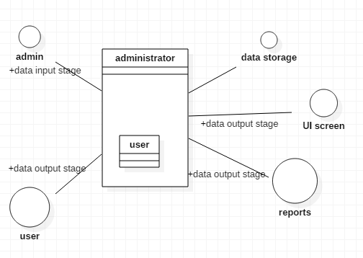

Figure 4.1Class diagram of login module

FLOW CHART

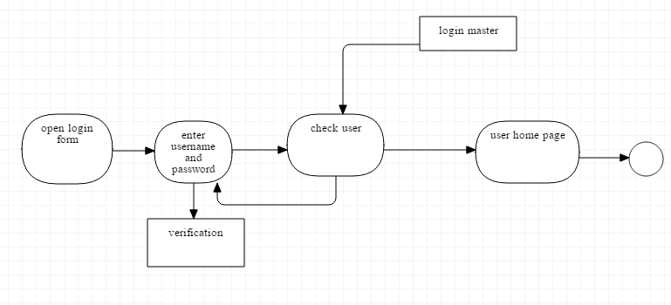

Figure 4.2Flow chart of login module

**4.3 Algorithm**

Step 1: Start

Step 2: Signup

Step 3: Login

Step 4: If successful redirect to index.php else

Login, go to step 2

Step 5: If Admin redirect to Home.php

Step 6: Admin get access to send sms and Upload files

Step 7: Student get access to read the tweets and download files

Step 8: Logout

Step 9: Stop

**4.3DATAFLOW DIAGRAM**

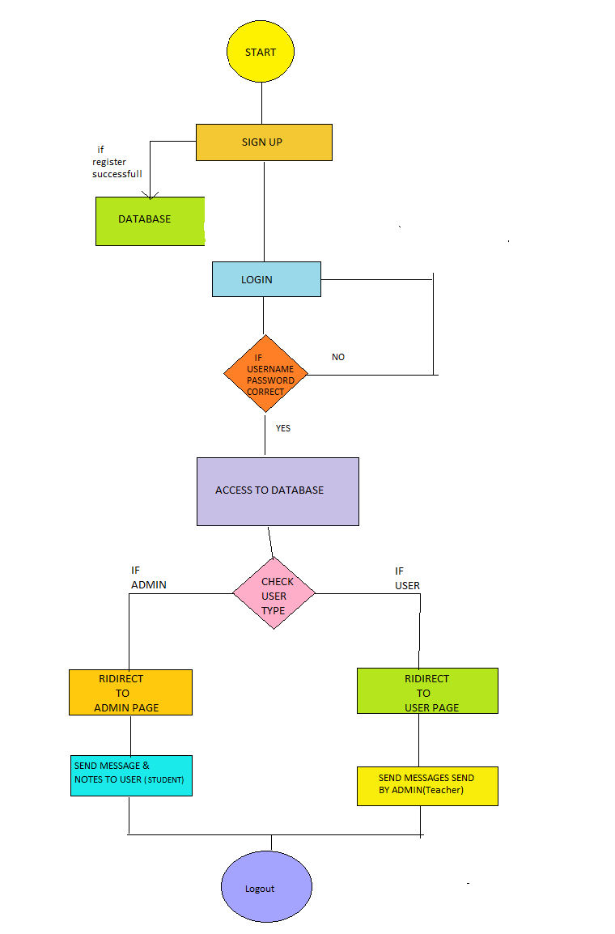

Figure 4.3Dataflow Diagram of Login System

**4.3.1 DATAFLOW DIAGRAM**

A Dataflow Diagram is a graphical representation of flow of the data through an information system modeling its Process aspects

**4.4UML DIAGRAM**

Communication Diagram. Communication diagrams model the interactions between objects in sequence. They describe both the static structure and the dynamic behavior of a system. In many ways, a communication diagram is a simplified version of a collaboration diagram introduced in UML 2.0.

**4.5FLOW CHART**

A **flowchart** is a type of [diagram](https://en.wikipedia.org/wiki/Diagram" \o "Diagram) that represents an [algorithm](https://en.wikipedia.org/wiki/Algorithm" \o "Algorithm), [workflow](https://en.wikipedia.org/wiki/Workflow" \o "Workflow) or process, showing the steps as boxes of various kinds, and their order by connecting them with arrows. This diagrammatic representation illustrates a solution model to a given [problem](https://en.wikipedia.org/wiki/Problem_solving" \o "Problem solving). Flowcharts are used in analyzing, designing, documenting or managing a process or program in various fields

**4.6DATABASE STRUCTURE**

The database schema of a database system is its structure described in a formal language supported by the database management system (DBMS). The term "schema" refers to the organization of data as a blueprint of how the database is constructed (divided into database tables in the case of relational databases).

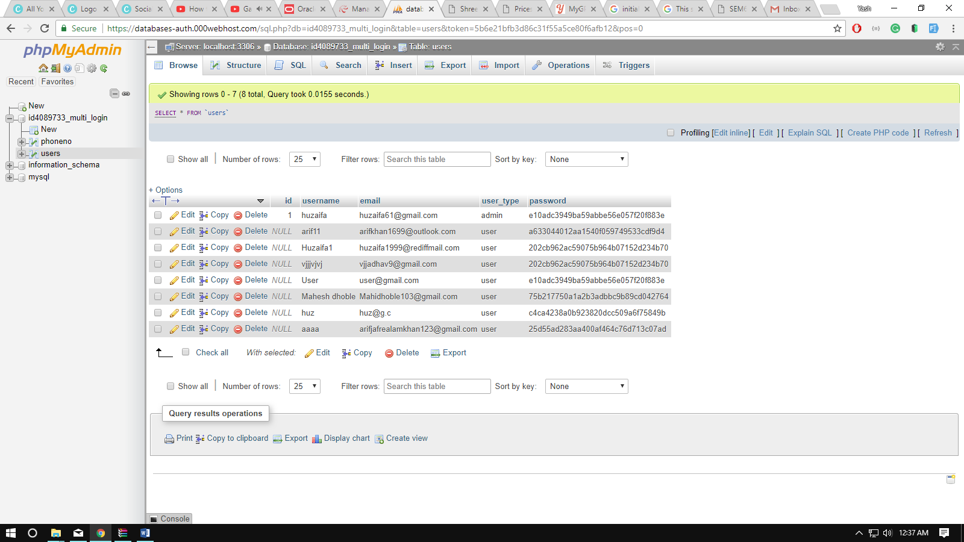

Figure 4.4 Database Structure

**CHAPTER 5**

**IMPLEMENTATION**

**5. IMPLEMENTATION**

**5.1 IMPLEMENTATION**

The implementation phase is when the end user of your software is foremost in your mind. During this phase you create the documentation and tools the customer uses to make informed decision about how to deploy your software securely.

To this end, the implementation phase is when you establish development best practices to detect and remove security and privacy issues early in the development cycle .

**5.1.1 IMPLEMENTATION PHASE: SOME IMPORTANT POINTS**

* COST OF WEBSERVER
* CUSTOMERS FEEDBACK
* TECHNICAL SUPPORT
* WEBSPACE
* BANDWIDTH
* CPU LIMIT
* CONTROL PANEL
* DATABASE SPACE
* UPTIME
* DOWNTIME
* HITS

**5.2 CODING OUTPUT**

**5.2.1 INDEX PAGE**

<!DOCTYPE html>

<html lang="en">

<head>

<title>MAHARASHTRA SCHOOL| Home </title>

<meta name="theme-color" content="#01E1FD">

<link href="timetable/favicon.ico" rel="icon" type="image/x-icon" />

<link rel="apple-touch-icon" sizes="180x180" href="/apple-touch-icon.png">

<script type="text/javascript" src="//platform-api.sharethis.com/js/sharethis.js#property=5a930508d57467001383d0f9&product=sticky-share-buttons"></script>

<meta name="viewport" content="width=device-width, initial-scale=1">

<meta http-equiv="Content-Type" content="text/html; charset=utf-8" />

<meta name="keywords" content="Learn Kids Responsive web template, Bootstrap Web Templates, Flat Web Templates, Android Compatible web template,

SmartPhone Compatible web template, free WebDesigns for Nokia, Samsung, LG, Sony Ericsson, Motorola web design" />

<script type="application/x-javascript"> addEventListener("load", function() { setTimeout(hideURLbar, 0); }, false); function hideURLbar(){ window.scrollTo(0,1); } </script>

<!-- Custom Theme files -->

<link href="css/bootstrap.css" type="text/css" rel="stylesheet" media="all">

<link href="css/style.css" type="text/css" rel="stylesheet" media="all">

<link href="css/font-awesome.css" rel="stylesheet">

<!-- font-awesome icons -->

<!-- //Custom Theme files -->

<!-- js -->

<script src="js/jquery-2.2.3.min.js"></script>

<!-- //js -->

<!-- web-fonts -->

<link href="//fonts.googleapis.com/css?family=Limelight" rel="stylesheet">

<link href="//fonts.googleapis.com/css?family=Open+Sans:300,300i,400,400i,600,600i,700,700i,800,800i" rel="stylesheet">

<!-- //web-fonts -->

<script>

function showResult(str) {

if (str.length==0) {

document.getElementById("livesearch").innerHTML="";

document.getElementById("livesearch").style.border="0px";

return;

}

if (window.XMLHttpRequest) {

// code for IE7+, Firefox, Chrome, Opera, Safari

xmlhttp=new XMLHttpRequest();

} else { // code for IE6, IE5

xmlhttp=new ActiveXObject("Microsoft.XMLHTTP");

}

xmlhttp.onreadystatechange=function() {

if (this.readyState==4 && this.status==200) {

document.getElementById("livesearch").innerHTML=this.responseText;

document.getElementById("livesearch").style.border="1px solid #A5ACB2";

}

}

xmlhttp.open("GET","livesearch.php?q="+str,true);

xmlhttp.send();

}

</script>

<style>

#custom-search-input{

padding: 3px;

border: solid 1px #E4E4E4;

border-radius: 12px;

background-color: #fff;

}

#custom-search-input input{

border: 0;

box-shadow: none;

}

#custom-search-input button{

margin: 2px 0 0 0;

background: none;

box-shadow: none;

border: 0;

color: #666666;

padding: 0 8px 0 10px;

border-left: solid 1px #ccc;

}

#custom-search-input button:hover{

border: 0;

box-shadow: none;

border-left: solid 1px #ccc;

}

#custom-search-input .glyphicon-search{

font-size: 23px;

}

img[src*="https://cdn.rawgit.com/000webhost/logo/e9bd13f7/footer-powered-by-000webhost-white2.png"]

{

display:none;

}

img {

width: 100%;

height: auto;

}

</style>

</head>

<body>

<!-- header -->

<div class="header-w3layoutstop">

<div class="container">

<div class="hdr-w3left navbar-left">

<p><span class="glyphicon glyphicon-earphone"></span><a href="tel:+022 2503-1288 ">+022 2503 1288 </p></a>

</div>

<script>

$(document).ready(function(){

$('[data-toggle="tooltip"]').tooltip();

});

</script>

<div class="w3ls-bnr-icons social-icon navbar-right">

<a href="https://twitter.com/mahaurdu" class="social-button twitter" data-toggle="tooltip" data-placement="bottom" title="twitter!"><i class="fa fa-twitter"></i></a>

<a href="https://www.facebook.com/Maharashtra-Urdu-School-182747945650495/" class="social-button facebook"><i class="fa fa-facebook"></i></a>

<a href="https://plus.google.com/105230525367321982912" class="social-button google"><i class="fa fa-google-plus"></i></a>

</div>

</div>

</div>

<!-- //header -->

<img src="images\logo5.png" width="460" height="345">

<!-- banner -->

<div class="agileits-banner">

<div class="bnr-agileinfo">

<!-- navigation -->

<div class="top-nav w3-agiletop">

<div class="container">

<div class="navbar-header w3llogo">

<button type="button" class="navbar-toggle" data-

toggle="collapse" data-target="#bs-example-navbar-collapse-1">

<span class="sr-only">Toggle navigation</span>

<span class="icon-bar"></span>

<span class="icon-bar"></span>

<span class="icon-bar"></span>

</button>

</div><br>

<br>

<!-- Collect the nav links, forms, and other content for toggling -->

<div class="collapse navbar-collapse" id="bs-example-navbar-collapse-1">

<div class="w3menu navbar-right">

<ul class="nav navbar">

<li><a href="index.html" class="active">HOME</a></li>

<li><a href="#" class="dropdown-toggle" data-toggle="dropdown" role="button" aria-haspopup="true" aria-expanded="false"><span data-letters="ABOUT">ABOUT US</span><span class="caret"></span></a>

<ul class="dropdown-menu">

<li><a href="about.html">ABOUT INSTITUTE</a></li>

<li><a href="principal.html">ABOUT PRINCIPAL</a></li>

<li><a href="Mission.html">MISSION & VISION</a></li>

<li><a href="timetable/govbody.pdf"><span class="glyphicons glyphicons-download-alt">GOVERNING BODY</span></a></li></ul>

<li><a href="gallery.html">GALLERY</a></li>

<li><a href="#" class="dropdown-toggle" data-toggle="dropdown" role="button" aria-haspopup="true" aria-

expanded="false"><span data-letters="Pages">STUDENT SECTION</span><span class="caret"></span></a>

<ul class="dropdown-menu">

<li><a href="timetable.html">TIME TABLE</a></li>

<li><a href="ac.html">ACADEMIC CALENDER</a></li>

<li><a href="cc.html">CURRICULUM</a></li>

<li><a href="or.html">ONLINE RESOURCES</a></li>

</ul>

</li>

<li><a href="contact.html">CONTACT</a></li>

<li><a href="login.php">LOGIN</a></li>

<li>

<form action="https://search.freefind.com/find.html" method="get" accept-charset="utf-8" target="_self">

<div id="custom-search-input">

<div class="input-group col-md-12">

<input type="hidden" name="si" value="45965268">

<input type="hidden" name="pid" value="r">

<input type="hidden" name="_charset_" value="">

<input type="hidden" name="bcd" value="&#247;">

<input type="text" name="query" size="15" class="form-control input-lg" placeholder="type here" onkeyup="showResult(this.value)">

<span class="input-group-btn">

<button class="btn btn-info btn-lg" type="submit">

<i class="glyphicon glyphicon-search"></i>

</button>

</span>

</div>

</div>

<div id="livesearch"></div>

</form> </li>

</div>

<div class="clearfix"></div>

</div>

</div>

</div>

</div>

<!-- //navigation -->

<div class="banner-w3text w3layouts">

<div class="container">

<h2>HOME</h2>

</div>

</div>

</div>

</div>

<!-- //banner -->

<!-- about -->

<div class="about">

<div class="container">

<div class="about-agileinfo">

<h3 class="w3ls-title">Welcome</h3>

<p><b>MAHARASHTRA URDU HIGH SCHOOL</b> enjoys the reputation of being one of the oldest high schools in Mumbai Established in june

<STRONG>1999</STRONG> the school has a glorious history of over 16 years. This history represents a grim struggle, fortitude and courage of some members of the Muslim community who devoted their lives to achieve the high and noble ambition of not only establishing an educational institution which was the need of the time, but also making it well –reputed for its high standard and quality of education.

</p>

</div>

</div>

</div>

<!-- //about -->

<!-- welcome -->

<div class="welcome agileits">

<div class="col-md-8 col-sm-8 w3welcome-img">

</div>

<div class="col-md-4 col-sm-4 w3welcome-right">

<div class="w3welcome-text">

<h5 class="w3l-subtitle">-OUR AIM-</h5>

<span style="color: #ff0000;"><strong>Enthuse:</strong></span>We aim to create future leaders through our commitment towards learning and imparting education that encourage students to think out of the box<br /><span style="color:

#ff0000;"><strong>Enlighten:</strong></span>Our constant endeavour is to challenge the normal and go beyond the ordinary<br /><span style="color: #ff0000;"><strong>Empower:</strong></span>We understand a school is a place for imbibing

knowledge and learning through fascinating experiences

</div>

</div>

<img src="images/gallery3.jpg" class="img-responsive" alt=""/>

</div>

<div class="clearfix"></div>

</div>

<!-- //welcome -->

<!-- services -->

<div class="services">

<div class="container">

<h3 class="w3ls-title">Our METHODS OF TEACHING</h3>

<div class="services-agileinfo">

<div class="col-md-3 col-sm-3 col-xs-6 services-w3lsgrids">

<div class="services-w3text">

<i class="fa fa-book" aria-hidden="true"></i>

<h5>ACADEMICS</h5>

</div>

</div>

<div class="col-md-3 col-sm-3 col-xs-6 services-w3lsgrids">

<div class="services-w3text srvs-w3text2">

<i class="fa fa-futbol-o" aria-hidden="true"></i>

<h5>SPORTS</h5>

</div>

</div>

<div class="col-md-3 col-sm-3 col-xs-6 services-w3lsgrids">

<div class="services-w3text srvs-w3text3">

<i class="fa fa-university" aria-hidden="true"></i>

<h5>EXPERIENCE</h5>

</div>

</div>

<div class="col-md-3 col-sm-3 col-xs-6 services-w3lsgrids">

<div class="services-w3text srvs-w3text4">

class="fa fa-smile-o" aria-hidden="true"></i>

<h5>CARING </h5>

</div>

</div>

<div class="clearfix"></div>

</div>

</div>

</div>

<!-- //services -->

<!-- news -->

<div class="services news">

<div class="container">

<h3 class="w3ls-title">Latest News </h3>

<div class="news-agileinfo">

<div class="col-sm-4 news-w3lgrids">

<div class="news-gridtext">

<div class="news-w3img">

<img src="NEWS/L6.jpeg" class="img-responsive zoom-img" alt=""/>

</div>

<div class="news-w3imgtext">

<h5 class="w3-agilep">Nov 12, 2017 </h5>

<h4><a href="timetable/tb1.pdf">CAMPAIGN</a></h4>

<p>TOBBACO FREE SCHOOL</p>

<a class="w3-agilebtn" href="timetable/tb1.pdf"><span>Read More</span></a>

</div>

</div>

</div>

<div class="col-sm-4 news-w3lgrids">

<div class="news-gridtext">

<div class="news-w3img">

<a href="#"><img src="images/TIME.png" class="img-responsive zoom-img" alt=""/></a>

</div>

<div class="news-w3imgtext">

<h5 class="w3-agilep">DEC 4, 2017</h5>

<h4><a href="timetable.html">TIME TABLE</a></h4>

<p>LATEST TIMETABLE OF PRIMARY & SECONDAARY.</p>

<a class="w3-agilebtn" href="timetable.html"><span>Read More</span></a>

</div>

</div>

</div>

<div class="col-sm-4 news-w3lgrids">

<div class="news-gridtext">

<div class="news-w3img">

<a href=#"><img src="images/notice.jpg" class="img-responsive zoom-img" alt=""/></a>

</div>

<div class="news-w3imgtext">

<h5 class="w3-agilep">Sept 21, 2016</h5>

<h4><a href="single.html">SPORTS & EVENTS</a></h4>

<p> WE HAVE CELEBRATED THE FOOTBALL DAY</p>

<a class="w3-agilebtn" href="timetable/sp1.pdf"><span>Read More</span></a>

</div>

</div>

</div>

<div class="clearfix"></div>

</div>

</div>

</div>

<!-- //news -->

<!-- features -->

<div class="features about">

<div class="container">

<div class="wthree-features-row">

<div class="col-md-4 features-w3grid">

<div class="col-xs-3 features-w3lleft">

<i class="fa fa-phone" aria-hidden="true"></i>

</div>

<div class="col-xs-9 features-w3lright">

<h4>CONTACT</h4>

<p>+022 2503 1288</p>

</div>

<div class="clearfix"></div>

</div>

<div class="col-md-4 features-w3grid">

<div class="col-xs-3 features-w3lleft">

<i class="fa fa-map-marker" aria-hidden="true"></i>

</div>

<div class="col-xs-9 features-w3lright">

<h4>LOCATION</h4>

<p>Kranti Nagar Pipe Line, Halavpool,kurla (WEST) Mumbai-400 070 </p>

</div>

<div class="clearfix"></div>

</div>

<div class="col-md-4 features-w3grid">

<div class="col-xs-3 features-w3lleft">

<i class="fa fa-envelope" aria-hidden="true"></i>

</div>

<div class="col-xs-9 features-w3lright">

<h4>EMAIL</h4>

<p><a href="mailto:maharashtraurduschool@ymail.com"> mhurhs@gmail.com</a></p>

</div>

<div class="clearfix"></div>

</div>

<div class="clearfix"></div>

</div>

</div>

</div>

<!-- //features -->

<!-- footer -->

<div class="footer w3layouts">

<div class="container">

<div class="footer-agileinfo">

<div class="col-md-3 col-sm-6 footer-grid">

<h3>Useful Info</h3>

<p>ADMISSION IN PROGRESS, FILL YOUR FORM AND GET ADMISSION</p>

</div>

<div class="col-md-3 col-sm-6 footer-grid footer-tags">

<h3>Navigation</h3>

<ul>

<li><a href="http://search.freefind.com/find.html?si=45965268&amp;m=0&amp;p=0"><i class="fa fa-angle-right"></i>Sitemap</a></li>

<li><a href="http://search.freefind.com/siteindex.html?si=45965268"><i class="fa fa-angle-right"></i>index</a></li>

<li><a href="index.html"><i class="fa fa-angle-right"></i> Home</a></li>

<li><a href="about.html"><i class="fa fa-angle-right"></i> About</a></li>

<li><a href="gallery.html"><i class="fa fa-angle-right"></i> Gallery</a></li>

<li><a href="contact.html"><i class="fa fa-angle-right"></i> Contact Us</a></li>

<li><!-- start of freefind search box html -->

<table cellpadding=0 cellspacing=0 border=0 >

<tr>

<td style="font-family: Arial, Helvetica, sans-serif; font-size: 7.5pt;">

<table width="90%" cellpadding=0 cellspacing=0 border=0 style="font-family: Arial, Helvetica, sans-serif; font-size: 7.5pt;">

<tr>

<td style="font-family: Arial, Helvetica, sans-serif; font-size: 7.5pt;" align=left ><a href="http://search.freefind.com/siteindex.html?si=45965268"></a></td>

<td style="font-family: Arial, Helvetica, sans-serif; font-size: 7.5pt;" align=center><a href="http://search.freefind.com/find.html?si=45965268&amp;m=0&amp;p=0"></a></td>

<td style="font-family: Arial, Helvetica, sans-serif; font-size: 7.5pt;" align=right><a href="http://search.freefind.com/find.html?si=45965268&amp;pid=a"></a></td>

</tr>

</table>

</td>

</tr>

<tr>

</td>

</tr>

</table>

<!-- end of freefind search box html -->

</li>

</ul>

</div>

<div class="col-md-4 col-sm-6 footer-grid footer-review">

<h3>Newsletter</h3>

<p>STAY UPDATED <i class="fa fa-hand-o-down" aria-hidden="true"></i></p>

<form action="https://mhurhs.us17.list-manage.com/subscribe/post?u=8c951d4d125c589b498a10325&amp;id=04042092a9" method="post" id="mc-embedded-subscribe-form" name="mc-embedded-subscribe-form" class="validate" target="_blank" novalidate>

<div id="mc_embed_signup_scroll">

<i class="fa fa-hand-o-right" aria-hidden="true"></i>

<input type="submit" value="Subscribe our news letter by clicking here"> <div class="clearfix">

</div>

</form>

</div>

</div>

</div>

<!--End mc_embed_signup-->

<div class="col-md-2 col-sm-6 footer-grid w3social">

<h3>Media</h3>

<ul>

<li><!--Start of Tawk.to Script-->

<script type="text/javascript">

var Tawk_API=Tawk_API||{}, Tawk_LoadStart=new Date();

(function(){

var s1=document.createElement("script"),s0=document.getElementsByTagName("script")[0];

s1.async=true;

s1.src='https://embed.tawk.to/5a69358cd7591465c70711b3/default';

s1.charset='UTF-8';

s1.setAttribute('crossorigin','*');

s0.parentNode.insertBefore(s1,s0);

})();

</script>

<!--End of Tawk.to Script--></li>

<li><a href="https://plus.google.com/105230525367321982912"><i class="fa fa-google-plus"></i>Google-plus</a></li>

<li><a href="https://www.facebook.com/Maharashtra-Urdu-School-182747945650495/"><i class="fa fa-facebook"></i>Facebook</a></li>

<li><a href="https://twitter.com/mahaurdu"><i class="fa fa-twitter"></i>Twitter</a></li>

</ul>

</div>

<div class="clearfix"></div>

</div>

</div>

</div>

<div class="copy-right wthree">

<div class="container">

<p><a href="dd.html">© 2017 MAHARASHTRA URDU HIGH SCHOOL. All rights reserved | Design by STUDENTS OF GPM</a></p>

</div>

</div>

<!-- //footer -->

<!-- modal-about -->

<div class="modal bnr-modal fade" id="myModal" tabindex="-1" role="dialog">

<div class="modal-dialog" role="document">

<div class="modal-content">

<div class="modal-header">

<button type="button" class="close" data-dismiss="modal" aria-label="Close"><span aria-hidden="true">&times;</span></button>

</div>

<div class="modal-body modal-spa">

<img src="images/img2.jpg" class="img-responsive" alt=""/>

</div>

</div>

</div>

</div>

<!-- //modal-about -->

<!-- start-smooth-scrolling -->

<script src="js/SmoothScroll.min.js"></script>

<script type="text/javascript" src="js/move-top.js"></script>

<script type="text/javascript" src="js/easing.js"></script>

<script type="text/javascript">

jQuery(document).ready(function($) {

$(".scroll").click(function(event){

event.preventDefault();

$('html,body').animate({scrollTop:$(this.hash).offset().top},1000);

});

});

</script>

<!-- //end-smooth-scrolling -->

<!-- smooth-scrolling-of-move-up -->

<script type="text/javascript">

$(document).ready(function() {

/*

var defaults = {

containerID: 'toTop', // fading element id

containerHoverID: 'toTopHover', // fading element hover id

scrollSpeed: 1200,

easingType: 'linear'

};

*/

$().UItoTop({ easingType: 'easeOutQuart' });

});

</script>

<!-- //smooth-scrolling-of-move-up -->

<!-- Bootstrap core JavaScript

================================================== -->

<!-- Placed at the end of the document so the pages load faster -->

<script src="js/bootstrap.js"></script>

</body>

</html>

**5.2.2 LOGIN PAGE**

<?php include('functions.php') ?>

<head>

<title>MAHA LOGIN</title>

<meta name="theme-color" content="#4682B4">

<link href="timetable/favicon.ico" rel="icon" type="image/x-icon" />

<link rel="stylesheet" type="text/css" href="style.css">

<style>

img[alt="www.000webhost.com"]

{

display:none;

}

img {

top: 430px;

}

.button {

padding: 15px 25px;

font-size: 24px;

text-align: center;

cursor: pointer;

outline: none;

color: #fff;

background-color: #4682B4;

border: none;

border-radius: 15px;

box-shadow: 0 9px #999;

}

.button:hover {background-color: #4682B4}

.button:active {

background-color: #3e8e41;

box-shadow: 0 5px #666;

transform: translateY(4px);

}

</style>

</head>

<body>

<div class="header">

<h2>Login</h2>

</div>

<form method="post" action="login.php">

<?php echo display_error(); ?>

<div class="input-group">

<label>Username</label>

<input type="text" name="username" >

</div>

<div class="input-group">

<label>Password</label>

<input type="password" name="password">

</div>

<div class="input-group">

<button type="submit" class="btn" name="login_btn">Login</button>

</div>

<p>

Not yet a member? <a href="register.php">Sign up</a>

</p>

</form>

<a href="https://twitter.com/login">

<center><img src="images/twitter.png" align="middle"></center>

</a>

<center><a href="index.html"><button class="button">GO TO HOME PAGE</button></a></center>

<!--Start of Tawk.to Script-->

<script type="text/javascript">

var Tawk_API=Tawk_API||{}, Tawk_LoadStart=new Date();

(function(){

var s1=document.createElement("script"),s0=document.getElementsByTagName("script")[0];

s1.async=true;

s1.src='https://embed.tawk.to/5a69358cd7591465c70711b3/default';

s1.charset='UTF-8';

s1.setAttribute('crossorigin','*');

s0.parentNode.insertBefore(s1,s0);

})();

</script>

<!--End of Tawk.to Script-->

html lang="en">

<head>

<meta name="google-signin-scope" content="profile email">

<meta name="google-signin-client_id" content="390880971285-45sk93eibo33p5sml3ohmemqph8nn6bj.apps.googleusercontent.com">

<script src="https://apis.google.com/js/platform.js" async defer></script>

</head>

<body>

<div class="g-signin2" data-onsuccess="onSignIn" data-theme="dark"></div>

<script>

function onSignIn(googleUser) {

// Useful data for your client-side scripts:

var profile = googleUser.getBasicProfile();

console.log("ID: " + profile.getId()); // Don't send this directly to your server!

console.log('Full Name: ' + profile.getName());

console.log('Given Name: ' + profile.getGivenName());

console.log('Family Name: ' + profile.getFamilyName());

console.log("Image URL: " + profile.getImageUrl());

console.log("Email: " + profile.getEmail());

// The ID token you need to pass to your backend:

var id_token = googleUser.getAuthResponse().id_token;

console.log("ID Token: " + id_token);

};

</script>

</body>

</html>

</body>

</html>

CHAPTER 6

**TESTING**

**6**.**TESTING**

**6.1 SOFTWARE TESTING**

Software testing is more than just error detection .Testing software is operating the software under controlled conditions.

1. To verify that behaves “as specified”,

2. To detect error.

3. To validate that what has been specified is what the actually wanted

* **Verification**: Verification is the checking and testing of items, including software, for conformance and consistency by evaluating the result against pre-specified requirements.
* **Error Detection:** Testing should intentionally attempt to make things go wrong to determine if things happen when they shouldn’t or things don’t happen when they should.
* **Validation**: Validation look at the system correctness. i.e. is the process of checking that what has been specified is what the users actually wanted.

In otherworld’s, validation checks to see if we are building what the customer want/needs, and verification checks to see if we are building that system correctly. Both verification and validation are necessary, but different component of any testing activity.

Testing is the process of analyzing a software items to detect the differences between existing and required condition and to evaluate the features of the software items.

**6.2 SOFTWARE TESTING OBJECTIVE**

* Testing is the process of executing a program with the intent of finding errors.
* A good test case is one with high probability.
* A successful test is one that discovers an as yet undiscovered error.

**6.3 TYPES OF TESTING**

* **Unit Testing:-** makes heavy use of testing techniques that exercise specific control paths to detect errors in each software component individually.

In our project we had tested the pages individually or testing only signup and then login page that’s we called Unit testing

* **Integration Testing:-** focuses on issue associated with verification and program construction as components being interacting with one another.

After testing pages individually we had move towards moving the website testing by integrating whole pages.

* **Validation Testing:-**provide assurance that the software validation criteria meet all function, behavioral, and performance requirements.
* **System Testing**:-verifies that all systems elements mesh properly and that overall system function and performance has been achieved.

**6.4 Testability**

Testability is used to means how adequately a particular set of tests will cover on that product following are set of characteristics that lead to testable software:

6.4.1 Operability

“The better it work the more efficiently it can be tested.”

* No bugs block the execution of texts.
* The product evolves in function stages.

**6.4.2 Observability**

“What you see is what you test.”

Distinct output is generated for each input.

1. All factors affecting the output are visible.
2. Incorrect output is easily identified.
3. Internal errors are automatically reported.

**6.4.3 Controllability**

“The better software can be controlled the more testing can be automated and optimized.”

* All possible outputs can be generated through same combination of input.
* All code is executable through some combination of input.
* Software and hardware states and variable can be controlled.

**6.4.4 Decomposability**

“By controlling the scope of testing, the more quickly problem can be isolated and retested intelligently.”

* The software system is built from independent modules.
* Software modules can test independently.

**6.4.5. Simplicity**

“The less there is to more quickly we can test.”

* Functional simplicity.
* Structural simplicity.
* Code simplicity.

**6.4.6 Stability**

“The fewer the change, the fewer the disruptions to testing.”

* Change to software are controlled
* The software recovers well form failures

**6.4.7 Understandability**

“The more information known, the smarter the testing.”

* The design is well understood
* Technical documentation is accurate

**6.5 There are two types of testing**

* **Black-box testing:-**It is a method of software testing that test the functionality of an application as opposed to its internal structures or workings.

**6.5.1 Following are the methods in black-box testing:-**

The easiest way to start is by treating the web page or the entire webpage or entire website as a black box you don’t any thing how it works you don’t have a specification

You just have a website in front you to test. What do you look for?

**6.5.2 What to test in black box testing :**

* **TEXT**

Check the audience level, the terminology, the content and subject matter, the accuracy – especially information that can become outdated

Checking contact information such as e-mail addresses are correct make sure that the copy right are correct and date appropriately. Test that each page has a correct this text appears in the browsers title bar.

When a user puts on mouse on graphic it should show ALT text

* **HYPERLINKS**

Links can be tied to text or graphics each link should be checked to make sure that it jumps to the correct destination and opens in the correct windows

* **Graphics**

Many possible bugs with graphics are covered later under usability testing ,but u can check a few obvious with a simple black box approach. for example :Do all graphics loaded and displayed properly?

* **Forms**

Forms contains fields for entering first name ,middle name, last name, and email address. There are obvious bugs on this page hopefully they are fixed by the time while testing.

## White-box testing:(a.k.a. clear box testing, glass box testing, transparent box testing or structural testing) is a method of testing software that tests internal structures or working of an application, as opposed to is functionality. Following method in white-box testing:-

## Its merely a tagging system for text and graphics to create these extra dynamic features requires the html to be supplemented with programming code that execute and flow decision paths.

## You’ve likely heard that popular web programming languages and technologies that can be use to create its types these types of features DHTML,JAVA,JAVASCRIPT,ACTIVEX,VBSCRIPT,PEARL,CGUI,ASP,XML.

## white box testing includes:-

## DYNAMIC CONTENT

## DATABASE DRIVEN WEBPAGES

## PROGRAMITACALLY CREATED WEBPAGES

## SERVER PROGRAMMING AND LOADING

## SECURITY

### Condition Testing (e.g. branch testing)

Focuses on testing is decision statement in a software module, it is important to ensure coverage of all logical combination of data.

* **Data Flow Testing**

Select test patch based according to the locations of variable definitions and users in the program (e.g. definition use chains)

* **Loop Testing**
  + Focuses on the validity of the program loop constructs (i.e. simple loop, concatenated loop, nested loops, and structured loops).
  + We checked whether all the tags were closed.
  + We checked whether all alignment and layouts were proper.
  + We checked while running the website there were some errors in forms. So we made changes in coding to fix those errors.
  + We checked the execution of check proper output of all forms.
* **USER ACCEPTANCE TESTING**

User acceptance testing is conducted when software is developed for specific customers and for large public /audience.

Purpose : allows customer to validate all requirements

Process : customer test the software feedback

* **ALPHA & BETA TESTING**
* Alpha testing is done by customers by developers site
* Testing done in controlled environment it consist of white box and black box testing
* Carried out before the Release of actual product
* Beta testing is done by customers at user/customer site
* Conducted in real environment
* Developers are present
* Carried out after release of actual product
* Failures are reported

Conducted in Real Environment

CHAPTER 7

**OUTPUT[RESULT]/SCREENSHOTS**

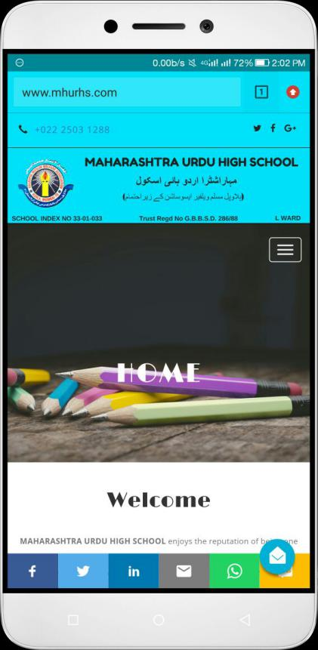**SCREENSHOTS/ OUTPUT**

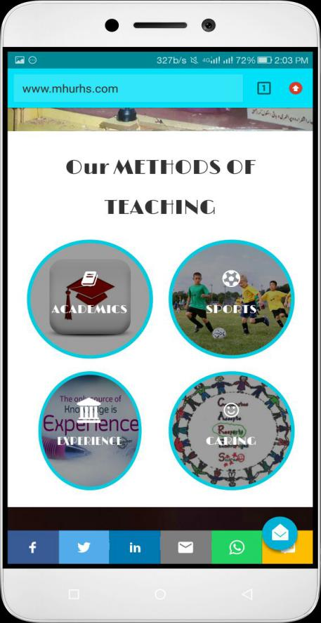Figure 7.1 Home page

Figure 7.2 Methods of teaching

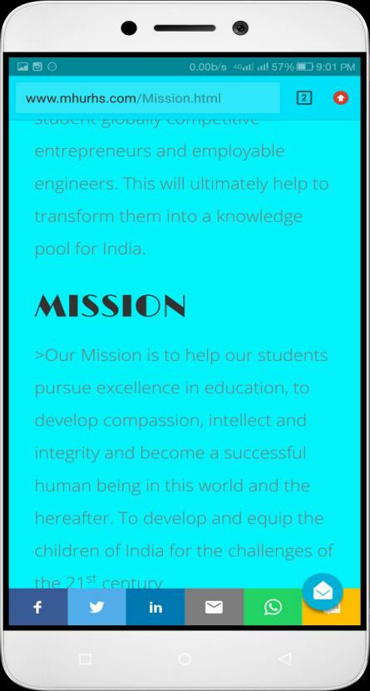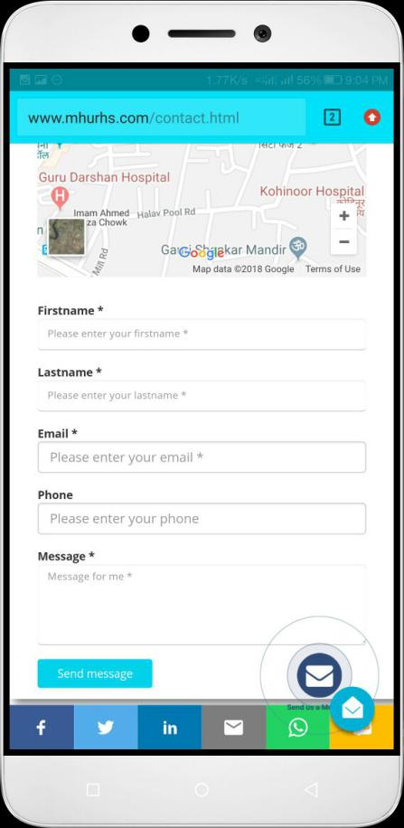

Figure 7.3 Mission And Vision

Figure 7.4 Contact

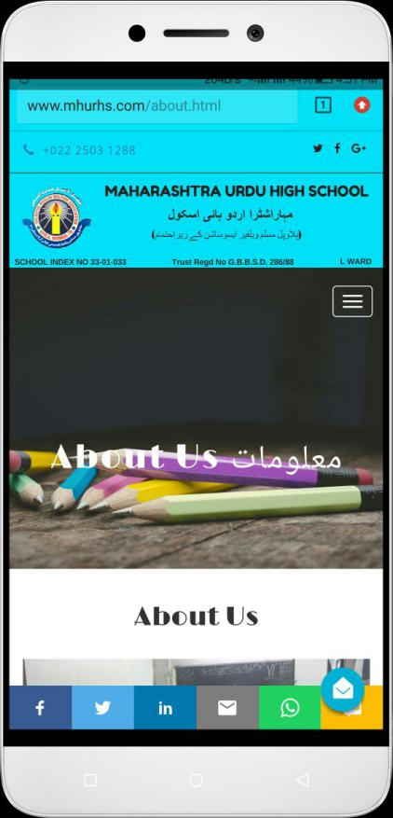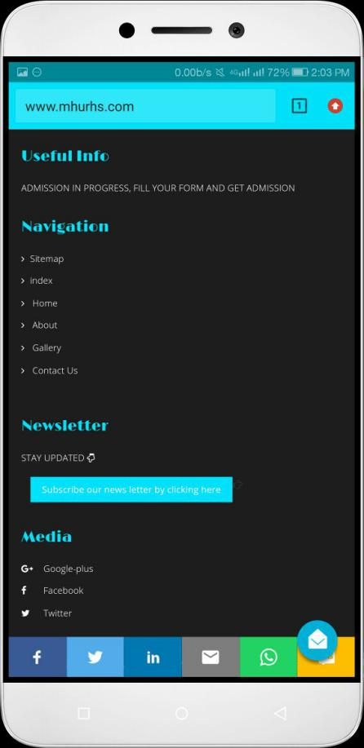 Figure 7.5 Newsletter & Navigation

Figure 7.6 About Us

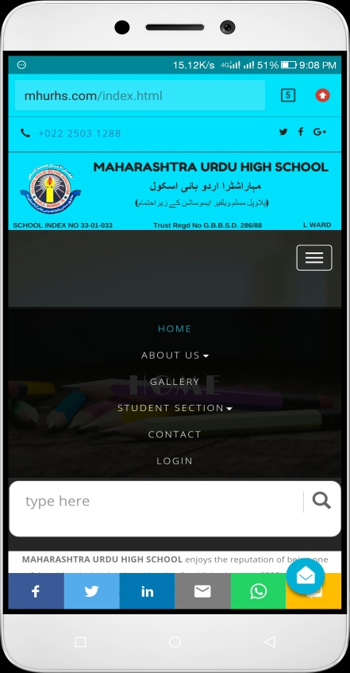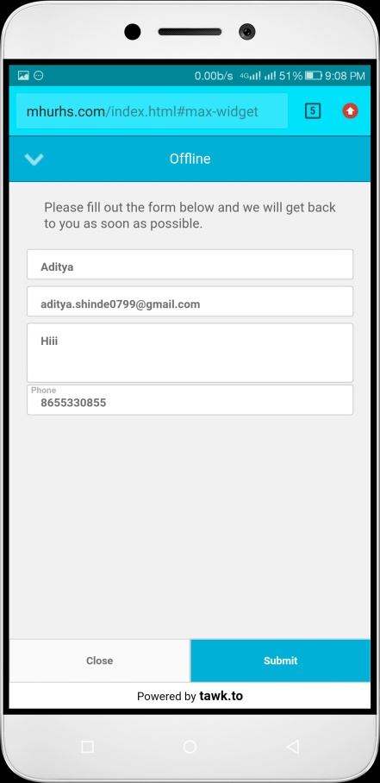

Figure 7.7 Search Engine

Figure 7.8 chat login

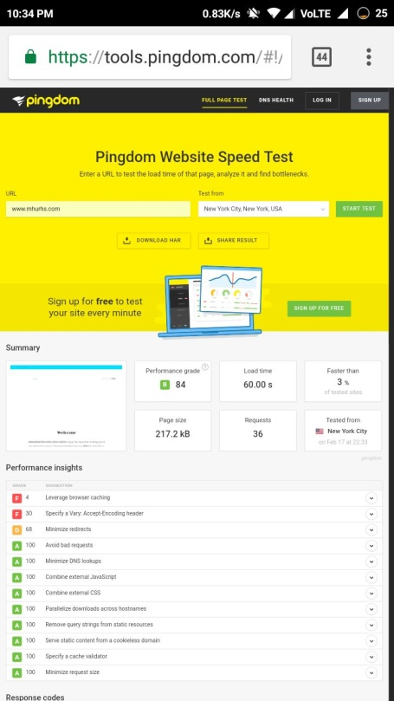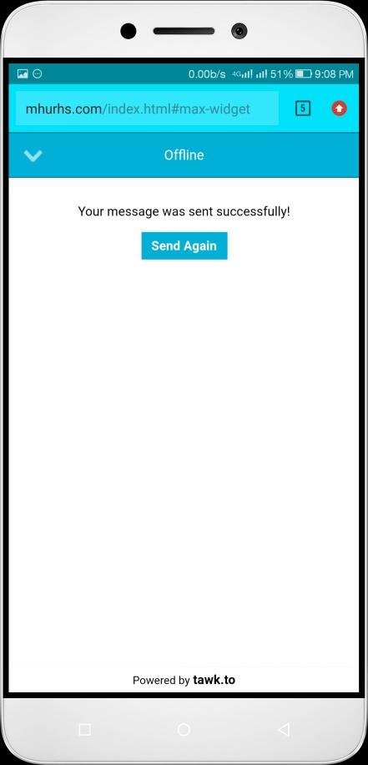 Figure 7.9 Offline chats

Figure 7.10 Testing

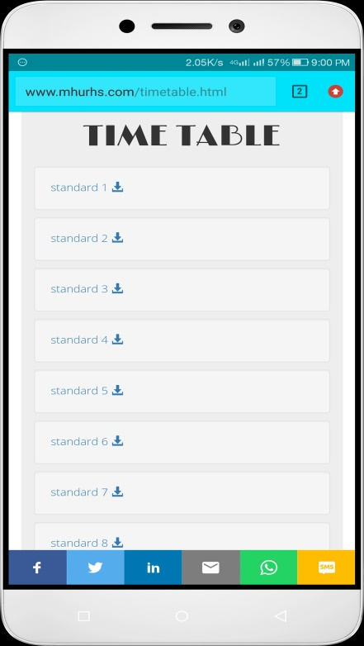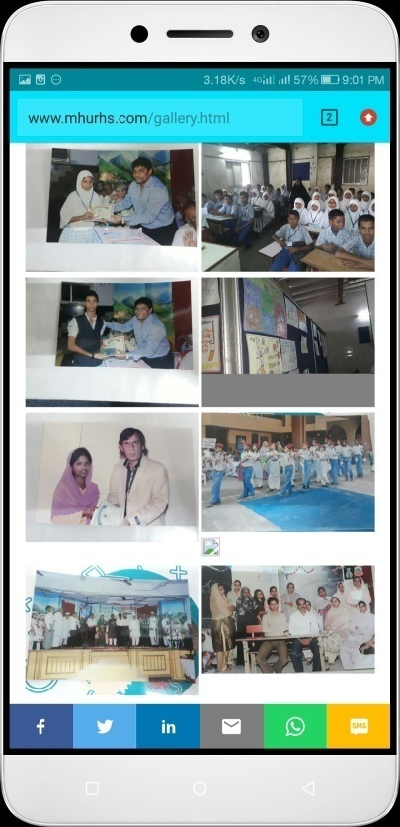 Figure 7.11 Gallery

Figure 7.12 Time Table

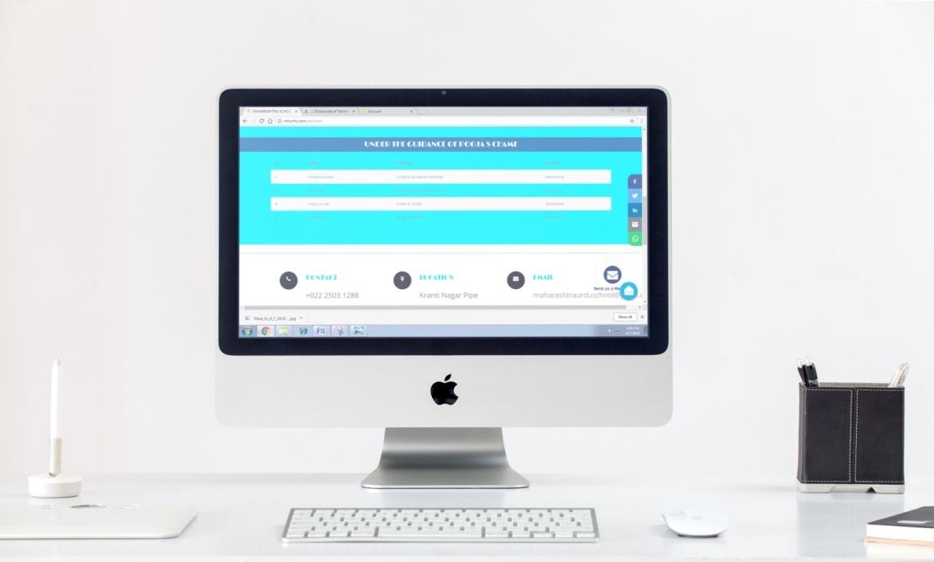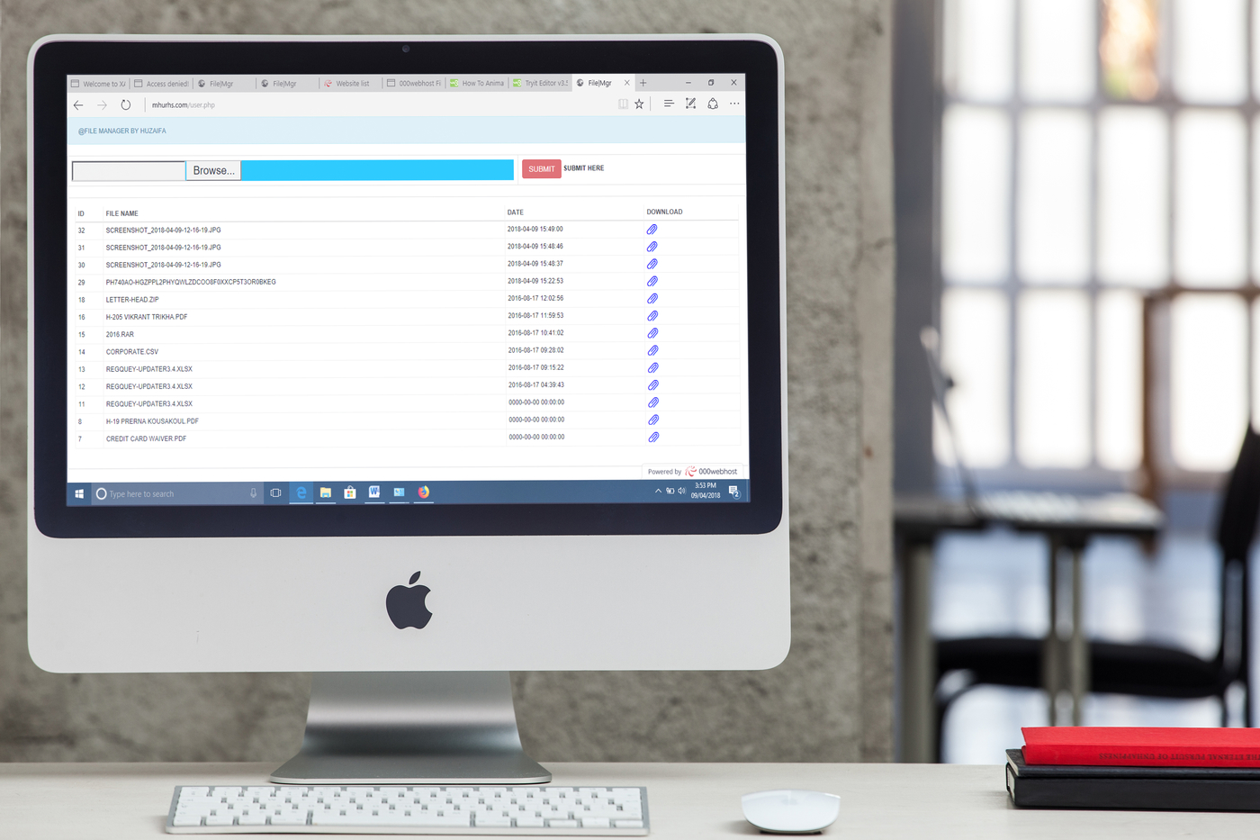 Figure 7.13 Documents Up loader

Figure 7.14 Developer Desk

Figure 7.15 SMS page



**8 CONCLUSION**

The project report entitled "**SCHOOL INFORMATION PORTAL WEBSITE” h**as come to its final stage. The system has been developed with much care that it is free of errors and at the same time it is efficient and less time consuming.

The important thing is that the system is robust. We have tried our level best to make the site as dynamic as possible. Also provision is provided for future developments in the system.

The entire system is secured. This online system will be approve and implemented.

**9 FUTURE SCOPE**

Any project can be improved if some enhancements and changes can be added. The current project can be made even better of some modifications can be made some of the enhancements include:

* APPLICATION
* E-BOOKS
* ONLINE LECTURES
* ONLINE PAYMENT

**10 BIBLIOGRAPHY AND REFERENCES**

1. **[WWW.W3SCHOOLS.COM](http://WWW.W3SCHOOLS.COM)**
2. **[WWW.GOOGLE.COM](http://WWW.GOOGLE.COM)**
3. **[WWW.GODADDY.COM](http://WWW.GODADDY.COM)**
4. **[WWW.000WEBHOST.COM](http://WWW.000WEBHOST.COM)**

**12.2 BOOKS**

**[1]WEB DESIGNING & DEVELOPMENT BPB PUBLICATION**

**[2]MASTERING CSS & JAVASCRIPT SAMS**

**[3]MODERN WEB DEVELOPMENT MICROSOFT**

**[4]RESPONSIVE DESIGN JOE CASABONA**

**[5]PHP: COMPLETE REFERENCE MCGRAW HILL**