NATIONAL ELECTRONICS COMPLEX OF PAKISTAN  (HRM Directorate)  APPLICATION FORM FOR INTERNSHIP |  | 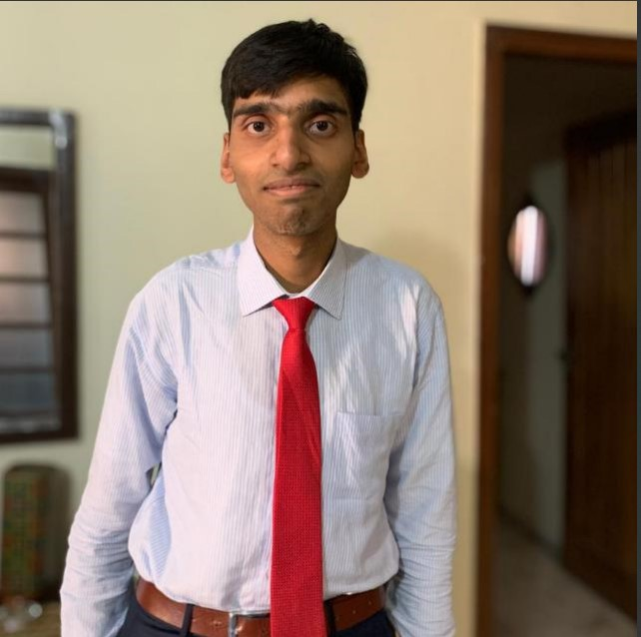
CNIC No: | 3 8 4 0 3 - 4 1 3 2 7 0 6 - 5
1. Name: Engr Huzaifa Shahbaz
2. Father's Name: Shahbaz Ghani
3. Father's Occupation: ARMY OFFICER AS LT COL AND MECHANCIAL ENGINEER
. Address - Present (a): HOUSE#12 UPPER FLOOR VALLEY ROAD WESTRIDGE RAWALPINDI
Phone: 03015606731
(b) Permanent: HOUSE 4-S-51 BLOCK 10 SARGODHA
Phone: 03015606731 Mobile No.: 03216037473
(c) E-Mail Address: huzaifashahbaz767@gmail.com
5. Date of Birth (a): 13-Nov-2002 (DD-MM-YYYY) (b) Age: 23yr. (s) 4 month(s)
6. Marital Status: Single 7. Domicile (a) City: Sargodha (b) Province: Punjab
8. Religion: Islam 9. Sect: Sunni
10. Nationality: Pakistani 11. Foreign Nationality (if any): N/A
(a) Are you a Pakistani born dual nationality Holder? (Yes/No): No
(b) Your Spouse/Family or dependent members residing with you and working on Foreign Mission(s) (Yes/No): No
(c) Are you married to a Foreign National/Pakistani born dual nationality holder? (Yes/No): No
12. Qualification: (please mention % age in case of annual system and CGPA in case of semester system)
SR# | LEVEL | PASSING YEAR | STANDARD ATTAINED MARKS & DIV | % AGE | CGPA | INSTITUTE | SUBJECTS QUALIFICATION
i. | Matric / O-Level | 2019 | 786/1100  A and Ist | 71.45 |  | APS EME College | Science
ii. | Intermediate / A-Level F.A/F.sc/I.Com | 2021 | 802/1100  A and Ist | 72.9 |  | APS EME College | ICS
iii. | BS Computer Engineering | 2025 | 2nd | 59.42 | 2.45/4 | HITEC University | Computer Engineering
iv. | B.Sc. (Engg)/B.E/BS (04 Years) M.A/ M.Sc./ MS or equivalent (16 years education)
v. | Any other Qualification
13. Previous Experience: - (If any)
SR# | Organization/Company | Designation | From | To
i. | MachaDev Engineering Pvt Ltd | Intern  R&D Trainee | 14-Jul- 2025  22-Sep 2025 | 25-Aug-2025  22-Nov-2025
ii. | Risetech, NUST EME College | Intern | 1-July-2024 | 5-Sep-2024
14. Purpose of Internship: To gain practical experience in Computer Engineering field and apply academic knowledge.
15. Duration: 30 weeks (In weeks)
Dated: _______________ (Signature of Candidate)
Referred By: PAKISTAN ENGINEERING COUNCIL

RECOMMENDATION OF CONCERNED DIRECTOR
Recommended/Not-Recommended
Dated: _______________ Signature

FOR OFFICE USE ONLY (HRM Dte.)
Approved/Not-Approved
Signature

Documents to be attached:
1. 01 x latest passport size photograph
2. 01 x attested copy of CNIC
3. 01 x set of complete academic documents

