**Online Bus Reservation System (OBRS)  
–  
Documentation**

***Team Members:***

*M. Huzaifa Mustafa*

*Mohammad Haseeb*

*Abdul Rehman*

*Talha Jilhani*

**Table of Contents**

**Online Bus Reservation System (OBRS) – Documentation** 1

**1. Introduction** 3

**2. Objectives** 3

**3. System Architecture** 4

**4. Project Flow** 5

**5. Database Design** 6

**6. Features** 7

**7. Technology Stack** 9

**8. Dashboard & Reports** 10

**9. Future Enhancements** 11

**10. Project Screenshots** 11

**11. Conclusion** 14

**1. Introduction**

The **Online Bus Reservation System (OBRS)** is a web-based application built using **ASP.NET Core MVC** with **Entity Framework Core** and **SQL Server** as the database.

It provides users the ability to:

* Search for available buses
* View routes and fares
* Book tickets online
* Manage bookings  
  And admins can:
* Manage buses, routes, and fares
* Monitor reservations
* Update booking statuses

**2. Objectives**

* Provide an online platform for **easy and fast bus reservations**.
* Reduce manual work for booking counters.
* Ensure **real-time availability** of seats.
* Provide admin with a **dashboard** for revenue and booking management.

**3. System Architecture**

This system follows a **3-Tier Architecture**:

1. **Presentation Layer** – ASP.NET MVC Views
2. **Business Logic Layer** – Controllers and Services
3. **Data Access Layer** – Entity Framework Core + SQL Server

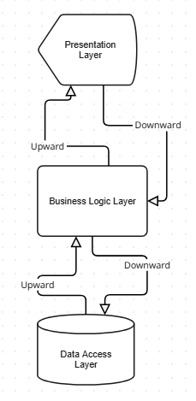

**4. Project Flow**

The overall flow of the project is as follows:

1. User searches for buses.
2. User selects a bus & route.
3. System displays **seat availability** and **fare**.
4. User books a seat (confirmation + payment).
5. Admin can **approve/reject/cancel** bookings.
6. Reports & revenues generated.

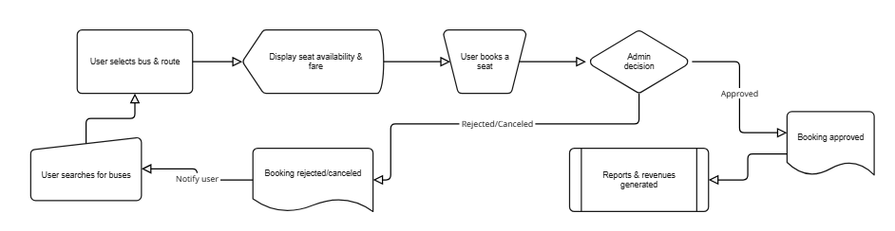

**5. Database Design**

**Main Tables:**

* **tbl_users** → stores user details
* **tbl_buses** → stores bus info (Bus No, Capacity, etc.)
* **tbl_routes** → route info (From, To, Distance, etc.)
* **tbl_prices** → stores fare (Base Fare, Final Fare)
* **tbl_bookings** → stores booking details (User, BusId, Seat, Status, Date, etc.)

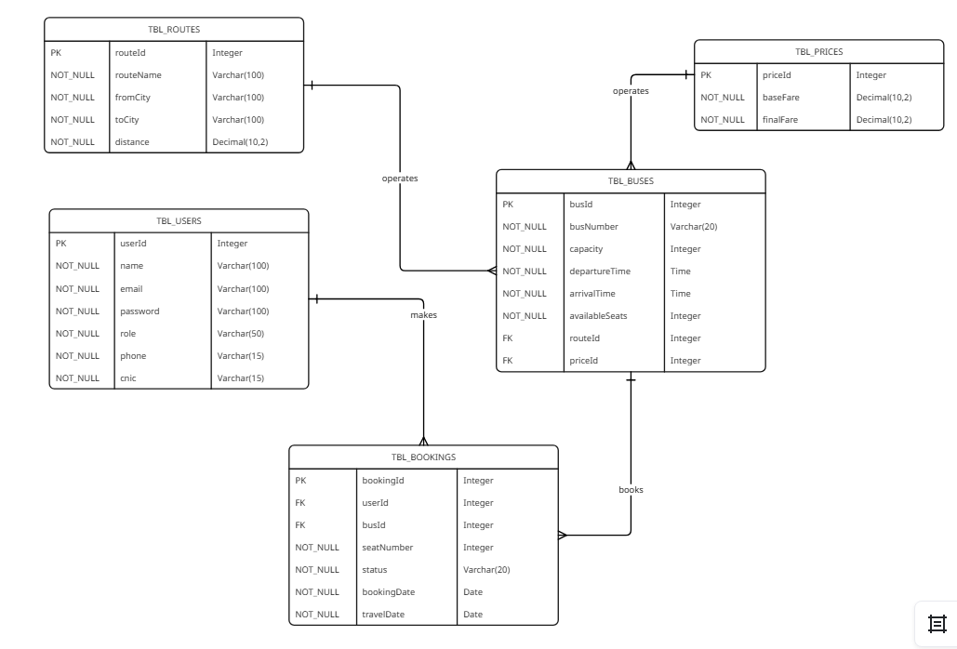

**6. Features**

**For Users**

* Search buses by route/date
* View seat availability
* Book tickets online
* View booking history
* Cancel bookings

**For Admins**

* Add/Edit/Delete buses
* Add/Edit/Delete routes
* Manage fares
* Manage bookings (approve, cancel, complete)
* Dashboard with revenue summary

📌 *Insert screenshots of key pages here:*

* 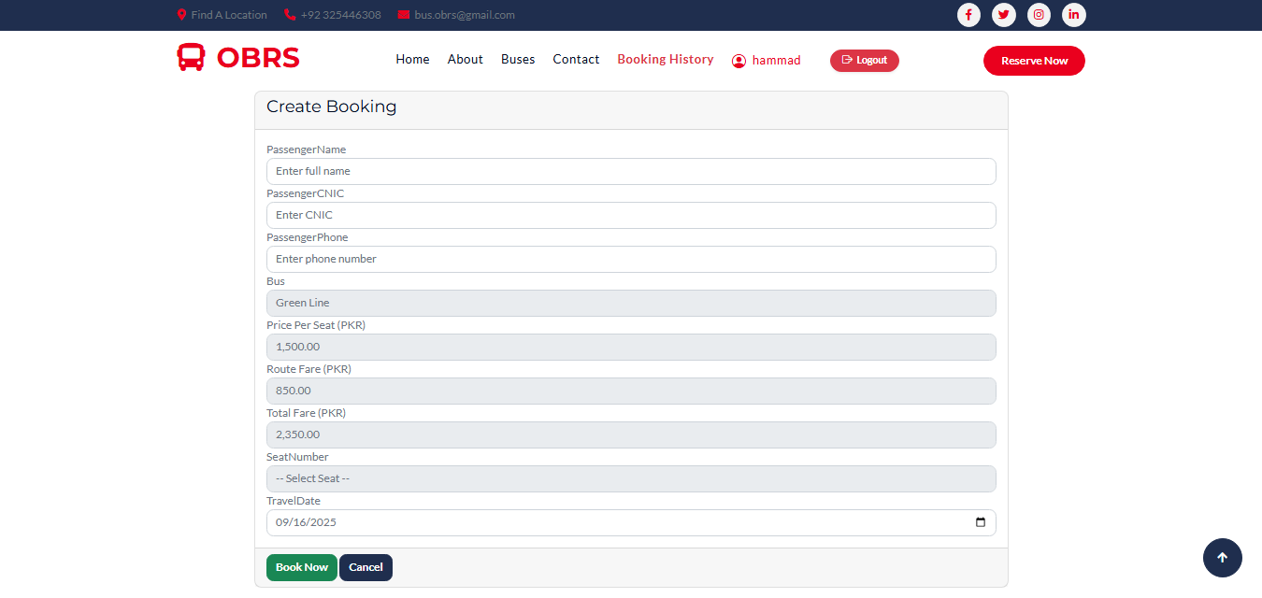![User Booking Screen]
* ![Admin Dashboard]

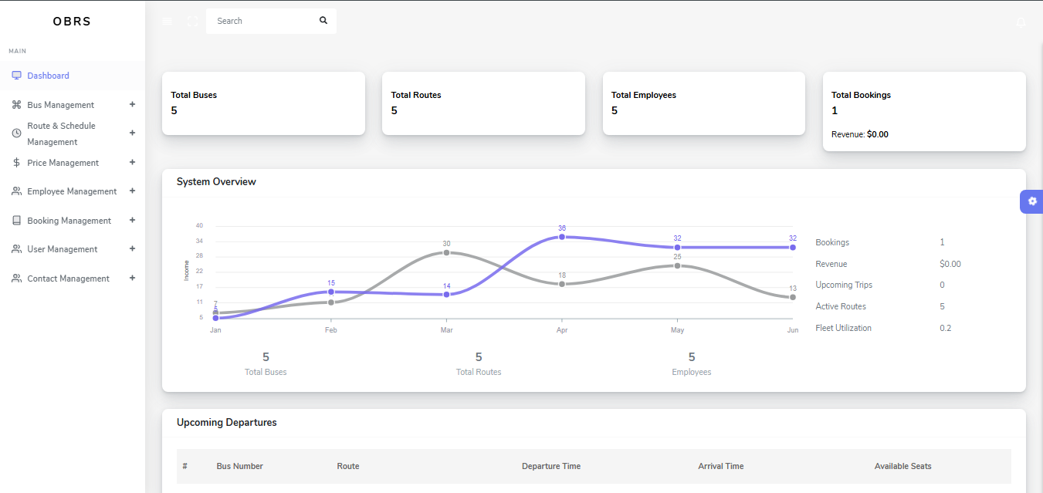

**7. Technology Stack**

* **Frontend**: HTML, CSS, Bootstrap
* **Backend**: ASP.NET Core MVC (C#)
* **Database**: SQL Server
* **ORM**: Entity Framework Core
* **Authentication**: Identity (with Role-based Authorization)

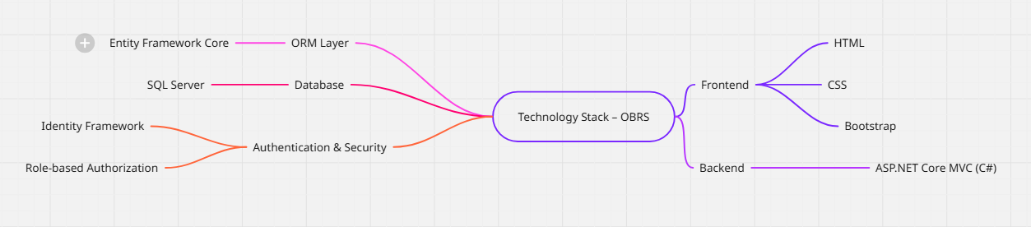

**8. Dashboard & Reports**

Admin dashboard provides:

* Total Bookings
* Revenue Generated
* Upcoming Departures
* Payment Summaries

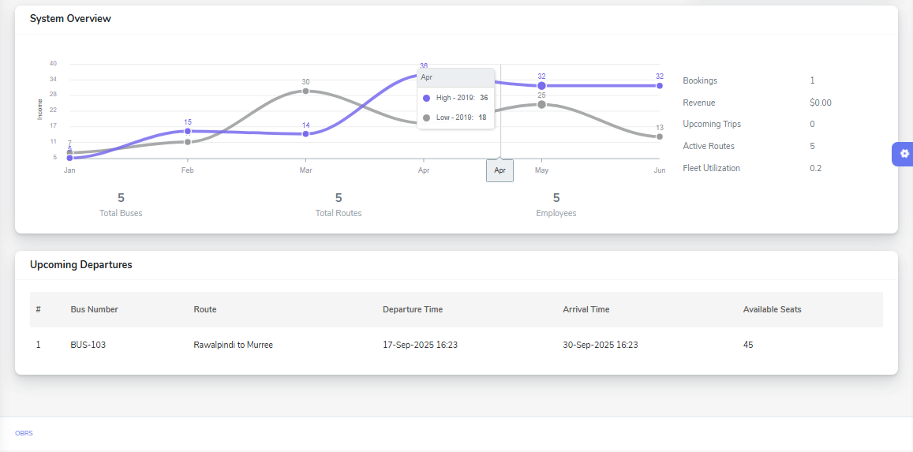

**9. Future Enhancements**

* Online Payment Gateway (JazzCash/EasyPaisa/Stripe)
* Email/SMS Notifications
* Mobile App (Xamarin / React Native)
* Real-time seat locking system

**10. Project Screenshots**

* 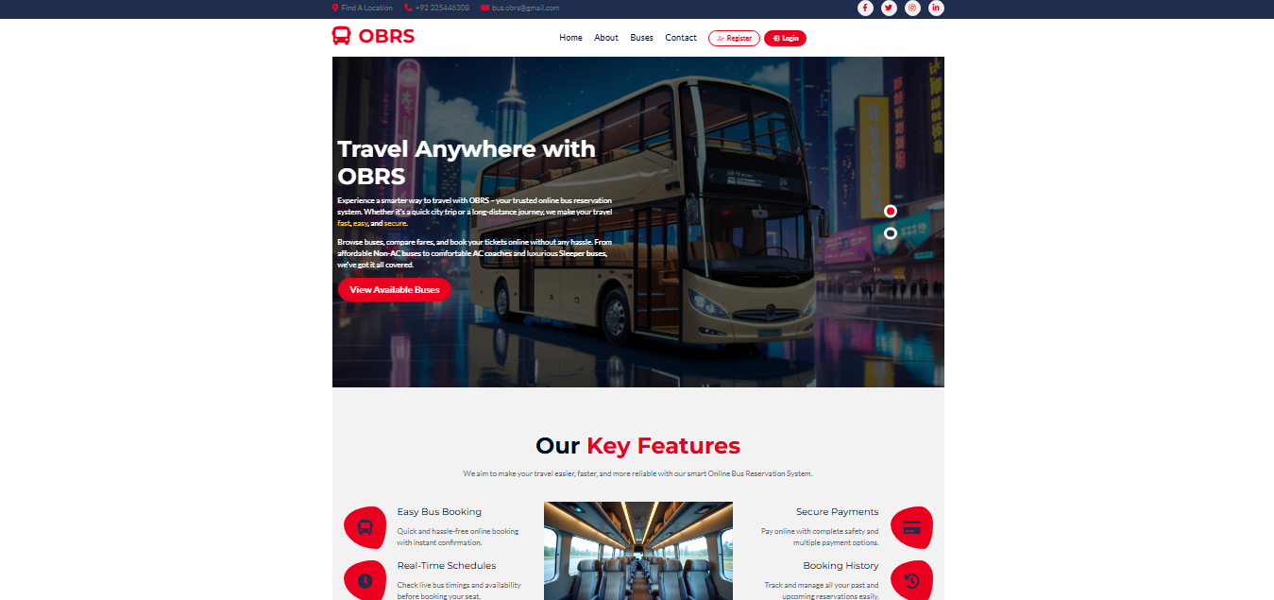Home Page →
* Booking Page →



* 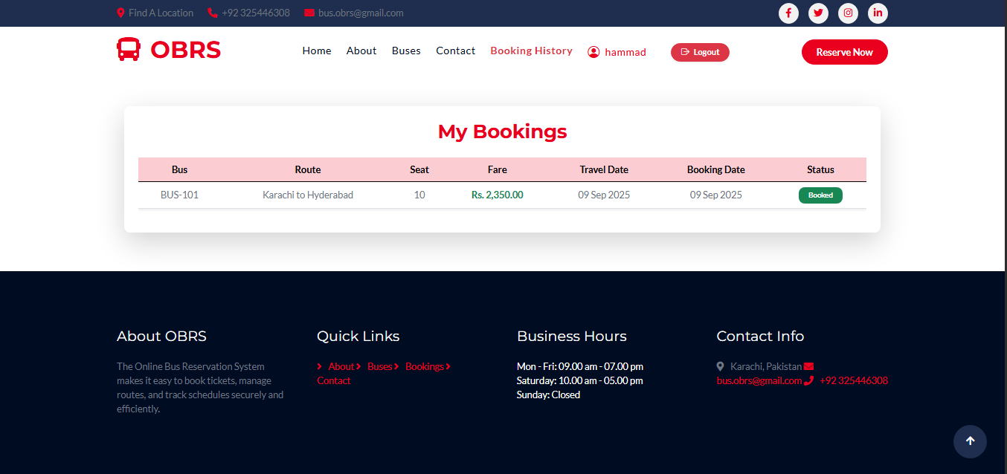Payment Summary →
* 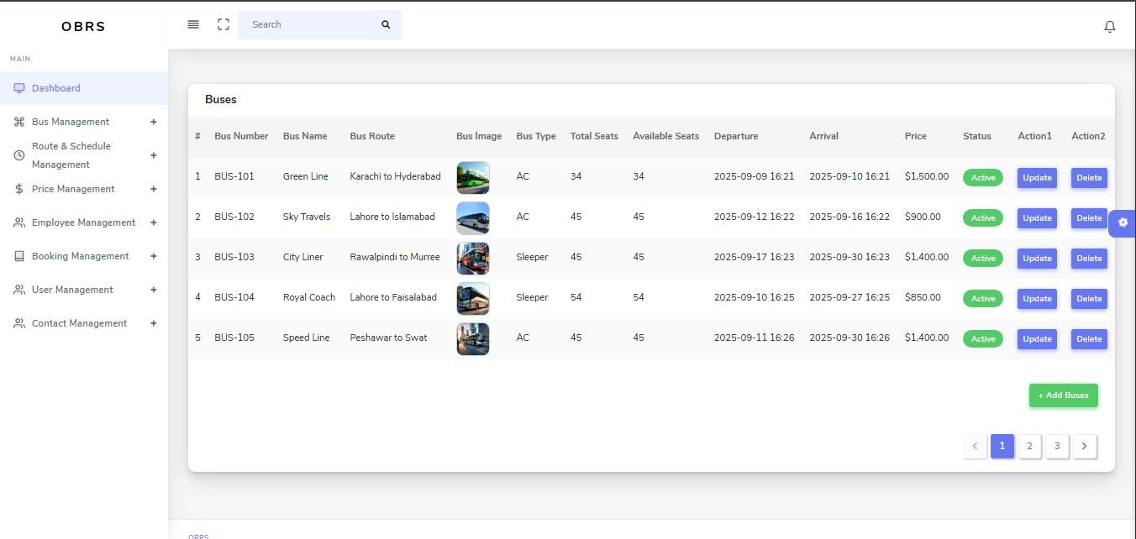Manage Buses (Admin) →
* Manage Bookings (Admin) →

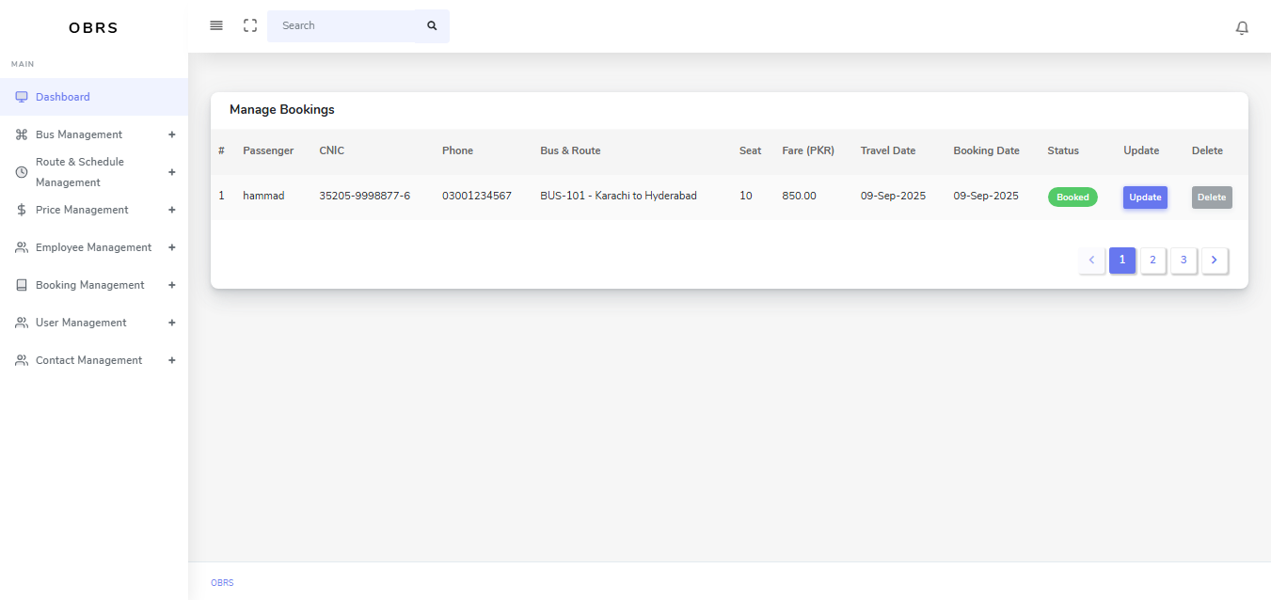

**11. Conclusion**

The **Online Bus Reservation System** provides a seamless platform for bus operators and passengers. It automates the entire process of searching, booking, and managing tickets.

It saves time, reduces errors, and increases operational efficiency.