NeuroAI
Dementia & Alzheimer’s Detection
A Multi-Modal Artificial Intelligence System
Clinical Data · MRI Imaging · EEG Signals — with a RAG AI Assistant
Program | Generative AI Internship
Author | Huzaifa Arshad
Project Type | Multi-Modal AI Web Application
Institution | National Centre of Artificial Intelligence, Lahore

Table of Contents
1. Introduction 3
2. Project Modules 3
3. Complete System Workflow 4
4. Model Details & Performance 5
4.1 Clinical Model 5
4.2 MRI Image Model 5
4.3 EEG Model 5
4.4 Multi-Modal Fusion 5
5. Technology Stack 6
6. User Interface Demonstration 7
7. Testing & Results 11
8. Conclusion & Future Work 11

1. Introduction
NeuroAI is a multi-modal artificial-intelligence web application that screens for dementia and Alzheimer’s disease by combining three independent data sources — clinical records, MRI brain scans, and EEG brain-wave signals. Each modality is analysed by a dedicated machine-learning model, and the individual risk scores are combined through a weighted fusion strategy to produce a single, easy-to-understand risk assessment.
The system is delivered as a polished web application with a doctor dashboard, a guided analysis workflow, a patient portal, and an AI assistant chatbot grounded in a curated dementia knowledge base (Retrieval-Augmented Generation). The goal is a tool that supports — but never replaces — the judgement of a qualified clinician.

Key Highlights
- Three trained ML models: Clinical (XGBoost, ~97%), MRI (ResNet50, 97.4%), and EEG (XGBoost, ~96%).
- Weighted multi-modal fusion (40% Clinical / 40% MRI / 20% EEG) with automatic re-normalisation when a modality is missing.
- Modern React + FastAPI web app with a 3-step analysis wizard and printable PDF reports.
- RAG-powered AI assistant using Google Gemini, grounded in a dementia knowledge base.

2. Project Modules
The project is organised into eight modules covering data modelling, fusion, the web application, the AI assistant, reporting, and deployment.
# | Module | Status
1 | Clinical Data Model (XGBoost) | Done
2 | MRI Image Model (ResNet50) | Done
3 | EEG Model (XGBoost) | Done
4 | Multi-Modal Fusion | Done
5 | Web App — React SPA + FastAPI | Done
6 | AI Chatbot (Gemini + RAG) | Done
7 | PDF Report (Print layout) | Done

3. Complete System Workflow
The diagram below shows the end-to-end workflow in three stages: (1) the offline training pipeline that turns raw datasets into saved model artifacts; (2) the live web-application runtime that performs inference and fusion; and (3) the AI assistant’s Retrieval-Augmented Generation flow.
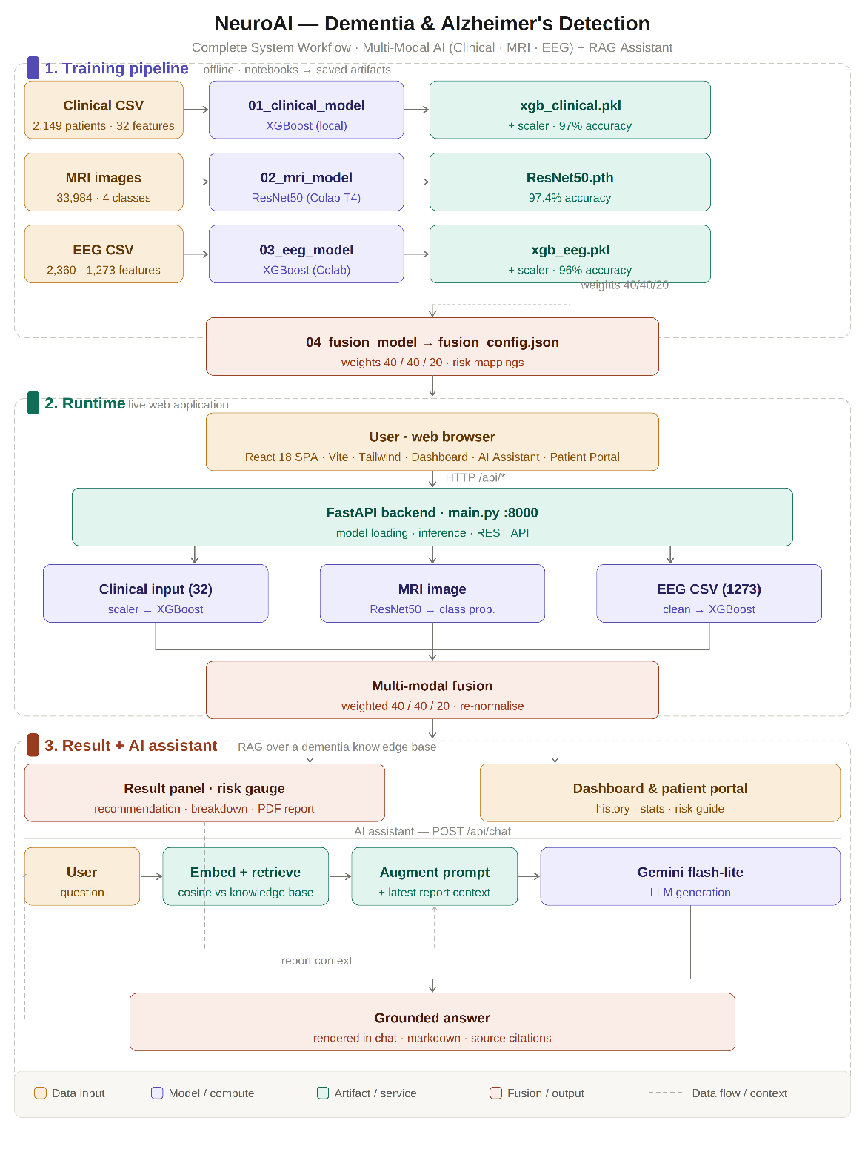
Figure 1 — Complete NeuroAI system workflow (training → runtime → RAG assistant).

4. Model Details & Performance

4.1 Clinical Model
Trained on a clinical dataset of 2,149 patients with 32 features (demographics, lifestyle, medical history, and cognitive scores). XGBoost gave the best accuracy and AUC.

4.2 MRI Image Model
Trained on 33,984 MRI images across four classes. Several architectures were compared; ResNet50 was selected as the production model.
Model | Test Accuracy
Custom CNN | 60.75%
VGG16 | 96.80%
ResNet50 (selected) | 97.42%
EfficientNetB3 | 69.12%

4.3 EEG Model
Trained on 2,360 EEG samples with 1,273 features. XGBoost outperformed Random Forest and an LSTM network.
Model | Test Accuracy
XGBoost (selected) | 95.97%
Random Forest | 92.37%
LSTM | 80.30%

4.4 Multi-Modal Fusion
Per-modality risk scores are combined using a weighted average. When a modality is missing, the weights are automatically re-normalised so the overall result remains valid.
Modality | Weight | Rationale
Clinical | 40% | Direct clinical biomarkers
MRI | 40% | Gold standard for diagnosis
EEG | 20% | Supporting indicator

Risk Categories
Score Range | Risk Category
0 – 25% | Low Risk
25 – 50% | Moderate Risk
50 – 75% | High Risk
75 – 100% | Very High Risk

5. Technology Stack
Layer | Technologies
Machine Learning | Python, PyTorch, XGBoost, scikit-learn
Backend | FastAPI, Uvicorn (REST API + inference)
Frontend | React 18, Vite, Tailwind CSS, React Router, Recharts
AI Assistant | Google Gemini (flash-lite) + semantic RAG
Training | Google Colab (T4 GPU) + local machine

6. User Interface Demonstration
The following screenshots are captured from the live application and demonstrate each major screen of the system.
The dashboard presents live KPI cards (total analyses, high-risk patients, average risk score, low-risk patients), a recent-analyses table, a risk-distribution panel, and quick-action shortcuts.
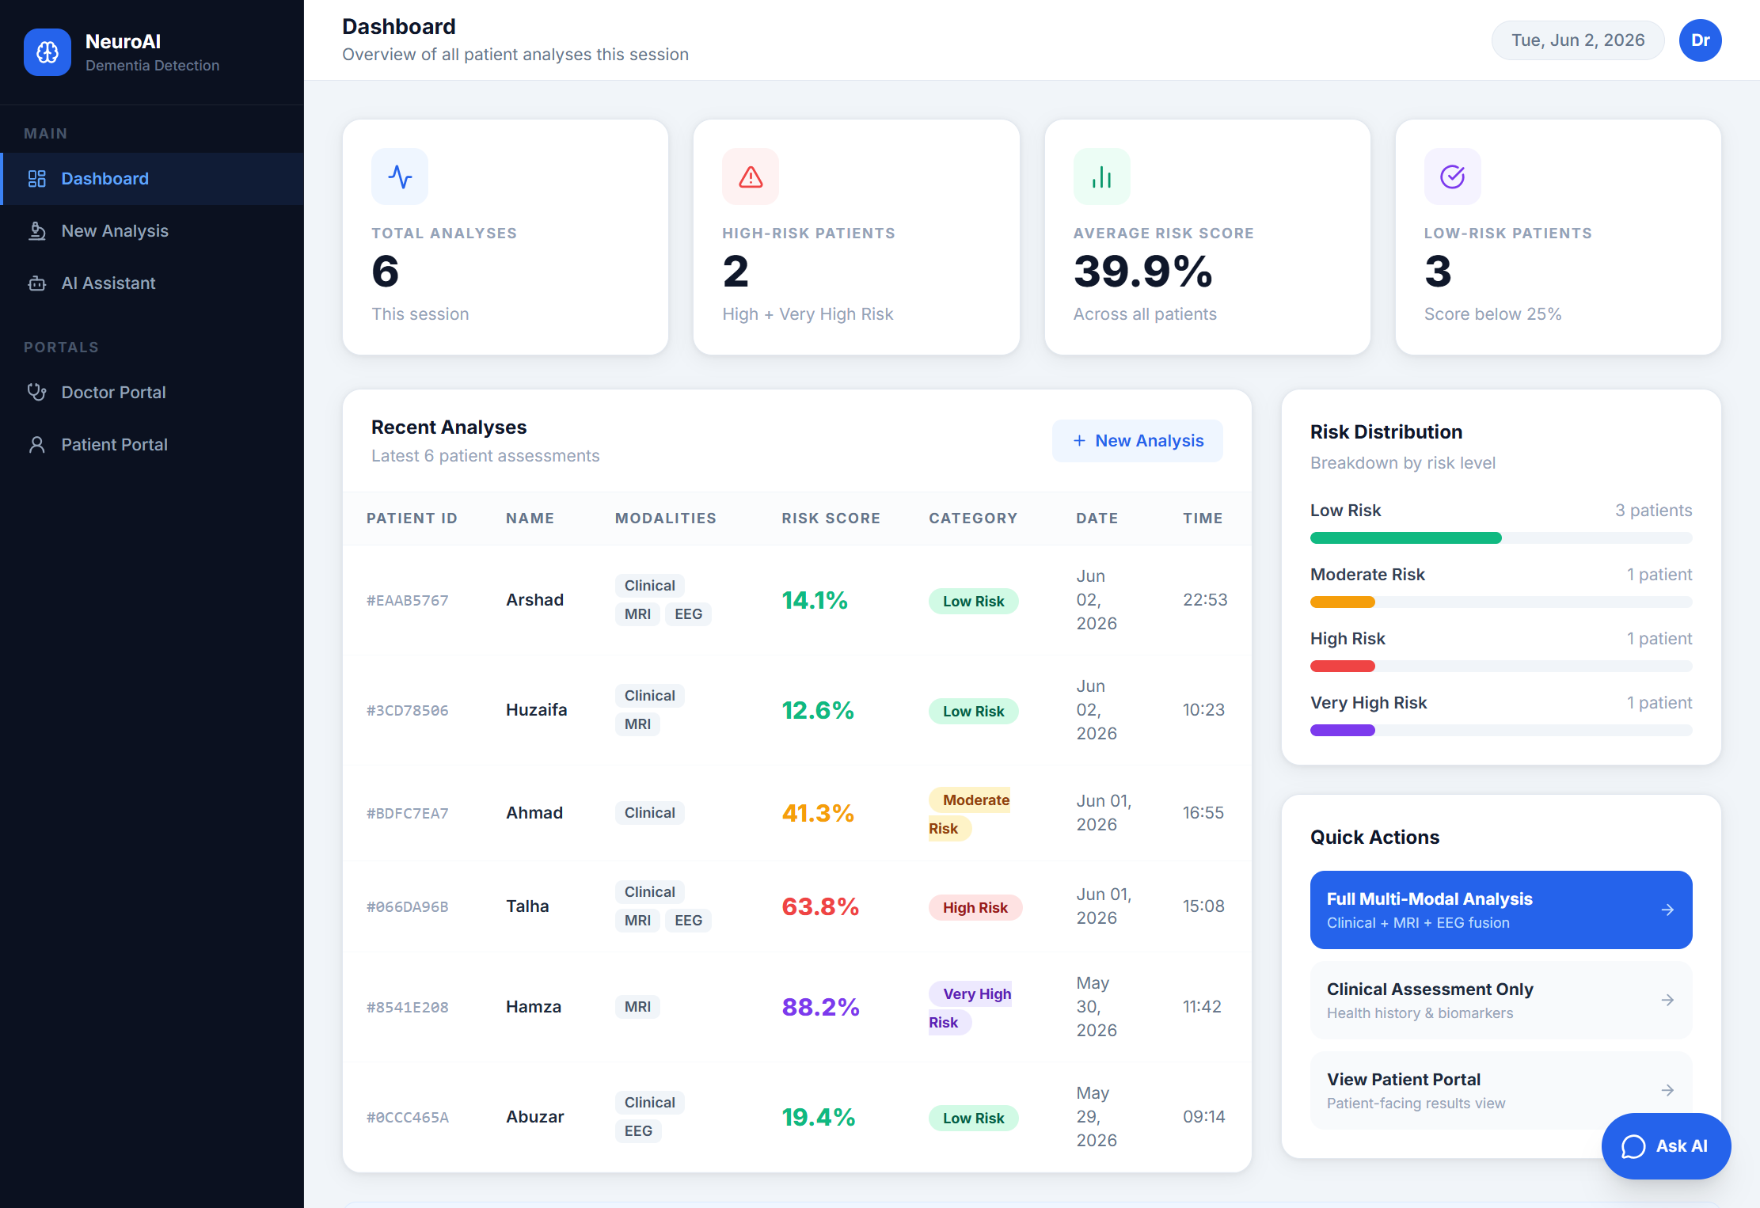
Figure 2 — Doctor Dashboard.
A guided 3-step wizard begins by collecting basic patient details — name, department, and priority.
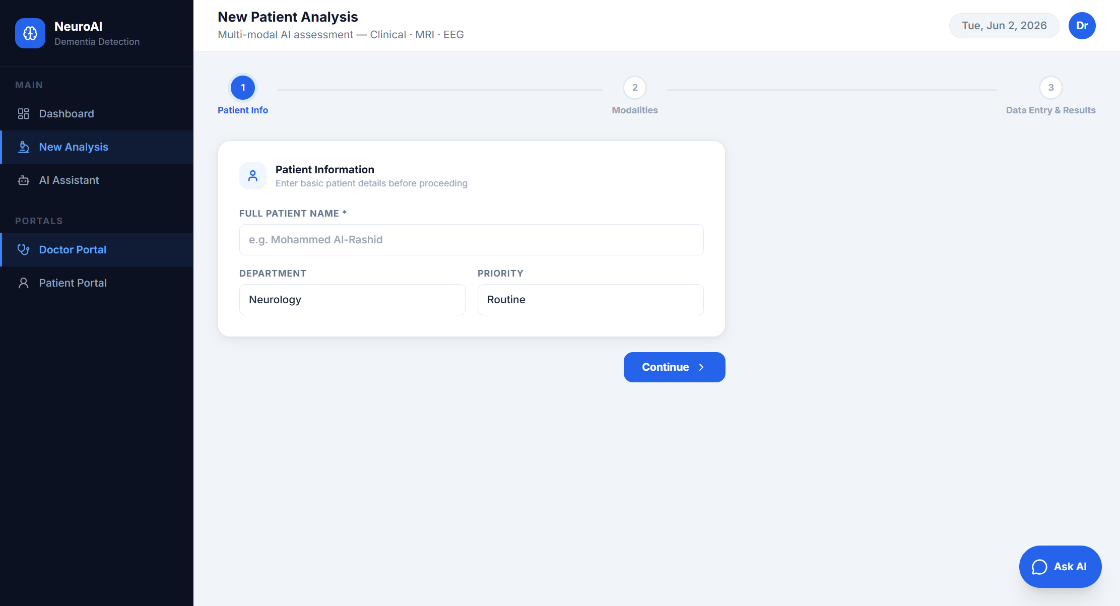
Figure 3 — New Analysis: Step 1 (Patient Information).
The clinician selects which data sources are available (Clinical, MRI, EEG). Using more sources increases the confidence of the result; missing data is handled automatically.
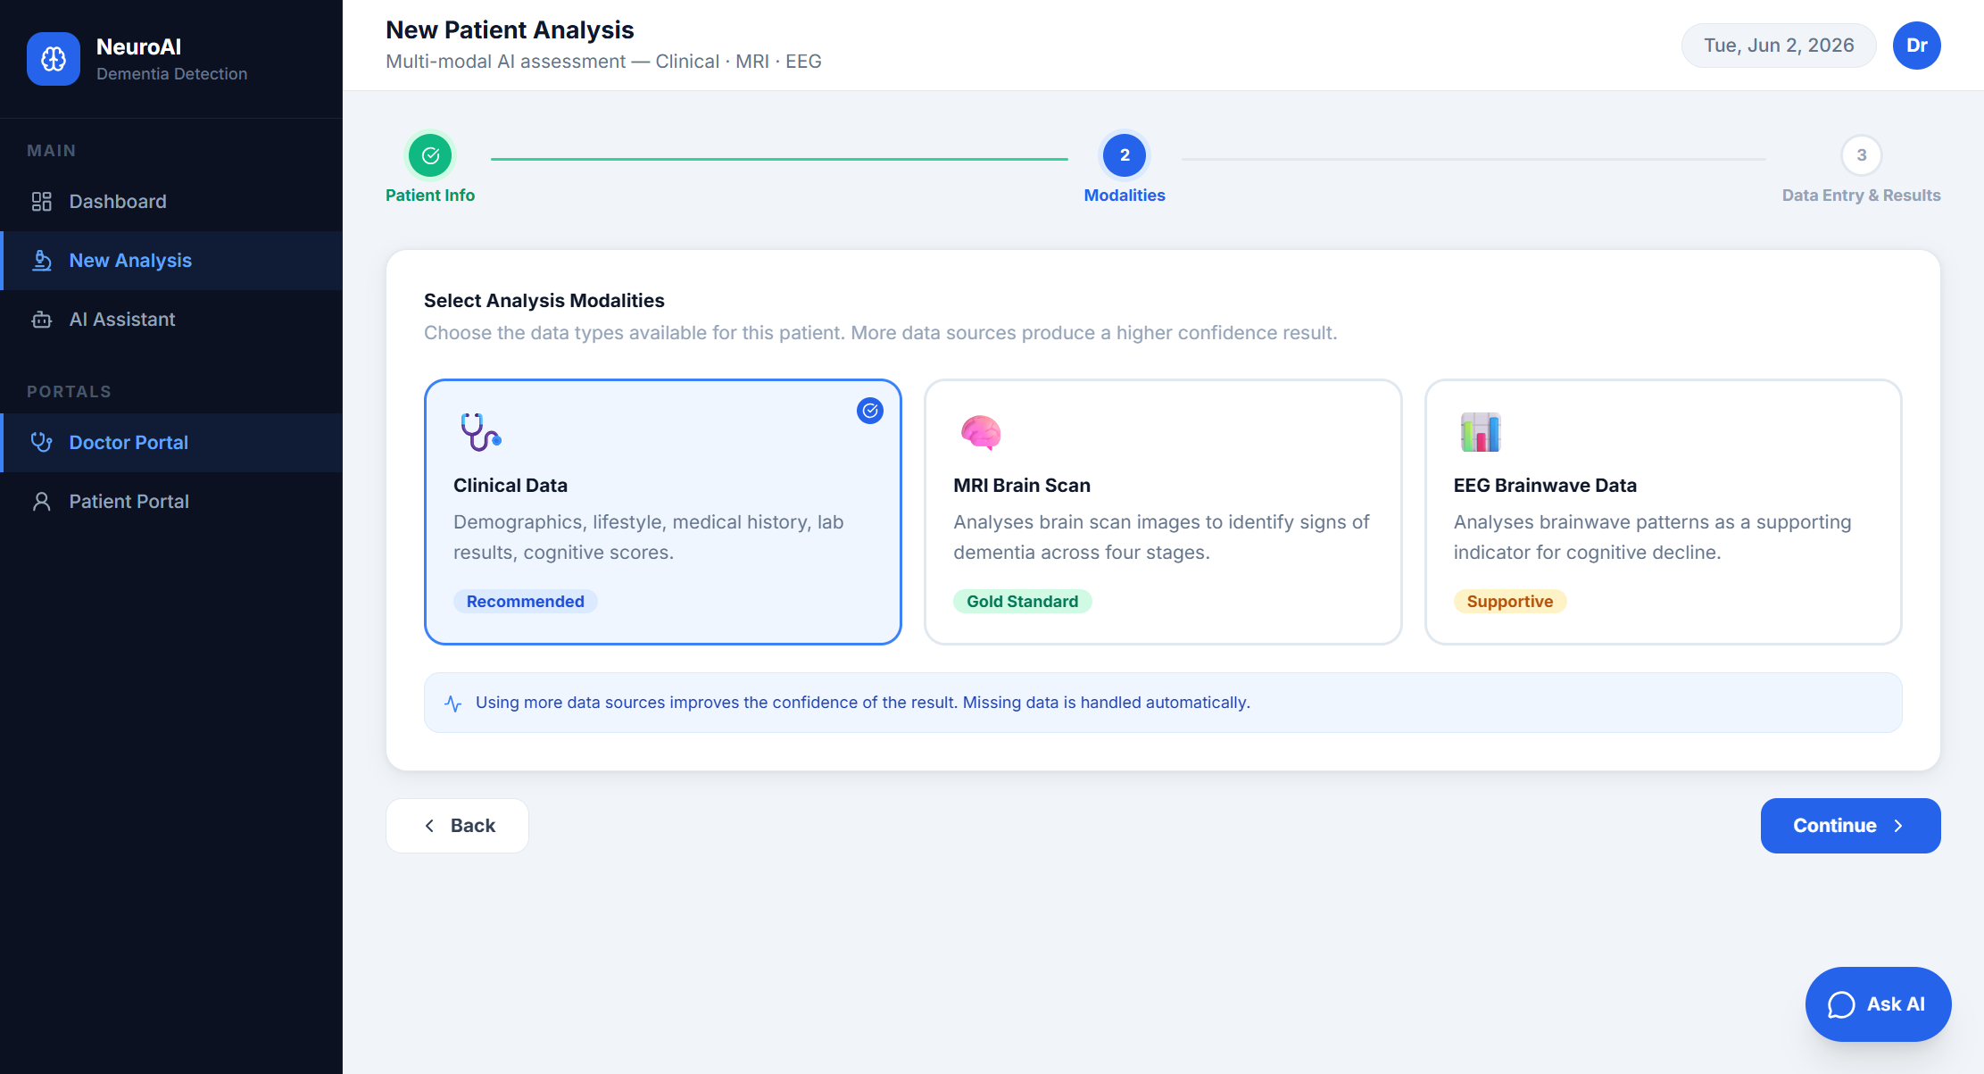
Figure 4 — New Analysis: Step 2 (Modality Selection).
Clinical data is entered through collapsible sections. After running the analysis, the result panel displays an animated risk gauge, the risk category, and a plain-language clinical recommendation.
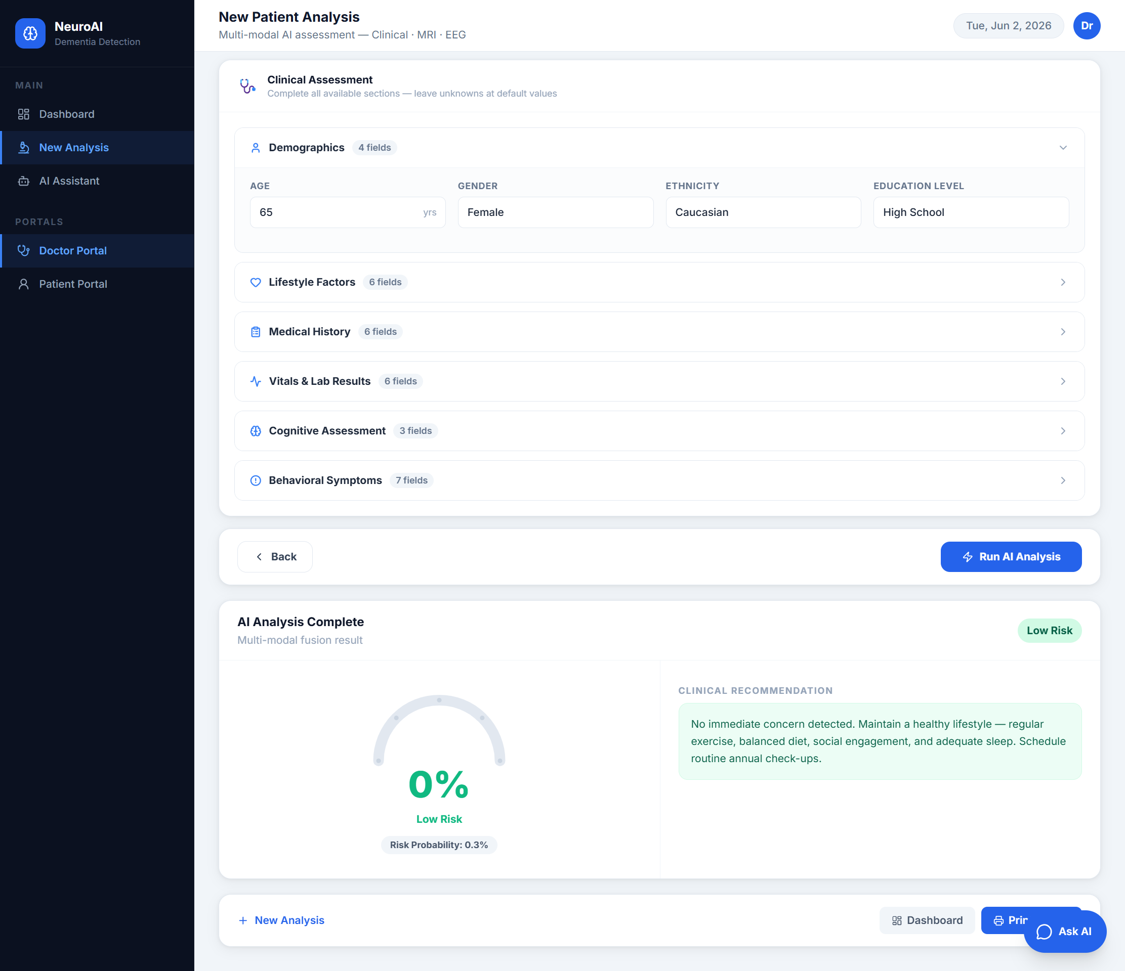
Figure 5 — New Analysis: Step 3 (Data Entry & Result).
A full-page healthcare assistant answers dementia questions and explains the patient’s report in plain language, grounded in a curated knowledge base.
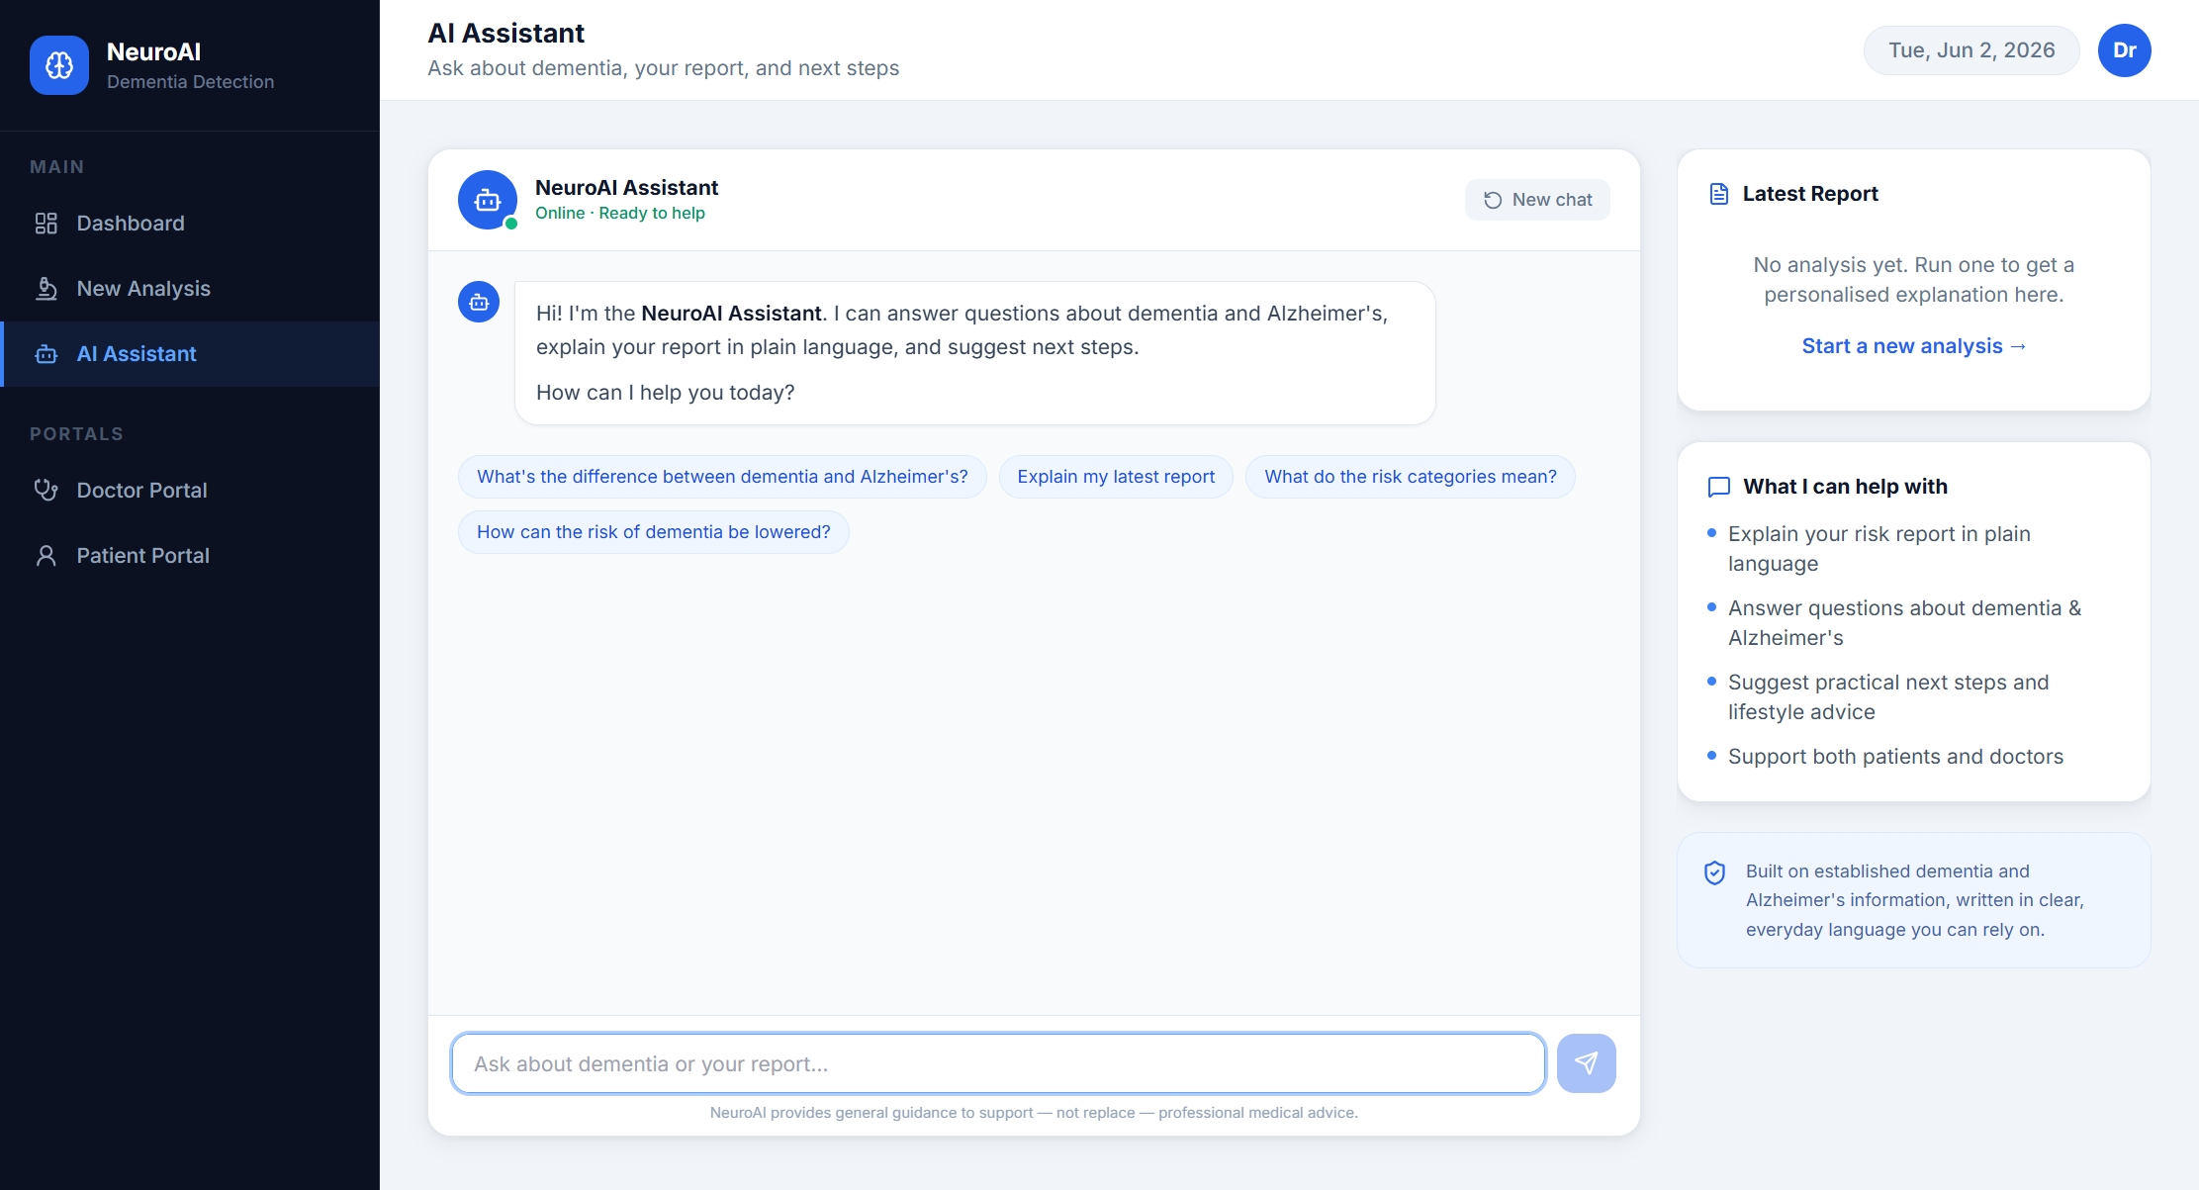
Figure 6 — AI Assistant (RAG Chatbot).
A patient-friendly portal with a health-summary hero banner, assessment-history cards, a risk guide, and educational information about Alzheimer’s.
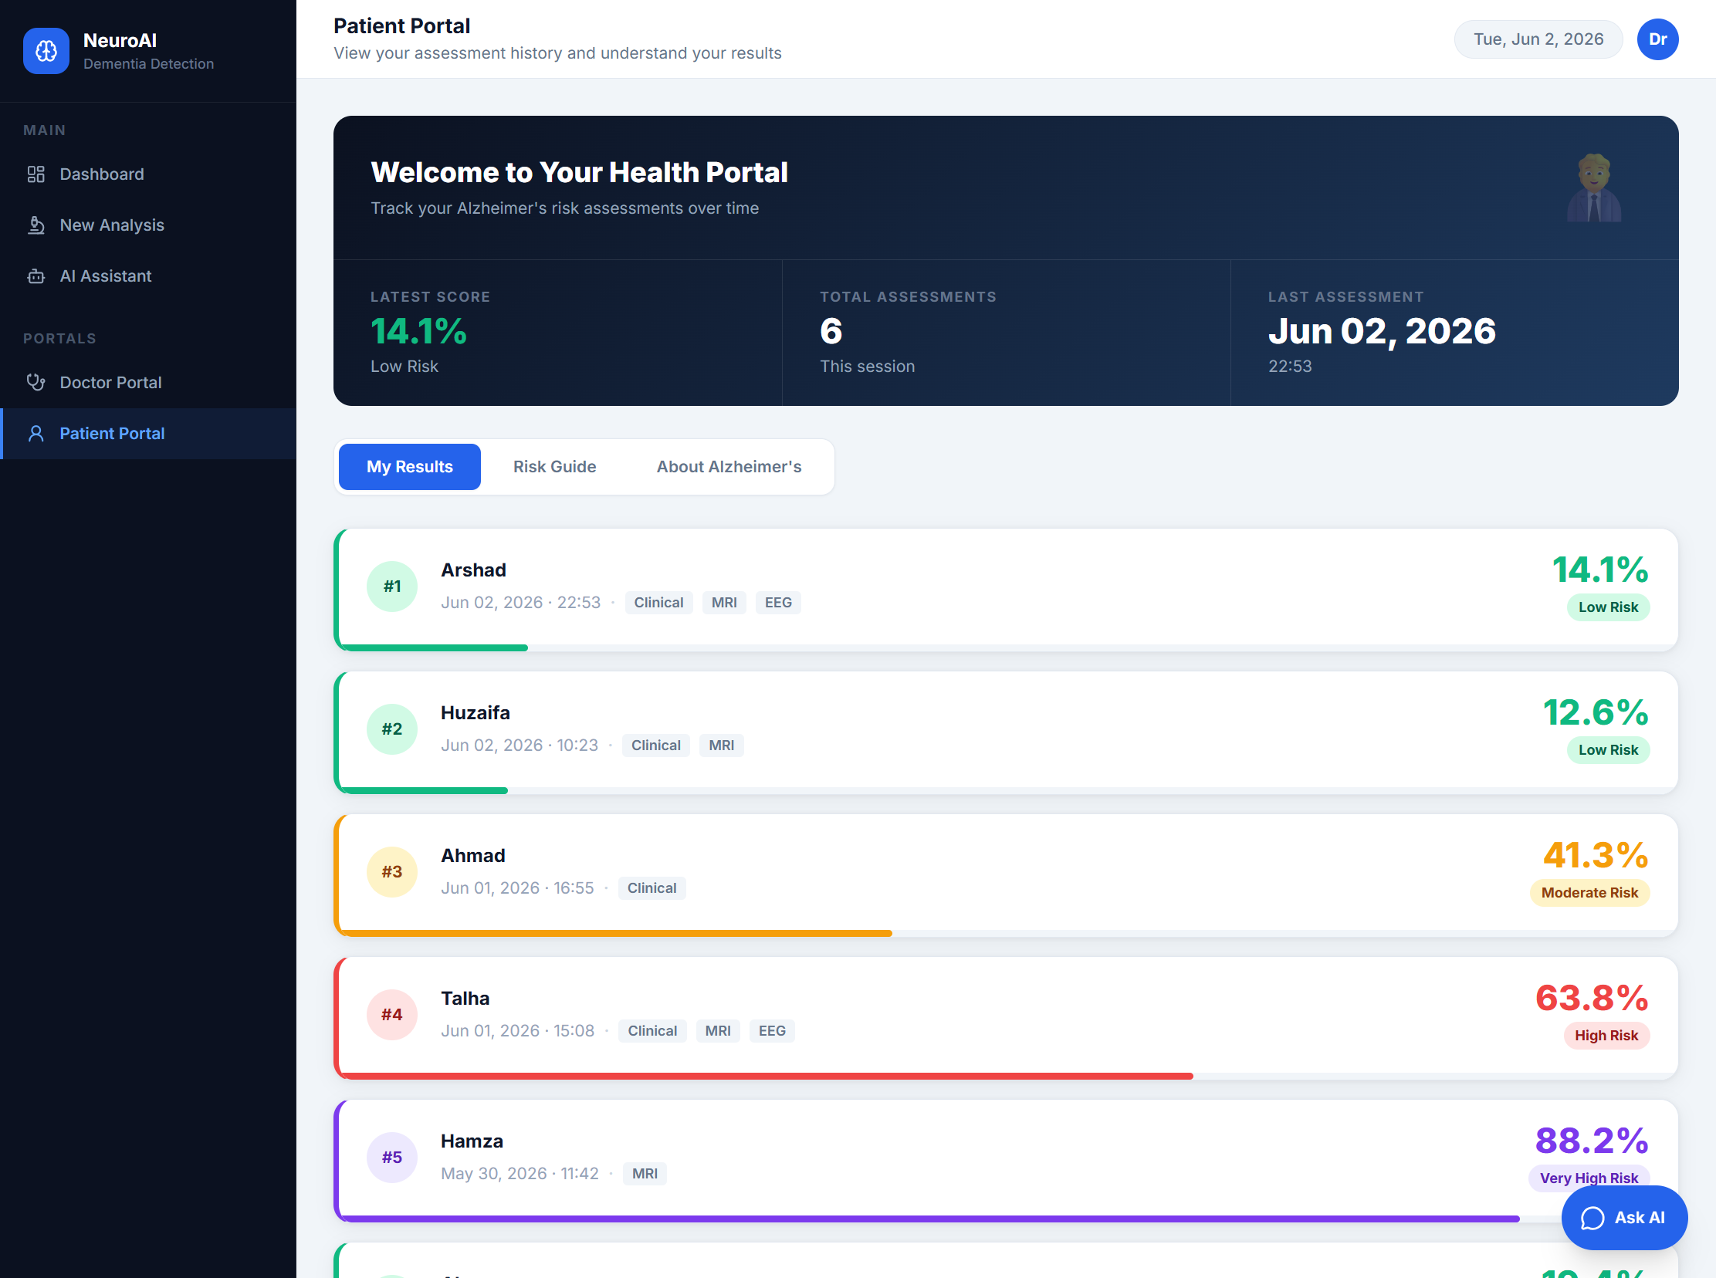
Figure 7 — Patient Portal.

7. Testing & Results
The application was tested end-to-end. All pages and API endpoints respond correctly, and predictions behave as expected across the full risk spectrum.
Test | Result
Web pages (Dashboard, Analysis, Portal) | 200 OK — served correctly
Clinical API — low-risk patient | ~5.7% — Low Risk
Clinical API — high-risk patient | ~99.9% — Very High Risk
MRI API — sample scan | Correct class + risk score
Fusion API — Clinical + MRI | Correctly weighted fusion
History & Stats API | Updates after every prediction

8. Conclusion & Future Work
NeuroAI successfully demonstrates an end-to-end multi-modal AI system for dementia and Alzheimer’s screening, combining three trained models with weighted fusion, a modern web interface, printable clinical reports, and an AI assistant grounded in a dementia knowledge base.
Planned future work (Module 8) focuses on deployment to a free cloud platform (e.g. Hugging Face Spaces) so the application can be accessed online, along with model-version pinning for reproducible installs.

