Parallel Data Preprocessing Pipeline for LLM Fine-Tuning


Session: 2023 – 2027

Submitted by:
Huzaifa Arshad 2023-CS-86

Supervised by:
Ms. Waqas Ali

Department of Computer Science
University of Engineering and Technology Lahore

Table of Contents
Table of Contents 2
1. Introduction & Problem Statement 4
2. The Preprocessing Pipeline (4 Stages) 4
Algorithm Details 5
Worked Example — One Real AG News Article 5
3. System Architecture & Design Philosophy 5
4. Dataset — AG News 6
5. Phase 1 — Sequential Baseline 7
Implementation Highlights 7
Correctness Counters — The Contract (Identical in All Later Phases) 7
Sample Terminal Output 8
6. Phase 2 — OpenMP (Shared Memory) 8
Shared vs. Private Variables — No Data Races 8
7. Phase 3 — MPI & Hybrid (Distributed Memory) 9
7.1 One Source of Truth — MPI and Hybrid Cannot Diverge 9
7.2 Communication Design (Master–Worker, Scatter → Gather) 9
7.3 Hybrid (MPI Across, OpenMP Within) 10
8. Performance Results & Analysis 10
8.1 Phase 2 — OpenMP Speedup & Efficiency 10
Total Wall-Clock Time (ms, best of runs) 10
Speedup S(p) = T(1) / T(p) 10
Efficiency E(p) = S(p) / p 11
8.2 Phase 3 — MPI Speedup 12
Total Wall-Clock Time (ms); baseline T(1) = MPI on 1 process 12
Speedup S = T(1) / T(p) 12
8.3 Phase 3 — Hybrid Speedup 12
8.4 Why MPI Scales Less Than OpenMP on One Node 13
9. LLM Fine-Tuning (DistilGPT-2) 13
Sample Generations (Coherent, AG-News Style) 14
10. Interactive Web Interface — Foundry 14
10.1 Run Console 14
10.2 Benchmarks 16
10.3 About 16
10.4 REST API Reference 17
11. Correctness Verification 17
12. Build & Run Guide 18
Step 0 — Dataset (Once) 18
Phases 1 & 2 — Windows (PowerShell) 18
Phase 3 — WSL / Ubuntu 18
Compilation Reference (All Phases) 18
13. Conclusion 19
Appendix A — Toolchain Notes 19
References 19

1. Introduction & Problem Statement
Large Language Model (LLM) fine-tuning requires large volumes of clean text. Raw corpora are messy: mixed case, punctuation and symbols, near-empty fragments, and many exact duplicates. Training on dirty or duplicated data wastes compute and degrades the model. A preprocessing pipeline fixes this — and because corpora are huge, that pipeline is a natural target for parallelism.
This project builds such a pipeline in C++ and implements it in four progressively parallel versions, each of which must produce a byte-identical result:

Version | Parallelism Model | Scope
Sequential | None (reference) | Correctness baseline
OpenMP | Shared-memory threads | One multi-core machine
MPI | Distributed-memory processes | Many machines (simulated on one)
Hybrid | MPI across + OpenMP within | One process per node × cores per node

The project is delivered to the instructor in three phases:

Phase | Goal | Status
Phase 1 | Sequential baseline + datasets + 4 stages + stats + timing | DONE
Phase 2 | OpenMP, benchmarks, speedup/efficiency analysis | DONE
Phase 3 | MPI master–worker + Hybrid MPI+OpenMP, benchmarks | DONE
DistilGPT-2 | Colab fine-tuning on the cleaned corpus | DONE

The guiding principle of the whole project: "Make it work, then make it fast" — without ever changing what "correct" means. The sequential version defines the correct output; every parallel version must reproduce it exactly, proving that the speedup came for free.

2. The Preprocessing Pipeline (4 Stages)
The pipeline is a linear flow of four independent, per-document stages:

raw .txt ──▶ [1 Clean] ──▶ [2 Quality Filter] ──▶ [3 Deduplicate] ──▶
[4 Tokenize/Count] ──▶ clean .txt + stats

Stage | What It Does | Module
1. Text Cleaning | Lowercase, remove special chars, normalize whitespace | src/common/1text_cleaning.*
2.Quality Filtering | Drop documents below a minimum word count | src/common/2quality_filter.*
3. Deduplication | FNV-1a 64-bit fingerprint per doc; keep first occurrence only | src/common/3deduplication.*
4. Tokenization | Whitespace tokenization; sum tokens across survivors (a reduction) | src/common/4tokenizer.*

Algorithm Details
- Stage 1 — Cleaning: One pass over characters: alphanumerics lowercased and kept; every non-alphanumeric run collapses to one space; leading/trailing spaces trimmed. Cache-friendly and O(n) in document length.
- Stage 2 — Quality Filter: Count words by detecting whitespace→word transitions (no allocation), and drop documents with fewer than min_words words (default 5).
- Stage 3 — Deduplication: Compute a 64-bit FNV-1a fingerprint of the cleaned text; keep only the first document per fingerprint using unordered_set<uint64_t>. FNV-1a chosen over std::hash because it is stable across compilers and machines — essential for MPI.
- Stage 4 — Tokenization: Whitespace tokenization; sum token counts over surviving documents (a reduction).

Worked Example — One Real AG News Article
Raw: Wall St. Bears Claw Back Into the Black (Reuters) Reuters - Short-sellers,
Wall Street's dwindling band of ultra-cynics, are seeing green again.

Clean: wall st bears claw back into the black reuters reuters short sellers wall
street s dwindling band of ultra cynics are seeing green again

The article has ~24 words (passes the 5-word filter), receives a fingerprint, is kept if unique, and contributes its tokens to the total.

3. System Architecture & Design Philosophy
The single most important design decision is that all stage logic lives in src/common/ as pure, per-document functions, separate from the orchestration loop. Each version of the pipeline changes only how it loops over documents, never the stage logic itself.

src/
├── common/ # SHARED stage logic — reused by EVERY version
│ ├── document.hpp # Document{ id, text }
│ ├── timer.hpp # <chrono> wall-clock timer
│ ├── statistics.hpp # PipelineStats counters + per-stage timings
│ ├── 1text_cleaning.* # Stage 1
│ ├── 2quality_filter.* # Stage 2
│ ├── 3deduplication.* # Stage 3
│ ├── 4tokenizer.* # Stage 4
│ ├── io_utils.* # file read/write + CSV stats appender
│ └── mpi_pipeline.hpp # Phase 3 shared MPI driver (mpi + hybrid)
├── sequential/main_sequential.cpp # Phase 1
├── openmp/main_openmp.cpp # Phase 2
├── mpi/main_mpi.cpp # Phase 3 (pure MPI)
└── hybrid/main_hybrid.cpp # Phase 3 (MPI + OpenMP)

The Correctness Contract: Because the stage logic never changes, a parallel run can only differ from the sequential run in speed, never in output. The only order-dependent decisions are (1) deduplication first-seen check and (2) document write order — both performed serially in original-id order in every version, guaranteeing byte-identical output by construction.

Stage | Pure / Independent? | Parallel Construct
1. Clean | ✅ Each doc independent | parallel for
2. Filter | ✅ Decision per doc; serial compaction | parallel for + serial compact
3. Dedup | Hash ✅ pure / Decision ❌ ordered | parallel for (hash) + serial walk
4. Tokenize | ✅ Per-doc count | parallel for reduction(+:)

4. Dataset — AG News
The project uses a single real dataset: AG News from the Hugging Face Hub (repository fancyzhx/ag_news) — approximately 120,000 real news articles across four categories (World, Sports, Business, Sci/Tech). Article text is used; labels are ignored. The download script scripts/download_agnews.py writes one article per line in four sizes, each smaller file being an exact prefix of the larger ones — enabling scaling benchmarks on identical, real text:

File | Documents
agnews_1k.txt | 1,000
agnews_10k.txt | 10,000
agnews_50k.txt | 50,000
agnews_full.txt | ~120,000

AG News articles are full sentences, so almost nothing falls below the 5-word quality bar (Removed = 0) — an honest result for clean, curated data. Raising min_words (e.g. to 30) makes the quality filter visibly drop documents.

5. Phase 1 — Sequential Baseline
Phase 1 establishes the correct reference implementation (src/sequential/main_sequential.cpp). It parses arguments, loads the file into a vector<Document>, runs the four stages in turn (each timed with <chrono>), updates the PipelineStats counters, writes the cleaned output, and prints the report.

Implementation Highlights
- Stages 2 and 3 build new survivor vectors rather than erasing from the middle (erasing is O(n) per element → O(n²); copying survivors is a single O(n) pass).
- Time is measured as wall-clock (high_resolution_clock) — the only metric that improves with parallelism (CPU time would increase with more threads).

Correctness Counters — The Contract (Identical in All Later Phases)
Dataset | Total | Removed | Duplicates | Kept | Total Tokens
1K | 1,000 | 0 | 2 | 998 | 41,588
10K | 10,000 | 0 | 55 | 9,945 | 402,830
50K | 50,000 | 0 | 112 | 49,888 | 1,993,026
Full | 120,000 | 0 | 218 | 119,782 | 4,750,500

Sample Terminal Output
==================== SEQUENTIAL ====================
Total documents : 10000
Removed (low quality): 0
Duplicates removed : 55
Kept documents : 9945
Total tokens : 402830
----------------------------------------------------
Stage timings (ms):
load : 41.965
clean : 50.935
filter : 26.209
dedup : 5.488
tokenize : 25.153
TOTAL : 158.161
====================================================
Cleaned dataset written to: results\clean_10k.txt

Observation motivating Phase 2: The dominant costs (cleaning, filtering, tokenization) are all per-document and embarrassingly parallel — roughly 70–80% of the runtime. By Amdahl's law a strong speedup is expected once threads are added.

6. Phase 2 — OpenMP (Shared Memory)
Phase 2 (src/openmp/main_openmp.cpp) keeps every src/common/ stage function unchanged and parallelizes only the driving loops with OpenMP. Central idea: parallelize the pure, per-document work; keep the order-dependent decisions serial.

Stage | Parallel Part | Serial Part | OpenMP Construct
1. Clean | clean_text on each doc | — | parallel for
2. Filter | Compute keep/drop per doc | Compact survivors in order | parallel for + serial compaction
3. Dedup | FNV-1a hash of each doc | First-occurrence decision | parallel for + serial set walk
4. Tokenize | Count tokens per doc | — | parallel for reduction(+:)

Shared vs. Private Variables — No Data Races
- Read-only shared: the document vectors, min_words.
- Written but disjoint: each index touched by exactly one thread — docs[i].text, keep[i], fps[i].
- Reduction: token_sum (private partial per thread, merged by OpenMP).
- Private by definition: the loop counter.
- Serial-only state: the dedup seen set and all push_backs run outside any parallel region — no locking needed.

Result: Up to 2.94× speedup (10K, 12 threads); 2.85× on the full set. Full numbers and analysis in Section 8.

7. Phase 3 — MPI & Hybrid (Distributed Memory)
Phase 3 distributes the pipeline across processes with MPI, then layers OpenMP inside each process (hybrid). Both new builds reproduce the sequential output byte-for-byte.

7.1 One Source of Truth — MPI and Hybrid Cannot Diverge
The entire distributed driver lives in src/common/mpi_pipeline.hpp as one function, run_pipeline_mpi(...), which already contains #pragma omp parallel for on its per-document loops:

Binary | Source | Compiled With | Effect of Pragmas
mpi_pipeline | src/mpi/main_mpi.cpp | mpicxx (no -fopenmp) | Ignored → pure MPI, serial within each process
hybrid_pipeline | src/hybrid/main_hybrid.cpp | mpicxx -fopenmp | Active → MPI + OpenMP threads within each process

Each main_*.cpp is a tiny wrapper calling run_pipeline_mpi(...). Because the two binaries are literally the same source, they cannot compute different results.

7.2 Communication Design (Master–Worker, Scatter → Gather)
rank 0 reads agnews_full.txt (single reader, like the sequential code)
│
split into P contiguous, ORDERED blocks (block r = docs[off_r .. off_r+cnt_r))
│ MPI_Scatterv (lengths array, then packed text bytes)
┌─────────┬────────────┬─────────┐
rank 0 rank 1 rank 2 rank 3 ← each runs the SAME common stages
clean clean clean clean Stage 1
filter filter filter filter Stage 2 (counts its own "removed")
fp … … … Stage 3a (FNV-1a, pure)
tokens … … … Stage 4 (count, pure)
└─────────┴────────────┴─────────┘
│ MPI_Gatherv (survivor {id,fp,ntok,text})
│ MPI_Reduce (Σ removed, max per-stage time)
▼
rank 0: SERIAL id-ordered dedup (Stage 3b) → write output

- Why byte-identical: Blocks are contiguous and ordered, so gathered survivors are already in global id order. Rank 0 walks that ordered list keeping the first occurrence of each fingerprint — identical semantics to the sequential code.
- Synchronization: All collective — MPI_Bcast, MPI_Scatterv, MPI_Gatherv, MPI_Reduce act as barriers. No locks, no point-to-point Send/Recv, no deadlock risk.
- Load balancing: Static block partition — each rank gets ⌊N/P⌋ docs, first N mod P ranks get one extra.
- Variable-length text: Sent as two flat buffers (int length array + packed char blob). Survivors return as a packed POD array SurvMeta{id, fp, ntok, len} sent as MPI_BYTE.

7.3 Hybrid (MPI Across, OpenMP Within)
The hybrid build adds the Phase 2 strategy inside each MPI process: clean / quality-mask / fingerprint / token-count loops are parallelized with #pragma omp parallel for; the serial compaction and rank-0 dedup stay serial. The intended deployment is one MPI process per node, OpenMP across that node's cores — MPI only at node boundaries, every core used.
Result: MPI up to ~1.64×, hybrid up to ~1.80× on this single node — deliberately lower than OpenMP. Analysis of why is the headline lesson of Phase 3, in Section 8.4.

8. Performance Results & Analysis
Experimental Setup: 12-logical-core laptop. Phases 1–2 on Windows (MinGW g++ 6.3.0, -O2 -std=c++17 -fopenmp); Phase 3 on WSL Ubuntu (g++ 13.3, OpenMPI 4.1.6). Datasets: real AG News, min_words = 5. Each configuration run several times; minimum total wall-clock time reported (least polluted by OS jitter).

8.1 Phase 2 — OpenMP Speedup & Efficiency

Total Wall-Clock Time (ms, best of runs)
Dataset | 1 Thread | 2 Threads | 4 Threads | 8 Threads | 12 Threads
10K | 135.2 | 82.2 | 58.2 | 58.9 | 45.9
50K | 643.1 | 416.3 | 335.6 | 315.6 | 294.4
Full | 1951.6 | 1073.8 | 923.6 | 760.7 | 684.3

Speedup S(p) = T(1) / T(p)
Dataset | p = 2 | p = 4 | p = 8 | p = 12
10K | 1.64× | 2.32× | 2.30× | 2.94×
50K | 1.54× | 1.92× | 2.04× | 2.18×
Full | 1.82× | 2.11× | 2.57× | 2.85×

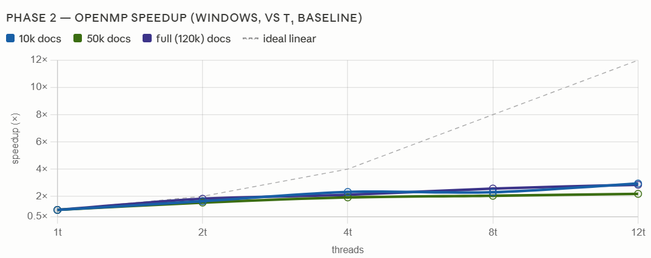
Figure 1: Phase 2 — OpenMP Speedup vs. Thread Count (Windows, vs. T₁ Baseline)

Efficiency E(p) = S(p) / p
Dataset | p = 2 | p = 4 | p = 8 | p = 12
10K | 82% | 58% | 29% | 25%
50K | 77% | 48% | 25% | 18%
Full | 91% | 53% | 32% | 24%

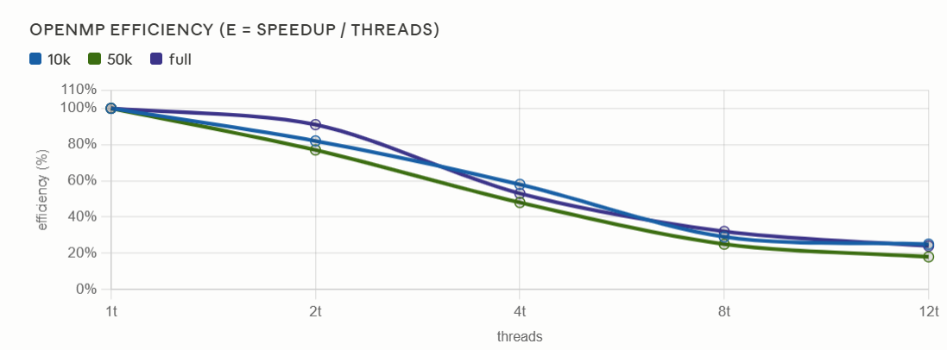
Figure 2: Phase 2 — OpenMP Efficiency (E = Speedup / Threads)
Efficiency is high at low thread counts (91% at 2 threads on the full set) and falls as threads are added — the classic shape of a memory-bound workload hitting a serial floor.

8.2 Phase 3 — MPI Speedup

Total Wall-Clock Time (ms); baseline T(1) = MPI on 1 process
Dataset | 1 Process | 2 Processes | 4 Processes | 8 Processes
10K | 292.8 | 227.1 | 202.0 | 178.1
50K | 1357.2 | 1032.5 | 1035.5 | 992.0
Full | 3240.6 | 2491.9 | 2210.9 | 2007.9

Speedup S = T(1) / T(p)
Dataset | p = 2 | p = 4 | p = 8
10K | 1.29× | 1.45× | 1.64×
50K | 1.31× | 1.31× | 1.37×
Full | 1.30× | 1.47× | 1.61×

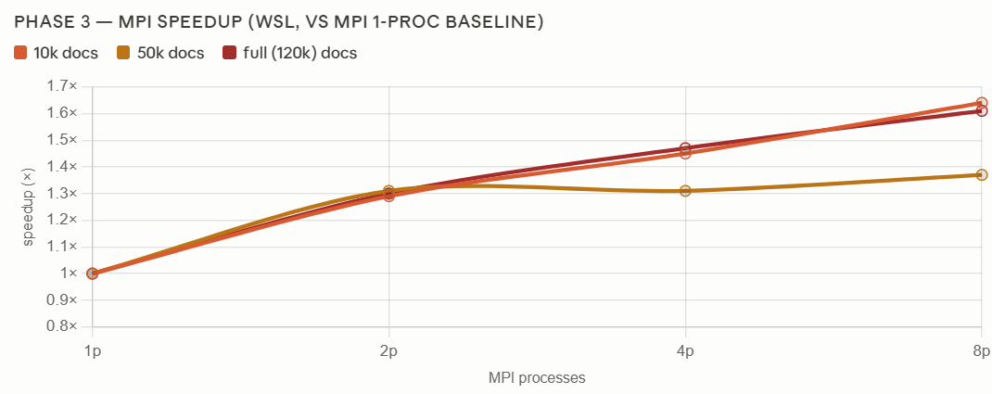
Figure 3: Phase 3 — MPI Speedup (WSL, vs. MPI 1-Process Baseline)

8.3 Phase 3 — Hybrid Speedup
Hybrid speedup vs. the MPI 1-process baseline, by configuration (processes × threads):
Dataset | 2×2 | 2×4 | 4×2 | 2×6 | 4×3 | 6×2
10K | 1.51× | 1.43× | 1.54× | 1.33× | 1.60× | 1.69×
50K | 1.80× | 1.52× | 1.47× | 1.45× | 1.41× | 1.55×
Full | 1.70× | 1.36× | 1.47× | 1.46× | 1.41× | 1.62×

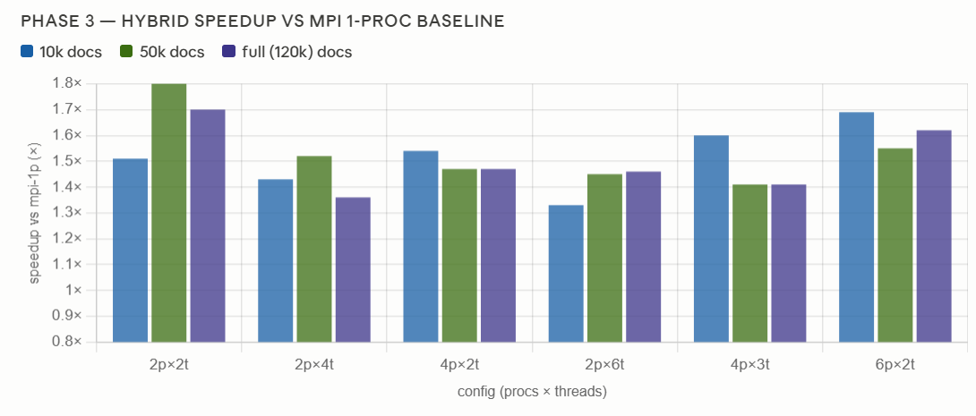
Figure 4: Phase 3 — Hybrid Speedup vs. MPI 1-Process Baseline

8.4 Why MPI Scales Less Than OpenMP on One Node
This is the core insight of the project, and an honest, expected result: OpenMP reaches 2.94× while MPI/hybrid top out near 1.6–1.8× on the same machine.
- Same memory-bandwidth ceiling, plus copies: All MPI processes run on the one laptop, sharing one memory bus and one disk — the same bandwidth wall that capped OpenMP — and MPI additionally copies every document into send/receive buffers (over the loopback network stack). OpenMP threads share memory and copy nothing, so on a single node OpenMP wins.
- A large serial file read: Under WSL the dataset lives on the Windows drive via the /mnt/d 9p mount, whose I/O is far slower than native. Only rank 0 reads the file, so this serial fraction is unusually large and, by Amdahl's law, caps the whole program near 2× no matter how many processes are added.
- Communication grows with P: Scattering tens of MB of text and gathering the survivors back to one rank is pure overhead that grows with process count — past a point extra communication costs more than the shrinking compute saves.

When does MPI actually win? Across multiple machines: P nodes give P× the aggregate memory bandwidth, P× disk read throughput, and P× the RAM — none of which a single multi-core node can offer. This single-node benchmark shows MPI's overhead without its payoff; it understates MPI. The hybrid model (one process per node × OpenMP within) is the production design that carries this verified-correct code to that multi-node world.
This is the empirical motivation for the whole progression: Sequential → OpenMP wins on one node; MPI → Hybrid is what scales the same code to many nodes once the data outgrows a single machine.

9. LLM Fine-Tuning (DistilGPT-2)
To close the loop from "messy data" to "a model trained on it," the cleaned corpus is used to fine-tune a real language model. The notebook docs/colab_finetune_distilgpt2.ipynb (Google Colab, GPU runtime) tokenizes it with DistilGPT-2's BPE tokenizer via Hugging Face Transformers, fine-tunes the model, reports perplexity, and generates sample text.
It was run on a Colab T4 GPU over results/clean_10k.txt (9,945 cleaned documents → 3,780 packed 128-token blocks, 90/10 train/validation split):

Metric | Value
Model | distilgpt2 (82M parameters)
Epochs / Steps | 1 epoch, 213 steps
Training Time | ~44 s (≈ 77 samples/s)
Training Loss | 5.12 → 4.78 (final avg 4.93)
Validation Loss | 4.557
Validation Perplexity | ≈ 95.3

Sample Generations (Coherent, AG-News Style)
- "the stock market" → "the stock market was down 2 percent on tuesday to a record high of 1 million at a time of record highs according to the latest quarterly report …"
- "the government announced" → "the government announced that it will hand over … its more than 600 000 workforce to the agency for its investigation …"
- "scientists have discovered" → "scientists have discovered that there is an essential difference between the two worlds …"

clean_full.txt produces a stronger fit — more data, lower perplexity, longer run.

10. Interactive Web Interface — Foundry
The project ships a professional web application, Foundry (web/), that runs the pipeline live and visualizes results. Frontend: React + Vite + Recharts. Backend: Node + Express, executing the real compiled binaries — Sequential and OpenMP as Windows .exe, MPI and Hybrid inside WSL through mpirun. A single server hosts both the UI and a JSON API.

Figure 5: Foundry — Application Header and Navigation

10.1 Run Console
Configuration: The user picks a dataset and one of the four modes; the relevant inputs (MPI processes, OpenMP threads) enable automatically, and min_words controls the quality filter.

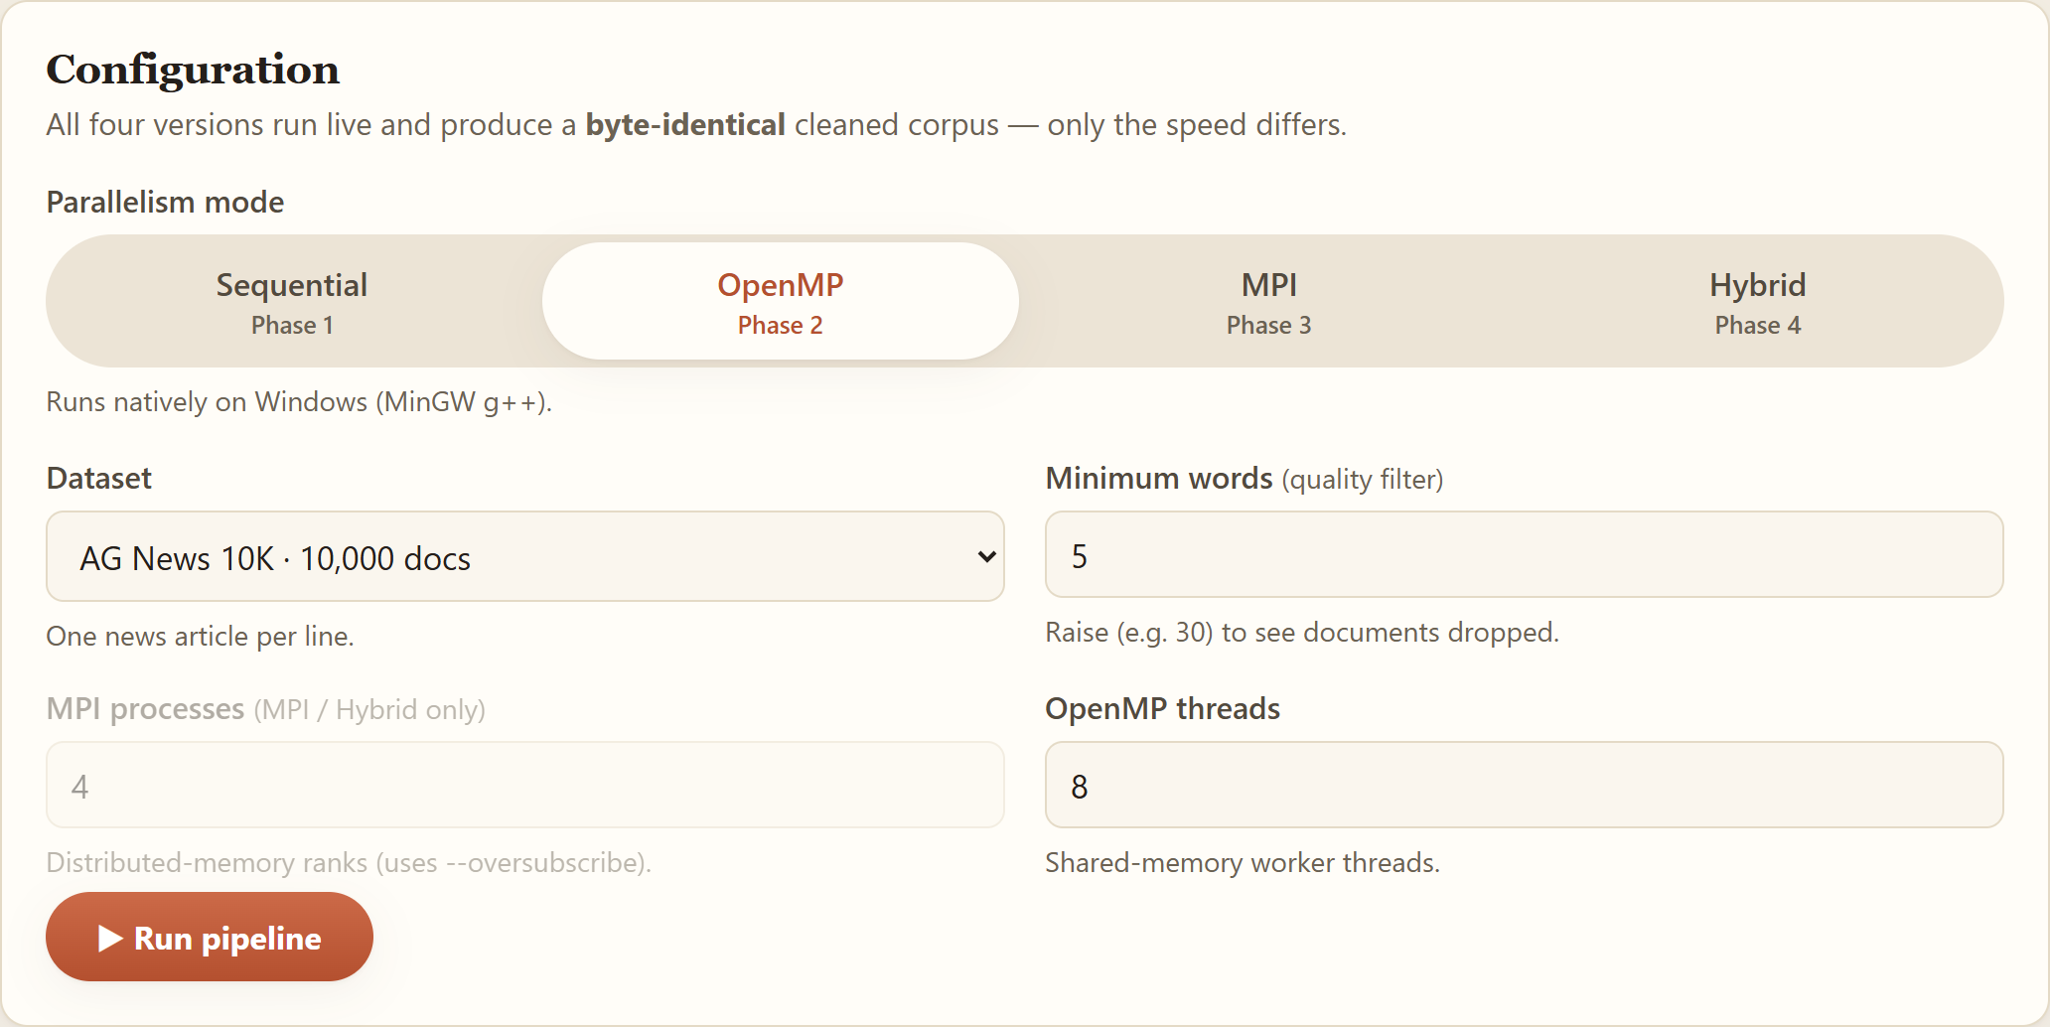
Figure 6: Foundry — Configuration Panel (Sequential / OpenMP / MPI / Hybrid)

Results: After a run, the page shows live counters, a prominent speedup vs. the sequential baseline, the exact command executed, the output SHA-256, and a byte-identical-to-sequential correctness badge.

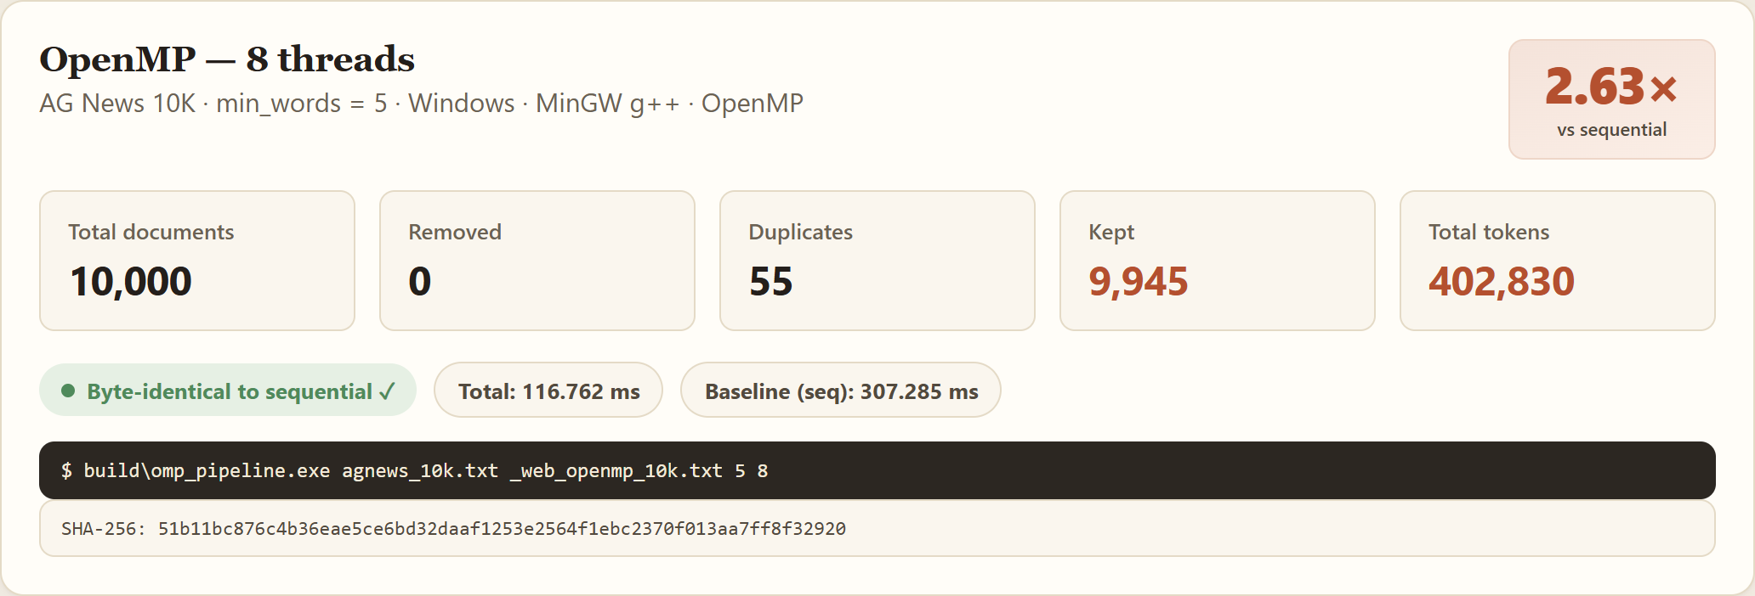
Figure 7: Foundry — Live Results with Speedup and Byte-Identical Badge

Per-stage timings: A bar chart breaks the run down by stage, exposing the serial file-load floor and the well-parallelized compute stages.

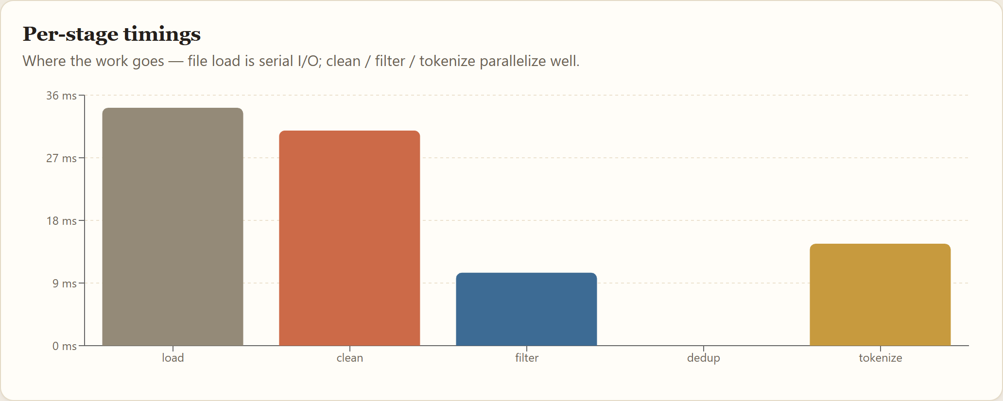
Figure 8: Foundry — Per-Stage Timing Breakdown

Cleaned output: A live preview of the cleaned corpus written by the run.

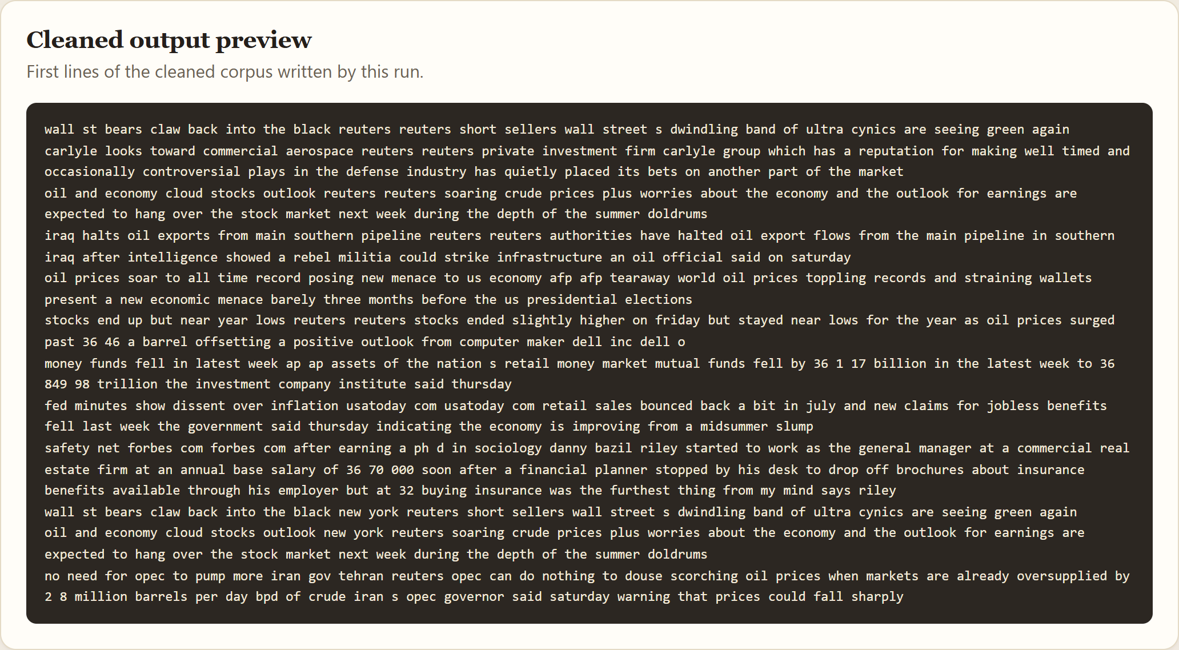
Figure 9: Foundry — Cleaned Output Preview

10.2 Benchmarks
The Benchmarks tab renders the OpenMP, MPI, and Hybrid speedup/efficiency charts interactively, aggregated on the server from results/benchmark_*.csv. These are the same measurements shown in Section 8.

10.3 About
A summary page covering the four pipeline stages, the one-source-of-truth design, the four implementations, and the end-to-end fine-tuning result.

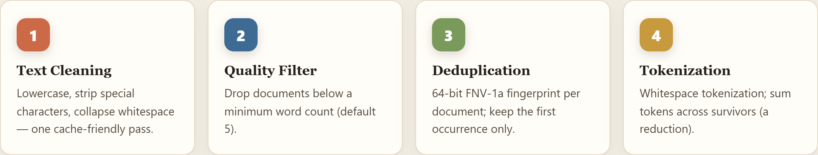
Figure 10: Foundry — The Four Pipeline Stages

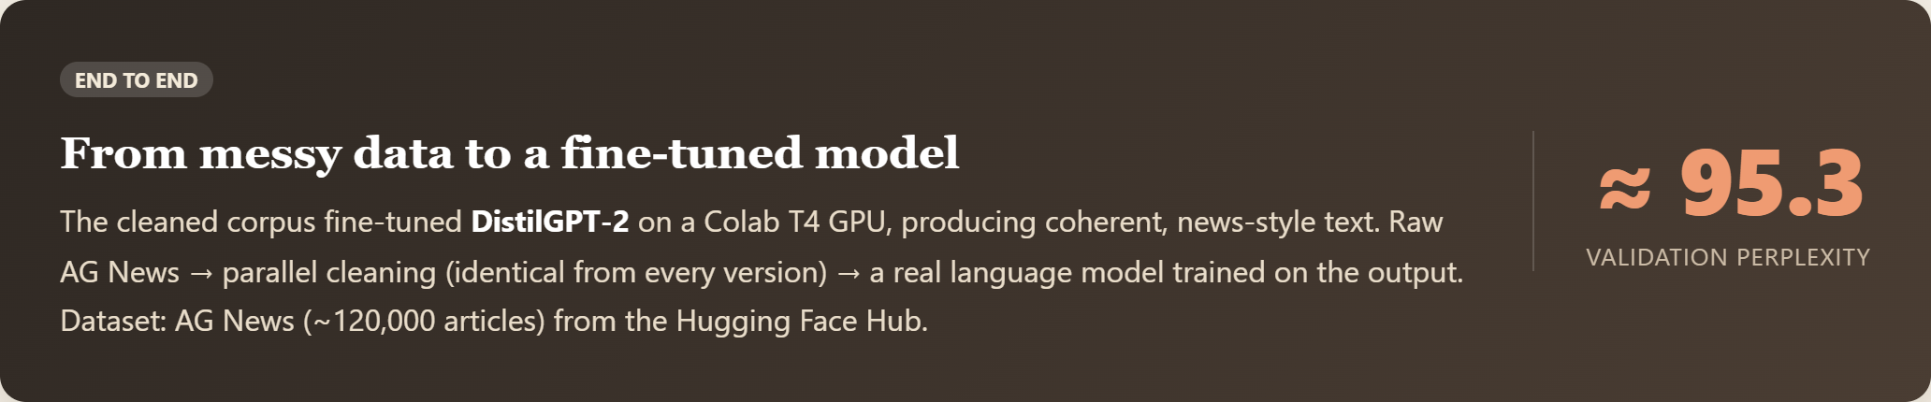
Figure 11: Foundry — End-to-End: Cleaned Corpus Fine-Tuned DistilGPT-2

10.4 REST API Reference
Method | Route | Purpose
GET | /api/health | Server status + which binaries are built
GET | /api/datasets | Available AG News files and document counts
POST | /api/run | Run a version live ({dataset, version, minWords, threads, procs})
GET | /api/benchmarks/openmp | Aggregated OpenMP speedup/efficiency
GET | /api/benchmarks/mpi | Aggregated MPI + Hybrid speedup

11. Correctness Verification
The correctness contract — identical output and counters across all four versions — is verified automatically.
- scripts/verify_openmp.ps1: Runs sequential build for reference, then OpenMP at 1/2/4/8 threads on all four datasets; checks (a) SHA-256 of cleaned output equals reference and (b) all five counters match. All pass — byte-identical.
- scripts/verify_mpi.sh: Same idea for MPI at 1/2/4/8 processes and hybrid at 2×2 / 2×4 / 4×3, on all four datasets — 28 configurations, all byte-identical.

The decisive evidence: all four versions, across two operating systems, produce the same SHA-256 for agnews_10k.txt (min_words = 5):

51b11bc876c4b36eae5ce6bd32daaf1253e2564f1ebc2370f013aa7ff8f32920

ALL CHECKS PASSED: OpenMP == Sequential on every dataset/thread count.
ALL CHECKS PASSED: MPI and HYBRID == Sequential on every dataset/config.
The determinism comes by construction: the only parallel work is pure per-document computation; every order-sensitive step (dedup decision, write order) is serial and id-ordered.

12. Build & Run Guide
Easiest way — the web app (Foundry): From the project root run cd web/server then npm start, open http://localhost:3001, pick a dataset and mode and click Run.

Step 0 — Dataset (Once)
pip install datasets
python scripts\download_agnews.py

Phases 1 & 2 — Windows (PowerShell)
.\build.ps1
build\seq_pipeline.exe data\agnews\agnews_10k.txt results\clean_10k.txt 5
build\omp_pipeline.exe data\agnews\agnews_10k.txt results\clean_omp.txt 5 8
.\scripts\verify_openmp.ps1
.\scripts\benchmark.ps1

Phase 3 — WSL / Ubuntu
sudo apt-get update && sudo apt-get install -y build-essential openmpi-bin libopenmpi-dev
cd "/mnt/d/Documents/Semester6/PDCL/PDC Project"
./build.sh
mpirun --allow-run-as-root -np 4 build/mpi_pipeline data/agnews/agnews_10k.txt results/out_mpi.txt 5
mpirun --allow-run-as-root -np 2 build/hybrid_pipeline data/agnews/agnews_10k.txt results/out_hyb.txt 5 4
./scripts/verify_mpi.sh
./scripts/benchmark_mpi.sh

Compilation Reference (All Phases)
# Sequential (Phase 1)
g++ -O2 -std=c++17 src/sequential/main_sequential.cpp src/common/*.cpp -o build/seq_pipeline

# OpenMP (Phase 2)
g++ -O2 -std=c++17 -fopenmp src/openmp/main_openmp.cpp src/common/*.cpp -o build/omp_pipeline

# MPI (Phase 3)
mpicxx -O2 -std=c++17 -Wno-unknown-pragmas src/mpi/main_mpi.cpp src/common/*.cpp -o build/mpi_pipeline

# Hybrid (Phase 3)
mpicxx -O2 -std=c++17 -fopenmp src/hybrid/main_hybrid.cpp src/common/*.cpp -o build/hybrid_pipeline

13. Conclusion
This project delivers a complete, modular data-preprocessing pipeline for LLM fine-tuning in four progressively parallel versions, all sharing one set of pure stage functions so that correctness is guaranteed by construction.
- Correctness: Every version produces a byte-identical cleaned corpus — verified across 28 MPI/hybrid configurations and all OpenMP thread counts, on both Windows and WSL (same SHA-256).
- OpenMP: Up to 2.94× speedup on 12 cores; efficiency analysis matches Amdahl's law (serial I/O floor + memory-bandwidth saturation).
- MPI / Hybrid: Up to ~1.64× / ~1.80× on a single node — honestly lower than OpenMP, because on one machine MPI pays for data copying and a serial file read without the multi-node payoff (P× bandwidth, disk, RAM). The hybrid model scales this same code across nodes.
- End-to-End: The cleaned corpus successfully fine-tunes DistilGPT-2 (validation perplexity ≈ 95.3, coherent generations) — proving the output is real, usable training data.

The progression itself is the lesson: make it correct (sequential), make it fast on one node (OpenMP), and make it scale across nodes (MPI → hybrid) — each step measured, explained, and proven not to change the result.

Appendix A — Toolchain Notes
- Phases 1–2 (Windows, MinGW g++ 6.3.0): Phase 2's -fopenmp needed the pthreads-w32 import library once: mingw-get install mingw32-pthreads-w32 (fixes cannot find -lpthread). No code change.
- Phase 3 (WSL Ubuntu): Windows MinGW has no mpicxx, so Phase 3 is built and run under WSL via /mnt/d. One-time: sudo apt-get install -y build-essential openmpi-bin libopenmpi-dev (provides g++ 13.3 + OpenMPI 4.1.6). ./build.sh builds all four targets.
- .vscode/c_cpp_properties.json: Points IntelliSense at the WSL OpenMPI headers so #include <mpi.h> resolves in the editor; it does not affect the build.

References
- X. Zhang, J. Zhao, and Y. LeCun, "Character-level Convolutional Networks for Text Classification," Advances in Neural Information Processing Systems (NIPS), 2015. AG News dataset: https://huggingface.co/datasets/fancyzhx/ag_news
- G. Fowler, L. C. Noll, and P. Vo, "FNV Hash," Fowler–Noll–Vo non-cryptographic hash function (FNV-1a, 64-bit variant). IETF draft: The FNV Non-Cryptographic Hash Algorithm, draft-eastlake-fnv.
- OpenMP Architecture Review Board, OpenMP Application Programming Interface, Version 5.2, 2021. https://www.openmp.org/specifications/
- Message Passing Interface Forum, MPI: A Message-Passing Interface Standard, Version 4.0, 2021. Open MPI 4.1.6. https://www.mpi-forum.org/
- G. M. Amdahl, "Validity of the single processor approach to achieving large scale computing capabilities," AFIPS Conference Proceedings, vol. 30, pp. 483–485, 1967.
- V. Sanh, L. Debut, J. Chaumond, and T. Wolf, "DistilBERT, a distilled version of BERT: smaller, faster, cheaper and lighter," NeurIPS EMC² Workshop, 2019. https://huggingface.co/distilbert/distilgpt2
- T. Wolf et al., "Transformers: State-of-the-Art Natural Language Processing," Proc. EMNLP: System Demonstrations, pp. 38–45, 2020. https://github.com/huggingface/transformers
- Performance graphs & analysis working session (Claude): https://claude.ai/share/d995b170-190e-458d-8682-540bee2fe0f7

