**Sir Syed University of Engineering & Technology**



**Assignment-01 GIT**

**Name: - Huzaifa Shakeel Ahmed**

**Roll-No: - 2017-BSCS-150**

**Class: - 3-C**

**Instructor: - Sir Muhammad Wasiq**

**Subject: - Object Oriented Programming**

**GIT**

**Q-1 what is GIT?**

**Answer: -**

GIT is a code hosting service or you can say social networking platform for the developers where more than one person can work on single project at the same time from anywhere. It helps you to share your code with people and your circles.

**Q-2 what are main difference b\w GIT and SVN?**

**Answer:-**

|  |  |
| --- | --- |
| **GIT** | **SVN** |
| It does not have a good user interface, primarily used on command line. | It does have a good user interface (UI). |
| GIT is decentralized; you have a local copy i.e. a repository or project in which committing occurs by you. | SVN, you have to always connect to a central repository for check-in. |
| It creates only .git directory. | It creates .svn directory in each folder. |
| It becomes slow when dealing with large binary files. | It can handle those files very easily. |
| Also GIT is little bit difficult to learn for some developers due to the use of its commands. | SVN is much easier to use. |

**Q-3 How do you commit your work in GIT?**

**Answer:-**

In your command prompt window, type the following,

**git commit –m “added new line”**

Here commit means saving your changes, m means displaying message on your change and sharing the work with your collaborators.

**Q-4 Create a repository with your name with unique roll number in GITHUB?**

**Answer:-**

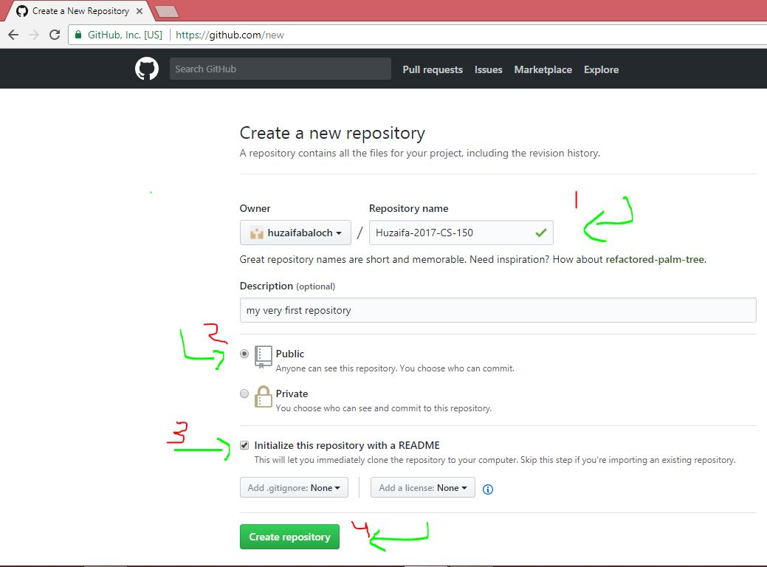

**Q-5 what are advantages of GIT?**

**Answer:-**

* Fast
* Efficient
* Distributed all over the systems
* Speed in term of data size
* Large
* Incredible branching System

**Q-6 what is GIT clone?**

**Answer:-**

GIT clone means copying the entire repository or project on your system. It is done might be for personal study/use or working with collaborators on that specific project.

**Q-7 what is a command to delete a branch in GIT?**

**Answer:-**

In your command prompt window, type the following,

**git branch -d another-branch**

Here branch keyword is for selecting branch d stands for delete which will delete the branch called another-branch.

**Q-8 Explain the architecture of GIT in my words...**

**Answer:-**

GIT is an open source technology and the largest code repository service that allows you to collaborate with anyone from anywhere. Basically if you want to work on your project or maybe someone else’s project, GIT provides the ability to do with it at the same time. It is primarily used on command line and it has got some commands like add for adding files, commit that allows you to provide comments on your change and share with your friends and collaborators and also you can come back again to your commits to look at what you did on your particular commit. Commit is just like you made changes and now you are saving it. After this we need to push our work to the server the git server and that brings me to something called branch. The branch is just another way of development without making any changes into the master branch also known as main branch. Let’s say you’re working on a project with group of people, you don’t want people to mess up with the original work you did, what you can do ask them to make their own branch with any name and GIT will automatically copy all the last work of the project on their systems. The term copy in GIT means clone and whatever the changes they make will not affect the original work, only if the desired task accomplished and then they will send the pull request which will ask the master or any other branch to merge the pull request to save those changes on the desired branch and after that you can delete that branch.

**Q-9 How to resolve conflicts in GIT?**

**Answer:-**

There could be any type of conflict maybe line, file or any other. In order to resolve conflicts, we need to open the terminal and check for the status to see where the conflict is occurring and open the text editor to see what is the conflict, now after opening and navigating through it , if someone has written “open an issue” and the other guy “ask your question”. Decide whether to keep your branch’s changes or other branch’s changes or just make a brand new change which may incorporate changes from both of branches. Delete the conflict marker and make changes you want in the final merge.

“If you have question, please open an issue”

And then add and commit your changes with comment to let them be satisfied.

**Q-10 Name the different vendors that are working on version control software (VCS)?**

**Answer:-**

1. GIT
2. BITKEEPER
3. BAZAAR
4. ARX
5. DARCS
6. FOSSIL
7. MONOTONE
8. VERACITY
9. SVK
10. BITBUCKET