

**NUST BALOCHISTAN CAMPUS**

**CALCULATOR**

PROJECT REPORT

**MUHAMMAD HUZAIFA BIN HAIDER (345737)  
TAYMOOR KHALID (336802)**

Submit to:-

***Sir Abid Hussain***

March 14, 2022

**Calculator:**

 A calculator is a device that performs arithmetic operations on numbers. The simplest calculators can do only addition, subtraction, multiplication, and division. More sophisticated calculators can handle modulus, square roots, expression wise operations, base number system conversions.

**NASM:**

The Netwide Assembler is an assembler and disassembler for the Intel x86 architecture. It can be used to write 16-bit, 32-bit and 64-bit programs. NASM is considered to be one of the most popular assemblers for Linux. NASM was originally written by Simon Tatham with assistance from Julian Hall.

But we have use 16-bit NASM in our project.

**Functionalities:**

We have used switch cases and used many functions which are as follows:

1. Base Number System Conversions

* Binary to Octal
* Binary to Decimal
* Binary to Hexa-Decimal
* Octal to Binary
* Octal to Decimal
* Octal to Hexa-Decimal
* Decimal to Binary
* Decimal to Octal
* Decimal to Hexa-Decimal
* Hexa-Decimal to Binary
* Hexa-Decimal to Octal
* Hexa-Decimal to Decimal

1. Performing Operations (in any number system)

* Addition
* Subtraction
* Multiplication
* Division and Modulus
* Square Root

1. Off Calculator

**CODE:-**

**Declare Strings and Variables:**

**Calculator Front Page:**

**

**Front Page and Switch Case Handling:-**

Perform Operations if selected then

**OUTPUT:-**

**Number System:-**

Then it will ask in which number system do you want to perform operation

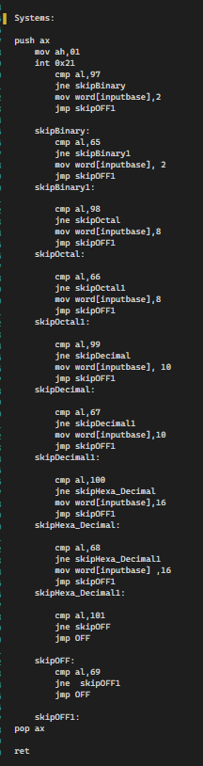

**OUTPUT:-**

**Two Number Operation**:

If any number system is selected, you can use calculator to perform operations on that number system which you have selected.

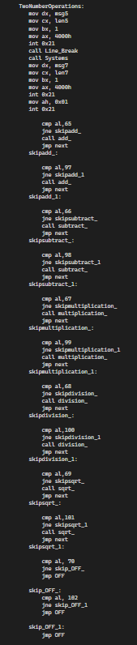

**Output:**

**Add Function:**

It will add two numbers in a selected number system and show result in same number system.

**OUTPUT:**

For example addition of binary numbers.

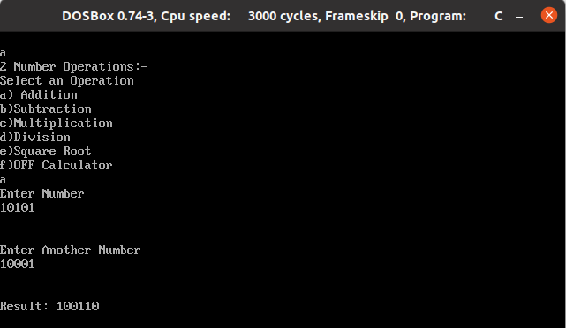

**Subtract Function:**

It will subtract two numbers in a selected number system and show result in same number system.

**OUTPUT:**

For example, subtraction of octal numbers.

**Multiplication Function:**

It will multiply two numbers in a selected number system and show result in same number system.

**OUTPUT:**

For example, multiplication of decimal numbers.

**Division Function:**

It will divide two numbers in a selected number system and show result as well as modulus in same number system.

**OUTPUT:**

For example, division of hexa-decimal numbers.

**Square Root Function:**

It will divide two numbers in a selected number system and show result as well as modulus in same number system.

**OUTPUT:**

For example, square-root of 9 in decimal number system.

**Switch Case for Number System Conversions:**

**Conversions:**

Binary to Octal

**Code:**

**Output:**

Binary to Decimal

**Code:**

**Output:**

Binary to Hexa-Decimal

**Code:**

**Output:**

Octal to Binary

**Code:**

**Output:**

Octal to Decimal

**Code:**

**Output:**

Octal to Hexa-Decimal

**Code:**

**Output:**

Decimal to Binary

**Code:**

**Output:**

Decimal to Octal

**Code:**

**Output:**

Decimal to Hexa-Decimal

**Code:**

**Output:**

Hexa-Decimal Binary

**Code:**

**Output:**

Hexa-Decimal to Octal

**Code:**

**Output:**

Hexa-Decimal to Decimal

**Code:**

**Output:**

**Other Functions:**

* **Line Break**

* **OFF**

* **Input**

* **Output**

Note: Input and Output functions are generalized regarding the base . The function input takes input base from the user and output function takes both the number and the base as parameter.