ASSIGNMENT #4: Report
Student: Huzaifa Khalid
Course: DS-3002 Data Mining

1. Introduction
This project explores an end-to-end machine learning pipeline applied to two contrasting datasets: the tabular UCI Cleveland Heart Disease dataset and the image-based MNIST handwritten digit dataset. The objective is to evaluate unsupervised clustering to find natural patient subgroups, compare tree-based ensemble methods against neural networks for disease prediction, and construct a convolutional network for digit classification. The culmination of this work is a local Streamlit dashboard that serves as a clinical decision-support tool.

2. Dataset and Preprocessing
The primary dataset consists of 303 instances. After cleaning the data by replacing missing markers ("?") and removing 6 incomplete rows, we retained 297 patients.
The original clinical target contained a severity scale from 0 to 4. For the purpose of binary disease screening, this was converted to a simple positive/negative indicator, yielding a mildly imbalanced dataset consisting of 46.13% disease-positive and 53.87% disease-negative patients.
To ensure rigorous evaluation and prevent data leakage, an 80/20 stratified train-test split was executed before any transformation. A preprocessing pipeline was established to standardise continuous variables (e.g., age, cholesterol) and one-hot encode categorical variables (e.g., chest pain type).
Figure: class_distribution.png
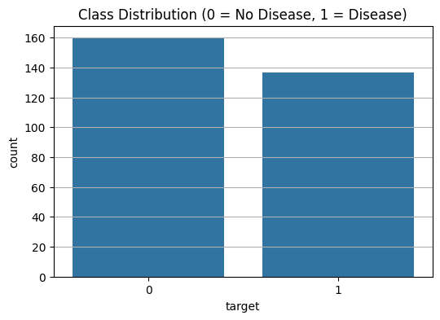
Figure: correlation_heatmap.png
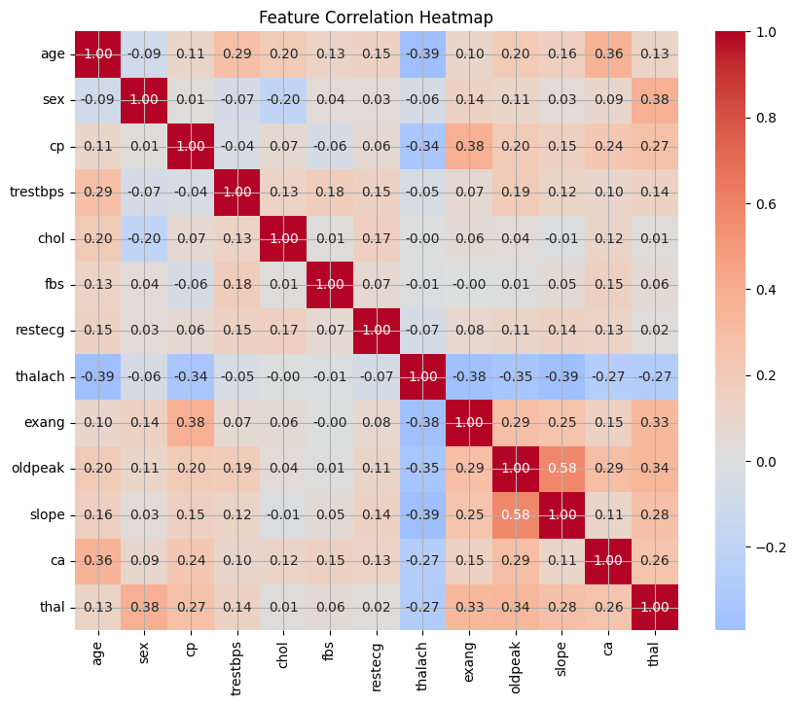

3. Part A: Unsupervised Learning
To determine if natural subgroups exist without leveraging clinical diagnosis, K-Means and Hierarchical clustering were applied to the fully processed dataset.
**K-Means & Hierarchical Clustering:**
Evaluating K-Means from $k=2$ to $k=8$ indicated an optimal $k=2$ based on silhouette scores and the WCSS elbow curve. Cluster profiling revealed that Cluster 0 contained a high-risk group (approx. 80% disease positive, lower maximum heart rate, and higher ST depression), while Cluster 1 represented a lower-risk group. Hierarchical clustering using Ward linkage produced an identical two-branch separation (Adjusted Rand Index > 0.99 between methods).

Interpretation
While unsupervised clustering successfully identifies clinical extremes (e.g., severe cardiovascular decay vs. healthy profiles), the Adjusted Rand Index against the true target was moderate (around 0.4). This proves that unsupervised methods capture broad physiological similarities but cannot replace definitive medical diagnoses due to significant overlap at the decision boundary.
**Dimensionality Reduction:**
PCA required over 13 components to explain 90% of the variance, indicating high dimensionality and complex independent signals. The t-SNE embedding further confirmed this by showing overlapping classes rather than distinct, linearly separable clusters.
Figure: hierarchical_dendrogram.png
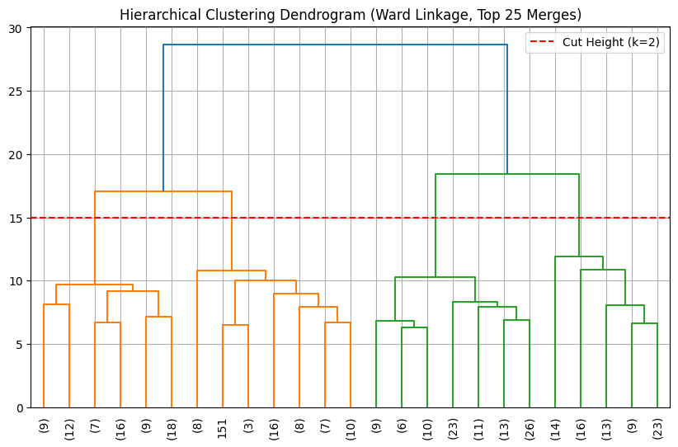
Figure: kmeans_elbow_silhouette.png
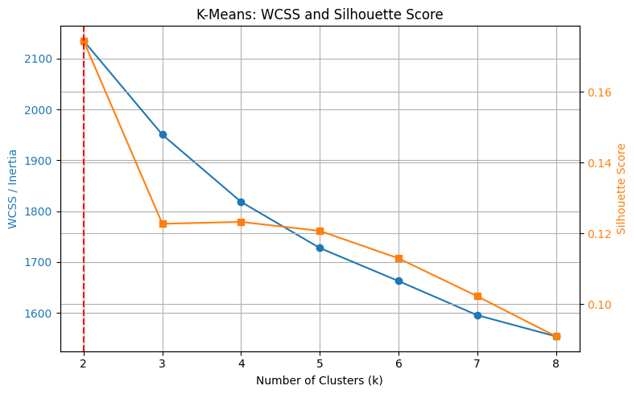
Figure: kmeans_pca_comparison.png
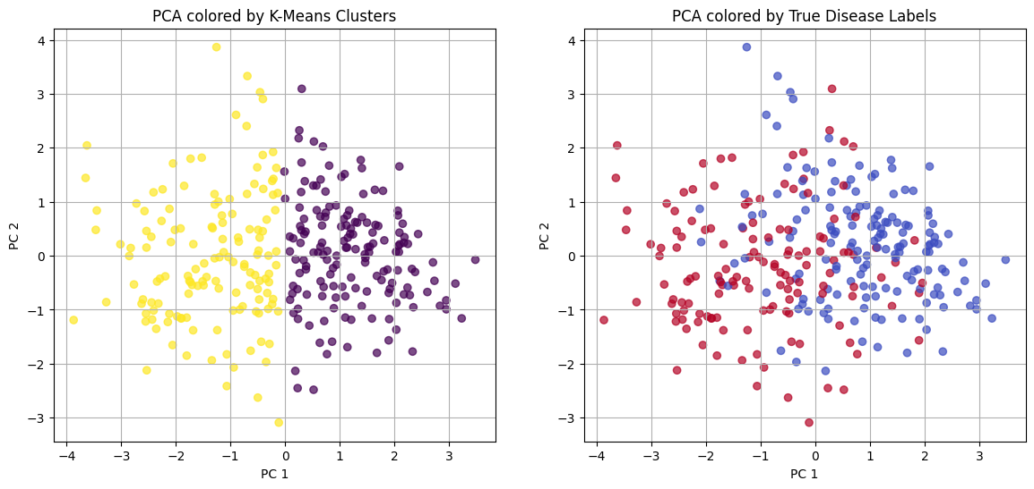
Figure: pca_variance.png
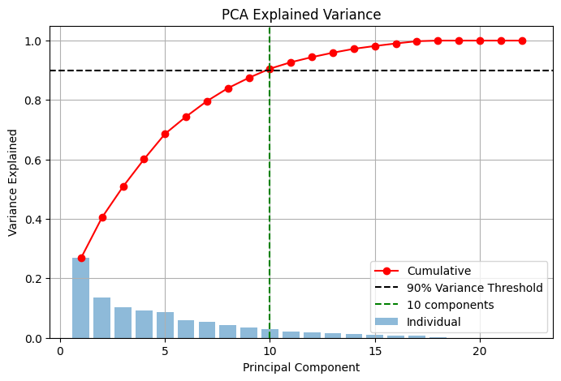
Figure: tsne_embedding.png
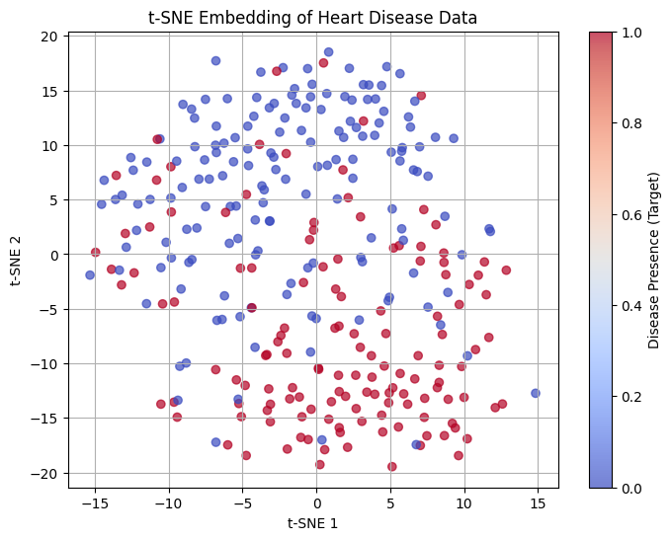

4. Part B: Bagging and Boosting
Tree-based ensembles were evaluated to model the non-linear boundaries identified during exploratory analysis.
**Random Forest:**
After grid search, the optimal Random Forest achieved an Out-Of-Bag error curve that stabilised around 50-100 trees. The model achieved an Accuracy of 0.833, an AUC of 0.942, and a disease recall of 0.786. The top three features driving its decisions were maximum heart rate (thalach), exercise-induced ST depression (oldpeak), and age.
**Gradient Boosting (XGBoost):**
XGBoost was trained with early stopping to prevent overfitting. While SHAP values confirmed it relied on the identical top features as the Random Forest, XGBoost slightly underperformed the Bagging model, achieving an Accuracy of 0.783, an AUC of 0.916, and a disease recall of 0.714.

Interpretation
In a cardiac screening context, recall for the disease class is fundamentally more critical than overall accuracy. A false negative is highly dangerous as it incorrectly reassures a patient who requires medical intervention. The baseline Logistic Regression unexpectedly achieved the highest recall (0.821), but the Random Forest remained highly competitive (0.786). Given its robustness and tree-based interpretability, Random Forest was selected as the deployment model.
Figure: mlp_cm.png
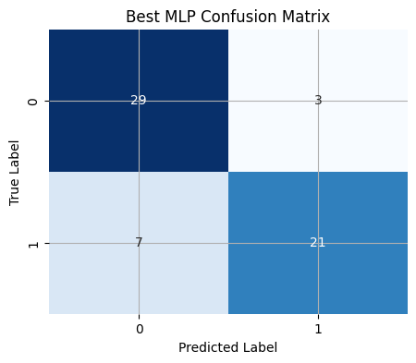
Figure: rf_cm.png
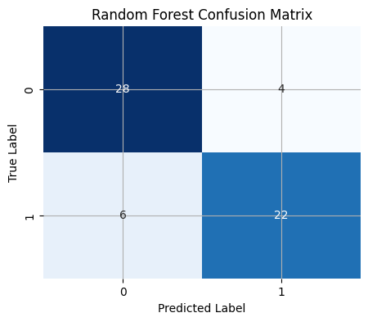
Figure: rf_feature_importances.png
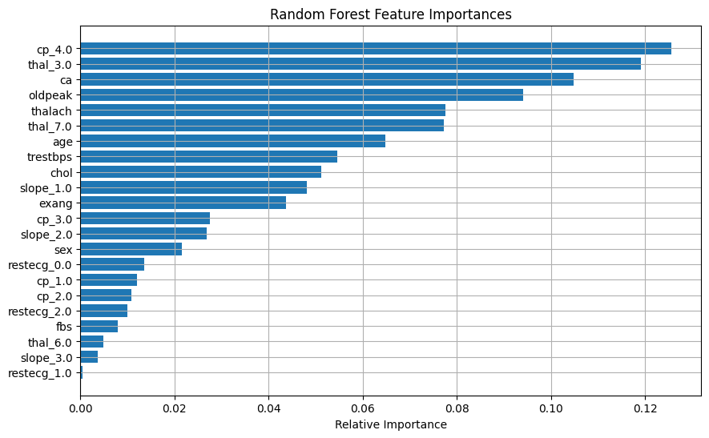
Figure: rf_oob_curve.png
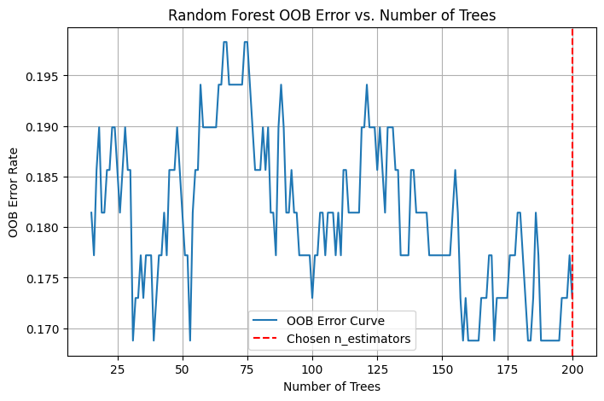
Figure: roc_comparison.png
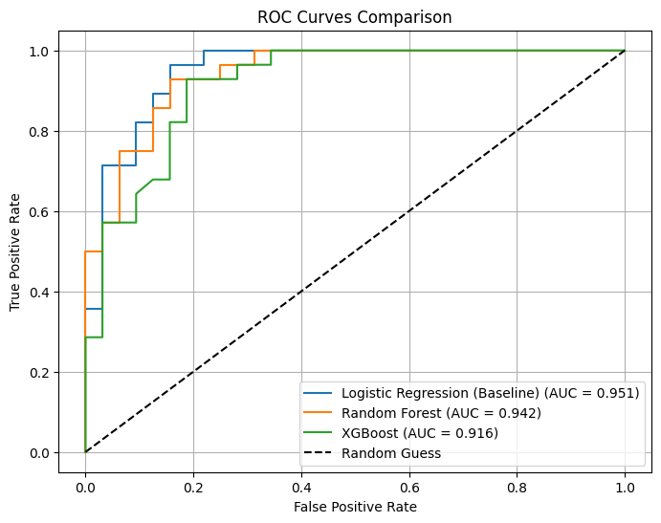
Figure: slp_cm.png
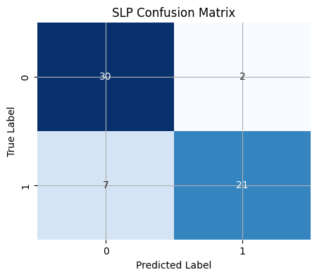
Figure: xgb_cm.png
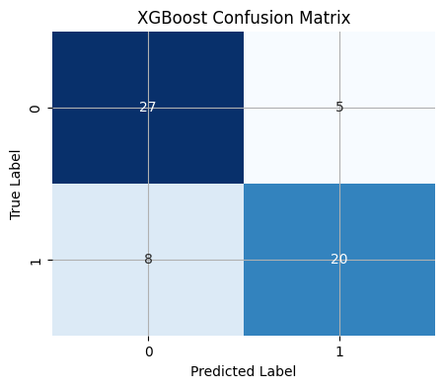
Figure: xgb_shap_summary.png
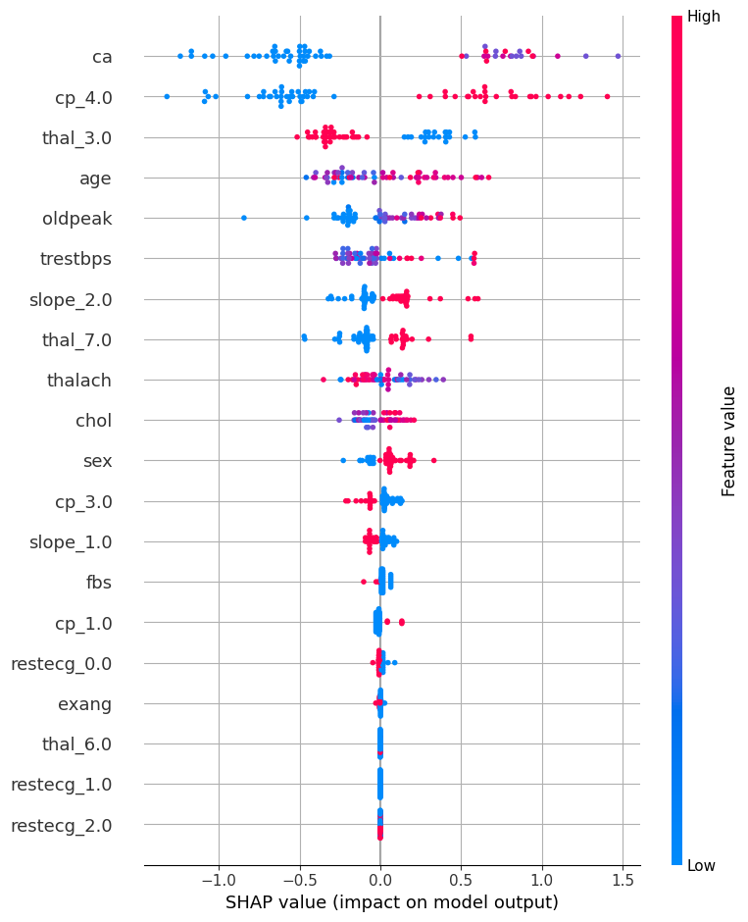
Figure: xgb_training_curve.png
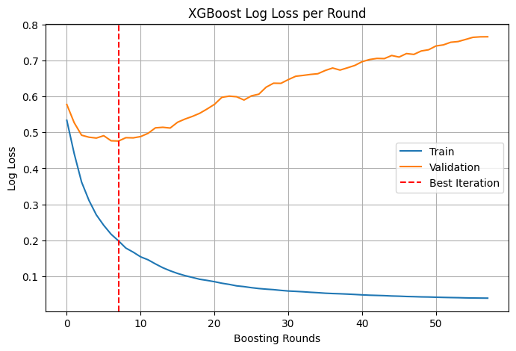

5. Part C: Artificial Neural Networks
A comparison between linear models and Multi-Layer Perceptrons (MLPs) was conducted on the tabular data.
**Single-Layer Perceptron (SLP):**
The SLP converged quickly but lacked hidden layers, functioning essentially as a logistic regression model. Its top weights aligned perfectly with the Random Forest feature importances, confirming the clinical validity of the features.
**Multi-Layer Perceptron (MLP):**
Three architectures (small, medium, large) were evaluated. The "medium" architecture (64 -> Dropout -> 32 -> Output) achieved the best balance. However, the neural network exhibited a high propensity to overfit the small 297-row dataset.
**Ablation Study:**
Removing Early Stopping caused catastrophic overfitting, driving validation loss upward almost immediately. Switching from ReLU to Sigmoid activations severely stalled convergence.

Interpretation
While MLPs are powerful, they are data-hungry. For small, structured tabular datasets, Tree-based ensembles (like Random Forest) provide better out-of-the-box performance, superior resistance to overfitting, and critical feature interpretability that black-box neural networks lack.
Figure: ablation_val_loss.png
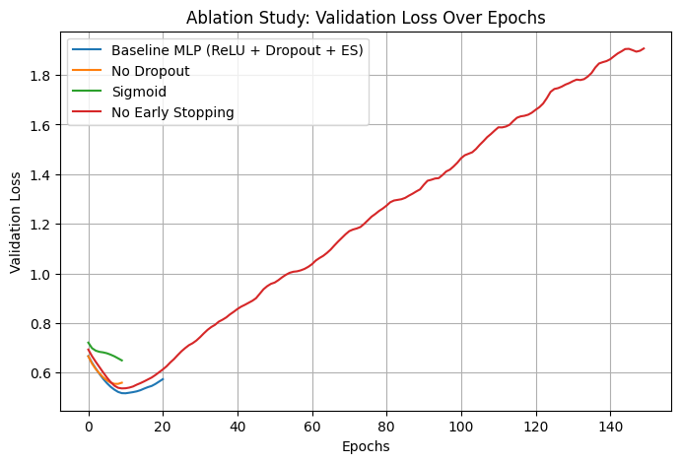
Figure: best_mlp_training_curve.png
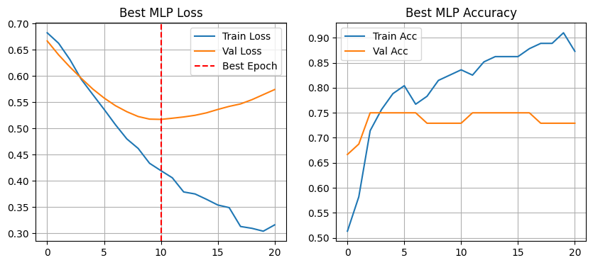
Figure: slp_training_curve.png
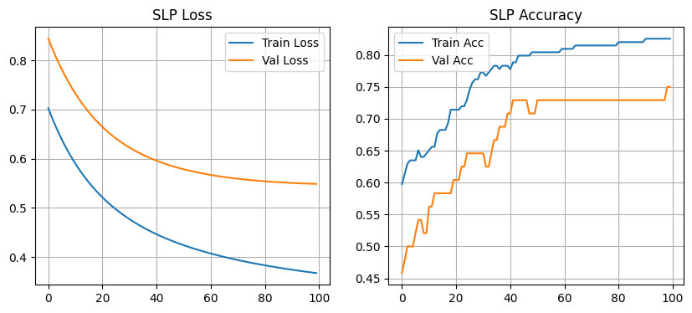

6. Part D: CNN on MNIST
A Convolutional Neural Network (CNN) was trained on a 12,000-image subset of the MNIST dataset to classify handwritten digits, with a baseline MLP trained for comparison.
**CNN Performance:**
The lightweight CNN, utilizing spatial convolutions and max pooling, rapidly outperformed the baseline MLP, achieving a high Test Accuracy (approx. 98%). The confusion matrix revealed that errors were concentrated on visually ambiguous pairs (e.g., 4s predicted as 9s).

Interpretation
By extracting the first layer of Conv2D filters, we visualised that the CNN acts as an edge and curve detector. Feature map projections of individual digits confirmed that the CNN maintains the 2D spatial locality of strokes and loops. This contrasts sharply with fully connected networks, which flatten images into 1D arrays, destroying structural context and relying purely on fixed pixel locations.
Figure: cnn_confusion_matrix.png
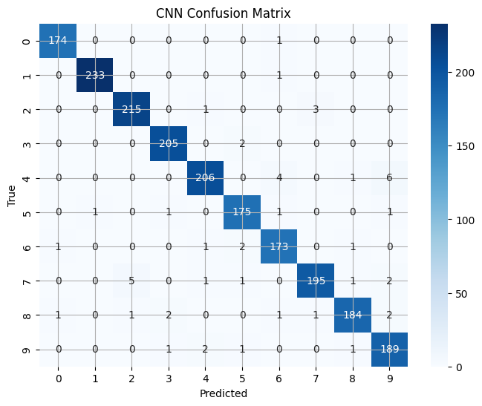
Figure: cnn_training_curve.png
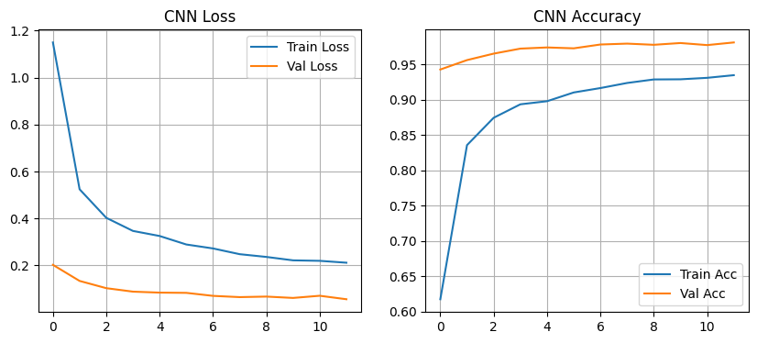
Figure: conv_filters.png
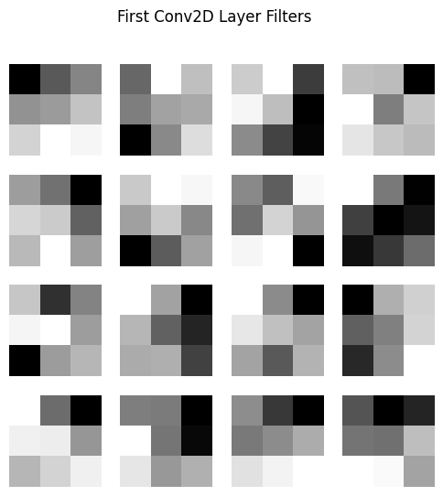
Figure: feature_maps.png
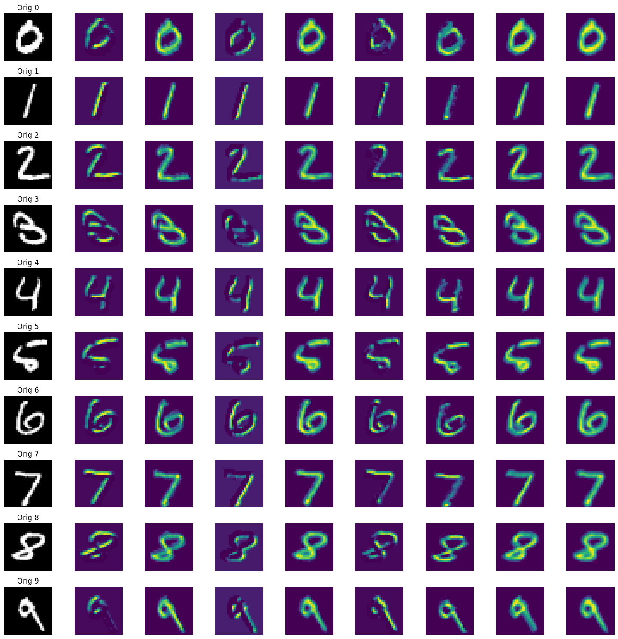
Figure: mnist_samples.png
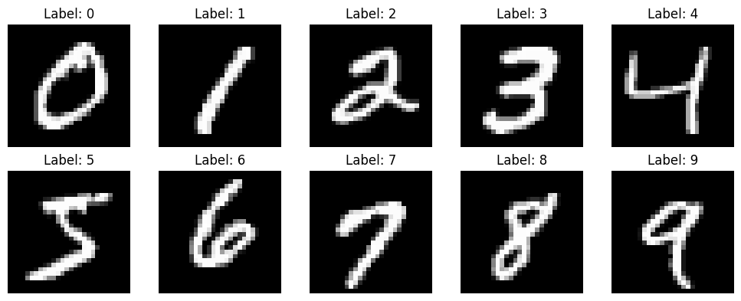

7. Dashboard Deployment
A Streamlit dashboard was constructed to provide interactive decision-support.
It utilizes the saved Random Forest model (`heart_model.pkl`) and preprocessing pipeline. Users can input a patient's 13 clinical variables and receive a live probability score. To ensure clinical safety, the dashboard includes a nurse-readable plain-English explanation powered by SHAP values, clarifying exactly which physiological markers (e.g., ST depression) drove the risk assessment.
*(See `/figures/app_screenshots/` for dashboard visualisations)*
Figure: input.png
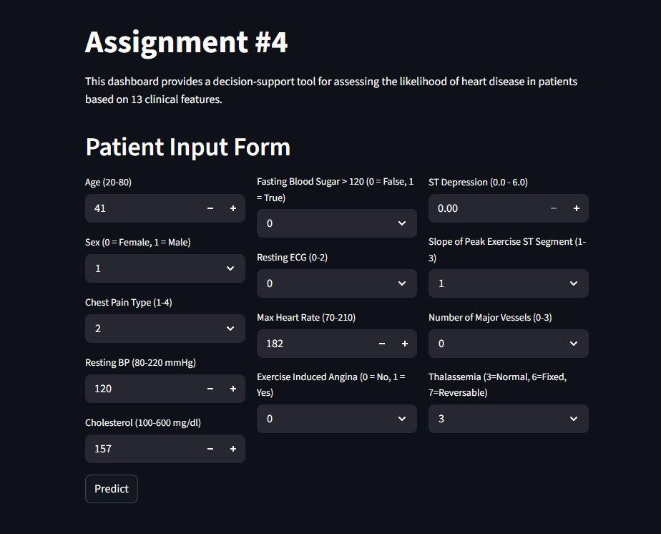
Figure: predcition.png
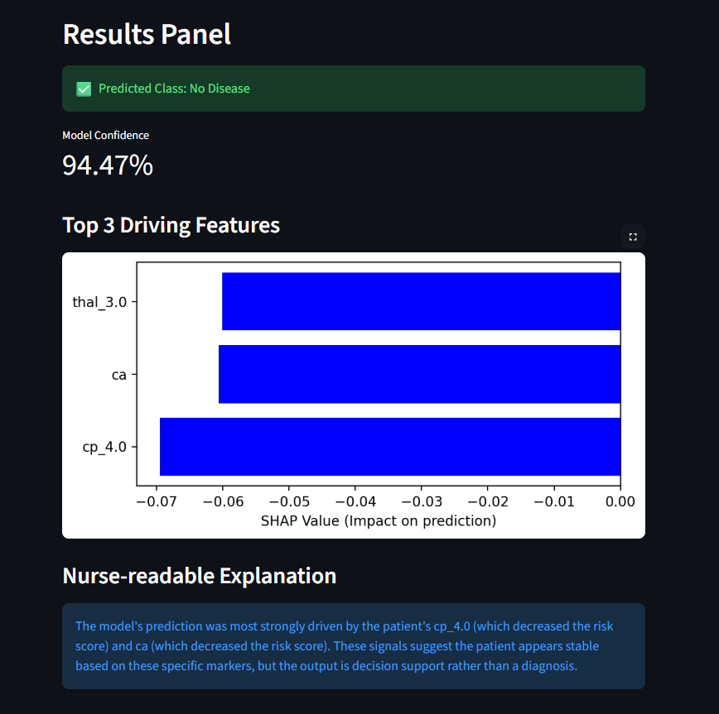

8. Conclusion
This project successfully maps a comprehensive machine learning workflow from unsupervised exploratory analysis to deployed diagnostic screening. We confirmed that while complex models like XGBoost and MLPs are powerful, simpler or bagged algorithms like Random Forest (and even Logistic Regression) often provide safer, higher-recall solutions for small medical datasets. Furthermore, evaluating CNNs on image data highlighted the absolute necessity of algorithm-to-data-structure matching (i.e., convolutions for images, trees for tabular data).

