Q:)

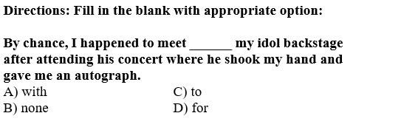

:Type: S

A:)A

B:)B

C:)C

D:)D

:Correct: B

:MsgCorrect:

:MsgIncorrect:

Q:)

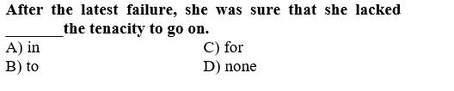

:Type: S

A:)A

B:)B

C:)C

D:)D

:Correct: D

:MsgCorrect:

:MsgIncorrect:

Q:)

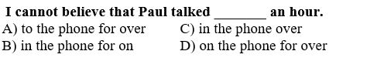

:Type: S

A:)A

B:)B

C:)C

D:)D

:Correct: D

:MsgCorrect:

:MsgIncorrect:

Q:)

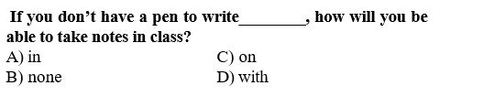

:Type: S

A:)A

B:)B

C:)C

D:)D

:Correct: D

:MsgCorrect:

:MsgIncorrect:

Q:)

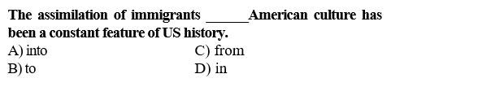

:Type: S

A:)A

B:)B

C:)C

D:)D

:Correct: A

:MsgCorrect:

:MsgIncorrect:

Q:)

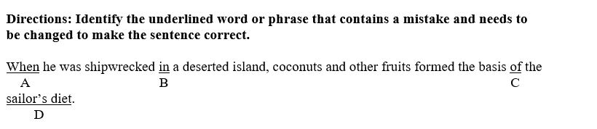

:Type: S

A:)A

B:)B

C:)C

D:)D

:Correct: B

:MsgCorrect:

:MsgIncorrect:

Q:)

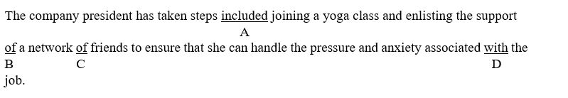

:Type: S

A:)A

B:)B

C:)C

D:)D

:Correct: A

:MsgCorrect:

:MsgIncorrect:

Q:)

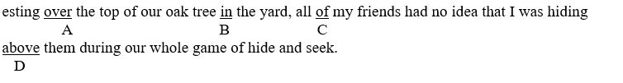

:Type: S

A:)A

B:)B

C:)C

D:)D

:Correct: A

:MsgCorrect:

:MsgIncorrect:

Q:)

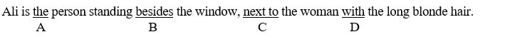

:Type: S

A:)A

B:)B

C:)C

D:)D

:Correct: B

:MsgCorrect:

:MsgIncorrect:

Q:)

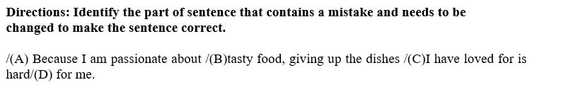

:Type: S

A:)A

B:)B

C:)C

D:)D

:Correct: C

:MsgCorrect:

:MsgIncorrect:

Q:)



:Type: S

A:)A

B:)B

C:)C

D:)D

:Correct: D

:MsgCorrect:

:MsgIncorrect:

Q:)

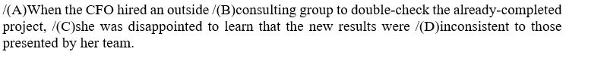

:Type: S

A:)A

B:)B

C:)C

D:)D

:Correct: D

:MsgCorrect:

:MsgIncorrect:

Q:)

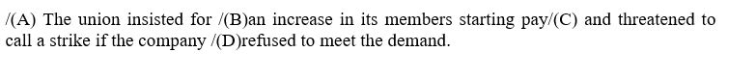

:Type: S

A:)A

B:)B

C:)C

D:)D

:Correct: A

:MsgCorrect:

:MsgIncorrect:

Q:)

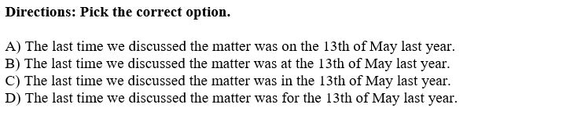

:Type: S

A:)A

B:)B

C:)C

D:)D

:Correct: A

:MsgCorrect:

:MsgIncorrect:

Q:)

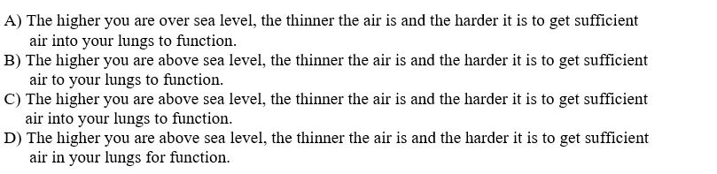

:Type: S

A:)A

B:)B

C:)C

D:)D

:Correct: C

:MsgCorrect:

:MsgIncorrect:

Q:)

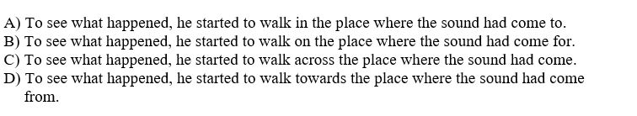

:Type: S

A:)A

B:)B

C:)C

D:)D

:Correct: D

:MsgCorrect:

:MsgIncorrect:

Q:)

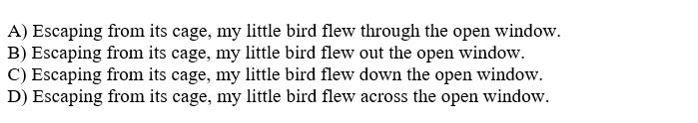

:Type: S

A:)A

B:)B

C:)C

D:)D

:Correct: A

:MsgCorrect:

:MsgIncorrect:

Q:)

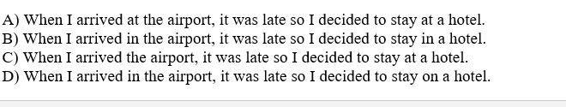

:Type: S

A:)A

B:)B

C:)C

D:)D

:Correct: A

:MsgCorrect:

:MsgIncorrect: