Q:)

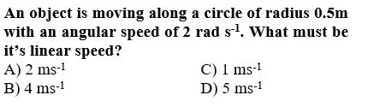

:Type: S

A:)A

B:)B

C:)C

D:)D

:Correct:C :MsgCorrect: :MsgIncorrect:

Q:)

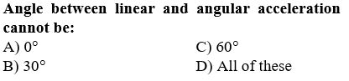

:Type: S

A:)A

B:)B

C:)C

D:)D

:Correct:D :MsgCorrect: :MsgIncorrect:

Q:)

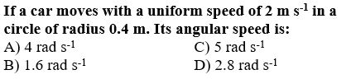

:Type: S

A:)A

B:)B

C:)C

D:)D

:Correct: C :MsgCorrect: :MsgIncorrect:

Q:)

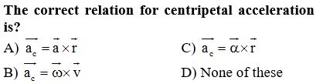

:Type: S

A:)A

B:)B

C:)C

D:)D

:Correct:B :MsgCorrect: :MsgIncorrect:

Q:)

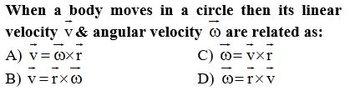

:Type: S

A:)A

B:)B

C:)C

D:)D

:Correct: A:MsgCorrect: :MsgIncorrect:

Q:)

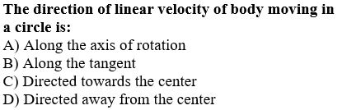

:Type: S

A:)A

B:)B

C:)C

D:)D

:Correct:B :MsgCorrect: :MsgIncorrect:

Q:)

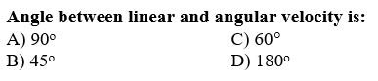

:Type: S

A:)A

B:)B

C:)C

D:)D

:Correct:A :MsgCorrect: :MsgIncorrect:

Q:)

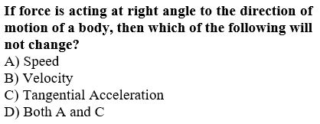

:Type: S

A:)A

B:)B

C:)C

D:)D

:Correct: D :MsgCorrect: :MsgIncorrect:

Q:)

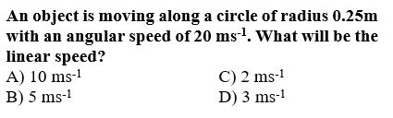

:Type: S

A:)A

B:)B

C:)C

D:)D

:Correct:B :MsgCorrect: :MsgIncorrect:

Q:)

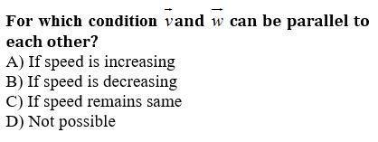

:Type: S

A:)A

B:)B

C:)C

D:)D

:Correct:D :MsgCorrect: :MsgIncorrect:

Q:)

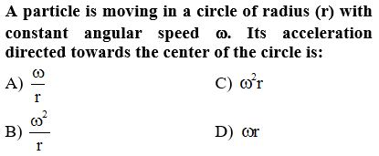

:Type: S

A:)A

B:)B

C:)C

D:)D

:Correct: C :MsgCorrect: :MsgIncorrect:

Q:)

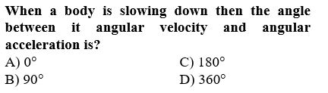

:Type: S

A:)A

B:)B

C:)C

D:)D

:Correct: C :MsgCorrect: :MsgIncorrect:

Q:)

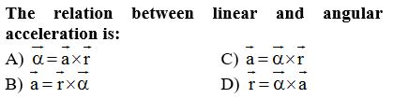

:Type: S

A:)A

B:)B

C:)C

D:)D

:Correct: C :MsgCorrect: :MsgIncorrect:

Q:)

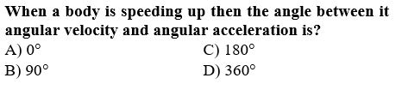

:Type: S

A:)A

B:)B

C:)C

D:)D

:Correct: A :MsgCorrect: :MsgIncorrect:

Q:)

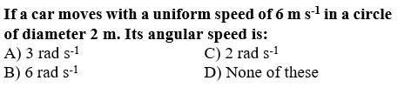

:Type: S

A:)A

B:)B

C:)C

D:)D

:Correct: B :MsgCorrect: :MsgIncorrect:

Q:)

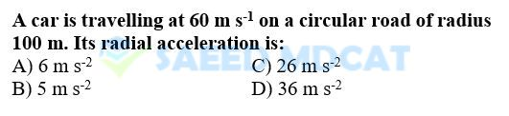

:Type: S

A:)A

B:)B

C:)C

D:)D

:Correct:D :MsgCorrect: :MsgIncorrect:

Q:)

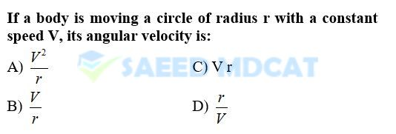

:Type: S

A:)A

B:)B

C:)C

D:)D

:Correct: B :MsgCorrect: :MsgIncorrect:

Q:)

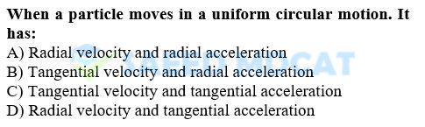

:Type: S

A:)A

B:)B

C:)C

D:)D

:Correct: B :MsgCorrect: :MsgIncorrect: