**Laravel PHP framework**

**PURPOSE:**

Laravel is a popular PHP framework used for building both complex web applications, like e-commerce websites, and simpler web applications, such as landing pages and blogs. It provides powerful pre-built tools that allow developers to create websites with high security and robust functionality.

**Key:**

* **API Development:** It provides tools and features for creating RESTful APIs that can be used by other applications or front-end frameworks.
* **E-commerce Platforms:** Laravel's features make it suitable for building online stores and e-commerce websites
* **Web Portals and Directories:** Laravel can be used to build web portals and directories.

**why it's used in modern PHP development:**

Ease of lerning and use

Open-Sourse and cost-Effective

Strong Community and Resources

Scurity

Folders And Files

1. **App**  
   The core application logic, containing models, controllers, and business logic. Often structured in an app/ directory.
2. **Routes**  
   Define URL endpoints and map them to controller actions. Found in routes.rb (Rails) or web.php (Laravel).
3. **Resources**  
   A RESTful convention for defining routes, controllers, and models for a single entity (e.g., resources :posts in Rails generates CRUD routes).
4. **Config**  
   Configuration files for the application (database settings, environment variables, etc.), typically in a config/ directory.
5. **Database**  
   Stores application data. Interacted with via models and migrations. Configured in config/database.yml (Rails) or .env (Laravel).

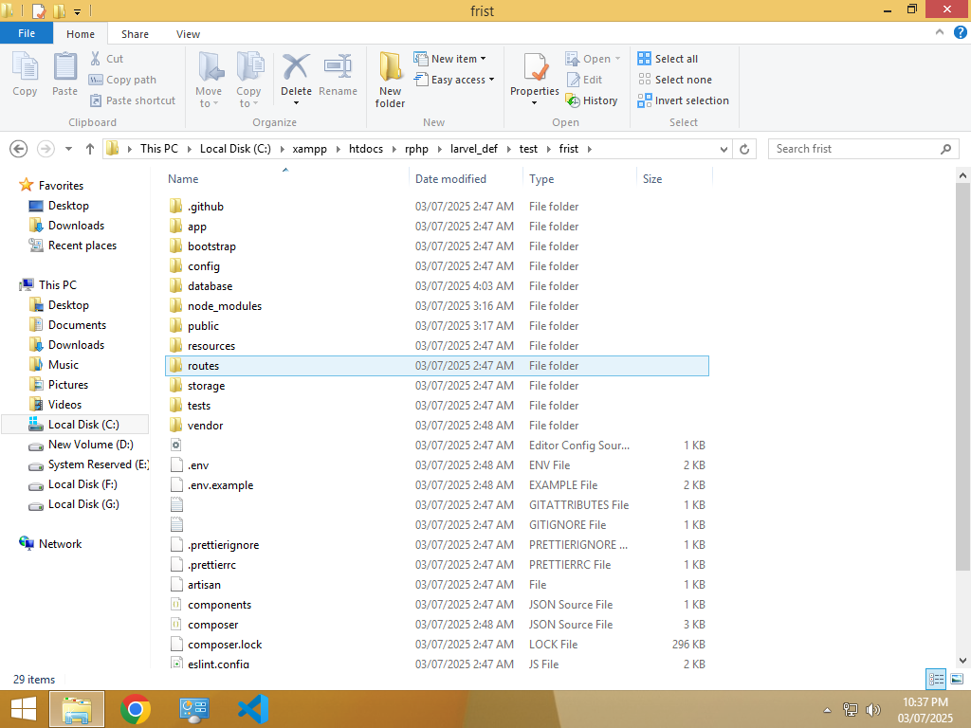

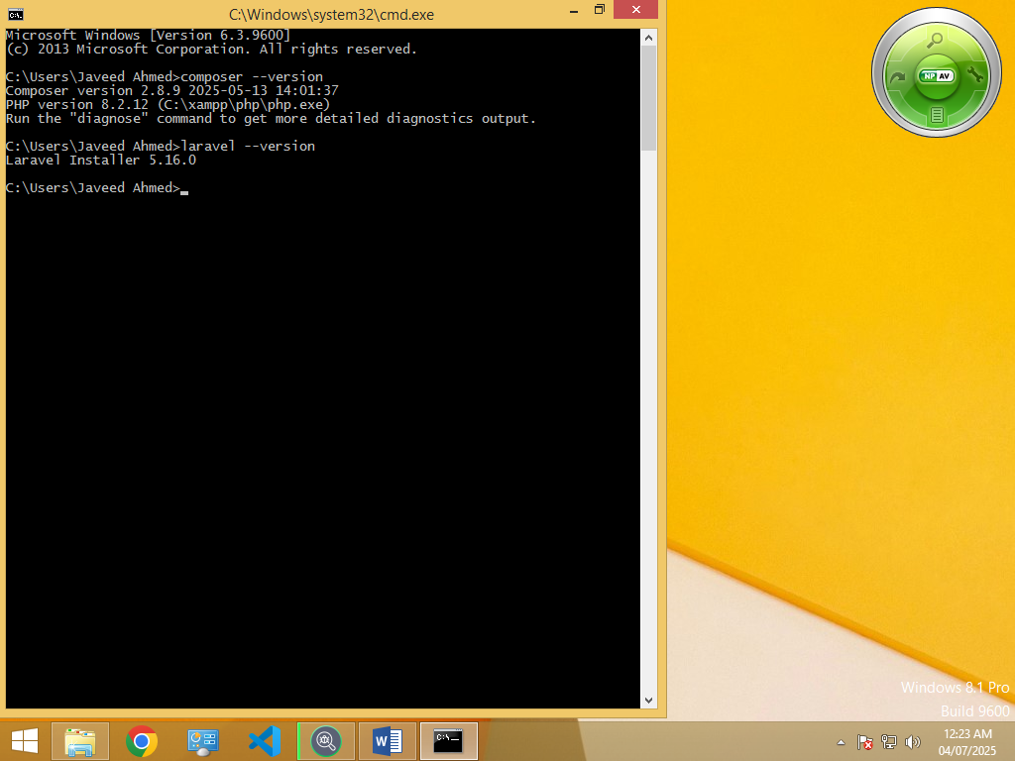

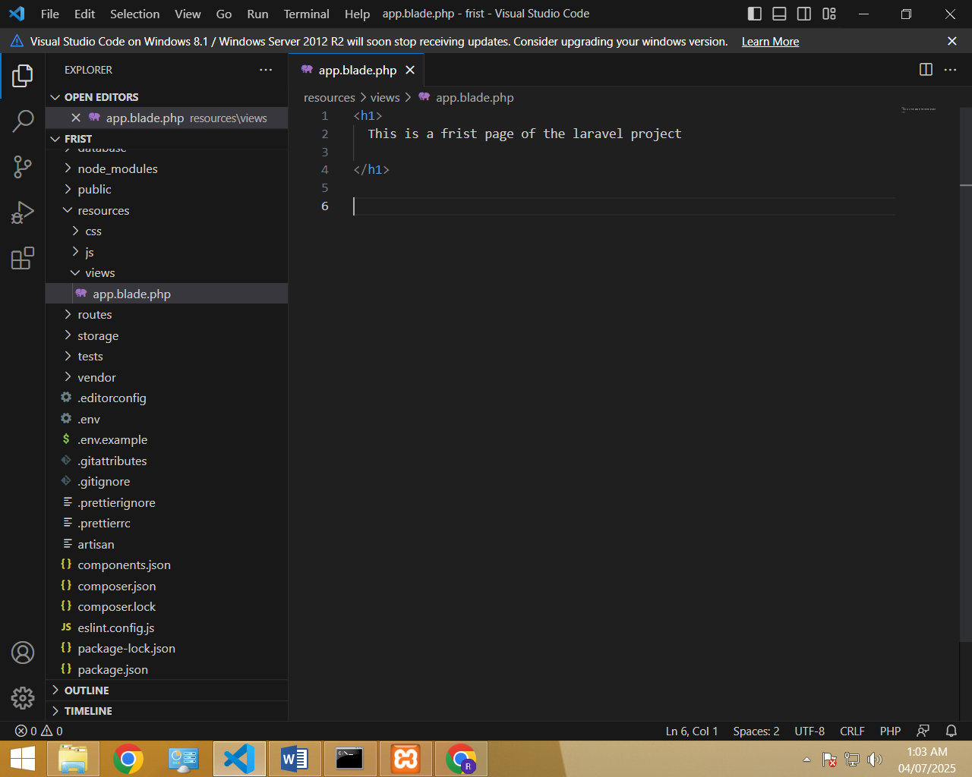

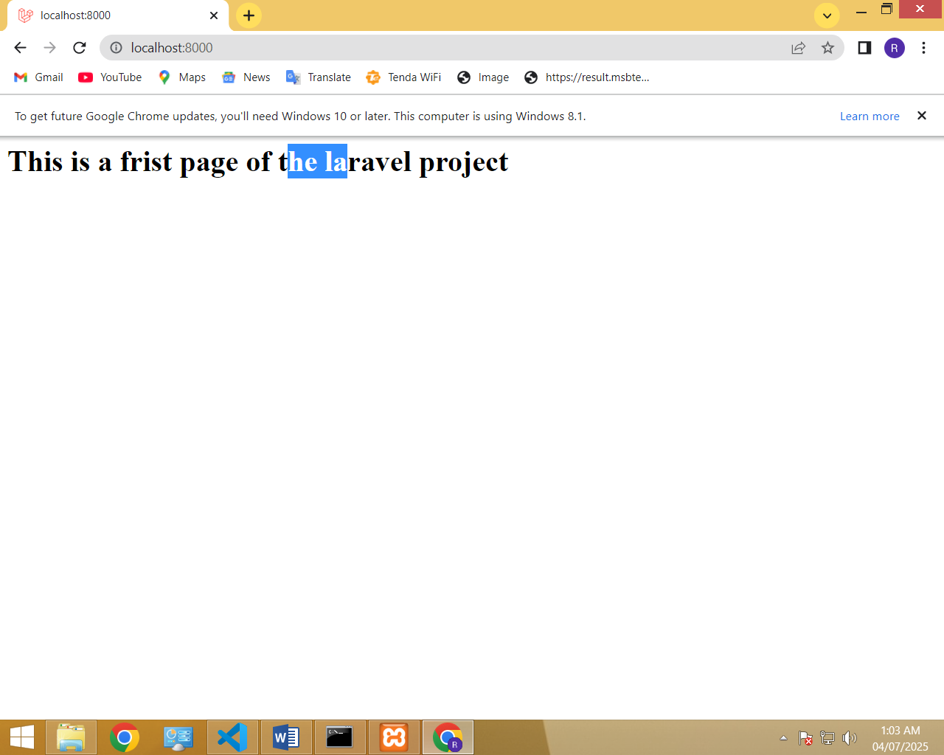

**Routing**

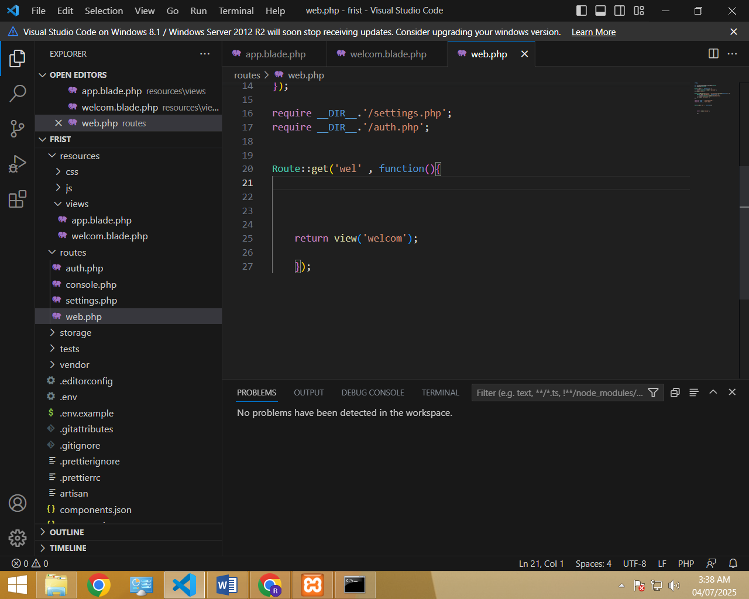

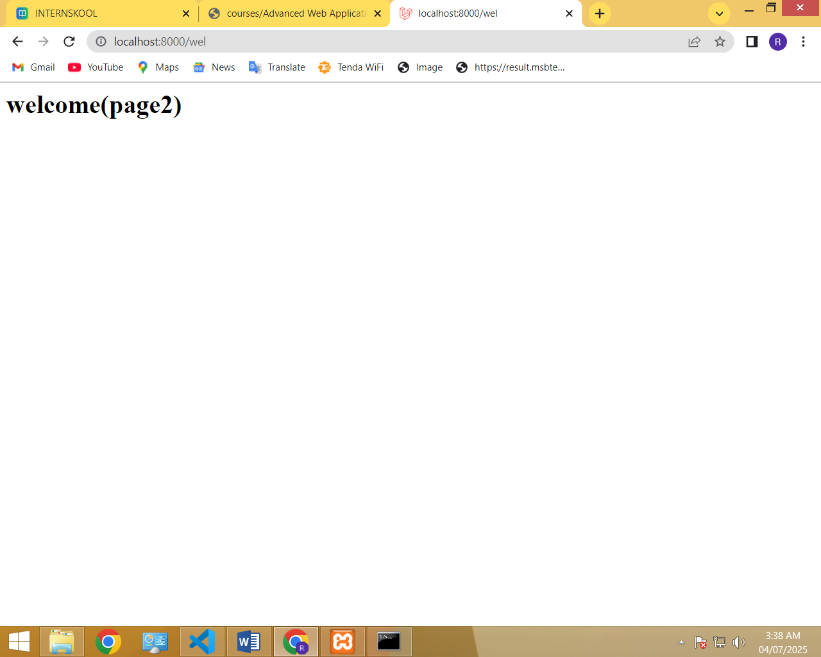

**Database setting already set by laravel famework**

