DATA STRUCTURES LAB PROJECT
P-12.61: Bucket-Sort for Integer Keys
Sorting n entries with keys in the range [0, N−1] in O(n + N) time
PROJECT DATE : 27-10-2026 SUBMITTED TO : SIR JAMAL
Project Members
Sr. No | Name | Roll Number
1 | MUHAMMAD ABDUL REHMAN KHAN | 25F-DS-106
2 | MUHAMMAD HUZAIFA SHAMSI | 25F-DS-135
3 | BASIT MIRZA | 25F-DS-140
4 | MUHAMMAD HASHIR | 25F-DS-152

Table Of Contents
Sr. No | Heading | Page No
1 | Introduction | 3
2 | Abstract | 3
3 | Objectives and Key Features | 3
4 | Methodology (Data Structures Used, Algorithms Implemented and Explanation) | 4
5 | Testing | 6
6 | Performance Analysis and Graphs | 8
7 | Complete Source Code With Output | 11
8 | Result and Evidence | 15
9 | Challenges and Limitations | 15
10 | Conclusion | 16
11 | References | 16
 | Appendix: Source Code (copy and run) | 17

Project :
P-12.61: Design and implement a version of the bucket-sort algorithm for sorting a list of n entries with integer keys taken from the range [0, N−1], for N ≥ 2. The algorithm should run in O(n + N) time.
This project is taken from Chapter 12 (Sorting and Selection) of the book "Data Structures and Algorithms in Python" by Goodrich, Tamassia and Goldwasser. Bucket-sort is explained in Section 12.4.2 of the book.

1. Introduction
Sorting means arranging data in an order, for example from smallest to largest. It is one of the most common tasks in programming. We use it for ranking students, showing products by price, or arranging contacts by name. There are many sorting algorithms and each one has its own speed and limits.
Most well-known algorithms like merge sort and quick sort work by comparing two values at a time and deciding which one is bigger. Such algorithms cannot do better than O(n log n) time. Bucket-sort is different. When all keys are small whole numbers, it does not compare keys at all. It uses the key itself to decide where an entry should go. Because of this, it can sort in O(n + N) time, which is faster than any comparison based sort when the range of keys is not too large.

2. Abstract
In this project we designed and implemented bucket-sort in Python for a list of n entries whose keys are integers in the range [0, N−1]. Each entry is stored as a key-value pair. The algorithm creates N empty buckets, places every entry in the bucket that matches its key, and then reads the buckets from 0 to N−1 to get the sorted list. We checked the correctness of our code with four kinds of automated tests. To see how fast it is in practice, we also implemented insertion sort, merge sort and quick sort and measured the running time of all of them using time.perf_counter(). We ran two experiments, one where we increased n and one where we increased N, and showed the results in tables and graphs. The results match the theory: bucket-sort grows linearly with n and is much faster than the other sorts, but it becomes slow when N is much larger than n.

3. Objectives and Key Features
- To implement bucket-sort for integer keys in the range [0, N−1] that runs in O(n + N) time.
- To keep the sort stable, so entries with equal keys stay in their original order.
- To test the code on normal cases, edge cases and wrong input.
- To compare bucket-sort with insertion sort, merge sort, quick sort and Python's built-in sorted().
- To measure running times and show them with graphs using matplotlib.
- To find out in which situations bucket-sort is a good choice and when it is not.

4. Methodology
We wrote the whole project in a single Python file. First we wrote the bucket-sort function, then three other sorting algorithms for comparison. After that we wrote tests to make sure everything gives the right answer. Finally we wrote a small timing function and two experiments that measure how long each algorithm takes on random data of different sizes, and a function that draws graphs from those results.

Data Structures Used:
Entry (key, value): Each item to be sorted is an Entry object that holds an integer key and a value. For example, the key can be the marks of a student and the value can be the name. We used __slots__ so that each object uses less memory.
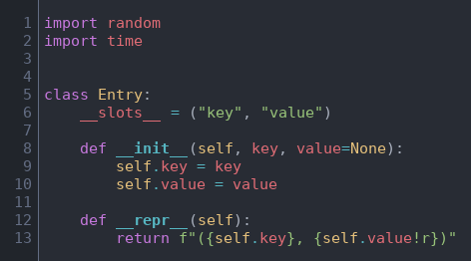
Python list: The input data is a normal Python list.
Array of buckets: The buckets are stored as a list of N lists. B[k] is the bucket for key k. Each bucket works like a queue: new entries are added at the end with append() and later read from the front. This is what makes our sort stable.

Algorithms Implemented:
Bucket-Sort (main algorithm):
Bucket-sort makes one empty bucket for every possible key. It goes through the input once and drops each entry into the bucket with the same number as its key. Then it goes through the buckets from 0 to N−1 and copies the entries back into the list. Since the buckets are visited in order of key, the list comes out sorted without comparing any two keys.
Code:
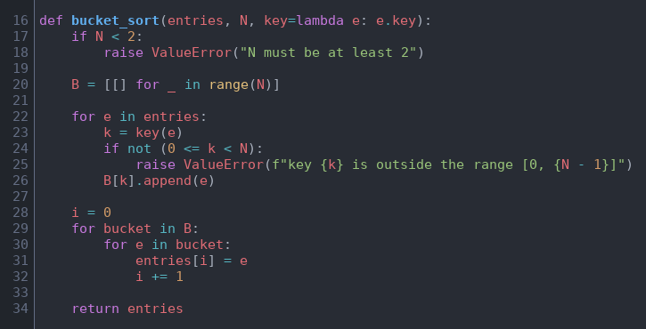
Explanation:
The function takes three inputs: the list of entries, the number N, and a small key function that tells how to get the key out of an entry. By default it reads e.key, and for a list of plain numbers we pass key=lambda x: x. First we check that N is at least 2. Then we create N empty buckets using a list comprehension. We did not write [[]] * N because that would create N references to the same single list.
In the scatter step (lines 22–26) we take each entry, find its key, check that the key is inside the range, and append the entry to bucket B[k]. If a key is outside the range we raise a ValueError. In the gather step (lines 28–32) we visit every bucket in order and write its entries back into the original list using the index i. Creating the buckets takes O(N), the scatter step takes O(n) and the gather step takes O(n + N), so the total time is O(n + N). The extra memory used is also O(n + N).
Insertion Sort (for comparison):
Insertion sort works the way we arrange playing cards in our hand. It picks the next item and moves it to the left until it reaches its correct place among the items already sorted.
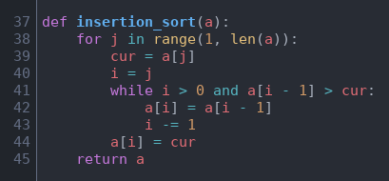
The outer loop picks each item starting from index 1 and saves it in cur. The while loop keeps shifting bigger items one place to the right as long as the item on the left is greater than cur. When it stops, cur is placed in the empty spot. Because there are two loops inside each other, the worst case time is O(n²).
Merge Sort (for comparison):
Merge sort splits the list into two halves, sorts each half by calling itself (recursion), and then merges the two sorted halves into one sorted list.
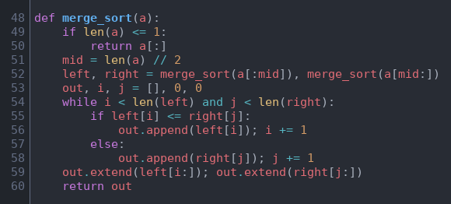
If the list has 0 or 1 items it is already sorted, so we return a copy. Otherwise we find the middle, sort both halves, and merge them. During merging, i points into the left list and j points into the right list. We keep taking the smaller of the two front items and add it to out. When one side finishes, the remaining items of the other side are added at the end. Using <= keeps equal items in their original order. Merge sort always takes O(n log n) time.
Quick Sort (for comparison):
Quick sort picks one item as the pivot and splits the list into three groups: items smaller than the pivot, items equal to it and items bigger than it. Then it sorts the smaller and bigger groups in the same way.
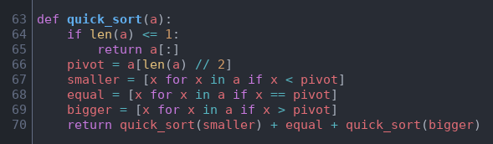
We take the middle item as the pivot. Three list comprehensions build the smaller, equal and bigger lists. The function then returns quick_sort(smaller) + equal + quick_sort(bigger). The equal items never need to be sorted again, which helps a lot when the data has many repeated keys. On average quick sort takes O(n log n) time, but in the worst case, when the pivot is always the smallest or largest item, it can take O(n²).
Summary of Complexities:
Algorithm | Best | Average | Worst | Compares keys?
Bucket-sort | O(n + N) | O(n + N) | O(n + N) | No
Insertion sort | O(n) | O(n²) | O(n²) | Yes
Merge sort | O(n log n) | O(n log n) | O(n log n) | Yes
Quick sort | O(n log n) | O(n log n) | O(n²) | Yes

5. Testing
Before measuring speed, we wanted to be sure that our bucket-sort gives the correct answer. The run_tests() function runs automatically when the program starts. Every check uses assert, so if any answer is wrong the program stops with an error.
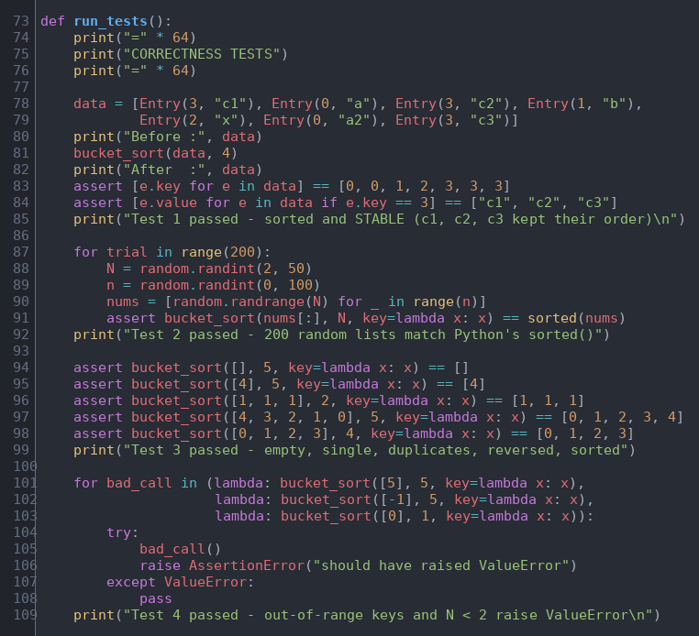
Test | What it checks | Result
1 | A small example of 7 entries with values. Checks that the keys come out sorted and that c1, c2, c3 (all with key 3) keep their order, which shows the sort is stable. | Passed
2 | 200 random lists with random n and N. The output of our bucket-sort is compared with Python's sorted(). | Passed
3 | Edge cases: empty list, one item, all items equal, reversed list, already sorted list. | Passed
4 | Wrong input: key equal to N, a negative key, and N = 1. Each call must raise ValueError. | Passed

In Test 2 we pass nums[:] (a copy) to bucket-sort so that sorted() gets the same unsorted input. In Test 4 each wrong call is wrapped in a lambda so that it runs inside the try block. If the call does not raise ValueError, the next line raises an AssertionError and the test fails.

6. Performance Analysis and Graphs

How we measured the time:
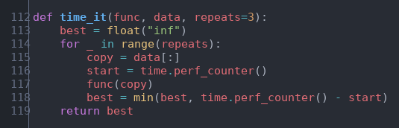
The time_it() function runs a sorting function three times, each time on a fresh copy of the same data, and returns the smallest time. We used time.perf_counter() as a stopwatch. A fresh copy is needed because after the first run the list would already be sorted. We take the best of three runs because other programs running on the computer can only make a run slower, never faster. We also used random.seed(42) so that the same random data is generated every time the program runs.
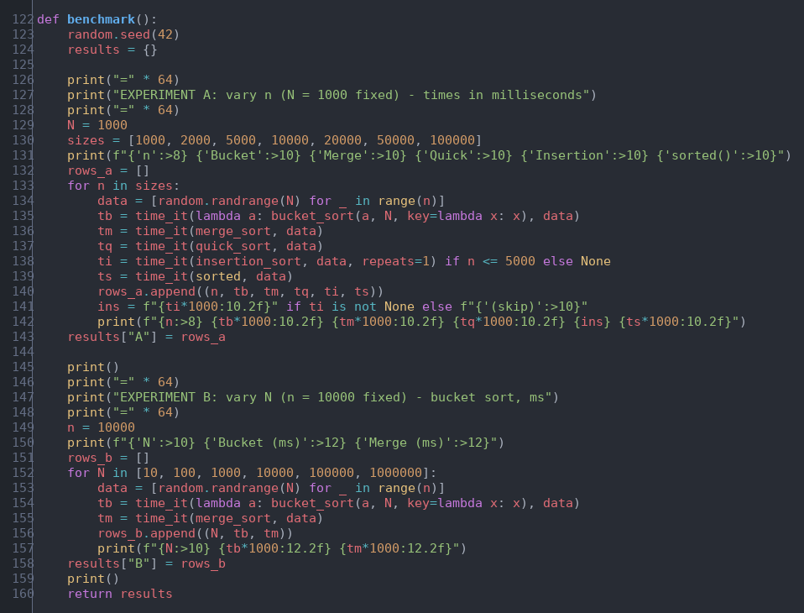
The benchmark() function runs two experiments. In Experiment A the key range is fixed at N = 1000 and the number of entries n grows from 1,000 to 100,000. All five sorts get the same random list in each round. Insertion sort is only run up to n = 5,000 because it is too slow after that. In Experiment B the number of entries is fixed at n = 10,000 and the key range N grows from 10 to 1,000,000. Here we only compare bucket-sort with merge sort, because merge sort does not depend on N and works as a reference. All times are printed in milliseconds.

Experiment A: increasing n (N = 1000)
n | Bucket | Merge | Quick | Insertion | sorted()
1,000 | 0.31 | 2.32 | 1.61 | 27.85 | 0.08
2,000 | 0.41 | 3.77 | 2.91 | 91.45 | 0.18
5,000 | 0.73 | 9.88 | 5.93 | 529.28 | 0.63
10,000 | 2.07 | 18.56 | 11.03 | skipped | 1.27
20,000 | 2.58 | 48.18 | 23.43 | skipped | 2.74
50,000 | 6.36 | 114.42 | 56.40 | skipped | 9.24
100,000 | 12.63 | 240.43 | 110.69 | skipped | 14.85
Table 1: Running times in milliseconds
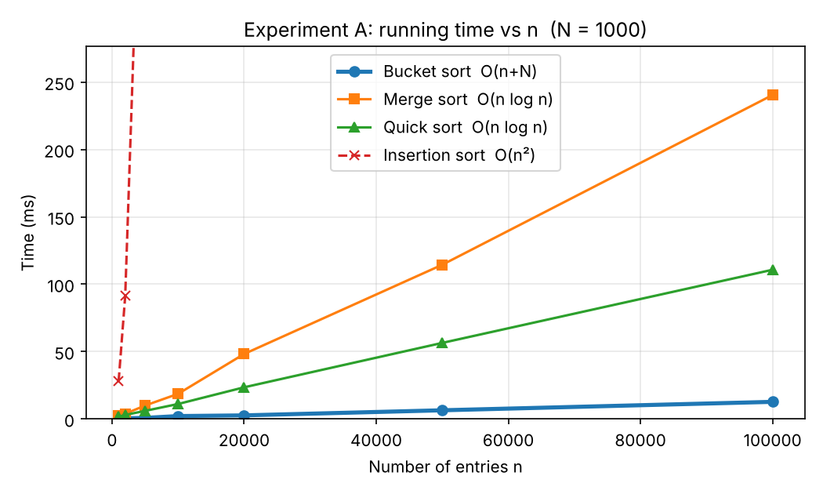
Graph 1: Running time vs n (N = 1000)
Observations: Bucket-sort is the lowest line in the graph and grows almost as a straight line. When n doubles from 50,000 to 100,000 its time also roughly doubles (6.36 ms to 12.63 ms), which shows linear growth. At n = 100,000 it is about 19 times faster than merge sort and about 9 times faster than quick sort. Insertion sort goes off the top of the graph, and its time grows about 3 to 6 times when n grows 2 to 2.5 times, which is the O(n²) pattern. Quick sort was faster than merge sort here because there are only 1000 different keys, so many values are equal to the pivot and go into the equal list in one step. Python's sorted() is written in C so it is very fast, but our pure Python bucket-sort still stays close to it.

Experiment B: increasing N (n = 10,000)
N (key range) | Bucket-sort (ms) | Merge sort (ms)
10 | 0.94 | 16.78
100 | 1.02 | 17.21
1,000 | 1.41 | 19.39
10,000 | 2.42 | 18.65
100,000 | 13.65 | 23.16
1,000,000 | 175.81 | 18.00
Table 2: Running times in milliseconds
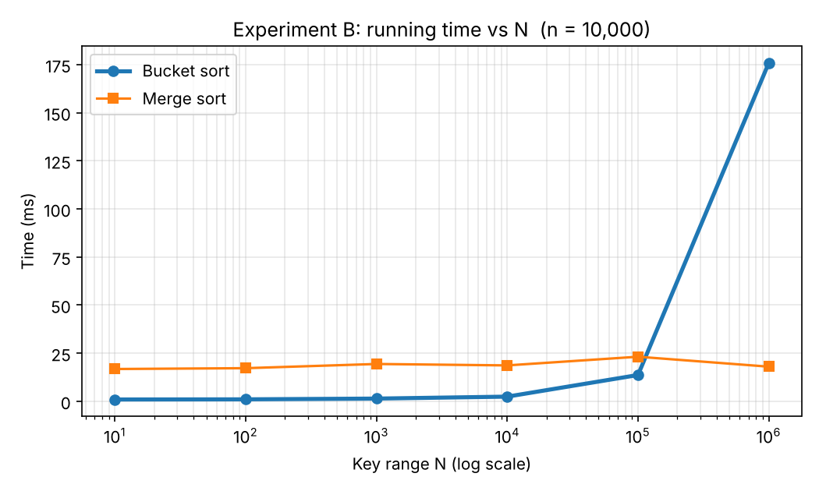
Graph 2: Running time vs key range N (n = 10,000), x-axis on log scale
Observations: Merge sort stays almost flat between 17 and 23 ms because it only compares keys and does not care about their range. Bucket-sort is very fast while N is smaller than or close to n. But when N becomes 1,000,000, it has to create and check one million buckets for only 10,000 entries, and most of them are empty. At that point it is about 10 times slower than merge sort. This shows that the "+N" part of O(n + N) is a real cost.

How the graphs are drawn:
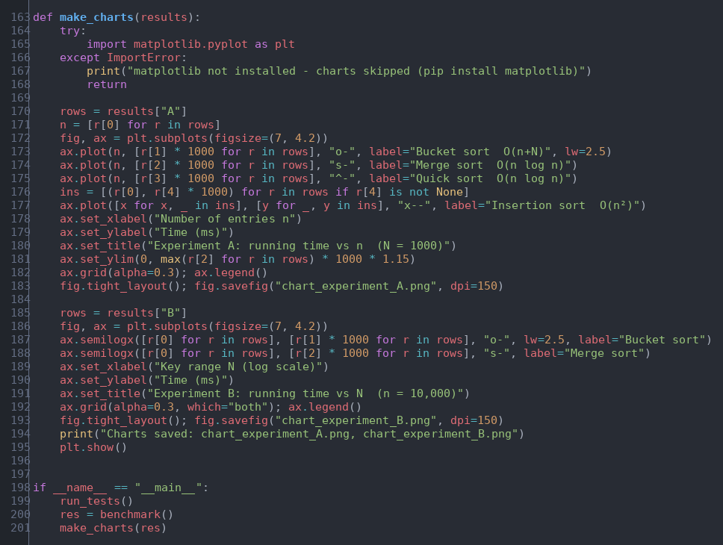
The make_charts() function uses matplotlib. For each line we give a list of x values and a list of y values taken from the results. Times are multiplied by 1000 to show milliseconds. The format strings "o-", "s-", "^-" and "x--" choose the marker shape and line style. In Graph 1 the y-axis is limited to a little above the highest merge sort time, otherwise insertion sort would squeeze all the other lines to the bottom. In Graph 2 we used semilogx so that the x-axis is on a log scale, because N goes from 10 to 1,000,000. Both graphs are saved as PNG files and shown on screen with plt.show(). If matplotlib is not installed, the program prints a message and skips the graphs.

7. Complete Source Code With Output
The complete program is shown below. A text version that can be copied and run is given in the Appendix at the end of this report.
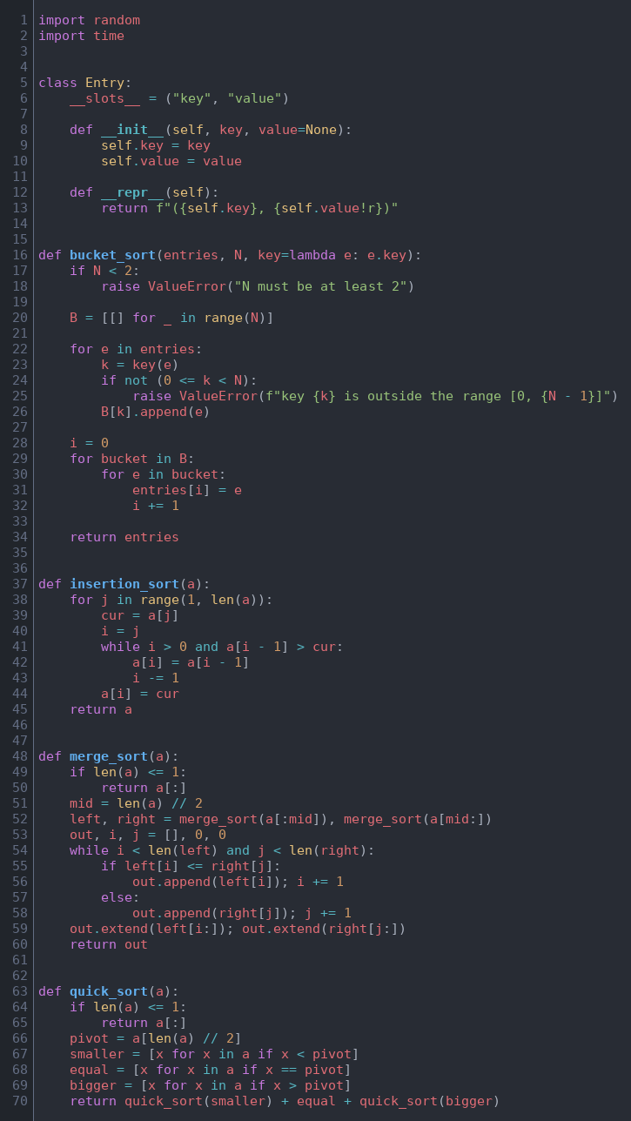
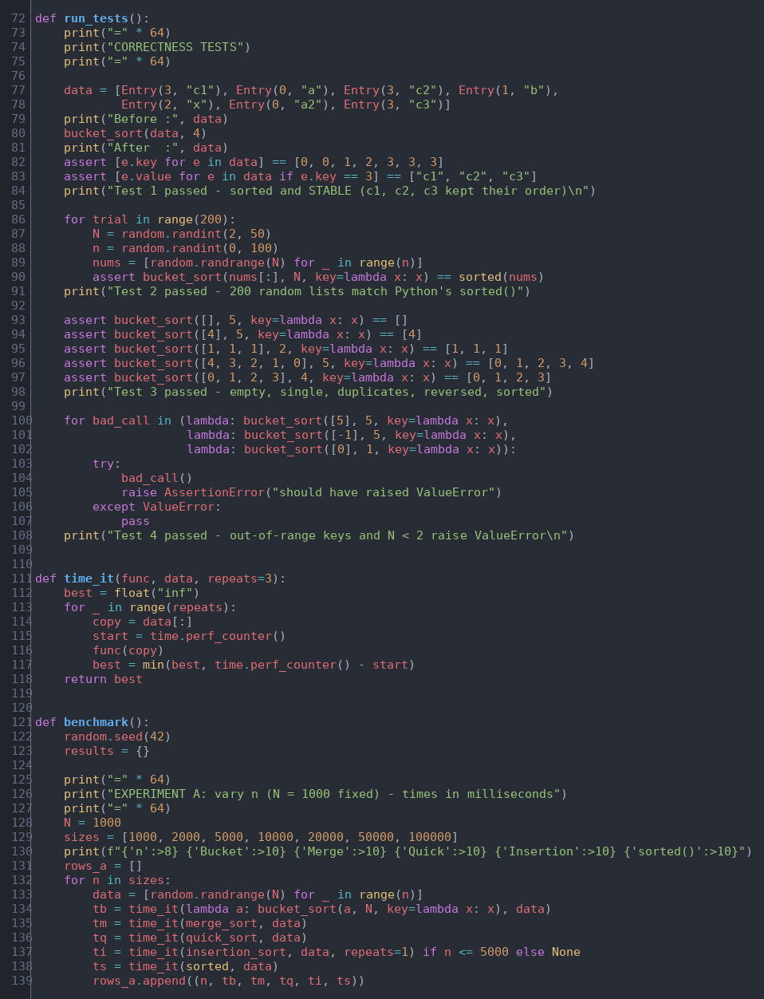
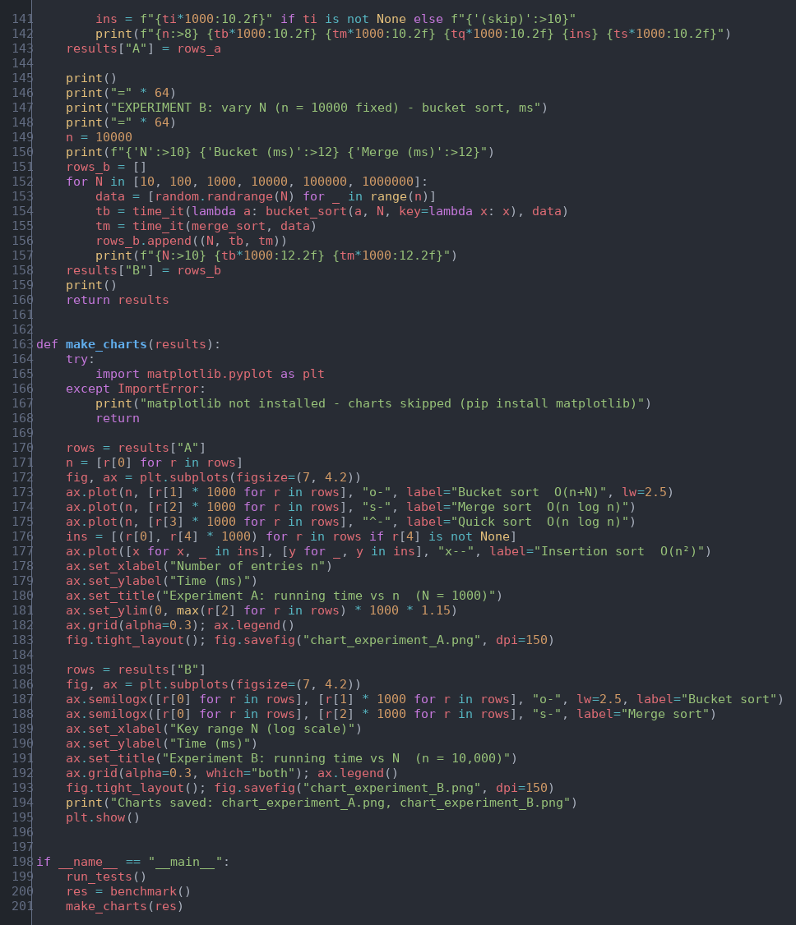

Output :
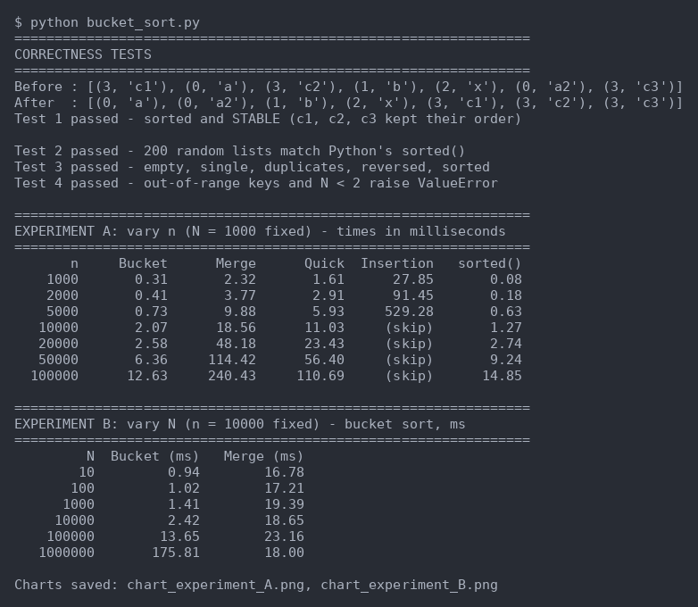
When the program finishes, the two graphs (chart_experiment_A.png and chart_experiment_B.png) are saved in the same folder and also open on the screen.

8. Result and Evidence
All four tests passed, so our bucket-sort gives correct and stable results, handles edge cases and rejects wrong input. In Experiment A, bucket-sort was the fastest of all the algorithms we wrote and its time grew linearly with n, as expected from O(n + N). Merge sort and quick sort grew like O(n log n) and insertion sort grew like O(n²). In Experiment B, merge sort stayed flat while bucket-sort became slow once N was much larger than n. Together the two experiments confirm both parts of the O(n + N) running time. The printed tables and the two graphs are the evidence for these results.

9. Challenges and Limitations
- At first it was confusing to understand how bucket-sort can sort without comparing anything. Doing a dry run on paper with a few buckets made it clear.
- Bucket-sort only works for integer keys in a known range. It does not work directly for decimal numbers, strings or negative keys.
- If N is much larger than n, most buckets stay empty and the algorithm wastes time and memory.
- Bucket-sort needs O(n + N) extra memory for the buckets, so it is not an in-place algorithm.
- The exact running times depend on the computer. On another laptop the numbers will be different, but the pattern of the results stays the same.
- Python is slower than languages like C++, so all our times are higher than they would be in a compiled language.

10. Conclusion
In this project we implemented bucket-sort for integer keys in the range [0, N−1] and showed that it runs in O(n + N) time. Our tests showed that it is correct and stable. The experiments showed that when the key range is small compared to the number of entries, bucket-sort is much faster than comparison based sorts like merge sort and quick sort. They also showed its weakness: when the key range becomes very large, the empty buckets make it slower than merge sort. So the best sorting algorithm depends on the data. Through this project we learned how theory like Big-O can be checked with real measurements, and how to choose an algorithm by looking at the type of keys we have.

11. References
1. Goodrich, M. T., Tamassia, R., & Goldwasser, M. H. (2013). Data Structures and Algorithms in Python. Wiley. Section 12.4.2 (Bucket-Sort). ISBN 978-1-118-29027-9. https://www.oreilly.com/library/view/data-structures-and/9781118290279/
2. Python documentation, time.perf_counter(): https://docs.python.org/3/library/time.html#time.perf_counter
3. Python documentation, random module: https://docs.python.org/3/library/random.html
4. Matplotlib documentation, pyplot: https://matplotlib.org/stable/api/pyplot_summary.html
5. Matplotlib documentation, Axes.semilogx: https://matplotlib.org/stable/api/_as_gen/matplotlib.axes.Axes.semilogx.html

Appendix: Source Code (copy and run)
Requirements: Python 3 and matplotlib (install with: pip install matplotlib). Copy the code below into a file named bucket_sort.py and run it with: python bucket_sort.py
import random
import time

class Entry:
__slots__ = ("key", "value")

def __init__(self, key, value=None):
self.key = key
self.value = value

def __repr__(self):
return f"({self.key}, {self.value!r})"

def bucket_sort(entries, N, key=lambda e: e.key):
if N < 2:
raise ValueError("N must be at least 2")

B = [[] for _ in range(N)]

for e in entries:
k = key(e)
if not (0 <= k < N):
raise ValueError(f"key {k} is outside the range [0, {N - 1}]")
B[k].append(e)

i = 0
for bucket in B:
for e in bucket:
entries[i] = e
i += 1

return entries

def insertion_sort(a):
for j in range(1, len(a)):
cur = a[j]
i = j
while i > 0 and a[i - 1] > cur:
a[i] = a[i - 1]
i -= 1
a[i] = cur
return a

def merge_sort(a):
if len(a) <= 1:
return a[:]
mid = len(a) // 2
left, right = merge_sort(a[:mid]), merge_sort(a[mid:])
out, i, j = [], 0, 0
while i < len(left) and j < len(right):
if left[i] <= right[j]:
out.append(left[i]); i += 1
else:
out.append(right[j]); j += 1
out.extend(left[i:]); out.extend(right[j:])
return out

def quick_sort(a):
if len(a) <= 1:
return a[:]
pivot = a[len(a) // 2]
smaller = [x for x in a if x < pivot]
equal = [x for x in a if x == pivot]
bigger = [x for x in a if x > pivot]
return quick_sort(smaller) + equal + quick_sort(bigger)

def run_tests():
print("=" * 64)
print("CORRECTNESS TESTS")
print("=" * 64)

data = [Entry(3, "c1"), Entry(0, "a"), Entry(3, "c2"), Entry(1, "b"),
Entry(2, "x"), Entry(0, "a2"), Entry(3, "c3")]
print("Before :", data)
bucket_sort(data, 4)
print("After :", data)
assert [e.key for e in data] == [0, 0, 1, 2, 3, 3, 3]
assert [e.value for e in data if e.key == 3] == ["c1", "c2", "c3"]
print("Test 1 passed - sorted and STABLE (c1, c2, c3 kept their order)\n")

for trial in range(200):
N = random.randint(2, 50)
n = random.randint(0, 100)
nums = [random.randrange(N) for _ in range(n)]
assert bucket_sort(nums[:], N, key=lambda x: x) == sorted(nums)
print("Test 2 passed - 200 random lists match Python's sorted()")

assert bucket_sort([], 5, key=lambda x: x) == []
assert bucket_sort([4], 5, key=lambda x: x) == [4]
assert bucket_sort([1, 1, 1], 2, key=lambda x: x) == [1, 1, 1]
assert bucket_sort([4, 3, 2, 1, 0], 5, key=lambda x: x) == [0, 1, 2, 3, 4]
assert bucket_sort([0, 1, 2, 3], 4, key=lambda x: x) == [0, 1, 2, 3]
print("Test 3 passed - empty, single, duplicates, reversed, sorted")

for bad_call in (lambda: bucket_sort([5], 5, key=lambda x: x),
lambda: bucket_sort([-1], 5, key=lambda x: x),
lambda: bucket_sort([0], 1, key=lambda x: x)):
try:
bad_call()
raise AssertionError("should have raised ValueError")
except ValueError:
pass
print("Test 4 passed - out-of-range keys and N < 2 raise ValueError\n")

def time_it(func, data, repeats=3):
best = float("inf")
for _ in range(repeats):
copy = data[:]
start = time.perf_counter()
func(copy)
best = min(best, time.perf_counter() - start)
return best

def benchmark():
random.seed(42)
results = {}

print("=" * 64)
print("EXPERIMENT A: vary n (N = 1000 fixed) - times in milliseconds")
print("=" * 64)
N = 1000
sizes = [1000, 2000, 5000, 10000, 20000, 50000, 100000]
print(f"{'n':>8} {'Bucket':>10} {'Merge':>10} {'Quick':>10} {'Insertion':>10} {'sorted()':>10}")
rows_a = []
for n in sizes:
data = [random.randrange(N) for _ in range(n)]
tb = time_it(lambda a: bucket_sort(a, N, key=lambda x: x), data)
tm = time_it(merge_sort, data)
tq = time_it(quick_sort, data)
ti = time_it(insertion_sort, data, repeats=1) if n <= 5000 else None
ts = time_it(sorted, data)
rows_a.append((n, tb, tm, tq, ti, ts))
ins = f"{ti*1000:10.2f}" if ti is not None else f"{'(skip)':>10}"
print(f"{n:>8} {tb*1000:10.2f} {tm*1000:10.2f} {tq*1000:10.2f} {ins} {ts*1000:10.2f}")
results["A"] = rows_a

print()
print("=" * 64)
print("EXPERIMENT B: vary N (n = 10000 fixed) - bucket sort, ms")
print("=" * 64)
n = 10000
print(f"{'N':>10} {'Bucket (ms)':>12} {'Merge (ms)':>12}")
rows_b = []
for N in [10, 100, 1000, 10000, 100000, 1000000]:
data = [random.randrange(N) for _ in range(n)]
tb = time_it(lambda a: bucket_sort(a, N, key=lambda x: x), data)
tm = time_it(merge_sort, data)
rows_b.append((N, tb, tm))
print(f"{N:>10} {tb*1000:12.2f} {tm*1000:12.2f}")
results["B"] = rows_b
print()
return results

def make_charts(results):
try:
import matplotlib.pyplot as plt
except ImportError:
print("matplotlib not installed - charts skipped (pip install matplotlib)")
return

rows = results["A"]
n = [r[0] for r in rows]
fig, ax = plt.subplots(figsize=(7, 4.2))
ax.plot(n, [r[1] * 1000 for r in rows], "o-", label="Bucket sort O(n+N)", lw=2.5)
ax.plot(n, [r[2] * 1000 for r in rows], "s-", label="Merge sort O(n log n)")
ax.plot(n, [r[3] * 1000 for r in rows], "^-", label="Quick sort O(n log n)")
ins = [(r[0], r[4] * 1000) for r in rows if r[4] is not None]
ax.plot([x for x, _ in ins], [y for _, y in ins], "x--", label="Insertion sort O(n²)")
ax.set_xlabel("Number of entries n")
ax.set_ylabel("Time (ms)")
ax.set_title("Experiment A: running time vs n (N = 1000)")
ax.set_ylim(0, max(r[2] for r in rows) * 1000 * 1.15)
ax.grid(alpha=0.3); ax.legend()
fig.tight_layout(); fig.savefig("chart_experiment_A.png", dpi=150)

rows = results["B"]
fig, ax = plt.subplots(figsize=(7, 4.2))
ax.semilogx([r[0] for r in rows], [r[1] * 1000 for r in rows], "o-", lw=2.5, label="Bucket sort")
ax.semilogx([r[0] for r in rows], [r[2] * 1000 for r in rows], "s-", label="Merge sort")
ax.set_xlabel("Key range N (log scale)")
ax.set_ylabel("Time (ms)")
ax.set_title("Experiment B: running time vs N (n = 10,000)")
ax.grid(alpha=0.3, which="both"); ax.legend()
fig.tight_layout(); fig.savefig("chart_experiment_B.png", dpi=150)
print("Charts saved: chart_experiment_A.png, chart_experiment_B.png")
plt.show()

if __name__ == "__main__":
run_tests()
res = benchmark()
make_charts(res)

