ORANGEHRM

LOGIN MODULE

TEST SUMMARY REPORT

Software Quality Assurance (SQA)

Prepared By
Muhammad Huzaifa Waheed

Project Date
23-May-2026

Application Under Test
OrangeHRM Demo

Project Type
Manual Testing Project

EXECUTIVE SUMMARY
This project was conducted to perform manual testing of the OrangeHRM Login Module. The testing activities focused on validating authentication functionality, input validation, password masking behavior, navigation functionality, and error message handling.
A structured testing approach was followed, including requirements analysis, test scenario creation, test case design, test execution, evidence collection, defect tracking, requirements traceability, and test reporting.
The project successfully demonstrated industry-standard software testing practices and resulted in the creation of comprehensive QA documentation, including test scenarios, test cases, RTM, defect tracking records, and test summary reporting.

PROJECT OVERVIEW
Item | Details
Application Name | OrangeHRM Demo
Module Tested | Login Module
Testing Type | Manual Testing
Tester | Muhammad Huzaifa Waheed
Browser | Google Chrome
Operating System | Windows 10

OrangeHRM is a web-based Human Resource Management System. The Login Module serves as the entry point for users and is responsible for authentication and access control.
This project focused on validating the functionality and usability of the Login Module under both positive and negative test conditions.

TESTING SCOPE

In Scope

Functional Testing
- Valid Login Verification
- Invalid Username Validation
- Invalid Password Validation
- Required Field Validation

UI Testing
- Login Page Layout Verification
- Error Message Verification

Security Related Validation
- Password Masking Verification

Navigation Testing
- Forgot Password Functionality

Out of Scope
The following modules were not included in this testing cycle:
- Dashboard Module
- Employee Management Module
- Recruitment Module
- Leave Management Module
- Admin Module

TEST ENVIRONMENT
Component | Details
Application | OrangeHRM Demo
Browser | Google Chrome
Operating System | Windows 10
Internet Connection | Stable Broadband
Testing Type | Manual Testing

Testing was conducted using Google Chrome on a Windows 10 operating system. All test cases were executed manually in a controlled environment.

TEST ARTIFACTS CREATED
The following QA artifacts were created during the execution of the OrangeHRM Login Module Manual Testing Project. These documents ensured complete test coverage, traceability, execution tracking, and reporting.
Artifact | Description | Status
Project Requirements Document | Defined project scope and testing objectives | Completed
Test Scenarios | High-level testing scenarios | Completed
Test Cases | Detailed test cases with expected results | Completed
RTM | Requirement traceability mapping | Completed
Bug Report | Defect tracking document | Completed
Test Summary Report | Final testing report | Completed
Screenshots | Test execution evidence | Completed

TEST EXECUTION SUMMARY
The execution phase involved running all planned test cases against the OrangeHRM Login Module. The objective was to verify expected behavior under both positive and negative testing conditions.
Metric | Count
Total Test Scenarios | 10
Total Test Cases | 10
Executed Test Cases | 10
Passed Test Cases | 10
Failed Test Cases | 0
Blocked Test Cases | 0
Not Executed Test Cases | 0
Pass Percentage | 100%

All planned test cases were executed successfully. No unexpected behavior was observed during testing.

DEFECT SUMMARY
Defect analysis was performed throughout the testing cycle to identify any issues affecting functionality, usability, validation mechanisms, or navigation behavior.
Severity Level | Count
Critical | 0
High | 0
Medium | 0
Low | 0
Total Defects | 0

Observation
No defects were identified during the execution of the planned test cases. All tested functionalities behaved according to the expected requirements and acceptance criteria.

Risk Assessment
No critical or high-risk issues were observed during testing. The Login Module demonstrated stable and consistent behavior throughout the execution cycle.

SCREENSHOT EVIDENCE
Screenshot ID | Description
SC-01 | Login Page
SC-02 | Successful Login Dashboard
SC-03 | Invalid Credentials Error
SC-04 | Required Username Validation
SC-05 | Required Password Validation
SC-06 | Both Fields Required Validation
SC-07 | Password Masking Verification
SC-08 | Forgot Password Page

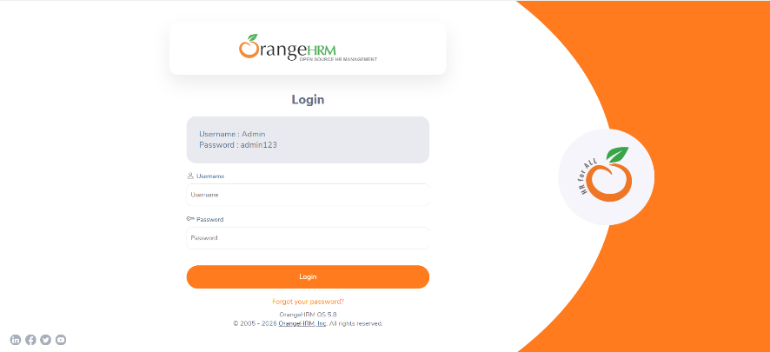
Figure 1: SC-01
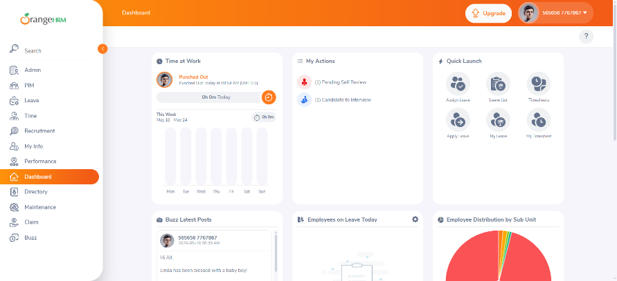
Figure 2: SC-02
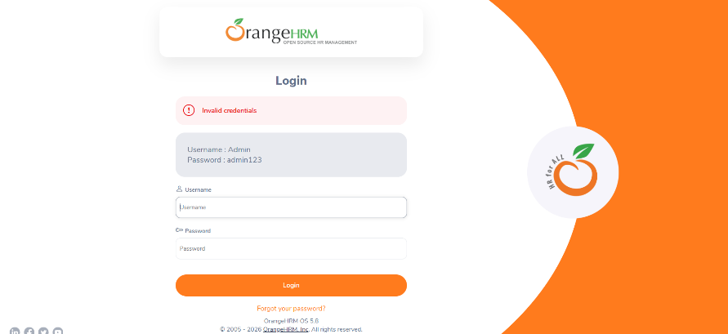
Figure 3: SC-03
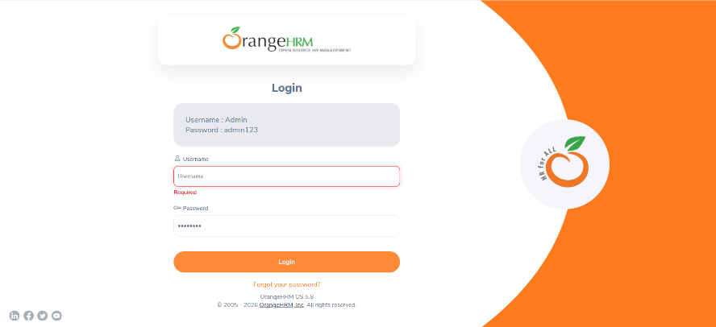
Figure 4: SC-04
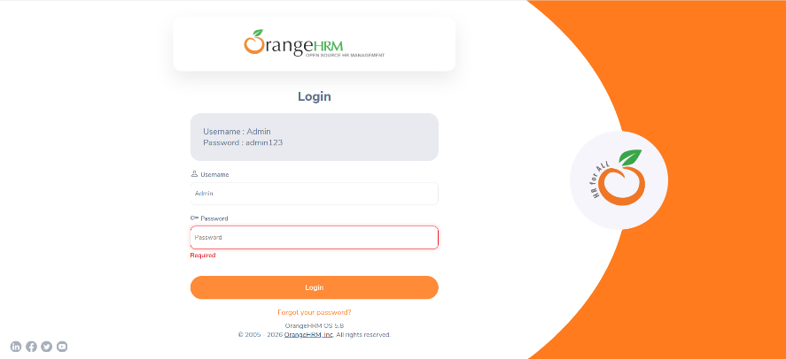
Figure 5: SC-05
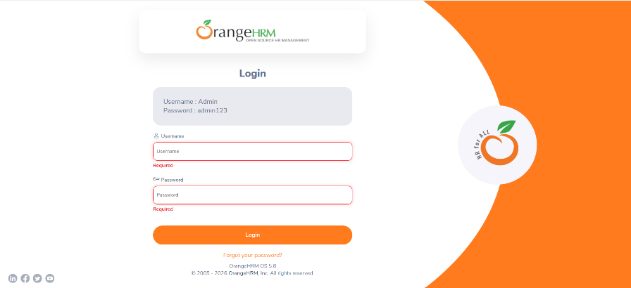
Figure 6:SC-06
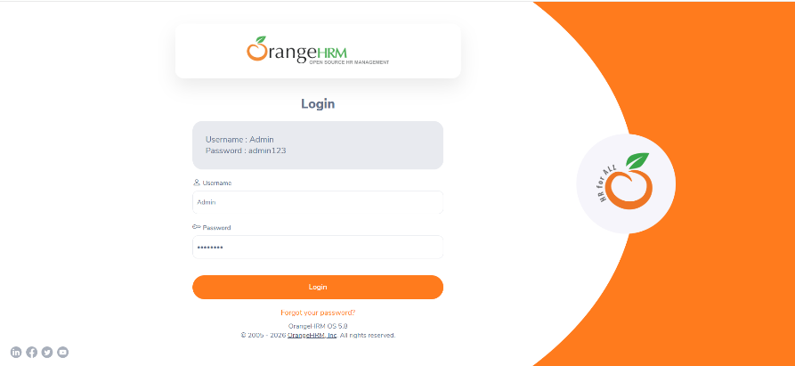
Figure 7: SC-07
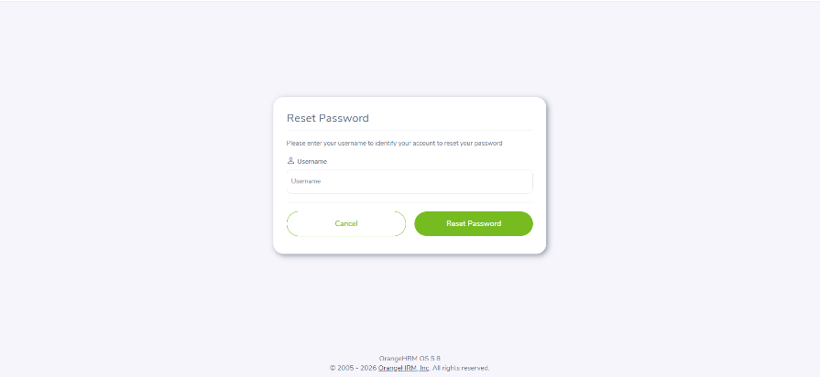
Figure 8:SC-08

CONCLUSION
A total of 10 test cases were designed and executed for the OrangeHRM Login Module.
The testing activities successfully validated authentication functionality, input validation, password masking behavior, navigation functionality, and error message handling.
All test cases passed successfully, resulting in a pass rate of 100%.
Based on the executed test cases and observed results, the Login Module is considered stable and functioning correctly under the tested conditions.

SKILLS DEMONSTRATED
- Manual Testing
- Functional Testing
- Negative Testing
- Validation Testing
- Test Case Design
- Test Execution
- Defect Reporting
- Requirements Traceability Matrix (RTM)
- Test Documentation

