Project 2
EXPLORATORY DATA ANALYSIS (EDA)

DecodeLabs Data Analytics Internship

Prepared By
Muhammad Huzaifa Waheed

Tools Used
Microsoft Excel
Pivot Tables
Power Query
Microsoft Word
GitHub

Project Objective
To perform Exploratory Data Analysis (EDA) on the provided dataset in order to identify patterns, trends, distributions, and outliers using descriptive statistics and analytical techniques.

Submission Date:
24 May 2026

Table of Contents
Project Overview 3
Dataset Overview 3
Data Quality Verification 3
Data Preparation 4
Exploratory Data Analysis (EDA) 5
Descriptive Statistics Analysis 5
Trend Analysis 6
Product Popularity Analysis 7
Product Revenue Analysis 7
Product Quantity Sold Analysis 8
Payment Method Analysis 8
Payment Method Revenue Analysis 9
Order Status Analysis 9
Referral Source Analysis 10
Referral Source Revenue Analysis 10
Key Business Insights 11
Business Observations 11
Outlier Analysis 12
Methodology 13
Quantity Outlier Analysis 13
UnitPrice Outlier Analysis 14
ItemsInCart Outlier Analysis 15
TotalPrice Outlier Analysis 15
Outlier Summary 16
Key Insights from Outlier Analysis 17
Conclusion 17
Final Conclusion 17

Project Overview
This project was completed as part of the DecodeLabs Data Analytics Internship Project 2. The objective of this project is to perform Exploratory Data Analysis (EDA) on a raw dataset to identify meaningful patterns, trends, distributions, and outliers.
The project focuses on descriptive statistics, data quality verification, trend analysis, and business insights using Microsoft Excel and Power Query.

Dataset Overview
The dataset contains e-commerce order information including product details, customer information, payment methods, order status, coupon usage, referral sources, and pricing data.
The dataset was analyzed to understand customer purchasing behavior, payment preferences, order outcomes, and overall business trends.
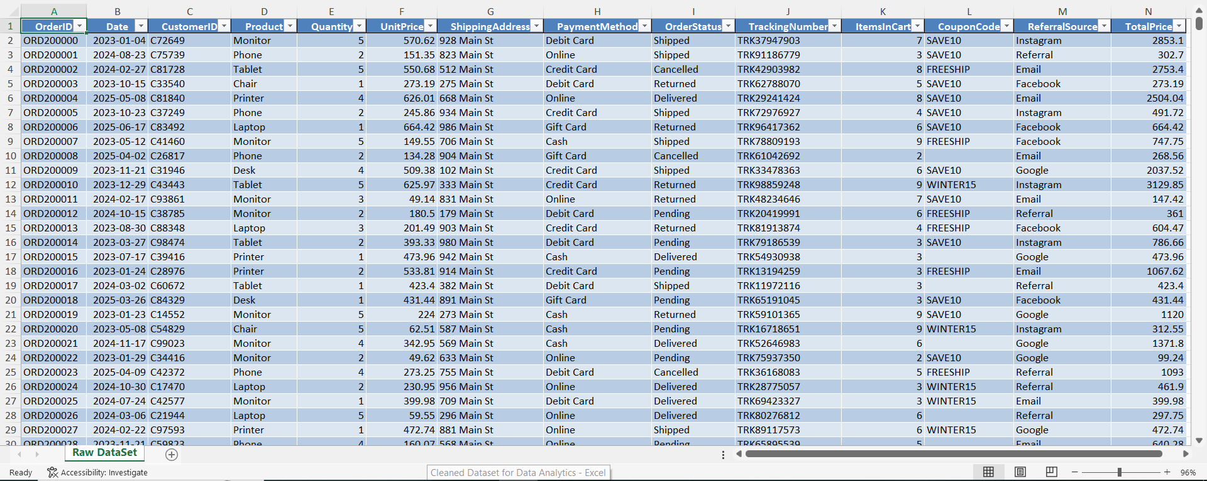

Data Quality Verification
Before starting the exploratory analysis, the dataset was inspected to verify data quality. Data profiling tools in Power Query were used to identify missing values, duplicate records, incorrect data types, and formatting inconsistencies.
The inspection confirmed that the dataset required minor preprocessing before analytical activities could begin.
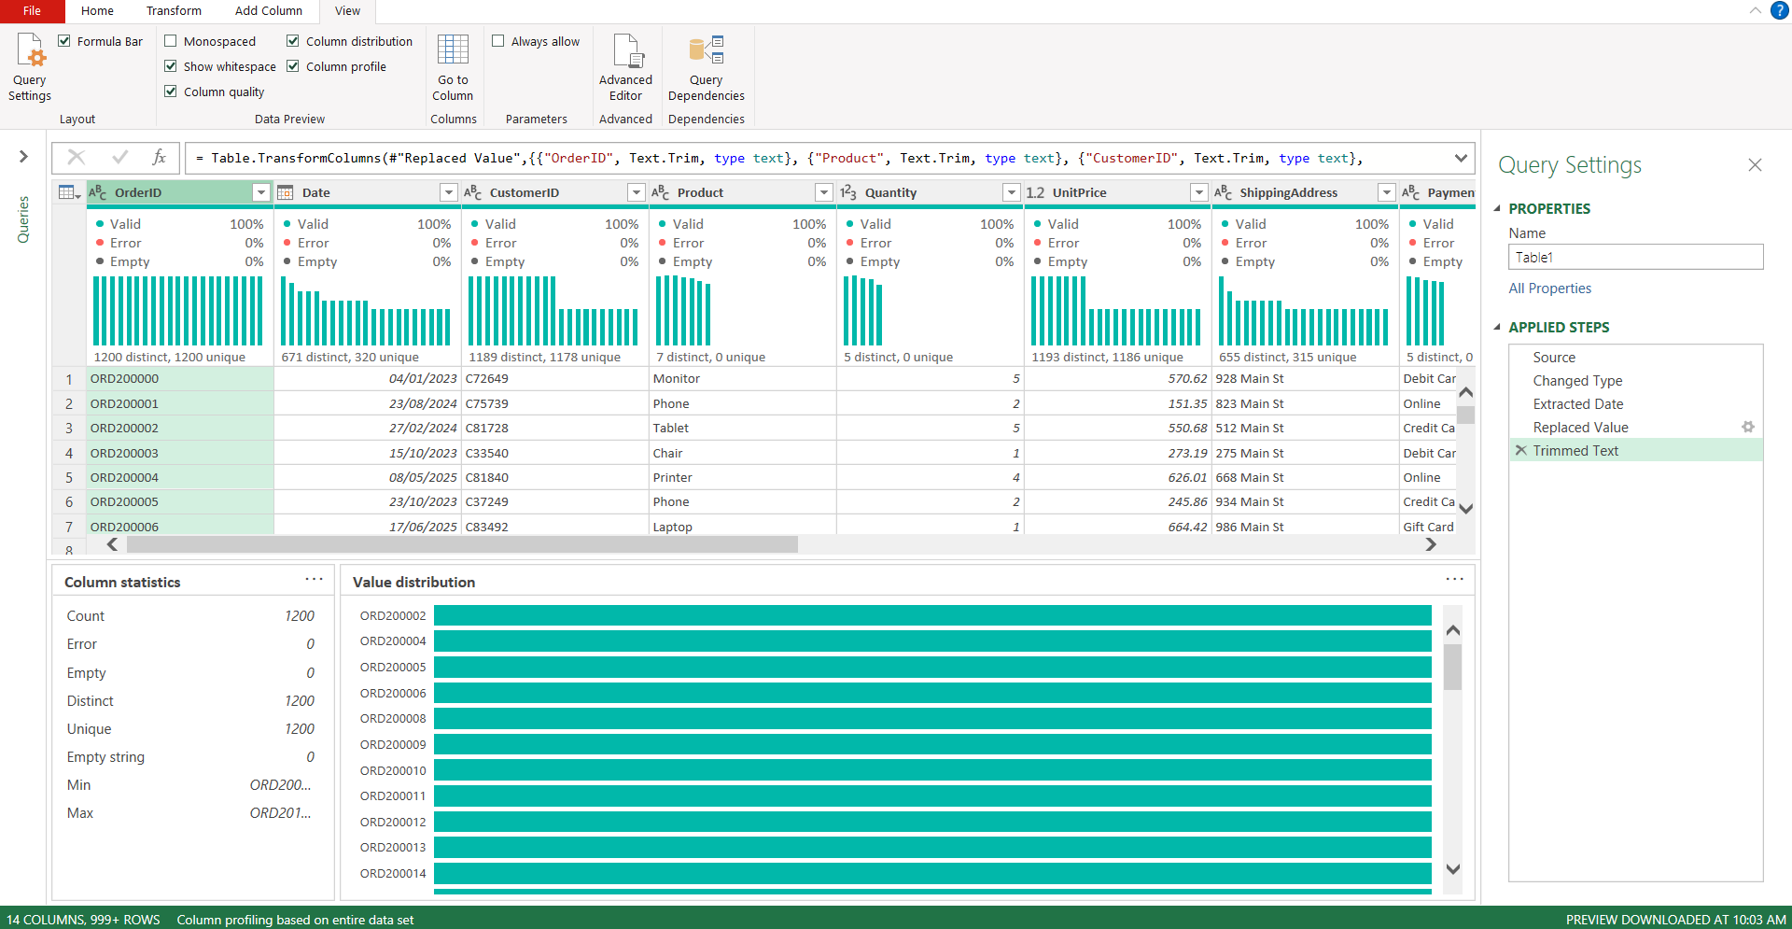

Data Preparation
Before performing exploratory data analysis, the dataset was prepared and reviewed to ensure consistency and analytical accuracy.
The preparation process included validation of records, verification of data structure, handling of missing values where required, and standardization of data formats. After preparation, a cleaned dataset was generated and used for all subsequent analyses.
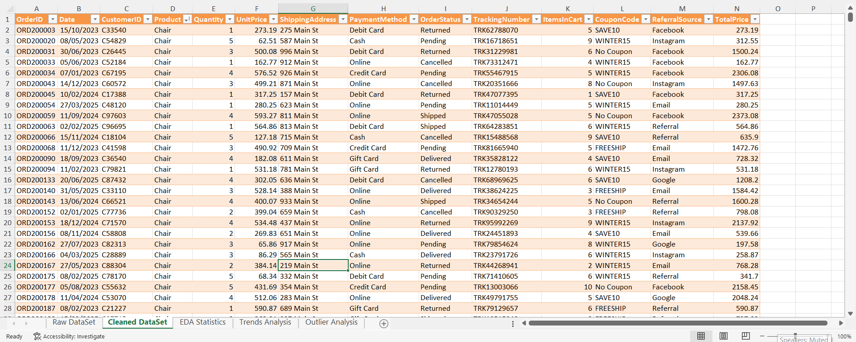

Exploratory Data Analysis (EDA)
Exploratory Data Analysis was performed to summarize the main characteristics of the dataset and identify meaningful patterns and trends.
The analysis included descriptive statistics, trend analysis, revenue analysis, and outlier detection. Pivot Tables, Pivot Charts, and Excel statistical functions were used to support the analytical process.

Descriptive Statistics Analysis
Descriptive statistics were calculated to summarize the key characteristics of the dataset and provide an overall understanding of the numerical variables.
The analysis revealed that the dataset contains 1,200 records, 7 unique products, 5 payment methods, 5 order statuses, and 5 referral sources.
The average Unit Price was 356.41, while the average Total Price was 1053.97. These values indicate the general spending pattern of customers within the dataset.
The numerical summary shows that:
- Quantity ranges from 1 to 5 units
- Unit Price ranges from 11.39 to 699.93
- Items In Cart ranges from 1 to 10
- Total Price ranges from 11.39 to 3456.40
The comparison between mean and median values indicates that most variables have relatively stable distributions, while Total Price shows greater variation due to a small number of high-value transactions.
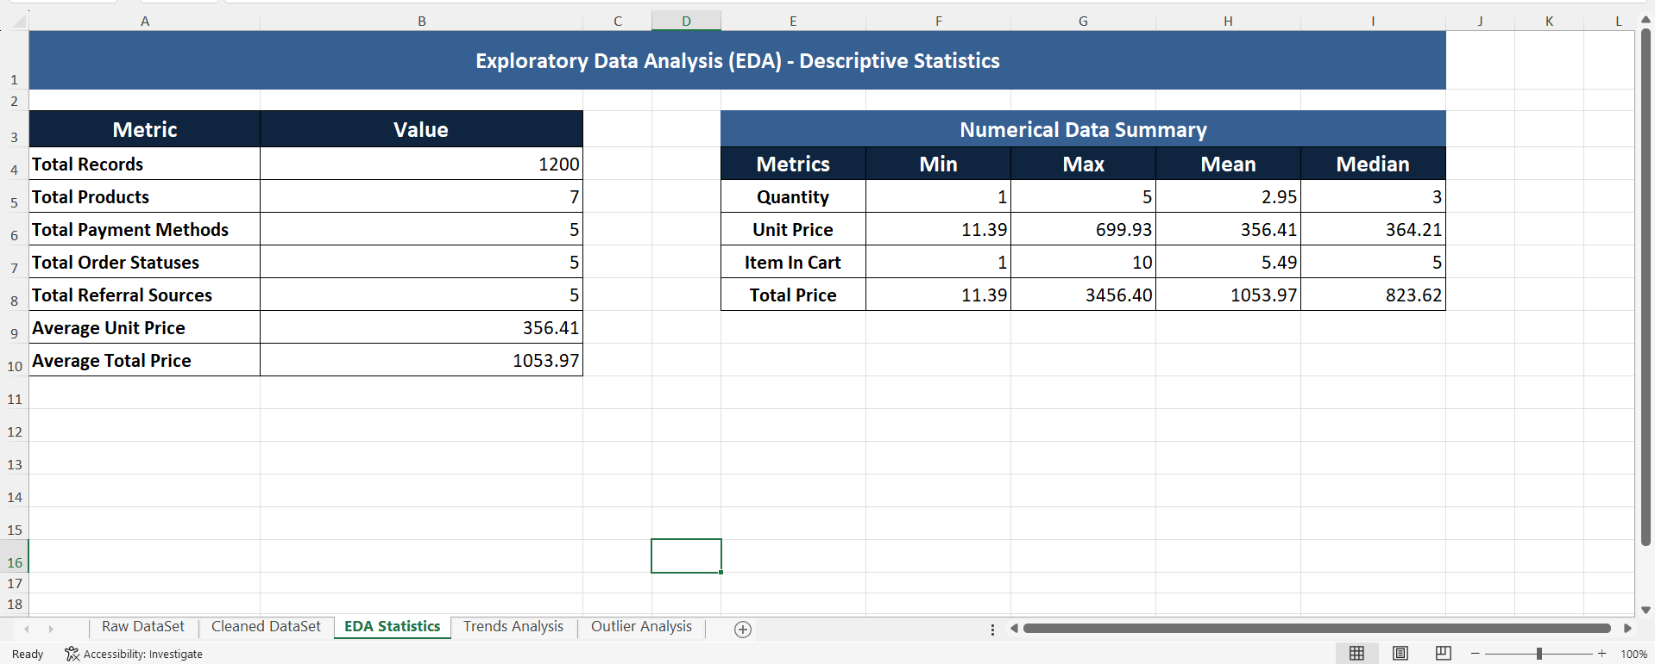

Trend Analysis
Trend analysis was performed to identify patterns in customer purchasing behavior, product performance, revenue generation, payment preferences, referral effectiveness, and order outcomes.
Pivot Tables and Pivot Charts were used to summarize and visualize business trends within the dataset. The analysis helped identify high-performing products, preferred payment methods, major referral sources, and revenue-driving factors.
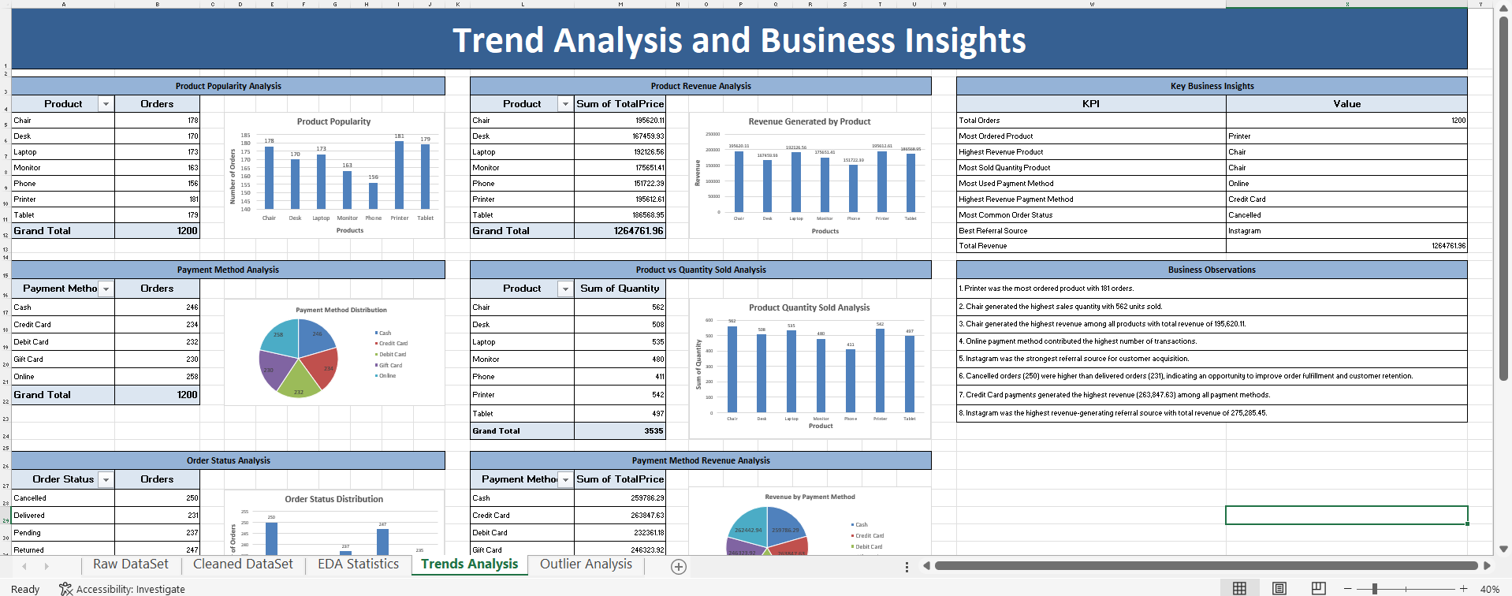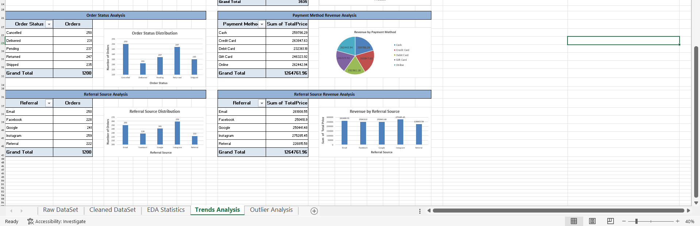

Product Popularity Analysis
Product popularity was evaluated based on the number of orders received by each product.
The analysis revealed that Printer was the most frequently ordered product with 181 orders, followed by Tablet (179 orders) and Chair (178 orders). Phone received the lowest number of orders with 156 orders.
This indicates that printers and tablets were the most preferred products among customers.
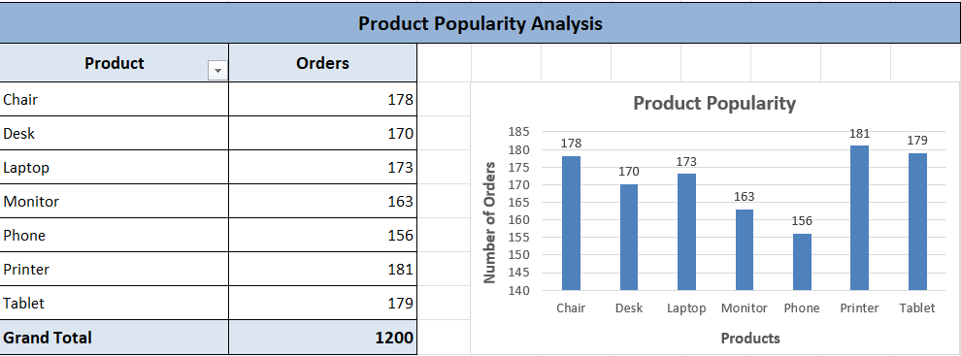

Product Revenue Analysis
Revenue analysis was conducted to determine which products contributed the most to total sales revenue.
The results showed that Chair generated the highest revenue of 195,620.11, closely followed by Printer (195,612.61) and Laptop (192,126.56).
These products contributed significantly to overall business revenue and represent the strongest-performing product categories.
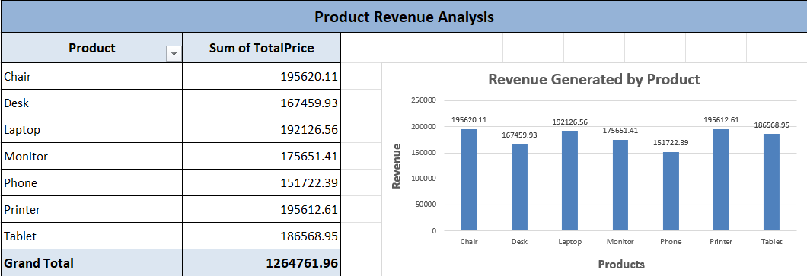

Product Quantity Sold Analysis
Product quantity analysis measured the total number of units sold for each product.
The analysis showed that Chair recorded the highest sales quantity with 562 units sold, followed by Printer (542 units) and Laptop (535 units).
This suggests that chairs experienced strong customer demand throughout the analyzed period.
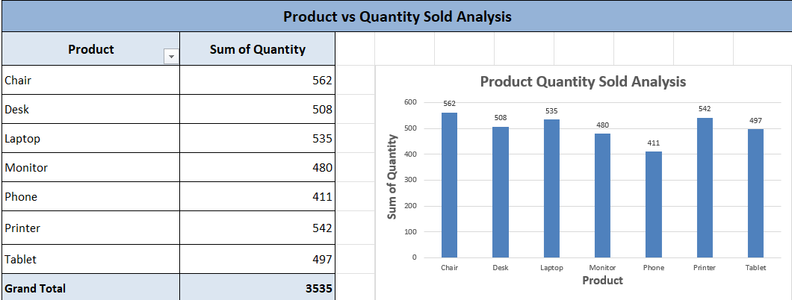

Payment Method Analysis
Payment method analysis was performed to understand customer transaction preferences.
The results indicated that Online payments were the most frequently used payment method with 258 transactions, followed by Cash (246 transactions).
This demonstrates a customer preference for digital payment channels.
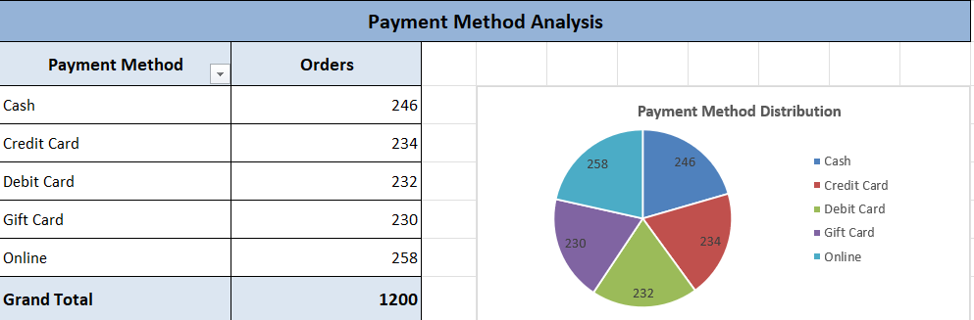

Payment Method Revenue Analysis
Revenue generated by each payment method was analyzed to determine which payment channel contributed the highest sales value.
The analysis revealed that Credit Card transactions generated the highest revenue of 263,847.63, followed by Online payments (262,442.94).
This indicates that customers using credit cards generally contributed higher-value purchases.
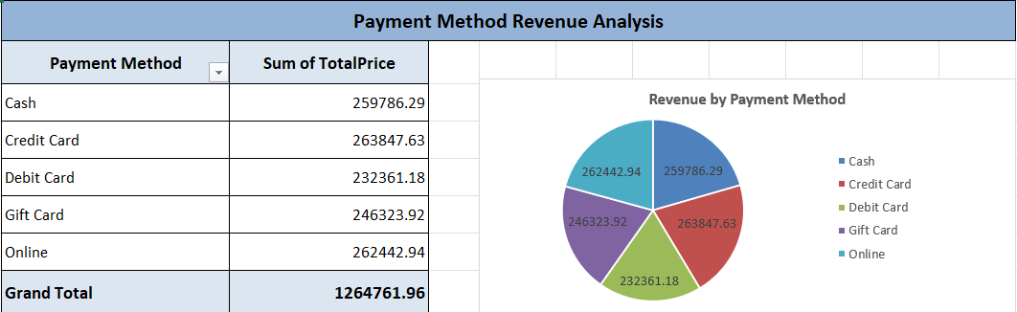

Order Status Analysis
Order status analysis was conducted to understand the distribution of completed and incomplete orders.
The results showed that Cancelled orders were the most common status with 250 records, while Delivered orders accounted for 231 records.
The difference between cancelled and delivered orders highlights a potential opportunity to improve order fulfillment and customer retention processes.
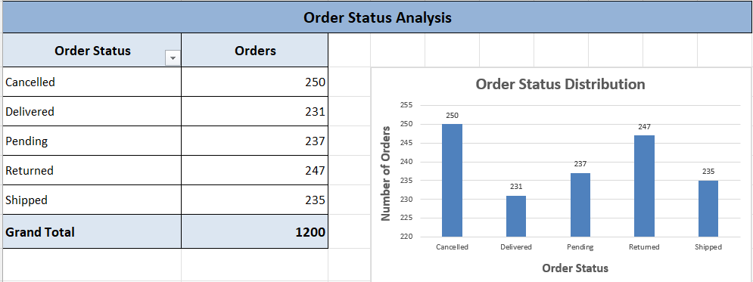

Referral Source Analysis
Referral source analysis examined how customers were acquired through different channels.
The analysis showed that Instagram generated the highest number of referrals with 259 orders, followed by Email (250 orders) and Google (241 orders).
This suggests that Instagram was the most effective customer acquisition channel within the dataset.
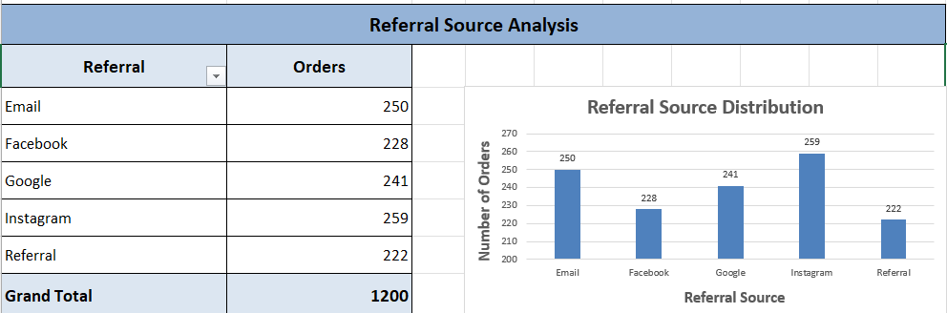

Referral Source Revenue Analysis
Revenue generated through referral channels was also evaluated.
The analysis revealed that Instagram generated the highest referral revenue of 275,285.45, making it both the most effective referral source and the strongest revenue-generating acquisition channel.
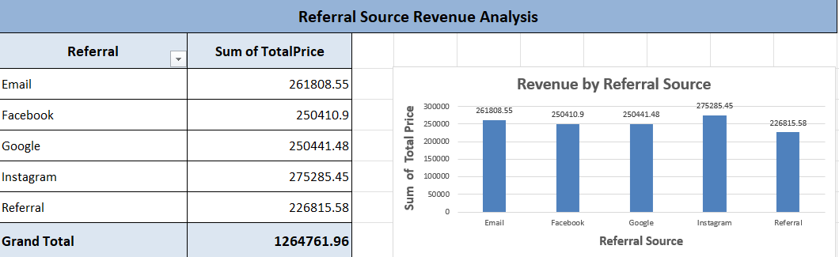

Key Business Insights
The trend analysis identified several important business performance indicators from the dataset.
The analysis revealed that the dataset contains a total of 1,200 orders. Printer was identified as the most frequently ordered product, while Chair generated the highest revenue and recorded the highest sales quantity.
Online payment was the most commonly used payment method, whereas Credit Card transactions generated the highest overall revenue. Instagram emerged as the strongest referral source for both customer acquisition and revenue generation.
These findings provide valuable insights into customer preferences, product performance, and revenue-driving factors within the business.
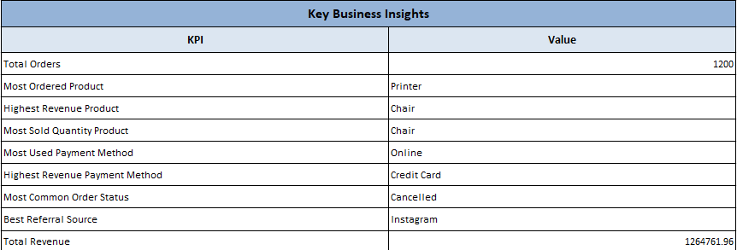

Business Observations
Based on the trend analysis, the following observations were identified:
- Printer was the most ordered product with 181 orders.
- Chair generated the highest sales quantity with 562 units sold.
- Chair generated the highest revenue among all products with a total revenue of 195,620.11.
- Online payment method contributed the highest number of transactions.
- Instagram was the strongest referral source for customer acquisition.
- Cancelled orders (250) were slightly higher than delivered orders (231), indicating an opportunity to improve order fulfillment and customer retention.
- Credit Card payments generated the highest revenue (263,847.63) among all payment methods.
- Instagram was the highest revenue-generating referral source with total revenue of 275,285.45.
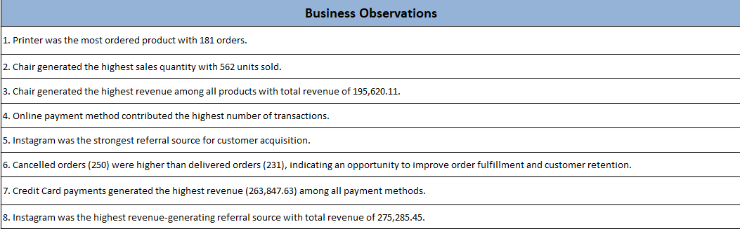

Outlier Analysis
The objective of outlier analysis was to identify unusual or extreme values within the dataset that could potentially influence statistical results and business insights. The Interquartile Range (IQR) method was used to detect outliers in key numerical variables including Quantity, UnitPrice, ItemsInCart, and TotalPrice.
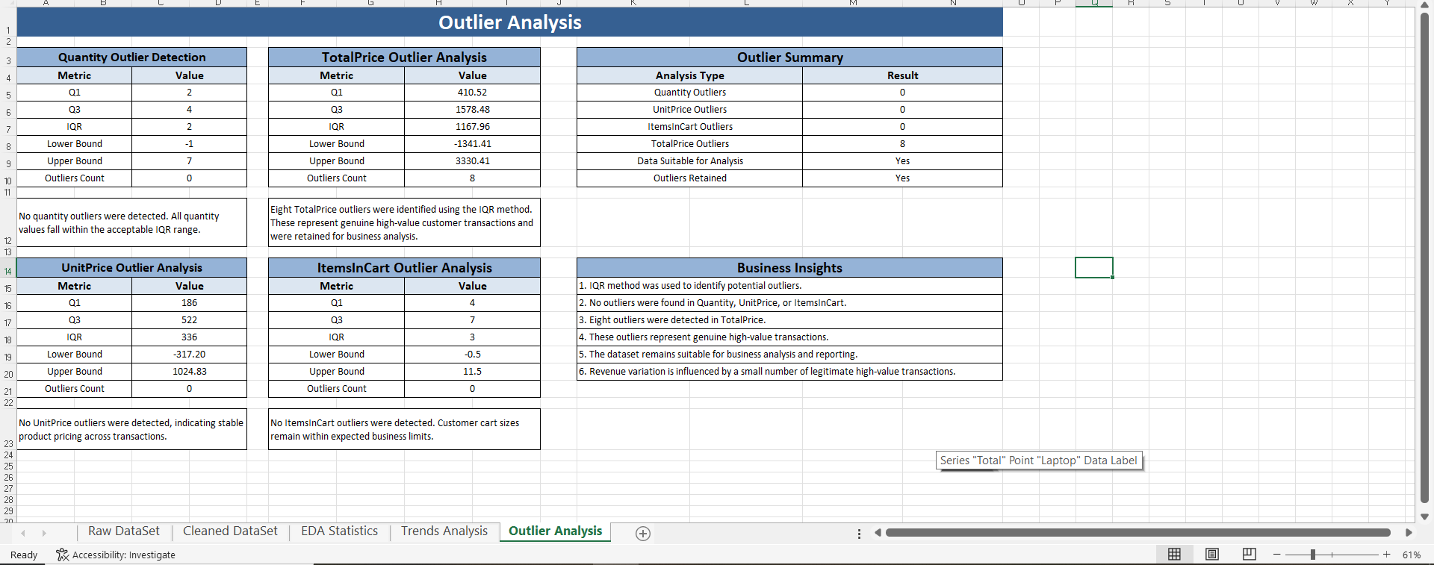

Methodology
Outliers were identified using the Interquartile Range (IQR) method.
The following calculations were performed:
- Q1 (First Quartile)
- Q3 (Third Quartile)
- IQR = Q3 − Q1
- Lower Bound = Q1 − (1.5 x IQR)
- Upper Bound = Q3 + (1.5 x IQR)
Any value falling below the lower bound or above the upper bound was considered an outlier.

Quantity Outlier Analysis
The Quantity variable was analyzed using the IQR method.
- Q1 = 2
- Q3 = 4
- IQR = 2
- Lower Bound = -1
- Upper Bound = 7
- Outliers Detected = 0
No quantity outliers were detected. All quantity values fall within the acceptable IQR range.
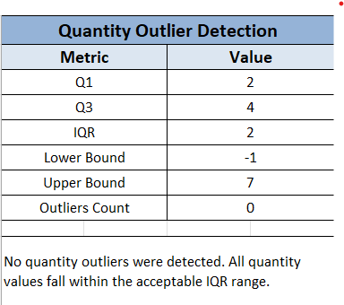

UnitPrice Outlier Analysis
The UnitPrice variable was evaluated to identify unusual product pricing values.
- Q1 = 186
- Q3 = 522
- IQR = 336
- Lower Bound = -317.20
- Upper Bound = 1024.83
- Outliers Detected = 0
No UnitPrice outliers were identified, indicating that product pricing remains consistent across transactions.
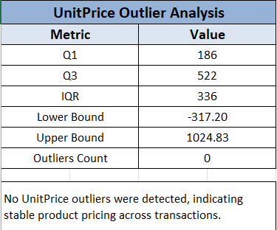

ItemsInCart Outlier Analysis
The ItemsInCart variable was analyzed to identify unusual cart sizes.
- Q1 = 4
- Q3 = 7
- IQR = 3
- Lower Bound = -0.5
- Upper Bound = 11.5
- Outliers Detected = 0
No outliers were detected for ItemsInCart, indicating that customer cart sizes remain within expected business limits.
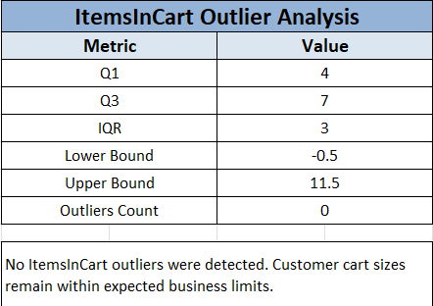

TotalPrice Outlier Analysis
The TotalPrice variable was analyzed to identify unusually high or low transaction values.
- Q1 = 410.52
- Q3 = 1578.48
- IQR = 1167.96
- Lower Bound = -1341.41
- Upper Bound = 3330.41
- Outliers Detected = 8
A total of eight outliers were detected in the TotalPrice column. These records represent legitimate high-value customer purchases and were retained for business analysis.
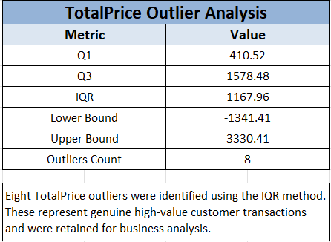

Outlier Summary
Variable | Outliers Detected
Quantity | 0
UnitPrice | 0
ItemsInCart | 0
TotalPrice | 8

The dataset remains suitable for analysis because the detected outliers are genuine business transactions rather than data entry errors.
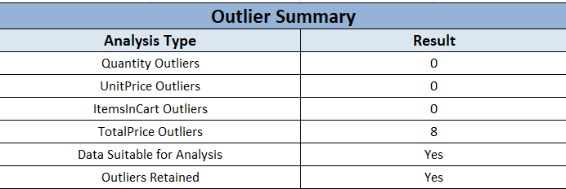

Key Insights from Outlier Analysis
- The IQR method successfully identified potential outliers.
- No outliers were found in Quantity, UnitPrice, or ItemsInCart.
- Eight outliers were detected in TotalPrice.
- The detected outliers represent legitimate high-value transactions.
- Revenue variation is influenced by a small number of high-value purchases.
- The dataset remains reliable and suitable for business reporting and decision-making.
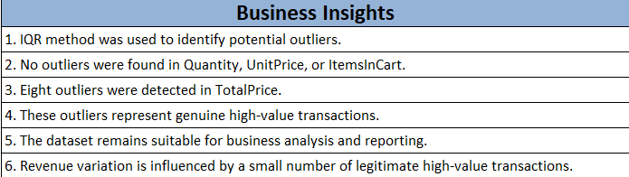

Conclusion
The outlier analysis confirmed that the dataset is generally well-balanced and free from abnormal values in most variables. Only TotalPrice contained a small number of high-value outliers, which were retained because they represent genuine customer purchases. Therefore, the dataset is considered reliable for exploratory data analysis and business insight generation.

Final Conclusion
This Exploratory Data Analysis (EDA) project successfully examined the e-commerce dataset using Microsoft Excel, Power Query, Pivot Tables, and statistical analysis techniques.
The analysis provided valuable insights into customer purchasing behavior, product performance, payment preferences, referral effectiveness, and revenue generation. Descriptive statistics helped summarize key numerical characteristics, while trend analysis identified important business patterns.
Outlier detection using the IQR method revealed only a small number of high-value transactions in the TotalPrice variable, which were retained as valid business records. Overall, the dataset was found to be clean, reliable, and suitable for analytical reporting.
The findings generated through this project can support business decision-making, performance monitoring, and future data-driven strategies.

