PROJECT 1
DATA CLEANING
DecodeLabs Data Analytics Internship
Prepared By
Muhammad Huzaifa Waheed
Tools Used
Microsoft Excel
Power Query
Microsoft Word
GitHub

Project Objective
To clean a raw dataset by handling missing values, removing duplicate records, and correcting date, numeric, and text formats.

Submission Date:
22 May 2026
Table of Contents
Project Overview 3
Dataset Overview 3
Dataset Statistics 3
Dataset Import and Initial Inspection 3
Importing Dataset into Power Query 4
Data Profiling and Quality Inspection 5
Date Format Standardization 5
Duplicate Record Validation 6
Missing Values Analysis 7
Data Type Validation 7
Final Validation Results 8
Validation Table 8
Final Cleaned Dataset 8
Transformation Summary Table 9
Project Deliverables 9
Conclusion 10

Project Overview
This project was completed as part of the DecodeLabs Data Analytics Internship Project 1. The objective of the project is to clean and prepare a raw dataset for analysis by handling missing values, removing duplicate records, and correcting inconsistent data formats.
The project was completed using Microsoft Excel Power Query, which provides an efficient and professional workflow for data transformation and cleaning.

Dataset Overview
The dataset was provided in Excel format and contained multiple columns with text, numeric, and date values. During the initial inspection, several data quality issues were identified, including missing values, duplicate records, inconsistent text formatting, and incorrect date formats.
Power Query profiling tools were used to inspect column quality, column distribution, and data consistency before starting the cleaning process.

Dataset Statistics
- Total Records: 1200
- Total Columns: 14
- Text Columns: 9 (including OrderID)
- Numeric Columns: 4
- Date Columns: 1
- Unique Order IDs: 1200

Dataset Import and Initial Inspection
The raw dataset was imported into Microsoft Excel and converted into a structured table format. Initial inspection of the dataset revealed multiple columns containing text, numeric, and date-based information.
During the initial review, formatting inconsistencies were identified in the Date column, which required correction before further processing in Power Query.
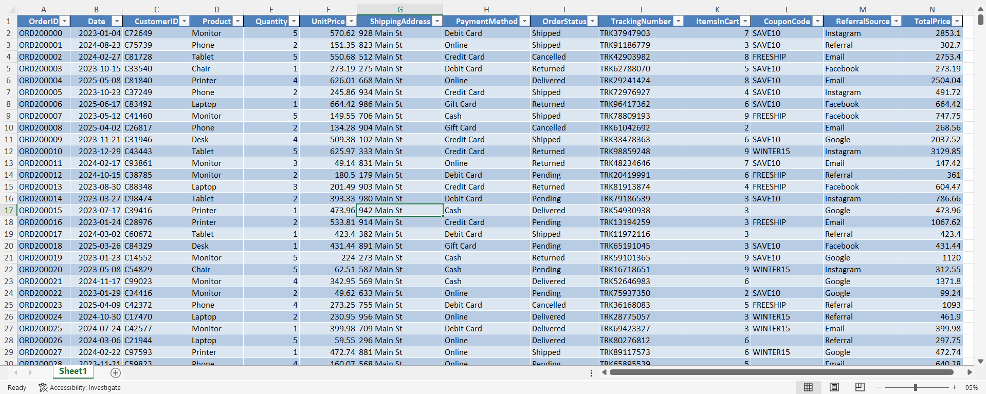
Figure 1: Raw Dataset in Excel Table Format

Importing Dataset into Power Query
After converting the dataset into a structured table, the data was imported into Microsoft Excel Power Query for further inspection and transformation.
Power Query provides advanced data cleaning and transformation capabilities, making it suitable for professional data preparation workflows.
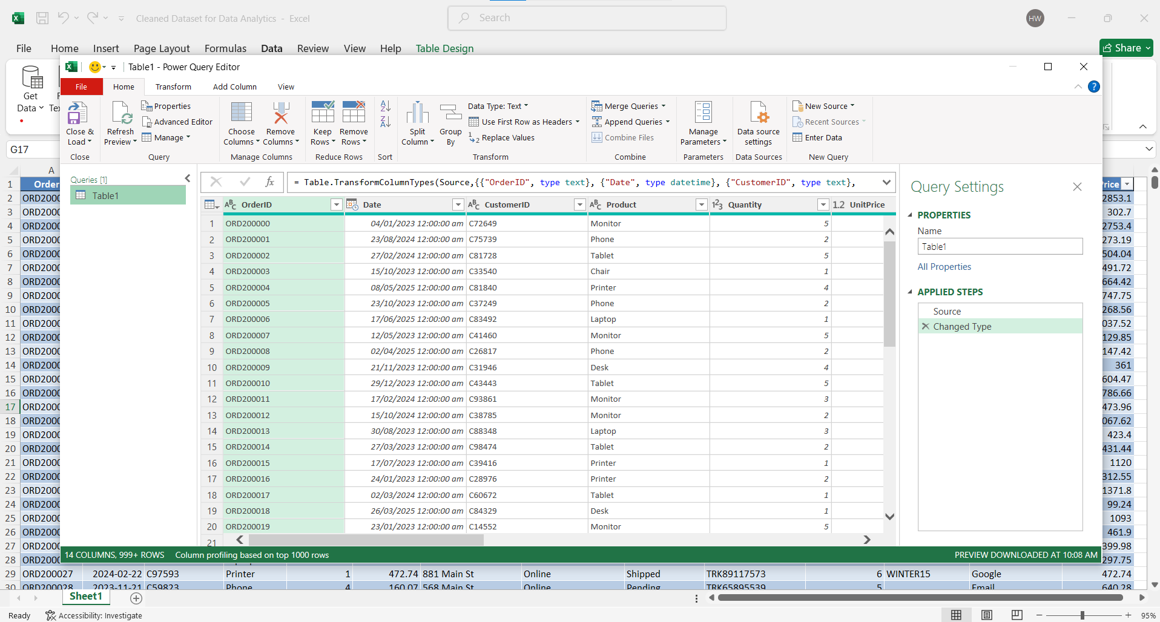
Figure 2: Dataset Imported into Power Query

Data Profiling and Quality Inspection
After importing the dataset into Power Query, data profiling tools were enabled to inspect data quality and identify inconsistencies within the dataset.
The Column Quality, Column Distribution, and Column Profile features were used to analyze valid values, empty values, duplicate entries, and overall column consistency before starting the cleaning process.
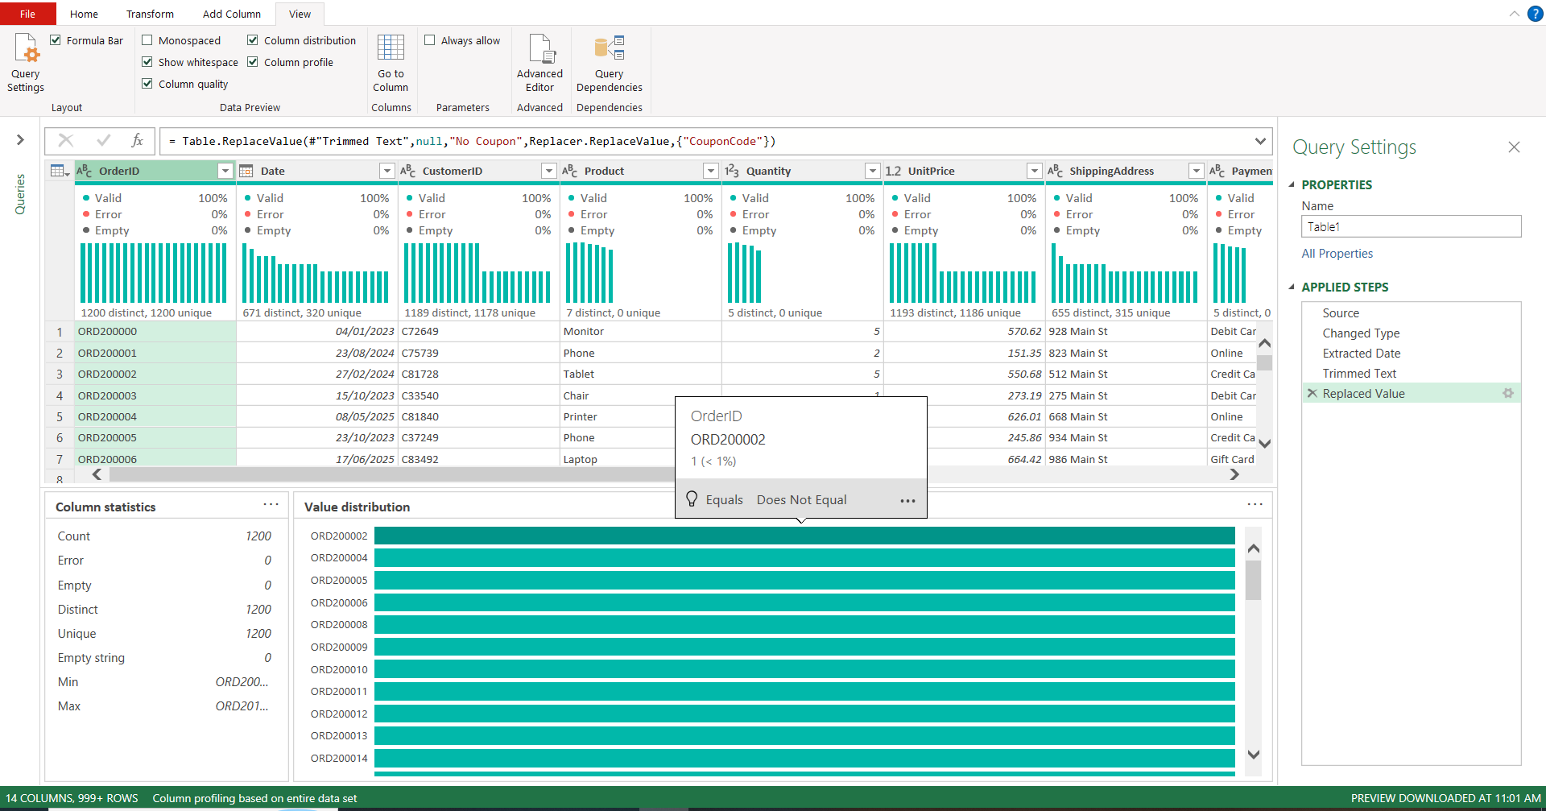
Figure 3: Data Profiling Results

Date Format Standardization
The Date column contained timestamp values with unnecessary time components. To improve consistency and prepare the dataset for analysis, the Date column was transformed into a clean date-only format using Power Query transformation tools.
This step ensured standardized date formatting across the dataset and eliminated unnecessary timestamp information.
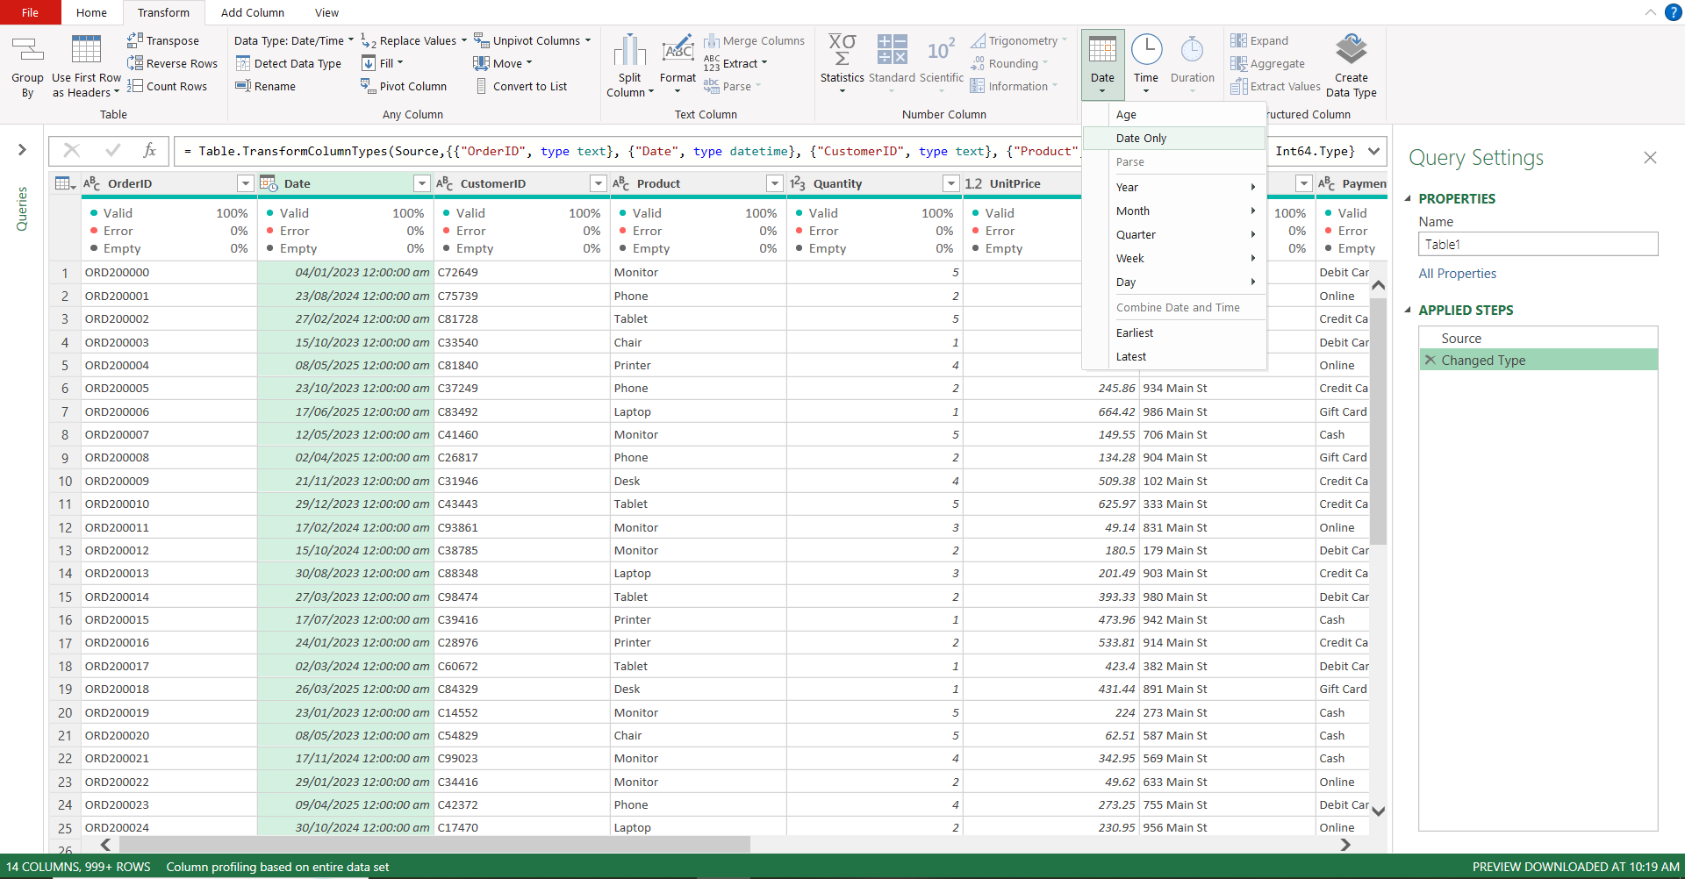
Figure 4: Date Format Standardization

Duplicate Record Validation
The OrderID column was analyzed to verify record uniqueness. Power Query statistics confirmed that all OrderID values were unique.
A total of 1200 distinct and 1200 unique Order IDs were identified, indicating that no duplicate records were present in the dataset.
This validation satisfied the project requirement of maintaining zero duplicate identifiers.
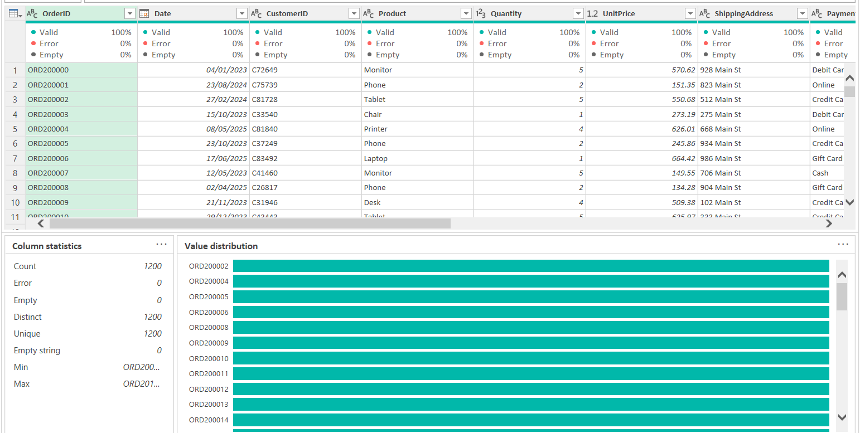
Figure 5: Duplicate Record Validation

Missing Values Analysis
During data profiling, missing values were identified in the CouponCode column. A total of 309 records contained null values, representing orders where no promotional coupon was applied.
Since the absence of a coupon code is a valid business scenario, missing values were replaced with the label "No Coupon" to improve data consistency and readability.
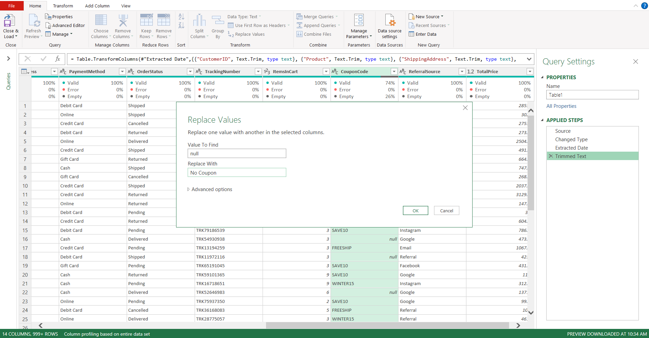
Figure 6: CouponCode Missing Values Handling

Data Type Validation
All dataset columns were reviewed to ensure appropriate data types were assigned. Text, numeric, and date columns were verified using Power Query's automatic type detection and validation features.
The Date column was assigned the Date data type, while Quantity, UnitPrice, ItemsInCart, and TotalPrice were maintained as numeric fields.
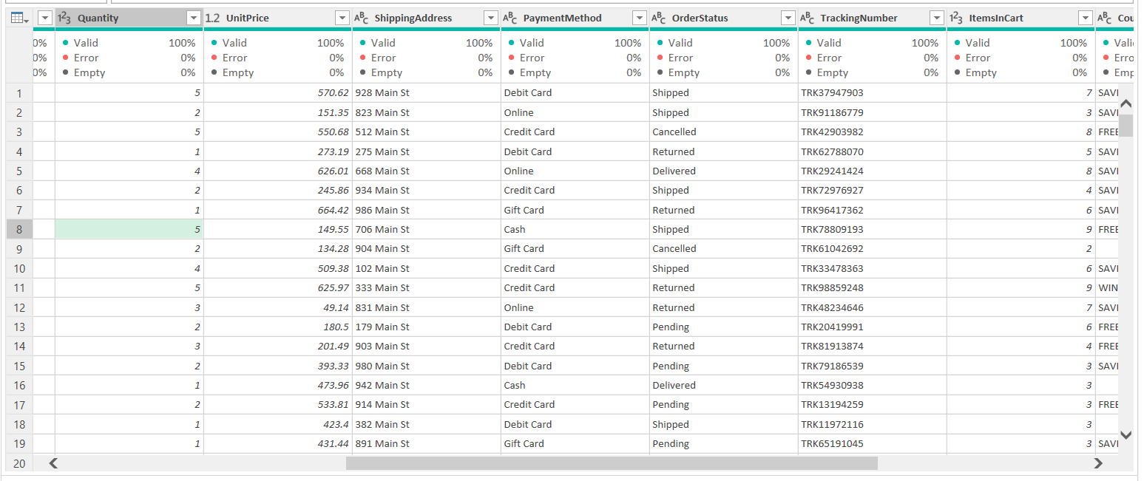
Figure 7: Data Type Validation

Final Validation Results
After completing the data cleaning process, the dataset was validated against all project requirements.

Validation Table
Validation Check | Status
Missing Values | Passed
Duplicate IDs | Passed
Date Formatting | Passed
Data Types | Passed
Data Consistency | Passed

The final dataset was confirmed to be clean, consistent, and ready for further analytical processing.

Final Cleaned Dataset
After completing all data cleaning and validation activities, the transformed dataset was loaded back into Microsoft Excel. The final dataset contained standardized date values, validated data types, unique Order IDs, and properly handled missing values.
The cleaned dataset is now ready for data analysis, reporting, dashboard creation, and business decision-making processes.
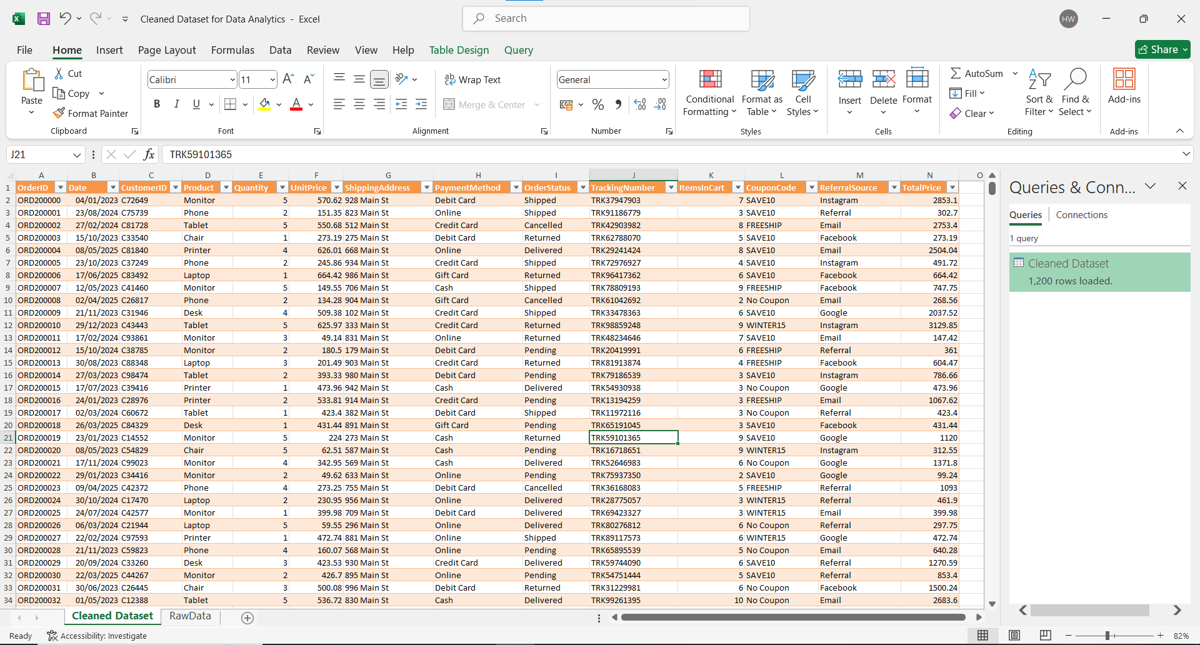
Figure 8: Final cleaned dataset loaded into Microsoft Excel after Power Query transformations

Transformation Summary Table
Step | Action Performed
1 | Converted dataset into Excel Table
2 | Imported data into Power Query
3 | Enabled Data Profiling
4 | Standardized Date Format
5 | Validated Unique Order IDs
6 | Replaced Null Coupon Codes with "No Coupon"
7 | Verified Data Types
8 | Final Validation Completed

Project Deliverables
- Raw Dataset (Dataset for Data Analytics.xlsx)
- Cleaned Dataset (Cleaned_Dataset.xlsx)
- Data Cleaning Report (.docx)
- Data Cleaning Report (.pdf)
- Power Query Transformation Steps
- Project Screenshots

Conclusion
This project provided practical experience in data cleaning and preparation using Microsoft Excel Power Query. The dataset was successfully inspected, validated, and standardized according to professional data quality practices.
Through this project, key data analytics skills such as data profiling, validation, transformation, and documentation were applied. The final dataset is now suitable for reporting, dashboard creation, and advanced analytical tasks.

