Project 3
SQL Data Analysis

DecodeLabs Data Analytics Internship

Prepared By
Muhammad Huzaifa Waheed

Tools Used
Microsoft SQL Server
Microsoft Excel
Microsoft Word
GitHub

Project Objective
To perform SQL-based data analysis on an e-commerce dataset using SQL queries for filtering, sorting, grouping, and aggregation in order to generate meaningful business insights.

Submission Date
June 2026

Project Overview
This project was completed as part of the DecodeLabs Data Analytics Internship Project 3.
The objective of this project is to use SQL queries to extract, analyze, and summarize business information from an e-commerce dataset. SQL Server was used to perform data retrieval, filtering, sorting, grouping, and aggregation operations.
The project demonstrates the practical use of SQL fundamentals including SELECT, WHERE, ORDER BY, GROUP BY, COUNT(), SUM(), and AVG() functions to generate business insights from transactional data.

Dataset Overview
The dataset contains e-commerce transaction records including Order ID, Customer ID, Product, Quantity, Unit Price, Payment Method, Order Status, Referral Source, Coupon Code, Items in Cart, and Total Price.
The dataset was analyzed to understand customer purchasing behavior, product performance, revenue generation, payment preferences, and order processing trends.

Data Preparation
Before importing the dataset into SQL Server, the data was reviewed to ensure consistency and accuracy.
The dataset was prepared with standardized date formats, validated records, consistent data types, and complete business information. The cleaned dataset was then used as the source for SQL analysis.
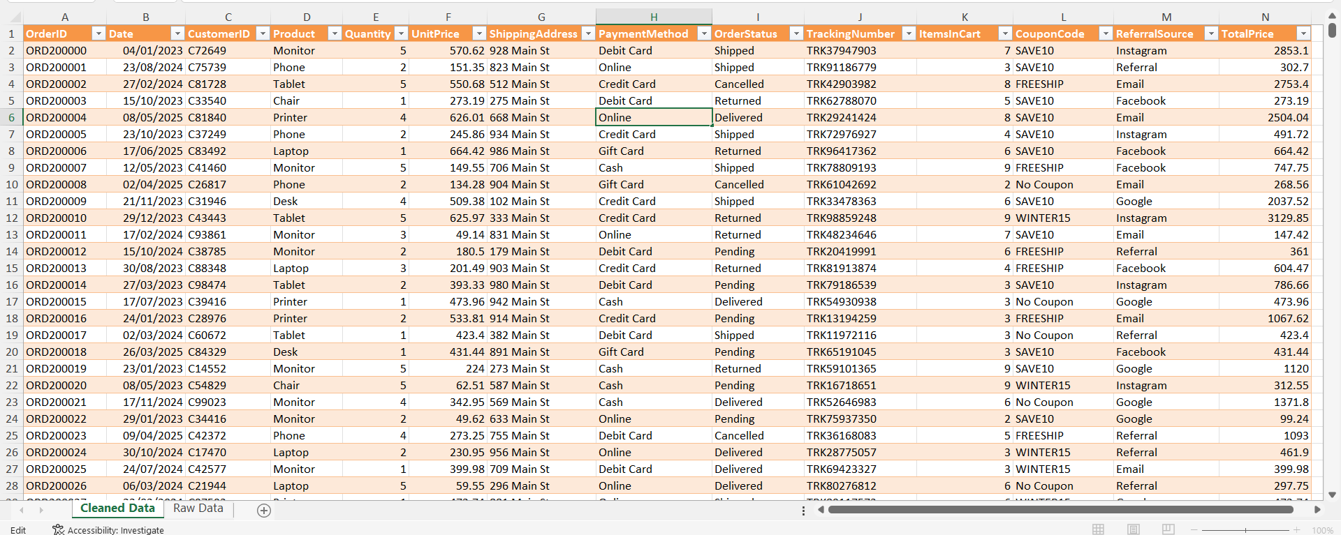

Working in SQL

Database Creation
To perform SQL-based analysis, a dedicated database named ECommerceAnalysis was created in Microsoft SQL Server. Creating a separate database helps organize project data and provides a structured environment for executing SQL queries and storing analytical results.
The database serves as the central repository for all e-commerce transaction records used throughout this project.
The following SQL command was used to create the database:
CREATE DATABASE ECommerceAnalysis;
After creation, the database was selected as the active working environment using:
USE ECommerceAnalysis;
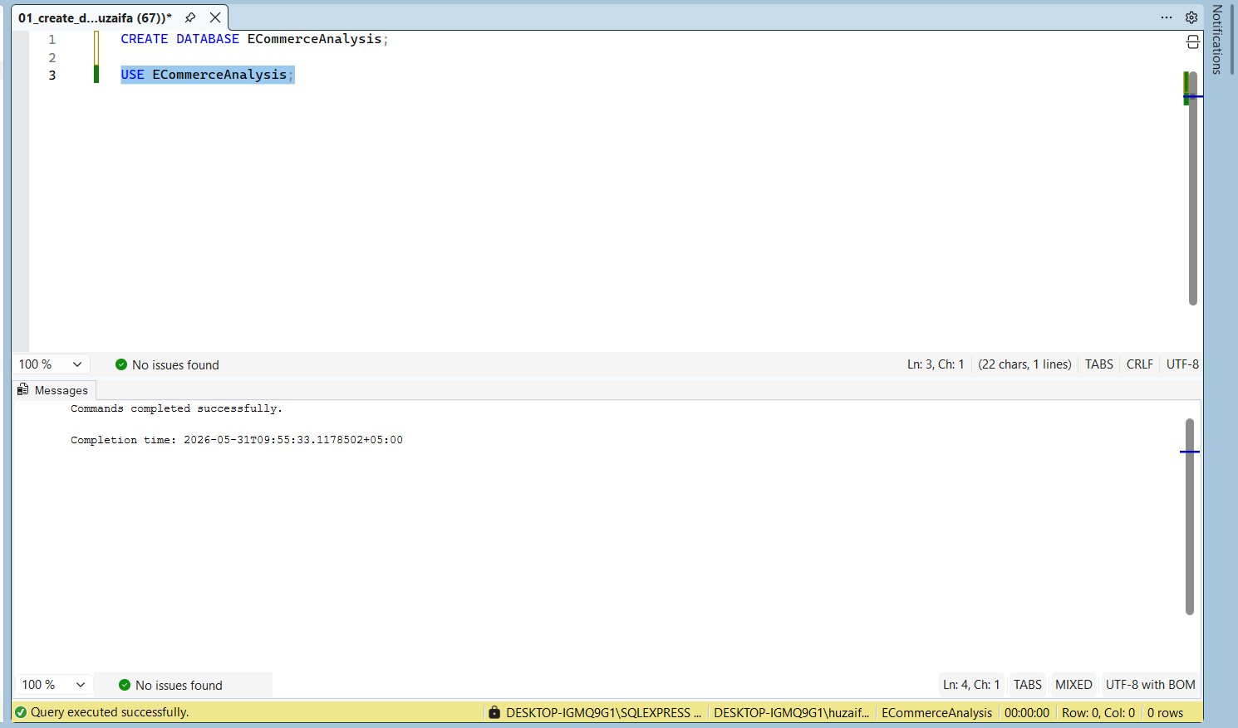

Table Creation
After creating the database, a table named Orders was created to store the e-commerce transaction records. The table structure was designed based on the dataset columns and included fields related to customer information, product details, payment methods, order status, referral sources, coupon codes, and revenue.
Appropriate SQL data types such as VARCHAR, INT, and DECIMAL were assigned to ensure accurate storage and analysis of data. During the initial implementation, the OrderDate column was defined using the DATE data type. However, while importing data from Excel, SQL Server generated date conversion errors because the source file contained date values in a format that was not directly compatible with the DATE field during the import process.
To ensure successful data loading, the OrderDate column was temporarily defined as VARCHAR(50) during the import stage. This approach allowed all records to be imported successfully without data loss. Date conversion and validation can be performed later during data analysis if required.
The Orders table serves as the primary data source for all SQL queries and analytical operations performed during this project.
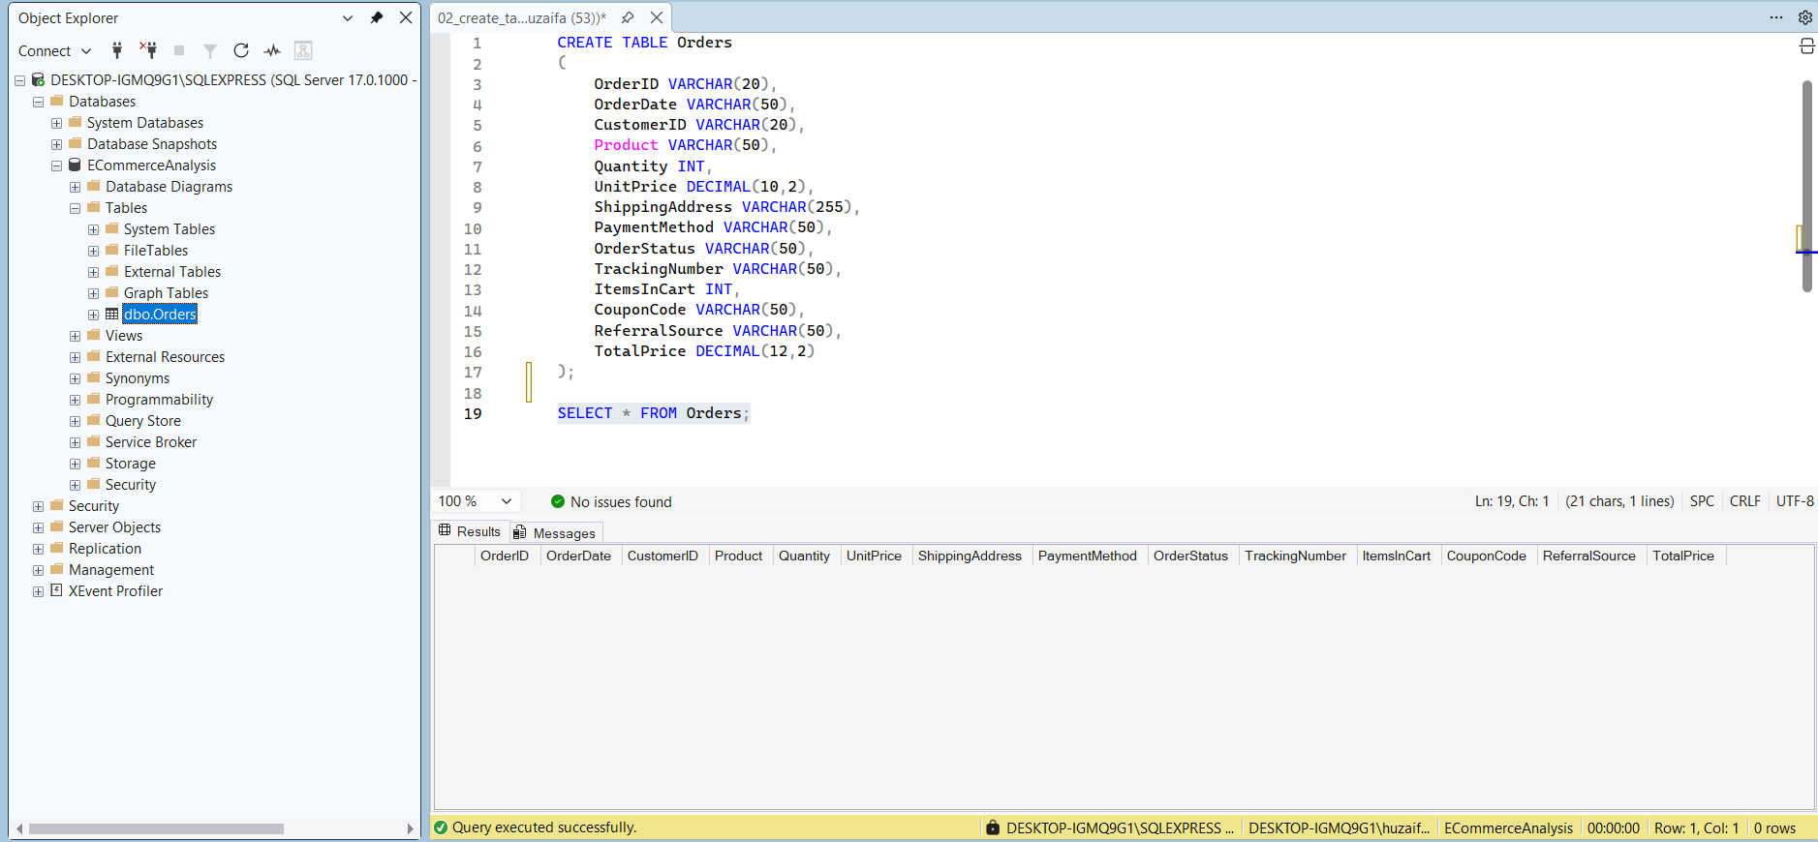

Data Import Process
After creating the Orders table, the cleaned dataset was imported into SQL Server using the SQL Server Import and Export Wizard. During the import process, column mappings and data type conversions were carefully reviewed to ensure compatibility between the Excel dataset and the SQL Server table structure.
Special attention was given to the OrderDate column because of date format conversion issues encountered during the initial import attempt. After adjusting the table structure, the dataset was imported successfully.
The import operation transferred all transaction records from the Excel dataset into the Orders table. This step established the foundation for performing SQL-based analysis, data exploration, and business reporting.
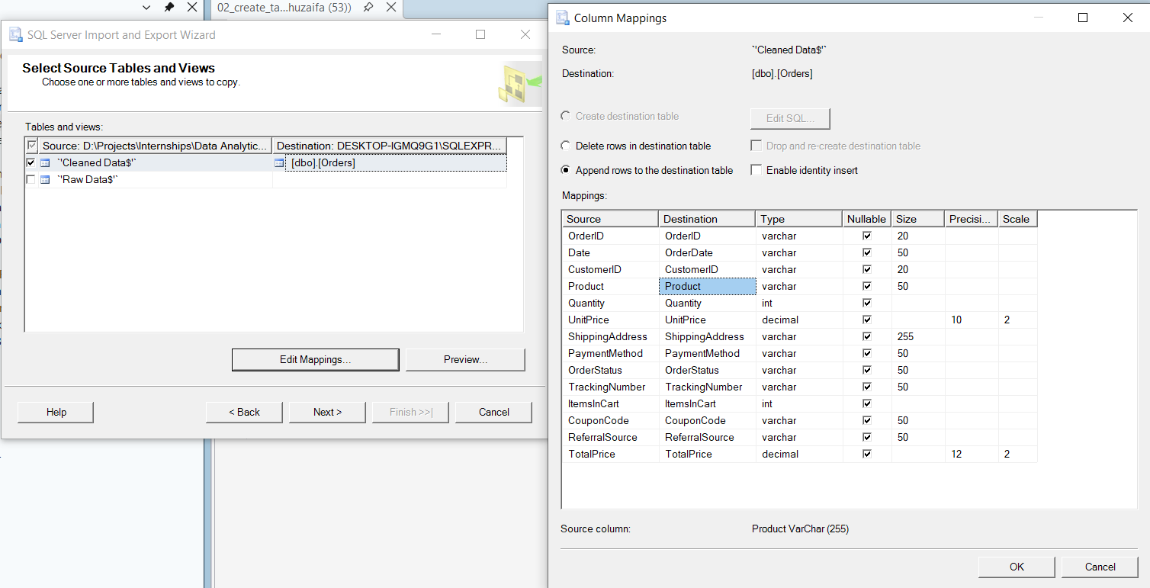
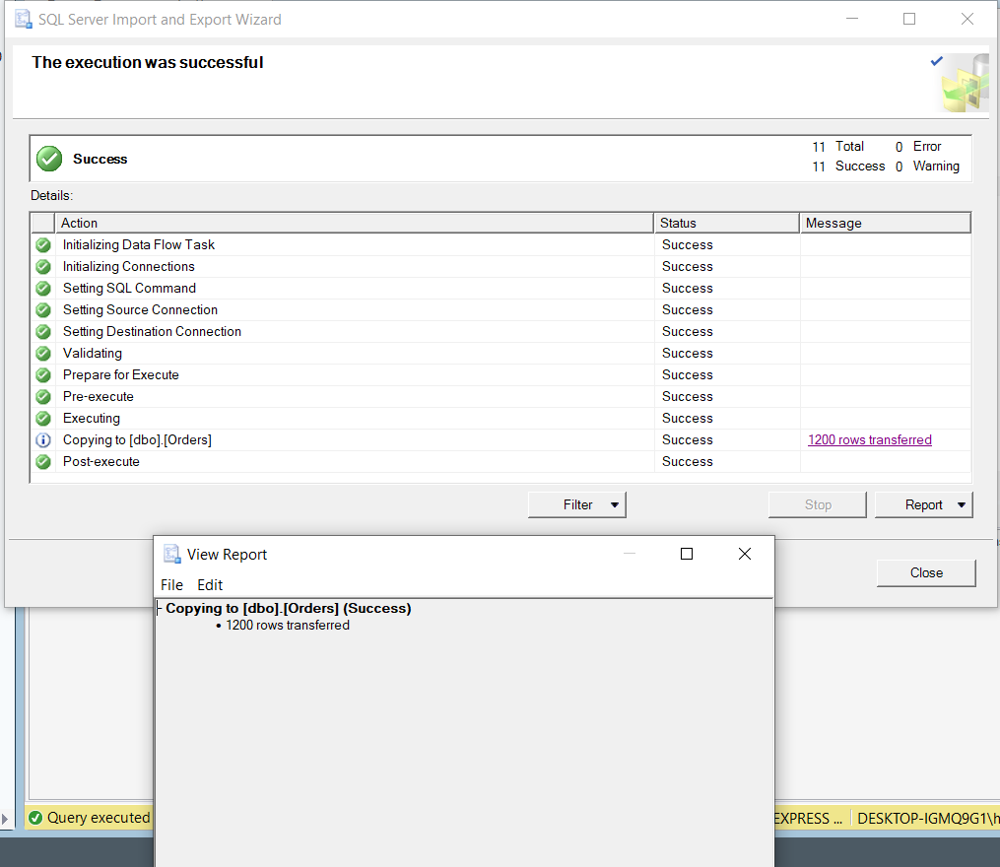

Data Type Conversion and Table Migration
During the data import process, a compatibility issue was encountered with the OrderDate column. The original Orders table defined the OrderDate field using the DATE data type. However, SQL Server generated conversion errors while importing date values from the Excel dataset due to format inconsistencies.
To resolve this issue, the OrderDate column was temporarily stored as VARCHAR(50) during the import stage. After the dataset was successfully imported, a new table named Orders_New was created with the OrderDate field defined as the DATE data type.
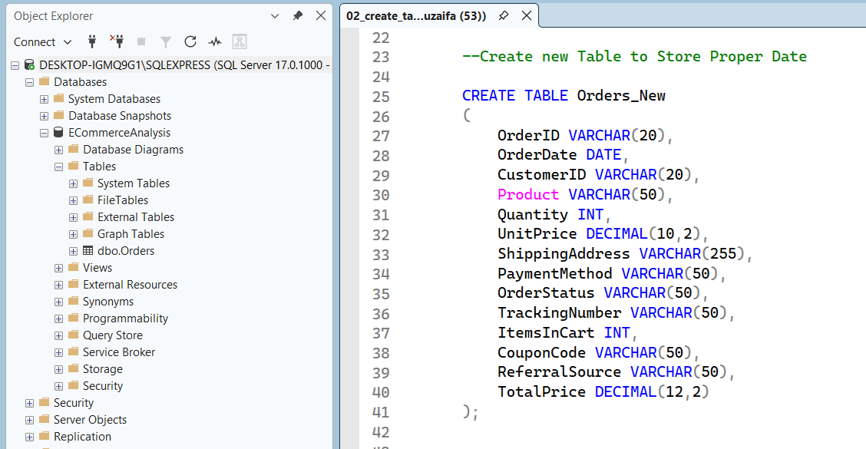
The TRY_CONVERT() function was used to safely convert the imported date values into the DATE format while transferring records from the Orders table to the Orders_New table.
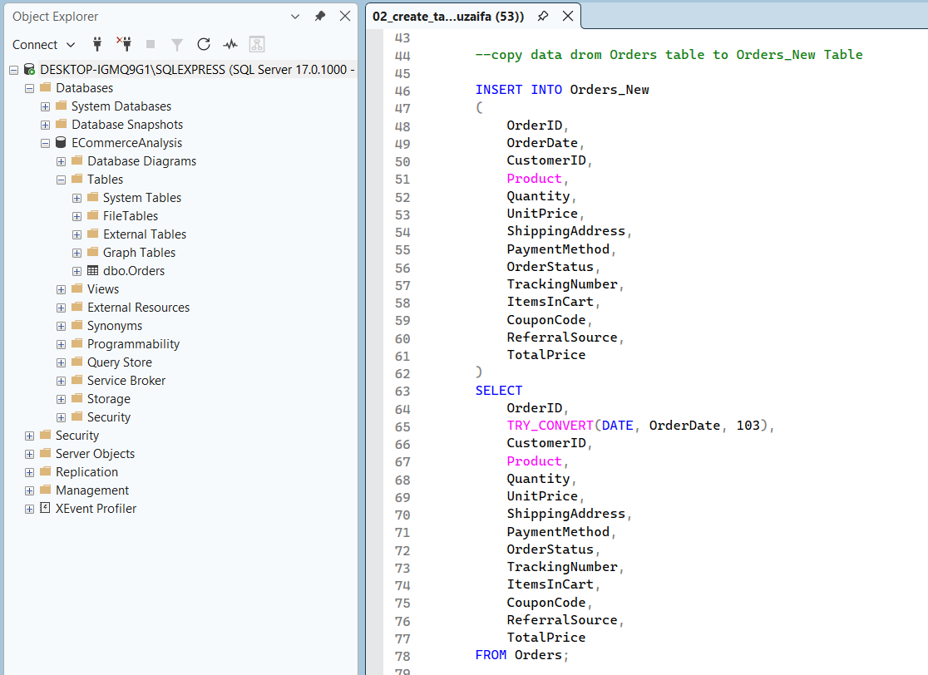
After verifying that all records were transferred successfully, the original Orders table was removed and the Orders_New table was renamed to Orders.
This process ensured that the final database structure contained the correct DATE data type while preserving all imported records.
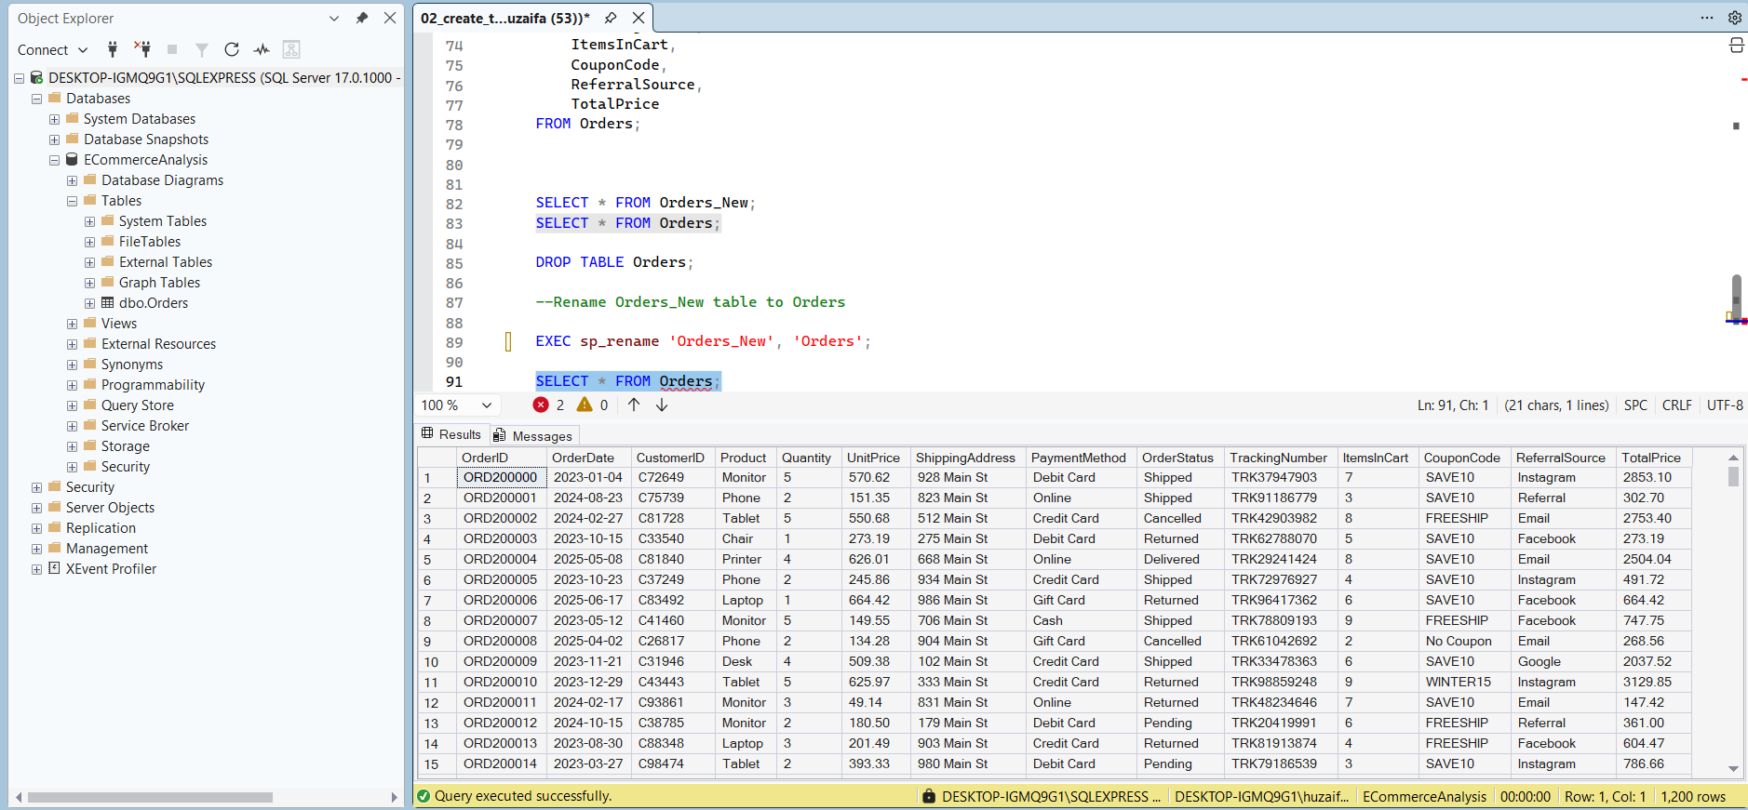

Data Verification
After completing the data import and migration process, a verification query was executed to ensure that all records were successfully transferred to the final Orders table.
The verification process involved displaying sample records from the table and confirming that all columns, including the OrderDate field, contained valid data.
The results confirmed that the dataset was successfully imported and was ready for SQL-based analysis.
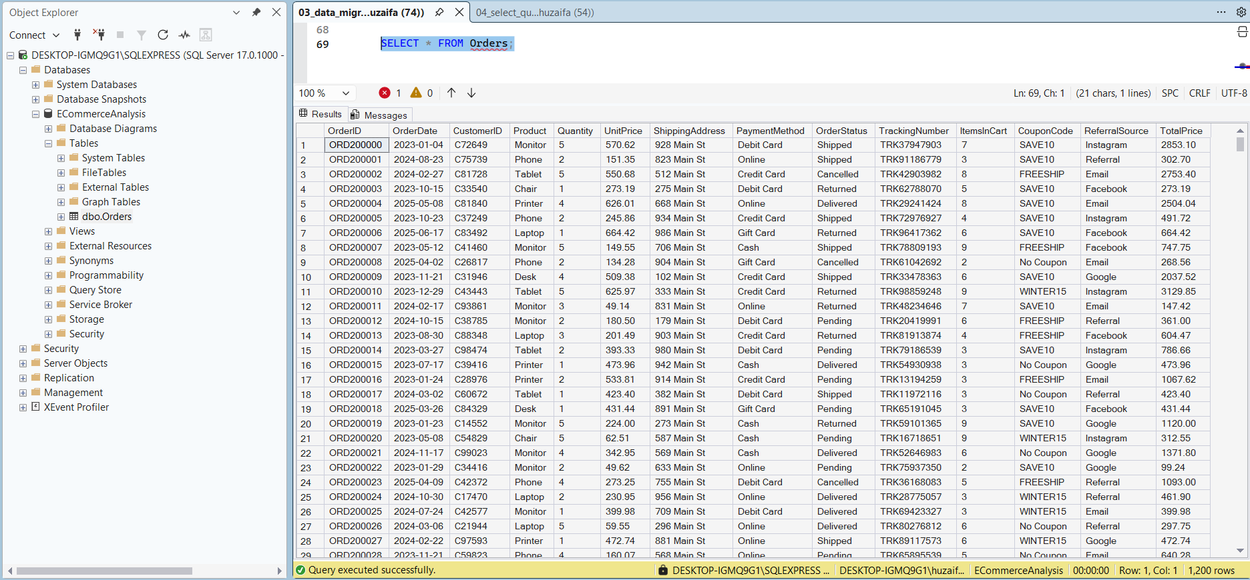

SQL Query Analysis
After verifying the imported dataset, several SQL queries were executed to retrieve, filter, sort, group, and summarize data. These queries demonstrate the practical implementation of SQL fundamentals and provide meaningful business insights from the e-commerce dataset.

Section 1. SQL Fundamentals (Internship Requirements)

Query 1. Retrieve All Records Using SELECT
The SELECT statement was used to retrieve all records from the Orders table. This query provides a complete view of the dataset and helps analysts understand the available information before performing advanced analysis.

Analysis
The query returned all 1,200 transaction records stored in the Orders table. The output included customer information, product details, order dates, payment methods, order statuses, referral sources, coupon codes, and revenue information.
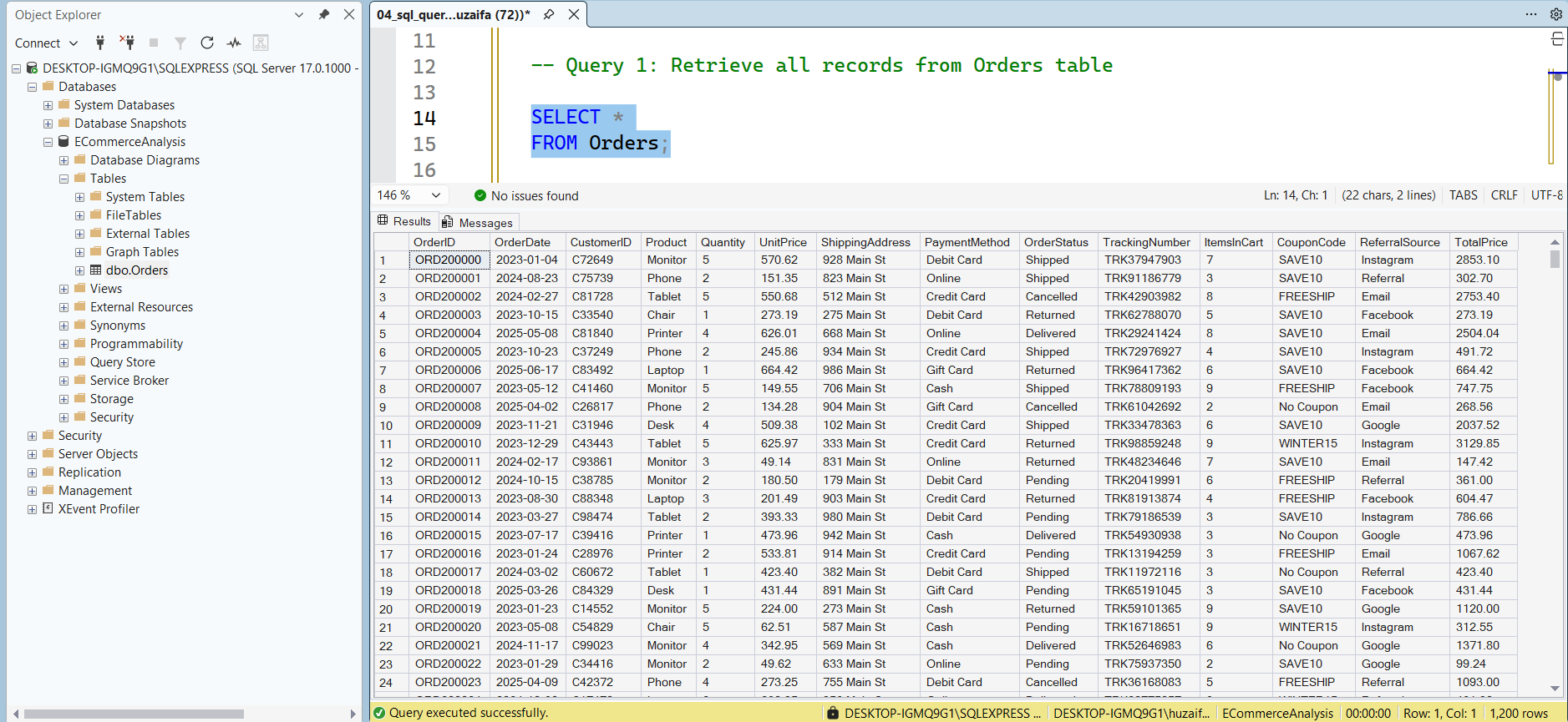

Query 2. Filter Records Using WHERE Clause
The WHERE clause was used to retrieve only those records that satisfy a specific condition.

Analysis
The query displayed transactions completed using the Online payment method. The results showed a significant number of customers preferred online payments, demonstrating how SQL can be used to filter records based on business requirements.
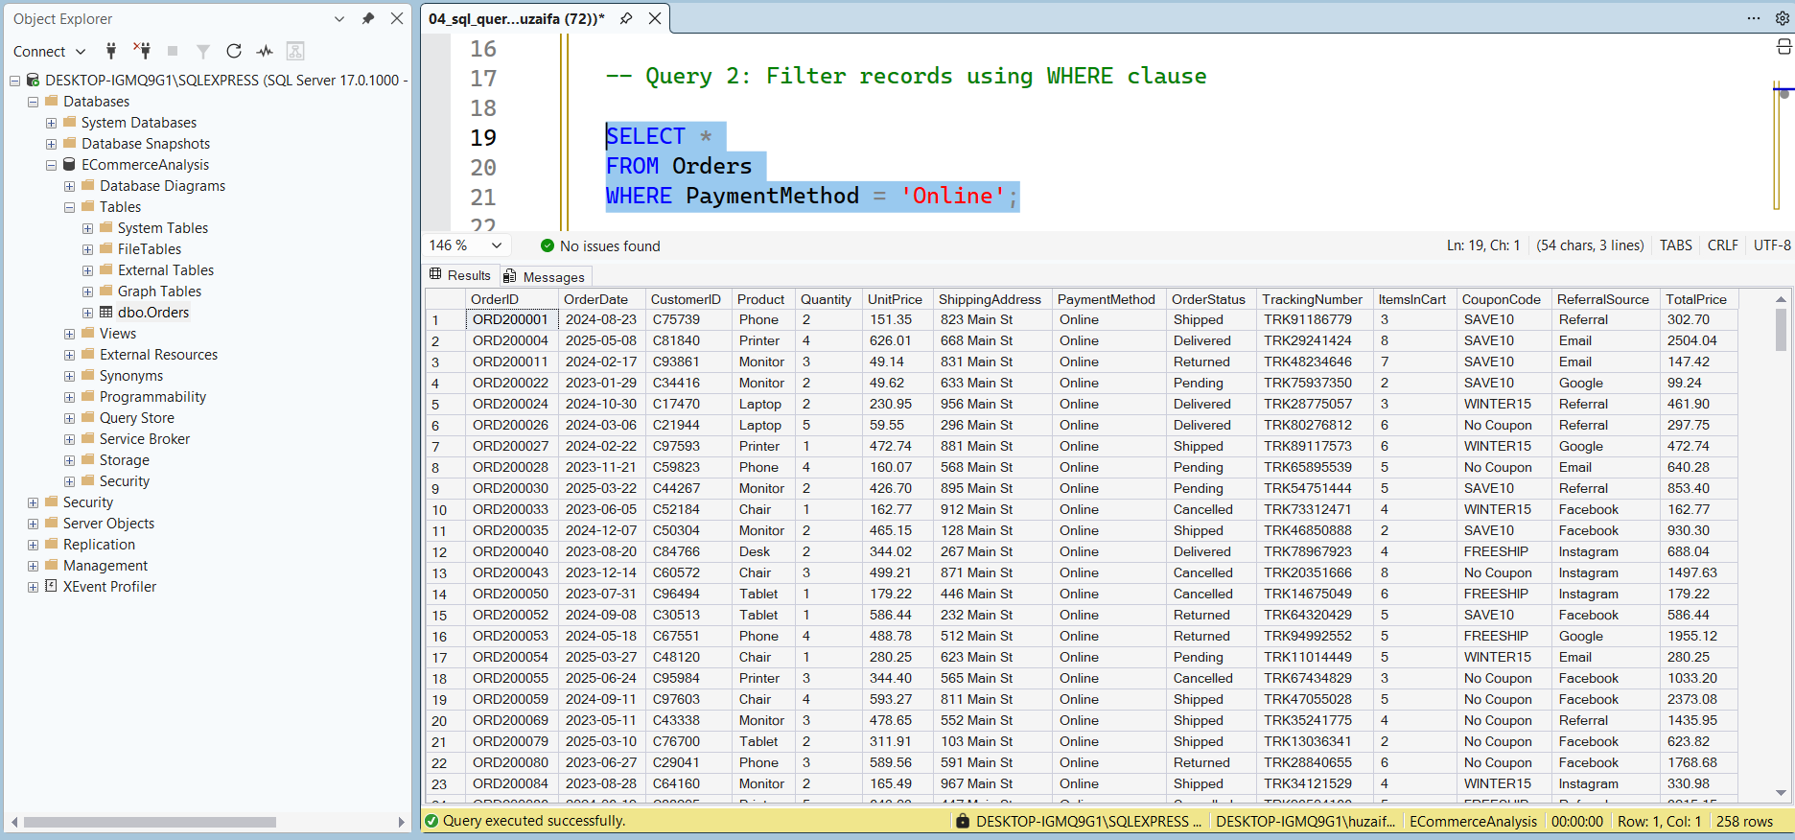

Query 3. Sort Records Using ORDER BY Clause
The ORDER BY clause was used to sort records based on TotalPrice in descending order.

Analysis
The query arranged transactions from the highest-value order to the lowest-value order. The highest transaction value observed in the dataset was approximately 3456.40, helping identify premium customer purchases and high-revenue transactions.
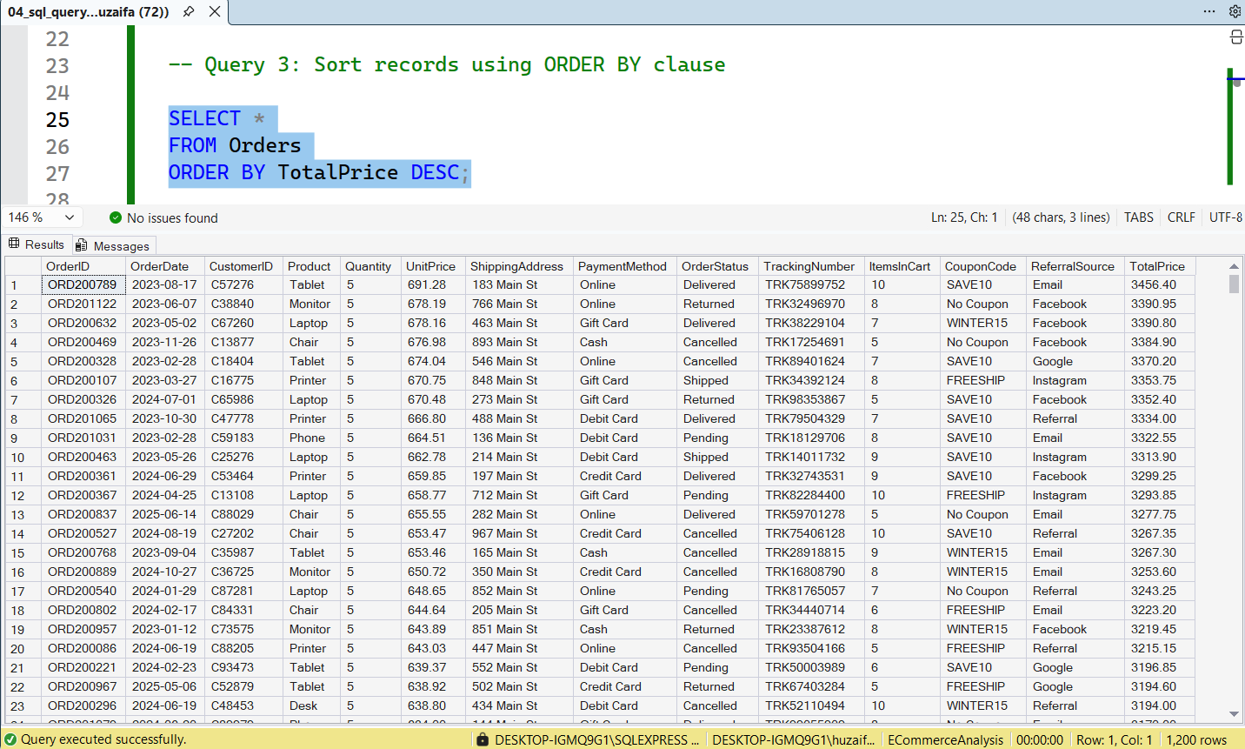

Query 4. Product Analysis Using GROUP BY
The GROUP BY clause was used to group records by product and calculate total orders for each product.

Analysis
The query summarized product demand across all transactions.
Based on the analysis, Printer was the most frequently ordered product with 181 orders, while Phone received the lowest number of orders with 156 orders.
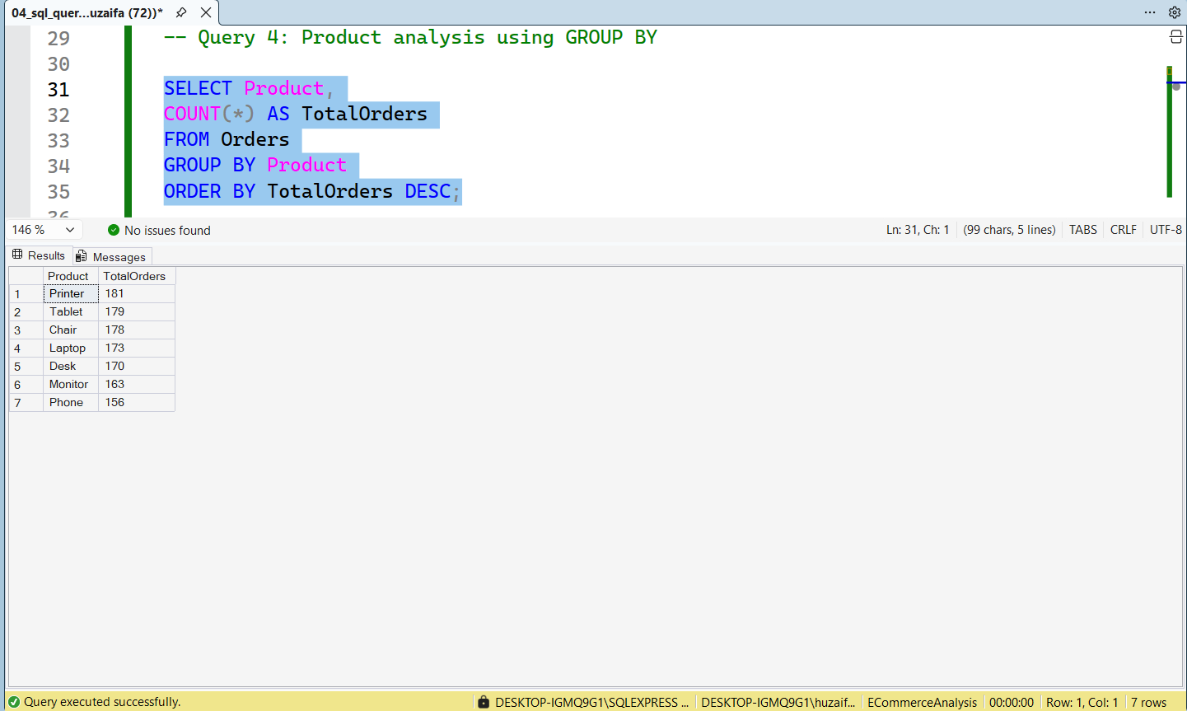

Aggregate Function Analysis
Aggregate functions were used to summarize large amounts of data and generate important business metrics.

Query 5. Total Orders Using COUNT()
The COUNT() function was used to calculate the total number of orders present in the dataset.

Analysis
The query returned a total of 1,200 orders, confirming that all records were successfully imported and available for analysis.
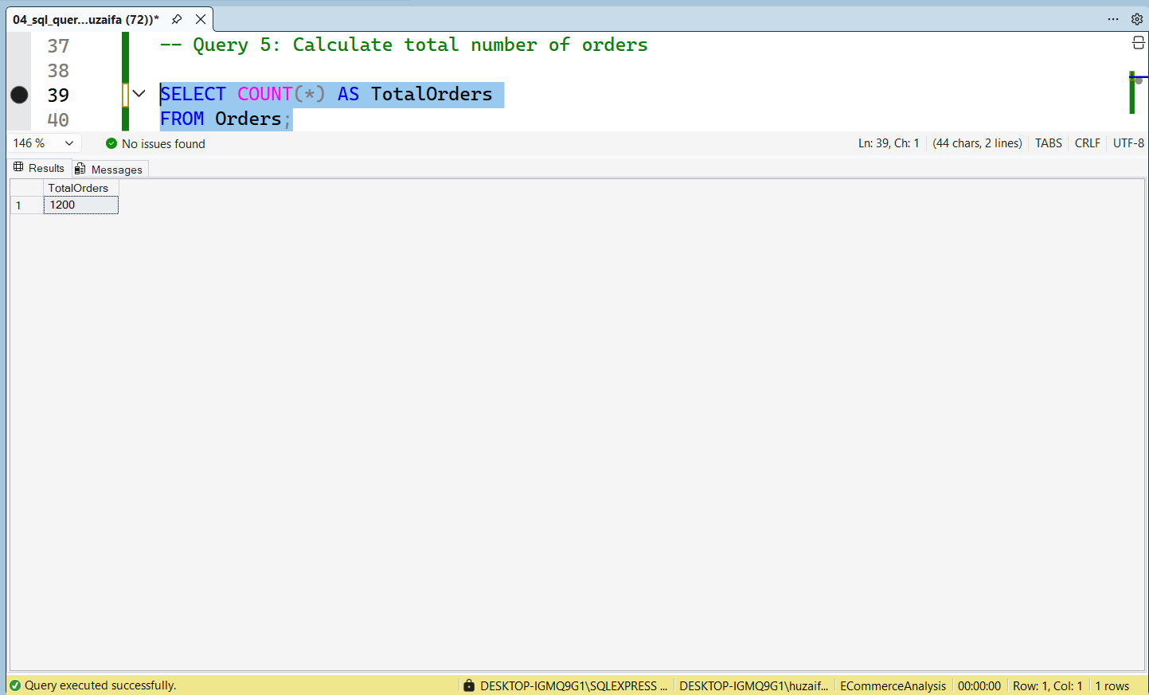

Query 6. Total Revenue Using SUM()
The SUM() function was used to calculate total revenue generated from all customer transactions.

Analysis
The query returned a total revenue of 1,264,761.96. This value represents the overall sales generated from all e-commerce transactions included in the dataset.
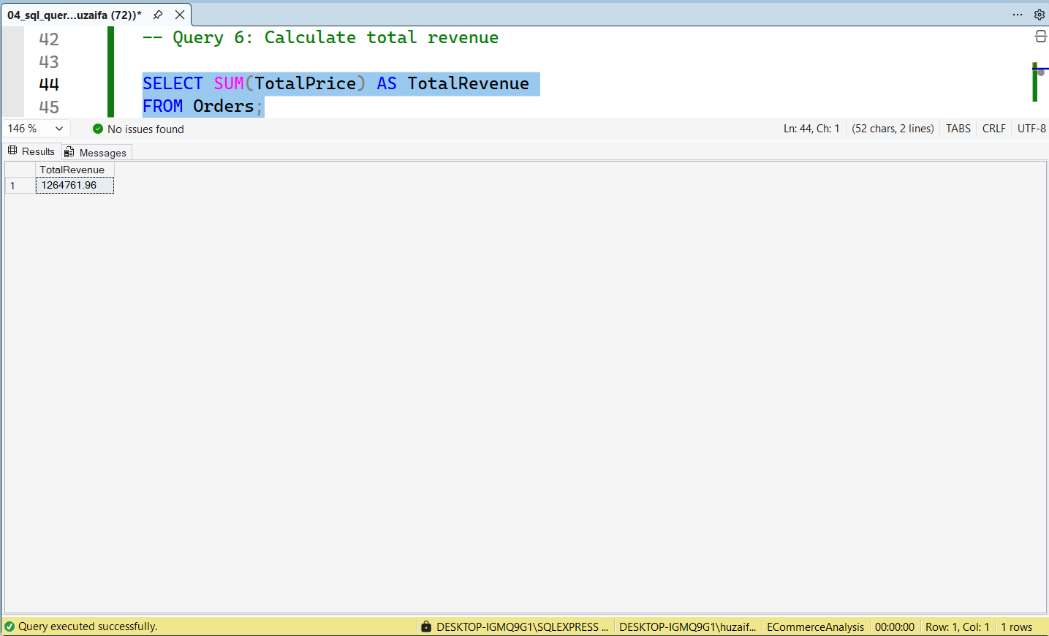

Query 7. Average Order Value Using AVG()
The AVG() function was used to calculate the average amount spent per order.

Analysis
The query returned an average order value of 1053.97. This indicates that customers spent approximately 1,054 currency units per transaction on average.
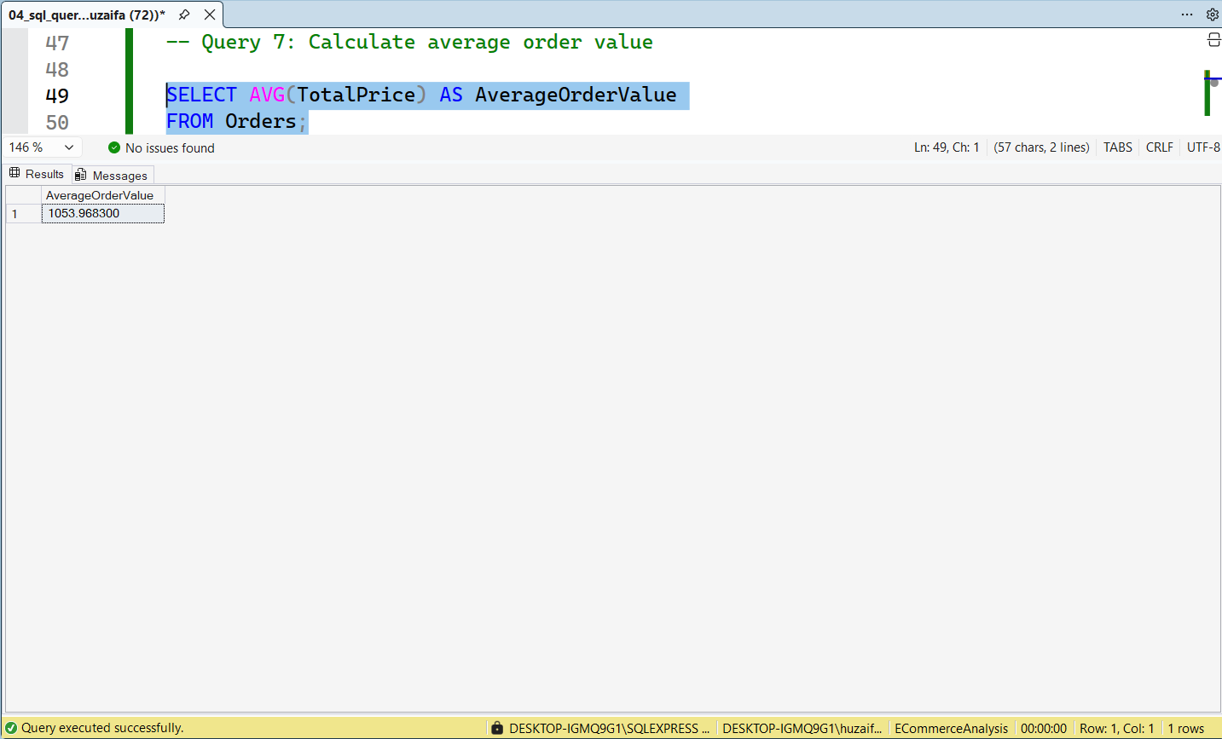

Section 2. Intermediate SQL Practice
After completing the fundamental SQL operations, additional queries were executed to practice intermediate-level SQL concepts. These queries demonstrate the use of logical operators, filtering techniques, pattern matching, distinct values, and additional aggregate functions.

Query 8. Filter Records Using AND Condition
The AND operator was used to retrieve records where multiple conditions were satisfied simultaneously.

Analysis
The query displayed transactions where customers used the Online payment method and the order status was Delivered. The result returned 63 records, indicating successfully completed online transactions. This analysis helps evaluate the effectiveness of online payment processing and order fulfillment.
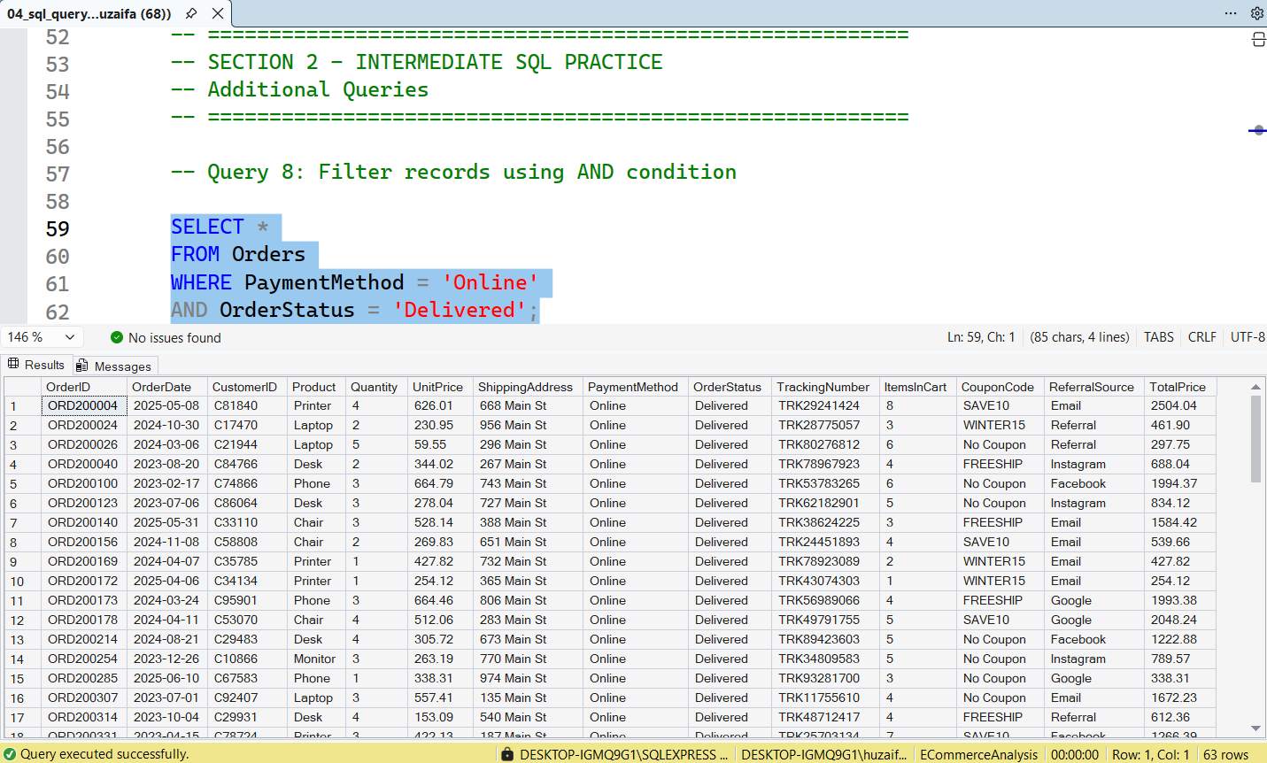

Query 9. Filter Records Using OR Condition
The OR operator was used to retrieve records matching either of the specified conditions.

Analysis
The query displayed orders processed through either Credit Card or Debit Card payment methods. The result returned 466 records, showing that card-based payments represent a significant portion of customer transactions.
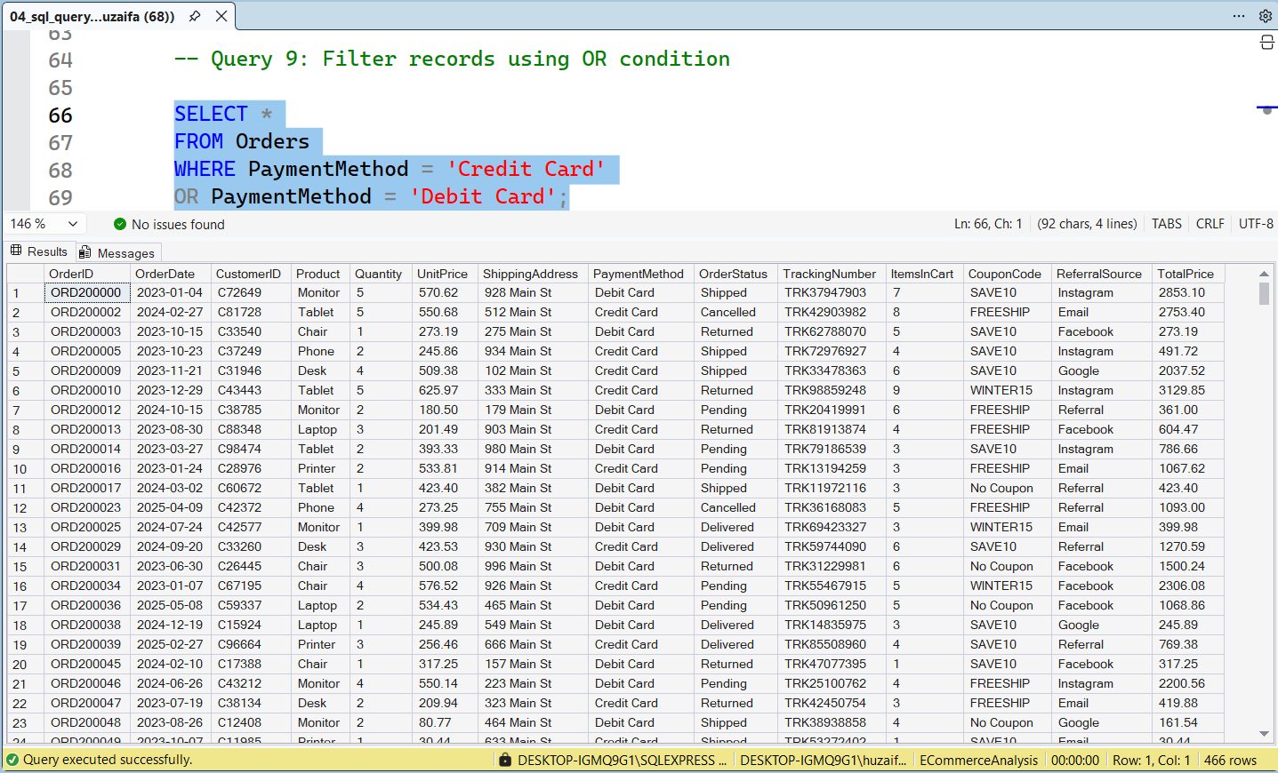

Query 10. Filter Records Using BETWEEN
The BETWEEN operator was used to retrieve orders whose TotalPrice falls within a specific range.

Analysis
The query returned 495 records with order values between 500 and 1500. This analysis helps identify medium-value purchases and provides insight into common customer spending patterns.
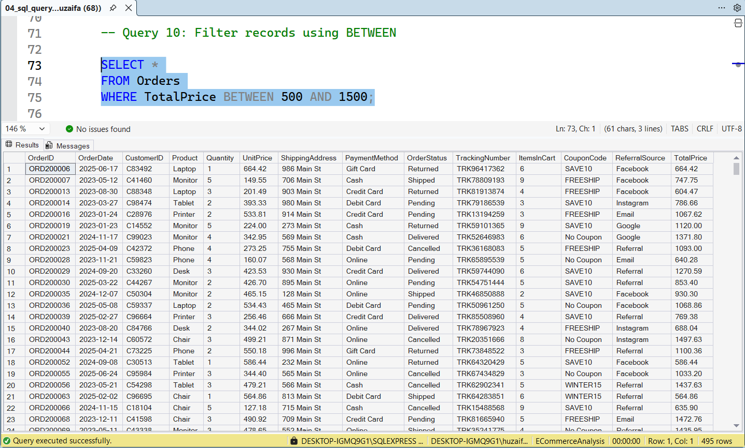

Query 11. Filter Records Using IN Operator
The IN operator was used to retrieve records belonging to selected products.

Analysis
The query displayed orders related to Laptop, Phone, and Monitor products. A total of 492 records were returned, demonstrating how the IN operator simplifies filtering multiple values within a single condition.
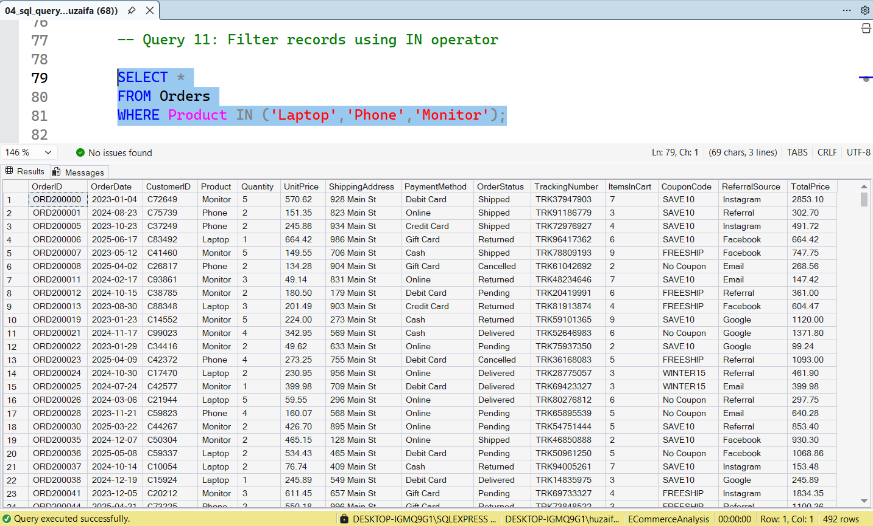

Query 12. Search Records Using LIKE Operator
The LIKE operator was used for pattern-based searching.

Analysis
The query retrieved customers whose CustomerID starts with "C1". The result returned 146 records, demonstrating the use of pattern matching for text-based searches and customer segmentation.
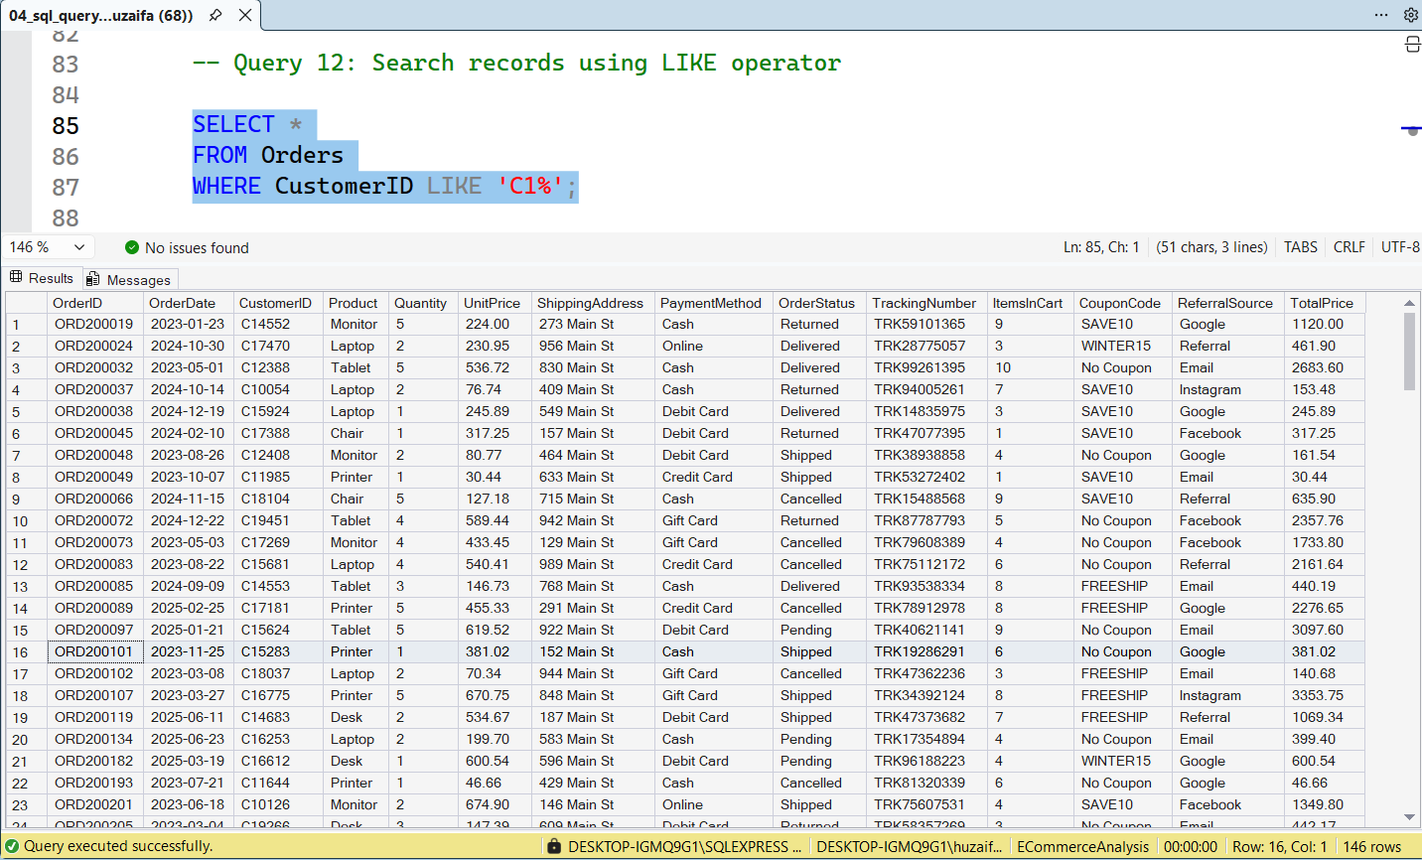

Query 13. Display Unique Payment Methods
The DISTINCT keyword was used to display unique payment methods.

Analysis
The query returned 5 unique payment methods available in the dataset:
- Debit Card
- Online
- Gift Card
- Credit Card
- Cash
This analysis helps understand the variety of payment options offered to customers.
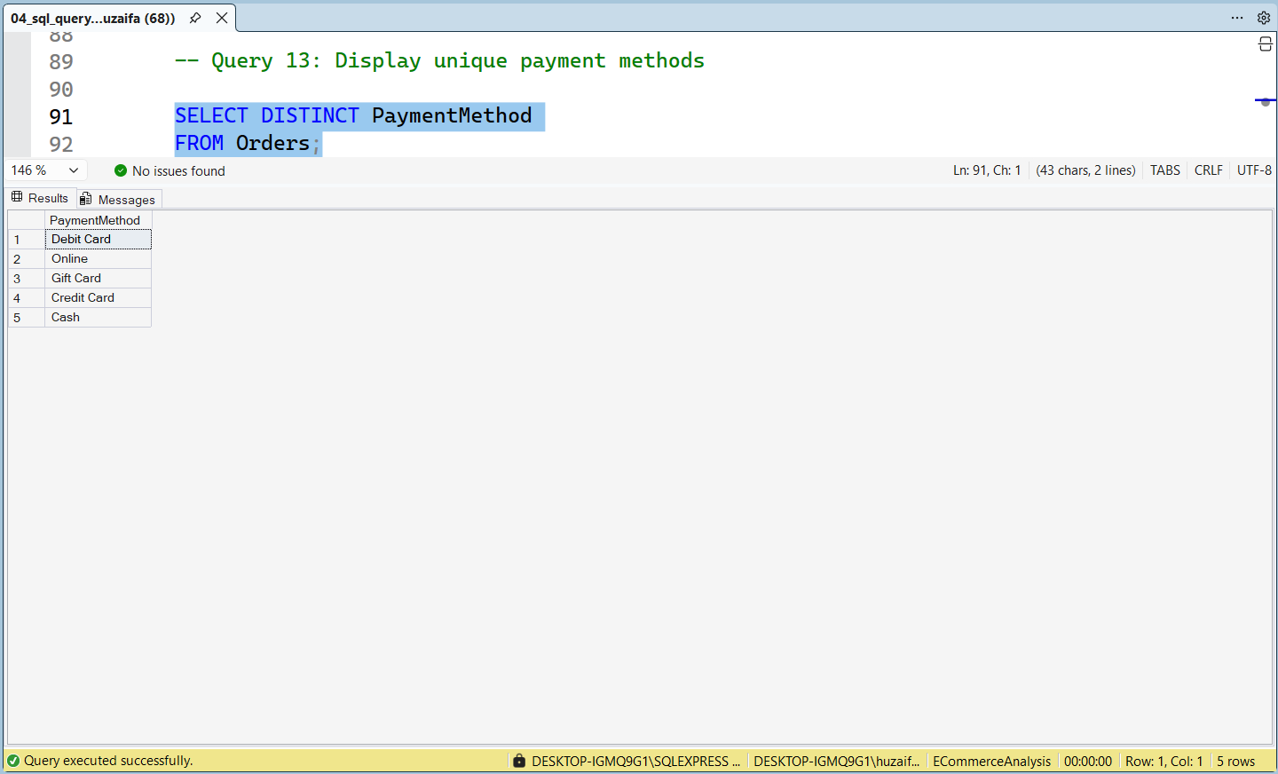

Query 14. Find Minimum Order Value
The MIN() function was used to identify the smallest transaction value.

Analysis
The query returned a minimum order value of 11.39, representing the lowest customer transaction recorded in the dataset.
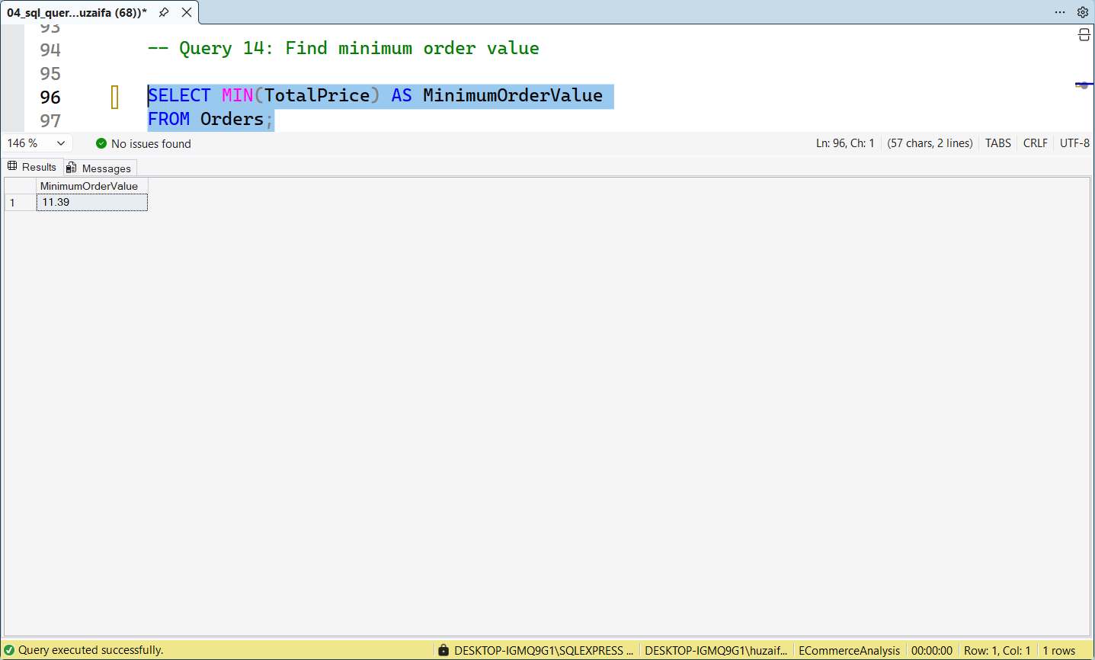

Query 15. Find Maximum Order Value
The MAX() function was used to identify the highest transaction value.

Analysis
The query returned a maximum order value of 3456.40, representing the highest-value transaction in the dataset. This helps identify premium purchases and high-spending customers.
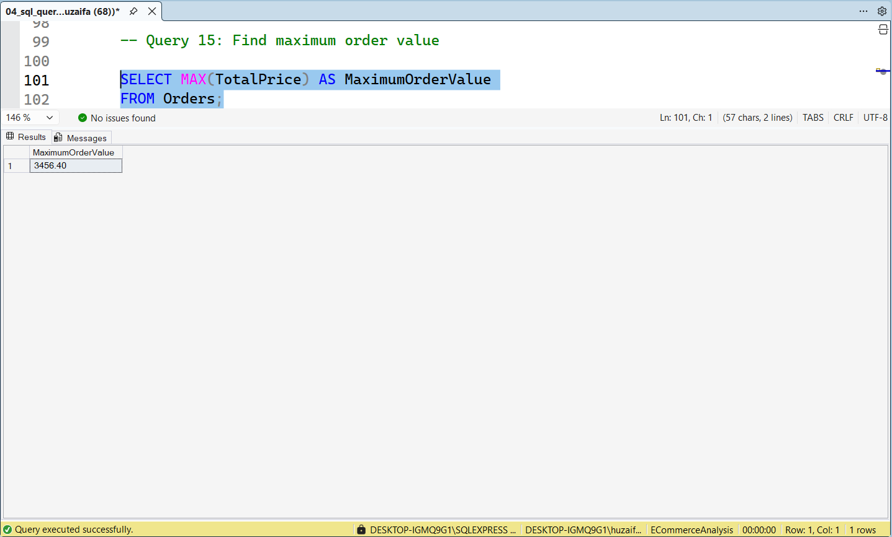

Section 3. Business Analysis
After learning SQL fundamentals and intermediate concepts, business-focused queries were executed to generate meaningful insights from the e-commerce dataset. These queries helped evaluate product performance, revenue generation, payment trends, referral effectiveness, and customer purchasing behavior.

Query 16. Top Selling Products
The query was used to calculate the total quantity sold for each product.

Analysis
The results showed that Chair was the top-selling product with a total quantity sold of 562 units, followed by Printer (542 units) and Laptop (535 units). On the other hand, Phone recorded the lowest sales volume with 411 units. This analysis helps identify customer preferences and supports inventory planning and product demand forecasting.
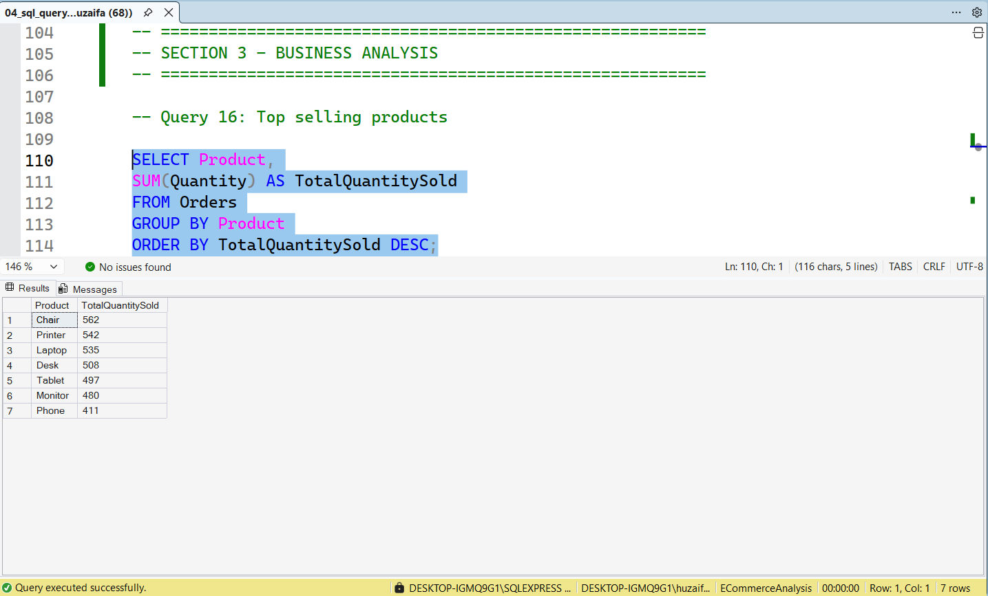

Query 17. Product Revenue Analysis
The query was used to calculate revenue generated by each product.

Analysis
The results indicated that Chair generated the highest revenue of 195,620.11, closely followed by Printer (195,612.61) and Laptop (192,126.56). Phone generated the lowest revenue at 151,722.39. This analysis helps identify high-performing products and supports pricing, inventory, and promotional decisions.
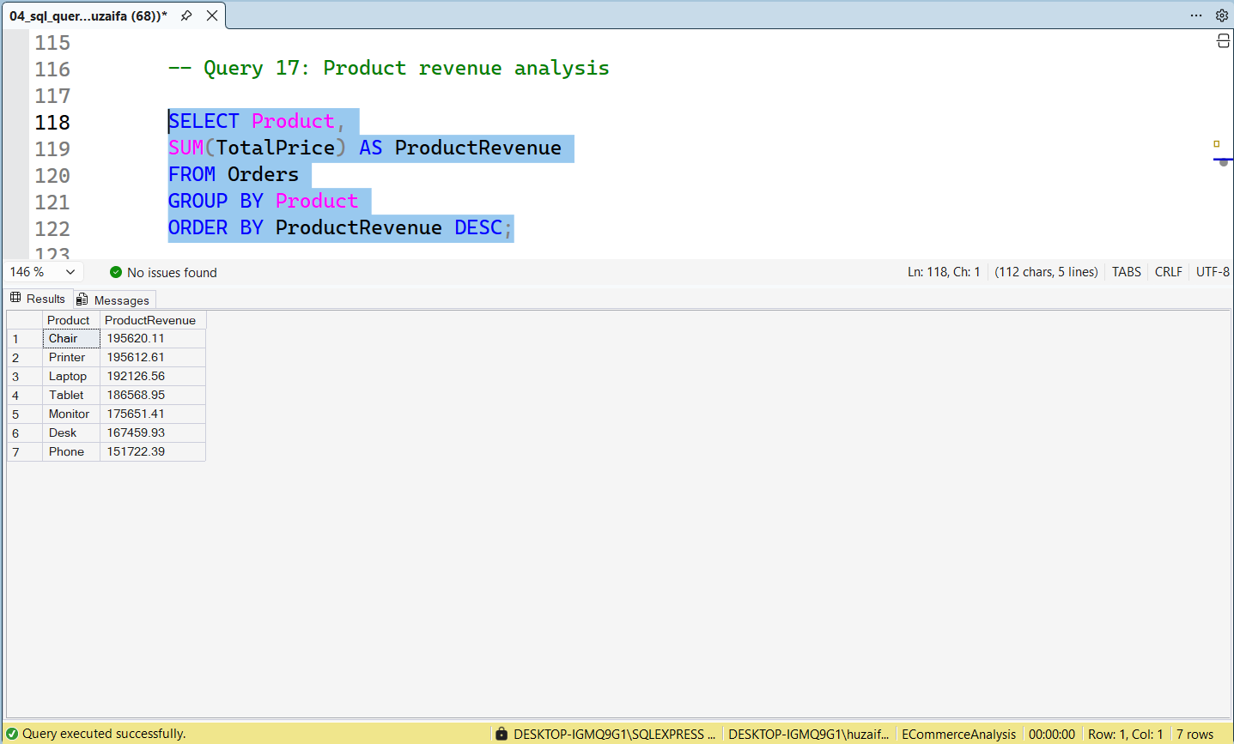

Query 18. Payment Method Analysis
The query was used to calculate the number of transactions completed using each payment method.

Analysis
The results showed that Online Payment was the most frequently used payment method with 258 transactions, followed by Cash (246 transactions). Gift Card recorded the lowest number of transactions with 230 orders. This information helps businesses understand customer payment preferences and optimize payment options.
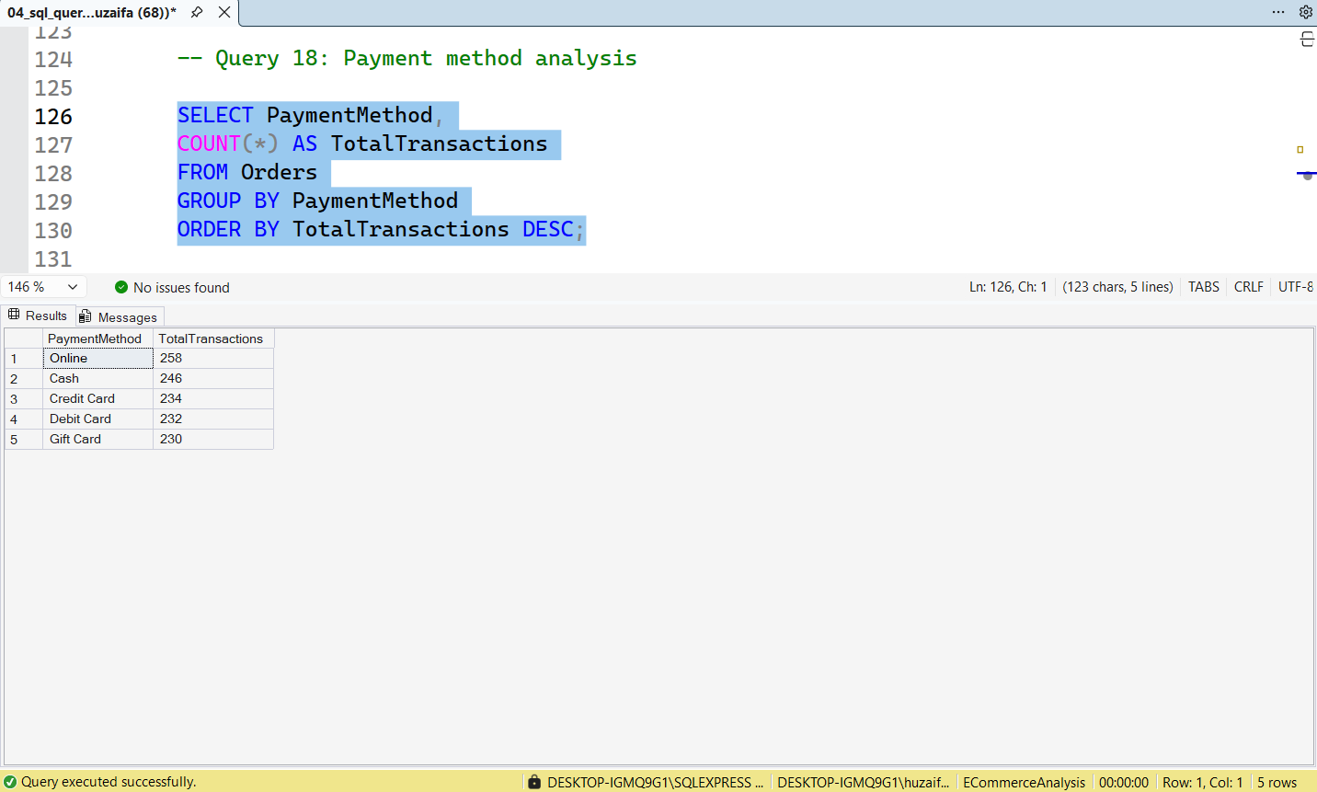

Query 19. Payment Method Revenue Analysis
The query was used to calculate revenue generated through each payment method.

Analysis
The results revealed that Credit Card payments generated the highest revenue of 263,847.63, followed closely by Online Payments (262,442.94) and Cash Payments (259,786.29). Debit Card generated the lowest revenue at 232,361.18. This analysis helps evaluate the financial contribution of different payment channels.
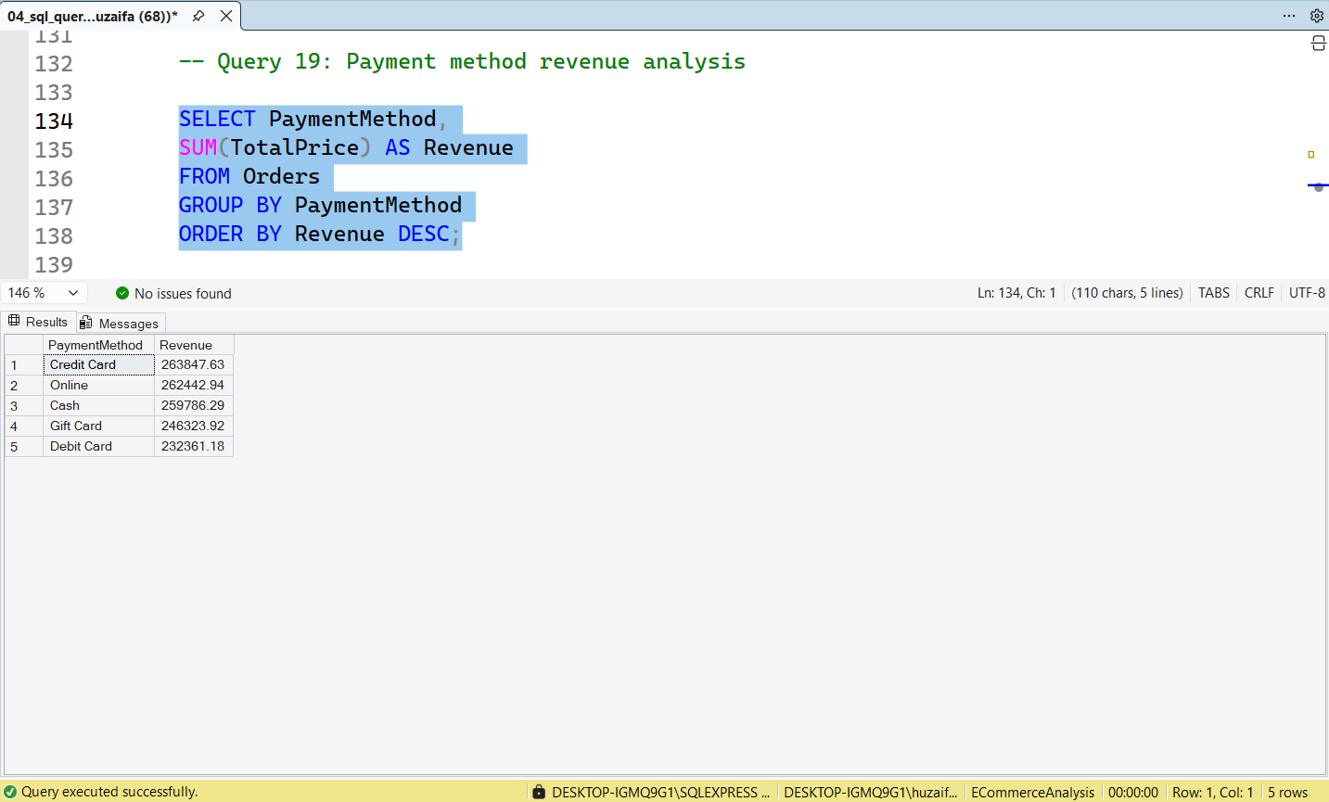

Query 20. Order Status Analysis
The query was used to count orders according to their current status.

Analysis
The results showed that Cancelled Orders were the highest with 250 orders, followed by Returned Orders (247) and Pending Orders (237). Delivered Orders accounted for 231 orders. This analysis provides insights into order fulfillment performance and highlights areas where operational improvements may be required.
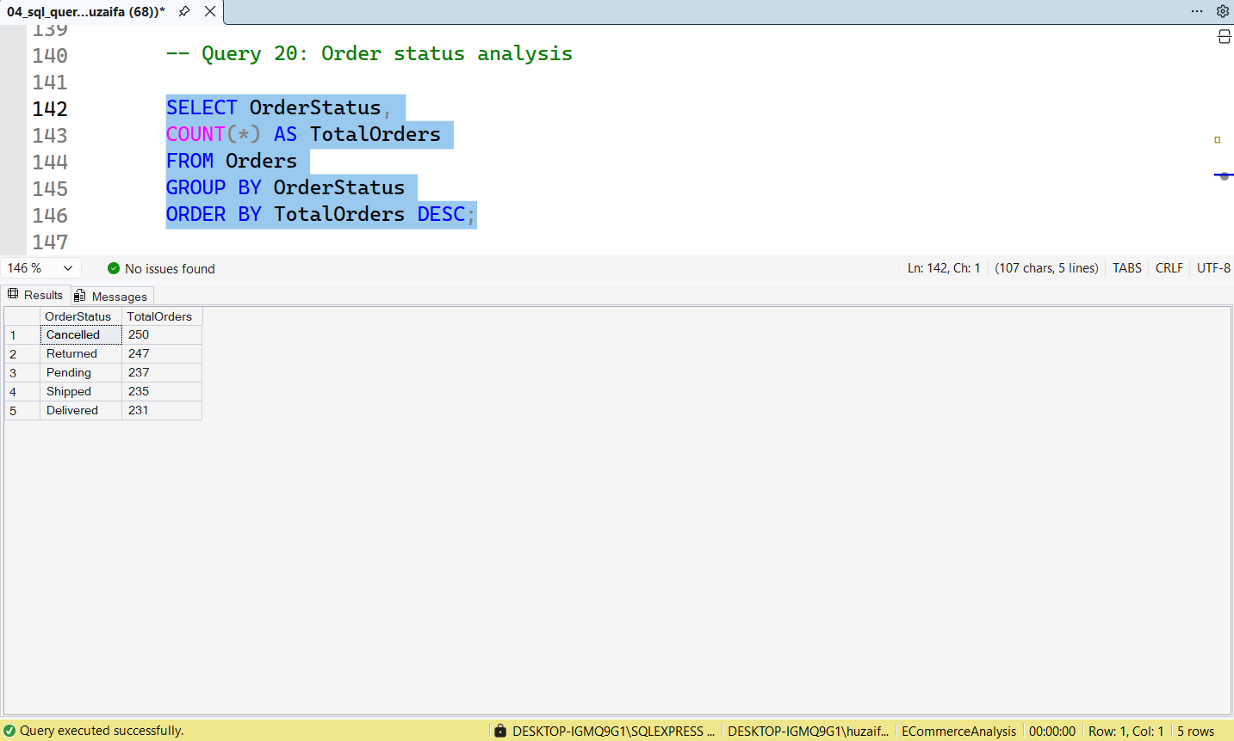

Query 21. Referral Source Analysis
The query was used to count orders generated from different referral sources.

Analysis
The results indicated that Instagram generated the highest number of orders with 259 transactions, followed by Email (250 orders) and Google (241 orders). Referral generated the lowest number of orders with 222 transactions. This analysis helps identify the most effective customer acquisition channels.
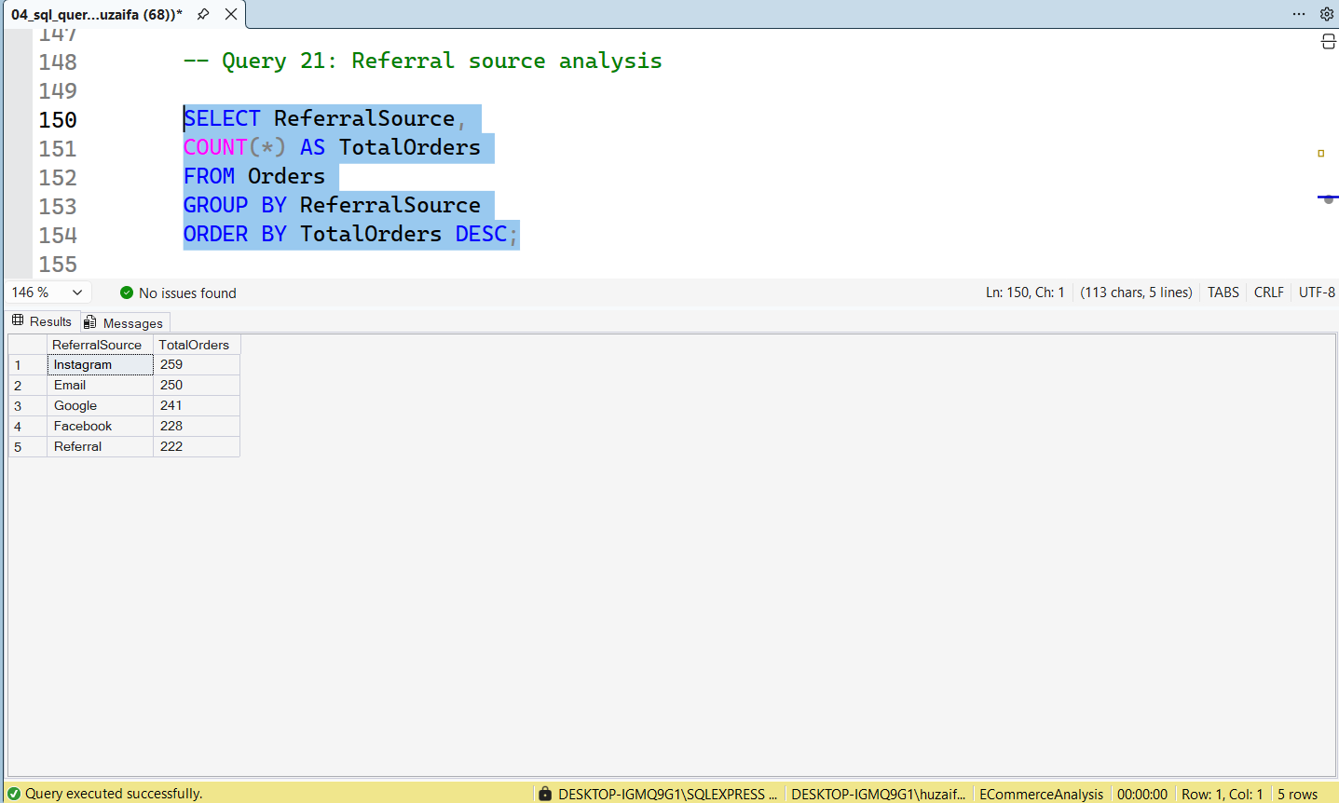

Query 22. Referral Source Revenue Analysis
The query was used to calculate revenue generated by each referral source.

Analysis
The results revealed that Instagram generated the highest revenue of 275,285.45, followed by Email (261,808.55) and Google (250,441.48). Referral generated the lowest revenue of 226,815.58. These findings help evaluate the profitability of marketing channels and support future advertising strategies.
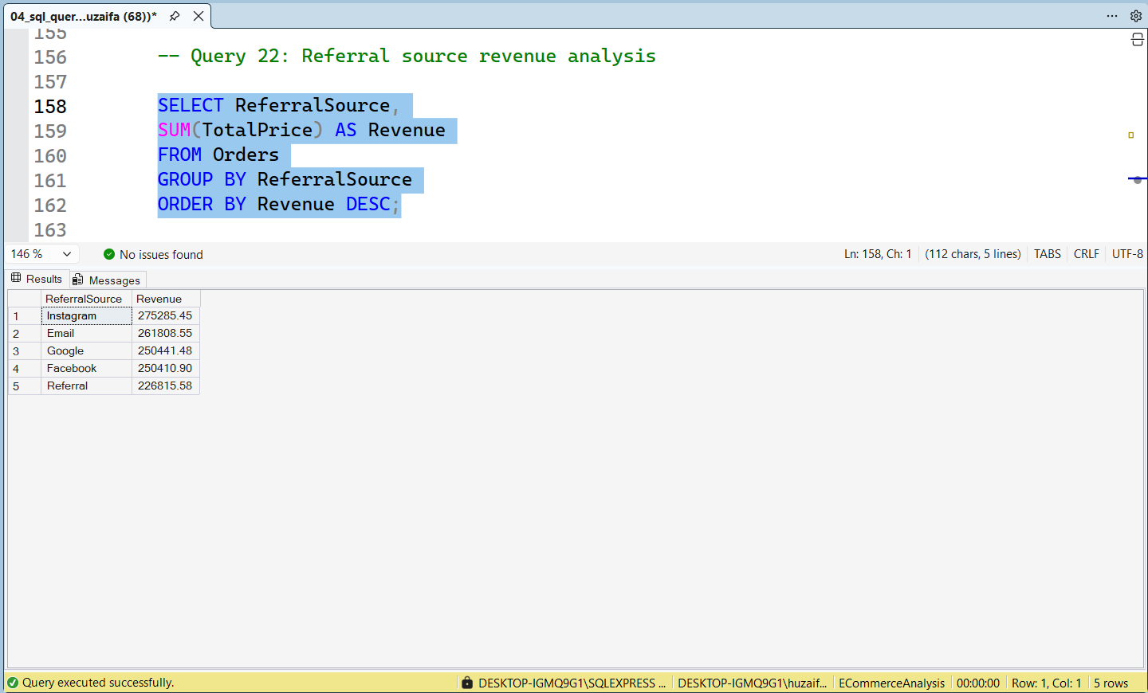

Query 23. Top 10 Highest Value Orders
The query was used to display the highest-value transactions in the dataset.

Analysis
The results identified the top ten customer orders based on total order value. The highest-value transaction was Order ID ORD200789 (Tablet) with a total value of 3456.40. Other high-value transactions included ORD201122 (Monitor - 3390.95) and ORD200632 (Laptop - 3390.80). This analysis helps identify premium purchases and valuable customer transactions that contribute significantly to overall revenue.
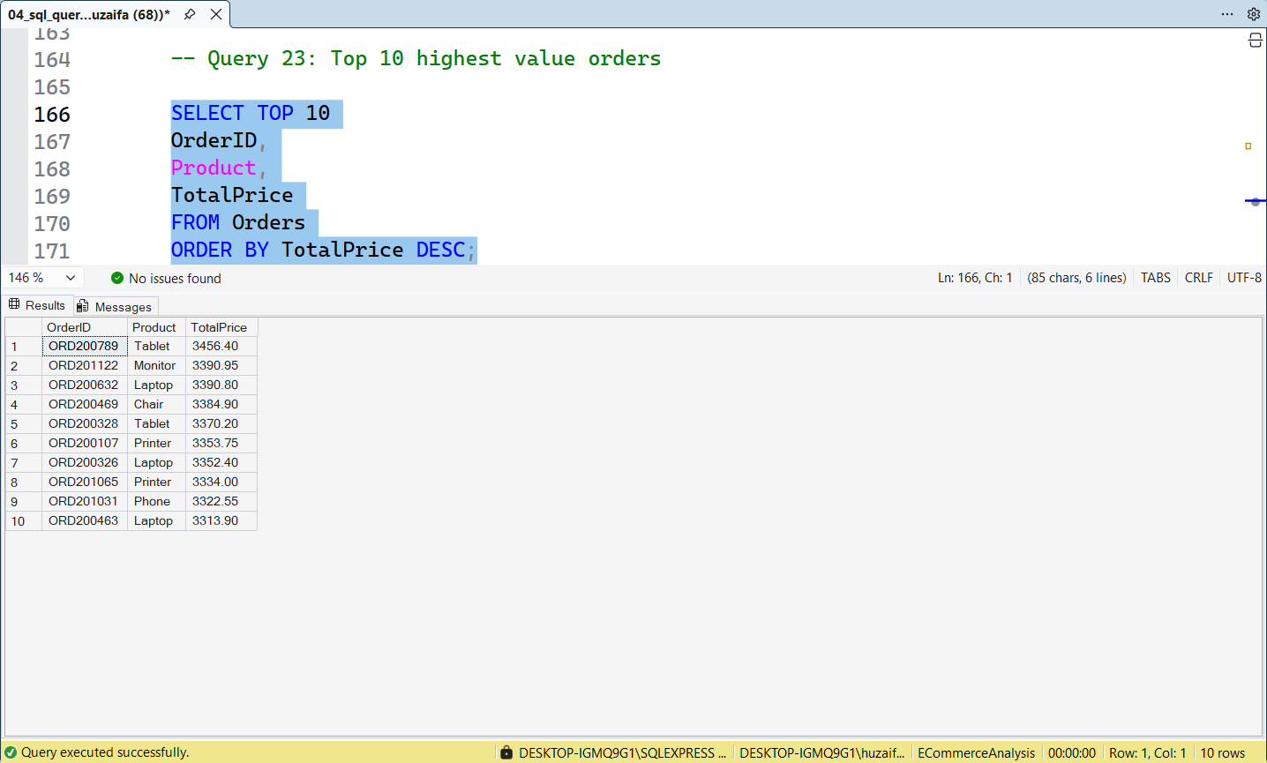

Section 4. Advanced Analysis
After performing business-oriented analysis, additional advanced SQL queries were executed to gain deeper insights into customer behavior, product pricing, and revenue trends. These queries demonstrate the use of advanced aggregation techniques and analytical reporting to support strategic business decision-making. The analysis focuses on identifying high-value customers, evaluating average product prices, measuring yearly business performance, and tracking monthly revenue patterns.

Query 24. Top 5 Customers by Spending
The query was used to identify the top five customers based on their total spending.

Analysis
The results revealed the highest-spending customers in the dataset. Customer C38840 generated the highest total spending of 5,723.23, followed by C57276 (3,456.40), C67260 (3,390.80), C13877 (3,384.90), and C18404 (3,370.20). Identifying these valuable customers helps businesses develop loyalty programs, improve customer retention, and target premium customers with personalized offers.
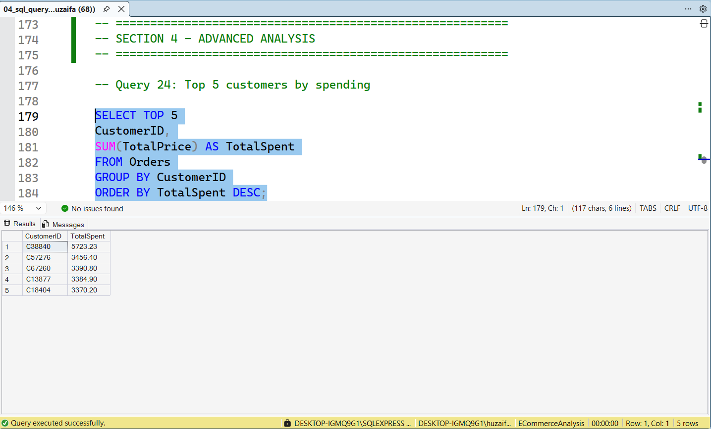

Query 25. Average Product Price
The query was used to calculate the average unit price for each product category.

Analysis
The results showed that Phone products had the highest average unit price (375.22), followed by Tablet (367.68), Monitor (358.66), and Laptop (357.71). The lowest average price was observed for Desk (329.61). This analysis helps the business understand pricing differences among products and supports pricing strategy and profitability analysis.
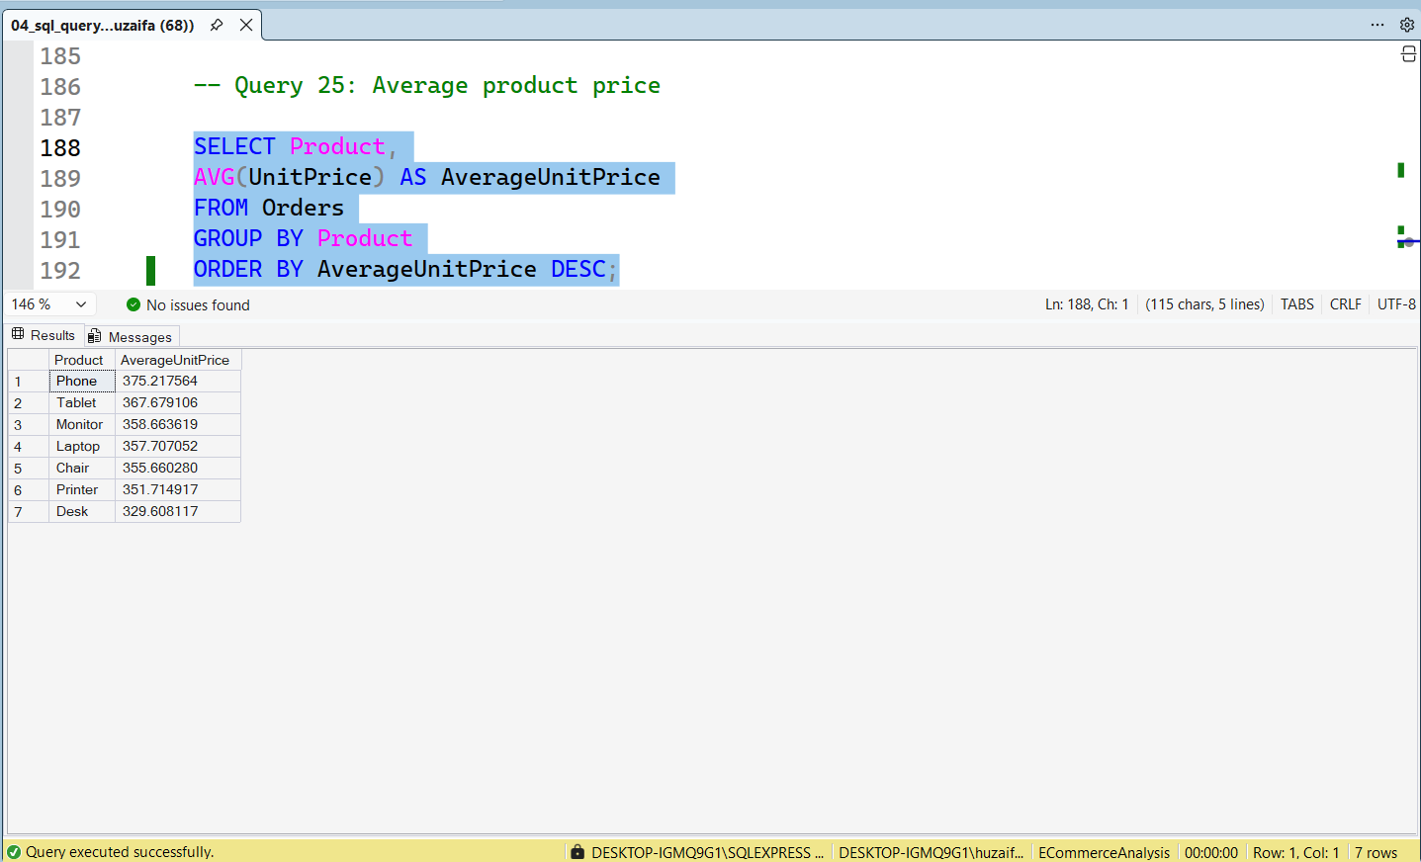

Query 26. Revenue by Year
The query was used to calculate total revenue generated in each year.

Analysis
The results indicated that 2023 generated the highest revenue of 552,643.24, followed by 2024 with 480,235.87, while 2025 generated 231,882.85. The analysis provides a clear overview of yearly business performance and helps management evaluate growth trends and financial outcomes over time.
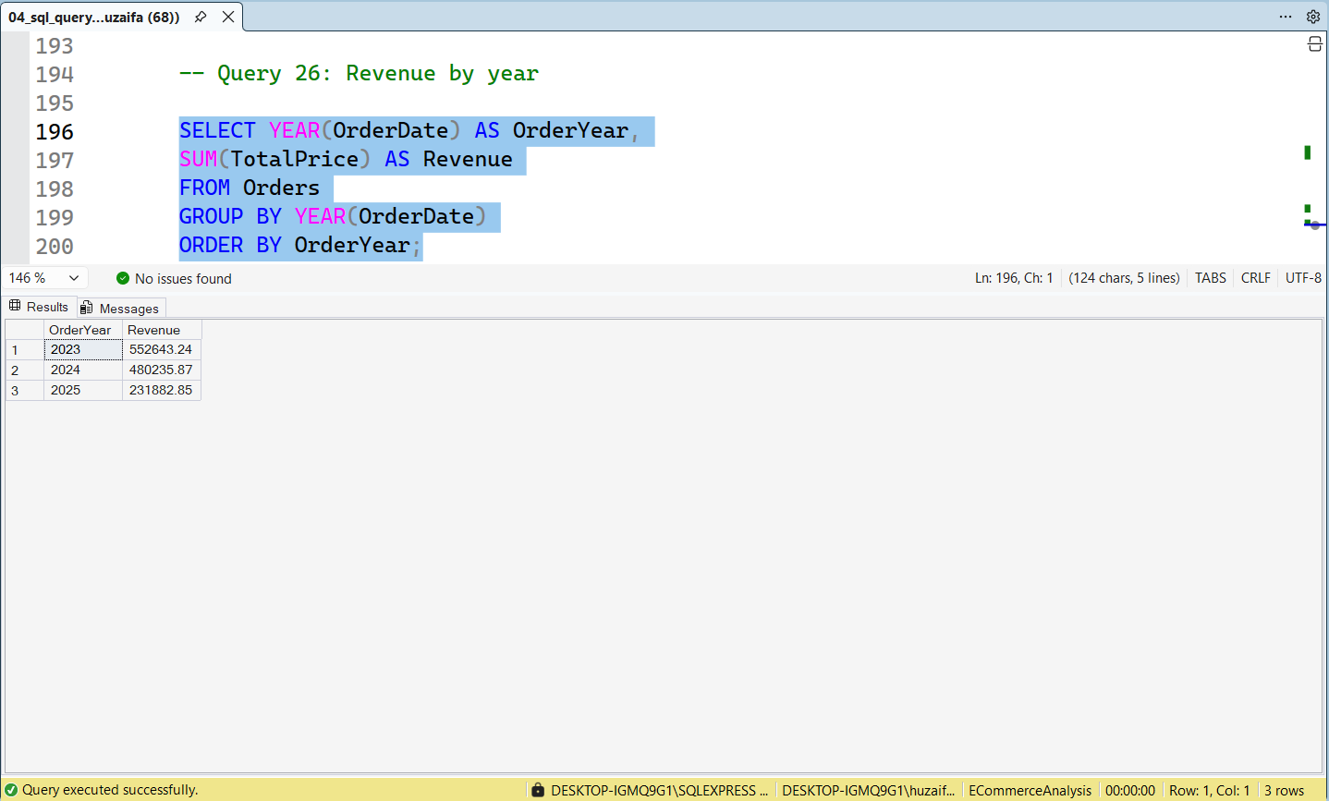

Query 27. Monthly Revenue Trend
The query was used to calculate monthly revenue generated throughout the dataset period.

Analysis
The results provided a month-wise breakdown of revenue across multiple years. Revenue fluctuated throughout the reporting period, with some months generating significantly higher sales than others. For example, May 2023 generated 63,836.84, while June 2024 generated 68,068.54, representing some of the strongest revenue-performing months. This analysis helps identify seasonal sales patterns, forecast future demand, optimize inventory planning, and support strategic business decision-making.
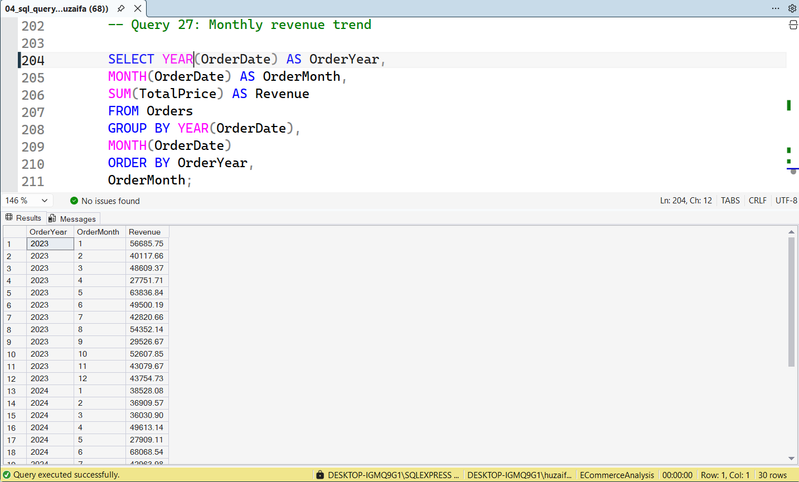

Conclusion
This project demonstrated the practical application of SQL for data analysis using an e-commerce dataset. Various SQL techniques including data retrieval, filtering, sorting, grouping, aggregation, and business analysis were performed using Microsoft SQL Server.
The analysis provided valuable insights into customer purchasing behavior, product performance, revenue generation, payment preferences, referral source effectiveness, and sales trends. Key findings revealed that Chair was the top-selling product, Instagram generated the highest revenue among referral sources, Credit Card transactions contributed the highest payment-method revenue, and the year 2023 generated the highest overall revenue.
The project enhanced practical SQL skills and demonstrated how SQL can be used to transform raw business data into meaningful insights that support data-driven decision-making.

