Requirements Specification

P07:Autolancer

team member names & ids

Student ID | Name
27100271 | Huzayfah Abid
27100435 | Zainab Raza
27100437 | Muhammad Hashim
27100222 | Muhammad Zakaria

Table of Contents

1. Introduction 4
2. Why can’t an AI chatbot with well-crafted prompts build your system? 5
3. System Actors 6
4. Use Cases 7
Use Case Diagrams 7
5. Class Diagram 32
● Diagram 32
● Description 32
6. Sequence Diagrams 33
Common subflows 33
State and data conventions 34
7. AI / ML Requirements 60
8. Data Requirements 71
9. Non-functional Requirements / Quality Attributes 72
10. Security Requirements 76
11. Security Engineer 77
12. Use of Generative AI 78
13. Who Did What? 80
14. Review checklist 80

Introduction
Autolancer is an autonomous end-to-end freelancer with a specialization in business finance. General software development, data analysis, research, and writing remain core capabilities: supported jobs in each category can be discovered, ranked, pursued, executed, verified, and delivered through the same complete workflow. Finance expertise strengthens the system’s ability to perform relevant assignments; it does not restrict all accepted work to finance.
The client-work lifecycle covers opportunity discovery and ranking, proposals, client communication, requirements discovery, specification, planning, execution, verification, authorized deployment where applicable, delivery, revisions, and agreed post-delivery support. Software work includes new applications, features, and bug fixes in existing projects. Versioned PRDs connect confirmed requirements to tasks, tests, architecture decisions, and delivered functionality. Data, research, and writing assignments use appropriate versioned briefs and category-specific checks.
The flagship financial example is a cash-flow forecasting dashboard built from authorized client records, with scenario comparisons and tailored budgeting or working-capital recommendations. Financial tasks use client-provided spreadsheets, CSVs, statements, and documents plus authorized reference data. Existing AI models are supported by financial references, executable calculations, forecasting tools, and independent validation. Custom model training is not a first-release commitment. Historical observations, assumptions, projections, and recommendations are identified separately; missing financial inputs and forecast-accuracy claims are not invented.
The first release retains one live marketplace integration, selected between Upwork and Freelancer.com after capability checks, and a repeatable marketplace simulator. The owner configures offered services, autonomy permissions, commitments, budgets, workload limits, deployment targets, and required reviews. The system autonomously pursues qualifying financial or general opportunities and delivers verified work when permissions and provider capabilities allow. Tailored business-planning recommendations may be delivered under the same policy; ambiguous mandatory scope, missing permissions, failed checks, and exceeded limits create visible exceptions.
The web hub gives the owner oversight of ranked opportunities, conversations, scope versions, agent activity, dependencies, requirement coverage, costs, deployment evidence, and pending decisions. Existing workload, budget, recovery, and retention targets remain applicable. The simulator evaluates both general and financial job categories, using task-specific objective checks and independent review where required. Simulated acceptance, earnings, and reputation are not evidence of real business outcomes.
The agreed first-release advice specialization covers business planning, including budgeting, cash flow, pricing, cost control, working capital, and scenario recommendations. Personalized investment, tax, and personal-finance advice, autonomous money transfers, and unauthorized deployment remain outside that scope. No guaranteed income, forecast accuracy, or coverage of every freelance niche is promised.

Why can’t an AI chatbot with well-crafted prompts build your system?

We tested chatbots using two prompting approaches: straightforward instructions and a structured simulated freelance environment. Both approaches included the same cash-flow dashboard assignment and financial inputs. The simulated approach additionally covered opportunity assessment, proposal drafting and project-record management. The purpose was to determine how much of Autolancer’s freelance workflow a general-purpose chatbot could perform through prompting alone, and which activities would require additional infrastructure or manual intervention.

Item | Details
Chatbot(s) and version used | Gemini 3.1 Pro  ChatGPT 6 Sol  ChatGPT 6.1
Task given | Complete a freelance cash-flow dashboard assignment using supplied financial data. We want the AI to clarify requirements, plan the work, generate a browser-based dashboard, calculate historical cash balances and three future scenarios, verify the results, and prepare handover instructions. The task was tested using three different approaches, straightforward instructions, and a structured simulated freelance environment. The simulated approach additionally covered opportunity assessment and proposal drafting. We did this to see how it would answer to different types of prompts asking similar questions and to what extent it could simulate an answer similar to our project
Best prompt used | For the workflow, the structured simulated approach was the strongest because it produced opportunity assessments, a proposal, a project brief, acceptance criteria, a dependency-based task plan, calculation explanations and handover instructions. It used an initial prompt followed by a corrective and execution prompt. The exact prompts are reproduced below.  prompt 1:  Act as my autonomous freelancer. Your task is to complete a freelance engagement from opportunity selection through verified delivery, using the tools available in this session.  My offered services are software development, data analysis, research, writing and business-finance analysis. My total execution budget is USD 10, and I can handle one active project at a time.  You may assess jobs, draft proposals, ask clarification questions, analyze supplied files, generate code and deliverables, and run available checks. Ask for approval before submitting a proposal externally, sending a client message or deploying software. Do not invent credentials, client responses, award events, test results or external receipts.  Assess and rank these fictional opportunities:  A. Build a cash-flow forecasting dashboard from client-provided CSV records. Payment: USD 150. Deadline: three days. The client wants historical summaries and three future scenarios.  B. Write a market-research report with ten credible sources. Payment: USD 80. Deadline: two days.  C. Fix a bug in an existing React application. Payment: USD 100. Deadline: one day. Repository access has not yet been provided.  Explain your ranking, identify missing information, select a suitable opportunity and draft a tailored proposal. Keep a project record containing scope, decisions, tasks, dependencies, checks, costs where observable, and current status.  Distinguish actions you actually perform from drafts, recommendations and simulated events. If a required action is unavailable, explain precisely what blocks it and continue with independent work that is possible.  prompt 2:  Continue with Opportunity A as a simulated engagement.  First, correct the project record:  Treat the ranking and three-day feasibility assessment as provisional until scope and inputs are checked.  Remove expertise claims that are not supported by supplied evidence.  Record execution cost as unknown unless you can measure it.  Remove deployment from committed scope. Do not deploy or perform external actions.  For this test, assume the client has awarded the job and confirmed the following requirements. Label the award as simulated.  Build a browser-based cash-flow dashboard showing:  Historical monthly inflows, outflows and net cash flow.  Opening and closing cash balances.  Three future months under baseline, optimistic and pessimistic scenarios.  Clearly labelled assumptions and a short explanation of the results.  Use these synthetic records:  month,inflows,outflows  2026-01,100000,75000  2026-02,120000,90000  2026-03,110000,95000  Currency: PKR.  Opening cash balance at the start of January: PKR 50,000.  Confirmed scenario assumptions:  Baseline monthly inflows and outflows equal their respective historical monthly averages.  Optimistic monthly inflows are 10% above baseline; outflows remain at baseline.  Pessimistic monthly inflows are 10% below baseline; outflows remain at baseline.  All future scenarios start from the historical closing cash balance at the end of March.  These are what-if scenarios, not validated predictions.  Create project brief version 1, acceptance criteria and a task plan with dependencies. Then build the actual deliverable using the tools available in this session.  Verify that:  Historical inflows total PKR 330,000.  Historical outflows total PKR 260,000.  Historical net cash flow totals PKR 70,000.  March closing cash is PKR 120,000.  Each monthly net cash flow equals inflows minus outflows.  Each closing balance equals opening balance plus net cash flow.  Scenario calculations follow the confirmed assumptions.  Run checks where possible and show the actual results. Distinguish executed tests from manual arithmetic checks and checks you could not perform. Do not claim independent verification solely from your own assertion.  Provide the actual dashboard file if supported. Otherwise, provide complete runnable code and explain exactly what I must do manually.  Update the project record with output versions, check evidence, observable costs and current status. Do not mark it deployed, submitted or client-accepted.
What the chatbot did well | Gemini assessed the fictional opportunities, identified missing information and drafted a tailored proposal. With more explicit instructions, it corrected unsupported cost and feasibility claims, recorded the award as simulated, created a project brief and acceptance criteria, and distinguished historical observations from scenario assumptions. Its written historical calculations were correct. The simulated response supplied dashboard code and manual execution instructions. The straightforward response produced a React dashboard component in one attempt, including historical and projected tables, scenario switching, a cash-balance chart and visible assumptions.
Where it fell short | The responses demonstrated code generation and conversational planning, but did not establish an independently verified, operational freelance workflow. The simulated response required a follow-up to correct unsupported expertise, timeline and cost claims. Its verification consisted of written arithmetic rather than demonstrated execution of application tests, and its use of “independent” verification was not supported by a separate verifier, meaning it hallucinated its own verification by referring to itself. The straightforward component hardcoded the financial outputs. It also required a React environment and supporting dependencies, without accompanying setup instructions in the supplied response. Neither attempt demonstrated real marketplace discovery, proposal submission, client-event handling, deployment, persistent scheduling or interrupted-action recovery.

Justification
The experiment shows that a general-purpose chatbot can create and carry out parts of the work like assessing supplied opportunities, drafting proposals, explaining requirements, generating interfaces and performing written calculations. Autolancer’s proposed contribution is to connect these capabilities to an operational freelance workflow with persistent records, authorized actions and evidence-based completion checks.
Data: Does your system depend on private, proprietary, real-time or locally collected data the chatbot cannot access?
Autolancer is intended to obtain and manage authorized project inputs, marketplace records, client communications, repository context and permitted reference material. These inputs must remain associated with the correct project and retain provenance, version and permission information.
In the experiment, the user supplied fictional job descriptions, synthetic financial records and scenario assumptions manually. For a real cash-flow assignment, Autolancer would maintain the authorized input collection, record its source and version, and block dependent calculations when mandatory inputs or financial definitions are missing. A pasted prompt alone did not demonstrate that data-management process.

- Actions and integration: Does it act in the real world or connect to other systems, such as payments, sensors, databases, hardware or third-party APIs?

Autolancer is intended to use capability-checked adapters for supported marketplace operations and authorized repository and deployment actions. External submissions must produce recorded receipts or remain explicitly uncertain until reconciled. Gemini drafted a proposal and generated dashboard code, but the observed attempts did not submit a real proposal, receive a real award, deliver to a marketplace or deploy software. For example, Autolancer would submit an approved, unchanged proposal through a supported integration and record provider evidence of submission. Unsupported operations would require a visible handoff rather than a fabricated success claim.

- State and workflow: Does it keep persistent records, manage multiple users and roles, or run multi-step workflows over time?

Autolancer is intended to maintain durable project state across opportunity discovery, award, confirmed scope, planning, execution, verification, delivery, revisions and support. Its scheduler would release tasks only when prerequisites, capacity and permissions permit. Gemini produced project-record tables within the conversation. These were useful summaries, but did not demonstrate a persistent workflow engine. In the supplied response, an earlier table still described requirements as pending while the later brief treated them as confirmed. Autolancer would instead record that transition explicitly and associate each task with the current confirmed scope version. For example, a client request to extend a three-month dashboard to six months would create a recorded change, identify affected tasks and checks, and require fresh agreement where commitments change.
- Reliability and accountability: Does it need consistent, auditable or verifiable results that a chatbot cannot guarantee?

Autolancer is intended to require evidence for the exact deliverable version before marking it ready. Verification would include executable checks and independent review where required, rather than accepting a worker’s completion claim alone. The straightforward component illustrates the need for this control: rounding the monthly average outflow before calculation produced June balances of PKR 189,999, PKR 222,999 and PKR 156,999, instead of PKR 190,000, PKR 223,000 and PKR 157,000. A calculation check against the confirmed scenario rules could detect this discrepancy before delivery. Autolancer would preserve the calculation inputs, tool or code version, check results and candidate identifier. Changed outputs would require fresh checks. Approval, verification, deployment, submission and client acceptance would remain separate states.

- Scale, cost and privacy: Does it need to run at a speed, cost or level of data privacy that a chatbot conversation cannot meet?

Autolancer is intended to coordinate work across projects while enforcing workload limits, bounded retries and spending controls. Budget decisions would include recorded expenditure and reserved costs for in-flight work. Project contexts would remain isolated, and model inputs would contain only necessary, authorized information. In the experiment, a USD 10 budget was stated in the prompt, but no measured spending ledger or enforced reservation mechanism was demonstrated. The initial response claimed zero expenditure and later corrected the cost to unknown. For example, before dispatching a billable task, Autolancer would check the remaining budget after existing reservations. If insufficient funds or worker capacity remain, the task would stay queued or blocked with an explanation. These controls require application logic beyond a conversational instruction to stay within budget. Autolancer is intended to evaluate software, data, research, writing and financial work using category-specific checks and isolated, versioned scenarios. Financial checks would cover source reconciliation, currency, units, periods, scenario assumptions and reproducible calculations.
- Domain evaluation: Is your system measured and validated against domain-specific criteria that a chatbot has never been tested on?
Autolancer is intended to evaluate software, data, research, writing and financial work using category-specific checks and isolated, versioned scenarios. Financial checks would cover source reconciliation, currency, units, periods, scenario assumptions and reproducible calculations. For the cash-flow example, evaluation would compare generated results against independently calculated balances and check that observations, assumptions, projections and recommendations are clearly distinguished. Simulated awards, earnings and acceptance would be reported as simulated outcomes, not evidence of real business success.

System Actors
Actors are external to Autolancer. The hub, orchestrator, scheduler, specialist workers, calculation and forecasting tools, validators, storage, and simulator are internal components. A provider is an actor only where the corresponding external service is used.
Actor name | Description
Platform owner | Connects authorized accounts, defines financial and general services, configures autonomy and resource limits, and supervises the hub. Reviews exceptions and can approve, revise, pause, resume, or stop permitted work. Acts as evaluator for isolated scenarios.
Client | Publishes a job or supplies a brief and authorized materials, answers clarification questions, confirms scope, and reviews deliveries. May commission software, data, research, writing, or financial work and request revisions or accept completed results.
Marketplace service | External source and destination for supported listings, proposals, client messages, award evidence, delivery receipts, and acceptance events. Available operations depend on the connected account and provider capabilities.
Repository service | External host of owner- or client-authorized repositories, branches, and pull requests. Provides permitted source access and submission operations without bypassing repository protections.
Deployment / hosting service | External target for an agreed authorized software release. Provides supported deployment, status, endpoint, and recovery operations; running verification establishes deployed status.
AI model provider | External inference service used for assessment, planning, extraction, generation, and supplementary review. Model output cannot change permissions, replace required verification, or establish unsupported financial facts.
Reference information service | External source of permitted research references and other supporting information. Returns available content and source identifiers or access errors; source suitability and claim support are checked within Autolancer.
Financial reference-data provider | External source of authorized financial reference information when a task needs it. Supplies available values or documents and associated provenance, dates, and usage conditions. No particular provider or live banking/accounting connector is committed.

Use Cases

Use Case Diagrams

UC-001 - Configure accounts, services, and autonomy policy :
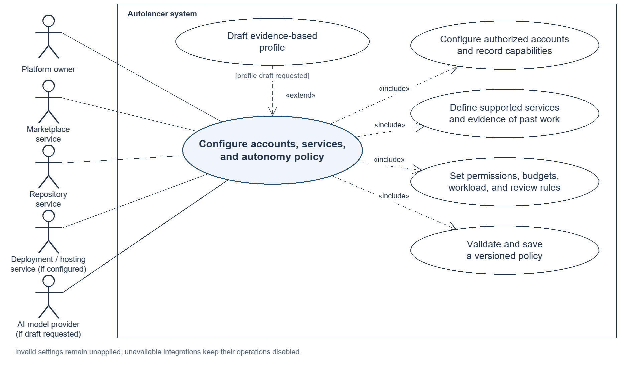
UC-002 - Discover and rank freelance opportunities:
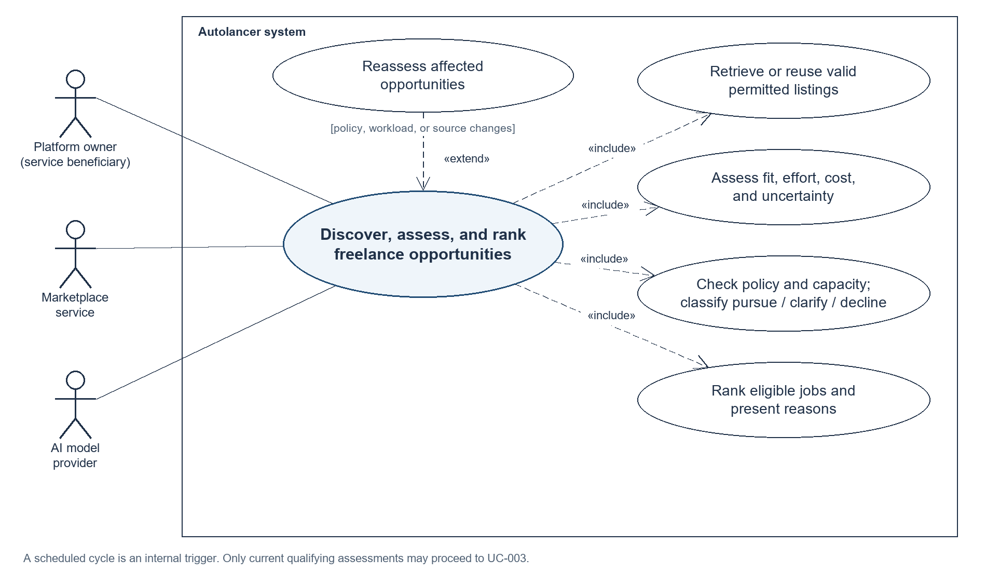

UC-003 - Submit a proposal and activate an awarded project:
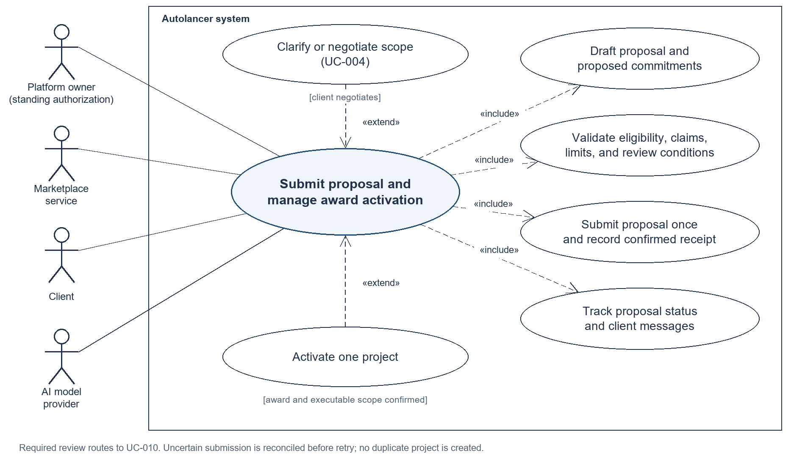
UC-004 - Clarify requirements and maintain PRD:
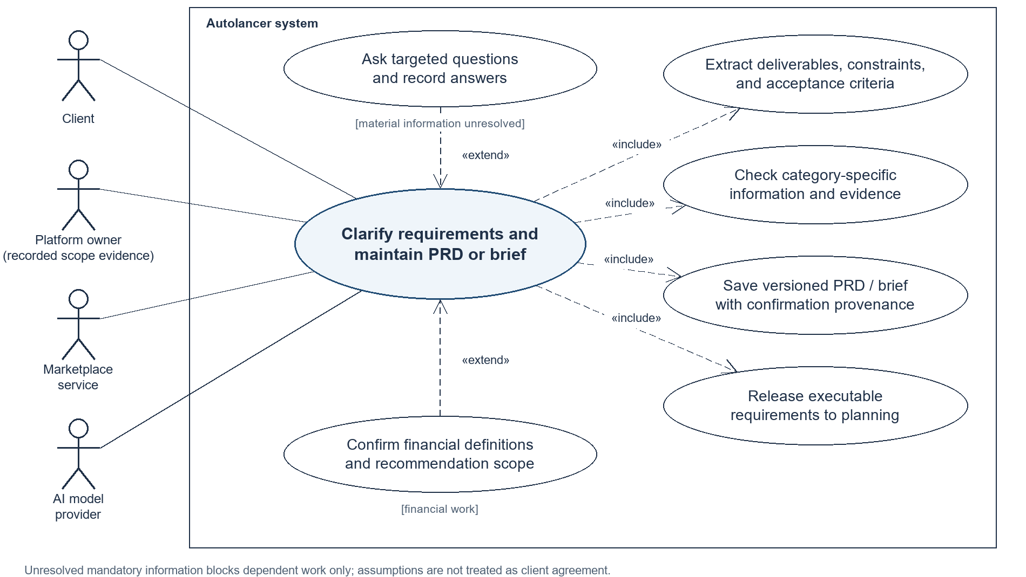

UC-005 - Receive and validate project data and source material: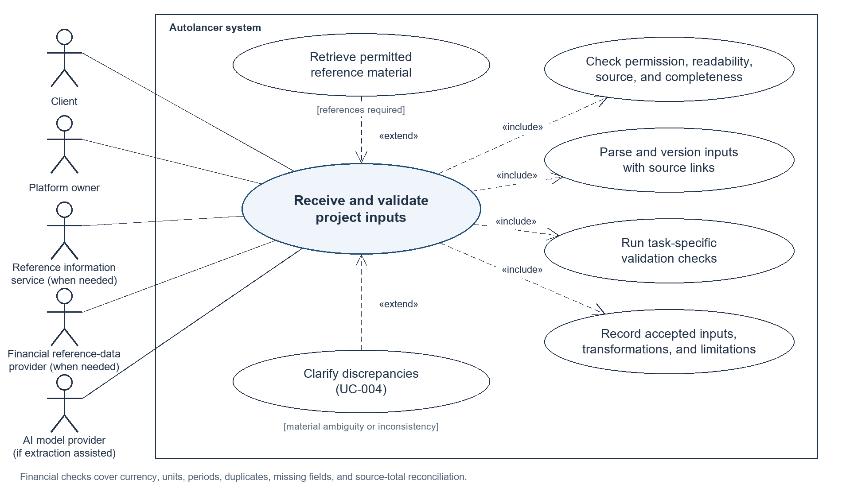
UC-006 - Plan work and coordinate: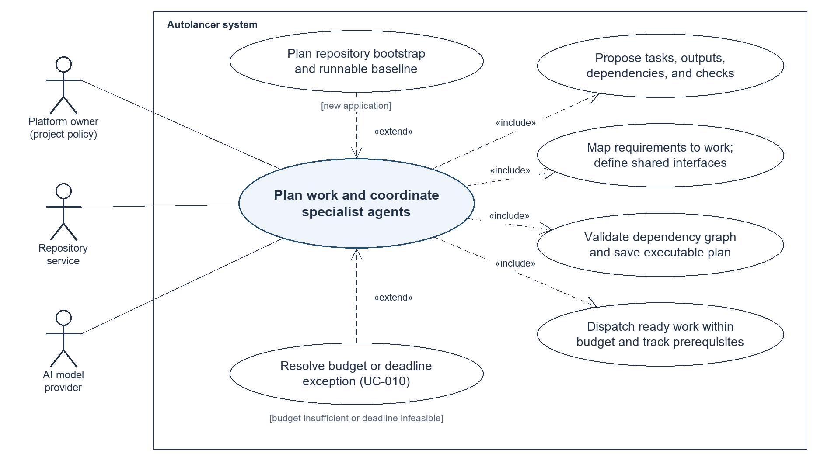
UC-007 - Build verify and deploy software: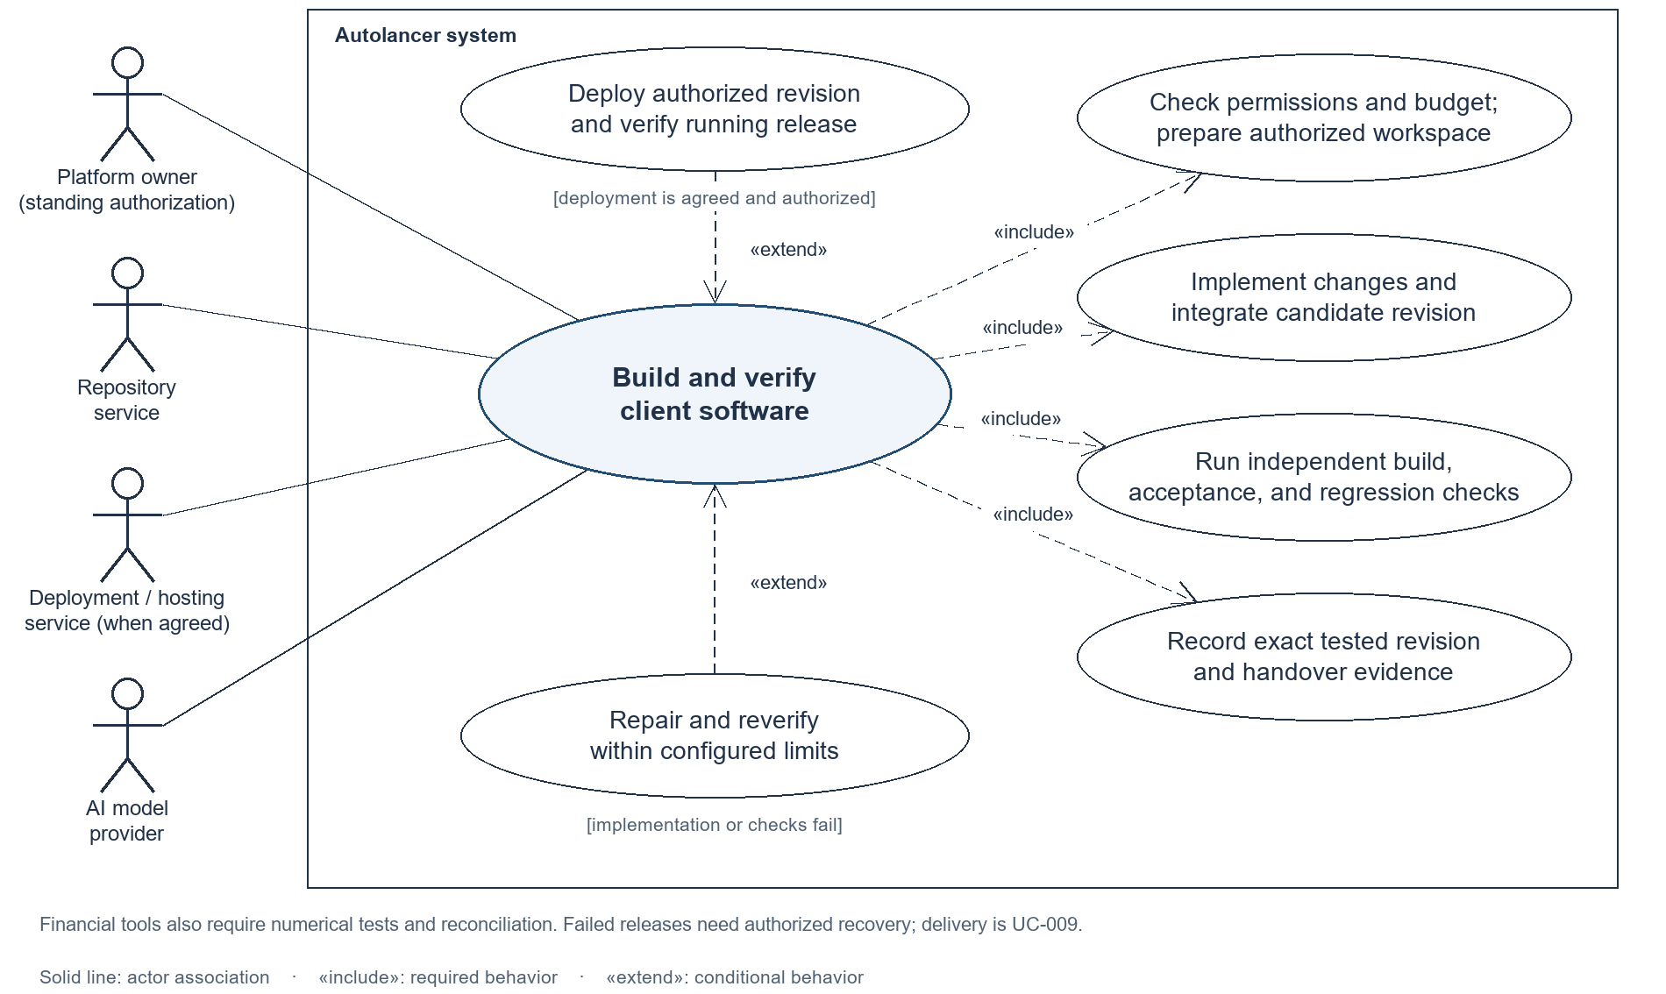
UC-008 - Complete data, research, writing and financial assignments: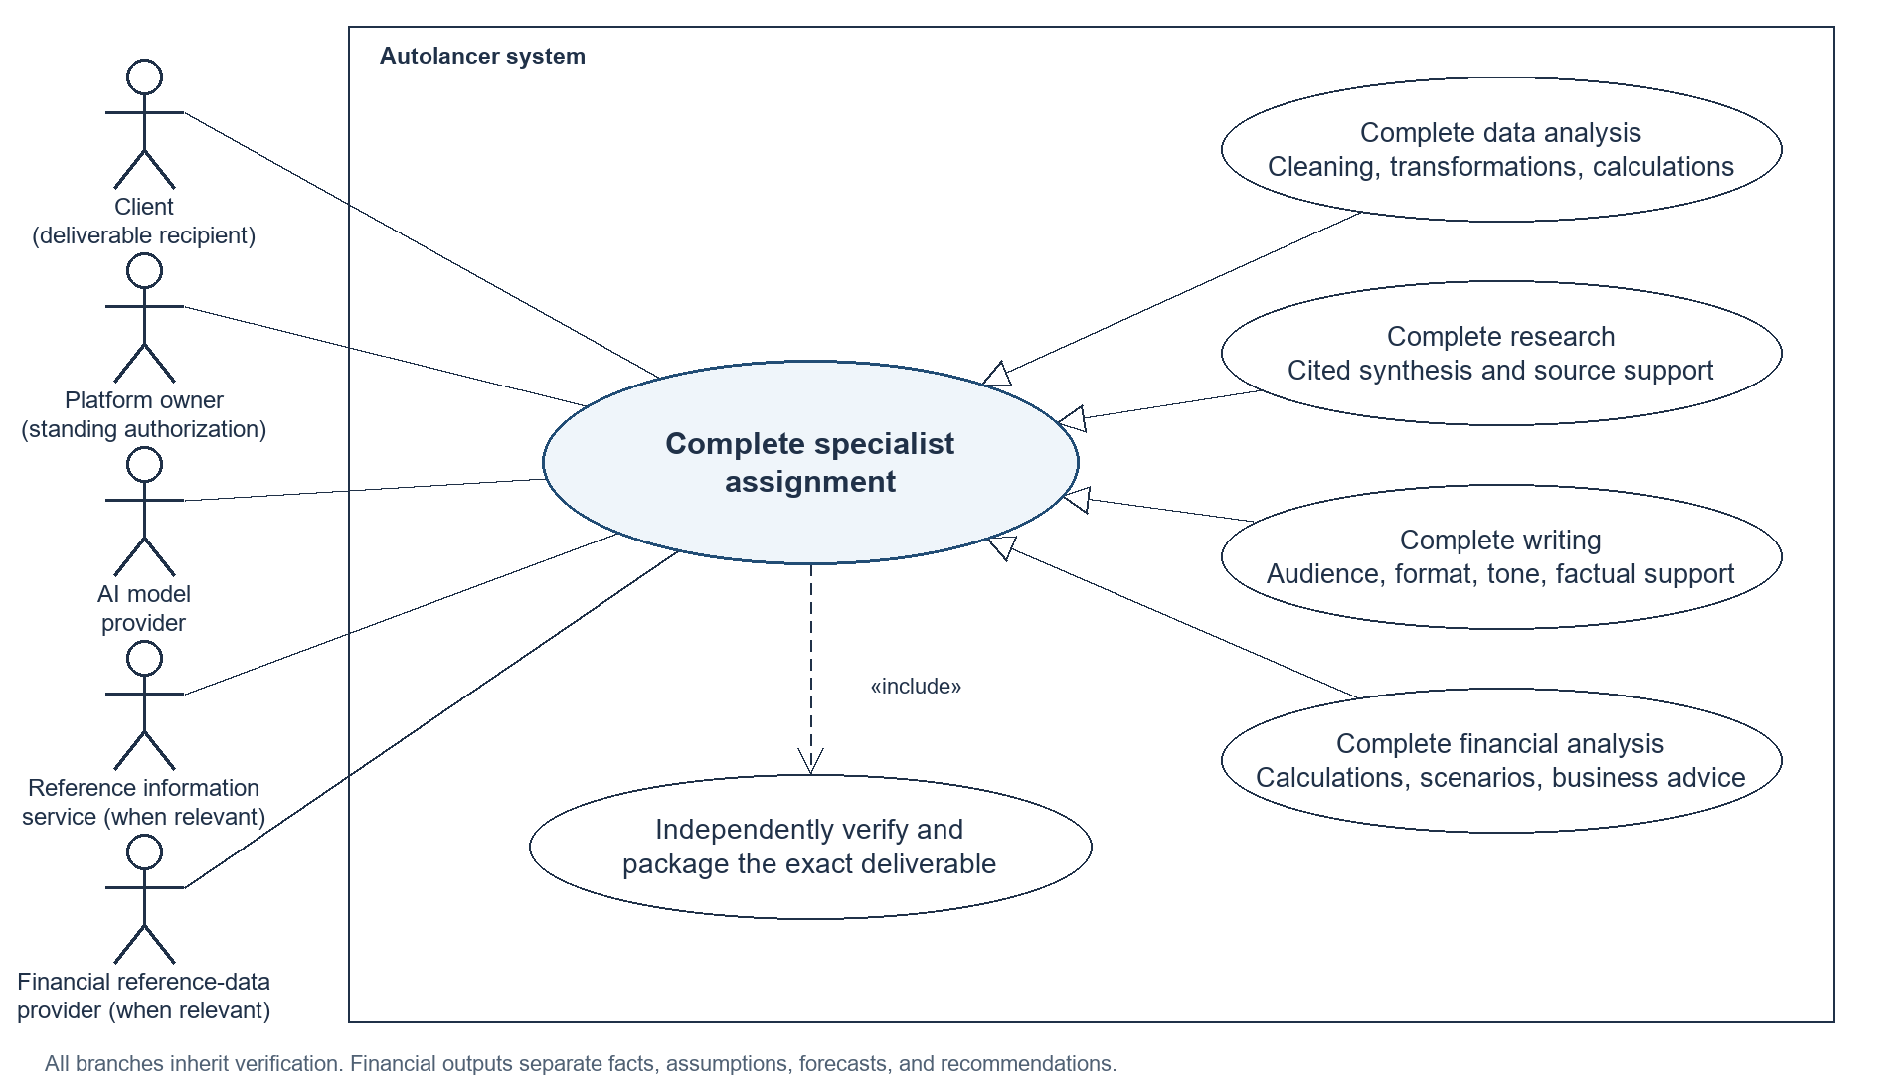
UC-009 - Deliver work, revise and close engagements: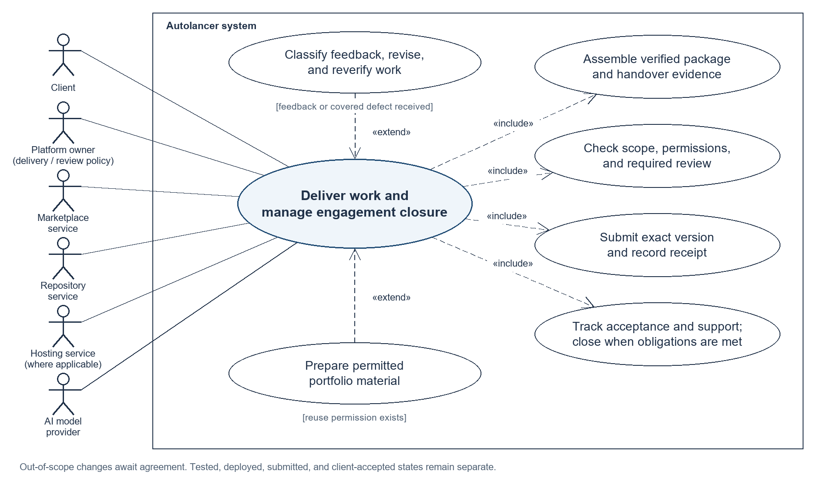
UC-010 - Monitor work, resolve expectations and control execution: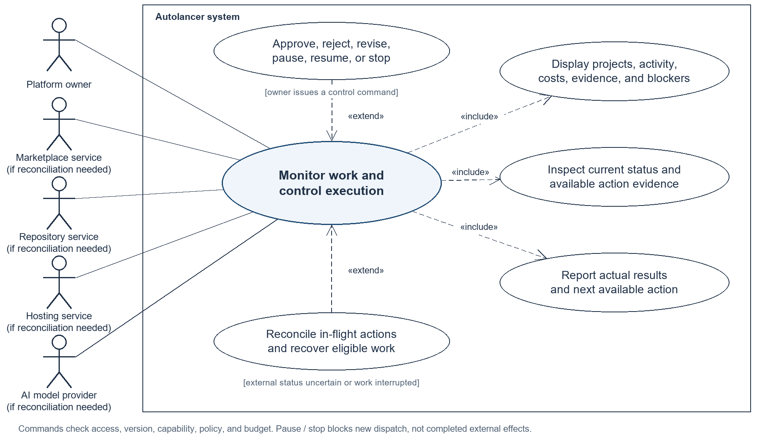
UC-011 - Apply retention rules and delete data: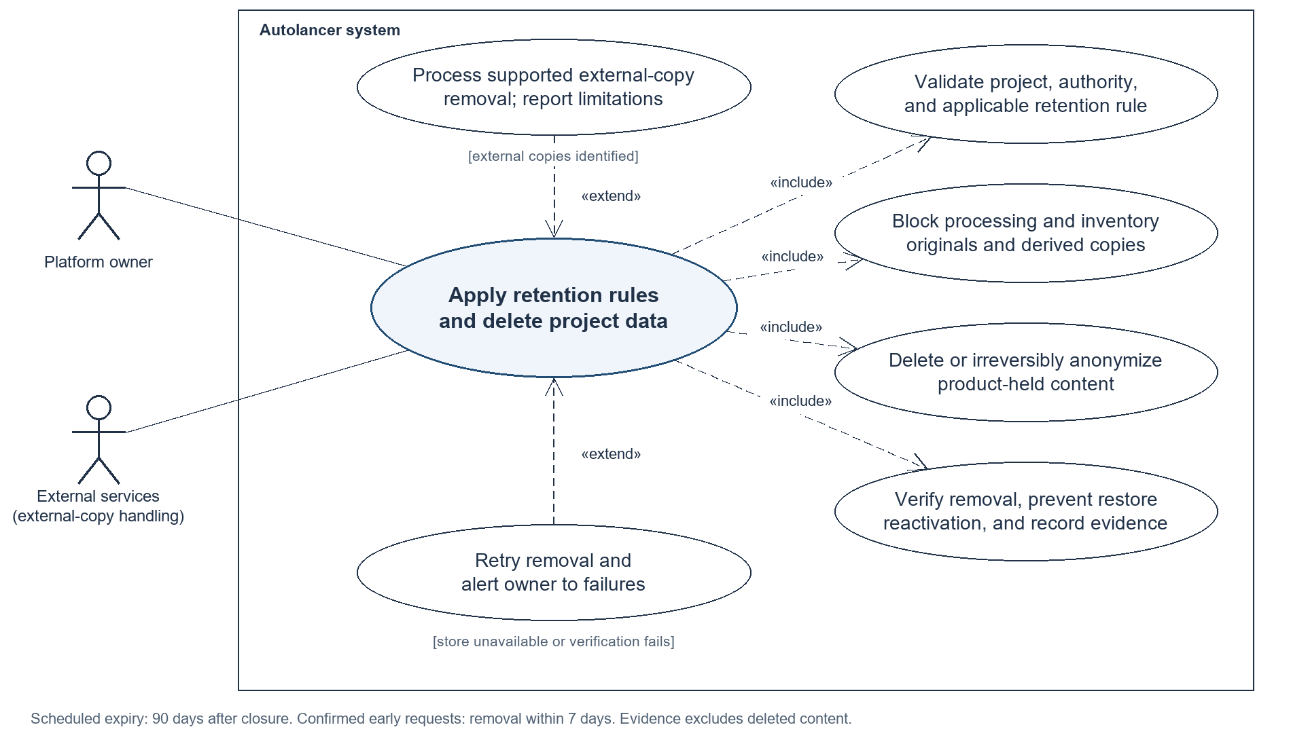
UC-012 - Run isolated workflow and specialist evaluation: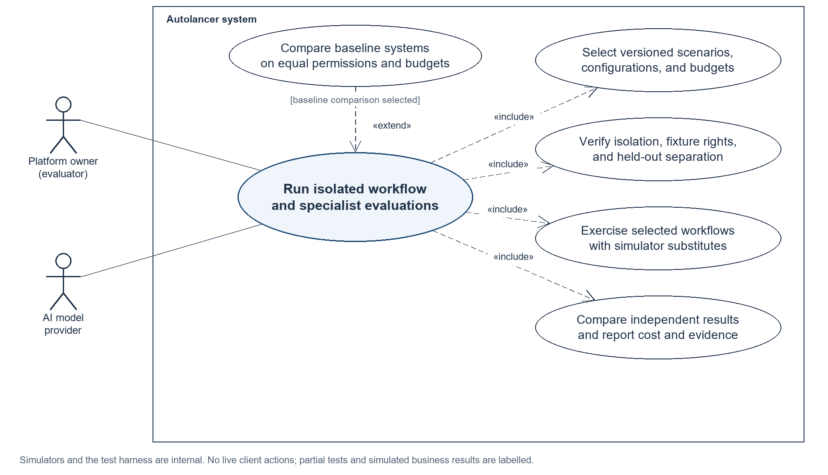

Description of Use Cases
The 12 use cases cover the complete lifecycle for general software, data, research, and writing work, with additional financial behaviour where needed. UC-007 covers general software and financial tools; UC-008 gives explicit branches for data analysis, research, writing, and finance. The cash-flow dashboard is an illustrative financial engagement, not a restriction on other accepted jobs.
Financial-data, business-recommendation, and financial-evaluation details marked as extensions are newly agreed scope and require source-requirement alignment.

Use case | Purpose and coverage
UC-001 | Configure accounts, services, and autonomy policy
UC-002 | Discover, assess, and rank freelance opportunities
UC-003 | Submit a proposal and activate an awarded project
UC-004 | Clarify requirements and maintain the PRD or brief
UC-005 | Receive and validate project data and source materials
UC-006 | Plan work and coordinate specialist agents
UC-007 | Build, verify, and deploy client software
UC-008 | Complete data, research, writing, and financial assignments
UC-009 | Deliver work, handle revisions, and close the engagement
UC-010 | Monitor work, resolve exceptions, and control execution
UC-011 | Apply retention rules and delete project data
UC-012 | Run isolated workflow and specialist evaluations

UC-001 Configure accounts, services, and autonomy policy
Field | Description
Identifier | UC-001
Purpose | Let the owner establish the connected accounts, evidence-based services, and enforceable operating rules for autonomous work.
Actors | Primary: Platform owner. Supporting: Marketplace service, Repository service, Deployment / hosting service when configured, AI model provider when a profile draft is requested.
Trigger | The owner establishes or updates services, account connections, or operating permissions.
Preconditions | An owner account exists. The owner is authorized to connect the external accounts and use the supplied work samples.
Postconditions | Success: Account capabilities, supported services, and a versioned autonomy policy are saved. Only permitted operations can be dispatched.  Failure: Invalid settings do not take effect. Unavailable integrations remain restricted and the previous valid policy remains inspectable.
Traceability | FR-001 to FR-004; AIR-002
AI involvement | AI may draft an evidence-based profile. Application rules validate permissions and limits; generated text cannot authorize actions.
Sensitive data | Protect account tokens, work samples, client references, and settings. Integrations hold credentials; model prompts and ordinary logs exclude secrets.

Typical course of action
Step | Action
1 | The owner signs in and opens account and service settings.
2 | The owner connects marketplace and repository accounts and any required deployment target.
3 | The system records enabled operations and displays connection status without revealing credentials.
4 | The owner defines finance-first and supported general services with permitted evidence of past work.
5 | If requested, AI drafts a profile grounded in those inputs and identifies claims lacking evidence.
6 | The owner sets action permissions, bid and spending limits, deadlines, workload limits, deployment targets, and review conditions.
7 | The system saves a valid policy version and applies it before subsequent governed actions.

Alternate courses of action
Path | Condition, action, and continuation
A1  Step 2 | If an integration is unnecessary, leave it disconnected and its operations unavailable; continue at step 4.
A2  Step 5 | If no profile draft is requested, use the supplied profile and continue at step 6.

Exception paths
Path | Condition, action, and continuation
E1  Step 1 | If authentication or ownership checks fail, deny access and end without exposing project or account data.
E2  Step 2–3 | If access fails or capability is insufficient, mark the connection unavailable. The owner reconnects at step 2 or continues at step 4 with that operation disabled.
E3  Step 5–6 | If generation fails, claims lack evidence, or settings are invalid, retain an unapproved draft or unsaved policy. Show the reason and resume at step 4 or 6 after correction.

UC-002 Discover, assess, and rank freelance opportunities
Field | Description
Identifier | UC-002
Purpose | Identify worthwhile financial and general opportunities and present an explainable ranking that can drive authorized pursuit.
Actors | Primary: Platform owner as beneficiary of the configured service. Supporting: Marketplace service, AI model provider. The scheduler is an internal trigger.
Trigger | A discovery cycle, marketplace update, or change in policy, workload, or source information triggers assessment.
Preconditions | An authorized marketplace or isolated simulator source is available; services, search constraints, and autonomy policy are configured.
Postconditions | Success: The ranked list records fit, estimates, uncertainty, reasons, source versions, and pursue/clarify/decline status. Qualifying jobs are eligible for UC-003.  Failure: Unassessed or stale information is labelled. No opportunity proceeds automatically without a valid qualifying assessment.
Traceability | FR-005 to FR-006; AIR-001
AI involvement | AI assesses scope and estimates; application logic checks capabilities, policy, capacity, and ranking eligibility.
Sensitive data | Use permitted listings, profile evidence, and relevant workload summaries. Do not disclose other clients’ confidential records to prospective clients.

Typical course of action
Step | Action
1 | The system loads the current filters, service profile, policy, workload, and source cursor.
2 | The adapter retrieves permitted listings and de-duplicates them by source identifier.
3 | The system prepares permitted assessment inputs and checks the assessment budget.
4 | AI assesses the job’s service category, capability fit, deliverables, effort and cost ranges, uncertainty, and clarification needs; finance expertise is an additional fit signal for financial jobs.
5 | Application checks classify jobs as pursue, clarify, or decline and reject infeasible commitments.
6 | The system ranks all eligible supported jobs using fit, workload, deadline, cost, uncertainty, and expected return. Financial expertise informs fit without excluding suitable general work.
7 | The hub displays ranks and material changes; eligible automatic pursuit proceeds without waiting for the owner to view the list.

Alternate courses of action
Path | Condition, action, and continuation
A1  Step 1 | If only policy or workload changes, reuse still-valid listings and resume at step 3 for affected jobs.
A2  Step 4–6 | If a supported general job ranks for pursuit, it follows the same autonomous proposal and execution path as a financial job; continue at step 7.

Exception paths
Path | Condition, action, and continuation
E1  Step 2 | If the source fails or is rate-limited, retain and label the last successful candidate set, record bounded retry status, and end this cycle deferred.
E2  Step 3–5 | If budget, evidence, or model service is insufficient, mark affected jobs unassessed or clarify. Do not pursue them; resume at step 3 after resolution.
E3  Step 6–7 | If source or policy versions change before pursuit, invalidate affected eligibility and resume at step 3.

UC-003 Submit a proposal and activate an awarded project
Field | Description
Identifier | UC-003
Purpose | Turn a qualifying opportunity into a valid proposal and, after confirmed award and scope, one executable client project.
Actors | Primary: Platform owner through standing authorization. Supporting: Marketplace service, Client, AI model provider.
Trigger | A currently assessed opportunity qualifies for pursuit under owner policy.
Preconditions | A qualifying assessment exists; marketplace capability and owner permissions support the requested pursuit action.
Postconditions | Success: Proposal submission has a confirmed receipt. One project activates only after award evidence and executable agreed scope exist.  Failure: Held or uncertain proposals are not reported submitted; unawarded opportunities do not start client execution work.
Traceability | FR-007, FR-010; AIR-001, AIR-002
AI involvement | AI drafts proposals and proposed commitments. Application checks authorize submission; recorded evidence controls award and activation.
Sensitive data | Use permitted profile evidence and job context. Exclude credentials and other clients’ confidential work from proposals and model input.

Typical course of action
Step | Action
1 | The system retrieves the opportunity, current assessment, and latest pursuit policy.
2 | AI drafts a proposal with price, deliverables, deadline, assumptions, and required clarification.
3 | The system validates the exact draft against permitted claims, scope, price, bid count, workload, and review conditions.
4 | The adapter submits an allowed proposal once and records its external receipt.
5 | The system waits for status updates and client messages linked to the proposal.
6 | On award, the system verifies external award or owner-recorded contract evidence and executable agreed scope.
7 | The system activates one project with its client, budget, deadline, and source evidence, then releases eligible work.

Alternate courses of action
Path | Condition, action, and continuation
A1  Step 3 | If policy requires review, invoke UC-010. Recheck an approved unchanged proposal at step 3; rejection ends pursuit without submission.
A2  Step 5–6 | If the client negotiates, invoke UC-004 and version the changed commitments. Resume at step 3 for resubmission or step 6 after award.

Exception paths
Path | Condition, action, and continuation
E1  Step 1–3 | If eligibility fails or the job closes, hold or decline and record why. UC-002 must reassess before restarting at step 1.
E2  Step 4 | If submission times out, reconcile before retry. A found receipt continues at step 5; unresolved status ends awaiting owner handoff without duplicate submission.
E3  Step 6–7 | If award or scope is unconfirmed, wait for evidence or UC-004. Duplicate award events return the existing project instead of creating another, then end with its current state.

UC-004 Clarify requirements and maintain the PRD or brief
Field | Description
Identifier | UC-004
Purpose | Convert client intent into evidence-backed requirements and resolve ambiguity before dependent work begins.
Actors | Primary: Client; Platform owner may supply recorded scope evidence. Supporting: Marketplace service, AI model provider.
Trigger | A job description, client message, or material scope change needs interpretation or clarification.
Preconditions | A separate conversation exists for the opportunity/project. Relevant source messages and permitted materials are available.
Postconditions | Success: A versioned PRD or brief links confirmed requirements to evidence and separates assumptions and questions. Only executable scope reaches dependent work.  Failure: Unresolved mandatory information blocks affected work; drafts and assumptions are not silently treated as client agreement.
Traceability | FR-008 to FR-009; AIR-002
AI involvement | AI extracts requirements, detects gaps, and drafts questions or replies. Application checks govern sending and scope-state changes.
Sensitive data | Client messages, proprietary plans, unpublished material, and any financial context remain project-scoped. Only necessary permitted content reaches the model or client.

Typical course of action
Step | Action
1 | The system links the brief or message to the correct project and loads its current scope.
2 | AI extracts deliverables, acceptance criteria, constraints, and proposed commitments with source references.
3 | The system checks the information required for the job category: software behaviour and environment; data definitions and transformations; research questions and evidence; or writing audience, format, and constraints. Financial work also follows A3.
4 | The system drafts targeted questions and checks outbound commitments against current policy.
5 | The system sends permitted messages and waits for answers, blocking only dependent work.
6 | Client replies or owner-recorded evidence resolve requirements with confirmation provenance.
7 | The system saves a new software PRD or task-specific brief, retaining prior versions.
8 | Executable requirements are released to activation or planning; later changes follow UC-009 change control.

Alternate courses of action
Path | Condition, action, and continuation
A1  Step 3–5 | If all material questions are already resolved by supplied evidence, record it and proceed directly to step 7.
A2  Step 7 | For supported general data, research, or writing jobs, use an appropriate brief and omit irrelevant finance fields; continue at step 8.
A3  Step 3 | For financial work, confirm required inputs, currency, units, reporting periods, forecast horizon, scenarios, and recommendation scope. Record gaps and continue at step 4; no financial default is silently assumed.

Exception paths
Path | Condition, action, and continuation
E1  Step 2–3 | If instructions conflict or data definitions are missing, record the gap and return to step 4. Affected work stays blocked until step 6 resolves it.
E2  Step 4–5 | If a reply exceeds permitted scope, price, deadline, or advice boundaries, hold it for UC-010 or UC-009 change control. Resume at step 4 after the required decision.
E3  Step 2 or 5 | If generation or messaging fails, retain an unsent draft or incomplete scope. Use bounded recovery and reconcile uncertain sends; resume the affected step or end waiting.

UC-005 Receive and validate project data and source materials
Field | Description
Identifier | UC-005
Purpose | Make permitted client data and reference materials usable and traceable for the task, with financial checks where applicable.
Actors | Primary: Client or Platform owner supplying material. Supporting: Reference information service; Financial reference-data provider for financial tasks; AI model provider when extraction assistance is used.
Trigger | An awarded software, data, research, writing, or financial project needs inputs specified by its current brief.
Preconditions | Award and current brief exist. Required datasets, documents, references, or other source materials and their permitted uses are defined.
Postconditions | Success: A versioned validated input collection, with source links, transformations, limitations, and check evidence, is available to authorized downstream tasks.  Failure: Unauthorized, unusable, or materially ambiguous inputs remain unvalidated and do not feed affected tasks.
Traceability | FR-009, FR-017 to FR-019, FR-030; AIR-005; newly agreed financial-data extension where applicable
AI involvement | AI may propose extraction or mappings. Source comparisons, calculations, and confirmed data definitions determine acceptance.
Sensitive data | Inputs may include proprietary code documentation, customer datasets, unpublished writing, business records, or financial statements. Keep access project-scoped, minimize model inputs, and exclude credentials.

Typical course of action
Step | Action
1 | The client or owner supplies files, their project association, source, and permission evidence.
2 | The system stores an input version and checks readability, file type, source identity, and completeness for the project brief.
3 | The system parses the required data or text; uncertain AI-assisted extraction or mappings remain proposals linked to source locations.
4 | Where required, the system retrieves permitted reference material and records provenance, date, and usage conditions; financial reference data follows A3.
5 | The system runs task-specific checks: required columns and transformations for data, accessible traceable sources for research, and source/brief consistency for writing. Financial inputs receive the additional checks in A3.
6 | Material ambiguity is clarified through UC-004; corrected sources and mappings receive new versions and repeat validation.
7 | The system records the accepted input set, transformations, limitations, and check evidence for software or specialist execution.

Alternate courses of action
Path | Condition, action, and continuation
A1  Step 3 | If deterministic parsing is sufficient, omit the model call and continue at step 4 with source-linked values.
A2  Step 4 or 6 | If no reference data or clarification is needed, record that outcome and continue at step 5 or 7 respectively.
A3  Step 4–5 | For financial inputs, obtain required authorized dated reference values and verify currency, units, reporting periods, duplicates, missing fields, and source-total reconciliations. Continue at step 6 for discrepancies or step 7 when all required checks pass.

Exception paths
Path | Condition, action, and continuation
E1  Step 1–2 | If permission is missing or a file is unreadable, block it and request permission or replacement. Resume at step 1 when supplied; until then end waiting.
E2  Step 3–6 | If input definitions or source evidence are inconsistent, preserve the discrepancy and invoke step 6. For financial data, do not silently impute values, convert currencies, or remove records without an agreed rule.
E3  Step 4 | If required reference material is unavailable, unsuitable in date, or not permitted for use, hold only dependent work. Resume at step 4 after an authorized source or revised brief is agreed.

UC-006 Plan work and coordinate specialist agents
Field | Description
Identifier | UC-006
Purpose | Translate agreed scope into coordinated, verifiable work while respecting dependencies, interfaces, capacity, and budgets.
Actors | Primary: Platform owner through project policy. Supporting: Repository service, AI model provider.
Trigger | An awarded project has executable scope, or a scope/interface revision requires a new plan.
Preconditions | The current scope identifies confirmed requirements, input availability, checks, budget, and deadline. Required repository or new-project authority exists.
Postconditions | Success: A valid versioned plan maps requirements to tasks and checks; ready work is dispatched within limits using consistent interfaces and project context.  Failure: Invalid or infeasible work remains held. No requirement is marked fulfilled without evidence or task launched without prerequisites.
Traceability | FR-011 to FR-012, FR-014, FR-026; AIR-003
AI involvement | AI proposes tasks, dependencies, and architecture. Graph, coverage, interface, budget, and capacity validators control dispatch.
Sensitive data | Plans and worker contexts may contain proprietary requirements, code metadata, and financial definitions; access is limited to permitted project inputs.

Typical course of action
Step | Action
1 | The system loads current scope, data readiness, repository context, workload, and policy.
2 | AI proposes tasks, outputs, dependencies, acceptance checks, and worker types.
3 | The system maps every confirmed requirement to implementation and verification work.
4 | The system records architecture and shared interfaces and identifies tasks requiring coordination or sequencing.
5 | The system validates the dependency graph and saves the executable plan and blockers.
6 | The scheduler selects ready tasks across projects and reserves bounded costs before dispatch.
7 | Compatible independent tasks run in parallel where capacity permits, with isolated contexts.
8 | The system tracks results and interface changes and releases dependents only after prerequisites pass.

Alternate courses of action
Path | Condition, action, and continuation
A1  Step 1–2 | For a new application, plan repository bootstrap and a runnable baseline before dependent features; continue at step 3.
A2  Step 6 | If capacity is full, queue ready work and report threatened deadlines. Resume at step 6 when capacity becomes available.

Exception paths
Path | Condition, action, and continuation
E1  Step 3–5 | If coverage or graph checks fail, reject the plan and return to step 2 within the configured replan budget. Exhausted limits end blocked.
E2  Step 6 | If budget is insufficient or the deadline is infeasible, hold affected work for UC-010. Resume at step 6 after a valid decision or revised commitment.
E3  Step 8 | If an interface change invalidates dependents, pause affected dispatch and return to step 4. Changed scope cannot reuse stale approval.

UC-007 Build, verify, and deploy client software
Field | Description
Identifier | UC-007
Purpose | Implement and verify a new application, feature, or bug fix and deploy it when agreed, including financial tools as a specialization.
Actors | Primary: Platform owner through standing project authorization. Supporting: Repository service, Deployment / hosting service, AI model provider.
Trigger | The scheduler dispatches authorized software tasks from a validated plan.
Preconditions | Award, executable PRD, validated task graph, required inputs, and budget exist. Deployment additionally requires an agreed target and scoped authorization.
Postconditions | Success: The exact integrated revision is tested with coverage evidence and, when required, deployed and checked while running. Submission and client acceptance remain separate UC-009 events.  Failure: Failed or incomplete candidates are not released. Retain the last passing revision and record failed, blocked, or recovered deployment accurately.
Traceability | FR-013 to FR-016, FR-016A, FR-020; AIR-004, AIR-006
AI involvement | Coding workers implement and repair code; AI review supplements independent checks. Passing model commentary cannot override missing or failing mandatory tests.
Sensitive data | Isolate client source, financial fixtures, workspaces, and deployment credentials. Use only permitted model context; provide secrets through authorized runtime mechanisms.

Typical course of action
Step | Action
1 | The system checks task permissions and budgets and prepares an existing repository or bootstraps a new runnable baseline.
2 | Workers receive separate branches/workspaces and the current PRD, data references, interfaces, and acceptance checks.
3 | Workers implement compatible tasks for a new application, feature, or bug fix and run local checks. Financial software uses the same process with the additional checks in A3.
4 | The integration component combines completed changes into a candidate revision.
5 | Independent checks build the combined application and test PRD coverage, acceptance behaviour, and regressions. Apply financial calculation checks when the project contains financial functionality.
6 | Failures enter targeted repair within the configured limits and repeat integration and relevant checks.
7 | On passing all mandatory checks, the system records the exact tested revision and release-readiness evidence.
8 | If deployment is required, the system rechecks permission and deploys that exact revision to the agreed target.
9 | The system verifies the running revision, required health/smoke checks, and endpoint before recording deployed status.
10 | The system prepares release and handover evidence for UC-009 without claiming client acceptance.

Alternate courses of action
Path | Condition, action, and continuation
A1  Step 1 | For an existing repository, use its authorized source revision and reproducible setup; for a new application, create a baseline first. Both continue at step 2.
A2  Step 8 | If deployment is not part of agreed scope, keep tested status and proceed to step 10. If required access is merely missing, use E3 rather than bypassing deployment.
A3  Step 3–5 | For the cash-flow dashboard or another financial tool, bind currency, periods, formulas, assumptions, and data-source versions to the PRD. Execute numerical tests and source-total reconciliations alongside application tests; continue at step 6 on failure or step 7 on pass.

Exception paths
Path | Condition, action, and continuation
E1  Step 1–4 | If setup fails, access is denied, or integration conflicts arise, hold affected work and invoke bounded repair or UC-010. Resume the affected step after correction; exhausted limits end blocked.
E2  Step 5–6 | If mandatory checks fail or repair limits are exhausted, retain the last passing revision and end blocked. Tests cannot be weakened solely to label the original scope complete.
E3  Step 8 | If target access or authorization is missing, hold required deployment for UC-010. If submission status is uncertain, reconcile through CF-04; resume at step 9 only after a confirmed release.
E4  Step 9 | If running checks fail, perform supported authorized rollback or recovery and verify its outcome. Record failed or rolled-back status; otherwise end blocked and alert the owner. Reattempt through step 4 or 8 only after correction.

UC-008 Complete data, research, writing, and financial assignments
Field | Description
Identifier | UC-008
Purpose | Complete general data, research, and writing assignments and specialist financial analyses using the appropriate execution and quality checks.
Actors | Primary: Client as recipient of commissioned work; Platform owner supplies standing authorization. Supporting: AI model provider, Reference information service, and Financial reference-data provider when relevant.
Trigger | An awarded data, research, writing, or financial-planning project has an executable specialist task.
Preconditions | A current brief defines audience, format, deliverables, permitted scope, inputs, and acceptance checks. Mandatory source inputs have passed UC-005.
Postconditions | Success: A versioned task-specific deliverable has passing required checks, reproducible calculations where applicable, and traceable source support. Financial outputs distinguish observations, assumptions, projections, and recommendations.  Failure: Failed checks or insufficient mandatory evidence prevent verified status and delivery. The owner may inspect an explicitly incomplete draft.
Traceability | FR-017 to FR-020; AIR-005, AIR-006; newly agreed financial-analysis and business-advice extension
AI involvement | AI assists analysis planning, synthesis, drafting, and review. Executable calculations, source checks, and brief checks establish readiness; financial forecasts use tools and independently checked inputs.
Sensitive data | Datasets, confidential documents, unpublished content, and business records remain project-scoped. Source permissions and model-input restrictions apply across every work category.

Typical course of action
Step | Action
1 | The system loads the current brief, validated sources, service category, and task budget.
2 | The specialist worker selects the agreed task workflow and checks that required methods, source material, audience, format, and acceptance criteria are sufficiently defined.
3 | The worker executes the appropriate data, research, writing, or financial branch described in A1–A4 and preserves source and transformation evidence.
4 | Independent task-specific checks verify calculations, source support, required content, or financial assumptions as applicable to that branch.
5 | The worker packages the result in the agreed format, with explanation, references, and material limitations where required.
6 | The system checks the exact package for brief compliance and consistency with verified results; financial recommendations also undergo the agreed advice-scope check.
7 | The verified version proceeds to UC-009 for policy-controlled delivery; incomplete or review-required candidates remain visible to the owner.

Alternate courses of action
Path | Condition, action, and continuation
A1  Step 3–4 | For a general data assignment, execute agreed CSV cleaning, transformations, or analysis. Preserve input/output versions and transformation code; check schema, row-level rules, and expected calculations. Continue at step 5 if checks pass, otherwise E2.
A2  Step 3–4 | For research, retrieve permitted sources, assess relevance, reconcile conflicting evidence, and build a cited synthesis with claim-to-source links. Unsupported conclusions are omitted or held; continue at step 5 when mandatory source checks pass, otherwise E3/E4.
A3  Step 3–4 | For writing, draft to the agreed audience, purpose, format, length, tone, required sections, and prohibited content. Check factual support when claims are made and verify the brief; continue at step 5 on pass, otherwise E3.
A4  Step 3–4 | For finance work, establish confirmed currency, units, periods, horizon, methods, and scenario assumptions. Tools calculate historical results, projections, and scenarios; independent checks reconcile figures to source records. Explain tailored business-planning recommendations while separating facts, assumptions, forecasts, and advice. Continue at step 5 on pass; gaps follow E1/E2.
A5  Step 2–3 | If the agreed financial deliverable is a what-if scenario model, label its outputs as scenarios rather than demonstrated predictive accuracy. Continue through A4 and the same verification gates.

Exception paths
Path | Condition, action, and continuation
E1  Step 1–2 | If mandatory inputs, methods, or scope are unclear, invoke UC-004/UC-005 and hold dependent work. Resume at step 1 after confirmed corrected input is available.
E2  Step 3–4 | If tools fail, transformations violate agreed rules, or calculations do not reconcile, retain evidence and attempt bounded repair. Rerun the affected branch at step 3; exhausted limits end blocked.
E3  Step 3–6 | If claims lack support, writing violates the brief, or financial recommendations exceed business-planning scope, revise or clarify the candidate and repeat the affected checks. Uncorrected candidates remain unverified.
E4  Step 4–7 | If a mandatory check or required source is unavailable, keep the candidate awaiting verification. Resume the affected check when evidence is restored; do not default to an AI-generated pass.

UC-009 Deliver work, handle revisions, and close the engagement
Field | Description
Identifier | UC-009
Purpose | Provide the agreed result to the client, respond to feedback, and complete the engagement with traceable acceptance and support outcomes.
Actors | Primary: Client; Platform owner acts under configured delivery/review policy. Supporting: Marketplace service, Repository service, Hosting service where applicable, AI model provider.
Trigger | A verified deliverable is ready, or the client submits acceptance, feedback, or a covered support request.
Preconditions | Delivery requires a verified candidate, current agreed scope, required deployment evidence where applicable, and permission to deliver. Revision handling requires an existing engagement.
Postconditions | Success: The exact version is submitted with a receipt, feedback is tracked, and acceptance is recorded separately. Final completion occurs only after delivery obligations and agreed support/closure conditions are satisfied.  Failure: Uncertain submission, outstanding required work, or unresolved feedback remains visible. Submission alone does not establish acceptance or completion.
Traceability | FR-016B, FR-021 to FR-024; AIR-002 to AIR-006 as applicable
AI involvement | AI drafts handover messages, interprets feedback, and proposes changes. Scope, permissions, verification evidence, and client outcomes control transitions.
Sensitive data | Deliver only the client-authorized package. Exclude credentials, unrelated client material, and unnecessary internal logs. Portfolio reuse requires separate permission.

Typical course of action
Step | Action
1 | The system assembles the verified package, coverage and test evidence, deployment status, limitations, and agreed support terms.
2 | The system checks the package and client message against current scope, permissions, and any required review.
3 | The adapter submits the permitted version and records the receipt without assuming client acceptance.
4 | The system waits for acceptance or feedback and maintains separate tested, deployed, submitted, and client-accepted states.
5 | For feedback, the system classifies the requested change against agreed scope and support terms and versions its interpretation.
6 | In-scope revisions return to planning, implementation or analysis, and verification before a new delivery; out-of-scope changes await agreement.
7 | Confirmed acceptance starts or continues support as agreed; covered defects repeat the revision and applicable redeployment flow.
8 | The system records final completion only when obligations, acceptance or documented closure, and support conditions are satisfied.
9 | The system records actual effort, cost, revisions, and outcomes and prepares portfolio material only with reuse permission.

Alternate courses of action
Path | Condition, action, and continuation
A1  Step 2 | If policy permits verified business-planning recommendations, deliver automatically. If review is required, invoke UC-010 and recheck the exact version at step 2 after approval.
A2  Step 7–8 | If no support period was agreed, omit support-active status. Once acceptance or documented closure and other obligations are satisfied, continue at step 8.

Exception paths
Path | Condition, action, and continuation
E1  Step 1–3 | If mandatory checks, deployment obligations, or permissions are missing, hold delivery and return to the relevant execution or review use case. Resume at step 1 after correction.
E2  Step 3 | If submission is unsupported or uncertain, retain the package and invoke CF-04 or owner handoff. Confirmed receipt continues at step 4; unresolved status remains awaiting delivery confirmation.
E3  Step 5–7 | If feedback is ambiguous, outside scope, or received after covered support ends, prepare clarification or a change proposal. Wait for agreement before affected work and resume at step 5.
E4  Step 8–9 | If acceptance evidence or covered-defect resolution is missing, retain the current state. If reuse permission is absent, omit portfolio preparation. Resume step 8 on new evidence; portfolio omission does not block client completion.

UC-010 Monitor work, resolve exceptions, and control execution
Field | Description
Identifier | UC-010
Purpose | Give the owner visibility and effective control over autonomous work, exceptions, budgets, and recovery.
Actors | Primary: Platform owner. Supporting: Marketplace, Repository, Hosting, and AI model services only when their in-flight operations need status reconciliation.
Trigger | The owner inspects the hub, an exception needs a decision, or execution is paused, resumed, stopped, or recovered.
Preconditions | The owner is authenticated and authorized for the project. Current states, policies, costs, and available evidence are recorded.
Postconditions | Success: The hub shows traceable current status and the owner decision or execution-control result. Only eligible authorized work resumes.  Failure: Denied, stale, or unsupported decisions do not execute. Unretractable external effects remain accurately reported rather than presented as cancelled.
Traceability | FR-025 to FR-029; relevant AIR oversight and fallback provisions
AI involvement | The owner may inspect AI-generated estimates, recommendations, or proposed actions. Control decisions and permission enforcement are application functions; no model can grant itself authority.
Sensitive data | The hub exposes only the owner’s project data and permitted evidence. Show credential references rather than secrets; preserve project separation in views and control actions.

Typical course of action
Step | Action
1 | The owner opens the hub and views ranked jobs, projects, agent activity, requirement coverage, conversations, costs, deployment evidence, and exceptions.
2 | The owner selects a project or exception and inspects the exact proposed action, its version, reasons, and supporting evidence.
3 | The owner approves, rejects, revises, pauses, resumes, or stops the selected work.
4 | The system checks current permissions, action version, provider capability, and applicable budget before applying the command.
5 | Allowed approvals release only the specified action; pause/stop prevents new task and outbound dispatch and identifies in-flight work.
6 | The system reconciles in-flight external actions and resumes only eligible unfinished work when permitted.
7 | The system logs the decision and displays actual results, remaining blockers, and the next available action.

Alternate courses of action
Path | Condition, action, and continuation
A1  Step 1–2 | If the owner only observes, no new approval is implied or required. Permitted background work continues and the use case ends after displaying status.
A2  Step 3–6 | If the owner revises an action, create a new version and route it through its originating use case. Resume at step 2 for any required decision on that new version.

Exception paths
Path | Condition, action, and continuation
E1  Step 1–4 | If owner access fails, deny the operation and end without exposing or changing the project.
E2  Step 4 | If approval is stale or an action still violates policy or provider restrictions, keep it held. Display the reason and resume at step 2 when a valid proposal or permission exists.
E3  Step 5–6 | If an external submission already completed or cannot be cancelled, stop further work and reconcile its actual result. Continue at step 7 with completed/uncertain status, not a false cancellation.
E4  Step 5–7 | If a worker or service interrupts, recover committed state through CF-04, preserving pause/stop instructions. Resume at step 6 only if eligible; otherwise remain paused or blocked.

UC-011 Apply retention rules and delete project data
Field | Description
Identifier | UC-011
Purpose | Remove project information according to retention policy or a confirmed owner request without reactivating deleted material.
Actors | Primary: Platform owner. Supporting: External services only to identify or process supported external-copy handling. Retention expiry is an internal scheduler event.
Trigger | A closed project reaches its retention deadline or the authorized owner confirms an earlier deletion request.
Preconditions | The project and product-held content can be identified. Early deletion requires owner confirmation; scheduled expiry uses the recorded closure and retention policy.
Postconditions | Success: Product-held content is deleted or irreversibly anonymized as required, deletion evidence is retained without preserving deleted content, and external-copy handling is separately identified.  Failure: Incomplete deletion is recorded as pending or failed with affected stores identified. No complete-deletion claim is made while required product-held content remains.
Traceability | FR-030; source retention and data-handling NFRs; AIR retention provisions
AI involvement | No AI decision is required. Deletion follows recorded policy and authorized requests; deleted client material is not sent to a model for summarization or retained through a new summary.
Sensitive data | Cover files, financial records, messages, model inputs/outputs, derived datasets, workspaces, indexes, caches, and logs. Preserve the existing deletion and backup-restoration requirements.

Typical course of action
Step | Action
1 | The system receives a retention-expiry event or a confirmed owner request and validates the project and authority.
2 | The system stops active work for early deletion and blocks new processing of content scheduled for removal.
3 | The system inventories product-held originals and derived copies and identifies external-service copies separately.
4 | The system deletes or irreversibly anonymizes product-held content under the applicable retention rule.
5 | The system verifies removal and ensures backup restoration cannot reactivate deleted records.
6 | The system records completion evidence without sensitive payloads and shows remaining external-copy limitations to the owner.

Alternate courses of action
Path | Condition, action, and continuation
A1  Step 1 | For scheduled expiry, use the existing 90-day post-closure policy without requesting fresh approval. Continue at step 2.
A2  Step 1 | For early deletion, use the confirmed request and existing seven-day removal deadline. A cancelled unconfirmed request ends without deletion.

Exception paths
Path | Condition, action, and continuation
E1  Step 1 | If identity, ownership, or confirmation fails, reject the early request and end without deletion or disclosure.
E2  Step 2–5 | If a store is unavailable or deletion verification fails, keep deletion pending, retry within the applicable deadline, and alert the owner to unresolved failures. Resume at the failed step without reactivating work.
E3  Step 3–6 | If an external copy cannot be removed through a supported interface, report that limitation separately. Do not represent it as product-held deletion failure or claim the external copy is deleted; continue verifying product-held removal at step 5.

UC-012 Run isolated workflow and specialist evaluations
Field | Description
Identifier | UC-012
Purpose | Evaluate the autonomous workflow and each supported work category reproducibly in isolation from real client actions.
Actors | Primary: Platform owner acting as evaluator. Supporting: AI model provider. Marketplace, client, repository, hosting, and reference-data interactions use isolated simulator/test substitutes.
Trigger | The owner starts an evaluation run against a versioned scenario set and selected system configurations.
Preconditions | Versioned held-out scenarios, expected outcomes, applicable budgets, and isolated evaluation access exist. Fixtures are synthetic or explicitly authorized and protected.
Postconditions | Success: The run reports scenario-level outcomes, failures, interventions, time, cost, and evidence, distinguishing simulated business results from real results and unmeasured finance targets.  Failure: Invalid isolation, missing required evidence, or budget exhaustion produces a blocked or failed run, not a successful benchmark. No real client action occurs.
Traceability | FR-031; AIR-001 to AIR-006; newly agreed finance-specific evaluation extension
AI involvement | Evaluation exercises AI assessment, drafting, planning, implementation, analysis, and review. Expected checks and independent labels determine results; model self-scoring is insufficient.
Sensitive data | Do not copy confidential production records into evaluation without permission. Restrict hidden tests and scenario answers from task workers; retain only authorized evaluation evidence.

Typical course of action
Step | Action
1 | The owner selects scenario versions, configurations, and applicable comparison budgets.
2 | The harness verifies isolation, fixture permissions, held-out separation, and availability of required checks.
3 | The harness initializes mixed finance and general opportunities and tests discovery, ranking, proposals, clarification, and PRD/brief creation against the simulator.
4 | The system ingests scenario inputs, plans tasks, and executes software, data, research, writing, or financial work using the same logical gates as live jobs.
5 | The simulator exercises delivery, revisions, competing deadlines, provider failures, and deployment outcomes as defined by the scenario.
6 | Independent checks compare lifecycle states and task results with hidden expectations: software tests, data calculations, research source support, writing rubrics, and financial reference results as applicable.
7 | The harness aggregates results with model/tool/configuration versions and actual resource usage, keeping scenario classes separate.
8 | The owner receives the report with simulated business outcomes labelled and finance-specific measures distinguished from unapproved targets.

Alternate courses of action
Path | Condition, action, and continuation
A1  Step 3–5 | If a scenario covers only one capability, execute that defined subset and label it as a partial-workflow test. Continue at step 6 without claiming end-to-end completion.
A2  Step 1–7 | For baseline comparisons, repeat the same held-out scenario using identical model/tool permissions and total scenario budgets. Continue at step 7 with separate per-system results.

Exception paths
Path | Condition, action, and continuation
E1  Step 2 | If a real external-write endpoint, leaked hidden answer, or unauthorized fixture is detected, abort before affected work. Correct the setup and restart at step 1; do not count the invalid run.
E2  Step 4–6 | If time/cost limits expire or mandatory checks fail, stop the affected scenario and record failure with evidence. Continue at step 7; do not omit failed cases.
E3  Step 6–8 | If a required reference result or independent review is missing, mark that measure unevaluated and the affected run incomplete. Continue reporting at step 8 without a quality claim; rerun after evidence is supplied.

5. Class Diagram

Status of this model
The class diagram in this section is a preliminary model, not a finalized design specification. Autolancer’s concept was only recently consolidated. Several decisions that will shape the system’s static structure are still open. The live marketplace integration has not yet been chosen between Upwork and Freelancer.com, pending capability and authorization checks. The breakdown of specialist agents, the orchestration framework and the persistence technology have not been fixed. The financial-analysis and business-advice extensions are newly agreed scope, and their alignment with the source requirements is still in progress. Each of these decisions is likely to add, merge or remove classes, and to change the multiplicities and responsibilities shown here.
At this stage the diagram is deliberately drawn at the level of the problem domain. It identifies the main entities the system must record and reason about: opportunities, proposals, projects, versioned PRDs and briefs, requirements, plans and tasks, source materials, verification evidence, deliveries, and the owner’s autonomy policy. It also shows the relationships the use cases depend on, such as tracing requirements to tasks and keeping the tested, deployed, submitted and client-accepted states separate. External services are represented as abstract interfaces. This follows NFR-013, and it lets the marketplace simulator in UC-012 stand in for live providers. Implementation details are left out on purpose: database schemas, framework classes, user-interface components, message formats and the internal structure of individual agents. Committing to them now would pre-empt design decisions the team has not yet made, and would make the model look more final than it is.
The model is therefore expected to evolve as the project moves from requirements into architecture and implementation. Classes may be split as their responsibilities become clearer. Attributes and operations will be filled in once interfaces are prototyped. Relationships will be revisited as the sequence specifications are built. Later deliverables will record these revisions and the reasons for them, so that changes to the static model remain traceable to the requirements they serve.

5.1 Diagram

The class model is presented at two levels of detail. Figure 5.1 is an overview of the whole domain. It shows the principal classes of Autolancer and the associations between them, from the owner’s autonomy policy and the discovery of opportunities, through scope definition, planning and execution, to verification and delivery. Attributes and operations are left out of this view on purpose. Its purpose is to set out the broad structure of the system: which entities exist, how they depend on one another, and where the main lines of ownership and traceability run. Read alongside the use cases in Section 4, it shows how each stage of the engagement lifecycle is reflected in the static structure.
For analysis, the domain is divided into seven packages that follow the engagement lifecycle: governance and autonomy policy; opportunity and engagement; scope and source materials; planning and execution; verification, deployment and delivery; control services and integration adapters; and oversight, cost, retention and evaluation. Given the preliminary status of the model, only two of these packages are elaborated in full here, as representative examples: scope and source materials (Figure 5.2) and verification, deployment and delivery (Figure 5.3). They show the level of detail each package is intended to reach: representative attributes and operations, multiplicities on every association, and explicit use of composition, generalisation and stereotypes where these carry meaning in the requirements.
These two packages were chosen because they contain the model’s most significant structural decisions. The scope package treats financial definitions as an optional component of any scope document rather than as a separate subclass. This reflects the position in Section 1 that finance is a specialisation applied across work categories, not a category of its own. The verification package represents the tested, deployed, submitted and client-accepted states as distinct evidence objects rather than values of a single status field. This makes concrete the requirement, repeated throughout Sections 4 and 6, that no state may be claimed without its corresponding evidence.
The remaining five packages appear in Figure 5.1 at the level of their classes and associations only. They will be elaborated to the same standard in later deliverables, once the decisions identified in the status statement above have been made. Developing every package in full at this stage would commit the team to attributes and operations that are likely to change, and would undermine the preliminary character of the model that this section sets out to make clear

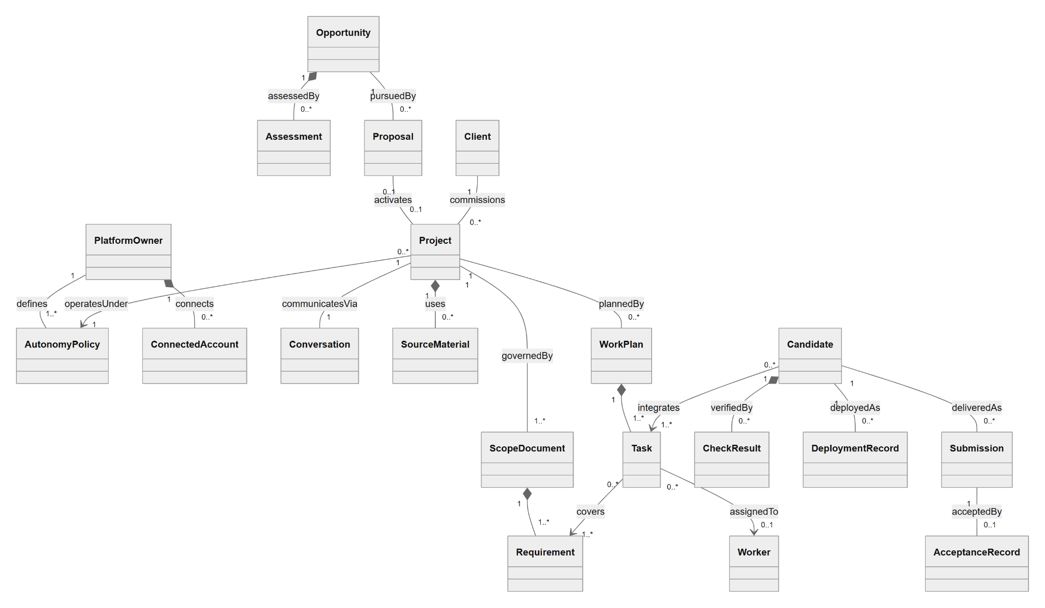
Figure 5.1: Core domain overview
Attributes and operations are omitted; Figures 5.2 to 5.8 detail each package.

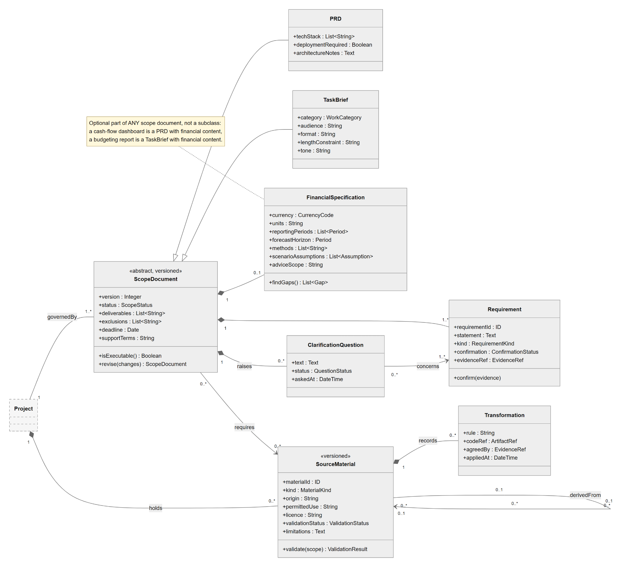
Figure 5.4: Scope and source materials
Dashed classes are detailed in another figure.
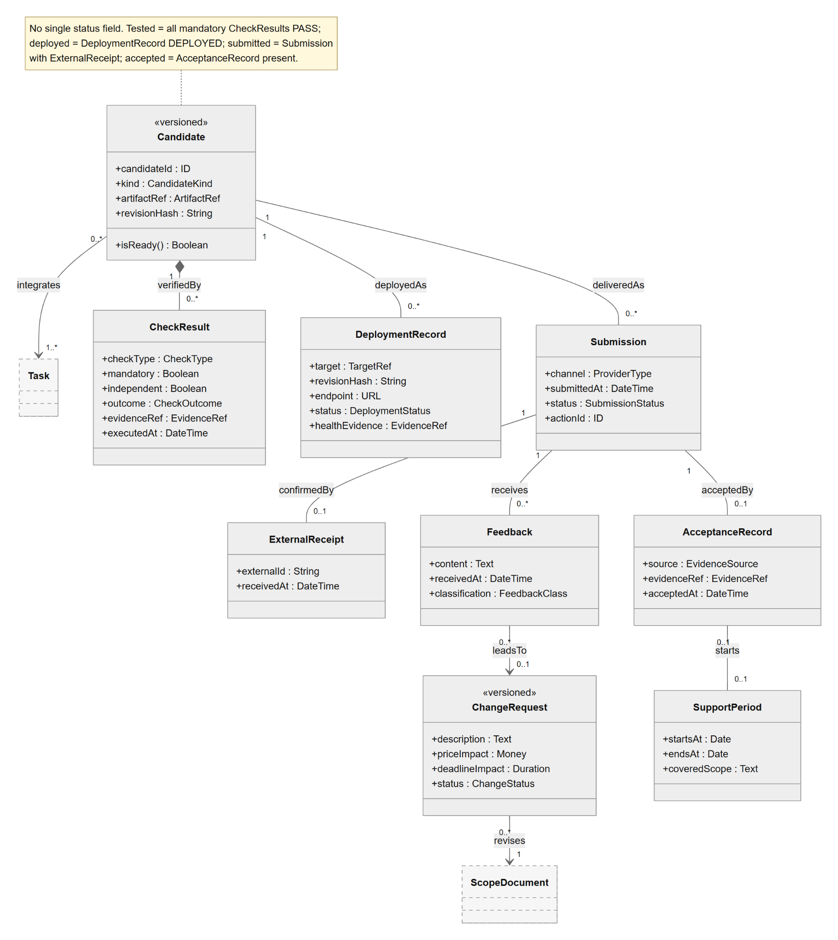
Figure 5.6: Verification, deployment and delivery
Dashed classes are detailed in another figure.

5.2 Description

5.2.1 Governance and autonomy policy (Figure 5.2)
This package captures the owner’s standing authority. It is deliberately separate from project data, because every governed action elsewhere in the model is checked against it rather than against model output.
Class | Purpose | Key relationships | Traceability
PlatformOwner | The single human principal for the first release. Connects external accounts, defines offered services and autonomy policy, and records oversight decisions. | Composes ConnectedAccount and ServiceOffering; defines AutonomyPolicy; records OwnerDecision. | UC-001, UC-010; FR-001–FR-004
ConnectedAccount | An authorised link to a marketplace, repository, hosting, model or reference provider. Holds a reference to a credential in the secrets store (never the secret itself) and the operations the provider actually supports. | Part of PlatformOwner; consulted by adapters before dispatch. | UC-001; SEC-002; NFR-019
ServiceOffering | A service the owner offers (software, data, research, writing or finance), together with evidence of prior work that grounds profile and proposal claims. | Part of PlatformOwner; used by Assessment as a fit signal. | UC-001, UC-002; AIR-002
AutonomyPolicy | «versioned» The owner’s enforceable operating rules: permitted actions, bid and spending limits, workload limits, review conditions and deployment targets. Exactly one version is active at a time. | Supersedes its predecessor; referenced by Project and OwnerDecision. | UC-001, UC-010; CF-02
OwnerDecision | An approval, rejection, revision, pause, resume or stop issued by the owner, bound to the exact version of the action it concerns. A changed action makes the decision stale. | Recorded by PlatformOwner; evaluated under an AutonomyPolicy version. | UC-010; CF-02; SEC-003

5.2.2 Opportunity and engagement (Figure 5.3)
This package follows a job from discovery to an active engagement. It encodes the rule that a Project exists only after both award evidence and an executable scope are recorded.
Class | Purpose | Key relationships | Traceability
Opportunity | A listing retrieved from the live marketplace or the simulator, de-duplicated by source identifier and versioned as the listing changes. Simulated listings are flagged. | Composes Assessment; pursued by Proposal; posted by Client. | UC-002; FR-005
Assessment | «versioned» An AI-assisted, application-checked evaluation producing a pursue/clarify/decline class, effort and cost ranges, uncertainty, a rank score and reasons. It becomes stale when the listing or policy version changes. | Part of Opportunity. | UC-002; AIR-001
Proposal | «versioned» A bid with structured commitments (price, deadline, deliverables, assumptions) that is validated against policy before submission. A stable action identifier prevents duplicate submission after a timeout. | Belongs to Opportunity; confirmed by ExternalReceipt; may activate a Project. | UC-003; FR-007; AIR-002
ExternalReceipt | A provider’s confirmation of an outbound action. A receipt alone establishes that a proposal, message or delivery was submitted. | Attached to Proposal and Submission. | CF-04; NFR-007
AwardEvidence | A marketplace award event or owner-recorded contract evidence that justifies project activation. | Justifies Project. | UC-003
Client | The party commissioning work. Identity attributes are kept out of opportunity-fit features. | Commissions Project; posts Opportunity. | UC-003, UC-004; AIR-001 fairness
Project | The central aggregate for an awarded engagement: budget, deadline and control state. Activation is idempotent, so a duplicate award event returns the existing project. | Hub of the model: owns conversation, scope, materials, plans and records. | UC-003 to UC-011
Conversation | The ordered, project-scoped communication thread, which may begin before award. | Composes Message; linked to Opportunity and Project. | UC-004; Section 8
Message | A single client, owner or system message. It records sender role and send status, and whether it serves as confirmation evidence for a requirement. | Part of Conversation. | UC-004; Section 8

5.2.3 Scope and source materials (Figure 5.4)
This package represents what has been agreed and what it rests on. Confirmed requirements, assumptions and open questions are kept distinct so that no assumption is silently treated as client agreement.
Class | Purpose | Key relationships | Traceability
ScopeDocument | «abstract, versioned» The agreed definition of deliverables, exclusions, deadline and support terms. Only a version whose status is executable releases dependent work. | Generalises PRD and TaskBrief; composes Requirement, ClarificationQuestion and an optional FinancialSpecification. | UC-004; FR-008–FR-009
PRD | The software specialisation of scope: technology stack, deployment expectations and architecture notes. | Specialises ScopeDocument. | UC-004, UC-007
TaskBrief | The specialisation for data, research and writing work: category, audience, format, length and tone. | Specialises ScopeDocument. | UC-004, UC-008
FinancialSpecification | An optional component carrying currency, units, reporting periods, forecast horizon, methods, scenario assumptions and advice scope. findGaps() reports missing definitions so that no financial default is silently assumed. | Part of any ScopeDocument (0..1). | UC-004 A3, UC-005 A3, UC-008 A4
Requirement | An individual requirement with a confirmation status (confirmed, assumed or open) and a reference to its evidence. It is the unit of traceability to tasks and checks. | Part of ScopeDocument; covered by Task. | AIR-002, AIR-003
ClarificationQuestion | A targeted question raised for a gap or conflict. Requirements it concerns remain blocked until it is answered. | Part of ScopeDocument; concerns Requirement. | UC-004
SourceMaterial | «versioned» A dataset, document, repository or reference with its origin, permitted use, licence, validation status and known limitations. Derived materials link back to their originals. | Held by Project; required by ScopeDocument; derivedFrom itself. | UC-005; Section 8
Transformation | An agreed rule applied to produce derived material, with its code reference and the evidence of agreement. | Part of SourceMaterial. | UC-005, UC-008 A1

5.2.4 Planning and execution (Figure 5.5)
This package turns executable scope into dispatchable work. Requirement-to-task coverage and the task dependency graph are first-class associations, because they are the objects validated before any worker is launched.
Class | Purpose | Key relationships | Traceability
WorkPlan | «versioned» The task graph for a project. It validates acyclicity and requirement coverage before dispatch and tracks how many replans have been consumed. | Composes Task. | UC-006; AIR-003
Task | A unit of dispatchable work with acceptance checks and an estimated cost. It is ready only when every prerequisite task has passed. | Part of WorkPlan; dependsOn other Tasks; covers Requirement; uses InterfaceContract; assigned to Worker. | UC-006 to UC-008
InterfaceContract | «versioned» A shared API, schema, component or financial definition that lets parallel tasks stay compatible. A change pauses dependent tasks. | Used by Task. | UC-006 step 4, E3
Worker | «abstract» An AI agent that executes one task inside a project-scoped context. It cannot alter permissions, interfaces owned by other tasks, or requirement fulfilment. | Generalises the specialist workers. | UC-006 to UC-008; SEC-003
CodingWorker | Implements and repairs software in an isolated workspace and branch, and runs local checks. | Specialises Worker. | UC-007; AIR-004
DataWorker | Executes agreed cleaning, transformation and analysis, and preserves transformation code. | Specialises Worker. | UC-008 A1; AIR-005
ResearchWorker | Retrieves permitted sources and builds cited syntheses with claim-to-source links. | Specialises Worker. | UC-008 A2; AIR-005
WritingWorker | Drafts to the agreed audience, format and constraints. | Specialises Worker. | UC-008 A3; AIR-005
FinancialWorker | Uses calculation and forecasting tools to produce historical results, projections and labelled what-if scenarios. | Specialises Worker. | UC-008 A4–A5

5.2.5 Verification, deployment and delivery (Figure 5.6)
This package carries the document’s central assurance rule. Tested, deployed, submitted and client-accepted are not values of one status field. Each is established by the presence of its own evidence object.
Class | Purpose | Key relationships | Traceability
Candidate | «versioned» An output that integrates one or more tasks: a software revision, dataset, report, document or financial analysis. isReady() is derived from its check results, never set directly. | Integrates Task; composes CheckResult; deployed and delivered via records. | UC-007, UC-008; CF-03
CheckResult | The outcome of a single deterministic or independent check, marked as mandatory and/or independent. A model review result cannot override a failed or missing mandatory check. | Part of Candidate. | CF-03; AIR-006
DeploymentRecord | A release of an exact revision to an agreed target, with endpoint and health evidence. Failed, rolled-back and uncertain outcomes are recorded as such. | Belongs to Candidate. | UC-007; FR-016A
Submission | A delivery of an exact candidate version through a channel. It remains uncertain until a receipt is reconciled. | Belongs to Candidate; confirmed by ExternalReceipt. | UC-009; CF-04
AcceptanceRecord | Evidence of client acceptance, recorded separately from submission. | Accepts Submission; may start SupportPeriod. | UC-009
Feedback | A client response, classified as in scope, out of scope, a covered defect or ambiguous. | Received on Submission; may lead to ChangeRequest. | UC-009
ChangeRequest | «versioned» A proposed change to scope, price or deadline. Once agreed, it produces a new ScopeDocument version. | Revises ScopeDocument. | UC-009, UC-004
SupportPeriod | The agreed post-acceptance support window and the scope it covers. | Started by AcceptanceRecord. | UC-009

5.2.6 Control services and integration adapters (Figure 5.7)
Control classes are shown at the level of responsibility only. They correspond to the logical participants of Section 6 and are connected to the rest of the model by dependencies rather than structural associations, leaving their eventual decomposition open.
Class | Purpose | Key relationships | Traceability
Orchestrator | «control» Coordinates the lifecycle: routes events, activates projects, dispatches tasks and reconciles uncertain external actions. | Depends on all other control services and adapters. | SEQ-001 to SEQ-009; CF-04
Scheduler | «control» Issues time- and event-based triggers: discovery cycles, ready-task selection under capacity limits, and retention expiry. | Triggers Orchestrator; reserves via PolicyService. | UC-002, UC-006, UC-011
PolicyService | «control» Checks actions against the current policy and holds cost reservations so that concurrent dispatch cannot exceed a budget. | Used by Orchestrator and Scheduler. | CF-02; NFR-011
VerificationService | «control» The readiness gate. It runs the required validators against an exact candidate and records the evidence. | Runs Validator. | CF-03
AccessControl | «control» Validates identity, project ownership and the permitted operation, and returns a scoped context. | Used by Orchestrator. | CF-01; SEC-001
Validator | «interface» The common contract for plan, scope, data, source, brief, financial and advice-scope validators. | Realised by concrete validators (not drawn). | CF-03; AIR-005, AIR-006
MarketplaceAdapter | «interface» Listing retrieval, proposal submission, messaging, delivery, status queries and capability discovery. | Realised by Live and Simulated adapters. | UC-002, UC-003, UC-009; NFR-013
LiveMarketplaceAdapter | The realisation for the single live marketplace, to be selected between Upwork and Freelancer.com. | Realises MarketplaceAdapter. | Section 1
SimulatedMarketplaceAdapter | The isolated, scenario-driven realisation used for evaluation. It never performs real external writes. | Realises MarketplaceAdapter. | UC-012
RepositoryAdapter | «interface» Workspace preparation, branch push and pull-request submission, without bypassing repository protections. | Used by Orchestrator. | UC-006, UC-007
DeploymentAdapter | «interface» Release of an exact revision, health checks and supported rollback. | Used by Orchestrator. | UC-007
ModelProviderAdapter | «interface» Access to the external AI model provider, applied only to permitted inputs. | Used by Orchestrator and workers. | CF-05
ReferenceAdapter | «interface» Search and retrieval of permitted research and financial reference material, with provenance. | Used by Orchestrator and workers. | UC-005, UC-008

5.2.7 Oversight, cost, retention and evaluation (Figure 5.8)
These records support the owner hub, budget enforcement, data retention and isolated evaluation. They are largely append-only.
Class | Purpose | Key relationships | Traceability
BudgetReservation | A cost held for in-flight work before billable dispatch. It is consumed into a CostEntry or released. | Held by Task; settled as CostEntry. | NFR-011; SEC-005
CostEntry | A model, execution, hosting or storage charge, marked as measured, estimated, shared or unreconciled. | Incurred by Project. | NFR-012
ActivityEvent | A durable, timestamped record of a transition or action with the policy and action versions in force and an evidence link. | Logged by Project. | CF-06; NFR-015
Alert | A failure, budget, deadline or approval exception surfaced in the owner hub until it is resolved. | Raised by Project. | UC-010; NFR-016
DeletionRequest | A retention-expiry or confirmed owner deletion, with its deadline, status and any external-copy limitations. | Applies to Project. | UC-011; NFR-018
EvaluationRun | An isolated execution of selected scenarios under a recorded configuration. It is invalid if isolation is not verified. | Executes Scenario. | UC-012
Scenario | «versioned» A held-out evaluation case with its dataset split and a hidden expected outcome that is inaccessible to workers. | Executed by EvaluationRun. | UC-012; Section 8

Sequence Diagrams

Participants are logical components. Store means the project record and artifact store. Model provider means the AI model provider actor. Policy service includes budget checks and reservations. Adapter is the external-service interface. Validators and specialist workers are internal roles.
Common flows
CF-01 Identity and project access
Hub, adapter, or worker → Access control: validate identity, project ownership, and permitted operation. Access control → Caller: scoped context or denial. Denial ends the request without revealing project data. Internal workers receive only authorized project inputs.
CF-02 Policy, budgets, and versioned approval
Caller → Policy service: exact action/version, scope, permissions, provider capability, and bounded maximum cost. Service checks recorded spend plus in-flight reservations and returns allow or hold. Required review invokes UC-010; changed actions invalidate old approval. Recheck current policy immediately before governed execution.
CF-03 Independent readiness gate
Caller → Verification service: exact candidate and required checks. The service records deterministic and independent evidence plus any required review. Only all passing mandatory checks establish readiness. Missing/failing evidence triggers bounded repair or a hold; AI self-assessment cannot override the gate.
CF-04 Recovery and uncertain external effects
Caller records action identity and committed progress before external dispatch. On interruption, restore committed state and reconcile possibly completed actions with the provider before retry. Reuse a found receipt; retry only confirmed unfinished work within limits. If status cannot be established or an operation is unsupported, retain uncertain/blocked state and request handoff.
CF-05 Permitted model and tool inputs
Caller checks rights, project scope, provider policy, and necessary input fields before a model/tool call. Exclude secrets and unrelated client records. Record permitted input references, model/tool version, output references, and usage under existing retention rules. External content cannot grant authority or override owner policy.
CF-06 Durable evidence and owner visibility
Components → Project store: versioned input/output references, actor or component, time, policy/action versions, checks, costs, and status. Store → Hub: scoped activity and exceptions. Apply the existing response, activity, alert, recovery, and retention targets; this section adds no new quantitative performance promise.

SEQ-001 Configure accounts, services, and autonomy policy
Use case: UC-001. Trigger: The owner establishes or updates services, account connections, or operating permissions.
Participants: Owner; Hub; Access control; Adapters; Marketplace, Repository and Hosting services; Orchestrator; Profile worker; Model provider; Policy service; Project store.
Initial state: An owner account exists. The owner is authorized to connect the external accounts and use the supplied work samples.
Successful final state: Account capabilities, supported services, and a versioned autonomy policy are saved. Only permitted operations can be dispatched.
Failure or waiting state: Invalid settings do not take effect. Unavailable integrations remain restricted and the previous valid policy remains inspectable.
Ordered interactions
Message | Sender, receiver, and message or result
1  UC-001.1 | Owner → Hub: sign in and open settings. Hub → Access control: authorize owner access [CF-01]. Access control → Hub: owner context.
2  UC-001.2 | Owner → Hub: request connections. Hub → Adapters → External services: supported authorization. Services → Adapters: scoped access and identity.
3  UC-001.3 | Adapters → Project store: connection references and capabilities. Store → Hub → Owner: enabled operations and connection status.
4  UC-001.4 | Owner → Hub: service scope and permitted samples. Hub → Project store: source evidence and service selections.
5  UC-001.5 | Orchestrator → Policy service: permit model use [CF-02, CF-05]. Profile worker → Model provider: draft from evidence. Worker → Hub: draft with claim references.
6  UC-001.6 | Owner → Hub: policy settings. Hub → Policy service: validate settings against supported capabilities and scope.
7  UC-001.7 | Policy service → Project store: commit policy. Store → Orchestrator: new policy version. Orchestrator → Hub: settings active [CF-06].

Alternate fragments
Fragment | Guard, messages, and continuation
UC-001.A1  Step 2 | If an integration is unnecessary, leave it disconnected and its operations unavailable; continue at step 4.  Owner → Hub: skip connection. Hub → Store: disconnected status; continue at step 4.
UC-001.A2  Step 5 | If no profile draft is requested, use the supplied profile and continue at step 6.  Hub → Store: supplied profile; omit model call and continue at step 6.

Exception and recovery fragments
Fragment | Guard, messages, and continuation
UC-001.E1  Step 1 | If authentication or ownership checks fail, deny access and end without exposing project or account data.  Access control → Hub: deny. Hub → Owner: access denied; end [CF-01].
UC-001.E2  Step 2–3 | If access fails or capability is insufficient, mark the connection unavailable. The owner reconnects at step 2 or continues at step 4 with that operation disabled.  Service → Adapter: authorization failure. Adapter → Store/Hub: restricted capability; reconnect or continue with disabled operations.
UC-001.E3  Step 5–6 | If generation fails, claims lack evidence, or settings are invalid, retain an unapproved draft or unsaved policy. Show the reason and resume at step 4 or 6 after correction.  Worker/Policy service → Hub: validation errors. Owner → Hub: corrected evidence or limits; revalidate the affected step.

SEQ-002 Discover, assess, and rank freelance opportunities
Use case: UC-002. Trigger: A discovery cycle, marketplace update, or change in policy, workload, or source information triggers assessment.
Participants: Scheduler; Orchestrator; Project store; Marketplace adapter; Marketplace; Assessment worker; Model provider; Policy service; Ranking component; Hub.
Initial state: An authorized marketplace or isolated simulator source is available; services, search constraints, and autonomy policy are configured.
Successful final state: The ranked list records fit, estimates, uncertainty, reasons, source versions, and pursue/clarify/decline status. Qualifying jobs are eligible for UC-003.
Failure or waiting state: Unassessed or stale information is labelled. No opportunity proceeds automatically without a valid qualifying assessment.
Ordered interactions
Message | Sender, receiver, and message or result
1  UC-002.1 | Scheduler → Orchestrator: discovery/reassessment event. Orchestrator → Store: load filters, services, policy, workload, and cursor.
2  UC-002.2 | Orchestrator → Marketplace adapter → Marketplace: request listings. Marketplace → Adapter: listings and updates. Adapter → Store: versioned candidates.
3  UC-002.3 | Orchestrator → Policy service: check permissions and reserve bounded cost [CF-02, CF-05]. Store → Assessment worker: permitted brief/context.
4  UC-002.4 | Assessment worker → Model provider: assess software, data, research, writing, or financial scope against offered services. Model → Worker: structured fit, estimates, assumptions, and evidence.
5  UC-002.5 | Worker → Policy service: assessment and commitments. Policy service → Orchestrator: capability, deadline, budget, and capacity eligibility.
6  UC-002.6 | Orchestrator → Ranking component: compare all validated assessments and domain-fit signals. Ranking component → Store: ordered opportunities and reasons across supported categories.
7  UC-002.7 | Store → Hub: ranked feed and material-change notifications [CF-06]. Orchestrator → UC-003: qualifying opportunity; end ranked or held.

Alternate fragments
Fragment | Guard, messages, and continuation
UC-002.A1  Step 1 | If only policy or workload changes, reuse still-valid listings and resume at step 3 for affected jobs.  Orchestrator → Store: read affected candidates; bypass retrieval and continue at step 3.
UC-002.A2  Step 4–6 | If a supported general job ranks for pursuit, it follows the same autonomous proposal and execution path as a financial job; continue at step 7.  Ranking component → Store: eligible general-job rank. Orchestrator → UC-003 at step 7: same pursuit path, without a finance-only restriction.

Exception and recovery fragments
Fragment | Guard, messages, and continuation
UC-002.E1  Step 2 | If the source fails or is rate-limited, retain and label the last successful candidate set, record bounded retry status, and end this cycle deferred.  Marketplace → Adapter: failure/rate limit. Adapter → Store/Hub: stale-source status. Scheduler → CF-04: bounded retry; end deferred.
UC-002.E2  Step 3–5 | If budget, evidence, or model service is insufficient, mark affected jobs unassessed or clarify. Do not pursue them; resume at step 3 after resolution.  Policy service/Worker → Store: assessment blocked. Store → Hub: reason; no UC-003 handoff until reassessment.
UC-002.E3  Step 6–7 | If source or policy versions change before pursuit, invalidate affected eligibility and resume at step 3.  Store → Orchestrator: changed version. Orchestrator → Ranking component: invalidate stale result; return to step 3.

SEQ-003 Submit a proposal and activate an awarded project
Use case: UC-003. Trigger: A currently assessed opportunity qualifies for pursuit under owner policy.
Participants: Orchestrator; Project store; Proposal worker; Model provider; Policy service; Marketplace adapter; Marketplace; Client; Owner; Hub.
Initial state: A qualifying assessment exists; marketplace capability and owner permissions support the requested pursuit action.
Successful final state: Proposal submission has a confirmed receipt. One project activates only after award evidence and executable agreed scope exist.
Failure or waiting state: Held or uncertain proposals are not reported submitted; unawarded opportunities do not start client execution work.
Ordered interactions
Message | Sender, receiver, and message or result
1  UC-003.1 | Orchestrator → Store: opportunity/assessment versions. Orchestrator → Policy service: verify continued eligibility [CF-02].
2  UC-003.2 | Proposal worker → Model provider: grounded proposal request [CF-05]. Model → Worker: draft and structured commitments.
3  UC-003.3 | Worker → Policy service: exact proposal version. Policy service → Orchestrator: allow/hold and reserve required costs [CF-02].
4  UC-003.4 | Orchestrator → Marketplace adapter: submit with stable action identity. Adapter → Marketplace: supported submission. Marketplace → Adapter → Store: receipt/time [CF-04].
5  UC-003.5 | Marketplace → Adapter → Orchestrator: status/message. Orchestrator → Store: pursuit state. Invoke UC-004 for questions; otherwise wait.
6  UC-003.6 | Adapter or Hub → Orchestrator: award evidence. Orchestrator → Store: check award and scope from UC-004.
7  UC-003.7 | Orchestrator → Store: activate project idempotently. Store → Hub: active status. Orchestrator → UC-005/UC-006: current project and scope references.

Alternate fragments
Fragment | Guard, messages, and continuation
UC-003.A1  Step 3 | If policy requires review, invoke UC-010. Recheck an approved unchanged proposal at step 3; rejection ends pursuit without submission.  Policy service → Hub: pending proposal. Owner → UC-010: decision. Approval → step 3; rejection → declined end state.
UC-003.A2  Step 5–6 | If the client negotiates, invoke UC-004 and version the changed commitments. Resume at step 3 for resubmission or step 6 after award.  Marketplace → Orchestrator: negotiation. Orchestrator → UC-004: clarify; return to step 3 or 6 according to outcome.

Exception and recovery fragments
Fragment | Guard, messages, and continuation
UC-003.E1  Step 1–3 | If eligibility fails or the job closes, hold or decline and record why. UC-002 must reassess before restarting at step 1.  Policy service → Store/Hub: invalid eligibility; cancel dispatch and end held/declined.
UC-003.E2  Step 4 | If submission times out, reconcile before retry. A found receipt continues at step 5; unresolved status ends awaiting owner handoff without duplicate submission.  Adapter → Marketplace: query status [CF-04]. Receipt found → step 5; unresolved → Store/Hub: uncertain, awaiting handoff.
UC-003.E3  Step 6–7 | If award or scope is unconfirmed, wait for evidence or UC-004. Duplicate award events return the existing project instead of creating another, then end with its current state.  Orchestrator → Store: check award identity/scope. Missing evidence → waiting; duplicate → existing project reference; no speculative execution.

SEQ-004 Clarify requirements and maintain the PRD or brief
Use case: UC-004. Trigger: A job description, client message, or material scope change needs interpretation or clarification.
Participants: Client; Owner; Marketplace; Adapter; Hub; Orchestrator; Project store; Requirements worker; Communication worker; Model provider; Financial validator; Scope validator; Policy service.
Initial state: A separate conversation exists for the opportunity/project. Relevant source messages and permitted materials are available.
Successful final state: A versioned PRD or brief links confirmed requirements to evidence and separates assumptions and questions. Only executable scope reaches dependent work.
Failure or waiting state: Unresolved mandatory information blocks affected work; drafts and assumptions are not silently treated as client agreement.
Ordered interactions
Message | Sender, receiver, and message or result
1  UC-004.1 | Marketplace → Adapter → Orchestrator: message with project reference. Orchestrator → Store: conversation, scope, and permitted evidence [CF-01].
2  UC-004.2 | Requirements worker → Model provider: extract from permitted context [CF-05]. Model → Worker: requirements, evidence, assumptions, and gaps.
3  UC-004.3 | Requirements worker → Scope validator: category-specific brief and evidence. Validator → Worker: missing or conflicting requirements. For financial work, invoke A3 before step 4.
4  UC-004.4 | Requirements worker → Communication worker: questions/reply. Communication worker → Policy service: validate send and commitments [CF-02].
5  UC-004.5 | Communication worker → Adapter → Client: permitted message. Orchestrator → Store: clarification wait and affected tasks; independent eligible work continues.
6  UC-004.6 | Client/Owner → Adapter/Hub → Orchestrator: answers/evidence. Requirements worker → Store: confirmed facts, source, and unresolved gaps.
7  UC-004.7 | Requirements worker → Store: scope version with deliverables, exclusions, assumptions, checks, deadline, deployment and support expectations where relevant.
8  UC-004.8 | Orchestrator → Scope validator: check mandatory dependencies. Validator → Orchestrator: executable scope. Orchestrator → UC-003/UC-006: version reference [CF-06].

Alternate fragments
Fragment | Guard, messages, and continuation
UC-004.A1  Step 3–5 | If all material questions are already resolved by supplied evidence, record it and proceed directly to step 7.  Validator → Worker: no mandatory gaps. Worker → Store: confirmation evidence; continue at step 7.
UC-004.A2  Step 7 | For supported general data, research, or writing jobs, use an appropriate brief and omit irrelevant finance fields; continue at step 8.  Requirements worker → Store: task-specific brief; continue at step 8.
UC-004.A3  Step 3 | For financial work, confirm required inputs, currency, units, reporting periods, forecast horizon, scenarios, and recommendation scope. Record gaps and continue at step 4; no financial default is silently assumed.  Requirements worker → Financial validator: financial definitions and evidence. Validator → Worker: confirmed fields or questions; continue at step 4, or A1 if no material gap remains.

Exception and recovery fragments
Fragment | Guard, messages, and continuation
UC-004.E1  Step 2–3 | If instructions conflict or data definitions are missing, record the gap and return to step 4. Affected work stays blocked until step 6 resolves it.  Validator → Store: mandatory gap. Worker → Communication worker: targeted question; return to step 4.
UC-004.E2  Step 4–5 | If a reply exceeds permitted scope, price, deadline, or advice boundaries, hold it for UC-010 or UC-009 change control. Resume at step 4 after the required decision.  Policy service → Hub: commitment exception. Authorized decision → Orchestrator: revised scope/permission; recheck at step 4.
UC-004.E3  Step 2 or 5 | If generation or messaging fails, retain an unsent draft or incomplete scope. Use bounded recovery and reconcile uncertain sends; resume the affected step or end waiting.  Worker/Adapter → Store: failed/uncertain operation. Orchestrator → CF-04: recover; resume step 2/5 only after a known outcome.

SEQ-006 Plan work and coordinate specialist agents
Use case: UC-006. Trigger: An awarded project has executable scope, or a scope/interface revision requires a new plan.
Participants: Orchestrator; Project store; Interface registry; Repository adapter; Repository; Planner; Model provider; Plan validator; Scheduler; Policy service; Workers; Hub.
Initial state: The current scope identifies confirmed requirements, input availability, checks, budget, and deadline. Required repository or new-project authority exists.
Successful final state: A valid versioned plan maps requirements to tasks and checks; ready work is dispatched within limits using consistent interfaces and project context.
Failure or waiting state: Invalid or infeasible work remains held. No requirement is marked fulfilled without evidence or task launched without prerequisites.
Ordered interactions
Message | Sender, receiver, and message or result
1  UC-006.1 | Orchestrator → Store: scope/data versions and workload. Repository adapter → Repository: inspect authorized baseline when present.
2  UC-006.2 | Planner → Model provider: plan from permitted context [CF-02, CF-05]. Model → Planner: tasks, prerequisites, checks, and interfaces.
3  UC-006.3 | Planner → Plan validator: requirement-to-task/check mappings. Validator → Planner: coverage gaps or passing coverage.
4  UC-006.4 | Planner → Interface registry: component, API, schema, and financial-definition versions. Validator → Planner: conflicts and required ordering.
5  UC-006.5 | Planner → Plan validator: graph/prerequisites. Validator → Store: accepted plan version and blocked-task reasons.
6  UC-006.6 | Scheduler → Policy service: priorities, deadlines, capacity, budget reservations [CF-02]. Policy service → Scheduler: allowed tasks and reserved costs.
7  UC-006.7 | Scheduler → Workers: dispatch authorized contexts [parallel for compatible tasks]. Workers → Store: started states and input/interface versions.
8  UC-006.8 | Workers → Orchestrator: evidence or interface-change proposal. Orchestrator → Store/Scheduler: update dependencies; continue scheduling through UC-007/UC-008 [CF-06].

Alternate fragments
Fragment | Guard, messages, and continuation
UC-006.A1  Step 1–2 | For a new application, plan repository bootstrap and a runnable baseline before dependent features; continue at step 3.  Planner → Validator: bootstrap prerequisite for empty baseline; continue at step 3.
UC-006.A2  Step 6 | If capacity is full, queue ready work and report threatened deadlines. Resume at step 6 when capacity becomes available.  Scheduler → Store: queued tasks. Scheduler → Hub: deadline risk where detected; wait and recheck step 6.

Exception and recovery fragments
Fragment | Guard, messages, and continuation
UC-006.E1  Step 3–5 | If coverage or graph checks fail, reject the plan and return to step 2 within the configured replan budget. Exhausted limits end blocked.  Validator → Planner: uncovered requirements/cycle. Planner → CF-02: replan budget check; retry step 2 or Store/Hub: blocked.
UC-006.E2  Step 6 | If budget is insufficient or the deadline is infeasible, hold affected work for UC-010. Resume at step 6 after a valid decision or revised commitment.  Policy service → Store/Hub: budget/deadline exception. No new billable dispatch; wait for resolution.
UC-006.E3  Step 8 | If an interface change invalidates dependents, pause affected dispatch and return to step 4. Changed scope cannot reuse stale approval.  Worker → Orchestrator: interface change. Orchestrator → Scheduler: pause affected work. Planner → Interface registry: re-coordinate at step 4.

SEQ-007 Build, verify, and deploy client software
Use case: UC-007. Trigger: The scheduler dispatches authorized software tasks from a validated plan.
Participants: Scheduler; Policy service; Orchestrator; Workspace manager; Repository adapter; Repository; Coding workers; Model provider; Execution tools; Integration component; Verification service; Financial validator; Deployment adapter; Hosting service; Running application; Project store; Hub.
Initial state: Award, executable PRD, validated task graph, required inputs, and budget exist. Deployment additionally requires an agreed target and scoped authorization.
Successful final state: The exact integrated revision is tested with coverage evidence and, when required, deployed and checked while running. Submission and client acceptance remain separate UC-009 events.
Failure or waiting state: Failed or incomplete candidates are not released. Retain the last passing revision and record failed, blocked, or recovered deployment accurately.
Ordered interactions
Message | Sender, receiver, and message or result
1  UC-007.1 | Scheduler → Policy service: authorize task [CF-02]. Orchestrator → Workspace manager/Repository adapter: prepare baseline. Manager → Store: revision and setup evidence.
2  UC-007.2 | Orchestrator → Workspace manager → Coding workers: isolated branches and bounded contexts [CF-01, CF-05]. Workers → Store: assigned versions.
3  UC-007.3 | Coding workers ↔ Model provider: permitted implementation assistance. Workers → Execution tools: build and local tests [parallel only as UC-006 permits]. Tools → Workers: results.
4  UC-007.4 | Workers → Integration component: branch revisions and local evidence. Integration component → Repository adapter/Workspace: merge candidate; return merge results.
5  UC-007.5 | Integration component → Verification service: exact candidate [CF-03]. Verification service → Execution tools: build, acceptance, regression checks. For financial functionality invoke A3. Validators → Store: evidence.
6  UC-007.6 | Verification service → Orchestrator: defects. Orchestrator → Policy service: repair allowance. Coding worker: repair; loop to step 4 within configured limits.
7  UC-007.7 | Verification service → Store: passing evidence bound to revision. Orchestrator → Policy service: readiness check [CF-03]. Store → Hub: tested candidate.
8  UC-007.8 | Orchestrator → Policy service: exact revision/target authorization [CF-02]. Orchestrator → Deployment adapter → Hosting service: release verified revision [CF-04]. Hosting → Store: deployment receipt.
9  UC-007.9 | Deployment adapter → Verification service: running endpoint/revision. Verification service → Running application: required checks. Service → Store: deployed only on pass, with URL and evidence.
10  UC-007.10 | Orchestrator → Store: release package, setup/run notes, limitations, coverage, and deployment status. Orchestrator → UC-009: verified candidate reference [CF-06].

Alternate fragments
Fragment | Guard, messages, and continuation
UC-007.A1  Step 1 | For an existing repository, use its authorized source revision and reproducible setup; for a new application, create a baseline first. Both continue at step 2.  Workspace manager → Repository adapter: inspect existing or initialize authorized repository; record runnable baseline and continue at step 2.
UC-007.A2  Step 8 | If deployment is not part of agreed scope, keep tested status and proceed to step 10. If required access is merely missing, use E3 rather than bypassing deployment.  Orchestrator → Store: deployment not applicable by scope; skip steps 8–9 and continue at step 10.
UC-007.A3  Step 3–5 | For the cash-flow dashboard or another financial tool, bind currency, periods, formulas, assumptions, and data-source versions to the PRD. Execute numerical tests and source-total reconciliations alongside application tests; continue at step 6 on failure or step 7 on pass.  Coding workers → Store: agreed financial definitions. Verification service → Financial validator/Calculation tools: expected-results, units, and reconciliation tests. Failed checks → step 6; all mandatory checks pass → step 7.

Exception and recovery fragments
Fragment | Guard, messages, and continuation
UC-007.E1  Step 1–4 | If setup fails, access is denied, or integration conflicts arise, hold affected work and invoke bounded repair or UC-010. Resume the affected step after correction; exhausted limits end blocked.  Manager/Integration component → Orchestrator: failure evidence. Orchestrator → repair/Hub: resolve; no unverified release.
UC-007.E2  Step 5–6 | If mandatory checks fail or repair limits are exhausted, retain the last passing revision and end blocked. Tests cannot be weakened solely to label the original scope complete.  Verification service → Store: failing evidence. Policy service → Orchestrator: allowance exhausted. Orchestrator → Hub: blocked candidate; no deployment/delivery.
UC-007.E3  Step 8 | If target access or authorization is missing, hold required deployment for UC-010. If submission status is uncertain, reconcile through CF-04; resume at step 9 only after a confirmed release.  Policy service/Hosting → Adapter: denied or uncertain. Adapter → CF-04: reconcile. Store/Hub: blocked/uncertain; wait for authority or receipt.
UC-007.E4  Step 9 | If running checks fail, perform supported authorized rollback or recovery and verify its outcome. Record failed or rolled-back status; otherwise end blocked and alert the owner. Reattempt through step 4 or 8 only after correction.  Verifier → Orchestrator: post-deployment failure. Orchestrator → Hosting adapter: authorized recovery if supported. Adapter → Verifier: recovered endpoint. Store/Hub: verified recovery or blocked failure.

SEQ-008 Complete data, research, writing, and financial assignments
Use case: UC-008. Trigger: An awarded data, research, writing, or financial-planning project has an executable specialist task.
Participants: Client; Owner; Orchestrator; Project store; Policy service; Specialist workers for data, research, writing, and finance; Model provider; Reference adapter; Financial reference-data provider when applicable; Execution and calculation/forecasting tools; Input/Scope validators; Data/Source/Brief/Financial validators; Verification service; Review worker; Hub; Reference information service.
Initial state: A current brief defines audience, format, deliverables, permitted scope, inputs, and acceptance checks. Mandatory source inputs have passed UC-005.
Successful final state: A versioned task-specific deliverable has passing required checks, reproducible calculations where applicable, and traceable source support. Financial outputs distinguish observations, assumptions, projections, and recommendations.
Failure or waiting state: Failed checks or insufficient mandatory evidence prevent verified status and delivery. The owner may inspect an explicitly incomplete draft.
Ordered interactions
Message | Sender, receiver, and message or result
1  UC-008.1 | Orchestrator → Store: brief, input versions, and category. Orchestrator → Policy service: authorize execution and bounded cost [CF-02, CF-05].
2  UC-008.2 | Orchestrator → Specialist worker: data, research, writing, or financial task. Worker → Input/Scope validator: check method and brief completeness.
3  UC-008.3 | Specialist worker → Task tools/Model provider: execute selected branch A1, A2, A3, or A4. Tools/Model → Worker/Store: candidate, source links, and execution evidence.
4  UC-008.4 | Worker → Verification service: candidate and required evidence [CF-03]. Service → Task validators: calculations, claim support, and/or brief checks. Validators → Service: pass/fail evidence.
5  UC-008.5 | Worker → Model provider: explain verified outputs or refine prose when needed. Worker → Store: candidate package with evidence and limitations.
6  UC-008.6 | Worker → Verification service/Review worker: package and evidence. Review worker ↔ Model provider: supplementary review if used. Task validators → Service: mandatory gate results; A4 includes advice-scope validation.
7  UC-008.7 | Verification service → Store: candidate version and readiness. Orchestrator → UC-009: ready candidate; Store → Hub: status [CF-06].

Alternate fragments
Fragment | Guard, messages, and continuation
UC-008.A1  Step 3–4 | For a general data assignment, execute agreed CSV cleaning, transformations, or analysis. Preserve input/output versions and transformation code; check schema, row-level rules, and expected calculations. Continue at step 5 if checks pass, otherwise E2.  Data worker → Execution tools: agreed transformations/calculations. Tools → Store: outputs/code. Data validator → Tools: independent schema/rule/result checks; pass → step 5, fail → E2.
UC-008.A2  Step 3–4 | For research, retrieve permitted sources, assess relevance, reconcile conflicting evidence, and build a cited synthesis with claim-to-source links. Unsupported conclusions are omitted or held; continue at step 5 when mandatory source checks pass, otherwise E3/E4.  Research worker → Reference adapter → Reference information service: retrieve permitted sources. Service → Adapter → Worker: source versions. Worker → Model provider: grounded synthesis. Source validator: verify claims/conflicts; pass → step 5, gaps → E3/E4.
UC-008.A3  Step 3–4 | For writing, draft to the agreed audience, purpose, format, length, tone, required sections, and prohibited content. Check factual support when claims are made and verify the brief; continue at step 5 on pass, otherwise E3.  Writing worker → Model provider: permitted brief and source material. Brief/source validators → Draft: check structure, length, constraints, and claims; pass → step 5, fail → E3.
UC-008.A4  Step 3–4 | For finance work, establish confirmed currency, units, periods, horizon, methods, and scenario assumptions. Tools calculate historical results, projections, and scenarios; independent checks reconcile figures to source records. Explain tailored business-planning recommendations while separating facts, assumptions, forecasts, and advice. Continue at step 5 on pass; gaps follow E1/E2.  Financial worker → Calculation/forecasting tools: versioned inputs and agreed assumptions. Financial validator → Independent checks: formulas, units, source totals, and expected results. Verified results → Model provider: grounded explanation/recommendations. Pass → step 5; gaps → E1/E2.
UC-008.A5  Step 2–3 | If the agreed financial deliverable is a what-if scenario model, label its outputs as scenarios rather than demonstrated predictive accuracy. Continue through A4 and the same verification gates.  Financial worker → Tools: agreed what-if assumptions. Tools → Store: scenario outputs and labels; continue through A4 without inventing forecast-accuracy claims.

Exception and recovery fragments
Fragment | Guard, messages, and continuation
UC-008.E1  Step 1–2 | If mandatory inputs, methods, or scope are unclear, invoke UC-004/UC-005 and hold dependent work. Resume at step 1 after confirmed corrected input is available.  Scope/Input validator → Orchestrator: missing evidence. Orchestrator → UC-004/UC-005: clarify/validate; wait and restart at step 1.
UC-008.E2  Step 3–4 | If tools fail, transformations violate agreed rules, or calculations do not reconcile, retain evidence and attempt bounded repair. Rerun the affected branch at step 3; exhausted limits end blocked.  Tools/Validator → Orchestrator: failure. Policy service → Worker: remaining allowance. Worker: bounded repair to step 3, or Hub: blocked.
UC-008.E3  Step 3–6 | If claims lack support, writing violates the brief, or financial recommendations exceed business-planning scope, revise or clarify the candidate and repeat the affected checks. Uncorrected candidates remain unverified.  Source/Brief/Financial validator → Worker: issue. Worker → Model provider or UC-004: correction/clarification. Return to step 4 or 6 according to the changed candidate.
UC-008.E4  Step 4–7 | If a mandatory check or required source is unavailable, keep the candidate awaiting verification. Resume the affected check when evidence is restored; do not default to an AI-generated pass.  Verification service → Store/Hub: missing evidence or review. Orchestrator: wait, then repeat the affected check before readiness.

AI / ML Requirements

AI Requirement ID | AIR-001
Related functional requirement | FR-005, FR-006, FR-007, FR-024
Capability | Assess opportunity fit, estimate effort and cost, and rank competing opportunities for autonomous pursuit. Inputs: brief, service profile, capacity and workload, owner policy, deadlines, and completed-job summaries. Outputs: pursue/clarify/decline, reasons, assumptions, estimate ranges, uncertainty, expected-return basis, and ranked position.
Approach | LLM-assisted extraction and comparison with completed work, followed by application checks against supported services and owner limits. A ranking function combines capability fit, effort and cost, deadline feasibility, current workload, uncertainty, and expected return. Estimates and rank are advisory evidence for policy-controlled pursuit and never guarantee profit.
Quality metric | Macro F1 across pursue/clarify/decline measures suitability classification. Interval coverage and relative interval width measure estimate usefulness. Ranking quality is measured with nDCG@10 against reviewer ordering and top-5 precision for opportunities reviewers judge worth pursuing.
Threshold | Targets: macro F1 at least 0.80; at least 80% of actual execution costs inside predicted ranges with median range width no greater than twice median actual cost; nDCG@10 at least 0.80 and top-5 pursue precision at least 0.80 on held-out marketplace snapshots.
Evaluation dataset | Create 120 held-out briefs: 40 per work class of software, data, and research/writing combined. Two reviewers label suitability. Create at least 20 held-out marketplace snapshots of 15–30 mixed opportunities and independently rank them using the stated pursuit criteria. At least 30 executable jobs supply measured cost and elapsed-time outcomes.
Measurement method | Freeze labels and reviewer rankings before testing. Compute confusion matrices, macro F1, estimate coverage and width, nDCG@10, and top-5 precision. Re-run selected snapshots after workload or policy changes to test reranking. Report time and cost separately and compare with fixed-rule filtering.
Human oversight | Owner reviews unclear jobs, unsupported commitments, and estimates that cannot be grounded. Policy limits remain mandatory.
Fallback behavior | If assessment or ranking fails, show unassessed or unranked status with the available brief and retain the last valid ranking where applicable. Retry within budget; do not automatically bid on an opportunity that lacks a valid qualifying assessment.
Fairness criterion | Exclude names, gender, and nationality from fit features. On 30 matched brief pairs differing only in irrelevant identity cues, require the same suitability class in at least 95% of pairs.
Cost and latency budget | Evaluation target per brief: p95 at most 60 seconds and USD 0.10 in model charges, including retries. Enforce configured live limits.
Data retention | Product-held model inputs, outputs, and execution logs: 90 days after project closure, or earlier owner deletion under FR-030. No training reuse without explicit consent. Provider retention settings are disclosed at connection; providers incompatible with the owner's policy are not used.

AI Requirement ID | AIR-002
Related functional requirement | FR-003, FR-007, FR-008, FR-009
Capability | Draft proposals, profile text, clarification questions, client replies, and versioned software PRDs. Inputs: job description, authorized profile evidence, project conversation, prior PRD or brief, and policy. Outputs: grounded prose, structured commitments, confirmed requirements, assumptions, unresolved questions, acceptance criteria, and requirement provenance.
Approach | LLM generation is grounded in project records. Structured extraction separates confirmed requirements from assumptions, records source evidence, identifies missing information, and produces clarification questions. Price, deadline, scope, and deployment commitments are extracted for application-level policy gates; generated prose cannot grant permission.
Quality metric | Human rubric pass rate covers relevance, correctness, clarity, and tone for communications. PRD quality measures coverage of material confirmed requirements, unsupported-assumption rate, correct separation of assumptions from confirmed requirements, and usefulness of clarification questions. Unsupported-claim and commitment-error rates cover invented experience or promises.
Threshold | Targets: at least 85% of communication drafts score at least 4/5 on each rubric dimension; at least 90% of material confirmed requirements are represented in generated PRDs; zero benchmark assumptions are presented as confirmed facts without supporting evidence; zero unsupported credentials or unapproved commitments appear in submitted benchmark messages.
Evaluation dataset | Create 100 held-out briefs or conversation states including price negotiation, ambiguous instructions, scope changes, missing credentials, contradictory requirements, new-application descriptions, deployment expectations, and adversarial messages. At least 40 cases include a reviewer-authored reference requirement set for PRD coverage and clarification scoring.
Measurement method | Two reviewers independently score communications and compare each generated PRD with the frozen job description, conversation evidence, and reference requirement set. Measure confirmed-requirement recall, assumptions incorrectly promoted to confirmed requirements, missing-information detection, clarification usefulness, and the complete send gate. Resolve disagreements and report pre-resolution agreement.
Human oversight | Owner handles policy exceptions and disputes; client or owner evidence confirms scope. Routine messages may be sent under explicit policy.
Fallback behavior | Keep an unsent draft or incomplete PRD version when generation is unavailable. Conflicting commitments, unresolved mandatory requirements, unverifiable claims, or assumptions that cannot safely support execution require clarification, correction, or owner review rather than silent completion.
Fairness criterion | On 30 matched cases varying only irrelevant client identity cues, require no change in proposed price, scope, or deadline. Review tone differences manually.
Cost and latency budget | Evaluation target per draft: p95 at most 60 seconds and USD 0.15 in model charges, including retries. Outbound waiting time is reported separately.
Data retention | Product-held model inputs, outputs, and execution logs: 90 days after project closure, or earlier owner deletion under FR-030. No training reuse without explicit consent. Provider retention settings are disclosed at connection; providers incompatible with the owner's policy are not used.

AI Requirement ID | AIR-003
Related functional requirement | FR-009, FR-011, FR-012, FR-014, FR-021
Capability | Decompose a versioned PRD or brief into executable work, identify dependencies and shared-interface conflicts, and maintain software traceability from confirmed requirements to tasks, tests or checks, and delivered functionality. Inputs: PRD, tickets, repository metadata, architecture/interface records, and prior revisions. Outputs: tasks, dependency links, overlap warnings, checks, and a requirement-coverage map.
Approach | LLM planning is combined with repository or project inspection, requirement provenance, architecture/interface records, and dependency analysis. A graph validator rejects cycles and missing prerequisites; application logic checks that confirmed requirements are covered before dispatch and that fulfilment states have linked evidence.
Quality metric | Dependency precision and recall measure unnecessary sequencing and missed prerequisites. Requirement-to-task coverage, requirement-to-test coverage, and false-fulfilment rate measure PRD traceability. Integrated success measures whether the resulting plan is executable rather than merely syntactically valid.
Threshold | Targets: dependency recall at least 0.85 and precision at least 0.75; at least 95% of confirmed software requirements map to an executable task and required verification check; zero benchmark requirements are marked fulfilled without linked passing evidence; all dispatched plans pass graph validation.
Evaluation dataset | Create 30 held-out software project bundles with versioned PRDs, each with 3–6 implementation tasks; at least 10 involve shared interfaces, 10 include a later requirement revision, and 10 begin from a new-application specification. Reviewers establish essential dependencies, requirement coverage, and expected verification links.
Measurement method | Compare predicted dependency links and traceability mappings with reviewed ground truth. Measure uncovered requirements and false fulfilment after execution. Evaluate full execution against single-agent and independent-parallel baselines using identical models, tools, and total scenario budgets; report time, regressions, and intervention.
Human oversight | Owner resolves contradictory requirements and architectural choices that materially change agreed scope. Workers cannot silently change another task's interface contract or mark a requirement fulfilled without its required evidence.
Fallback behavior | If dependency confidence is inadequate, sequence affected tasks conservatively. Invalid or unresolved plans remain blocked instead of launching all workers.
Fairness criterion | Report results separately for Python, React/TypeScript, and mixed projects and by ticket count; do not imply equal performance from one pooled score.
Cost and latency budget | Evaluation target per 3–6-ticket plan: p95 at most 180 seconds and USD 0.75 in model charges. Repository setup is timed separately.
Data retention | Product-held model inputs, outputs, and execution logs: 90 days after project closure, or earlier owner deletion under FR-030. No training reuse without explicit consent. Provider retention settings are disclosed at connection; providers incompatible with the owner's policy are not used.

AI Requirement ID | AIR-004
Related functional requirement | FR-013, FR-014, FR-015, FR-016, FR-016A, FR-016B, FR-022
Capability | Implement and repair bounded software changes or new applications, integrate verified release candidates, prepare handover artifacts, and execute authorized deployment with running verification. Inputs: PRD-linked tasks, source or empty project baseline, architecture/interface contracts, test failures, and deployment target configuration. Outputs: repository revisions, runnable application, check logs, release artifacts, deployment evidence, and recovery status.
Approach | Tool-using coding workers operate in isolated workspaces. For new applications the system bootstraps a repository and runnable baseline; the orchestrator coordinates architecture and interfaces, integrates branches, and runs independent acceptance and regression checks. Failed candidates enter a bounded repair loop. Only the exact verified revision can enter the authorized deployment adapter, followed by running health or smoke verification and supported rollback or recovery.
Quality metric | Measure existing-project success, bounded new-application success, deployment-and-running-verification success, repair success, requirement coverage, human intervention, wall time, and cost separately. Project success requires all mandatory held-out acceptance checks and no new regression; deployment success additionally requires the expected verified revision to be running and post-deployment checks to pass. Local worker claims alone do not count.
Threshold | Targets: at least 70% of held-out existing-project bundles succeed within their benchmark budget without human code edits; at least 60% of bounded new-application scenarios reach a tested runnable release within their separate budget; at least 90% of deployment cases correctly reach deployed or failed/rolled-back status according to the hidden environment outcome; zero candidates with known failing mandatory checks are automatically delivered or marked successfully deployed.
Evaluation dataset | Use 20 held-out existing-project bundles with runnable environments and hidden tests, 10 bounded new-application scenarios starting without a repository, and at least 10 deployment scenarios covering successful release, bad configuration, failing health checks, and supported rollback. Include textual merge conflicts, behavioural conflicts without overlapping edits, and handover-document requirements.
Measurement method | Run each implementation approach three times per existing-project and new-application scenario. Keep the scenario-specific token, execution-time, and repair budgets equal across compared approaches and count timeouts as failures. For deployment scenarios verify the released revision, URL or endpoint, health evidence, status transition, and rollback result against hidden expected outcomes. Report results separately by scenario class and stack.
Human oversight | Owner handles blocked jobs, unresolved requirements, exhausted repairs, and deployments that fall outside explicit authorization. Changing tests solely to make failures disappear cannot satisfy the original acceptance criteria, and deployment authorization cannot be inferred from model output.
Fallback behavior | Retain the last passing revision. Stop after the applicable repair or scenario budget and present failing checks and attempted repairs. If deployment fails, retain or restore the last known good release when supported and mark deployment failed or blocked; do not label partial code or an unverified running instance complete.
Fairness criterion | Use the same resource budget and tool permissions for each approach. Report performance by stack and task category, including failures rather than selecting successful examples.
Cost and latency budget | Evaluation caps are scenario-specific rather than a universal application promise. Existing 3–6-task change bundle: 60 minutes, USD 5 model charges, USD 1 workspace allowance, maximum three repair cycles. Bounded new application: 180 minutes, USD 15 model charges, USD 3 workspace allowance, maximum five repair cycles. Deployment stage: 30 minutes and USD 2 model charges; hosting/provider charges are recorded separately. Live limits remain owner-configured.
Data retention | Product-held model inputs, outputs, and execution logs: 90 days after project closure, or earlier owner deletion under FR-030. No training reuse without explicit consent. Provider retention settings are disclosed at connection; providers incompatible with the owner's policy are not used.

AI Requirement ID | AIR-005
Related functional requirement | FR-017, FR-018, FR-019
Capability | Produce bounded data, research, and writing deliverables. Inputs: source data or references and an agreed brief. Outputs: reproducible analysis files, cited reports, or brief-compliant writing.
Approach | Specialist generation modules with task-specific validators: executed calculations and data checks, claim-to-source review, and writing rubrics. Model review supplements these checks.
Quality metric | Data exact-check pass rate; research factual-claim support rate; writing rubric pass rate. Report each separately because fluency does not establish numerical or factual correctness.
Threshold | Targets: at least 90% of data cases pass all expected calculations; at least 95% of research factual claims are supported by cited sources; at least 85% of writing cases score at least 4/5 for brief compliance, clarity, and factual consistency.
Evaluation dataset | Create 60 held-out cases: 20 CSV tasks with expected results, 20 research briefs with frozen reference collections, and 20 writing briefs with scoring guides. Include missing fields, conflicting evidence, and revisions.
Measurement method | Execute data checks; reviewers inspect source support and writing against the frozen brief. Two reviewers score subjective cases independently and resolve disagreements; report each category and exception handling.
Human oversight | Owner reviews subjective quality when required by policy. Missing data and unresolved factual conflicts require clarification rather than invented content.
Fallback behavior | Return a clearly incomplete draft and failed-check evidence to the owner. Unsupported claims are removed or held, and missing columns block affected calculations.
Fairness criterion | Evaluate a spread of business domains and writing styles. Demographic generalizations require relevant source evidence; stereotypes and fabricated personal attributes fail review.
Cost and latency budget | Benchmark cap per assignment: 15 minutes and USD 1 model charges, including repairs, plus USD 0.25 execution allowance. Time spent waiting for external sources is reported separately.
Data retention | Product-held model inputs, outputs, and execution logs: 90 days after project closure, or earlier owner deletion under FR-030. No training reuse without explicit consent. Provider retention settings are disclosed at connection; providers incompatible with the owner's policy are not used.

AI Requirement ID | AIR-006
Related functional requirement | FR-020, FR-022
Capability | Review a delivery candidate for scope gaps and defects. Inputs: agreed criteria, artifacts, tests, and evidence. Output: pass, revise, or escalate with identified issues; the application makes the final readiness decision.
Approach | Separate review pass combined with deterministic checks and, where required, human review. A generated pass cannot override a failed, absent, or irrelevant mandatory check.
Quality metric | Defect recall measures missed faults; false-pass rate measures acceptance of defective candidates; false-rejection rate captures unnecessary rework. Evaluate both model review and the complete readiness gate.
Threshold | Targets: reviewer defect recall at least 0.85; model false-pass rate at most 10% and false-rejection rate at most 20%; zero known mandatory-check failures pass the application delivery gate.
Evaluation dataset | Create 100 held-out candidates: 50 correct and 50 defective across supported work types. Seed omitted requirements, wrong calculations, unsupported claims, and integrated software regressions.
Measurement method | Use independently labelled defects and checks withheld from generation. Count a false pass when a defective candidate is accepted; test missing-evidence cases separately. Report rates by work type.
Human oversight | Owner handles ambiguous quality and required subjective approvals. Delivery policy and original acceptance criteria remain controlling.
Fallback behavior | If the reviewer is unavailable or evidence is incomplete, keep the candidate awaiting review. Escalate disagreements rather than defaulting to pass.
Fairness criterion | Use identical review criteria for equivalent deliverables regardless of author or client identity. Report false-pass rates separately for each work type.
Cost and latency budget | Evaluation target per candidate: p95 at most 120 seconds and USD 0.25 in model charges. Independent build/test execution is charged to the project and reported separately.
Data retention | Product-held model inputs, outputs, and execution logs: 90 days after project closure, or earlier owner deletion under FR-030. No training reuse without explicit consent. Provider retention settings are disclosed at connection; providers incompatible with the owner's policy are not used.

Data Requirements

Data Sources
Source | Intended use and requirements
Team-created marketplace and client scenarios | The team shall create job listings, client conversations, service profiles, requirements, policy settings, and simulated marketplace events. These shall cover software, data analysis, research, writing, and business-finance assignments. Each scenario shall identify its author, version, expected workflow, and relevant AIR requirement. Simulated awards, acceptance, earnings, and reputation shall remain explicitly labelled as simulated.
Team-created software projects | Small Python, React/TypeScript, and mixed-stack repositories shall support planning, implementation, integration, repair, and deployment tests. Each existing-project case shall include a fixed starting revision, reproducible setup, task description, and independent acceptance tests. New-application cases shall begin with a specification and permitted setup resources rather than an already completed solution.
Team-created financial and tabular datasets | Synthetic spreadsheets and CSV files shall represent sales, expenses, budgets, opening cash balances, receivables, payables, and scenario assumptions as required by each task. Reference calculations shall be produced independently using reviewed formulas or scripts. Deliberately incomplete, inconsistent, and malformed variants shall test whether the system requests clarification or blocks affected work.
Candidate public transaction dataset | The UCI Online Retail dataset contains 541,909 transaction records and is published under a CC BY 4.0 licence. Selected, documented subsets may support cleaning, cancellation handling, aggregation, and sales-analysis exercises. Attribution shall be retained. Its transaction records shall not be treated as a complete business cash-flow dataset; additional synthetic expenses or payment assumptions shall be separately identified.
Candidate public financial reference source | SEC EDGAR data provides company filings and extracted financial-statement information. Selected records may support source-linked extraction, reporting-period checks, and reconciliation exercises. The selected filing, company, reporting period, units, and retrieval date shall be recorded. Use shall follow the source’s access conditions. These records shall not be presented as representative of all small businesses.
Research and writing reference collections | Each evaluation case shall include a frozen collection of permitted sources relevant to its brief. Official documentation, original publications, and primary organizational sources shall be preferred where appropriate. The collection shall record source titles, URLs or document identifiers, publication dates where available, retrieval dates, and permitted uses. Conflicting or insufficient sources shall be included in selected cases to test appropriate qualification and escalation.
Future live marketplace and client data | One marketplace integration shall be selected between Upwork and Freelancer.com after capability and authorization checks. Client files, repositories, conversations, and financial records shall be accepted only with documented permission for their intended use. Live integrations and private records are not prerequisites for the controlled evaluation. No partner organization or private-data commitment is assumed.

Data Content and Quality
Area | Requirements
Opportunity and communication data | Opportunity records shall contain a source identifier, listing version, description, work category, and available budget, deadline, and deliverable information. Conversation records shall preserve message order, sender role, timestamps, project association, and confirmation evidence. Unknown values shall remain unknown. Client statements, owner decisions, system assumptions, and generated suggestions shall be distinguishable.
Project and workflow data | Each project shall maintain its current PRD or brief, input versions, task dependencies, acceptance criteria, permissions, budget, and execution state. Artifacts and verification results shall link to the exact project, task, and candidate version. Tested, deployed, submitted, client-accepted, and completed states shall remain separate and require their corresponding evidence.
Software inputs | Software cases shall identify the repository revision, required runtime and dependencies, setup instructions, permitted modification scope, and expected behaviour. Test fixtures shall exclude production credentials. Hidden acceptance tests and reference solutions shall be stored separately from worker-accessible project material.
Financial inputs | Each financial case shall state the currency, units, reporting periods, accounting or cash-timing definitions relevant to the task, calculation method, and scenario assumptions. A cash-flow case shall provide an opening balance and the required inflow and outflow information. Receivables, payables, payment dates, prices, volumes, or costs shall be included where the agreed calculation depends on them. No universal historical-data length is required for controlled scenario testing.
Supported input formats | Initial structured test data shall use CSV and XLSX. Briefs and reference materials shall use text, DOCX, or readable PDF files as appropriate. Source code shall be supplied through controlled repositories. Scanned or otherwise unreadable documents shall not silently produce accepted values; they shall require verified extraction or a replacement input.
Source and version tracking | Each dataset or document shall have a unique identifier, source, version, intended use, permission or licence record, and validation status. Derived files shall link to their originals and record the transformations applied. Financial references shall additionally retain relevant dates, currencies, units, and reporting periods.
Preprocessing | The system shall check file readability, expected columns, data types, date formats, encodings, duplicate candidates, and inconsistent units. Normalization shall preserve the original input and record the transformation. Currency conversion, imputation, record removal, and category remapping shall require an agreed rule. Negative amounts, cancellations, refunds, and unusual transactions shall not automatically be discarded as errors.
Missing and ambiguous values | Missingness shall be measured by field and dataset. No single missing-value percentage shall apply to every assignment. Before a result is accepted, all inputs mandatory for that result shall be available or resolved through an explicitly agreed treatment. Missing optional values may remain absent when they do not invalidate the task. Mandatory gaps shall block dependent work rather than trigger invented values.
Numerical validation | Financial and data-analysis outputs shall be checked against independently calculated reference results. Checks shall include applicable totals, balances, transformations, and scenario relationships. For example, closing cash shall reconcile with opening cash plus inflows minus outflows. Rounding rules and numerical tolerances shall be documented before evaluation and applied consistently.
Dataset completeness | Every scored evaluation case shall include its inputs, task definition, expected result or review rubric, and relevant checks. Cases missing required reference evidence shall be marked incomplete and reported separately. System failures, timeouts, and exhausted budgets on otherwise valid cases shall remain in the evaluation results.
Coverage and representativeness | Evaluation data shall cover the supported work categories, different task difficulties, ambiguous requirements, scope changes, provider failures, and successful workflows. Software results shall be reported by stack and scenario type. Controlled datasets shall not be described as statistically representative of all freelancers, clients, businesses, or financial conditions.
Excluded attributes and fairness checks | Names, gender, and nationality shall not be used as opportunity-fit features, consistent with AIR-001. Other irrelevant identity attributes shall also be excluded from assessment inputs. Necessary contact information may remain in restricted operational records. The evaluation shall retain the 30 matched brief pairs in AIR-001 and 30 matched communication cases in AIR-002, varying only irrelevant identity cues. Demographic quotas are not required for these task-based datasets.

Dataset Preparation and Evaluation Controls
Area | Requirements
Development, validation, and final testing | Development examples may be used to design prompts, tools, and workflows. A separate validation set shall support model and configuration selection. Final held-out cases shall be reserved for evaluation after the configuration is selected. Dataset membership and versions shall be recorded before final testing.
Leakage prevention | Related versions of the same project, conversation, repository, or financial scenario shall remain within the same split. Duplicate and near-duplicate cases shall be checked across splits. Hidden answers, labels, and tests shall not enter worker prompts, retrieval indexes, or reusable project memory. Public-source cases shall be identified because prior exposure during a provider’s model training cannot be ruled out.
Reference-result preparation | Expected values shall be established through reviewed calculations, executable tests, source evidence, or independent human labels. AI may assist with drafting synthetic inputs, but its output shall not become ground truth without verification. Subjective cases shall follow the two-reviewer procedures specified in the applicable AIR requirements.
Reproducibility | Evaluation records shall include dataset version, model identifier, prompt/configuration version, tool versions, applicable budgets, token usage, costs, elapsed time, interventions, and results. Random seeds shall be recorded where supported. Provider-dependent nondeterminism shall be acknowledged rather than concealed.
Isolation | Tests shall use synthetic or explicitly authorized materials and isolated marketplace, repository, and deployment substitutes. Evaluation runs shall not submit real proposals, send real client messages, or deploy to production targets. Missing isolation shall invalidate the affected run.
Changes and retesting | Changes to data, labels, reference calculations, or scoring rubrics shall create a new dataset version. Corrections shall include their reason and affected cases. If final test cases are used to tune the system, subsequent results shall be identified as retests; fresh held-out cases shall be used for a new independent evaluation claim.

Data Protection and Retention

Area | Requirements
Permission and minimization | Data shall be collected and processed only for documented, authorized purposes. Permission for a client assignment shall not automatically authorize reuse for evaluation, portfolio publication, or model training. Only necessary project information shall be sent to external models or tools. Credentials and unrelated client records shall be excluded.
Storage and access | Original inputs, derived datasets, model inputs/outputs, and evaluation evidence shall remain associated with their project or authorized evaluation collection. Access shall be restricted to the owner and components that require it. Hidden evaluation answers shall be accessible only to the evaluation process and authorized reviewers.
Provider handling | Provider processing/storage locations, retention settings, and relevant data-use conditions shall be recorded before use. Providers incompatible with the owner’s policy shall not receive the data. No fixed geographic restriction or general legal-compliance claim is introduced by this section.
Retention and deletion | Product-held project data, including derived files, prompts, outputs, indexes, caches, and relevant logs, shall follow the existing 90-day post-closure retention rule or earlier deletion within seven days of a confirmed request. Backup restoration shall not reactivate deleted records. External-service copies and removal limitations shall be identified separately.
Evaluation-data reuse | Team-created synthetic fixtures and permitted public-source test collections may be retained as versioned evaluation assets under their recorded usage conditions. Client-derived evaluation material shall remain subject to the client’s permissions and applicable deletion requirements. Copying data into an evaluation collection shall not bypass those requirements.

Non-functional Requirements / Quality Attributes

ID | Category | Requirement (measurable) | How it will be measured
NFR-001 | Performance | The system shall complete at least 95% of ordinary hub views and control acknowledgements within 2 seconds under the baseline load. Long-running AI work shall retain the separate timing targets in Section 6. | Measure browser-observed time from user action to usable view or acknowledgement. Report the 95th percentile, failures, and test workload. Record AI execution, queueing, and external waiting times separately.
NFR-002 | Performance | The system shall display recorded activity in the connected owner hub within 5 seconds of persistence under the baseline load. | Compare persisted-event timestamps with hub-display timestamps for known activity events during the load test. Verify each sampled event appears within 5 seconds.
NFR-003 | Performance | The system shall support one owner, five active client projects, and 10 simultaneous workers. Worker allocation shall depend on task needs and configured limits; waiting projects shall not consume execution slots. | Run five projects with 10 concurrent worker tasks and owner hub activity. Verify concurrency limits, queueing, project separation, and NFR-001 and NFR-002. Record the hardware and resource configuration.
NFR-004 | Reliability | The system shall achieve at least 99% availability of its own services per calendar month. External-provider outages shall be reported separately from own-service availability. | Use fixed-interval probes of the hub and workflow control service. Calculate successful probes divided by scheduled probes times 100; count own-service downtime, including maintenance. Report external outages separately and claim achievement only after a complete calendar month.
NFR-005 | Reliability | The system shall recover from a recoverable service interruption within 5 minutes without losing committed workflow state. Recovery shall reconcile uncertain external actions before retrying them (FR-028). | Inject worker and service-process failures with persistent storage available. Time from interruption to restored service and eligible-work resumption. Compare committed checkpoints and verify that proposals, deliveries, and deployments are not duplicated.
NFR-006 | Reliability | After a database or storage failure, the system shall restore usable service within 4 hours with no more than 1 hour of stored-data loss. This backup-restoration target is separate from process recovery in NFR-005. | Use timestamped records in a timed backup-restoration exercise. Measure failure-to-restoration time and the gap between the failure and latest recoverable record. Reconcile potentially completed external actions before work resumes.
NFR-007 | Reliability | When an external service fails, the system shall preserve the last known valid state, visibly block affected operations, and continue independent eligible work. It shall not report unconfirmed actions as successful. | Inject marketplace, model-provider, and hosting failures and response timeouts. Verify preserved state, affected-operation status, independent progress, and reconciliation without duplicate submissions or false success.
NFR-008 | Scalability | At 50 active projects, the system shall retain the configured 10-worker test limit, queue excess work, meet NFR-001 and NFR-002, and display threatened deadlines. Unchanged project completion times are not required. | Repeat the baseline test with 50 active projects and ready work exceeding 10 execution slots. Verify queueing, worker limits, hub latency, and deadline warnings. Measure CPU, memory, storage, and queue growth to identify the first bottleneck.
NFR-009 | Usability | All scripted owner workflows shall complete successfully with clear status and action feedback: inspect ranked jobs, locate a blocked task and its reason, review costs, and pause and resume a project. | Run a documented walkthrough for every listed workflow and record pass/fail evidence and resulting status. Require all scripts to pass. This verifies workflow usability, not participant success rates or quantified learnability.
NFR-010 | Accessibility | Main owner workflows shall support keyboard operation without traps, visible focus, labelled controls, readable contrast, and screen-reader-readable status updates. These are specific accessibility commitments, not a claim of full WCAG conformance. | Run automated checks and manual keyboard, focus, and screen-reader tests against the corresponding WCAG 2.2 criteria: 1.4.3, 1.4.11, 2.1.1, 2.1.2, 2.4.7, 2.4.11, 3.3.2, 4.1.2, and 4.1.3. Require the applicable checks to pass for each main workflow.
NFR-011 | Cost | The system shall enforce owner-configured project budgets using recorded expenditure and reserved in-flight costs before dispatch, consistently with FR-026. Section 6 benchmark cost caps shall remain applicable to their evaluation scenarios. | Test insufficient budgets, concurrent dispatch, and unknown charge limits. Verify that new billable work does not start when the budget check fails, reservations prevent over-allocation, and benchmark expenditure includes retries and participating workers.
NFR-012 | Cost | The system shall account for model, execution, hosting, and storage charges, clearly distinguishing measured, estimated, shared, and unreconciled costs. No fixed monthly spending ceiling is specified. | Compare usage-ledger entries with available provider billing exports. Verify each cost category is recorded, shared-cost allocation is documented, and estimates or unreconciled differences are visible rather than presented as confirmed charges.
NFR-013 | Maintainability | Marketplace, model, execution, and deployment integrations shall use documented interfaces so that a test adapter can replace each integration without changes to unrelated workflow logic. | Substitute a test adapter for each integration. Inspect the change scope, verify interface contracts, and run all applicable regression tests; require those tests to pass.
NFR-014 | Maintainability | The system shall document dependencies and versions, required configuration, setup steps, and automated verification commands sufficient to install and verify it in a clean supported environment. | Follow the documented steps in a clean environment. Record dependency installation, service startup, and execution of the documented checks; require successful setup and all applicable checks to pass.
NFR-015 | Observability | The system shall record workflow transitions, worker actions, external submissions, verification outcomes, deployments, and costs with timestamps, outcomes, and links to the relevant project and task where applicable (FR-025). | Compare recorded histories with the complete expected event list of a known simulator run. Require every expected event to be present and correctly correlated, including failures and retries, with relevant policy versions and evidence links.
NFR-016 | Observability | Detected failures and budget or deadline exceptions shall appear as owner-hub alerts within 60 seconds of detection. | Inject failures and budget/deadline exceptions. Compare detection and alert-visibility timestamps and verify that each alert identifies the affected work and reason within 60 seconds.
NFR-017 | Portability and compatibility | Main owner workflows shall work in current stable Chrome and Edge on desktop, Chrome on Android, and Safari on iPhone. The web hub shall adapt to the tested desktop and phone viewports with usable controls; no native application is required. | Run the owner workflow scripts on each supported browser/device combination. Record browser and operating-system versions and viewport sizes. Verify readable layout, reachable controls, and no clipped content that prevents task completion.
NFR-018 | Data handling | The system shall apply the existing 90-day retention after project closure, earlier deletion within seven days of a confirmed request, and no training reuse without explicit consent (FR-030 and Section 6). | Use dated test records to verify expiry and early deletion across product-held content. Restore a backup and verify deleted records cannot become active again. Check that training reuse is disabled without recorded consent and external-service copies are identified separately.
NFR-019 | Data handling and compliance | The system shall record provider storage and processing locations, consent evidence, and applicable source-material or dataset permissions, and check them before approved use. No fixed geographic restriction or jurisdiction-wide legal-compliance claim is specified. | Inspect provider records and a test inventory of sources and datasets. Verify that required location, consent, permission, and licence records exist before use, and that missing required authorization holds the affected operation.

Security Requirements

ID | Security Risks | Potential Losses | Controls
SEC-001 | Unauthorized access and account takeover. An attacker or incorrectly authorized worker could access project records, change permissions, or misuse connected accounts. Relevant categories: Broken Access Control, Authentication Failures, and Broken Object Level Authorization. | Exposure or deletion of client work, unauthorized proposals or deployments, financial loss, and loss of client trust. | The system shall require owner authentication with multi-factor authentication, limit repeated failed sign-in attempts, and invalidate sessions on logout or expiry. Server-side checks shall verify permission for every protected operation. Workers shall receive access only to their assigned project and required resources.
SEC-002 | Sensitive information disclosure. Client records or credentials could leak through model requests, logs, deliveries, storage, or another project’s context. Relevant categories: Sensitive Information Disclosure and Cryptographic Failures. | Loss of confidential business information, misuse of credentials, contractual disputes, and reputational damage. | The system shall encrypt sensitive data in transit and at rest, store credentials in a restricted secrets store, and exclude secrets from prompts and ordinary logs. Model inputs and deliveries shall contain only necessary, authorized project information. Project files, contexts, and retrieval indexes shall remain separated. Provider processing and retention settings shall comply with the owner’s recorded policy.
SEC-003 | Prompt injection and excessive agent authority. Malicious instructions in job listings, client messages, repositories, or retrieved documents could redirect agents into unauthorized actions. Relevant categories: Prompt Injection and Excessive Agency. | Unauthorized commitments, disclosure of client information, harmful repository changes, unintended deployments, and excessive spending. | he system shall treat external content and model outputs as untrusted inputs that cannot alter permissions. Application-level checks shall enforce current scope, budgets, permitted tools, and deployment targets before actions execute. Required approvals shall apply only to the exact action version. Missing authorization shall block execution, and owner pause or stop commands shall prevent further dispatch.
SEC-004 | Malicious inputs and unsafe output execution. Uploaded files, generated code, external URLs, or compromised dependencies could exploit the platform. Relevant categories: Injection, Improper Output Handling, Software Supply Chain Failures, and Server Side Request Forgery. | Host compromise, stolen credentials, corrupted deliverables, data loss, and service disruption. | The system shall validate file types, sizes, paths, and tool arguments; use parameterized database queries; and safely encode content displayed in the hub. Untrusted code shall run in restricted sandboxes without host secrets or other projects’ files. External URL retrieval shall block internal and cloud-metadata endpoints. Dependencies shall be versioned and checked for known vulnerabilities before release.
SEC-005 | Resource exhaustion and uncontrolled consumption. Repeated requests, oversized inputs, or agent retry loops could exhaust model budgets and execution capacity. Relevant categories: Unbounded Consumption and Unrestricted Resource Consumption. | Unexpected charges, unavailable services, missed deadlines, and reduced capacity for other projects. | The system shall enforce request and upload limits, execution timeouts, worker limits, and bounded retries. Before billable dispatch, budget checks shall include recorded expenditure and reserved costs for in-flight work. Tasks exceeding their limits shall stop or remain queued, with the reason visible to the owner.

Security Engineer
Name of the Security Engineer | Huzayfah Abid

Use of Generative AI

Declare every use of generative AI tools (ChatGPT, Claude, Gemini, Copilot, diagram generators, etc.) in preparing this deliverable. Undeclared use will be treated as academic misconduct. The team is fully responsible for the correctness of all content, whether or not AI helped produce it.

Add one row per distinct use. Put separate uses in separate rows.

Purpose of use: say what the tool did, e.g., brainstorming, drafting text, or generating a diagram, reviewing or critiquing the draft, grammar/language editing. "Helped with the section" is NOT acceptable.

- AI Usage Log

Sr# | Tools & Version | Section(s) | Purpose of use
1 | GPT-6 Sol Huzayfah | Use case descriptions | Generated drafts for UC 9-12. I ran out of ideas. Also used it to help identify exception paths and things I might have considered trivial but needed to be added due to convention of use cases for UC-1-8.
2 | GPT-6 Sol Huzayfah | Sequences | Helped me formalize and professionalize my ideas regarding the flow of the program. I wrote them very roughly and without proper terminology so it corrected it for me.
3 | Gemini 3.8 Huzayfah | Use case diagrams | Generated images of the use case descriptions
4 | GPT-6 Sol Huzayfah | Data requirements | Helped me identify source data for testing and the parts I missed (e.g. user keys). Also completed data sources and data evaluation sections autonomously.
5 | Deepseek v4.1 flash Huzayfah | All | Paired with a local voice model so I didn’t have to write and could just talk my ideas into the document. It had context of deliverable 1 so it reminded me of certain points and features that were more minor and I might have forgot.
6 | GPT-6 Astra Huzayfah | All | Used to professionalize and formalize alot of the writing (in use cases, sequences and intro). I was using voice mode paired with a cheap LLM mostly for quick editing and drafting so things ended up sounding silly and not complete. Had to rewrite and formalize the document to match a professional software style.
7 | GPT-6 Sol Huzayfah | Security requirements | I was struggling to figure out security requirements so it helped draft for points 2-5.
8 | GPT-6 Sol Huzayfah | Sequence diagrams | It separated out common flows to match software document standards. Previously these flows were incorporated directly in the diagrams but this separation made things easier to understand.
9 | GPT-6 Sol Huzayfah | Introduction | Helped to write the introduction after the fact and make sure every feature was properly mentioned and represented. It formalized the language and made the product easy to understand for a technical person.
10 | GPT-6 Sol Hashim | Why can’t AI chatbot do this | Needed to make sure the longer prompts were giving enough details to cover each and every part of the requirements that were to be asked, also used to touch up on the explanations.
11 | Claude Opus 5.5 Zakariya | Class Diagram | Initial brainstorm for overarching structure was done with Claude with respect to use cases

- Verification and Modification

For each row in the table above (AI Usage Log), explain how the team checked the AI output and what it changed. Mention any errors, hallucinations or irrelevant content the AI produced that you corrected or removed.

Sr# |  |  | Changes Made by the Team
  How the Output Was Verified
  Errors Found in AI Output
1 | I read through them all and made sure they matched our actual product | Assumed it was ONLY a finance freelancer | Had to correct its context manually so it assumed right
2 | Read through | None because I was very detailed with the prompts. It didn’t assume things. Also it had most of the context already of what it needed to do. | Didn’t need to as the prompts were detailed.
3 | Compared to actual cases | None, it based the diagrams solely off the already written descriptions | Didn’t need to
4 | Read through | Assumed some things that didn't apply to our context. Assumed certain legal regulations that didn't apply to our context either. | Re-prompted and edited manually as well after the fact. Hallucinated certain features of our freelancer that needed to be corrected. It took a certain dataset from the internet that was no longer available. It also used a certain dataset that wasnt needed. Also the data evaluation guidelines seemed off to me, so I edited those too manually.
5 | Read through | It was live and constantly looking at my document and the voice model was simple transcription paired with auto correct so it didn’t make mistakes | Unneeded, basically just an adapter between my voice and the document
6 | Read through | Overly formalized and professionalized some lines to the point where the document sounded like corporate buzzword gibberish. Had to correct it and calm it down. | Re-wrote certain lines and sections (It butchered certain sequences) and had to re-prompt to correct its tone.
7 | Read through | None, the requirements it told applied to our product fully. | Didn’t need to as the requirements were fully correct. Just added on more information and corrected some language as it did rough drafts.
8 | Read through | None, it just separated out and formalized parts already written in the main sequence. | Didn’t need to. It was already fine as is.
9 | Read through | None, all the ideas were already in the introduction and my prompt was detailed too. It’s main job here was to make the product more understandable and the introduction to properly introduce a technical person to the features and especially the newly added finance-first nature which was added after deliverable 1. | Didn’t need to, as I said the prompts were detailed and most of the context was already there so it didn't assume things.

- Reflection

Answer the following questions briefly:

(a) Which parts of this deliverable were done without AI, and why?
Well nothing fully because Astra touched it all when I asked it to formalize and bring the professional standard up. So everything was done with AI in a certain way. And I used AI extensively during the drafting process to convey my architectural decisions and program ideas into writing. I wrote the introduction manually before handing it over to AI to formalize, but the final delivery was spruced up with AI.

(b) Where did AI help most, and where was it unhelpful or misleading?
It helped the most with the sequence diagrams. While I had the full idea and flow already I was struggling alot to formalize my thoughts into proper architecture names, while I had the overall separation clearly. It helped separate certain layers of the product and establish clear bridges. It also separated out common flows which made the doc more professional and helped to understand it better. Astra touched all the document when I asked it to formalize and bring the professional standard up, and it helped here alot as without it the document felt rough and non-serious. And I used AI extensively during the drafting process to convey my architectural decisions and program ideas into writing, this was potentially the most helpful use but it's more of a convenience thing rather than a substitution for human reasoning. It also helped alot in trying to uncover edge cases during the use case descriptions, particularly for UC 4,7 and 10.
(c) Did using AI change any design or requirements decision? If yes, explain.
Yes, certain architectural choices I thought of weren’t the best during sequence diagrams so it suggested better rules. The idea of a unified project store was introduced there, which also helps increase accuracy of the system and communication with clients because it has persistent knowledge of its history. The integrated hubs' specific financial features were also suggested by AI.

Who Did What?

Name of the Team Member | Tasks done
Huzayfah Abid | Intro, System Actors, Use Cases, Sequence Diagram, Data Requirements, Security Requirements
Muhammad Hashim | Why cant an AI bot do this
Muhammad Zakariya | Class diagram
Zainab Raza | Review, overall editing

Review checklist

Before submission of this deliverable, the team must perform an internal review. Each team member will review one or more sections of the deliverable.

Section Title | Reviewer Name(s)
Intro, Sequence, Use cases, Security, Data, AI/ML, NFR, System Actors, Class Diagram | Huzayfah
Use cases, AI prompt section, NFR, AI/ML, Security requirements | Hashim
Use cases, class diagram, intro | Zakariya
Everything | Zainab

