App Flow Document
AI-Powered Vinyl Wrapping Visualization System
Screen-by-screen navigation and user journey mapping
Field | Detail
Companion Document | Product Requirements Document (PRD) v1.0
Status | Draft v1.0
Date | August 1, 2026

Table of Contents
1. Overview3
2. High-Level App Flow Diagram3
3. Flow 1: Onboarding & Authentication4
4. Flow 2: Core Visualization Flow (Homeowner)4
5. Flow 3: Catalogue Browsing4
6. Flow 4: Saved Projects / Visualization History5
7. Flow 5: Sales Representative Flow5
8. Flow 6: Installer Flow5
9. Flow 7: Account & Settings6
10. Full Screen Inventory6
11. Navigation Rules & Edge Cases7

1. Overview
This App Flow Document maps every screen a user encounters in the AI-Powered Vinyl Wrapping Visualization System, organized by user journey. It complements the PRD by defining navigation paths, screen purpose, on-screen elements, and the actions that move a user from one screen to the next — for all three personas: Homeowner, Sales Representative, and Vinyl Installer.
Flows are read left to right / top to bottom in the diagram below, with dashed arrows indicating optional loops or approval hand-offs between personas.

2. High-Level App Flow Diagram
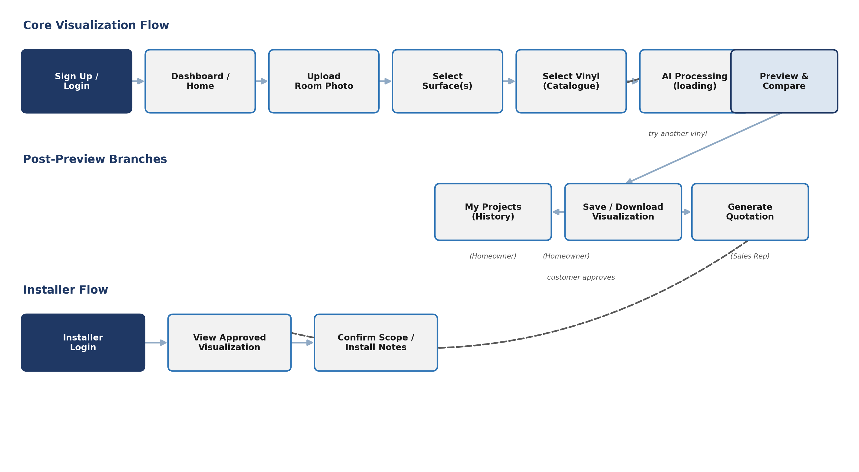
The core visualization flow (top row) is shared by Homeowners and Sales Representatives. After a preview is generated, the flow branches into saving/downloading, revisiting history, or — for Sales Representatives — generating a quotation. The quotation hands off to a separate Installer flow once the customer approves a design.

Flow 1: Onboarding & Authentication
Entry flow for all personas before reaching their respective home screens.
Screen | Purpose | Key Elements | User Actions | Next
Splash / Landing | Introduce the product and route to sign in or sign up. | Logo, tagline, Sign In / Sign Up buttons | Tap Sign In or Sign Up | Login or Sign Up screen
Sign Up | Create a new account (Homeowner, Sales Rep, or Installer role). | Name, email, password, role selector | Fill form, submit | Email verification / Dashboard
Login | Authenticate an existing user. | Email, password, forgot-password link | Enter credentials, submit | Role-based Dashboard
Forgot Password | Recover account access. | Email input, reset link confirmation | Submit email | Login screen

Flow 2: Core Visualization Flow (Homeowner)
The primary flow: turning a room photo into a photorealistic vinyl preview.
Screen | Purpose | Key Elements | User Actions | Next
Dashboard / Home | Entry point after login; shows recent projects and quick actions. | New Visualization button, recent projects list, catalogue shortcut | Tap New Visualization | Upload Room Photo
Upload Room Photo | Capture or upload the surface/room image. | Camera capture, file upload, image preview | Upload/capture photo, confirm | Select Surface(s)
Select Surface(s) | Mark one or more wrappable components on the uploaded image. | Tappable overlay regions, component list (wall, door, cabinet, etc.), multi-select toggle | Tap/draw surface region(s), confirm selection | Select Vinyl (Catalogue)
Select Vinyl (Catalogue) | Choose a vinyl design to apply to the selected surface(s). | Catalogue grid, filters (color, finish), search | Browse, tap a vinyl to select | AI Processing
AI Processing (loading) | System runs segmentation, texture mapping, and rendering. | Progress indicator, estimated time | Wait (or cancel) | Preview & Compare
Preview & Compare | View the generated visualization; compare against other vinyls or the original. | Before/after toggle, side-by-side compare, try-another-vinyl action | Compare, accept, or try another design | Save/Download, History, or Quotation

Flow 3: Catalogue Browsing
Standalone browsing flow, reachable from the Dashboard without starting a new visualization.
Screen | Purpose | Key Elements | User Actions | Next
Catalogue Home | Browse all available vinyl designs by category. | Category tabs, search, filters | Browse categories, search | Vinyl Detail
Vinyl Detail | View a single vinyl's texture, color code, and metadata at full resolution. | Large texture preview, color code, product name, "Use this design" button | Tap "Use this design" | Upload Room Photo (starts core flow) or back to Catalogue

Flow 4: Saved Projects / Visualization History
Lets users revisit, re-edit, or re-download past visualizations.
Screen | Purpose | Key Elements | User Actions | Next
My Projects (History) | List of previously generated visualizations. | Thumbnail grid, date, surface/vinyl labels, search | Tap a saved project | Project Detail
Project Detail | View a saved visualization; re-edit or re-download. | Full-size image, re-edit button, download button, delete option | Re-edit, download, or delete | Preview & Compare (re-edit) or stays on Project Detail

Flow 5: Sales Representative Flow
Extends the core visualization flow with consultation and quotation tools.
Screen | Purpose | Key Elements | User Actions | Next
Rep Dashboard | Sales-specific home screen with customer session tools. | Start New Consultation button, recent customer sessions | Tap Start New Consultation | Core Visualization Flow (on behalf of customer)
Generate Quotation | Produce a price estimate tied to the approved visualization. | Selected surfaces/vinyl summary, price fields, notes | Fill/confirm pricing, generate | Quotation Summary
Quotation Summary | Shareable summary combining the visualization and price estimate. | Visualization thumbnail, price breakdown, share/export, "Send for approval" | Share with customer or send for approval | Customer approval → Installer Flow

Flow 6: Installer Flow
Read-focused flow for installers to confirm the scope of approved work.
Screen | Purpose | Key Elements | User Actions | Next
Installer Dashboard | List of jobs assigned to the installer. | Job list with customer name, address, status | Tap a job | View Approved Visualization
View Approved Visualization | See the customer-approved preview and selected materials. | Full visualization image, surface list, vinyl ID/color code | Review details | Confirm Scope / Install Notes
Confirm Scope / Install Notes | Acknowledge the job scope and add installation notes. | Checklist of surfaces, notes field, confirm button | Check off items, add notes, confirm | Installer Dashboard (job marked in progress)

Flow 7: Account & Settings
Shared across all personas.
Screen | Purpose | Key Elements | User Actions | Next
Account Settings | Manage profile and preferences. | Name, email, password change, notification toggles | Edit fields, save | Dashboard
Company / Tenant Settings | (Admin only) manage catalogue and team access. | Catalogue upload, team member list, branding | Edit settings, save | Dashboard

10. Full Screen Inventory
# | Screen | Flow | Persona(s)
1 | Splash / Landing | Onboarding | All
2 | Sign Up | Onboarding | All
3 | Login | Onboarding | All
4 | Forgot Password | Onboarding | All
5 | Dashboard / Home | Core Visualization | Homeowner
6 | Upload Room Photo | Core Visualization | Homeowner, Sales Rep
7 | Select Surface(s) | Core Visualization | Homeowner, Sales Rep
8 | Select Vinyl (Catalogue) | Core Visualization | Homeowner, Sales Rep
9 | AI Processing (loading) | Core Visualization | Homeowner, Sales Rep
10 | Preview & Compare | Core Visualization | Homeowner, Sales Rep
11 | Catalogue Home | Catalogue Browsing | Homeowner, Sales Rep
12 | Vinyl Detail | Catalogue Browsing | Homeowner, Sales Rep
13 | My Projects (History) | History | Homeowner
14 | Project Detail | History | Homeowner
15 | Rep Dashboard | Sales Rep | Sales Rep
16 | Generate Quotation | Sales Rep | Sales Rep
17 | Quotation Summary | Sales Rep | Sales Rep
18 | Installer Dashboard | Installer | Installer
19 | View Approved Visualization | Installer | Installer
20 | Confirm Scope / Install Notes | Installer | Installer
21 | Account Settings | Account | All
22 | Company / Tenant Settings | Account | Admin

11. Navigation Rules & Edge Cases
- Back navigation is always available except during AI Processing (loading), where only Cancel is offered.
- Cancelling AI Processing returns the user to Select Vinyl (Catalogue) with the prior selections retained.
- Preview & Compare supports switching vinyls without re-selecting surfaces — this loops back to Select Vinyl (Catalogue) directly.
- A Sales Rep's consultation session is tied to a customer record; leaving mid-flow auto-saves as a draft in Rep Dashboard.
- Installers only gain access to a job's visualization after the Sales Rep or Homeowner marks the quotation as customer-approved.
- Deleting a saved project from Project Detail requires a confirmation step (not shown as a separate screen).

