Data Flow Document
AI-Powered Vinyl Wrapping Visualization System
How data moves between users, processes, and storage
Field | Detail
Companion Documents | PRD v1.0, App Flow Document v1.0
Status | Draft v1.0
Date | August 1, 2026

Table of Contents
1. Overview3
2. Notation Legend3
3. Context Diagram (Level 0)3
4. Level 1 Data Flow Diagram4
5. External Entities5
6. Process Descriptions5
7. Data Stores6
8. Data Dictionary6
9. Data Flow Narrative (End-to-End)7
10. Data Retention & Access Notes7

1. Overview
This Data Flow Document describes how data moves through the AI-Powered Vinyl Wrapping Visualization System — from the moment a user uploads a room photo, through AI processing, to the final stored visualization and any downstream quotation or installer hand-off. It complements the PRD (feature scope) and App Flow Document (screen navigation) with a data-centric view suitable for engineering and data-privacy review.

2. Notation Legend
Diagrams in this document use simplified Gane-Sarson data flow notation:
- External Entity (solid navy rectangle) — a person or system outside the platform that sends or receives data (e.g., Homeowner, Company Admin, Vinyl Installer).
- Process (rounded rectangle, numbered) — a function that transforms or acts on data (e.g., Surface Segmentation).
- Data Store (open rectangle, labeled D#) — a persistent data repository (e.g., a database or object storage bucket).
- Arrow — a labeled data flow indicating what data moves and in which direction.

3. Context Diagram (Level 0)
At the highest level, the entire platform is a single process exchanging data with three external entities:
- Homeowner / Sales Representative — sends room photos, surface selections, and vinyl selections; receives visualization previews, downloads, and quotations.
- Company Admin (Tenant) — sends vinyl catalogue uploads and metadata; receives confirmation of catalogue updates.
- Vinyl Installer — sends login credentials; receives the approved visualization and quotation summary for a job.
The Level 1 diagram in Section 4 expands this single process into its constituent processes and data stores.

4. Level 1 Data Flow Diagram
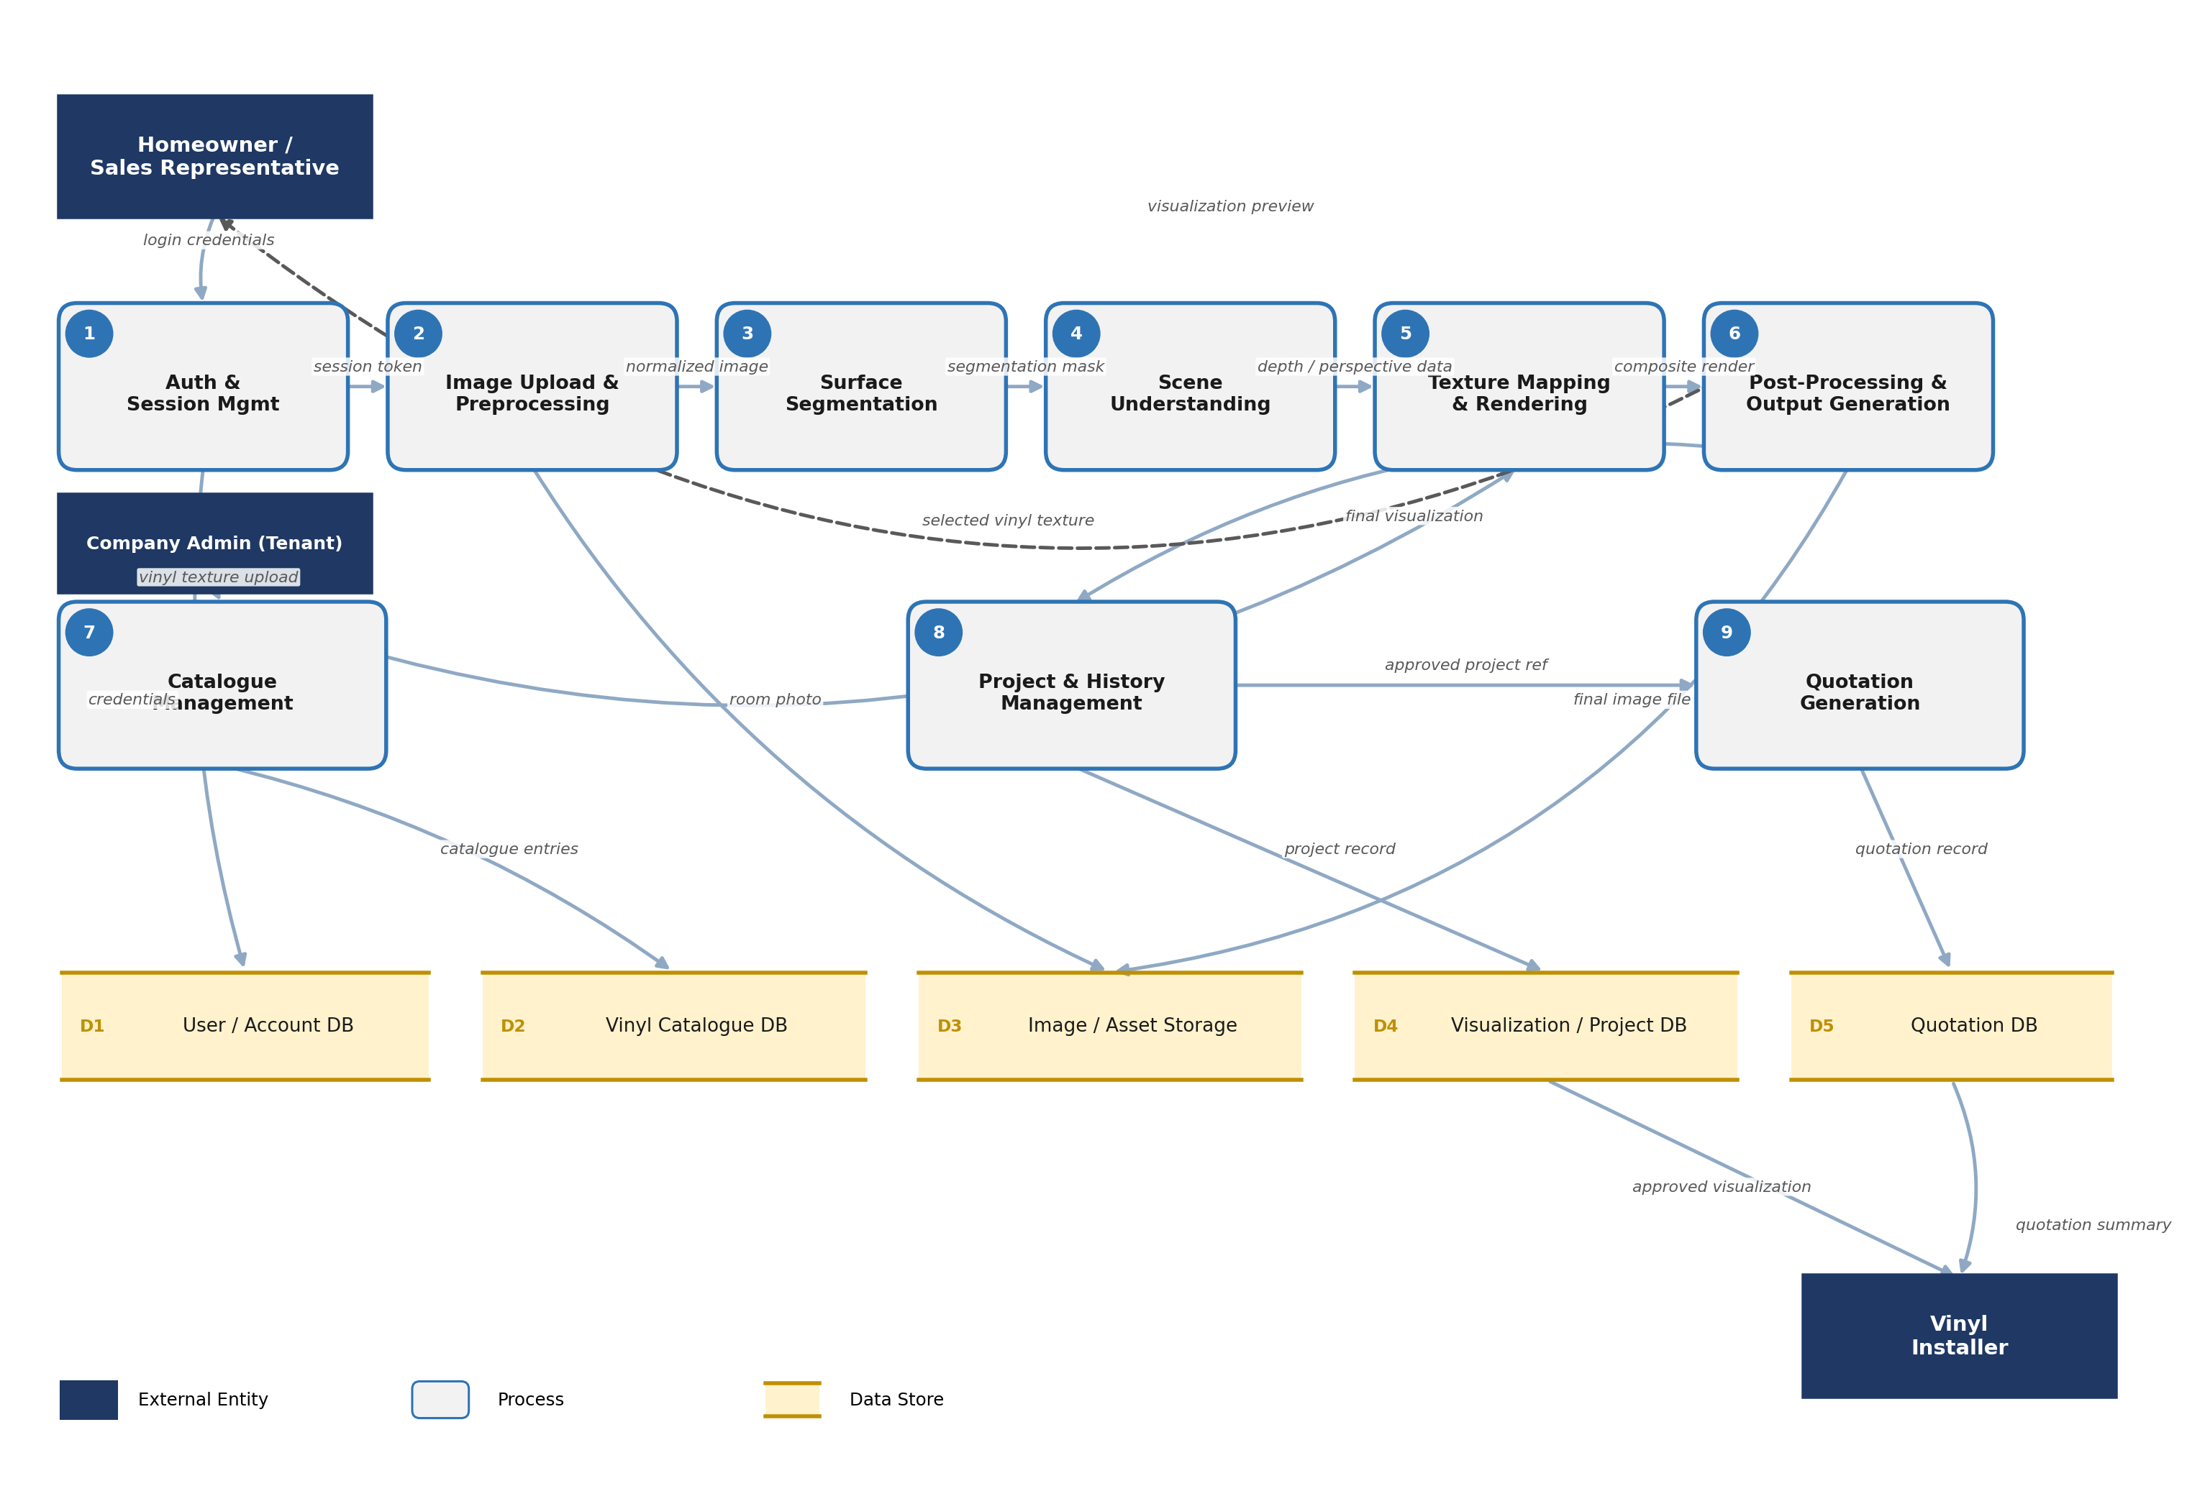
The dashed arrow from Post-Processing & Output Generation back to the Homeowner / Sales Representative represents the visualization preview returned at the end of the core pipeline (Processes 1–6). Processes 7–9 support catalogue management, project history, and quotation generation respectively, each reading from and writing to their own data store.

5. External Entities
Entity | Sends to System | Receives from System
Homeowner / Sales Representative | Login credentials, room photo, surface selection, vinyl selection, quotation inputs (Sales Rep) | Session token, visualization preview, downloadable image, quotation summary
Company Admin (Tenant) | Vinyl texture uploads, catalogue metadata, team/branding settings | Catalogue update confirmation
Vinyl Installer | Login credentials | Approved visualization, selected surfaces/vinyl details, quotation summary

6. Process Descriptions
# | Process | Inputs | Outputs
1 | Auth & Session Management | Login credentials | Session token; reads/writes User/Account DB (D1)
2 | Image Upload & Preprocessing | Room photo, session token | Normalized image (size, orientation, color corrected); writes to Image/Asset Storage (D3)
3 | Surface Segmentation | Normalized image, selected component(s) | Segmentation mask for selected surface(s)
4 | Scene Understanding | Segmentation mask, normalized image | Depth, perspective, and surface orientation data
5 | Texture Mapping & Rendering | Depth/perspective data, selected vinyl texture (from D2) | Composite render with vinyl projected onto the surface
6 | Post-Processing & Output Generation | Composite render | Final high-resolution visualization; writes to Image/Asset Storage (D3) and Project DB (D4)
7 | Catalogue Management | Vinyl texture uploads, metadata from Admin | Catalogue entries written to Vinyl Catalogue DB (D2); texture data supplied to Process 5
8 | Project & History Management | Final visualization from Process 6 | Project record written to Visualization/Project DB (D4); approved project reference to Process 9
9 | Quotation Generation | Approved project reference, pricing inputs | Quotation record written to Quotation DB (D5); quotation summary to Sales Rep and Installer

7. Data Stores
ID | Data Store | Description | Written By | Read By
D1 | User / Account DB | Account credentials, roles (Homeowner, Sales Rep, Installer, Admin), profile data | Process 1 | Process 1
D2 | Vinyl Catalogue DB | Vinyl ID, product name, texture references, color code, finish type, metadata | Process 7 | Process 5, 7
D3 | Image / Asset Storage | Uploaded room photos, normalized images, final rendered visualizations | Process 2, 6 | Process 3, 8
D4 | Visualization / Project DB | Saved project records: selected surfaces, applied vinyl, generation history, approval status | Process 8 | Process 8, 9
D5 | Quotation DB | Quotation records: pricing, associated project reference, approval/status | Process 9 | Process 9

8. Data Dictionary
Data Element | Description
Room Photo | User-supplied image of the surface/room to be visualized, any resolution.
Normalized Image | Room photo after size, orientation, and color normalization.
Segmentation Mask | Pixel-level mask identifying the selected room component(s) within the image.
Depth / Perspective Data | Estimated scene geometry (depth map, camera perspective, surface orientation).
Vinyl Texture | High-resolution catalogue texture image tied to a Vinyl ID and color code.
Composite Render | Intermediate image with vinyl texture projected onto the segmented surface, pre-refinement.
Final Visualization | Post-processed, artifact-free output image delivered to the user.
Project Record | Stored metadata linking a user, room image, selected surfaces, applied vinyl(s), and outputs.
Quotation Record | Pricing and scope details tied to an approved project, used for customer sign-off and installer hand-off.

9. Data Flow Narrative (End-to-End)
A Homeowner authenticates (Process 1), producing a session token validated against the User/Account DB (D1). They upload a room photo, which Process 2 normalizes and stores in Image/Asset Storage (D3). After the user selects a surface, Process 3 generates a segmentation mask, and Process 4 estimates depth and perspective from the normalized image and mask.
In parallel, the user's vinyl selection is resolved against the Vinyl Catalogue DB (D2), populated earlier by Company Admins through Process 7. Process 5 projects the selected vinyl texture onto the segmented surface using the depth/perspective data, producing a composite render. Process 6 refines this render into the final visualization, storing the output in Image/Asset Storage (D3) and recording the project in the Visualization/Project DB (D4) via Process 8.
If a Sales Representative is driving the session and the customer approves the design, Process 9 generates a quotation referencing the approved project and writes it to the Quotation DB (D5). Once the quotation is marked approved, a Vinyl Installer can retrieve the approved visualization and quotation summary to confirm installation scope.

10. Data Retention & Access Notes
- Room photos and generated visualizations are tenant-scoped — a Company Admin's catalogue and a Homeowner's project data are logically isolated per company account.
- Installers only gain read access to a project's visualization and quotation after it is marked customer-approved (see App Flow Document, Section 11).
- Vinyl catalogue texture assets (D2) are shared read-only across all sessions within a tenant, but are not writable by Homeowners or Installers.
- Specific retention periods, encryption-at-rest requirements, and deletion workflows are to be defined during technical design and are out of scope for this document.

