mEagle V1.0 Technology White Paper

Version1.0，applicable to mEagle V1.0
Copyright © 2006，Beijing Feynman Software Technology Co., Ltd.
Latest revision：2006/12/6

You are welcome to redistribute the paper without permission,
But you should reserve the paper, the copyright information,
and this announcement is clean and complete.

Catalog
Forward 1
1 A Brief Introduction of mEagle 2
2 Main Features of mEagle V1.0 3
3 Framework of mEagle 5
4 mEagle Applications 6
5 mEagle V1.0 Screenshots 7
6 Contact Us 9

Forward
In recent years, with the rapid development of geographic information system (GIS), people’s requirements for spatial data are increasing. Integrating GIS into embedded technology to form an embedded geographic spatial platform is an important current. Embedded GIS is easy to use, less expensive and seamlessly integrated with other applications. It provides a good technical base for GIS integrating into other information technology.
In mapping, intelligent traffic system (ITS), maritime, national defence, police etc, embedded GIS has infinite application foreground and can be applied to military, mapping, medical treatment, auto navigation etc. At present, embedded GIS is used widely, especially in the field of intelligent transport, outdoor surveying and mapping.
The main application fields of embedded GIS can be divided into the following categories:
- ITS (Traffic information system, vehicle navigation system etc).
- Data collection and many censuses (road census, environmental protection census etc).
- Military and national defence (doughboy equipment, armor, tank, information collection etc).
- Intelligent auto (With communications, information, navigation, map, entertainment and all kinds of safe electronic systems, the intelligent auto is the direction of the auto development.).
- Individual customer (With the applications of mobile telephone and individual PDA, it will provide the real-time map information and the travel information, and greatly improve quality of life.).
With the variety of the positional methods (U.S.A. GPS, Russia GLONASS, Europe Galileo, China ‘Beidou’), the universality of the communication network (GPRS, CDMA, CDPD etc wireless network), the universality of the user terminal (mobile telephone and PDA) and the immensity of the great market potential, we can see an extensive foreground of the embedded GIS.
Because of the importance and the extensive foreground of the embedded GIS, Beijing Feynman Software Technology Co., Ltd. developed an embedded GIS--mEagle which consumes low resource and can run on different operating systems and hardware. For developers, mEagle will become the first choice tool for developing embedded GIS software.
This white paper will give you a complete introduction of mEagle.

1 A Brief Introduction of mEagle
mEagle is a geographic information system for embedded system, which is developed by Feynman Software. mEagle is based on MiniGUI embedded graphics middleware, so it is able to run on more than 10 embedded OSes which MiniGUI supported. mEagle is an embedded GIS development platform which addresses the needs of map browse, query, analysis, etc. mEagle supports most embedded equipments in accordance with industry standards such as car computer, PDA, intelligence handset, etc.
In fact, mEagle allows you to develop custom desktop GIS applications or embed GIS functionality in existing applications. As a development tool, the user can easily and rapidly develop embedded GIS applications based on mEagle, which encapsulate entire GIS functions into different class library. By using these mEagle classes, users can rapidly develop applications according to different requirements of application systems and hardware. New applications based on mEagle can directly read the map data from the device, without wireless connecting, so that will improve the response speed of the information inquiry.
In view of the common application of geographic information system in embedded devices, for example, electronic map operations (roam, zoom, rotation), GPS positioning, path tracking, and so on, Feynman Software has carried on a careful optimized design to mEagle, and make it have a fast speed, low resource consumption. Therefore mEagle will be the first choice tool for developing graphics geographic software on mobile device.

2 Main Features of mEagle V1.0
- Cross-operating-system support
Because mEagle is developed on MiniGUI, the systems which suitable for porting MiniGUI, such as Linux, vxWorks, can support mEagle.
- Flexible, Convenient and expandable Development
mEagle encapsulates entire GIS functions into different class library. By using these mEagle classes, users can rapidly develop applications according to different requirements of application systems and hardware.
The system expandability was considered while designing mEagle. The tri-layer software architecture of mEagle can facilitate the users to do second development greatly to meet all kinds of possible special requirements.
- Faster map’s loading
Compared with different application and embedded equipment characteristics, mEagle has designed one special kind of map storage format: MEG. The new map format is particularly designed for embedded equipment, which can greatly reduce map's loading time.
For proving loading speed, the AMD development board, which consists of 396MHz CPU, 16M Flash Memory and 32M SDRAM, was used to run mEagle. The two different maps were respectively loaded. Following table is the test result.
Table 1 comparison of mEagle map’s loading time
 | Original Map |  |  |  | MEG Map
 | Format | Size | Loading Time | Loading Speed | Szie | Loading Time | Loading Speed
1 | MapInfo | 156 K | 5.30 S | 29.4 K/S | 156 K | 0.37 S | 421.6 K/S
2 | Arcinfo | 6.0 M | 702.56 S | 8.76 K/S | 8.8 M | 16.56 S | 544.2 K/S

The loading speed of MEG map is faster than other formats maps. That is show that MEG format greatly reduces map's loading time.
- Various formats of map files support
Mainly support MapInfo and ARCInfo map formats to meet the requirements of different users.
- Interface customization
Users can customize the interfaces according to their demands.
- Common GIS function
Mainly use to display, zoom in, zoom out, pan or rotate map etc.
- Eagle eye
Display a full view in Eagle eye window.
- Layer management
Load, unload, open, close, show or hide a layer, according to users’ demands.
- Search
Support keyword search and regional search for map information, and it can locate the search result as well.
- Measure
Support map distance measure.
- Common Objects Editing
mEagle has powerful edit functions such as edit point, line, polygon and text.
- Coordinate transition
Support the map coordinate data processing function, and it can be integrated with GPS module to provide GPS navigation and location functions.
- Font
Because mEagle is developed on MiniGUI library，mEagle takes good advantage of MiniGUI's well support for Chinese font and English font etc.

3 Framework of mEagle
As development tool, the tri-layer software architecture of mEagle is shown in Figure 1.
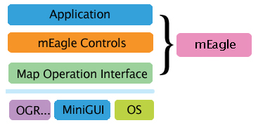
Figure 1 mEagle tri-layer framework
Application: It provides mEagle application based on the two bottom layers, the application is suitable for the small screen or large screen. It supports for the common map operations as well, such as zoom, pan, rotation, map search, path tracking, and navigation, etc.
mEagle Controls: Feynman has developed two controls which are EagleMap control and EagleEye control to develop the applications of mEagle fast and conveniently.
Map Operation Interface: It provides basic interface of map operations, such as loading a map layer, editing a layer, zoom, rotation, etc.
Users can develop embedded geography system application software based on mEagle by calling the third layer’s interface, or using the second layer’s mEagle controls.
mEagle tri-layer framework has provided a very flexible platform for the embedded GIS software development.
Users can use the following functions:
- Appending and editing the user-defined features. It can be used to mark and highlight the feature, or path tracking, path setting, and so on.
- Search features according to the keyword or the region.
- Navigation. Although mEagle does not have path planning function, you can integrated your own or third party's path planning module with mEagle, and provide the planned path to mEagle, then you will achieve vehicle navigation function. Navigation demonstration function has been provided in mEagle application.

4 mEagle Applications
In short, mEagle can be applied to various kinds of work similar to the below working module.
- Car navigator /monitoring system
Particular car navigator/monitor, local vehicle self navigation/ monitor navigation system.
- Military information system
Field operations single portable instrument information system.
- Traffic control system
It can display the accident place, record the accident, list current traffic status, display ride trace of some vehicle, and record the trace information.
- City development system
City wiring system can make lines’ position distinctively. Field workers can position the cable and effectively record the problem location according to the map information getting from hand equipment.
- Criminal information system
Based on Criminal information system police can record all the criminal information, including vipers, frequent venue. When some crime taking place, we can search in the area quickly.
- Material distribution system
Based on Material distribution system we can record and mark the client location and the material location. Positioning current material position and displaying the path that will quicken material distribution, and improve clients’ satisfaction level.
- Tourism cicerone system
Cicerone system.
- Various society emergency systems
Hygiene and disease control command system.

5 mEagle V1.0 Screenshots
mEagle provides good map operations support, and the following is the display effect of mEagle with different operations.
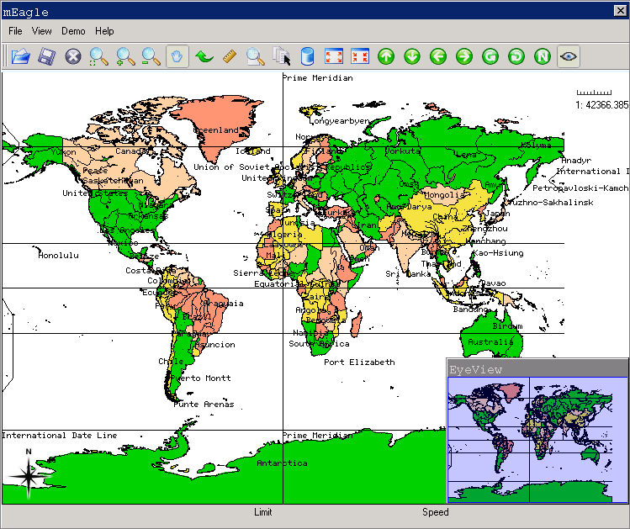
Figure 2 mEagle V1.0 large screen with eagle eye
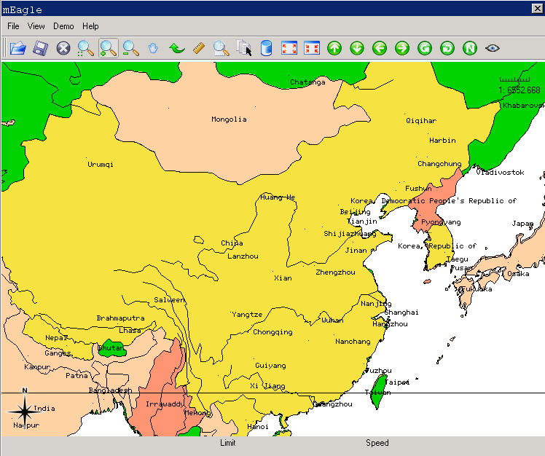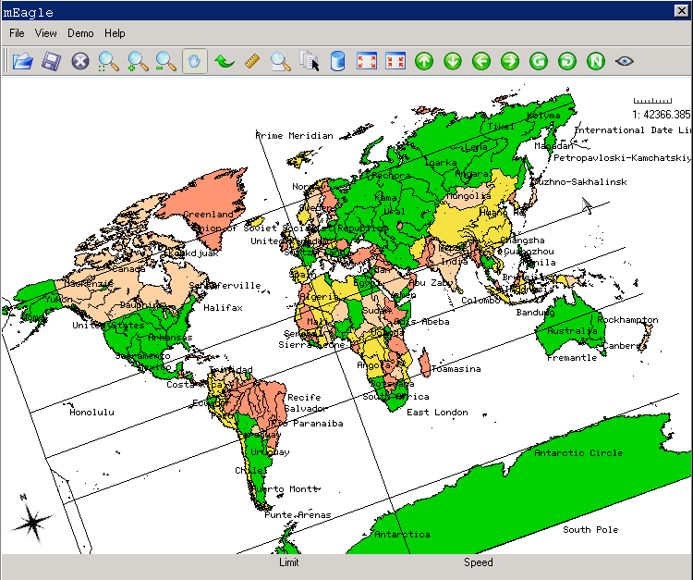
Figure 3 mEagle V1.0 with zoom in Figure 4 mEagle V1.0 with rotation
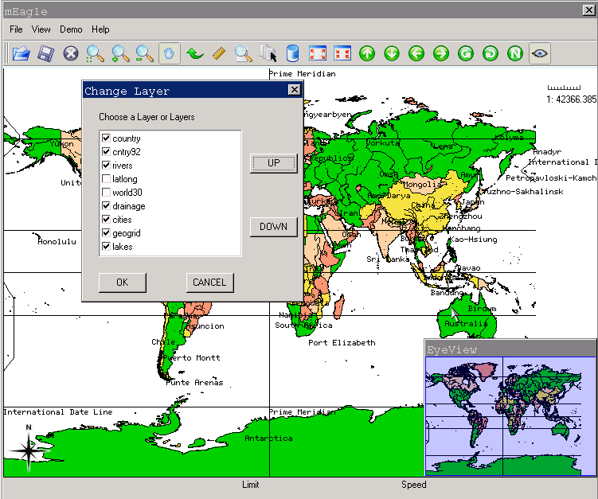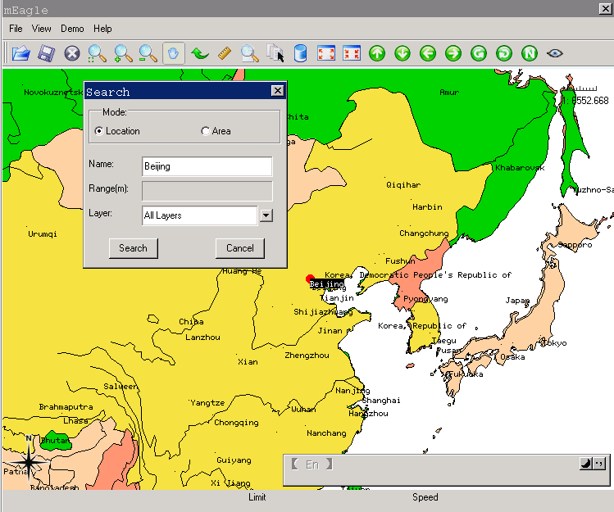
Figure 5 mEagle V1.0 with layer management Figure 6 mEagle V1.0 with search
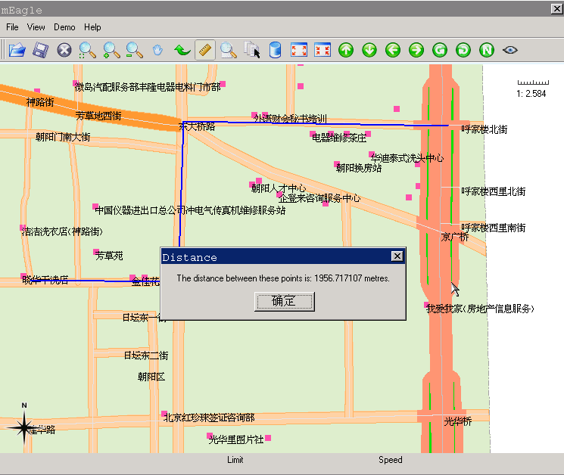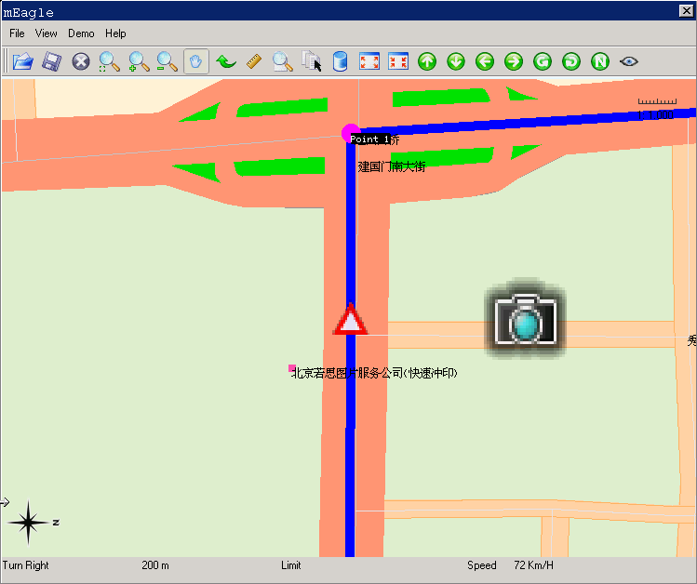
Figure 7 mEagle V1.0 with measurement Figure 8 mEagle V1.0 with PT demo
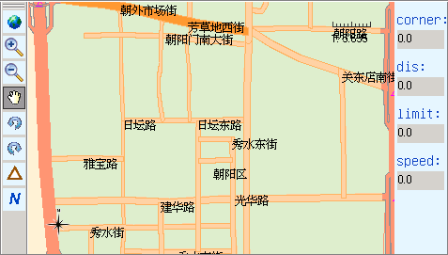
Figure 9 mEagle V1.0 small screen

6 Contact Us
If you want to know more about mEagle and Feynman Software, please visit the following URL:

http://www.minigui.com

You can visit the following URL to see other products information:

http://www.minigui.com/product/index.html

If you have any questions or you want to know how to purchase mEagle, please email us:

sales@minigui.com
info@minigui.com

