**编号组：**

WL1

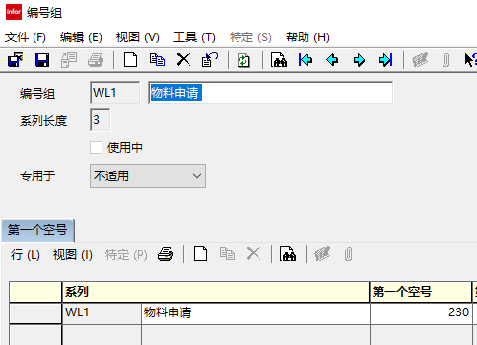

**域:**

tccus501lc

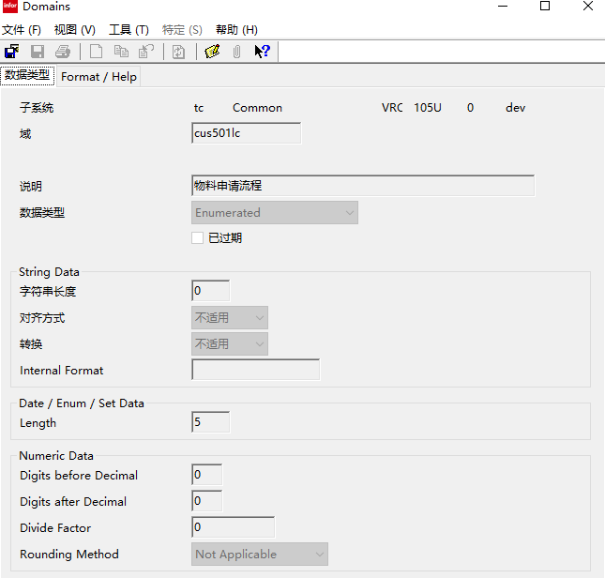

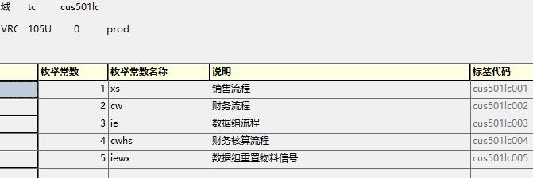

**message：**

tccus501notsh

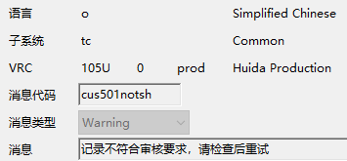

tccus501repeat

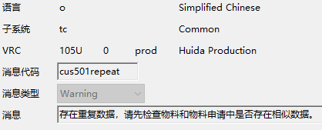

tccus501iejs

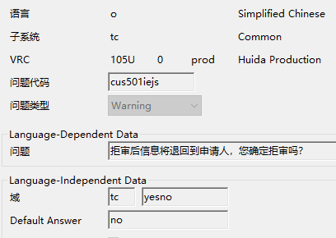

**lable：**

**tccus501001~tccus50601001**

**tccus5101m000001~tccus5106m000001**

**tccus5401m000001~tccus5506m000001**

**Tbale：**

tccus501~~tccus506

**Session:**

**tccus5101m000~tccus5106m000**

**tccus5401m001~tccus5506m000**

**脚本：**

**tccusdll501**

**tccusdll501ws**

**tccus5101m000~tccus5106m000**

**dal:**

**tccus501~tccus506**