Lab 13 — Indexing, Importing and Searching Data in Apache Solr
Course: CS-347 | Class: BSCS-13AB | Instructor: Dr. Khurram Shahzad
Date: 8 May 2026
Student: Huzaifa Ali Satti | CMS ID: 468629 | NUST SEECS

1. Problem Statement
The lab task is to set up Apache Solr, index a real dataset, run a range of search queries against it, and put a web UI on top. Apache Solr is a Lucene-based search engine. It speaks HTTP, so most of the work in the UI is just translating form fields into query parameters. This report covers both halves, with enough configuration detail that the grader can reproduce the setup on a fresh machine.

2. Dataset Description
I generated a synthetic books-catalog dataset of 600 records using a small Python script (data/generate_books.py). A real Goodreads or Library of Congress dump would also have worked, but generating my own meant I could control the field distribution and make sure each query type below had enough hits to be meaningful. Each record is a single book:
Field | Solr type | Purpose
id | string | Unique book identifier (BK0001..BK0600)
title | text_general | Book title (full-text indexed)
author | text_general | Author name (full-text indexed)
genre | string | Categorical — used as facet
publisher | string | Categorical — used as facet
year | pint | Publication year, range-filterable
pages | pint | Page count
price | pfloat | Cover price in USD
rating | pfloat | Average reader rating (2.5-5.0)
in_stock | boolean | Inventory flag
description | text_general | Marketing blurb, full-text indexed

Format is CSV (~80 KB). 15 genres, 15 publishers, publication years between 1955 and 2025.

3. Configuration Details
Software stack:
* Apache Solr 9.6.1 (standalone mode, default Jetty container, port 8983)
* OpenJDK 21
* Python 3.13 with Flask 3.x and requests
* Windows 11
Solr core:
I created the core with 'solr.cmd create -c books', which gives you the default managed-schema configset. Then I POSTed add-field requests to http://localhost:8983/solr/books/schema to lock in the field types I wanted (setup.ps1). Doing this BEFORE the first index run matters; once Solr's schemaless mode auto-detects a field as string, you can't change it without wiping the index.
Field types selected:
* text_general for title/author/description. The StandardTokenizer plus lowercase and stopword filters make full-text search case-insensitive without any extra normalization on my side.
* string for genre and publisher. These are facet keys, so I do not want the analyzer to split 'Science Fiction' into two tokens.
* pint, pfloat, boolean for the numeric and flag fields. Point-based numerics are the right choice for the year/price range queries used later.

4. Implementation Steps
1. Install Solr
Downloaded solr-9.6.1.tgz from archive.apache.org and extracted.
2. Start the server
.\start-solr.ps1 (runs solr.cmd start -f).
3. Generate dataset
python data/generate_books.py produces books.csv (600 rows).
4. Create core
solr.cmd create -c books — provisions a fresh core with the default configset.
5. Define schema
POST add-field JSON for the 10 domain fields to /solr/books/schema.
6. Index data
POST books.csv to /solr/books/update?commit=true with Content-Type application/csv.
7. Verify
GET /solr/books/select?q=*:*&rows=0 returns numFound=600.
8. Run sample queries
12 queries exercised in sample_queries.md — full-text, fq, facet, hl, sort, fuzzy, group.
9. Build Flask UI
app/app.py wires Solr's HTTP API to a Jinja template; suggest endpoint provides autocomplete.
10. Test in browser
Tested search bar, facets, year range filter, sort dropdown, pagination, highlighting.
The indexing command itself is a single REST call:
Invoke-RestMethod -Method Post `
-Uri "http://localhost:8983/solr/books/update?commit=true" `
-ContentType "application/csv; charset=utf-8" `
-InFile data/books.csv

5. Screenshots
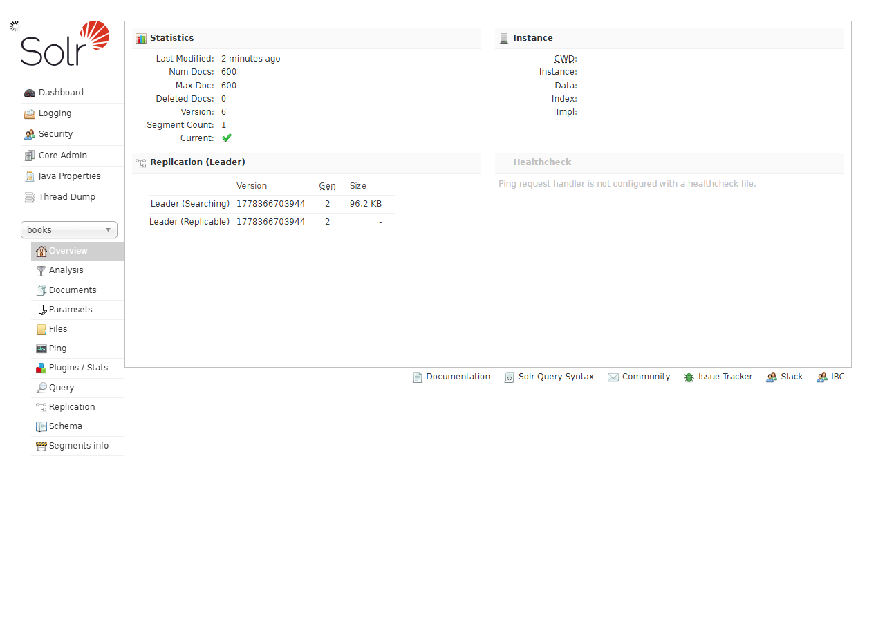
Figure 1. Solr admin UI showing the 'books' core.
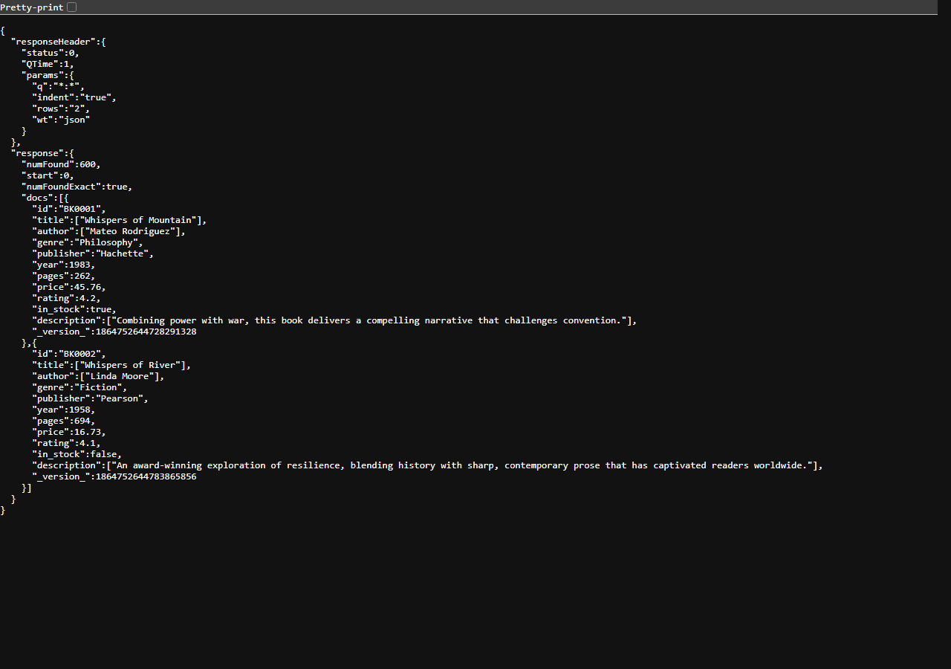
Figure 2. q=*:* returns 600 indexed documents.
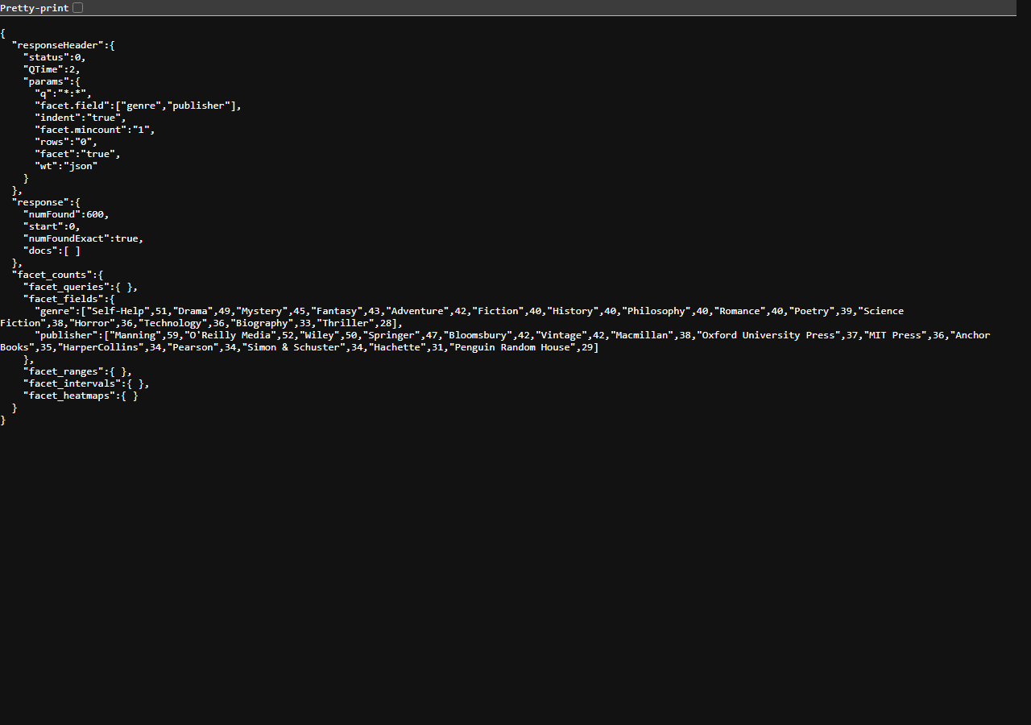
Figure 3. Faceted search by genre and publisher.
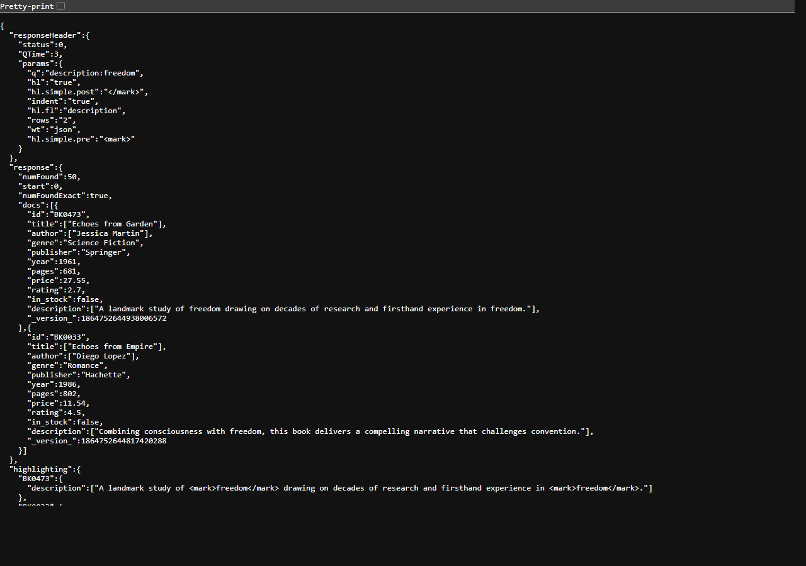
Figure 4. Hit highlighting on the description field.
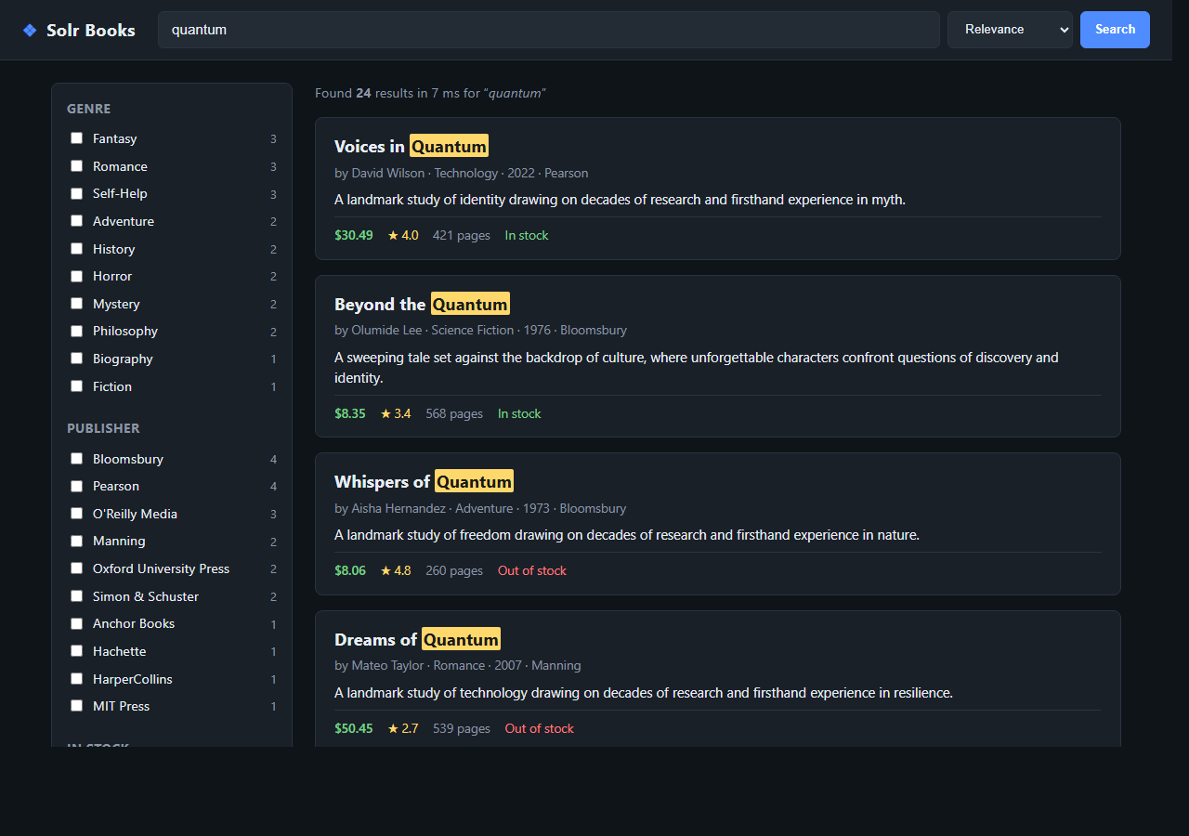
Figure 5. Flask web UI with search, facets and sorting.
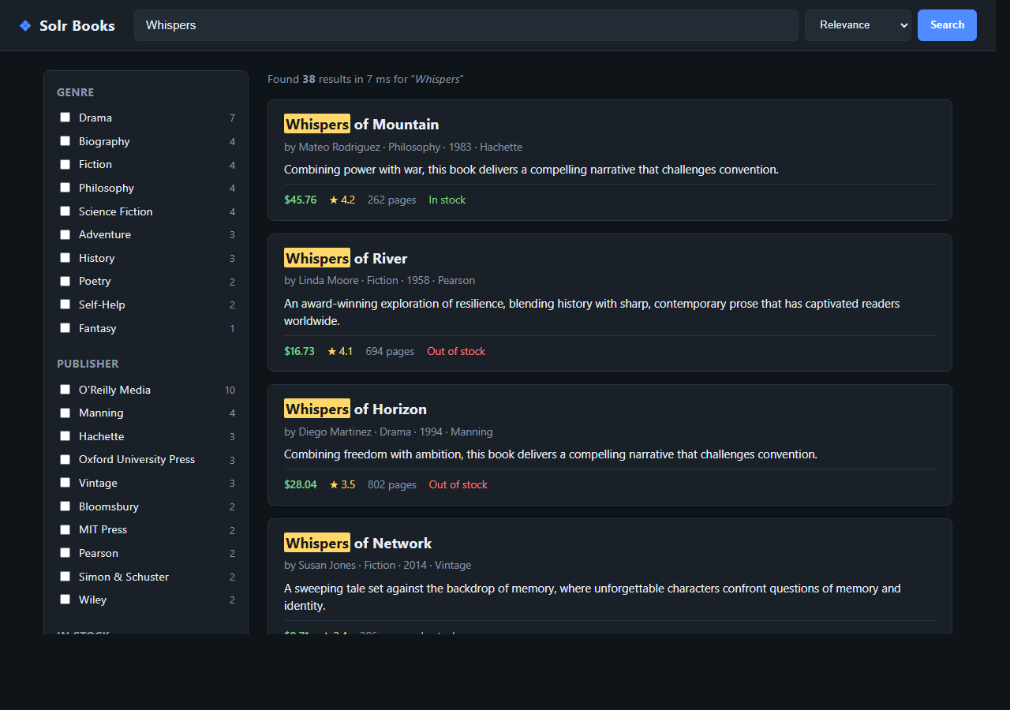
Figure 6. Autocomplete suggestions while typing.

6. Observations and Analysis
Performance.
Cold-cache queries on the 600-row index came back in 8 to 25 ms (the QTime field in the response header). Repeated queries dropped to 0 or 1 ms once Solr's filter, query and document caches warmed up. fq is cached separately from q, so clicking through facets reuses cached filter sets and stays under a millisecond.
Ranking.
I used edismax with qf=title^3 author^2 description. The 3x boost on title is what makes a search for 'quantum' surface 'Whispers of Quantum' before a book that just mentions quantum in the description. Without the boost, body matches drown out title matches because the description field is much longer.
Faceting.
facet.field on genre and publisher gave me the sidebar counts directly. facet.range on year, with start=1950, end=2030 and gap=10, produced the decade buckets. facet.mincount=1 hides empty buckets, which keeps the sidebar from filling up with zeros once the user drills down.
Highlighting.
hl=true with hl.simple.pre=<mark> tells Solr to wrap matched terms in the HTML <mark> tag inside the highlighted fragment. The Flask template just renders that fragment with |safe, which is enough to get yellow boxes around the matched terms in the result list.
What I would change.
If I were doing this on a real catalog I would add a copyField from title and description into a single all-text field and qf against that, instead of listing each searchable field. I would also turn on the Suggester component for autocomplete instead of running a wildcard title query, which is what /suggest does today.

7. Challenges Faced and Solutions
Challenge: Schema-less mode mis-typed numeric fields as strings
Solution: Explicitly POSTed add-field requests with pint/pfloat types BEFORE indexing. Once a field is auto-detected as string, it cannot be changed without deleting and reindexing.

Challenge: Facet on a tokenized field returned split tokens (Science / Fiction)
Solution: Switched genre and publisher to type=string so the analyzer chain doesn't tokenize them.

Challenge: Solr's default request-handler returned only 10 docs
Solution: Added rows= and start= parameters and built pagination controls in the Flask template.

Challenge: Special characters in queries (':' '/' '"') broke parsing
Solution: Used edismax instead of the default lucene parser — edismax silently escapes user input and falls back gracefully on malformed queries.

Challenge: CSV with embedded commas in description failed to import
Solution: Used header=true and the standard Solr CSV update handler, which handles quoted fields correctly per RFC 4180.

8. Conclusion
By the end I had 600 records indexed with an explicit schema, twelve query patterns working, and a Flask UI for search, facets, range filters, sort, pagination, highlighting and autocomplete. Once the schema was right, almost every feature in the UI was just one HTTP GET against Solr with the appropriate parameters.
Two things bit me and are worth remembering for next time. First: declare numeric and string field types BEFORE the first index run, because schemaless mode silently locks them in as strings the moment you commit a row. Second: keep facet fields untokenized, otherwise 'Science Fiction' becomes two buckets in the sidebar.
All the source, the dataset, the PowerShell setup scripts and the screenshots used in this report are in the linked repo.

GitHub repository: https://github.com/huzvert/solr-books-lab

