Week 7: MLOPS
Designing a Simple SageMaker Pipeline using SageMaker Unified Studio
1. Open Amazon SageMaker in AWS
2. Go to domains in the left panel
3. Create a domain (if not already created) and under the link click Open Unified Studio
4. Click Sign with AWS IAM
5. The following window will appear
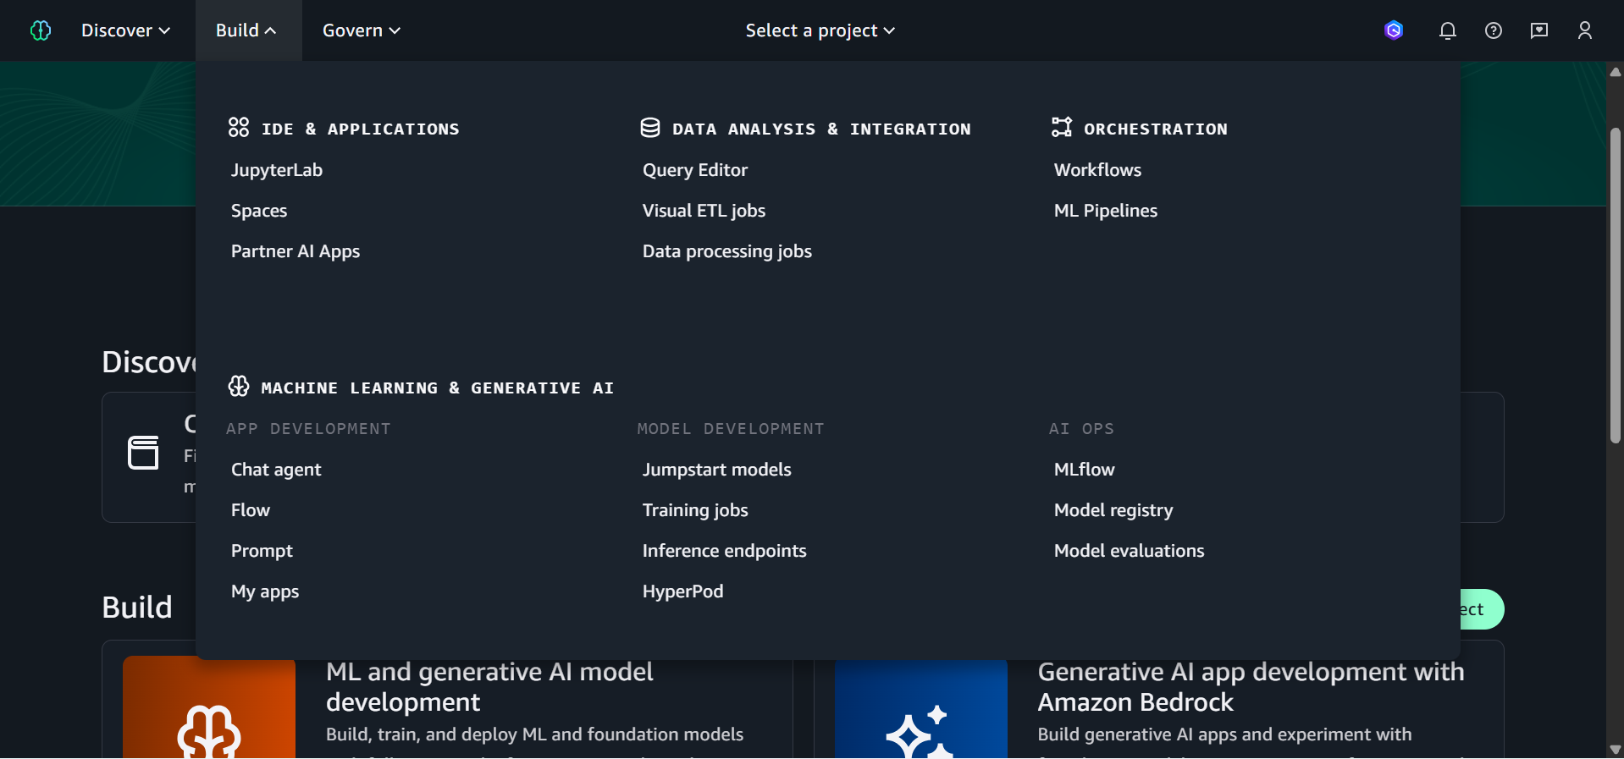
6. Proceed to ML Pipelines under Orchestration section
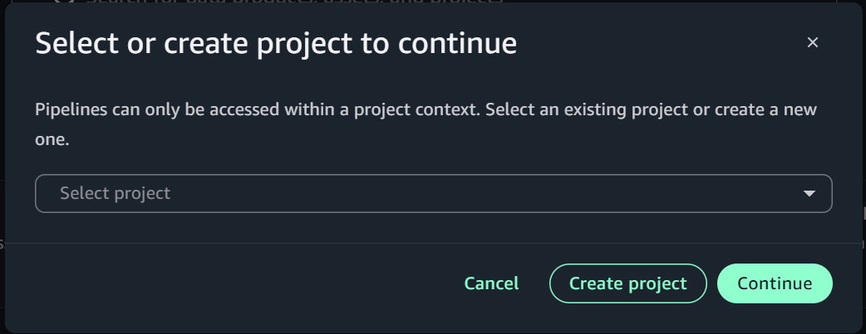

7. Create or select an existing Project

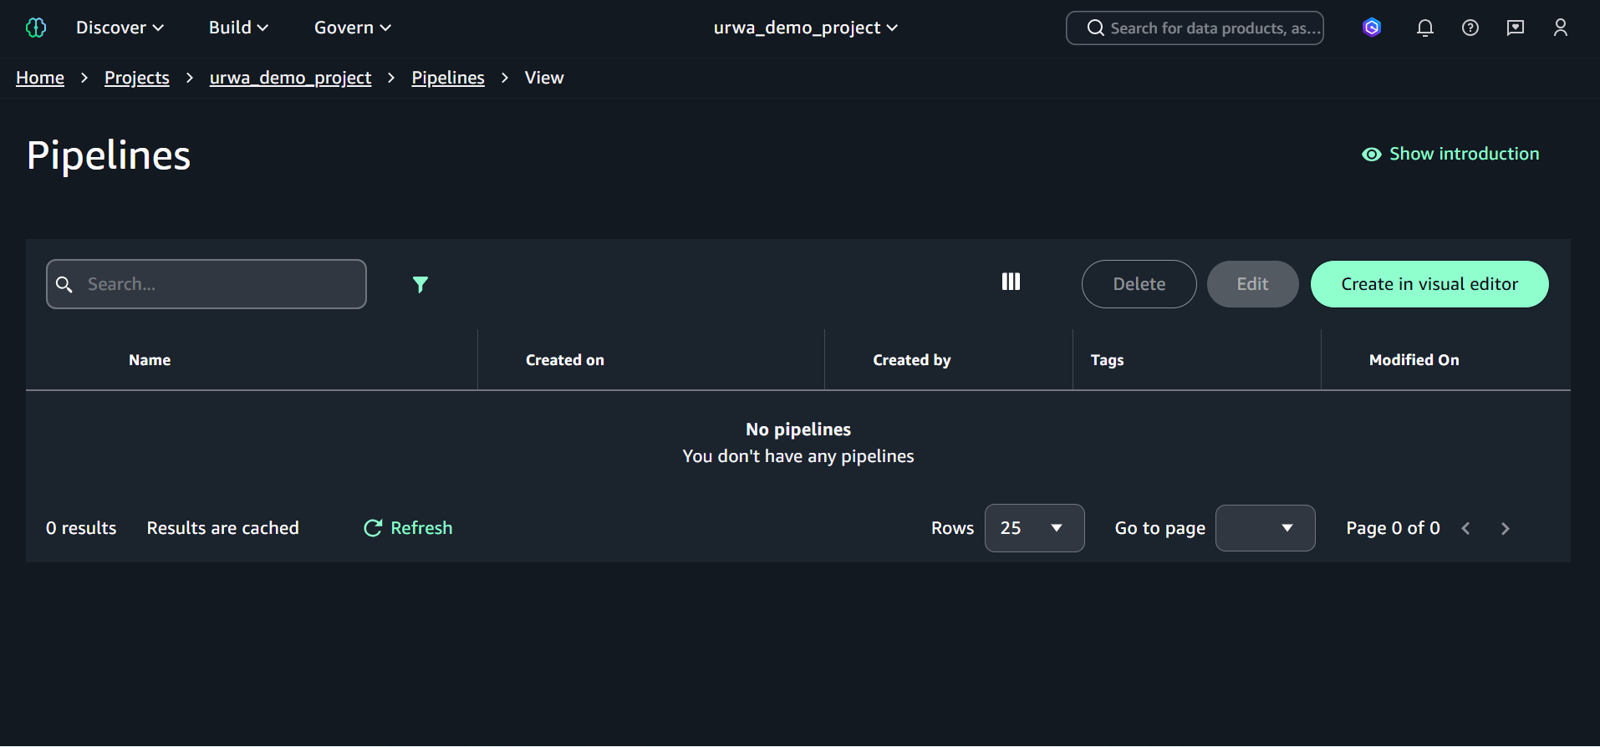
8. Click Create in visual editor to design a conceptual ML workflow

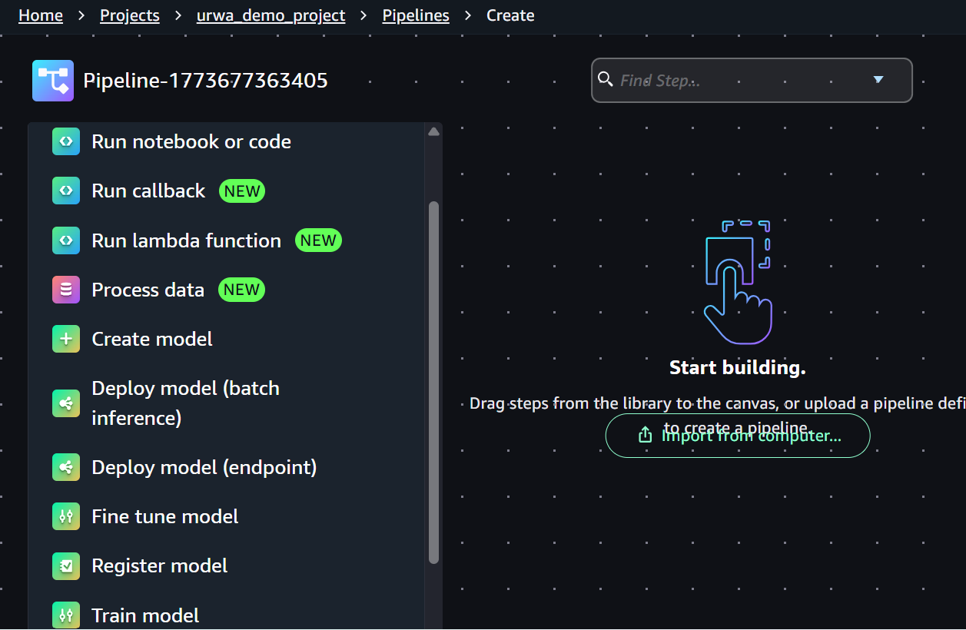

9. Now to design an ML Pipeline follow the steps:
Step-by-step: Drag these steps onto the canvas in order
1. Process data → drag it first onto the canvas
- This handles your data ingestion + preprocessing from S3
- In the config panel add input data S3 URI (stored in S3) as s3://bucket-name-file
- Add local path, usually ‘/opt/ml/processing/input/input-1’ and Click Save.
2. Train model → drag it second, connect it below Process data
- This is your training job step
- In the config panel Add S3 URI s3://bucket-name/,
Location (ECR URI): 683313688378.dkr.ecr.us-east-1.amazonaws.com/sagemaker-scikit-learn:1.0-1-cpu-py3
- Connect it from the Process Data step
3. Run notebook or code → drag it third (for Evaluation)
- Use this to run your evaluation script
- In the config panel add the python notebook to run from locally and add ECR URI as 885854791233.dkr.ecr.us-east-1.amazonaws.com/sagemaker-distribution-prod:1-cpu
- Connect it from the Train Model step
4. Register model → drag it last
- This registers the trained model to the Model Registry
- Name the model group (any name) and Connect it from Run notebook step

DAG (ML Pipeline)
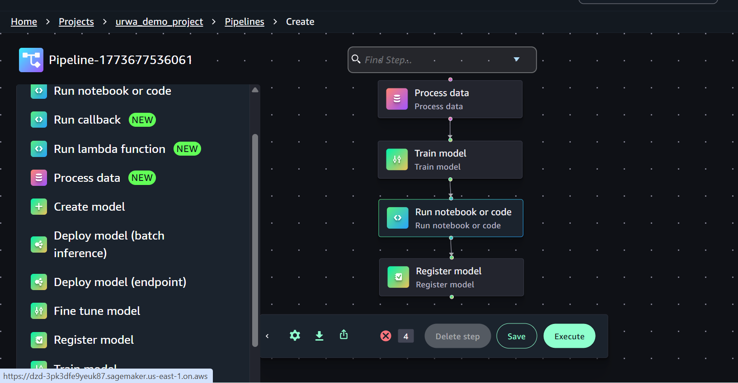

10. Click Execute once everything is configured and your pipeline will create and Run.
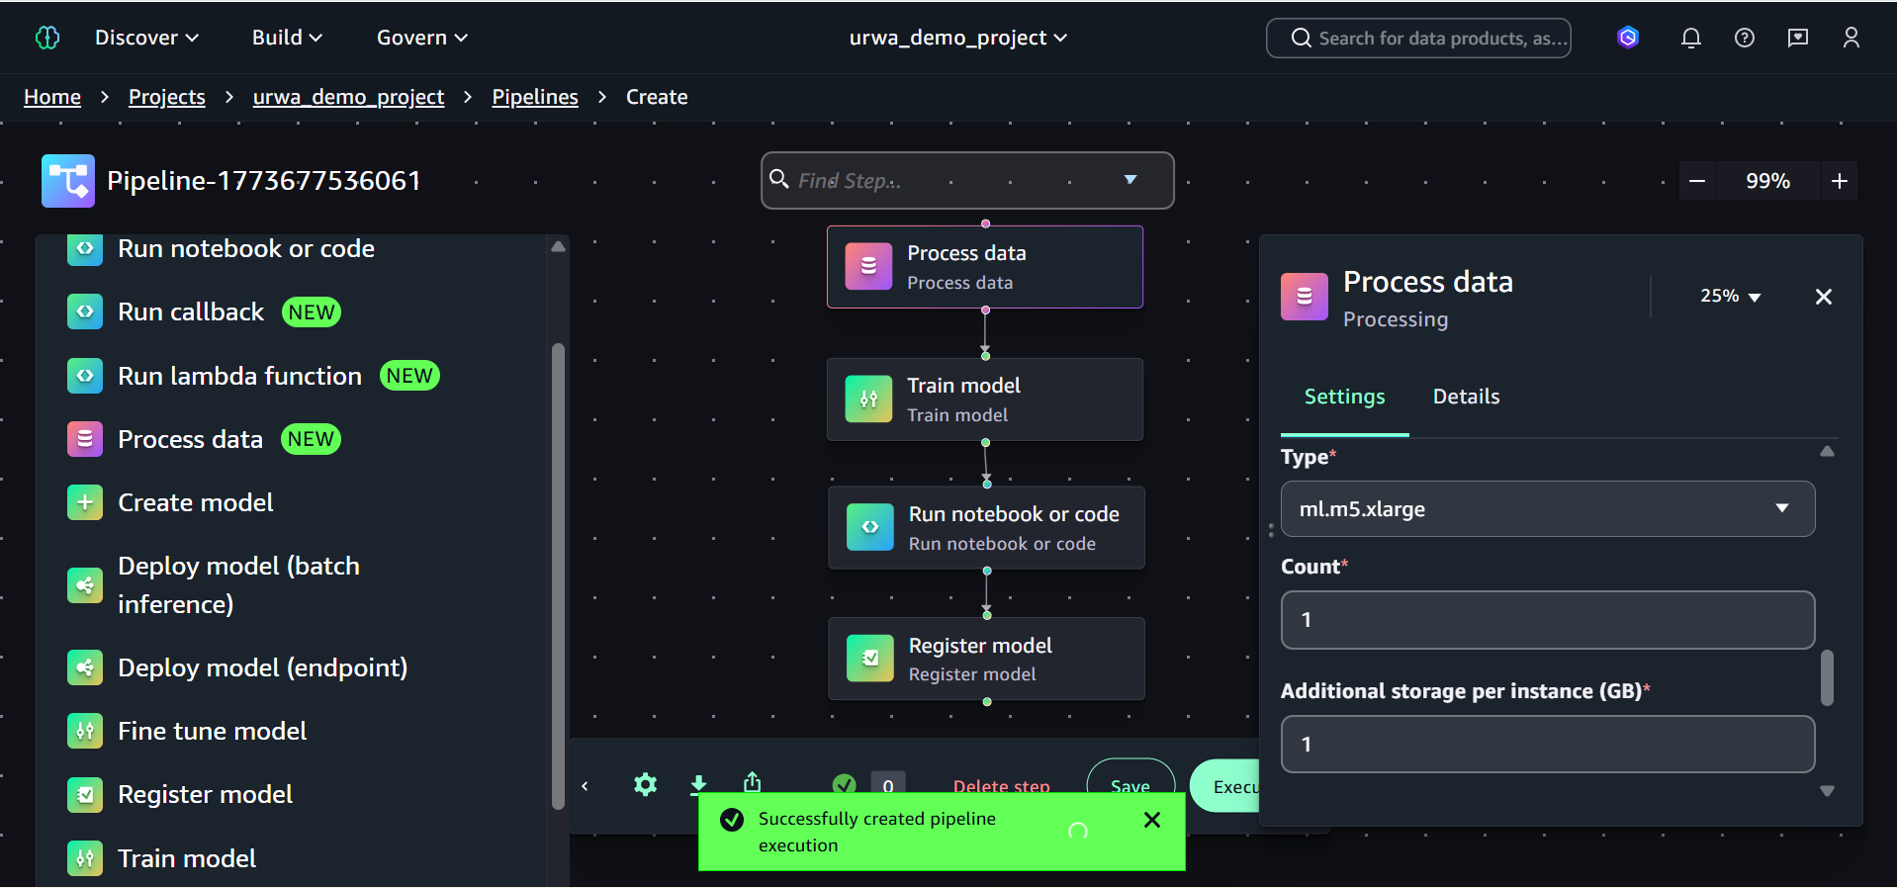

11. To check logs and executions of the pipeline, Click Pipelines or Go Back then Click on the Pipeline which would appear in the Pipelines section and you will be proceeded to the section where you can visualize Logs, Executions, Graphs and also view errors (if any) for each step.

Explainable AI (XAI) refers to techniques that make machine learning models interpretable, i.e., help humans understand why a model made a certain prediction.

SHAP
- Based on Shapley values from cooperative game theory.
- Assigns an importance value to each feature for a particular prediction.
- Works for any model type (tree-based, deep learning, etc.).
- Example: If a Random Forest predicts a customer will churn, SHAP can show that “tenure < 12 months” contributed +0.3 to the probability of churn.

LIME (Local Interpretable Model-agnostic Explanations)
- Focuses on local interpretability, i.e., explaining individual predictions.
- Creates a simpler, interpretable model (like linear regression) locally around the data point to approximate the black-box model.
- Example: LIME can explain why a single customer got a high churn score by weighting the most influential features for that instance.

SageMaker Model Monitor (Data Drift Monitoring)

Setup Steps for a Deployed Model
- Baseline Dataset
  - Use the training dataset to define expected feature distributions (e.g., mean, variance, categorical distributions).
  - SageMaker can automatically generate a baseline constraints file.
- Configure Monitoring Schedule
  - Define a monitoring job that periodically samples incoming inference requests (e.g., every 1 hour or 1 day).
  - Connect the job to the endpoint where the model is deployed.
- Specify Metrics / Checks
  - Feature distributions: compare current input distributions with baseline.
  - Data drift metrics: e.g., KL divergence, Jensen-Shannon divergence, or simple statistical tests.
  - Missing values, outliers, categorical feature changes.
  - Optional: prediction drift (if you want to monitor output distributions).
- Interpret Results
  - If metrics exceed thresholds → indicates data drift, e.g., a new customer demographic appears in incoming data.
  - Alerts can trigger retraining or further investigation.
  - Visualizations help identify which features are drifting the most.

Conceptual Flow

Deployed Model Endpoint
↓
SageMaker Model Monitor (scheduled job)
↓
Compare input data stats vs baseline
↓
Drift detected? → Alert / Retraining

