Week 8
Churn Prediction Model Development and deployment & MLOps pipeline
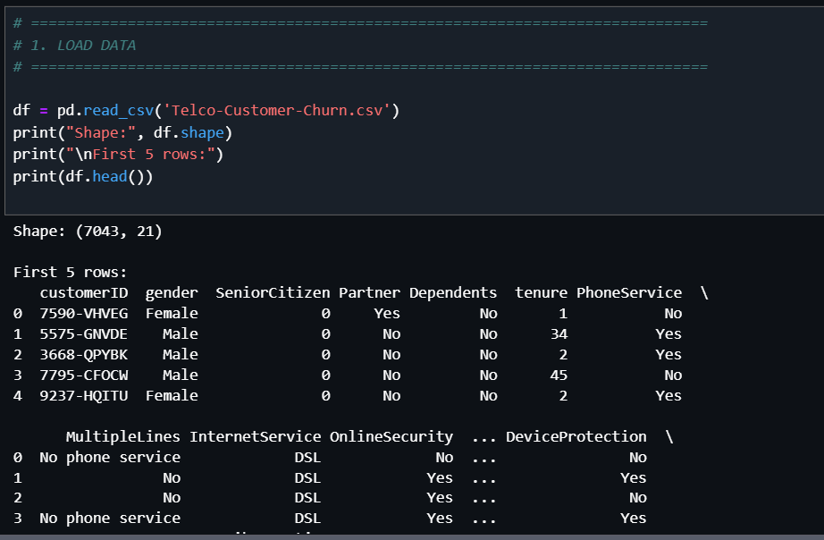
Data Cleaning / Type Conversion
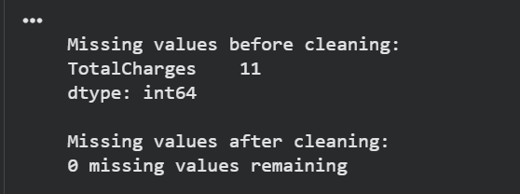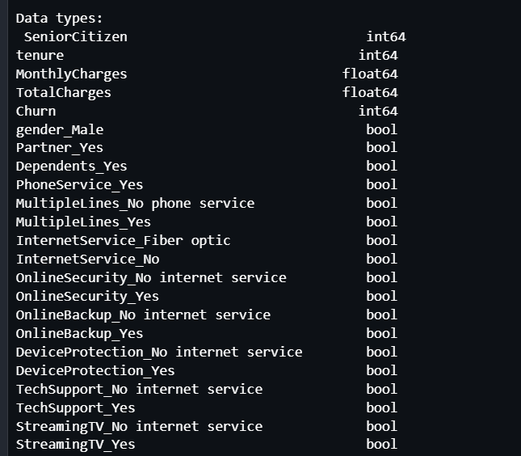
EDA

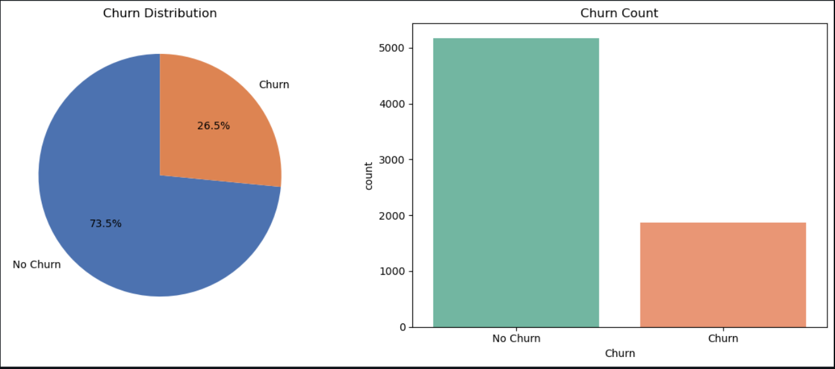
Feature Engineering
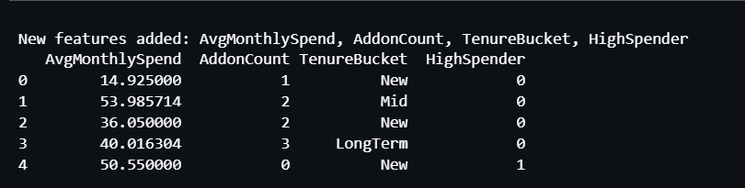

Pre-processed dataframe
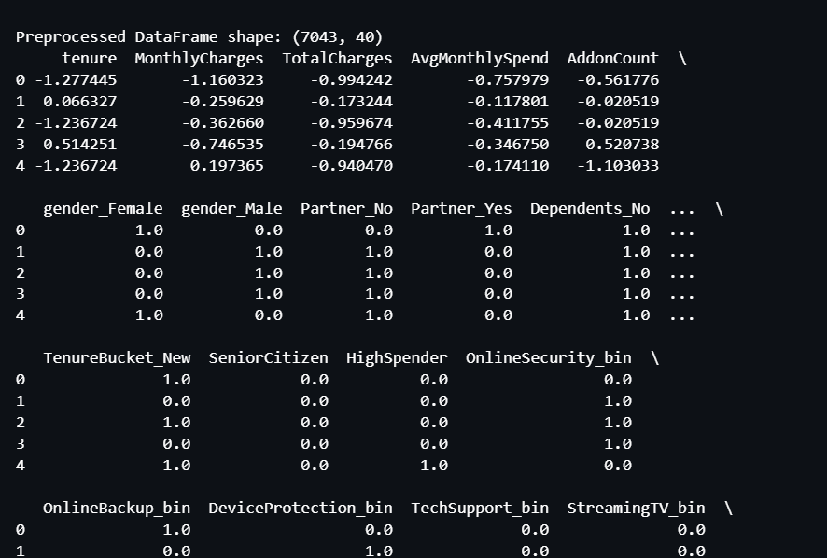

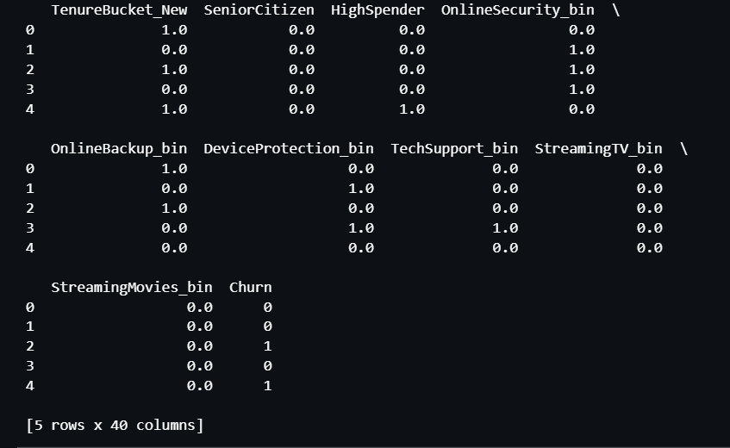

Saving data in S3

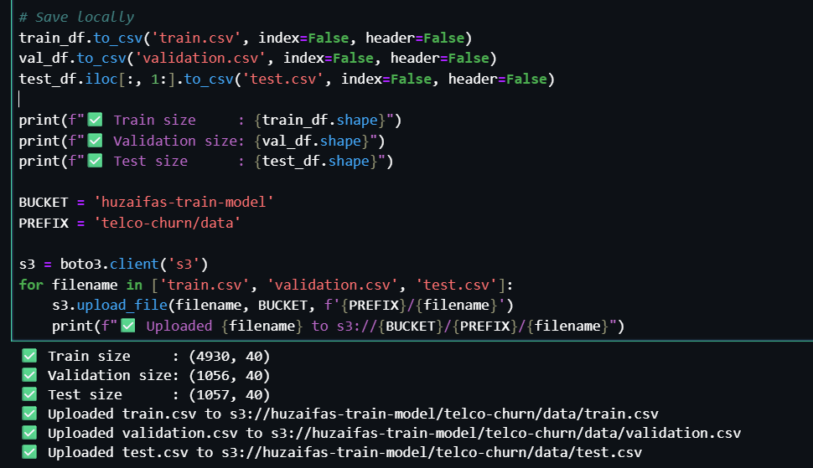

Exclude Target column while saving to S3 bucket for Batch Inferencing

Train/test split samples and class weights
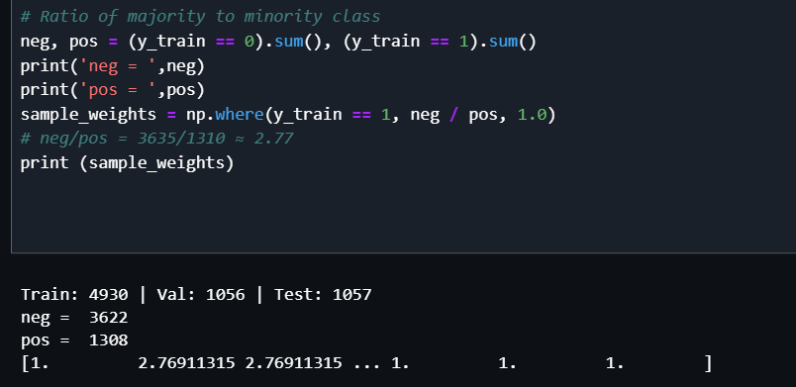
Train → 70%
Validation → 15%
Test → 15%
Model selected: XGBoost

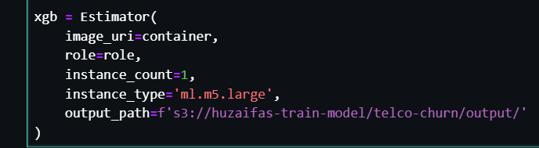
Saved model artifacts (trained weights and parameters of XGBoost model) stored in output folder.
SageMaker often includes information about how the model was trained, which is useful for auditability and model versioning.
For the Evaluation Step: evaluation code will look into s3://huzaifas-train-model/telco-churn/output/ to download the model.tar.gz so it can run predictions against your test set.

Setting XGBoost hyperparameters
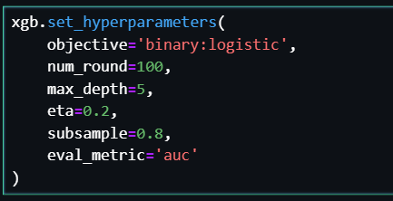
objective='binary:logistic': Binary classification ( Churn vs. No Churn).
num_round=100: Specifies that the model will build exactly 100 trees in total.
max_depth=5: It limits how "deep" each tree can grow. A depth of 5 means each tree can have a maximum of 2^5 = 32 terminal nodes (leaves).
eta=0.2 (Learning Rate): step size
subsample=0.8: For every tree, XGBoost will randomly select 80% of training rows to build that specific tree.
eval_metric='auc': It calculates the Area Under the ROC Curve (AUC).
AUC measures how well the model separates the two classes across all probability thresholds. It distinguishes between customers who will leave (churn) and those who will stay (retain).

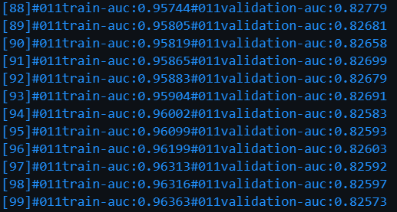
Overfitting!
Training auc keeps increasing while Val auc keeps descreasing.

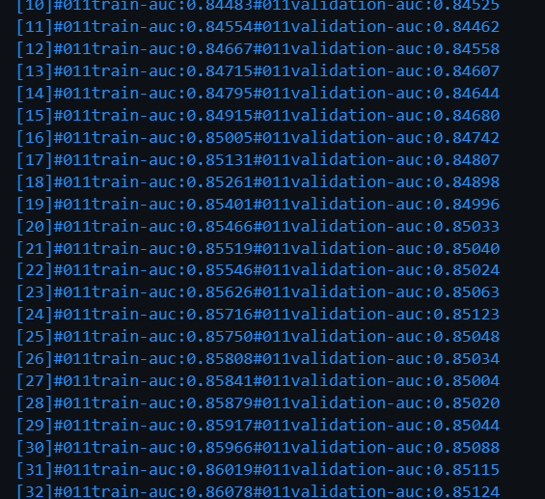
Corrected!

Hyperparameter Tuning (HPO)
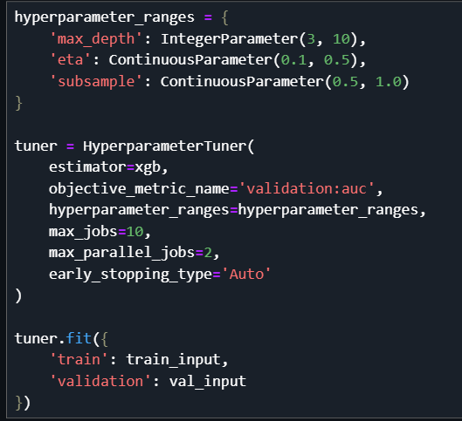

Evaluation Results
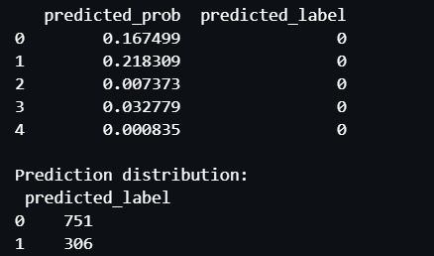
Threshold can be adjusted for more aggressive churn detections

AUC – ROC Curve

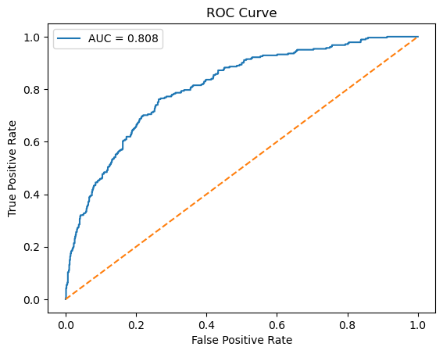
AUC Score: 0.8076572073228895

Model Registration
