generalnie nie twierdzę, że wszystkie zadania są zrobione dobrze

TABELA A: TABELA B:

ID ID

1 2

2 3

a. A JOIN B

b. A LEFT JOIN B

c. A FULL JOIN B

d. A UNION ALL B

e. select count(*),count(distinct id),sum(id) from(select * from A union all select * from B)

f. select count(*),count(distinct id),sum(id) from(select * from A union select * from B)

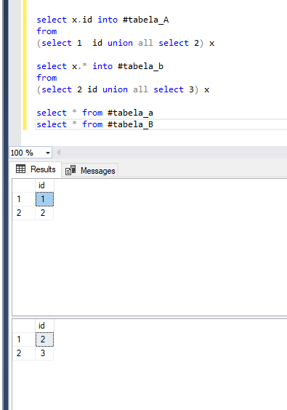

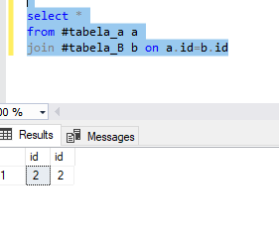

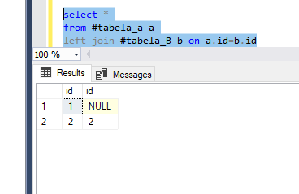

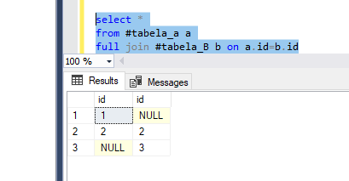

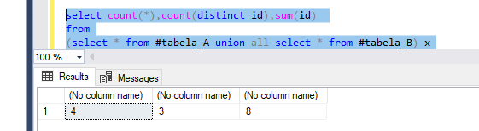

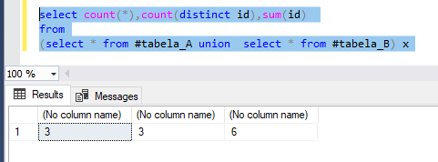

Zadanie na order by z case

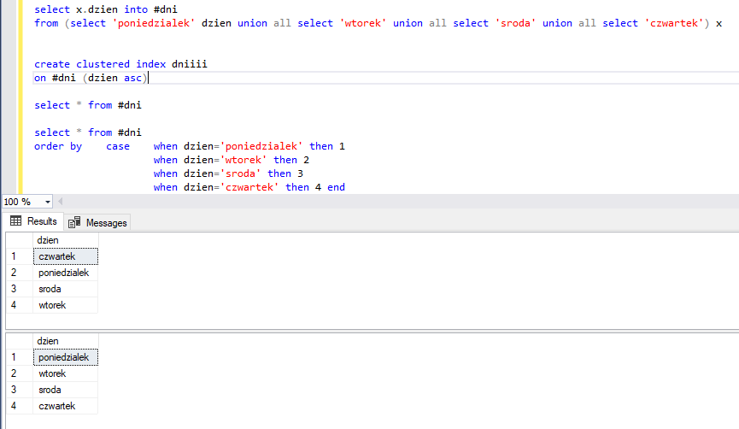

Zadania na logike trójwartościową (nie pamiętam)

Wybierz zduplikowane wartości z tabeli:

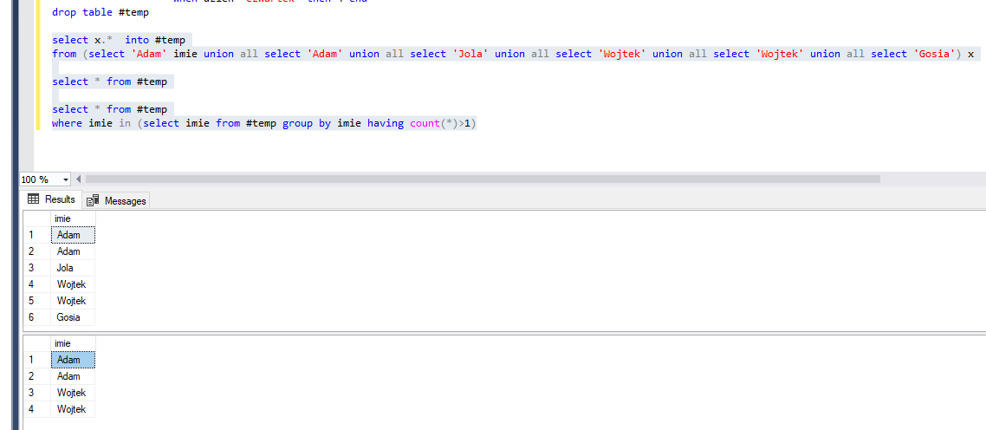

Policz ile razy występuje w danej kolumnie zadany ciąg znaków

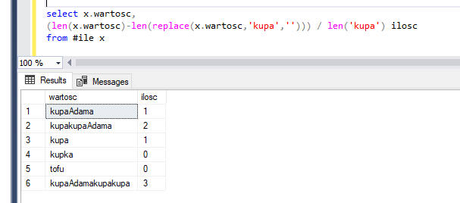

Podaj Wynik zapytania dla wartości 500

Select id, case when Wartosc >500 then 1

When wartosc <400 then 0

When wartość >=400 then 2

When wartośc =500 then 3 end

From tabela

Where wartosc > 500

ODP: wynik pusty – bo ważniejszy jest warunek where niż casy w selectie (500 nie spełnia warunku wartosc >500)

Wynik zapytania:

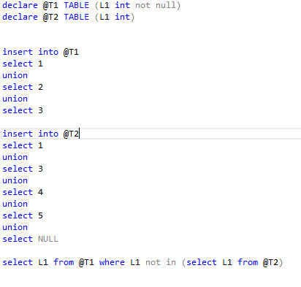

Odp: puste, bo null siedzi w podzypytaniu (logika trójwartościowa)

majac tabele, policz sumy (per kraj, region i całosciowa)

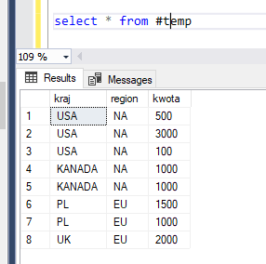

O takie mają być: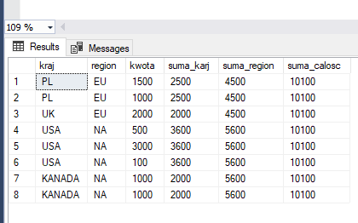

Query:

select t.*

,sum(kwota) over(partition by kraj) as suma_karj

,sum(kwota) over(partition by region) as suma_region

,sum(kwota) over() as suma_calosc

from #temp t

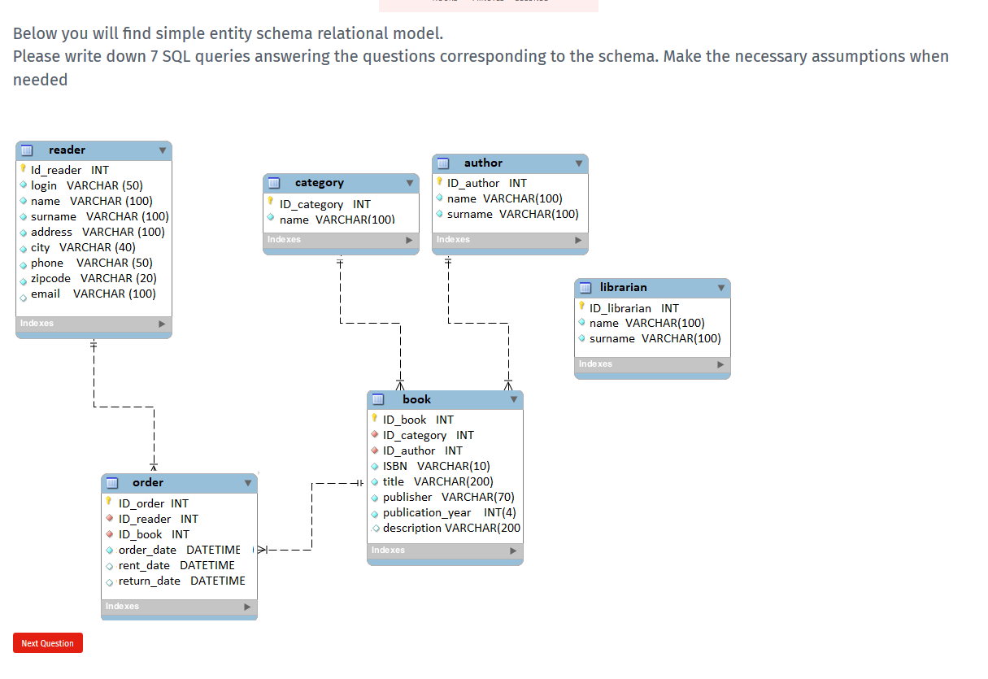

jako date rejestracji uznaje date pierwszego wyporzyczenia - bo lepszej nie widzę

1.Please retrieve the names and surnames of all authors ordered by surnames and names (descending)

SELECT name,surname

FROM author

order by surname, name desc

2.Please retrieve all the readers registered in the current month

SELECT ID_reader,login,name,surname

FROM reader r

JOIN

(SELECT ID_reader,min(order_date) order_date

FROM order

GROUP BY ID_reader) x ON r.ID_reader=x.ID_reader

WHERE convert(varchar(7),x.order_date,121)=convert(varchar(7),getdate(),121)

3.Please retrieve the number of readers registered in the individual years

SELECT convert(varchar(4),order_Date,121),count(distinct ID_Reader)

FROM

(SELECT ID_reader,min(order_date) order_date

FROM order

GROUP BY ID_reader) x

GROUO BY convert(varchar(4),order_Date,121)

4.Please retrieve the list of: reader name, reader surname, author name, author surname, book title for all the books rent within current month

SELECT distinct r.name reader_name, r.surname reader_surname, a.name author_name, a.surname author_surname, b.title

FROM order o b.title

JOIN reader r on r.ID_reader=o.ID_Reader

JOIN book b on b.ID_book=o.ID_book

JOIN author a on a.ID_author=b.ID_author

WHERE convert(varchar(121),o.rent_date,7)=convert(varchar(121),getdate(),7)

5.Please retrieve the amount of authors whose books were not rent

SELECT count(ID_author)

FROM author a

WHERE not exists

(SELECT 1

FROM author a1

JOIN book b on a1.ID_author=b.ID_author

JOIN order o on o.ID_book=b.ID_book

where a1.ID_author=a.ID_author)

6.Please retrieve the name and surname of author having the biggest amount of books

SELECT top 1 name,surname

from author

group by ID_author,name,surname

order by count(*) desc

7.Please retrieve name and surname of top 3 authors owning the biggest amount of books and top 3 authors owning the smallest amount of books

SELECT top 3 name,surname

from author

group by ID_author,name,surname

order by count(*) desc

UNION ALL

SELECT top 3 name,surname

from author

group by ID_author,name,surname

order by count(*)

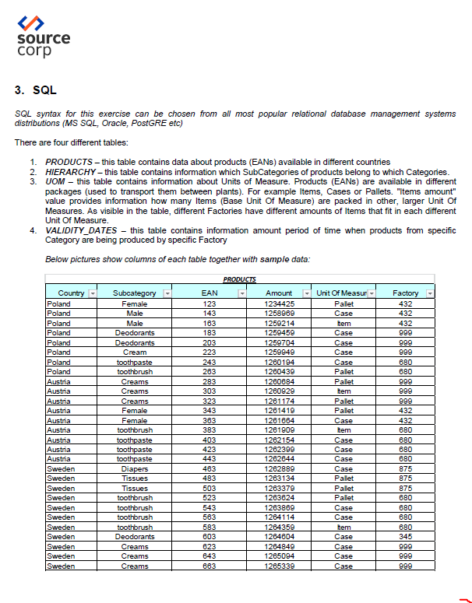

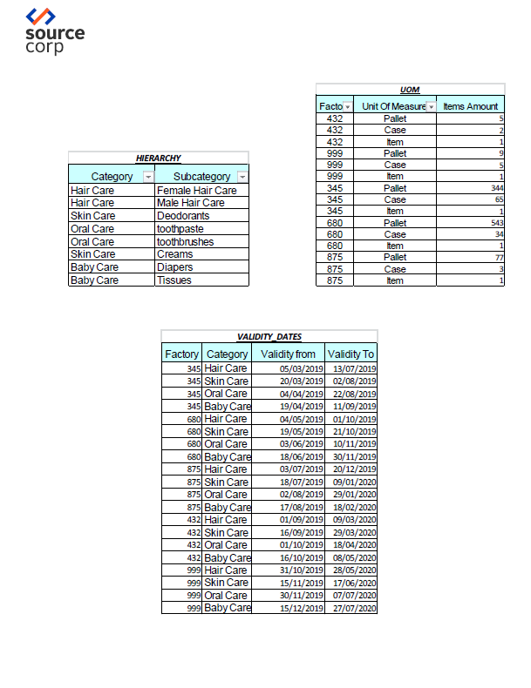

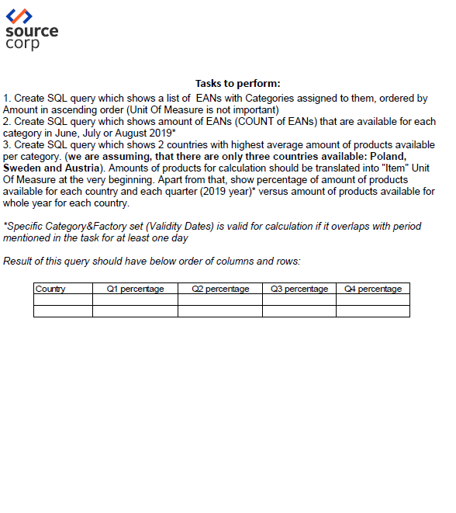

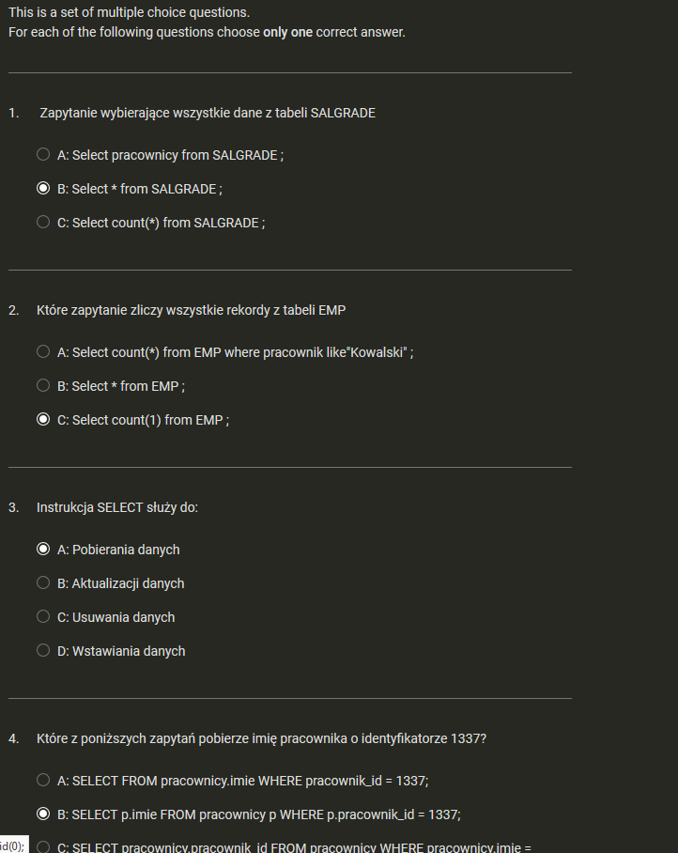

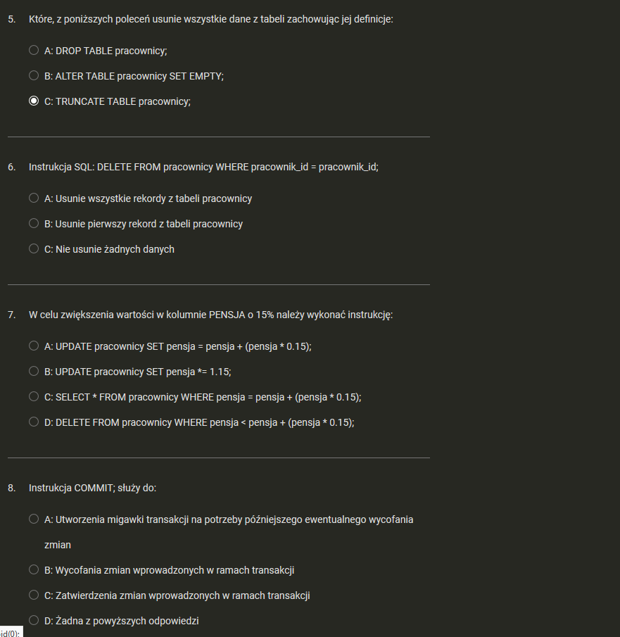

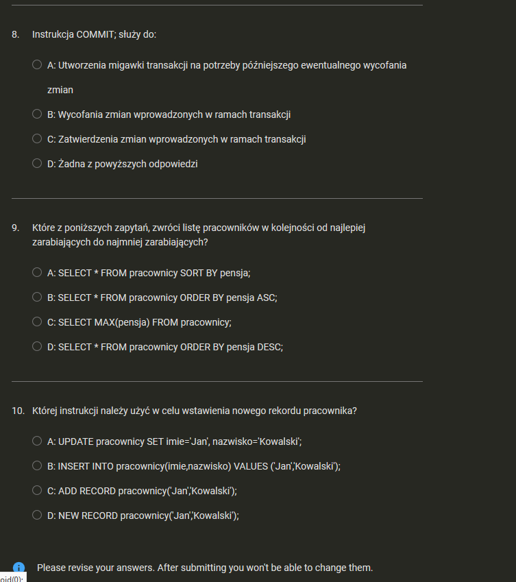

6 A

7 A

8 C

9 D

10 B

