Game Design Document

[Fill up the following document](Project+Questionairre.docx)

1. Write the title of your project.

Olympic Racing game

1. What is the goal of the game?

To Create a player racing game

1. Write a brief story of your game.

In this game the four players will play. So,First of all we have main screen where form will appear. In form the players give Information about themselves like name;after form the Greeting will appear and the game will start.When the game starts the four players race against each other. On the basis of time the score will display on board and the score board shows the information about race like distance,time and players name.

1. Which are the playing characters of this game?

* Playing characters are the ones who respond to the user based on the input from the user.
* Cars, monkeys, dinos, wizards, etc., are the playing characters in the game.

|  |  |  |
| --- | --- | --- |
| Number | Character Name | What can this character do? |
| 1 | Runner1 | Racing |
| 2 | Runner2 | Racing |
| 3 | Runner3 | Racing |
| 4 | Runner4 | Racing |
| 5 |  |  |
| 6 |  |  |
| 7 |  |  |
| 8 |  |  |

1. Which are the Non-Playing Characters of this game?

* Non-Playing characters are the ones that don't have an action or behavior when the user interacts with the game.
* Hurdles, stones, bananas, coins, etc., are non-playing characters in the game.

|  |  |  |
| --- | --- | --- |
| Number | Character Name | What can this character do? |
| 1 | For each current player,rest of the player non-playing | This character runs against the opponent players |
| 2 |  |  |
| 3 |  |  |
| 4 |  |  |
| 5 |  |  |
| 6 |  |  |
| 7 |  |  |
| 8 |  |  |

Draw your imagination of this game. What does this game look like?

* Draw the game either on your computer or on paper.
* Add images of the game scenes to show each of the playing and non-playing characters at least once.

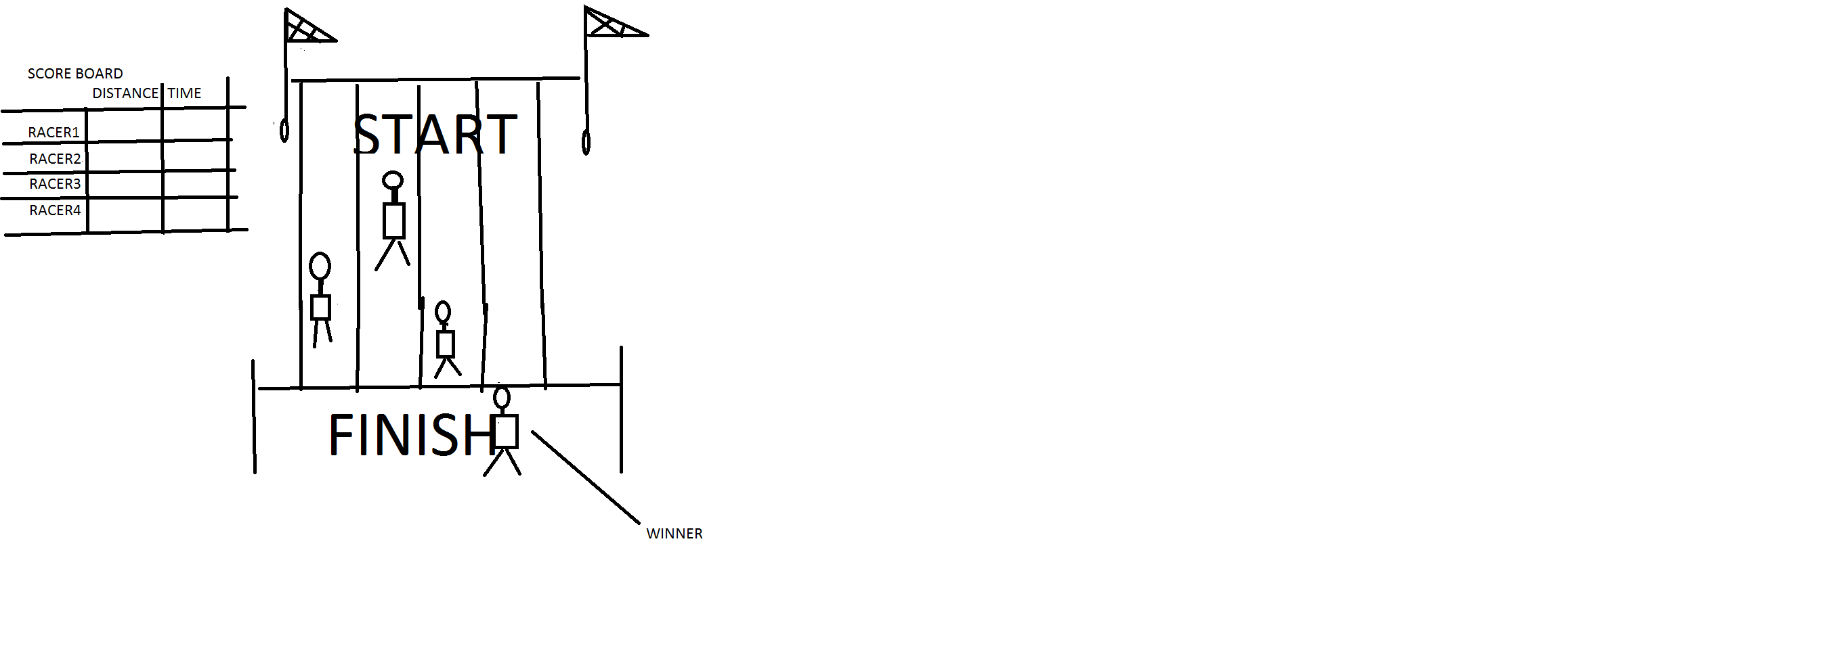

How do you plan to make your game engaging?

By adding sound,annimation and feedback