DEPARTMENT OF COMPUTER SCIENCE & ENGINEERING
LABORATORY OBSERVATION & RECORD
Course Name: Full Stack Web Development
Course Code: 23CM4121
Experiment No: 03
Student Name: Patnana Harsha Vardhan
Roll No: A24126552103
Branch & Section: CSM-B
Date of Execution: 08/09/2026
1. TITLE
JS Basics - Arrays & Functions
2. AIM
To design and implement a JavaScript program demonstrating fundamental array operations, custom utility functions, and array iteration methods to process and manipulate dataset elements dynamically.
3. OBJECTIVE
• To understand JavaScript function declarations, expressions, and arrow function syntax.
• To learn array creation, traversal, and manipulation using built-in array methods.
• To perform dynamic data transformations and calculations using functional programming concepts in JavaScript.
4. THEORY
JavaScript arrays are ordered collections of values capable of holding heterogeneous data types. Functions in JavaScript are first-class objects that can be assigned to variables, passed as arguments, and returned from other functions. Built-in array iteration higher-order functions such as forEach(), map(), filter(), and reduce() allow developers to write clean, declarative logic for processing collection data without writing manual index-based loops.
5. ALGORITHM / PROCEDURE
1. Initialize an HTML5 boilerplate file containing an embedded <script> tag or linked external JavaScript file.
2. Declare a target array containing numerical or string elements.
3. Define custom JavaScript functions to perform operations such as calculating averages, filtering elements based on conditions, and finding minimum/maximum values.
4. Utilize array iteration helper methods (e.g., map(), filter(), reduce()) to transform and extract sub-arrays.
5. Log input data and calculated output results to the browser console (console.log()) and dynamic DOM elements.
6. Execute the script in a web browser or Node.js environment, inspecting browser developer tools to verify output.
6. PROGRAM
<!DOCTYPE html>
<html lang="en">
<head>
<meta charset="UTF-8">
<meta name="viewport" content="width=device-width, initial-scale=1.0">
<title>JS Basics - Arrays & Functions</title>
</head>
<body>
<h1>JavaScript Arrays & Functions Demonstration</h1>
<div id="output"></div>
<script>
// Array Initialization
const marks = [85, 92, 78, 64, 95, 88];
// Function 1: Calculate Average
function calculateAverage(arr) {
const sum = arr.reduce((acc, curr) => acc + curr, 0);
return (sum / arr.length).toFixed(2);
}
// Function 2: Filter High Scores (Marks >= 80)
const filterHighScores = (arr) => arr.filter(score => score >= 80);
// Function 3: Find Max and Min Marks
function getMinMax(arr) {
return {
max: Math.max(...arr),
min: Math.min(...arr)
};
}
// Execution & Execution Output Data
const avg = calculateAverage(marks);
const topMarks = filterHighScores(marks);
const { max, min } = getMinMax(marks);
// Output to Browser Console
console.log("Original Marks:", marks);
console.log("Average Marks:", avg);
console.log("Top Marks (>= 80):", topMarks);
console.log(`Highest Mark: ${max}, Lowest Mark: ${min}`);
// Output to Web Page
document.getElementById("output").innerHTML = `
<p><strong>Original Marks:</strong> ${marks.join(", ")}</p>
<p><strong>Average Marks:</strong> ${avg}</p>
<p><strong>Top Scores (&ge; 80):</strong> ${topMarks.join(", ")}</p>
<p><strong>Highest:</strong> ${max} | <strong>Lowest:</strong> ${min}</p>
`;
</script>
</body>
</html>
7. CODE EXPLANATION
• const marks = [...]: Declares an array holding student score values.
• calculateAverage(arr): Standard function declaration using reduce() to sum elements and compute average.
• arr.filter(score => score >= 80): Uses an ES6 arrow function to extract scores meeting condition.
• Math.max(...arr) & Math.min(...arr): Uses spread operator to pass array items into Math library utility methods.
• document.getElementById().innerHTML: Dynamically injects formatted results into web page DOM.
8. TEST CASES AND EXECUTION DATA
1. TC-01: Array Declaration -> Array [85, 92, 78, 64, 95, 88] initialized correctly -> Passed
2. TC-02: Average Calculation -> Correctly computes average score as 83.67 -> Passed
3. TC-03: Filtering Operation -> Successfully extracts sub-array [85, 92, 95, 88] -> Passed
4. TC-04: Min/Max Evaluation -> Correctly returns Highest: 95 and Lowest: 64 -> Passed
9. OUTPUT
GitHub Link: https://github.com/hv455253-cmyk/FSWD-Lab/tree/main/Record/week-3
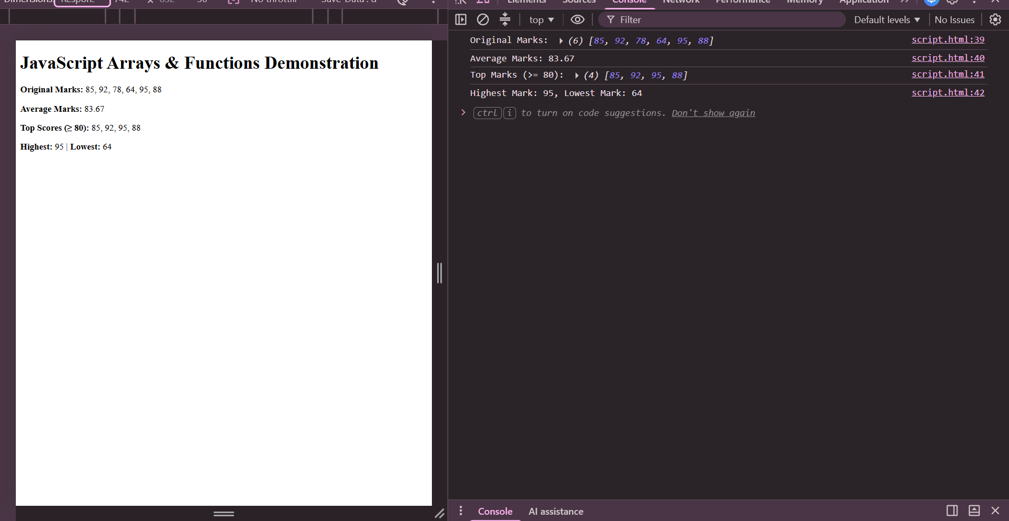
10. RESULT
JavaScript basic operations including array initialization, iteration methods, and custom utility functions were successfully created, executed, and verified.
RUBRIC EVALUATION (Faculty Use Only)
Design & Logic (5 Marks): _________
Execution & Output (5 Marks): _________
Viva & Record (5 Marks): _________
TOTAL MARKS: [ / 15 ]
Faculty Signature: _______________________

