DEPARTMENT OF COMPUTER SCIENCE & ENGINEERING
LABORATORY OBSERVATION & RECORD
Course Name: Full Stack Web Development
Course Code: 23CM4121
Experiment No: 04
Student Name: P. Harsha Vardhan
Roll No: A24126552103
Branch & Section: CSM-B
Date of Execution: 15/09/2026
1. TITLE
Develop Dynamic Webpage Using DOM & JS
2. AIM
To design and build an interactive web page that dynamically processes form input data, modifies the DOM content in real time, and handles background style changes using JavaScript event listeners.
3. OBJECTIVE
• To link external CSS stylesheets and JavaScript files using DOMContentLoaded listeners.
• To capture form submit events, prevent default reloads, and parse data using FormData.
• To dynamically update DOM text content and modify element inline background styles.
4. THEORY
The Document Object Model (DOM) presents an HTML page as a node tree that JavaScript can query and modify dynamically. Using event listeners like DOMContentLoaded ensures DOM elements exist before binding listeners. The FormData API extracts submitted form entries efficiently, allowing client-side JS code to display form values dynamically in paragraph tags without triggering full web page reloads.
5. ALGORITHM / PROCEDURE
1. Create index.html, styles.css, and script.js files in the project workspace.
2. Construct an HTML page containing a personal information form, action button, and an output display container.
3. Apply CSS styling to form components, set up gradient background styles, and adjust box boundaries.
4. Add a DOMContentLoaded event listener in script.js to safely query and attach event listeners.
5. Attach a click listener to the background toggle button to switch background colors dynamically.
6. Intercept form submit events using event.preventDefault(), construct a FormData object, and update DOM output paragraphs with user details.
7. Open index.html in a web browser, test form submissions, and verify dynamic output rendering.
6. PROGRAM
<!-- index.html -->
<!DOCTYPE html>
<html lang="en">
<head>
<meta charset="UTF-8">
<meta name="viewport" content="width=device-width, initial-scale=1.0">
<title>Dynamic Webpage</title>
<link rel="stylesheet" href="./styles.css">
<script src="./script.js"></script>
</head>
<body>
<h1>This is a Dynamic webpage</h1>
<form action="#submit" id="form">
<legend>Personal Information</legend>
<label for="fullname">Name: </label>
<input id="fullname" name="fullname" type="text" placeholder="enter your name"><br>
<label for="email">Mail-Id: </label>
<input id="email" name="email" type="email" placeholder="email@example.com"><br>
<label for="phone">Phone: </label>
<input id="phone" name="phone" type="tel" min="10" placeholder="9123456780"><br>
<label for="address">Address: </label>
<textarea id="address" name="address" placeholder="Enter your address" rows="10" cols="50"></textarea>
<button id="submit">submit</button>
</form>
<button type="button" id="bg">click the button to change text</button>
<div id="output">
<p id="output-name"></p>
<p id="output-email"></p>
<p id="output-phone"></p>
<p id="output-address"></p>
</div>
</body>
</html>
/* styles.css */
body {
background: linear-gradient(to right, #ff7e5f, #feb47b);
align-items: center;
}
#form {
color: #fff;
align-items: center;
border: 2px solid #fff;
border-radius: 10px;
border-width: 2px;
width: 50%;
height: 50%;
}
#form label {
font-size: 1.5rem;
font-weight: bold;
font-family: Arial, sans-serif;
}
#form legend {
font-size: 1.5rem;
font-weight: bold;
font-family: Arial, sans-serif;
}
// script.js
document.addEventListener("DOMContentLoaded", () => {
const background = document.getElementById("bg");
const form = document.getElementById("form");
if (background) {
background.addEventListener("click", () => {
const nextColor = background.style.backgroundColor === "lightblue" ? "lightgreen" : "lightblue";
background.style.backgroundColor = nextColor;
});
}
const output = document.getElementById("output");
if (form) {
form.addEventListener("submit", (event) => {
event.preventDefault();
const formData = new FormData(form);
const submittedData = Object.fromEntries(formData.entries());
console.log("Form data stored in variable:", submittedData);
if (output) {
document.getElementById("output-name").textContent = `Name: ${submittedData.fullname}`;
document.getElementById("output-email").textContent = `Email: ${submittedData.email}`;
document.getElementById("output-phone").textContent = `Phone: ${submittedData.phone}`;
document.getElementById("output-address").textContent = `Address: ${submittedData.address}`;
}
});
}
});
7. CODE EXPLANATION
• document.addEventListener('DOMContentLoaded'): Ensures script executes after HTML document parsing.
• event.preventDefault(): Prevents the form submission from triggering a page refresh.
• new FormData(form) & Object.fromEntries(): Extracts form control input keys and values into an object.
• textContent: Updates DOM paragraph nodes with user-entered values dynamically.
• background.style.backgroundColor: Toggles element inline background color dynamically on click.
8. OUTPUT

Test- Case 01: Load the page in browser
Output :

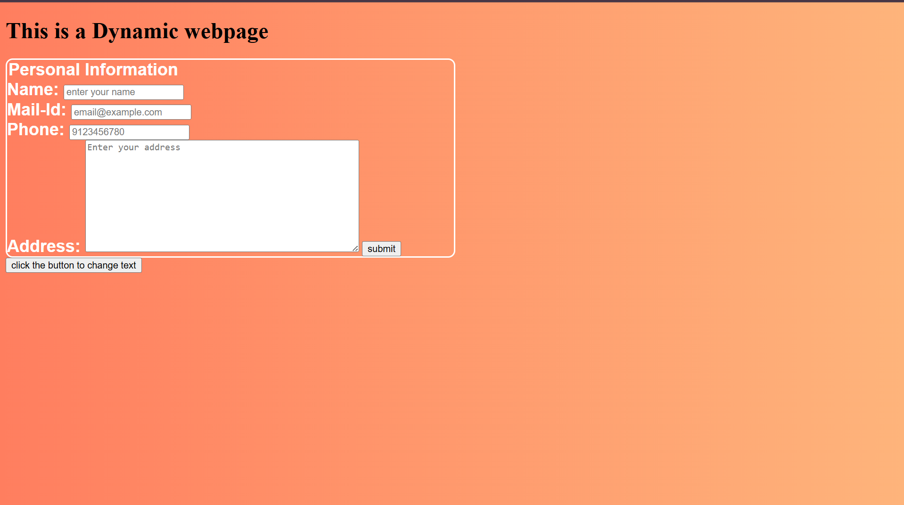

Test-Case 02 : Submitting empty form
Output: returns empty data with field names only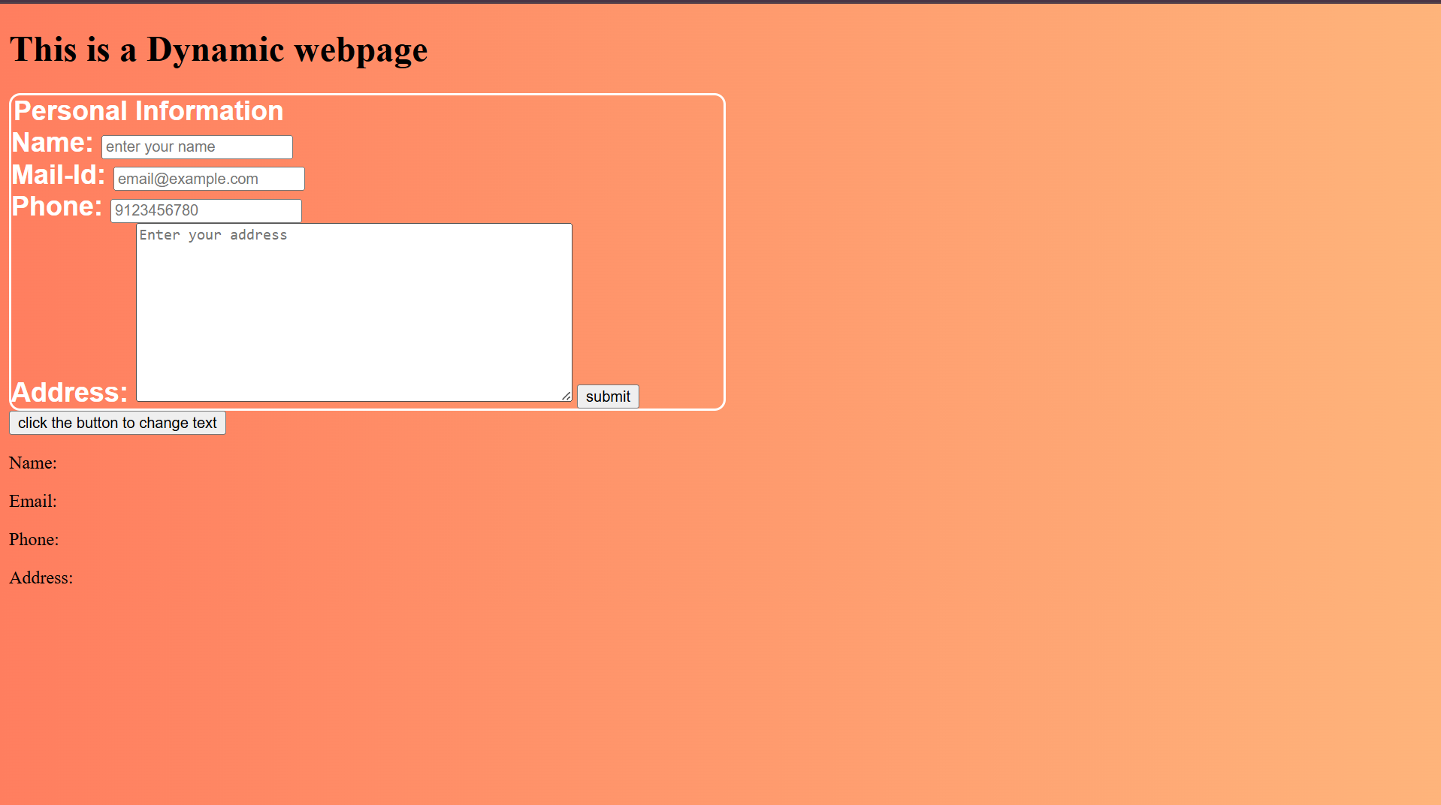

Test case 03 : submitting form with an empty field
Output :
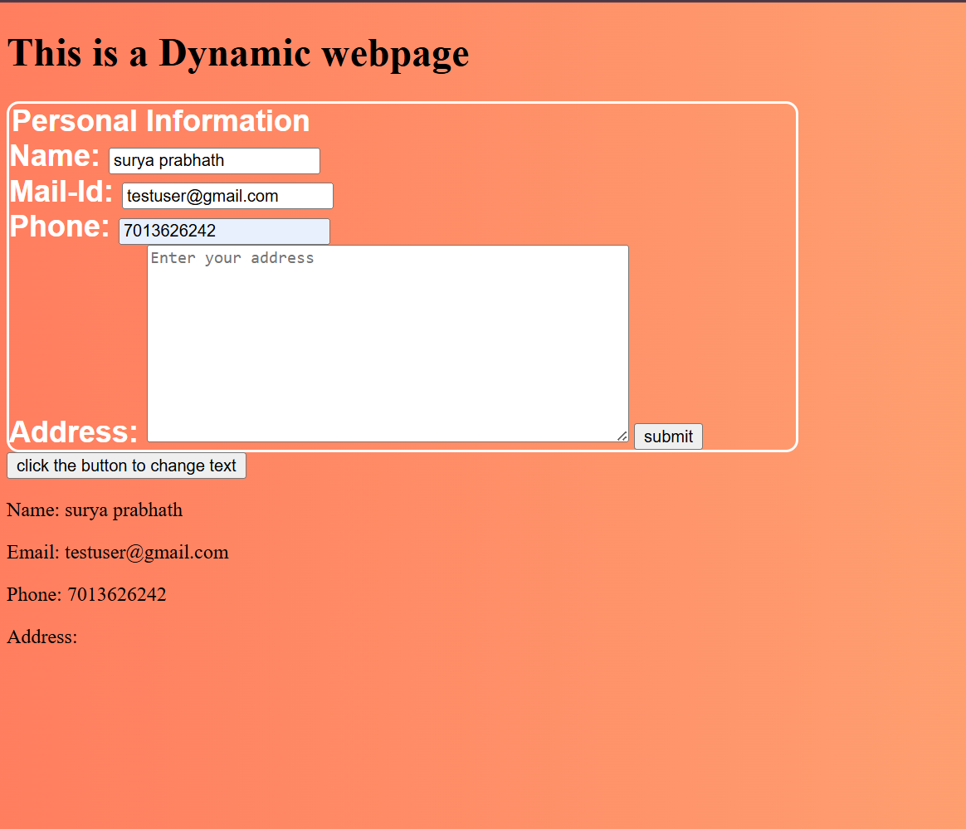

Test Case 04 : Submitting Form with all fields
Output :
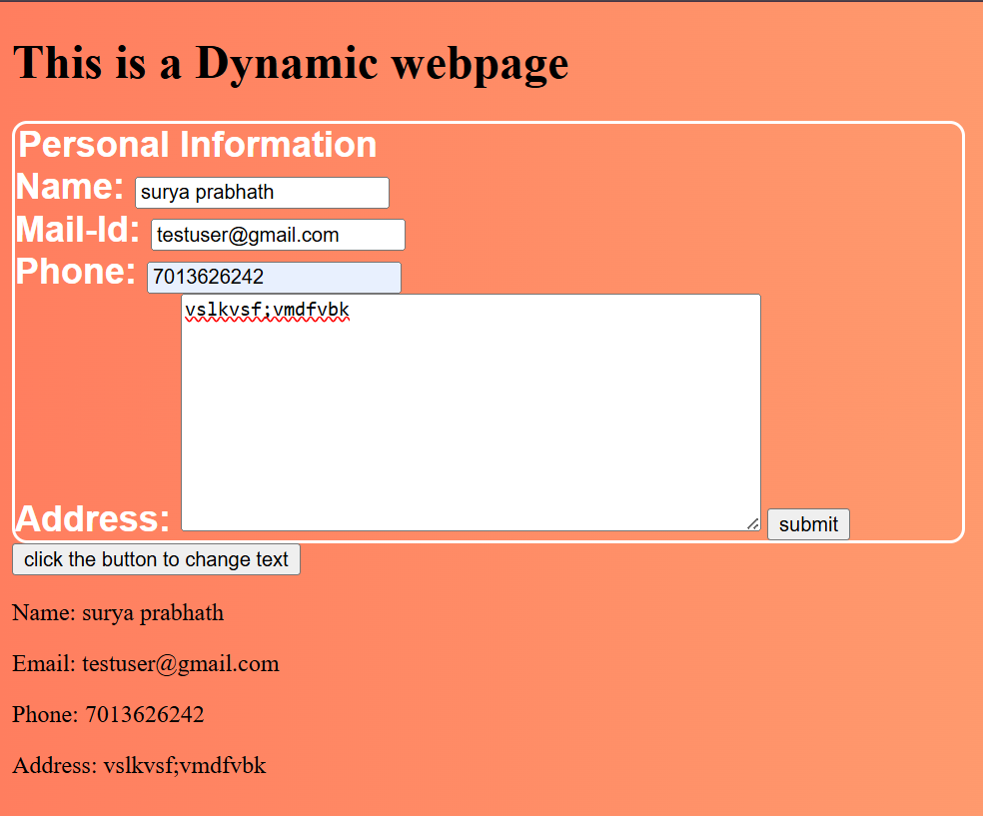
9. RESULT
A dynamic webpage handling form submissions, real-time DOM element manipulation, and event listeners was successfully created, executed, and verified.
RUBRIC EVALUATION (Faculty Use Only)
Design & Logic (5 Marks): _________
Execution & Output (5 Marks): _________
Viva & Record (5 Marks): _________
TOTAL MARKS: [ / 15 ]
Faculty Signature: _______________________

