DEPARTMENT OF COMPUTER SCIENCE & ENGINEERING
LABORATORY OBSERVATION & RECORD
Course Name: Full Stack Web Development
Course Code: 23CM4121
Experiment No: 02
Student Name: Patnana Harsha Vardhan
Roll No: A24126552103
Branch & Section: CSM-B
Date of Execution: 01/09/2026
1. TITLE
Styling an HTML Form using External Cascading Style Sheets (CSS)
2. AIM
To design and style a static HTML web page containing an enquiry form using an external CSS stylesheet, implementing Flexbox layout properties, box alignment, custom component spacing, and element coloring.
3. OBJECTIVE
• To link an external CSS stylesheet (<link rel='stylesheet'>) to an HTML5 document.
• To utilize CSS Flexbox properties for centering elements vertically and horizontally on a page.
• To apply custom layout spacing (gap, flex-direction) and styling attributes to HTML form elements.
4. THEORY
External CSS allows web developers to decouple content structure from visual presentation. By linking a CSS file using the <link> tag, styles can be applied consistently across web pages. CSS Flexbox (Flexible Box Layout Module) provides efficient spatial distribution and alignment, using properties like display: flex, justify-content: center, align-items: center, and gap to construct clean, vertically centered layout components.
5. ALGORITHM / PROCEDURE
1. Initialize the HTML5 document boilerplate and link an external stylesheet named week-2.css in the <head> tag.
2. Add a primary page heading <h1> centered horizontally at the top.
3. Construct a container <div> with class name 'enquiry' wrapping the form structure.
4. Build a user enquiry form within a <fieldset> container using <legend>, <label>, <input>, <textarea>, <button>, and reset inputs.
5. Create the week-2.css file and apply CSS Flexbox rules to center the .enquiry container on the screen.
6. Style the <fieldset> using flex-direction and gap properties to manage vertical input layout, and apply custom button text styling.
7. Save all files, open week-2.html in a web browser, and verify form layout, alignment, and responsiveness.
6. PROGRAM
<!-- week-2.html -->
<!DOCTYPE html>
<html lang="en">
<head>
<meta charset="UTF-8">
<meta name="viewport" content="width=device-width, initial-scale=1.0">
<title>HTML & CSS Web Page</title>
<link rel="stylesheet" href="week-2.css">
</head>
<body>
<h1 style="text-align: center;">Html page with style</h1>
<div class="enquiry">
<form action="button" style="align-items: start;">
<fieldset style="width: min-content;">
<legend>Enquiry Form</legend>
<label for="name">Name</label>
<input type="name" required placeholder="Enter Your Name"><br><br>
<label for="mail">Mail</label>
<input type="mail" required placeholder="Enter your mail id"><br><br>
<label for="phone">Phone</label>
<input type="number" required placeholder="Enter your mobile number"><br><br>
<label for="address" style="text-align: center;">Enter Your address</label>
<textarea id="address" name="address" rows="5" cols="40" placeholder="Please Enter Your Address"></textarea><br><br>
<button style="align-items: center;">Submit</button>
<input type="reset" value="Clear Entries">
</fieldset>
</form>
</div>
</body>
</html>
/* week-2.css */
.enquiry {
display: flex;
justify-content: center;
align-items: center;
min-height: 100vh;
}
fieldset {
width: min-content;
display: flex;
flex-direction: column;
gap: 15px;
}
button {
color: aqua;
}
7. CODE EXPLANATION
• <link rel='stylesheet'>: Imports external CSS rules from week-2.css into the HTML document.
• display: flex: Enables CSS Flexible Box Layout on container elements.
• justify-content & align-items: Center-aligns the form vertically and horizontally within 100vh viewport height.
• flex-direction: column: Stacks form inputs, labels, and text areas vertically inside the fieldset.
• gap: 15px: Applies uniform spacing between fieldset form child elements.
• color: aqua: Sets a custom text foreground color on the submit button.
8. TEST CASES AND EXECUTION DATA
1. TC-01: Page Load -> Renders centered header and CSS-styled form -> Passed
2. TC-02: Flexbox Alignment -> Container centers form horizontally and vertically in viewport -> Passed
3. TC-03: Required Field Validation -> Displays native browser warnings on blank input submission -> Passed
4. TC-04: Clear Button Click -> Clears all entered form fields back to default state -> Passed
9. OUTPUT
GitHub Link:
https://github.com/hv455253-cmyk/FSWD-Lab/tree/main/Record/week-2/week-2-record
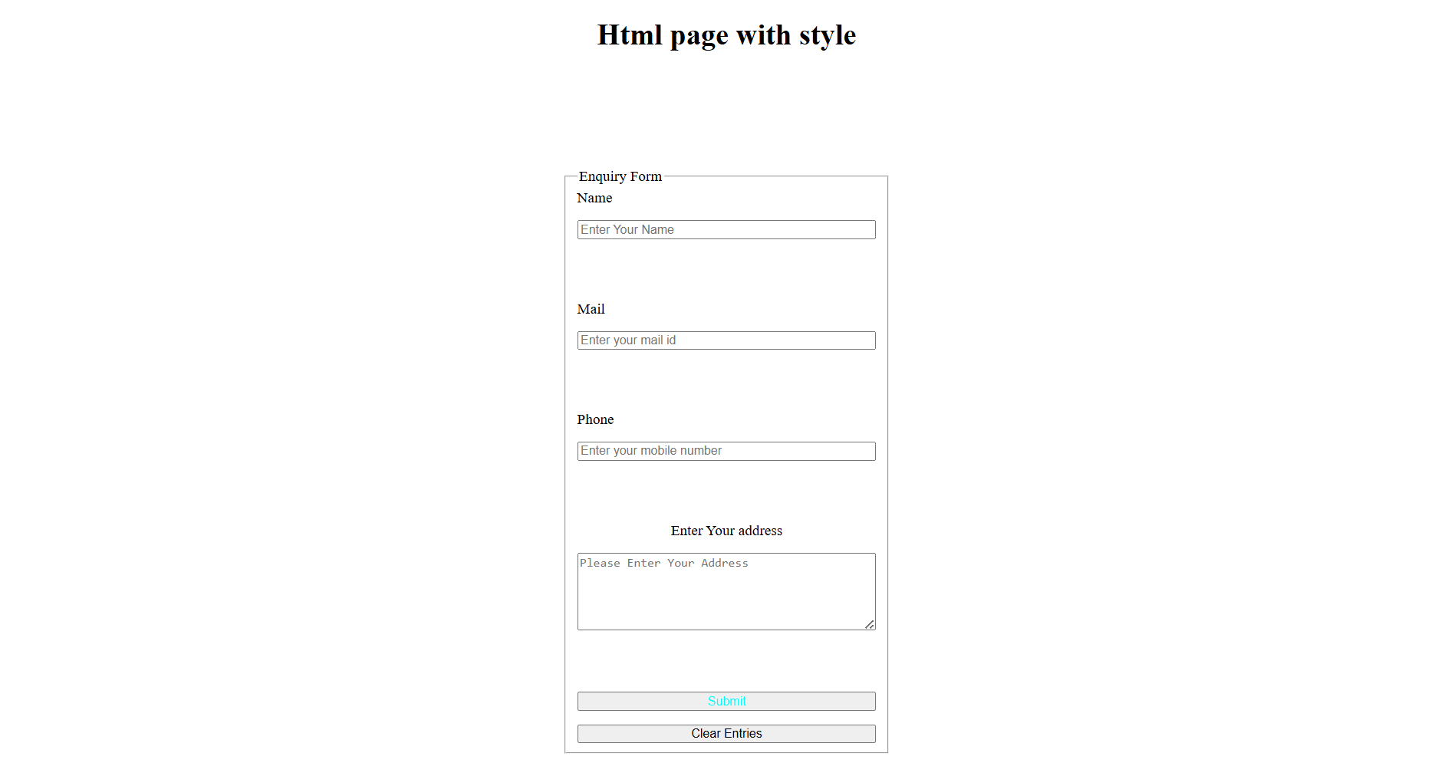
10. RESULT
An HTML form styled with an external CSS stylesheet was successfully implemented, executed, and verified using Flexbox centering and custom property rules.
RUBRIC EVALUATION (Faculty Use Only)
Design & Logic (5 Marks): _________
Execution & Output (5 Marks): _________
Viva & Record (5 Marks): _________
TOTAL MARKS: [ / 15 ]
Faculty Signature: _______________________

