Secure Student Records Using AES-GCM and a Blockchain-Inspired Audit Chain
Trần Thị Hà Vy
Faculty of Information Technology
Van Hien University
Ho Chi Minh City, Vietnam
VY231A010297@st.vhu.edu.vn
[CO-AUTHOR/ADVISER, CORRESPONDING AUTHOR, AND ORCID: TO BE CONFIRMED]
Abstract—This paper presents a single-node student-record management prototype that combines AES-256-GCM authenticated encryption, keyed identifiers, versioned storage, and a SHA-256 hash-linked audit chain. Student identifiers are represented by HMAC-SHA-256 lookup tokens, while record context and operator identity are bound to ciphertext through associated data. Each create, update, or logical-delete operation commits the encrypted version and its audit block in one SQLite transaction. The verifier checks record-version continuity, audit-chain linkage, envelope hashes, lookup tokens, and GCM authentication. A 30-repetition experiment on synthetic datasets of 100, 1,000, and 10,000 records compared plain SQLite, SQLite with AES-GCM, and the complete design. At 10,000 records, the complete design required 8.377 ms per insertion and 1.578 s for full verification; all 180 injected modifications across six tampering classes were detected. The experiment records raw measurements, descriptive statistics, and execution metadata. The prototype provides tamper evidence within its stated trust boundary, not distributed-ledger immutability.
Keywords—AES-GCM, audit logging, data integrity, hash chain, student records

INTRODUCTION
University information systems process identity data, enrolment information, courses, and grades. Access control limits legitimate application users, but it does not by itself make out-of-band database changes observable. Research on blockchain in education commonly targets credential issuance, portability, and third-party verification [1], [2]. Those goals normally assume a distributed trust model that is unnecessary for a local proof of concept.
This work instead investigates a narrower question: can authenticated encryption and an append-only, hash-linked history provide practical confidentiality and tamper evidence for versioned student records on one institutional node? The implementation combines AES-GCM, a keyed lookup token, canonical serialization, envelope hashing, actor-aware audit blocks, and atomic SQLite writes. Secure-log research motivates the separation between tamper evidence and absolute tamper prevention [3], [4].
The contributions are: (1) an implemented record lifecycle that commits encrypted versions and audit blocks atomically; (2) context binding that covers record, version, operation, schema, and actor; (3) a verifier spanning database structure, cryptographic envelopes, and hash-chain continuity; and (4) reproducible scripts for performance and mutation testing. The paper deliberately calls the ledger blockchain-inspired because it has no peer-to-peer replication or consensus, which distinguishes it from a blockchain system such as [5].

RELATED WORK
Kataev and Bulysheva describe a blockchain approach for storing broad student activities and achievements [1]. The OECD reviews blockchain-based educational credentials as a means to verify and transfer academic claims [2]. These systems emphasize distributed validation or learner-facing credentials. The present prototype instead protects operational record versions inside a single administrative application and does not expose public verification.
Kelsey and Schneier develop cryptographically protected audit logs for machines that may later be compromised [3]. Crosby and Wallach formalize tamper-evident logging around commitments and auditing, and show why external observations matter when detecting rollback or equivocation [4]. Our linear hash chain is simpler than their tree-based construction: it supports complete sequential verification but no logarithmic inclusion proof.

SYSTEM AND THREAT MODEL

System Scope
The prototype runs as a Flask application bound to a local interface and stores state in an SQLite database using write-ahead logging. Roles are admin, registrar, and auditor. Passwords are hashed with scrypt, failed logins trigger temporary lockout, sessions are signed, and state-changing forms require CSRF tokens. The protected payload contains a student code, name, date of birth, program, courses, scores, and GPA. Deletion is logical so that prior encrypted versions remain auditable.

Adversary and Assumptions
The verifier is intended to detect direct modifications to ciphertext, nonce, envelope metadata, version order, audit blocks, and block links. The application assumes that the AES master key is unavailable to an attacker who changes only the database. Availability, traffic confidentiality, endpoint compromise, and malicious authorized data entry are out of scope. An attacker controlling both the database and key can reconstruct a consistent history; restoring both to an older snapshot is also undetectable without an independent anchor. Therefore, the design provides detection under stated assumptions rather than unconditional immutability.
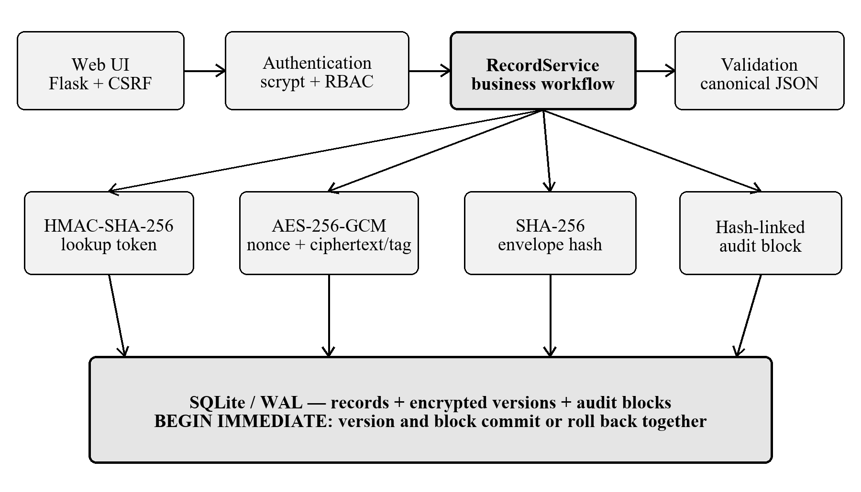
- Implemented single-node architecture and atomic write boundary.

CRYPTOGRAPHIC AND STORAGE DESIGN

Authenticated Record Envelope
The application validates and canonicalizes each record as UTF-8 JSON. A 32-byte key is used with AES-256-GCM, which provides authenticated encryption with associated data [6]. A fresh 12-byte nonce is generated for every encryption, and the library stores the 16-byte authentication tag at the end of the ciphertext. The associated data A contains record_id, version, operation, schema_version, actor_id, and actor_role. Consequently, copying an otherwise valid ciphertext into another record or execution context causes authentication to fail.

Private Exact-Match Lookup
The normalized student code is not stored in plaintext. A purpose-specific lookup key is derived from the master key with HKDF [7], and T = HMAC-SHA-256(K_lookup, code) is stored for exact-match queries. This is not searchable encryption: equality leakage remains, and low-entropy identifiers may still be enumerable if the derived key is compromised.

Envelope and Audit-Block Hashes
A domain-separated SHA-256 digest covers the envelope fields and their context. SHA-256 is defined by the Secure Hash Standard [8]. For audit block i, the implementation hashes the block index, record and version identifiers, operation, timestamp, actor identity and role, envelope hash, and previous block hash. A fixed genesis block starts the chain. Any change to a covered field propagates to subsequent links, but the chain head is not yet signed or anchored outside the host.

Atomicity and Verification
RecordService is the sole write coordinator. It begins an IMMEDIATE transaction, writes the new encrypted version, appends its audit block, updates the current-version pointer and status, and then commits. SQLite permits only one simultaneous write transaction [9], which matches the single-writer scope. Verification checks genesis and index continuity, previous hashes, recomputed block hashes, version sequences and operations, one-to-one mapping between versions and blocks, envelope digests, GCM tags, and current lookup tokens.
- IMPLEMENTED CONTROLS AND THEIR SECURITY BOUNDARIES
Control | Implemented mechanism | Boundary
Confidentiality | AES-256-GCM | Depends on key secrecy
Context integrity | AAD binds record/version/actor | Application-defined context
Private lookup | HMAC-SHA-256 token | Exact match; leaks equality
History | SHA-256 linked blocks | No external anchor
Consistency | BEGIN IMMEDIATE | Single SQLite writer
Authorization | Session, CSRF, RBAC | Does not stop host admin

IMPLEMENTATION
The proof of concept is implemented in Python with Flask, cryptography, and SQLite. Domain validation rejects missing fields, malformed ISO dates, nonfinite grades, and scores outside 0–10. JSON serialization fixes key order and separators before encryption and hashing. The database separates record heads, encrypted record_versions, audit_blocks, and users. Schema version 2 adds actor information while retaining a compatibility path for schema version 1.
The web layer does not issue SQL or perform cryptography directly. Routes authenticate the request, apply role checks, validate form limits, and call RecordService. This separation reduces the chance that a UI path bypasses versioning or auditing. Optimistic version checks reject updates based on a stale version. Security headers and reduced-motion-aware, keyboard-accessible views improve the local demonstration, although production HTTPS and managed key storage remain unimplemented.

EVALUATION METHODOLOGY

Performance Experiment
Synthetic datasets contain 100, 1,000, and 10,000 normalized student records. Three profiles are measured: P1, plain JSON in SQLite; P2, AES-GCM envelopes in SQLite; and P3, the complete versioned design with AES-GCM and a hash-linked audit chain. Each size/profile combination is executed 30 times, with reproducibly shuffled profile order and a fixed seed of 2026. The timer is perf_counter_ns. Insert time, read time, verification time, cryptographic sub-times, and database size are exported as raw CSV and descriptive statistics.
Measurements were collected on Windows 11 using an Intel Core i5-10300H processor and 7.84 GiB of physical memory, with Python 3.12.13, SQLite 3.50.4, Flask 3.1.3, and cryptography 49.0.0. The measured application and experiment code corresponds to Git commit 18d5f84297a4f7d24173362d2234a0a15eeafb2d.

Mutation and Software Tests
For each of six mutation classes, a temporary valid database is created and altered below the service layer: ciphertext change, GCM-tag change, nonce change, envelope-hash change, previous-link change, and deletion of a middle block. Each class is repeated 30 times. The repository also reports 113 automated tests with 91.04% statement coverage. Coverage supports implementation confidence but is not a security proof.

Data and Reproducibility
The source code, synthetic datasets, experiment scripts, raw measurements, statistical summaries, and environment metadata are organized under experiments/ in the project repository [10]. The datasets are deterministically generated and contain no real student records. Each new benchmark run also records host, operating-system, Python, SQLite, and library metadata so that the reported results can be traced to a specific execution environment.

RESULTS
- COMPLETE-DESIGN PERFORMANCE (30 REPETITIONS)
Records | Insert  (ms/record) | Verify  (ms) | DB  (MiB)
100 | 10.800 | 25.584 | 0.203
1,000 | 8.257 | 142.585 | 1.406
10,000 | 8.377 | 1578.284 | 13.628
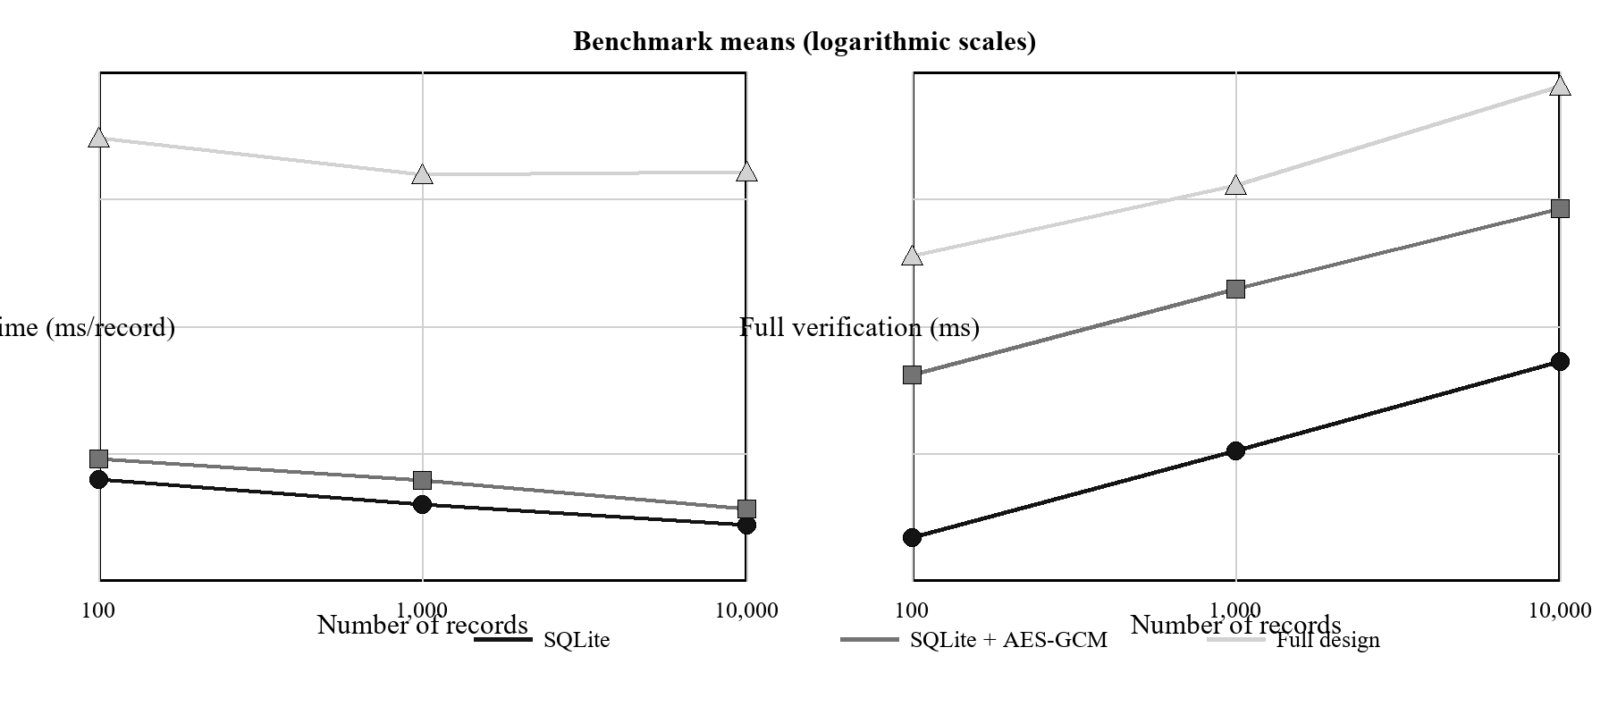
- Insertion and full-verification means; logarithmic axes.
For the complete design, mean insertion time was 10.800, 8.257, and 8.377 ms per record at 100, 1,000, and 10,000 records, respectively. Full verification increased from 25.584 ms to 142.585 ms and 1,578.284 ms, consistent with a full sequential scan of versions and blocks. At 10,000 records, the median verification time was 1,321.945 ms and the maximum was 5,682.612 ms, indicating substantial run-to-run variability. The mean database footprint was 13.628 MiB compared with 3.695 MiB for plain SQLite, or approximately 3.69 times larger.
The complete profile's insertion cost was 11.71–13.86 times that of plain SQLite across the three sizes. This ratio includes per-record transaction handling, version and block writes, serialization, and verification metadata; it should not be interpreted as AES overhead alone. Likewise, profile verification tasks are intentionally unequal: P1 checks readability, P2 authenticates ciphertext, and P3 additionally verifies record structure and the audit chain.
- MUTATION-DETECTION RESULTS
Injected change | Detected/trials
Ciphertext | 30/30
GCM tag | 30/30
Nonce | 30/30
Envelope hash | 30/30
Previous block link | 30/30
Middle-block deletion | 30/30
All 180 injected mutations were reported. These tests establish detection for the tested operators and generated states only; they do not estimate detection probability against an adaptive adversary who can rewrite the database and recompute values with the secret key.

LIMITATIONS AND THREATS TO VALIDITY
The experiment uses synthetic records and one machine, so external validity across workloads, storage media, concurrency levels, and deployments is unknown. Per-record transactions favor audit isolation but differ from batched imports. OS cache effects and background tasks may contribute to variance. The 10,000-record verification measurements were especially variable, with the mean exceeding the median and a maximum of 5.683 s. Measurements were collected in two sequential size groups on the same host; future work should repeat them on additional machines and report confidence intervals.
The security evaluation uses deterministic mutation operators rather than penetration testing or formal verification. The linear chain detects internal inconsistencies but cannot prove freshness after a coordinated rollback. Keys and the database currently reside on the same host, and no KMS/HSM, rotation protocol, remote witness, digital signature, or consensus layer is present. Calling the prototype a distributed blockchain would therefore overstate both its architecture and threat resistance.

CONCLUSION
This paper described an implemented student-record prototype that integrates AES-256-GCM, keyed exact-match lookup, actor-bound associated data, version history, a SHA-256 hash-linked audit chain, and atomic SQLite writes. Experiments on the current actor-aware schema show practical local operation and detection of all tested mutations, with measurable storage and verification costs. The result is a tamper-evident single-node design, not immutable distributed storage. Before FAIR submission, the remaining author/publication metadata and public artifact upload must be confirmed. Future work should add managed key storage, key rotation, signed or independently witnessed chain-head anchors, backup/restore testing, HTTPS deployment, and multi-organization consensus only where the trust model requires it.

ACKNOWLEDGMENT
[ADVISER/CO-AUTHOR DECISION, ACKNOWLEDGMENT, AND FUNDING INFORMATION: TO BE CONFIRMED]

REFERENCES
- [1] M. Kataev and L. Bulysheva, “Blockchain system in the higher education: Storing academical students’ records and achievements accumulated in the educational process,” Systems Research and Behavioral Science, vol. 39, no. 3, pp. 589–596, 2022, doi: 10.1002/sres.2872.
- [2] N. Smolenski, “Blockchain for education: A new credentialing ecosystem,” in OECD Digital Education Outlook 2021. Paris, France: OECD Publishing, 2021, doi: 10.1787/589b283f-en.
- [3] J. Kelsey and B. Schneier, “Minimizing bandwidth for remote access to cryptographically protected audit logs,” in Proc. 2nd Int. Workshop Recent Advances in Intrusion Detection, 1999.
- [4] S. A. Crosby and D. S. Wallach, “Efficient data structures for tamper-evident logging,” in Proc. 18th USENIX Security Symp., Montreal, QC, Canada, 2009, pp. 317–334.
- [5] S. Nakamoto, “Bitcoin: A peer-to-peer electronic cash system,” 2008. [Online]. Available: https://bitcoin.org/bitcoin.pdf
- [6] M. Dworkin, Recommendation for Block Cipher Modes of Operation: Galois/Counter Mode (GCM) and GMAC, NIST Special Publication 800-38D, Nov. 2007, doi: 10.6028/NIST.SP.800-38D.
- [7] H. Krawczyk and P. Eronen, HMAC-based Extract-and-Expand Key Derivation Function (HKDF), RFC 5869, May 2010, doi: 10.17487/RFC5869.
- [8] National Institute of Standards and Technology, Secure Hash Standard (SHS), FIPS PUB 180-4, Aug. 2015, doi: 10.6028/NIST.FIPS.180-4.
- [9] SQLite Consortium, “Transaction,” SQLite Documentation. [Online]. Available: https://www.sqlite.org/lang_transaction.html. Accessed: Aug. 7, 2026.
- [10] T. T. H. Vy, “Secure student record blockchain: Source code, synthetic datasets, and reproducibility artifacts,” GitHub repository, 2026. [Online]. Available: https://github.com/hv6z/secure_student_record_blockchain. Accessed: Aug. 9, 2026.

