NAME  ALEMANIA, HAZEL ANDREAH V. |  | DATE  FEBRUARY 4, 2017 | SCORE
SCHEDULE  S 10:00-13:00 | SCORE |  | SCORE

LABORATORY EXERCISES
RECURSION

OBJECTIVES:
- Understand recursion and its parts
- Use recursion to solve programming problems

PROCEDURE:
- Encode the C++ program below.
- Save as rec1.cpp,and rec2.cpp, respectively.
- Compile and run the program by pressing Ctrl + F9.
- For each syntax or logical error encountered in the given program, do the following:
- Correct the error
- Recompile the program
- Repeat step 4 until no errors are encountered in the program.
- Illustrate the output of the modified program.

Program No. 1
Output:
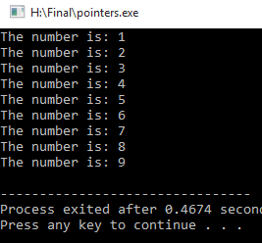

#include <iostream>
using namespace std;

void numberFunction(int i) {
cout << "The number is: " << i << endl;
i++;
if(i<10) {
numberFunction(i);
}
}

int main() {

int i = 1;
numberFunction(i);

return 0;
}

Program No. 2

#include <iostream>
using namespace std;

int factorial(int);

int main() {
int n;
cout<<"Enter a number to find factorial: ";
cin>>n;
cout<<"Factorial of "<<n<<" = "<<factorial(n);
return 0;
}
Output:
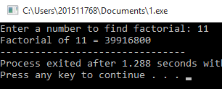

int factorial(int n) {
if (n>1) {
return n*factorial(n-1);
}
else {
return 1;
}
}

Supplementary Problem

- A recursive function that sums up the 10 integers in an array.

Program:

#include <iostream>
using namespace std;

int array_sum(int array[], int n ){
if (n == 0){
return array[0];
}

return (array[n] + array_sum(array,n-1));
}

int main(void)
{
int array[] = {2,4,6,8,10,12,14,16,18,20};
int sum;

sum = array_sum(array,9);
cout << "The sum of ten (10) Integers is: " << sum;

return 0;
}

Output:

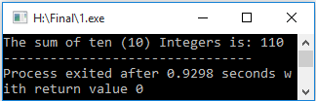

- A recursive function to produce the Fibonacci number for a given index in the series.
Use the function int fibonacci(int n)

Program:

#include <iostream>
using namespace std;

int givNum;
int fib(int e){
if (e==0){
return 0;
}
else if(e==1){
return 1;
}
else{
return fib(e-1) + fib(e-2);
}
}
int main(){
cout<<"Insert a given number: ";
cin>>givNum;
cout<<"The Fibonacci number is "<<fib(givNum);
return 0;
}

Output:

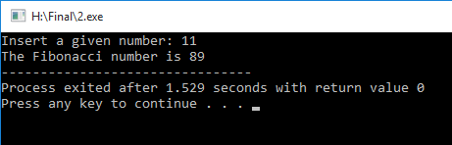

- A recursive function which raises its first parameter to the power of its second parameter.
Use the function int power(int number, int power)

Program:

#include<iostream>
using namespace std;

int Power(int number, int power){
if (power == 1)
return number;
return number*Power(number,power-1);
}

int main(){
int x,y;
cout<<"Enter number: ";
cin>>x;
cout<<"Enter power: ";
cin>>y;
cout<<"Result: "<<Power(x,y);
return 0;
}

Output:

