TMFC003 Product Order Delivery Orchestration and Management v3.0.0
Components and Canvas

Exported on 2026-07-31 08:56:21

Table of Contents

1 Overview 4
2 eTOM Processes, SID Data Entities and Functional Framework Functions 6
2.1 eTOM business activities 6
2.2 SID ABEs 9
2.3 eTOM L2 - SID ABEs links 10
2.4 Functional Framework Functions 10
3 TM Forum Open APIs & Events 18
3.1 Exposed APIs 18
3.2 Dependent APIs 19
3.3 Events 21
4 Machine Readable Component Specification 22
5 References 23
5.1 TMF Standards related versions 23
5.2 Jira References 23
5.2.1 eTOM 23
5.2.2 SID 23
5.2.3 Functional Framework 23
5.2.4 API 23
5.2.5 Further resources 24
6 Administrative Appendix 25
6.1 Document History 25
6.1.1 Version History 25
6.1.2 Release History 25
6.1.3 Acknowledgments 26

In this deliverable:

Overview

Component Name | ID | Description | ODA Function Block
Product Order Delivery Orchestration and Management | TMFC003 | This component orchestrates the delivery of Product Orders (status accepted). Based on the level of Product Offering Specification and / or Product Specification Information available in the Product Catalog (eg prerequisite links between product specifications, links between product and CFS specifications...) it determines in which order the product specification level order items need to be delivered, and to which CFS (or Resource) specification each ordered product corresponds, and prepares and addresses each related service (or Resource) order to the production system in charge. During the delivery process execution, this component is in charge of the evolution of the status of the product specification level order items, and of the related product items, triggering updates of the related inventories.  After the delivery of the customer product order items, this component is also in charge of the commercial closure of the order. It includes update of the Product Inventory (status and starting/end date of tariffs and discounts) and potential commercial rules control (eg receipt of the contract document signed by the customer). | Core Commerce Management

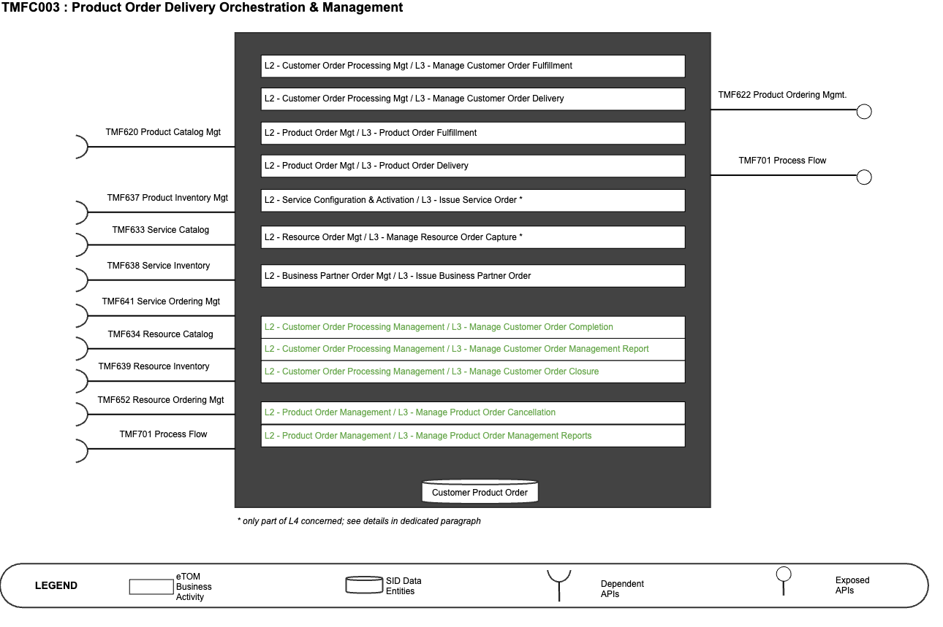

eTOM Processes, SID Data Entities and Functional Framework Functions

eTOM business activities
eTOM business activities this ODA Component is responsible for:
Identifier | Level | Business Activity Name | Description
1.3.3 | L2 | Customer Order Handling  Customer Order Processing Management | Customer Order Handling processes are responsible for accepting and issuing orders. They deal with pre-order feasibility determination, credit authorization, order issuance, order status and tracking, customer update on order activities and customer notification on order completion.  Responsibilities of the Order Handling processes include:  - Testing the completed offering to ensure it is working correctly;  - Updating of the Customer Inventory Database to reflect that the specific product offering has been allocated, modified or cancelled;  - Assigning and tracking customer provisioning activities;  - Managing customer provisioning jeopardy conditions  - Reporting progress on customer orders to customer and other processes.  Customer Order Processing Management business process directs and controls all activities that operationally realize orders for customer.  Customer Order Processing Management assures the capture, processing, fulfillment, "shipping", delivery and reporting of customer orders from feasibility assessment, purchasing, payment, fulfillment and follow up with the customer for closure.
1.3.3.12 | L3 | Manage Customer Order Fulfillment | Manage Customer Order Fulfillment business activity directs and controls all activities that provision and activate orders marked for fulfillment.  Manage Customer Order Fulfillment ensure customer orders are organized and arranged (orchestrated), and tracked to meet committed ordering terms.
1.3.3.8 1.3.3.12.1 | L3 L4 | Manage Customer Order Fallout | This process defines tasks involved in handling fallouts (exceptions) generated in the order fulfillment lifecycle. It deals with identifying, assigning, managing, monitoring and reporting order fallouts  Manage Customer Order Fallout business activity controls orders that have failed during the fulfillment stage of a customer order process.
1.3.3.9 | L3 | Customer Order Orchestration | Customer Order Orchestration ensures customer order provisioning activities are orchestrated, managed and tracked efficiently to meet the agreed committed availability date.
1.3.3.13 | L3 | Manage Customer Order Delivery | Manage Customer Order Delivery business activity directs and controls activities that deliver orders according to the requirement of the customer.
1.2.9 | L2 | Product Offering Purchasing | Make an inbound/outbound purchase of one or more product offerings, change an offering being purchased, review an entire purchase, and other processes that manage the lifecycle of a purchase of one or more product offerings.
1.2.9.5 | L3 | Complete Product Offering Purchase | Complete a product offering purchase which may trigger other processes, such as ones that accept payment and deliver the purchased offerings.  L4 - 1.2.9.5.3 - Coordinate Product Offering Purchase Provisioning  Coordinate any necessary provisioning activities for inbound product offering purchases by generating the service order and resource order creation request(s) to Issue Service Orders and Issue Resource Orders  L4 - 1.2.9.5.4 - Initiate Additional Product Offering Purchase(s)  Prepare product offering purchases in the form of product offering orders for each product offering fulfilled by another party.
1.3.3.15 | L3 | Manage Customer Order Completion | Manage Customer Order Completion business activity controls activities to confirm that an order has been successfully delivered/shipped to the customer.
1.3.3.16 | L3 | Manage Customer Order Management Report | Manage Customer Order Management Report business activity provides detailed account of Customer Order Management activities, representing state and status of customer orders across the customer order lifecycle.  Manage Customer Order Management Report provides monitoring, tracking and customer order status updates/notification as needed to all stakeholders linked to the customer ordering and fulfillment activities.
1.3.3.17 | L3 | Manage Customer Order Closure | Manage Customer Order Closure business activity ensures that customer has confirmed the delivery of a completed customer order.  Manage Customer Order Closure business activity closes-the-loop of between the Customer Order Completion process and the confirmation by the Customer. This business activity includes tasks to communicate and confirm delivery to customer; cancellation of any open line items in the customer order; and reports the customer order completion to related stakeholders.
1.2.27 | L2 | Product Order Management | Product Order Management business direct and control processes that capture, track, fulfil, deliver and close product order requests.
1.2.27.2 | L3 | Manage Product Order Fulfillment | Manage Product Order Fulfillment business activity is responsible for directing and controlling for product orders, the configuration of product order fulfillment steps, managing the product order fulfillment profile, managing the product order picking and packing, managing product order shipment, managing product order returns, tracking product order fulfillment, and closing fulfillment of product orders.
1.2.27.3 | L3 | Manage Product Order Delivery | Manage Product Order Delivery business activity directs and controls the activities to validate products in the product order.  Manage Product Order Delivery business activity ensures product can be successfully be supplied to consignee of the product order to enable complete the product order process.
1.2.27.4 | L3 | Manage Product Order Cancellation | Manage Product Order Cancellation business activity directs and controls the product order cancellation requests.
1.2.27.5 | L3 | Manage Product Order Management Reports | Manage Product Order Management Reports business activity directs and controls monitoring of product order management activities, notify product order management status and reporting product order management activities.
1.4.5 | L2 | Service Configuration & Activation | Allocation, implementation, configuration, activation and testing of specific services to meet customer requirements.
1.4.5.6 | L3 | Issue Service Order | Issue correct and complete service orders.
1.4.5.6.1 | L4 | Assess Service Request | This process assesses the information contained in the customer order, through a service order request, relating to the purchased product offering, initiating service process or party initiated request, to determine the associated service orders that need to be issued.
1.5.6 | L2 | Resource Provisioning | Allocation, installation, configuration, activation and testing of specific resources to meet the service requirements, or in response to requests from other processes to alleviate specific resource capacity shortfalls, availability concerns or failure conditions.
1.5.6.7 | L3 | Issue Resource Order | Issue correct and complete resource orders.  L4 - 1.5.6.7.1 - Assess Resource Request  This process assesses the information contained in the service order, through a resource order request, initiating resource process request or supplier/partner initiated request, to determine the associated resource orders that need to be issued.
1.5.5 | L2 | Resource Order Management | Resource Order Management business process directs and controls ordering, scheduling, and allocation of resources (such as materials, equipment, and personnel) within the business.
1.5.5.6 | L3 | Manage Resource Order Capture | Manage Resource Order Capture is responsible for directing and controlling the capture and collection of resource orders from internal and external customers.
1.5.5.6.1 | L4 | Initiate Resource Order Capture | Initiate Resource Order Capture business activity is responsible for the initial activity of capturing and collecting resource orders from internal and external customers.  This business activity begins with the identification of the needed resources, either by a "customer" and facilitating creating the request for the resources. This business activity will gather the necessary information to complete the request order, such as the type and quantity of resources needed, delivery location, and any special instructions.
1.6.8 | L2 | Business Partner Order Management | Track, monitor and report on an order to another Business Partner to ensure that the interactions are in accordance with the agreed commercial agreements with the other Business Partner.
1.6.8.5 | L3 | Issue Business Partner Order | Generate a correctly formatted and specified Business Partner order and issue this to the selected Business Partner.

SID ABEs
SID ABEs this ODA Component is responsible for:
SID ABE Level 1 | SID ABE L1 Definition | SID ABE Level 2 (or set of BEs)
Customer Product Order | Handles single customer orders and the various types thereof, such as regulated and non-regulated orders.  Orders ProductOfferings and concerns Products | CustomerProductOrder

Note: SID doesn't currently describe Orchestration Plan and delivery process to manage at Product Order level. This could be added at least as specialization from Project ABE or Workflow ABE. Refer to JIRA paragraph at the end of the document.

eTOM L2 - SID ABEs links

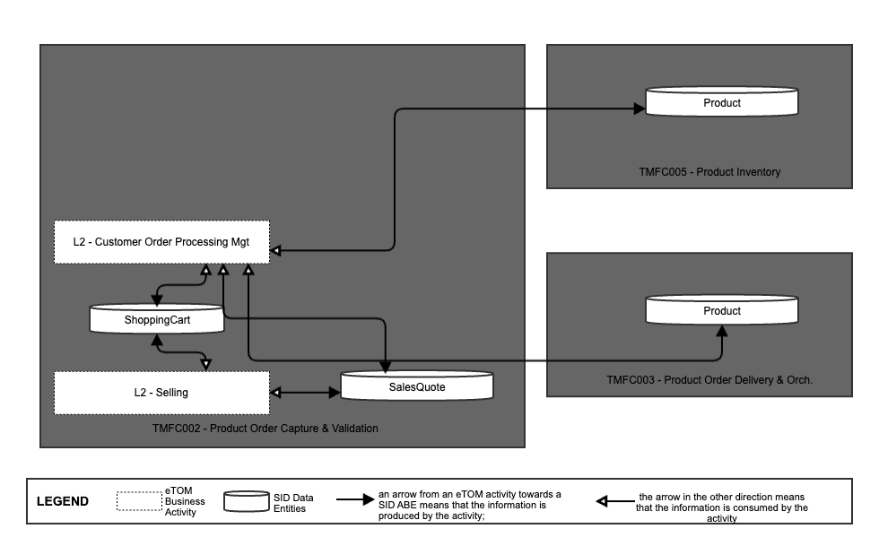

Functional Framework Functions

Function ID | Function Name | Function Description | Aggregate Function Level 1 | Aggregate Function Level 2
16 | Fallout Automated Correction | Fallout Automated Correction function tries to automatically fix fallouts in workflows before they go to a human for handling.  This includes a Fallout Rules Engine that provides the capability to handling various errors or error types based on built rules. These rules can facilitate autocorrection, correction assistance, placement of errors in the appropriate queues for manual handling, as well as access to various systems. | Fallout Management | Fallout Correction Management
17 | Fallout Correction Information Collection | Fallout Correction Information Collection collects relevant information for errors or situations that cannot be handled via Fallout Auto Correction. The intent is to reduce the time required by the technician in diagnosing and fixing the fallout. | Fallout Management | Fallout Correction Management
18 | Fallout Management to Fulfillment Application Accessing | Fallout Management to Fulfillment Application Accessing function provides a variety of tools to facilitate Fallout Management access to other applications and repositories to facilitate proper Fallout Management. This can include various general access techniques such as messaging, publish and subscribe, etc. as well as specific APIs and contracts to perform specific queries or updates to various applications or repositories within the fulfillment domain. | Fallout Management | Fallout Repository Management
19 | Fallout Manual Correction Queuing | Fallout Manual Correction Queuing function provides the required functionality to place error fallout into appropriate queues to be handled via various staff or workgroups assigned to handle or fix the various types of fallout that occurs during the fulfillment process. This includes the ability to create and configure queues, route errors to the appropriate queues, as well as the ability for staff to access and address the various fallout instances within the queues. | Fallout Management | Fallout Correction Management
20 | Fallout Notification | Fallout Notification function provides the means to alert people or workgroups of some fallout situation. This can be done via a number of means, including email, paging, (Fallout management interface bus) etc. This function is done via business rules. | Fallout Management | Fallout Repository Management
21 | Fallout Orchestration | The Fallout Orchestration function provides workflow and orchestration capability across Fallout Management. | Fallout Management | Fallout Correction Management
22 | Fallout Reporting | Fallout Reporting provides various reports regarding Fallout Management, including statistics on fallout per various times periods (per hour, week, month, etc) as well as information about specific fallout. | Fallout Management | Fallout Repository Management
23 | Fallout Dashboard System Log-in Accessing | Fallout Dashboard System Log-in Accessing provides auto logon capability into various applications needed to analyze and fix fallout | Fallout Management | Fallout Repository Management
24 | Pre-populated Fallout Information Presentation | Pre-populated Fallout Information Presentation automatically position the analyzer on appropriate screens pre-populated with information about the order(s) that's subject for fallout handling. | Fallout Management | Fallout Correction Management
172 | Customer Order Reporting | Customer Order Reporting function provides front end support for Business, Financial and Operational reporting and analyzing of the ordering activities. | Customer Order Management | Customer Order Repository Management
174 | Customer Order Error Resolution Support | Customer Order Error Resolution Support provides to view pool of orders resulted in error or stuck orders and enable the Customer Support to act accordingly (e.g., resend the request, notify the user with recommended action) | Customer Order Management | Customer Order Repository Management
175 | Customer Support Jeopardy Notification | Customer Support Jeopardy Notification provide to view jeopardy notifications queue and enable the Customer Support to act accordingly (e.g., notify customer on due date delay) | Customer Order Management | Customer Order Repository Management
178 | Customer Order Administration | Customer Order Administration provide to view all outstanding orders, progress and history displays | Customer Order Management | Customer Order Repository Management
723 | Customer Order Item Decomposition | Customer Order Item Decomposition prepares the customer order structure for breakdown into customer order items.
208 | Customer Order Change Management | Customer Order Change Management amend pending order resulted from customer change requests or provisioning system limitation and revalidate the order. | Customer Order Management | Customer Order Change Management
209 | Customer Order Cancellation | Customer Order Cancellation can optionally support Cancel for order completed by Service Order Management (this capability is dependent on the Service Order Management system’s ability to roll back service provisioning). This function assesses the feasibility of order cancellation and the potential charge to the customer. If the cancellation is confirmed, it proceeds with the cancellation. | Customer Order Management | Customer Order Validation
211 | Customer Order Activity Supervision | Customer Order Activity Supervision governs the control of the order amongst the ordering channels. This allows keeping the order data consistency, sharing the order data among order application channels, and alternating the control between them. | Customer Order Management | Customer Order Repository Management
212 | Customer Order Versioning | Customer Order Versioning maintains order versioning including Tracking & Logging of the changes made to a purchased product. | Customer Order Management | Customer Order Repository Management
213 | Pending Customer Orders Maintenance | Pending Customer Orders Maintenance saves the order/quote for future processing (in case the customer is not sure if they want to go through with the order at this point) | Customer Order Management | Customer Order Repository Management
214 | Customer Order Orchestration | The Customer Order Orchestration function provides workflow and orchestration capabilities at the Product Order Item level for a dedicated Customer Order.  Customer Order Orchestration function identifies Service Order Items (CFS level) according to Order Items of the Customer Order, sequences Service Order Items and distributes the Service Order requests to appropriate systems. For example : Service Order Management (SOM), potential 3rd parties, ...  This identification of Service Order Items relies on :  - the articulation between ProductSpecifications and CFSSpec described in the Catalogue Repository  - the articulation between Product Operations and CFS Operations described in the Catalogue Repository  - existing installed CFS  - the potential rules of choice if several CFS can fit in with the product.  Orchestration can take into account :  - constraints between Customer Product Order Items inside the Customer Product Order, or successive Customer Orders including modification or cancellation (in-flight changes)  - any type of business rules based on information even external to the Customer Product Order. For example : high level of priority for VIP customers  - Triggering of exception process or delivery planning update, depending on Customer Product Order or Service Order events. | Customer Order Management | Customer Order Orchestration
215 | Retro-active order orchestration | Retro-active Order Orchestration provides submission of a retroactive order with a past effective date (e.g., retroactive price plan change) and the handling of manual intervention requests (for order fallouts). | Customer Order Management | Customer Order Orchestration
217 | Customer Order Establishment Tracking | Customer Order Establishment Tracking provides the functionality necessary to track and manage the distributed requests decomposed by Customer Order Orchestration. | Customer Order Management | Customer Order Repository Management
272 | Order Status Viewing | Order Status Viewing provides self-empowered fulfillment function of an internet technology driven interface for the customer to undertake Order status enquiry. | Customer Order Management | Customer Order Repository Management
342 | Mass Service/product pre-activation | Mass service/product pre-activation function. To prepare for a swift activation at sales affiliate services/products may be pre-activated. | Service Configuration & Activation | Service Activation
366 | Customer Order Management | Customer Order Management provides an online access function to specific orders, to be used for management, monitoring and tracking for customer support and external agents for Upgrade of customer’s products/services. | Customer Order Management | Customer Order Repository Management
716 | Order Data Enrichment | Order Data Enrichment function acquire missing order data from surrounding systems (often values taken from catalogs and inventories, billing, fraud, etc.) or from external 3rd party systems (like country's common address or credit check system). | Customer Order Management | Customer Order Completion
717 | Calculated Order Data Enrichment | Calculated Order Data Enrichment calculates missing order data values on-the-fly from existing data and ordering rules. E.g., Contract end dates, Discounted period, etc. | Customer Order Management | Customer Order Completion
718 | Customer Order Validation | Customer Order Validation Function ensures that the qualified order is valid in any moment of order lifecycle, usually as data become available. Validation ensures early fallout which is less costly than encountering errors in later stages of order handling. | Customer Order Management | Customer Order Validation
719 | Customer Order Storage | The Customer Order Storage function stores the valid and complete customer orders into an appropriate data storage. | Customer Order Management | Customer Order Repository Management
720 | Customer Order Searching | Customer Order Searching function makes the customer orders available to other applications.
743 | Number Portability Orchestration | Number Portability Orchestration communication mechanism that ensures the orders' activation according to criteria set, allowing in this way the correct execution of orders | Resource Management | Regulated Logical Resources Management
724 | Customer Order Work Item Decomposition | Customer Order Work Item Decomposition decomposes customer order items into a set of customer order work items. | Customer Order Management | Customer Order Orchestration
756 | Fallout Rule Based Error Correction | Fallout Rule Based Error Correction function provides the capability to handle various errors or error types based on pre-defined rules. These rules can facilitate autocorrection, correction assistance, placement of errors in the appropriate queues for manual handling, as well as access to various systems via the Fallout Interface Bus. | Fallout Management | Fallout Correction Management
1070 | Orchestration Customer Order Error Resolution | Orchestration Customer Order Error Resolution provides to view pool of orders resulted in error or stuck orders during orchestration and enable the Customer Support to act accordingly.  For example, a delay change because of resource unavailability or appointment not respected may trigger the resend of the request or notify the user with recommended action. | Customer Order Management | Customer Order Orchestration
1202 | Delivery Items Identification | The Delivery Items Identification function allows in the context of a customer order to consult catalogs and installed bases to identify what needs to be delivered: Service Specification (CFS Spec) and its configuration, Stock Item, Supplier Product, Work Spec, related to the ordered product. | Customer Order Management | Customer Order Delivery Preparation
1203 | Order Preparation | The Order Preparation Function allows in the context of a customer order to prepare a Service Order, Supplier Order, Stock Item Order or Work Order with the necessary information.  In the case of a Product associated with an Internal Service (Know-How), this function also allows to:  • check if a corresponding Installed CFS is operational in the Service Installed Base, and so determine the operation at CFS level (creation or modification)  • possibly group in the same Service Order several ordered product, based on the same CFS specification, and/or identified to be delivered at the same time by the Customer Order Delivery Orchestration. | Customer Order Management | Customer Order Delivery Preparation
1325 | Customer Order Distribution | Customer Order Distribution function enables distributing finalized customer orders to any parties and systems that need the order information and/or the notification that the order has been finalized. | Customer Order Management | Customer Order Completion

TM Forum Open APIs & Events
The following part covers the APIs and Events; This part is split in 3:
- List of Exposed APIs - This is the list of APIs available from this component.
- List of Dependent APIs - In order to satisfy the provided API, the component could require the usage of this set of required APIs.
- List of Events (generated & consumed ) - The events which the component may generate are listed in this section along with a list of the events which it may consume. Since there is a possibility of multiple sources and receivers for each defined event.

Exposed APIs
The following diagram illustrates API/Resource/Operation:

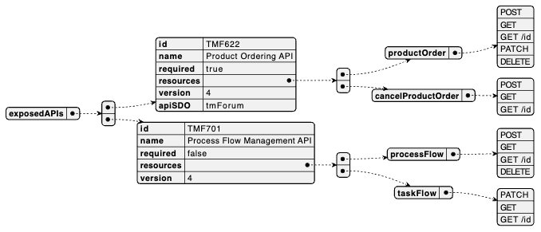
API ID | API Name | Mandatory / Optional | Resource | Operations
TMF622 | Product Ordering API | M;andatory | - productOrder:  - POST  - GET  - GET /id  - PATCH  - DELETE  - cancelProductOrder:  - POST  - GET  - GET /id
TMF701 | Process Flow | Optional | processFlow  - GET  - GET /id  - POST  - DELETE /id
taskFlow
- GET
- GET /id
- PATCH /id
TMF688 | Event | Optional

Dependent APIs
The following diagram illustrates API/Resource/Operation:
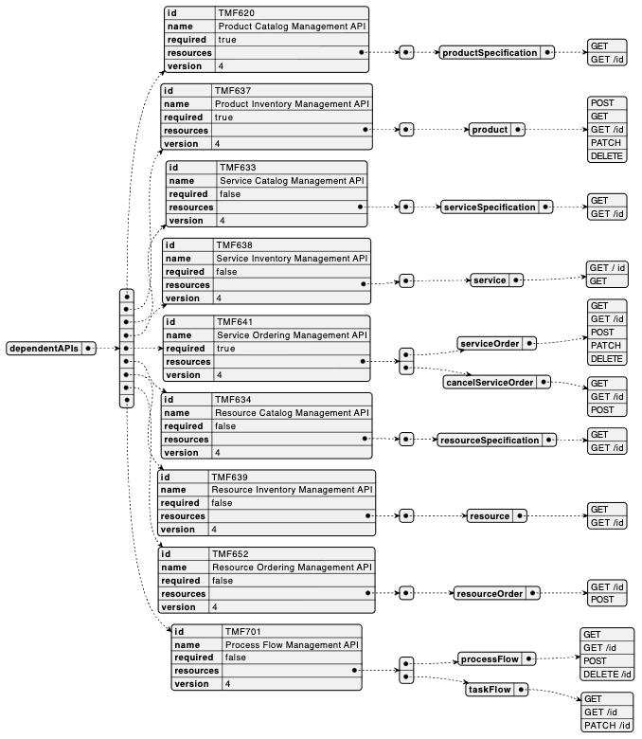
API ID | API Name | Mandatory / Optional | Resource | Operations | Rationales
TMF620 | Product Catalog Management API | Mandatory | productSpecification | GET  GET /id | as illustrated in IG1228, TMFS004, TMFS008 and TMFS014
TMF622 | Product Ordering Management API | Mandatory | productOrder | GET /id  PATCH /id | as illustrated in IG1228, TMFS004, TMFS008 and TMFS014
TMF637 | Product Inventory Management API | Mandatory | product | POST  GET  GET /id  PATCH /id  DELETE | as illustrated in IG1228, TMFS004, TMFS008 and TMFS014
TMF633 | Service Catalog Management API | Optional | serviceSpecification | GET  GET /id
TMF638 | Service Inventory Management API | Optional | service | GET  GET /id
TMF641 | Service Ordering Management API | Mandatory | serviceOrder | POST  GET /id | as illustrated in IG1228, TMFS004, TMFS008 and TMFS014
TMF634 | Resource Catalog Management API | Optional | resourceSpecification | GET  GET /id
TMF639 | Resource Inventory Management API | Optional | resource | GET  GET /id
TMF652 | Resource Ordering Management API | Optional | resourceOrder | POST  GET /id
TMF701 | Process Flow | Optional | processFlow | GET  GET /id  POST  DELETE /id
 |  |  | taskFlow | GET  GET /id  PATCH /id
TMF688 | TMF688 Event | Optional

Events
The diagram illustrates the Events which the component may publish and the Events that the component may subscribe to and then may receive. Both lists are derived from the APIs listed in the preceding sections.
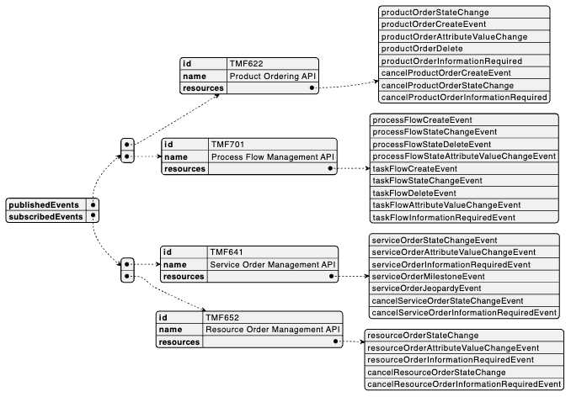

Machine Readable Component Specification
Refer to the ODA Component Map on the TM Forum website for the machine-readable component specification files for this component.

References

TMF Standards related versions
Standard | Version(s)
SID | 23.5
eTOM | 23.5
Functional Framework | 23.5

Jira References

eTOM
- ISA-389 - Improve Manage Order Fallout (1.3.3.8) description and decomposition done 1.3.3.8 - Manage Order Fallout: as this L3 is shared by POCV and POOM components (to be consistent with Functional Framework mapping), clarify which type of fallout need to be managed during the order delivery orchestration (at POOM level) and which need to be managed at Product Order Capture and Follow-Up level (by POCV).

SID
- ISA-399 - New BEs to describe Orchestration Plan and Delivery Process backlog Describe Orchestration Plan and delivery process at Product Order level. This could be added at least as specialization from Project ABE.

Functional Framework
These updates are already integrated in Functional Framework R22.0:
- Function 174 - Customer Order Error Resolution Support: review the definition of this function and may be split it in 2 as it is proposed to be mapped to POCV and to POOM
- Function 723 - Customer Order Item Decomposition: term "decomposition" in function name or definition doesn't seem appropriate as by definition a product order is built up of order items, according to catalog structure of product offerings and products

The updates need to be studied for R22.0 or R22.5:
- ISA-397 - Split Function 342 - Mass Service/product pre-activation sme review Function 342 - Mass Service/product pre-activation: need to split this function in 2, one at product level, the other at service level
- ISA-398 - Review Function 743 - Number Portability Orchestration done Function 743 - Number Portability Orchestration: review functions related to Number Portability and clarify which level (product/service/resource) each of them concern and split if necessary.

API
- AP-3664 - Manage Amend Order backlog - Does POOM need to issue TMF641 PATCH /serviceOrder and TMF652 PATCH /resourceOrder? We cannot think of any scenarios where POOM would need to PATCH a service or resource order. PATCH is certainly applicable to other use cases (e.g., to allow a user with appropriate privileges to add a note). However, order updates due to change in intent should be done through amendments, preferably using a task-based mechanism similar to cancellation requests. For example, an amendment of a product order would result in a new orchestration plan and changes would trickle down to POOM, SOM and ROM as amendment and/or cancellation requests. See also On Revisions. We need Amend task operations for all P/S/R order APIs.
- [TAC-144] Open Issue: Resources owned by Product Order Orchestration and Management - TM Forum JIRA
- TAC-147 - Open Issue: How order delivery is triggered in progress

Further resources
This component is involved in the following use cases described in IG1228 How to use ODA - Using Open APIs to realize Use Cases:

Administrative Appendix

Document History

Version History

Version Number | Date Modified | Modified by: | Description of changes
1.0.0 | 29 Mar 2022 | Gaetano Biancardi , Anastasios Sarantis , Sylvie Demarest  Dimitrios Lagkouvardos | Final edits prior to publication
1.0.1 | 25 Jul 2023 | Ian Turkington | No content changed, simply a layout change to match template 3.
1.0.1 | 15 Aug 2023 | Amaia White | Final edits prior to publication
1.1.1 | 25 Jun 2024 | Sylvie Demarest | Aligned to Frameworks 23.5  Aligned to latest template
2.0.0 | 21 Oct 2024 | Gaetano Biancardi | Dependant API:  - Correct typo and setting mandatory the following APIs: TMF620 , TMF737
2.0.0 | 13 Mar 2025 | Rosie Wilson | Final administrative updates
2.0.1 | 15 Sep 2025 | Rosie Wilson | Updates to description per agreed YAML updated on 03 Jun 2025  Final administrative updates prior to publication
3.0.0 | 10 Mar 2026 | Gaetano Biancardi | Exposed API updates, in details following API have been added  - TMF622 Product Ordering (from TMFC002 Product Order Capture and Validation)
3.0.0 | 28 Mar 2026 | Amaia White | Final adminstrative updates

Release History

Release Status | Date Modified | Modified by: | Description of changes
Pre-production | 29 Mar 2022 | Goutham Babu | Initial release
Production | 20-May-2022 | Adrienne Walcott | Updated to reflect TM Forum Approved Status
Pre-production | 15-Aug-2023 | Amaia White | New version 1.0.1
Production | 06-Oct-2023 | Adrienne Walcott | Updated to reflect TM Forum Approved status
Pre-production | 12-Jul-2024 | Amaia White | New version 1.1.1
Production | 30-Aug-2024 | Adrienne Walcott | Updated to reflect TM Forum Approved status
Pre-production | 13 Mar 2025 | Rosie Wilson | New version 2.0.0
Production | 09-May-2025 | Adrienne Walcott | Updated to reflect TM Forum Approved status
Pre-production | 15 Sep 2025 | Rosie Wilson | New Version 2.0.1
Production | 14-Nov-2025 | Adrienne Walcott | Updated to reflect TM Forum Approved status
Pre-production | 28 Mar 2026 | Amaia White | New version 3.0.0

Acknowledgments

Team Member (@mention) | Company | Role*
Anastasios Sarantis | Vodafone | Editor
Ian Turkington | TM Forum | Additional Input
Hugo Vaughan (TM Forum) | TM Forum | Additional Input
Gaetano Biancardi | Accenture | Reviewer
Sylvie Demarest | Orange | Editor
Dimitrios Lagkouvardos | Oracle | Reviewer
Abinash Vishwakarma | Netcracker | Reviewer
Elisabeth Andersson | MATRIXX | Reviewer
Kamal Maghsoudlou | Ericsson | Reviewer
Jose Macaluso | Xacria | Reviewer
Milind Bhagwat | BT | Reviewer
Ritu Arora | BT | Reviewer
Rosie Wilson | TM Forum | Additional Input
*Select from: Project Chair, Project Co-Chair, Author, Editor, Key Contributor, Additional Input, Reviewer

