TMFC001 Product Catalog Management v2.2.2
Components and Canvas
In this deliverable:

Overview
Component Name | ID | Description | ODA Function Block
Product Catalog Management | TMFC001 | The product catalog management component is responsible for organizing the collection of products and product offering specifications that identify and define all requirements of a product or a product offering that can be commercialized. | Core Commerce

eTOM Processes, SID Data Entities and Functional Framework Functions

eTOM business activities
eTOM business activities this ODA Component is responsible for:
Identifier | Level | Business Activity Name | Description
1.2.20 | L2 | Product Catalog Lifecycle Management | Catalog Lifecycle Management business process covers a set of business activities that enable manage the lifecycle of an organization’s catalog from design to build according to defined requirements.
1.1.19 | L2 | Loyalty Program Management | Define all aspects of a loyalty program, such as requirements and objectives of a loyalty program, determine the benefits to participants. Develop a program, prototype it, test it, rollout/launch it, amend and evaluate it, and terminate it when it is no longer viable for an enterprise.
1.1.19.1 | L3 | Loyalty Program Development & Retirement | Define all aspects of a loyalty program, such as requirements, its name, and objectives of the loyalty program, determine the benefits to participants. Develop a program, prototype it, test it, rollout/launch it, amend and evaluate it, and terminate it when it is no longer viable for an enterprise.
1.2.7 | L2 | Product Specification & Offering Development & Retirement | Product Specification & Offering Development & Retirement processes develop and deliver new product specifications as well as enhancements and new features, ready for use by other processes. Additionally, they handle the removal of specifications no longer offered. / Product specifications represent the types of services and resources made available as product offerings to the market by an enterprise. / / The key measures of this process are how effectively the enterprise’s offerings are broadened by these specifications or new specification features. These processes also manage updates and enhancements to product specifications. Business case development tracking and commitment are key elements of this process. / / They also develop new product offerings and their associated features. Pricing for the offerings is also developed, such as standard pricing and feature-based pricing. The offerings and selected processes are included in product catalogs which are also developed by these processes.
1.2.8.7 | L3 | Implement Product Capacity Plan | Implement Product Capacity Plan business activity is in charge of putting into effect the steps needed to achieve Product Capacity plans, with required product capacity, and product capacity management course of action.
1.6.4 | L2 | Business Partner Offering Development & Retirement | Business Partner Offering Development & Retirement supports the management of on-boarding and off-boarding another Business Partner's product specifications and product offerings that a required to facilitate the business model of the enterprise. / It also manages the involvement the enterprise has with a product specification and product offering. For example, the enterprise may accept an order for one of its offerings, but it may be fulfilled by another Business Partner. / / Note: / - Product Specification Development & Retirement and Product Offering Development & Retirement processes are used to manage most of the lifecycle of product specifications and product offerings. This is done to eliminate redundant processes. For example, the Product Offering Pricing processes are used to manage the prices associated with on-boarded product offerings. / - This process therefore focuses on managing the relationship that parties, including the enterprise, have with product specifications and product offerings as well as the impact of off-boarding specifications and offerings on a provider's service and resource infrastructure.
1.2.8 | L2 | Product Capacity Management | Product Capacity Management business process manages the activities required to ensure a business is able to plan, model, analyze, optimize, monitor and report product capacity, and related constraints according the commercial objectives in a timely and effective manner.
1.2.22 | L2 | Product Catalog Content Management | Product Catalog Content Management business process defines and provides the business activities that support the day-to-day operations of Product Catalogs in order to realize the business operations goals. / Product Catalog Content Management business processes include administering the Product Catalog instance in production, maintaining catalog entries, assuring catalogs, managing catalog access, managing entry lifecycle through versioning, handling catalog entity entry and changes, supporting distribution of catalogs as needed, and supporting user-facing activities.
1.2.21 | L2 | Product Catalog Operational Readiness Management | Product Catalog Operational Readiness Management business process establishes and administers the support needed to operationalize Product catalogs for ongoing day-to-day business needs. / These business activities implement the Product Catalog through Release and Deploy business activities. / Release Product Catalog business activity ensure all cross-functional activities needed to support catalog maintenance and operations, such as training and updating the support of the catalog are in place. / Release Product Catalog business activity includes identifying stakeholders, catalog integration, catalog federation etc. for any scenario in support of the organizations business goals, including Release conditions that support users, customers and business partners.
1.2.19 | L2 | Product Catalog Planning Management | Product Catalog Planning Management business process covers a set of business activities that understand and enable establish the plan to define, design and operationalize a catalog in order to meet the needs and objectives of Product cataloging. / The Product Catalog Planning Management business process ensures that the organization is able to identify the most appropriate scheme and goal for its catalog. It includes designing the Catalog plan and developing the specification according to Product management requirement.
1.2.23 | L2 | Product Specification Management | Product Specification Management business process leverages captured product requirements to develop, master, analyze, and update documented standard and personalized conditions that must be satisfied by product design and/or delivery. / Product Specifications Management can result in establishing, in a centralized way, technical (know-how) standards for products. Such standards provide the organization with a means to control and approve the values and inputs of product specification through structure, review, approval and distribution processes to users (including customers and business partners).
1.2.8.7.1 | L4 | Specify Required Product Capacity | Specify Required Product Capacity business activity is in charge of implementing product capacity plans by identifying clearly and definitely product capacity expectations.

SID ABEs
SID ABEs this ODA Component is responsible for:
SID ABE Level 1 | SID ABE Level 2 (or set of BEs) | SID ABE L1 Definition | SID ABE L2 Definition
Product Offering Specification |  | The Product Offering Specification ABE describes tangible and intangible goods made available for a certain price to the market in the form of product catalogs. This ABE is also responsible for targeting market segments based on the appropriate market strategy. | *(no description available)*
Product Specification |  | The Product Specification ABE contains all that represents a product specification as perceived by the business user and specifies what the marketing operator wants to sell at a functional level (i.e. what are the capacities, which usages are available…). | *(no description available)*
Product Configuration | ProductConfigSpec | The Product Configuration ABE represents the specification of the different possible Product configurations as well as the Product Configurations instantiated for a Product. | The definition of how a Product operates or functions in terms of CharacteristicSpecification(s) and related ResourceSpec(s), ProductSpec(s), ServiceSpec(s).
Product Usage | Product Usage Specification | Product Usage ABE represents specification of usages enabled by Products and usages of products tracked. | The Product Usage Specification ABE specifies types and characteristics of usage of ProductSpecifications.
Loyalty | Loyalty Program Specification | A loyalty program is one of the tools used by the loyalty process to retain customers. The Loyalty ABE contains all entities useful to specify and instantiate loyalty programs. A LoyaltyProgramProdSpec defines the LoyaltyRules that have to be checked in order to identify the actions to apply. Depending on the type of LoyaltyRules a LoyaltyAccount might be needed to collect gains or not. A LoyaltyProgramProduct is a type of ProductComponent and described by a LoyaltyProgramProdSpec. | The Loyalty Program Specification ABE contains all entities specifying a loyalty program such as LoyaltyProgramProdSpec and LoyaltyRule.
Party Product Specification and Offering |  | The Party Product Specification and Offering ABE contains the entities required to specify the involved parties are playing in business processes related to ProductSpecifications and Product Offerings, such as ordered from and billed by. The sub-ABEs represent the intersection of entities in the two domains. For example, PartyRoleProductOffering is the intersection between the ProductOffering and the PartyRole entities. These ABEs are only needed when a ProductSpecification and ProductOffering are on-boarded and offered to the market by an enterprise or when an offering is procured from another party. | *(no description available)*

eTOM L2 - SID ABEs links
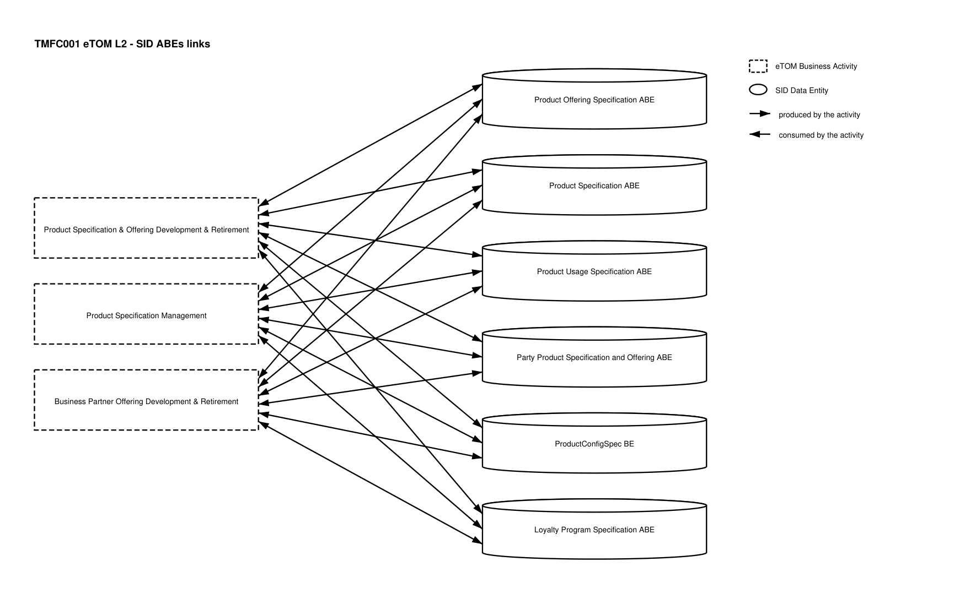
eTOM L2 - SID ABEs links diagram

Functional Framework Functions
Function ID | Function Name | Function Description | Aggregate Function Level 1 | Aggregate Function Level 2
3 | Repository Entity Relations Configuration | Repository Entity Relations Configuration manages hierarchical, inheritance and reuse relations between catalog entities. Re-usability is a major requirement for management of a catalog. Re-usability is achieved through inheritance and through the re-use of standalone entities as well as entity hierarchies. | Master Data Management | Data Repository Management
4 | Repository Entity Grouping Configuration | Repository Entity Grouping Configuration defines the grouping of catalog entities. A catalog user needs flexibility and openness in configuring data catalog entities. One of the configuration options that enable high re-usability is the possibility to group entities and re-use the group level. | Master Data Management | Data Repository Management
6 | Repository Entity Data Model Configuration | Repository Entity Data Model Configuration enables the catalog to provide the capability to have a flexible data model with the ability to structure entities and attributes as desired by the user and to extend the model according to the requirements. | Master Data Management | Data Repository Management
11 | Repository Entity Hierarchy Management | Repository Entity Hierarchy Management manages rules that governs the relationships between entities in different layers. A catalog that manages different layers needs to maintain the rules within the layer and between the layers. For example, how product definition translate corresponds to different services provisioning rules, and so on. | Master Data Management | Data Repository Management
123 | Product Catalog Browsing | Product Catalog Browsing provides a browsing function to identify products available for purchase by a given customer, provide selected relevant information (e.g. cost, requirements, configurable attributes) to the customer. This information will be used in the step guidance. | Product Specification & Offering Management | Product Specification & Offering Development
210 | Centralized Ordering Rules Management | Centralized Ordering Rules Management provides centralized business rules for ordering (eligibility, compatibility). | Product Specification & Offering Management | Ordering Rules Development
238 | Customer Loyalty Rules Management | Customer Loyalty Rules Management provides Loyalty Program Rules and customer loyalty profiles management | Product Specification & Offering Management | Product Specification & Offering Development
263 | Product Compatibility Checking | Product Compatibility Checking function provides an internet technology driven interface for the customer to check product compatibility. | Product Specification & Offering Management | Product Specification & Offering Development
360 | Product Agreement Specification Design | Product Agreement Specification Design Function creates and maintains predefined Product Agreement options and templates for Product Offerings. It includes general terms or conditions and approval rules. | Product Specification & Offering Management | Product Specification & Offering Development
407 | Product Modeling Support | Product Modeling Support supports Lifecycle Management in the design and build phase of the Product Offerings and Product Specifications. | Product Specification & Offering Management | Product Modeling Support
408 | Product Retirement | Product Retirement Function retires obsolete product offering as part of Lifecycle Management (LM). | Product Specification & Offering Management | Product Specification Lifecycle Management
415 | Product Strategy linking | Product Strategy Linking links strategy to propositions and links propositions to products | Product Specification & Offering Strategy Definition & Analysis | Product Specification & Offering Strategy Management
649 | Product Sourcing Registration | Product Sourcing Registration provides initiation of product instantiation into the service provider product catalog and/or storefront, including product prices. | Business Partner Product Specification and Offering Management | Business Partner Product Specification and Offering Onboarding
650 | Partner Product Certification | Partner Product Certification provides product certification/decertification to be an integrated part of the service provider's value proposition. | Business Partner Product Specification and Offering Management | Business Partner Product Specification and Offering Onboarding
662 | Sourcing Reference Data Collection | Sourcing Reference Data Collection collects definition of products and services, pricing schemes, partner entities and contracts into the system. Easy uploading of reference data from external sources such as XML files. | Business Partner Product Specification and Offering Management | Business Partner Product Specification and Offering Onboarding
721 | Customer Order Rules Configuration | Customer Order Rules Configuration function provides in addition to the Product rules, rules like cross/up sell rules, compatibility rules, eligibility rules, address/service availability rules, etc. Some specific types of rules must be available for all decision-based actions on customer orders. These rules could be customer fraud check, decomposition rules, priority rules, order duplication prevention rules, complex rules involving multi-system checks, etc. | Product Specification & Offering Management | Ordering Rules Development
722 | Order Rules Retrieval | Order Rules Retrieval function makes the Order Rules available to e.g. customer order related applications. | Product Specification & Offering Management | Ordering Rules Development
992 | Entity Management Notification | Entity Management Notification provides notifications after Entity Management actions to associated applications or application functions. | Master Data Management | Data Repository Management
993 | Entity Management Reporting | Entity Management Reporting reports to users or applications with defined and formatted content, scheduled on-demand or subscribed. | Master Data Management | Data Repository Management
1050 | Product Onboarding Management | Product Onboarding Management function supports the managing of the onboarding of a Product Offering sourced from an external source e.g. a business partner. | Business Partner Product Specification and Offering Management | Business Partner Product Specification and Offering Onboarding
1053 | Onboarded Product Workflows Definition | Onboarded Product Workflows Definition function identifies appropriate workflows related to the use of the onboarded product in fulfillment, assurance and billing. | Business Partner Product Specification and Offering Management | Business Partner Product Specification and Offering Onboarding
1076 | Product Specification Design | Product Specification Design Function provides the means to describe for every product commercialized through one or several offers: / • characteristics of the product, and their possible values (ex: speed, volume, duration, phone number, …) / • available operations (ex: create, change of speed) / • functional incompatibilities or prerequisites (deducted from CFS specification incompatibilities or pre-requisites) / • link with the know-how type (CFS specification) from which the intangible product is a restriction (ex: mobile line, VOIP, …), or directly with the resource type for tangible products (ex: smartphone, SIM Card), or to the Supplier product type in case of purchase products. / It includes facilities to design a new Product Specification based on an existing one and integrity rules controls. / The Product Catalogue describes, according to strategy, all the tangible and intangible products that can be commercialized through standard offers, loyalty offers. / Example: / • goodies can be sold or offered as a reward in exchange for fidelity points (same product commercialized through 2 offers) / • a special discount can be granted through a retention offer / • … / A Product Specification restricts a Customer Facing Service Specification (CFSSpec). | Product Specification & Offering Management | Product Specification & Offering Development
1077 | Product Offering Design | Product Offering Design function provides the means to describe Product Offering, according to marketing strategy: / • commercial name / • packaging rules of the contract: mandatory offers, optional offers, offers that can be ordered in number (ex: 1 to 4 mobile lines) / • commercial incompatibilities or prerequisites (ex: necessary to be the holder of a X contract to subscribe Y contract) / • available commercial operations (ex: contract migration) / • available commitment durations / • any commercial criteria such as authorized sales channel or geographic area, customer criteria, … / • tariff specifications – and possible alterations. They are associated with the offer, to commercial operations or usage types and can be recurring or one shot. They are expressed as rules that can consider many criteria (ex: commitment duration, product configuration, sales channel, customer’s age, …) and will be evaluated during the order capture process, or during the rating process for usage. / It includes facilities to design a new Product Offering based on an existing one and integrity rules controls. | Product Specification & Offering Management | Product Specification & Offering Development
1078 | Product Specification and Offering Change Auditing | Product Specification and Offering Change Auditing manages the implications of Product Specifications and Offerings changes to determine the consequences of any given change. Product Specifications and Offerings changes may impact other Product Specifications and / or Offerings according to relationships between them. / The function logs Product Specifications changes and supports the analysis of relationships between Product Specifications. / In addition, it tracks the history of changes in an easy and accessible manner. | Product Specification & Offering Management | Product Specification & Offering Development
1079 | Product Specification and Offering Repository Management | Product Specification and Offering Repository Management is able to create, modify and delete Product Specification and Offering. / This includes the ability to manage the state of an entity during its lifecycle (e.g. planned, deployed, in operation, replaced by, locked…). / It includes Product Specifications and Offerings retrieval, integrity rules check and versioning management. / It also provides Product Specification and Offering views adapted to the different roles. | Product Specification & Offering Management | Product Specification & Offering Development
416 | Product Propositions Operations Planning | Product Propositions Operations Planning supports the planning of the introduction of propositions for new or updated product offerings and/or product specifications, by planning which operating groups are delivering what of the product proposition and where are the organization and operations touchpoints. | Product Specification & Offering Strategy Definition & Analysis | Product Specification & Offering Strategy Management
417 | Product Strategy to Proposition Alignment | Product Strategy to Proposition Alignment captures and manages details of the business strategy and applies them to the propositions for new or updated product offerings and/or product specifications. | Product Specification & Offering Strategy Definition & Analysis | Product Specification & Offering Strategy Management
418 | Product Strategy/Propositions Creation | Product Strategy/Propositions Creation delivers a product strategy and/or propositions for new or updated product offerings and/or product specifications. | Product Specification & Offering Strategy Definition & Analysis | Product Specification & Offering Strategy Management
419 | Product Strategy performance reporting | Product Strategy Performance Reporting enables performance reporting of the strategy, driven by the performance of the underlying products. | Product Specification & Offering Strategy Definition & Analysis | Product Specification & Offering Strategy Analysis
897 | Building Access Control | Building Access Control checks, stops or allows physical access to facilities according to access roles and rules. | Identification and Permission Management | Permission Control
900 | Authorization Control Management | Authorization Control Function controls permissions according to roles and related rules. / It consists in evaluating if a requester is granted permission to act by providing the required evidence. The evidence corresponds to the condition specified for each right (for instance keying the correct password to use a specific mailbox). If the action is protected via a right which is assigned (possibly via a role) to a person, then the person has to be identified to retrieve their rights and verify if the request to act can be granted. | Identification and Permission Management | Permission Control
651 | Product Onboarding Support | Product Onboarding Support provides product onboarding, updating, and decommissioning. | Business Partner Product Specification and Offering Management | Business Partner Product Specification and Offering Onboarding
1291 | External Product Specification Development | External Product Specification Development function supports the definition of, and sometimes development related to, Product Specifications to be provided either by a Business Partner via the Service Provider or provided with the Business Partner in conjunction with the Service Provider. / This function differs from internal Product Specification Development in that this function addresses both the collaborative aspects of inter-company product specification development and the divisions of responsibilities, costs and benefits among the partners. / This function provides the means to describe for every product commercialized through one or several offers: / - characteristics of the product, and their possible values (ex: speed, volume, duration, phone number, etc.) available operations (ex: create, change of speed) / - functional incompatibilities or prerequisites (deducted from CFS specification incompatibilities or pre-requisites) / - link with the know-how type (CFS specification) from which the intangible product is a restriction (ex: mobile line, VOIP, etc.), or directly with the resource type for tangible products (ex: smartphone, SIM Card), or to the Supplier product type in case of purchase products. / It includes facilities to design a new Product Specification based on an existing one and integrity rules controls. / A Product Specification restricts a Customer Facing Service Specification (CFSSpec). | Product Specification & Offering Management | Product Specification & Offering Development
1292 | External Product Offering Development | External Product Offering Development function includes the definition of, and sometimes the creation of, Product Offerings provided either by a Business Partner via the Service Provider or provided with the Business Partner in conjunction with the Service Provider. / This function differs from internal Product Offering Development in that this function addresses both the collaborative aspects of inter-company product Offering development and the divisions of responsibilities, costs and benefits among the partners. / This function provides the means to describe Product Offerings, according to marketing strategy: / - commercial name / - packaging rules of the contract: mandatory offers, optional offers, offers that can be ordered in number (ex: 1 to 4 mobile lines) / - commercial incompatibilities or prerequisites (ex: necessary to be the holder of an X contract to subscribe Y contract) / - available commercial operations (ex: contract migration) / - available commitment durations / - any commercial criteria such as authorized sales channel or geographic area, customer criteria, etc. / - tariff specifications and possible alterations. They are associated to the offer, to commercial operations or usage types and can be recurring or one shot. They are expressed as rules that can consider many criteria (ex: commitment duration, product configuration, sales channel, customer's age, etc.) and will be evaluated during the order capture process, or during the rating process for usage. / It includes facilities to design a new Product Offering based on an existing one and integrity rules controls. | Product Specification & Offering Management | Product Specification & Offering Development
1293 | Product Specification Recalls Support | Product Specification Recalls Support function supports carrying out follow-through with Service Provider or Business Partner Product Specification Recalls, including notifying customers and, where appropriate, coordinating returns and replacement logistics. | Product Specification & Offering Management | Product Specification Lifecycle Management
1341 | Product Specification Change Notification | Product Specification Change Notification function enables notifying systems, stakeholders and involved business partners that a new product specification change is pending. This function is ideally automated but can be a manual notification to those systems and processes that require manual intervention to make a product specification change. | Product Specification & Offering Management | Product Specification & Offering Realization
1342 | Product Specification Version Control | Product Specification Version Control function facilitates multiple iterations (versions) of product specifications being kept in production to avoid inconveniencing existing customers of the previous versions. | Product Specification & Offering Management | Product Specification Lifecycle Management

TM Forum Open APIs & Events
The following part covers the APIs and Events; this part is split in 3:

List of Exposed APIs - This is the list of APIs available from this component.

List of Dependent APIs - In order to satisfy the provided API, the component could require the usage of this set of required APIs.

List of Events (generated & consumed) - The events which the component may generate are listed in this section along with a list of the events which it may consume. Since there is a possibility of multiple sources and receivers for each defined event.

API Context Diagram
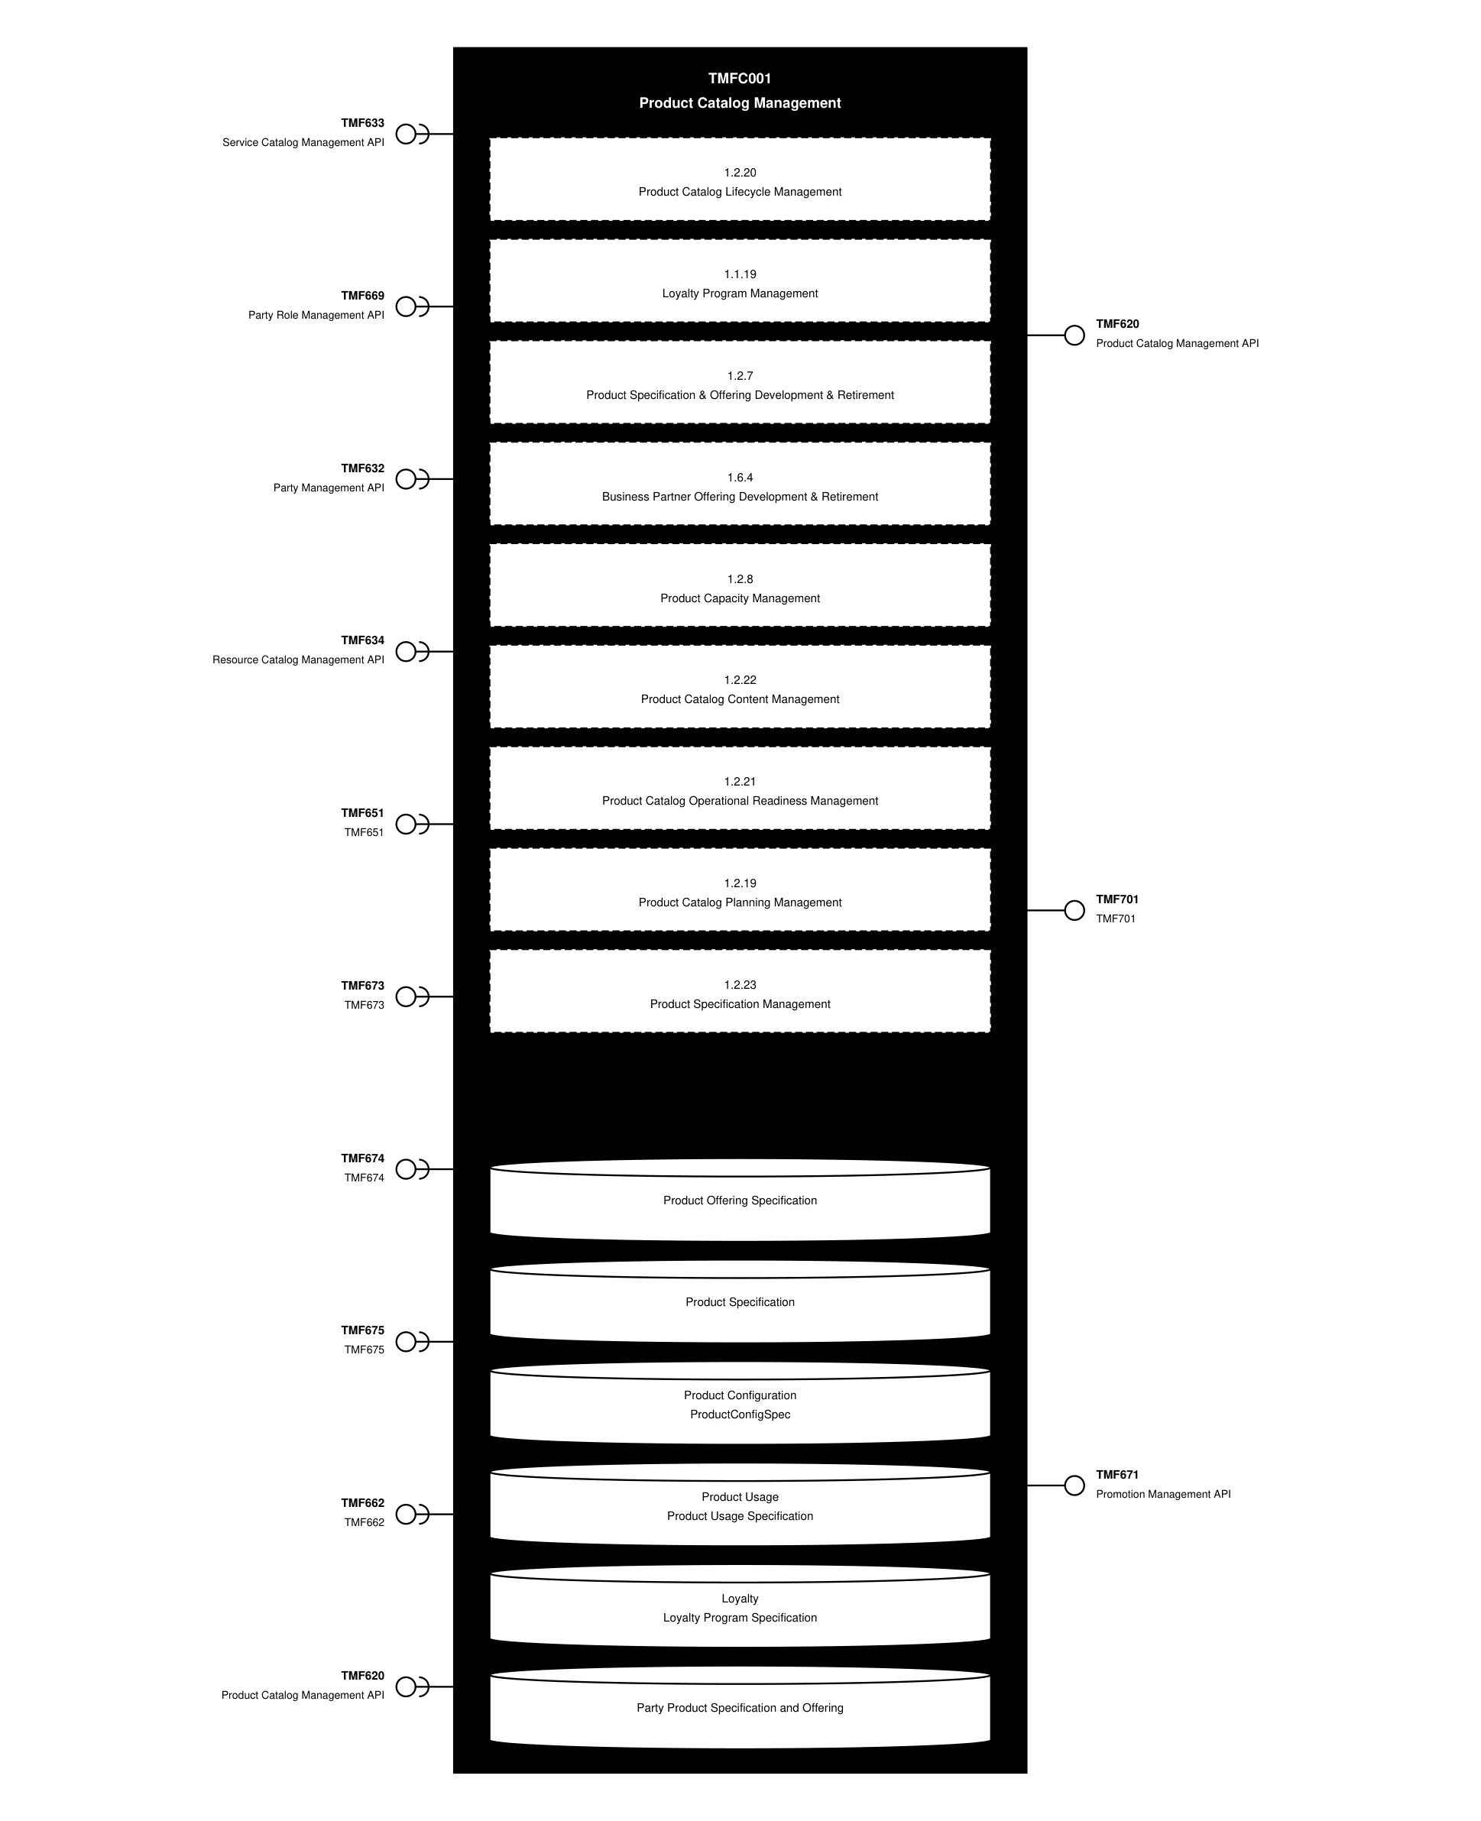
API Context diagram

Exposed APIs
API ID | API Name | Mandatory / Optional | API Version | Resource | Operations
TMF620 | Product Catalog Management API | Mandatory | 5 | productCatalog  category  exportJob  importJob  productOffering  productOfferingPrice  productSpecification | GET  GET /id  POST  PATCH  DELETE
TMF620 | Product Catalog Management API | Mandatory | 4 | catalog  category  productSpecification  productOffering  productOfferingPrice  exportJob  importJob | GET  GET /id  POST  PATCH  DELETE
TMF701 | TMF701 | Optional | 4 | processFlow  taskFlow | POST  GET  GET /id  DELETE  PATCH
TMF671 | Promotion Management API | Optional | 4 | promotion | GET  GET /id  POST  PATCH  DELETE

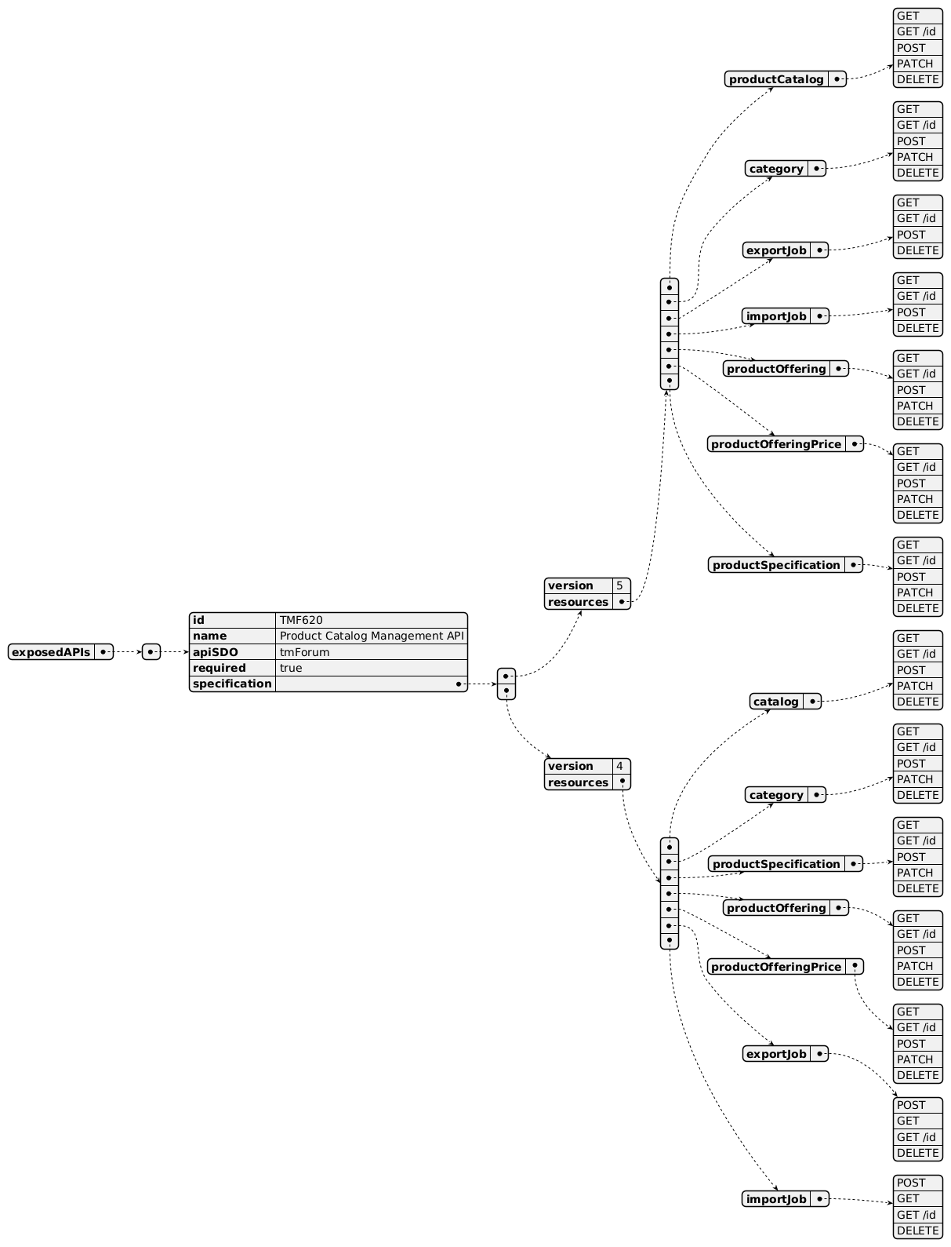
Exposed API diagram (1 of 2)
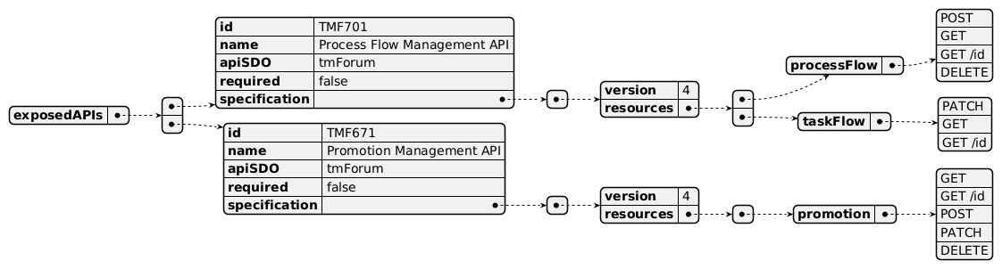
Exposed API diagram (2 of 2)

Dependent APIs
API ID | API Name | API Version | Mandatory / Optional | Resource | Operations
TMF633 | Service Catalog Management API | 4 | Optional | serviceSpecification | GET  GET /id
TMF669 | Party Role Management API | 5 | Optional | partyRole | GET  GET /id
TMF669 | Party Role Management API | 4 | Optional | partyRole | GET  GET /id
TMF632 | Party Management API | 5 | Optional | individual  organization | GET  GET /id
TMF632 | Party Management API | 4 | Optional | individual  organization | GET  GET /id
TMF634 | Resource Catalog Management API | 5 | Optional | resourceSpecification | GET  GET /id
TMF634 | Resource Catalog Management API | 4 | Optional | resourceSpecification | GET  GET /id
TMF651 | TMF651 | 4 | Optional | agreement  agreementSpecification | GET  GET /id
TMF673 | TMF673 | 4 | Optional | geographicAddress | GET  GET /id
TMF674 | TMF674 | 4 | Optional | geographicSite | GET  GET /id
TMF675 | TMF675 | 4 | Optional | geographicLocation | GET  GET /id
TMF662 | TMF662 | 4 | Optional | entitySpecification  associationSpecification | GET  GET /id
TMF620 | Product Catalog Management API | 5 | Optional | productCatalog  category  exportJob  importJob  productOffering  productOfferingPrice  productSpecification | GET  GET /id  POST  PATCH  DELETE
TMF620 | Product Catalog Management API | 4 | Optional | catalog  category  productOffering  productSpecification  productOfferingPrice  importJob  exportJob | GET  GET /id  POST  PATCH  DELETE

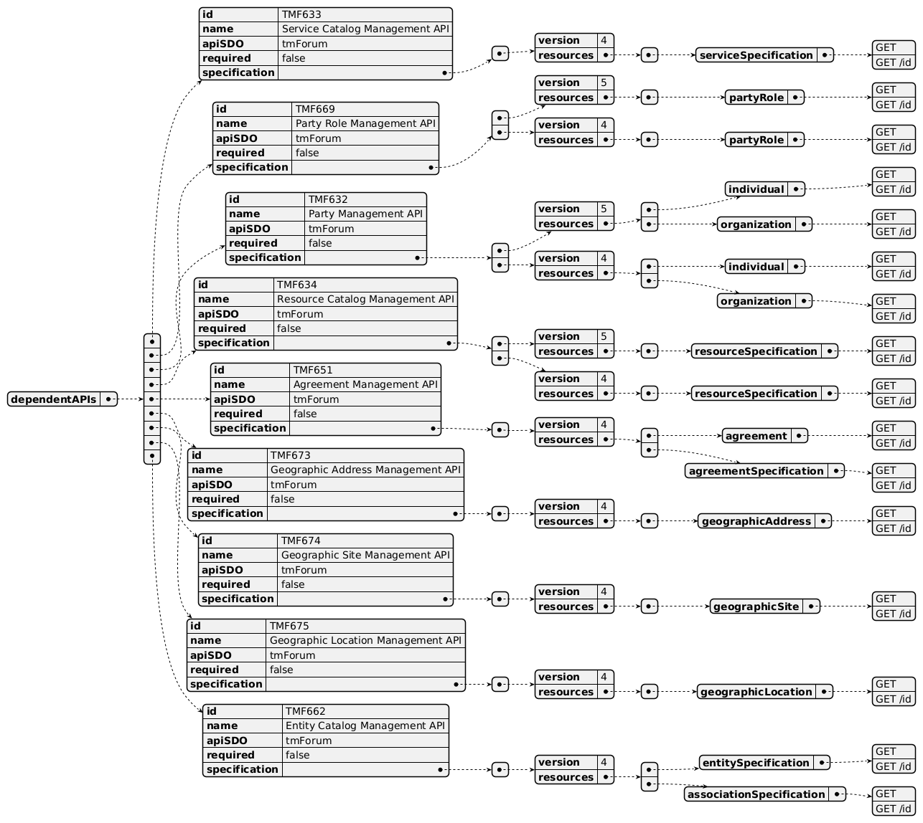
Dependent API diagram (1 of 2)
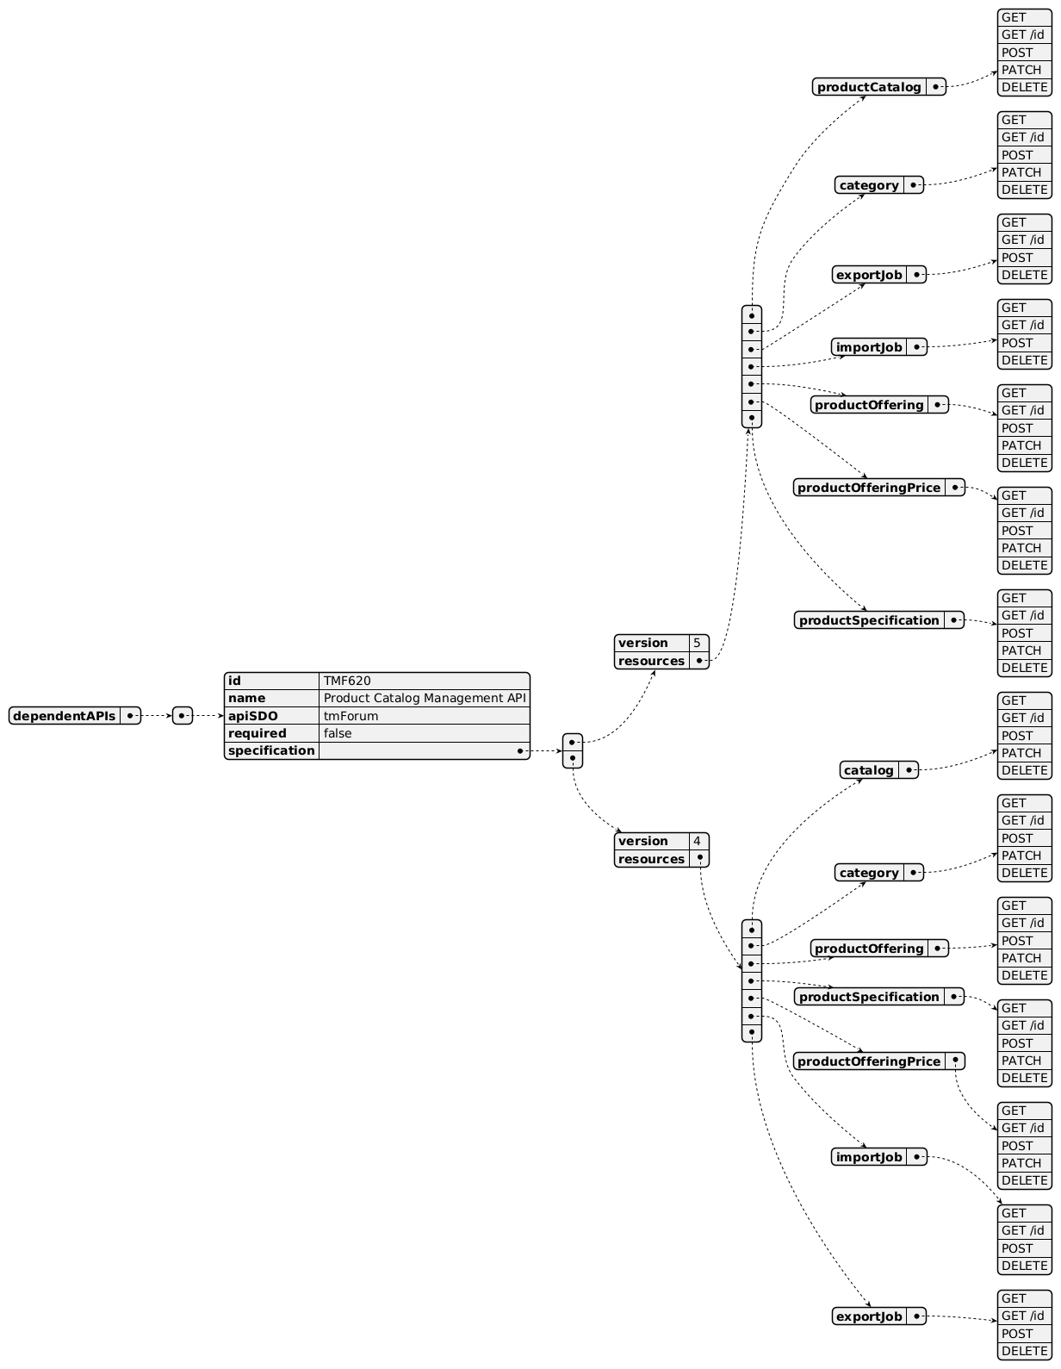
Dependent API diagram (2 of 2)

Events
The diagram illustrates the Events which the component may publish and the Events that the component may subscribe to and then may receive. Both lists are derived from the APIs listed in the preceding sections.

Published Events
API ID | API Name | Event Resources
TMF620 | Product Catalog Management API | productSpecificationCreate  productSpecificationDeleteEvent  categoryCreateEvent  categoryDeleteEvent  productOfferingCreateEvent  productOfferingAttributeValueChangeEvent  productOfferingStateChangeEvent  productOfferingDeleteEvent  productOfferingPriceCreateEvent  productOfferingPriceAttributeValueChangeEvent  productOfferingPriceStateChangeEvent  productOfferingPriceDeleteEvent  catalogCreateEvent  catalogDeleteEvent  catalogBatchEvent  productSpecificationCreateEvent
TMF671 | Promotion Management API | promotionCreateEvent  promotionDeleteEvent  promotionAttributeValueChangeEvent  promotionStateChangeEvent  promotionInformationRequiredEvent
TMF701 | ProcessFlowManagement | processFlowCreateEvent  processFlowStateChangeEvent  processFlowStateDeleteEvent  processFlowStateAttributeValueChangeEvent  taskFlowCreateEvent  taskFlowStateChangeEvent  taskFlowDeleteEvent  taskFlowAttributeValueChangeEvent  taskFlowInformationRequiredEvent

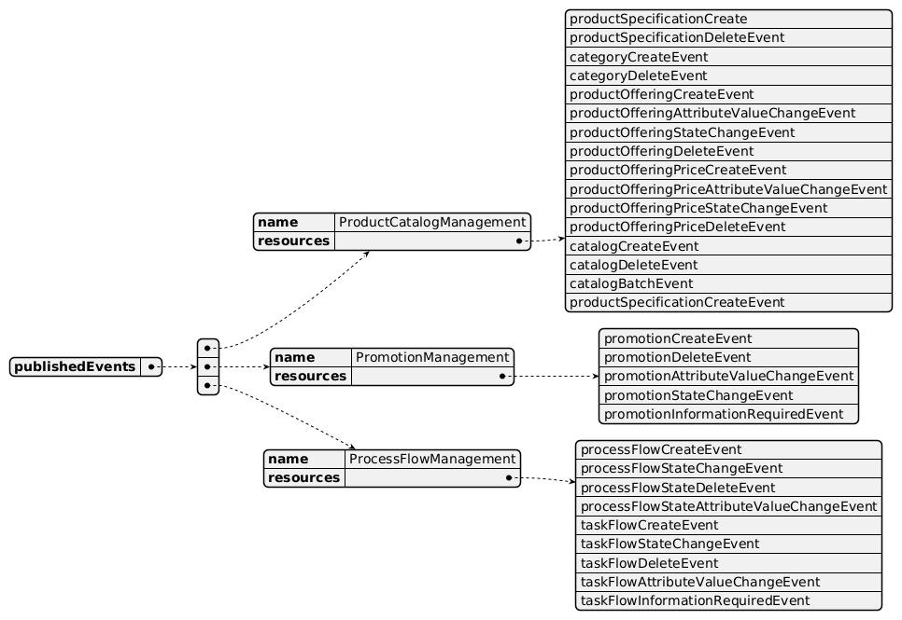
Published Events diagram

Subscribed Events
API ID | API Name | Event Resources
TMF669 | Party Role Management API | partyRoleDeleteEvent
TMF632 | Party Management API | individualDeleteEvent  organizationDeleteEvent
TMF633 | Service Catalog Management API | serviceSpecificationChangeEvent  serviceSpecificationCreateEvent  serviceSpecificationDeleteEvent
TMF634 | Resource Catalog Management API | resourceSpecificationCreateEvent  resourceSpecificationDeleteEvent  resourceSpecificationStatusChangeEvent  resourceSpecificationAttributeValueChangeEvent  resourceSpecificationChangeEvent

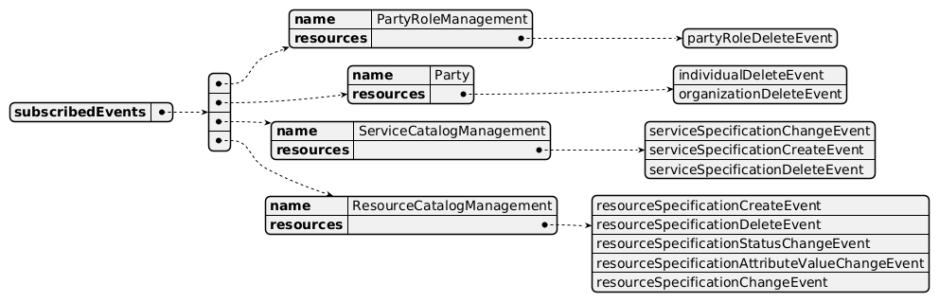
Subscribed Events diagram

Machine Readable Component Specification
Refer to the ODA Component Directory on the TM Forum website for the machine-readable component specification files for this component.

References

TMF Standards related versions
Standard | Version(s)
eTOM | v24.0
SID | v25.0
Functional Framework | v24.0

Jira References
Functional Framework

ISA-996 - Master Data Management has repurposed catalog related functions (BACKLOG): As part of reviewing the Product, Service and Resource Catalogs to align with the updates to the Functional Framework, a lot of functions have either been removed or re-purposed by Master Data Management, resulting in a decision to remove these functions from the Components:

Removed deleted unclassified functions (1, 2, 5, 7, 9, 10, 12, 14, 15)

Removed functions that used to be related to Catalog management but now have been re-purposed by Master Data Management (3, 4, 6, 11, 13)
Concern: catalog functions may be missing due to re-use of Master Data Management.
Open APIs

Work in progress to create a Product Usage API (as Service Usage and Resource Usage APIs) - when ready, it would be added to the exposed APIs for the usage specification part

[AP-6616] TMF620 - rename ProductOffering into ProductOfferingSpecification

TAC-1289 TMFC001 - update exposed API for TMF767 Product Usage Management

New ticket to be opened: need for an Open API able to offer TaxDefinition

Further resources
none currently listed

Administrative Appendix

Document History

Version History
Version Number | Date | Modified by | Description of changes
1.0.0 | 28-May-2021 | Alan Pope | Final edits prior to publication
1.1.0 | 07-Oct-2022 | Alan Pope | Final edits prior to publication
1.2.0 | 13-Apr-2023 | Amaia White | Final edits prior to publication
1.2.1 | 25-Jul-2023 | Ian Turkington | No content changed, simply a layout change to match template 3. Separated the YAML files to a managed repository.
1.2.1 | 14-Aug-2023 | Amaia White | Final edits prior to publication
2.0.0 | 23-Apr-2024 | Sylvie Demarest | Updated to latest template; aligned with 23.5 SID, eTOM and Functional Framework; simplified eTOM mapping due to new definitions and clarifications (Loyalty Program Mgt and Product Capacity Mgt removed); Product Capacity ABE and Product Test Specification BE removed from the SID mapping (managed by other components); new functions added, definitions and Aggregate Functions classifications updated, functions classified in Master Data Mgt removed as too generic; TMF623 SLA Mgt API removed from the dependent APIs chapter (old API in V2 in Historic API table)
2.0.0 | 02-May-2024 | Amaia White | Final edits prior to publication
2.1.0 | 12-Nov-2024 | Gaetano Biancardi | TMF688 removed from the core specification, moved to supporting functions; TMF672 removed from the core specification, moved to supporting functions; API version, only major version to be specified
2.1.0 | 26-Nov-2024 | Amaia White | Final edits prior to publication
2.1.1 | 08-Jul-2025 | Rosie Wilson | Updates to description per agreed YAML updated on 03-Jun-2025; 5.2.2 added API ticket as requested by Olivier Arnaud
2.1.1 | 15-Jul-2025 | Rosie Wilson | Final edits prior to publication
2.1.2 | 28-Oct-2025 | Gaetano Biancardi, Julien Rouland | Updates to description per agreed YAML updated on 03-Jun-2025; 5.2.2 added API ticket as requested
2.1.2 | 19-Nov-2025 | Rosie Wilson | Final edits prior to publication
2.2.2 | 28-April-2026 | Hugo Vaughan | Gen 5 API update
2.2.2 | 25-Jun-2026 | Sannah Sibaya | Final edits prior to publication

Release History
Release Status | Date Modified | Modified by | Description of changes
Pre-production | 28-May-2021 | Alan Pope | Initial release of document
Pre-production | 05-Jul-2021 | Adrienne Walcott | Updated to reflect Member Evaluated status
Pre-production | 07-Oct-2022 | Alan Pope | Version 1.1.0
Pre-production | 13-Apr-2023 | Amaia White | Version 1.2.0
Pre-production | 14-Aug-2023 | Amaia White | Version 1.2.1
Production | 06-Oct-2023 | Adrienne Walcott | Updated to reflect TM Forum Approved status
Pre-production | 02-May-2024 | Amaia White | Version 2.0.0
Production | 28-Jun-2024 | Adrienne Walcott | Updated to reflect TM Forum Approved status
Pre-production | 26-Nov-2024 | Amaia White | Version 2.1.0
Production | 07-Mar-2025 | Adrienne Walcott | Updated to reflect TM Forum Approved status
Pre-production | 15-Jul-2025 | Rosie Wilson | Version 2.1.1
Production | 05-Sep-2025 | Adrienne Walcott | Updated to reflect TM Forum Approved status
Pre-production | 19-Nov-2025 | Rosie Wilson | Version 2.1.2
Pre-production | 28-Apr-2026 | Hugo Vaughan | Gen 5 API updates
Pre-production | 25-Jun-2026 | Sannah Sibaya | Version 2.2.2

Acknowledgements
This document was prepared by the members of the TM Forum ODA Components & Canvas team.
Team Member | Company | Role
Gaetano Biancardi | Accenture | Editor/Reviewer
Anastasios Sarantis | Vodafone | Reviewer
Sylvie Demarest | Orange | Editor
Hugo Vaughan (TM Forum) | TM Forum | Additional Input
Ian Turkington | TM Forum | Additional Input
Abinash Vishwakarma | Netcracker | Reviewer
Elisabeth Andersson | MATRIXX | Reviewer
Kamal Maghsoudlou | Ericsson | Reviewer
Jose Macaluso | Xacria | Reviewer
Milind Bhagwat | BT | Reviewer
Ritu Arora | BT | Reviewer
Julien Rouland | Orange | Editor/Reviewer

