TMFC002 Product Order Capture and Validation v3.0.0
Components and Canvas
In this deliverable:

Overview
Component Name | ID | Description | ODA Function Block
Product Order Capture and Validation | TMFC002 | This component captures what a customer wants to order based on the CSP's Product Catalog. It enables configuration of the product offerings and products desired, provides quotes, checks the eligibility of the customer order, and completes it with information needed such as the related parties or associated billing account and the delivery appointment. This component owns quote management, order capture and validation, using dedicated components (eg Offering Configurator, Service Qualification, Party Management) when needed. After the delivery of the customer product order items, this component is also in charge of the commercial closure of the order. It includes update of the Product Inventory (status and starting/end date of tariffs and discounts) and potential commercial rules control (eg receipt of the contract document signed by the customer). | Core Commerce

eTOM Processes, SID Data Entities and Functional Framework Functions

eTOM business activities
eTOM business activities this ODA Component is responsible for:
Identifier | Level | Business Activity Name | Description
1.1.9 | L2 | Selling | Responsible for managing prospective customers, for qualifying and educating customers, and matching customer expectations / Managing prospective parties with whom an enterprise may do business, such as potential existing or new customers and partners, for qualifying and educating them, and ensuring their expectations are met.
1.1.9.2 | L3 | Develop Sales Proposal | Develop a sales proposal to respond to the customer’s requirements / Develop a sales proposal to respond to a sales prospect's requirements.
1.1.9.5 | L3 | Negotiate Sales/Contract | Close the sale with terms that are understood by the customer and are mutually agreeable to both the customer and the service provider. / Close the sale with terms that are understood by the sales prospect, which now becomes a customer or some other party
1.3.3 | L2 | Customer Order Handling | Responsible for accepting and issuing orders. / Customer Order Processing Management business process directs and controls all activities that operationally realize orders for customer. / Customer Order Processing Management assures the capture, processing, fulfillment, "shipping", delivery and reporting of customer orders from feasibility assessment, purchasing, payment, fulfillment and follow up with the customer for closure.
1.3.3.10 | L3 | Manage Customer Order Placement | Manage Customer Order Placement business activity directs and controls the capture of information to enable create customer order, change customer order and validate customer order based on ordering information from customer.

SID ABEs
SID ABEs this ODA Component is responsible for:
SID ABE Level 1 | SID ABE Level 2 (or set of BEs) | SID ABE L1 Definition | SID ABE L2 Definition
Customer Product Order | SalesQuote | Handles single customer orders and the various types thereof, such as regulated and non-regulated orders. / Orders ProductOfferings and concerned Products | A SalesQuote is a document that allows a Prospect to view the cost involved in purchasing specific Products. It is generally used by suppliers or resellers to begin a business transaction and specifies validity period for acceptance of the quote and possibly an authorisation process depending on the value of the quote.
Customer Product Order | ShoppingCart | Handles single customer orders and the various types thereof, such as regulated and non-regulated orders. / Orders ProductOfferings and concerned Products | Shopping Cart entity is used for the temporarily selection and reservation of product offerings in e-commerce and retail purchase. Shopping cart supports purchase of both tangible and intangible goods and service (e.g. handset, telecom network service). The charge includes the one-off fee such as the fee for handset and the recurring fee such as the fee of a network service. It is mainly used in case of unknown customer with only a ContactMedium instead of a Party and PartyRole with their ContactMedium.

eTOM L2 - SID ABEs links
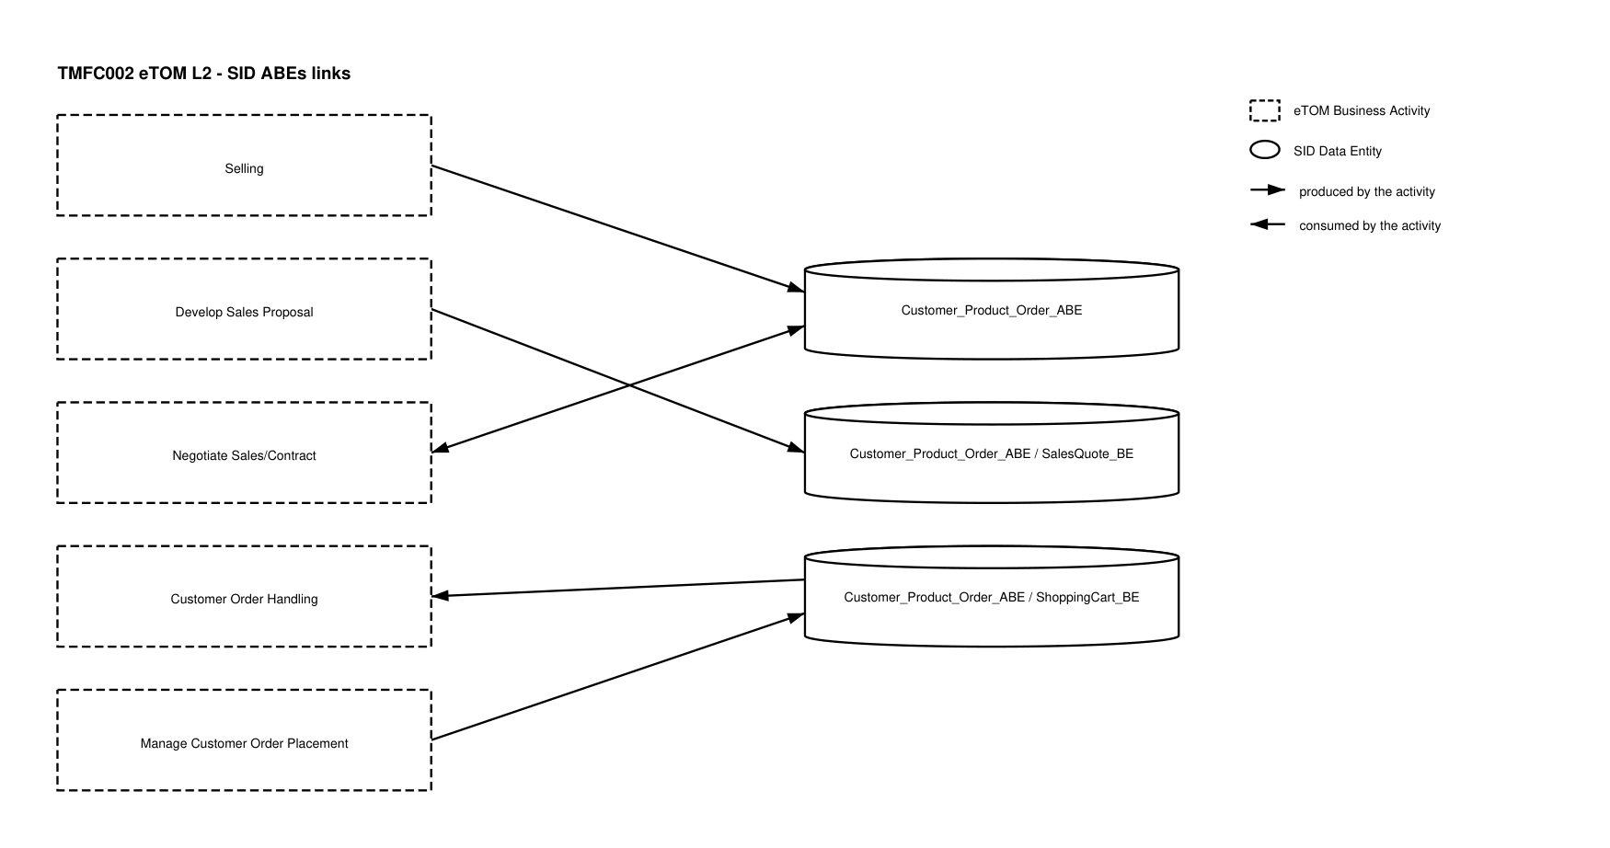
eTOM L2 - SID ABEs links diagram

Functional Framework Functions
Function ID | Function Name | Function Description | Aggregate Function Level 1 | Aggregate Function Level 2
16 | Fallout Automated Correction | Fallout Automated Correction function tries to automatically fix fallouts in workflows before they go to a human for handling. / This includes a Fallout Rules Engine that provides the capability to handling various errors or error types based on built rules. These rules can facilitate autocorrection, correction assistance, placement of errors in the appropriate queues for manual handling, as well as access to various systems. | Fallout Management | Fallout Correction Management
17 | Fallout Correction Information Collection | Fallout Correction Information Collection collects relevant information for errors or situations that cannot be handled via Fallout Auto Correction. The intent is to reduce the time required by the technician in diagnosing and fixing the fallout. | Fallout Management | Fallout Correction Management
18 | Fallout Management to Fulfillment Application Accessing | Fallout Management to Fulfillment Application Accessing function provides a variety of tools to facilitate Fallout Management access to other applications and repositories to facilitate proper Fallout Management. This can include various general access techniques such as messaging, publish and subscribe, etc. as well as specific APIs and contracts to perform specific queries or updates to various applications or repositories within the fulfillment domain. | Fallout Management | Fallout Repository Management
19 | Fallout Manual Correction Queuing | Fallout Manual Correction Queuing function provides the required functionality to place error fallout into appropriate queues to be handled via various staff or workgroups assigned to handle or fix the various types of fallout that occurs during the fulfillment process. This includes the ability to create and configure queues, route errors to the appropriate queues, as well as the ability for staff to access and address the various fallout instances within the queues. | Fallout Management | Fallout Correction Management
20 | Fallout Notification | Fallout Notification function provides the means to alert people or workgroups of some fallout situation. This can be done via a number of means, including email, paging, (Fallout management interface bus) etc. This function is done via business rules. | Fallout Management | Fallout Repository Management
21 | Fallout Orchestration | The Fallout Orchestration function provides workflow and orchestration capability across Fallout Management. | Fallout Management | Fallout Correction Management
22 | Fallout Reporting | Fallout Reporting provides various reports regarding Fallout Management, including statistics on fallout per various times periods (per hour, week, month, etc.) as well as information about specific fallout. | Fallout Management | Fallout Repository Management
23 | Fallout Dashboard System Log-in Accessing | Fallout Dashboard System Log-in Accessing provides auto logon capability into various applications needed to analyze and fix fallout | Fallout Management | Fallout Repository Management
24 | Pre-populated Fallout Information Presentation | Pre-populated Fallout Information Presentation automatically position the analyzer on appropriate screens pre-populated with information about the order(s) that's subject for fallout handling. | Fallout Management | Fallout Correction Management
120 | Customer Order Capturing | Customer Order Capturing provides access to Order capture and negotiation capabilities or receives the captured Customer Order data from channels. Takes care of persistence using Customer Order Lifecycle Management. Including support of contract printing, integration with a locally installed cash management/cash register and a retail inventory system for order completion and ordered product versioning. | Product Configuration & Activation | Offer and Product Configuration
176 | Customer Order Capturing Access | Customer Order Capturing Access provides front end support for the Customer Order Capturing functions defined by the order management. | Fulfillment Integration Management | Customer Fulfillment Access Management
177 | Customer Order Take-over Management | Customer Order Take-over Management provides an ability to take over governance of orders handled by other channels (e.g., self-service) amend and relinquish while preserving all the captured data. | Customer Order Management | Customer Order Completion
181 | Product Order Data Collection | Product Order Data Collection provides an aid in verification and issuance of a complete and valid customer order. This function checks delivery address, link with a payment, a billing account, a certified holder, etc. | Customer Order Management | Customer Order Completion
204 | Customer Order Completion | The Customer Order Entry Finalization function enables finalization of the Customer Order with collection of Customer Data or installed base data according to the Catalog. It allows to complete the configuration element not necessary for the quotation. The complements could also concern links with actors, dates, address, billing account. | Customer Order Management | Customer Order Completion
217 | Customer Order Establishment Tracking | Customer Order Establishment Tracking provides the functionality necessary to track and manage the distributed requests decomposed by Customer Order Distribution. | Customer Order Management | Customer Order Repository Management
236 | Customer Loyalty Subscription Management | Customer Loyalty Subscription Configuration function manages information for subscription and deactivation to a Loyalty program. / Loyalty Subscription Management can assign multiple traffic channels to loyalty subscriptions (sim-cards, PBX, Call Data Network etc.) | Product Configuration & Activation | Offer and Product Configuration
259 | External Call Center Access | External Call Center Access provides access to call center self-empowered fulfillment function providing an internet technology driven interface for the customer to undertake a variety of fulfillment functions directly for themselves. | Customer Order Management | Customer Order Repository Management
277 | Shopping Cart Purchasing Access | Shopping Cart Purchasing Access function provide an internet technology driven interface to the customer to undertake self-service purchase. | Customer Order Management | Customer Order Repository Management
317 | Product Availability Area Checking | *(no description available in the source document or the Functional Framework spreadsheets)* | *(no description available)* | *(no description available)*
343 | Mass Transaction Ordering | Mass Transaction Ordering feed function of new orders. For bulk sales by e.g., affiliates and corporate customer self-empowered fulfillment provided e.g., by an internet technology driven interface for bulk ordering. | Product Configuration & Activation | Offer and Product Configuration
379 | Product Customization Offering Management | Product Customization Offering Management provides the necessary functionality to manage the customer personalized proposals, taking into account the customer location, needs, current products, as well as the service provider's products, sales emphasis and targets, etc. | Sales Management | Opportunity Management
388 | Sales Order Reporting | Sales Order Reporting provides reporting of order handoff. | Sales Reporting | Sales Performance Management
756 | Fallout Rule Based Error Correction | Fallout Rule Based Error Correction function provides the capability to handle various errors or error types based on pre-defined rules. These rules can facilitate autocorrection, correction assistance, placement of errors in the appropriate queues for manual handling, as well as access to various systems via the Fallout Interface Bus. | Fallout Management | Fallout Correction Management
934 | Sales Negotiation Support | Sales Negotiation Support provides support for negotiating the sale by providing multiple quotations as needed, taking into account the customer data, customer qualification, and offers made. Functionality includes access to products, product pricing, scheduling of appointments if a dispatch is necessary, etc. / Sales Negotiation generates A Customer order request. / Customer order request generation – send solution design details to update proposal product order in Customer Order Management systems | Sales Management | Opportunity Management
1063 | Sales Quote Management | Sales Quote Management creates and manages quotes, including internal approval. | Sales Management | Opportunity Management

TM Forum Open APIs & Events
The following part covers the APIs and Events; this part is split in 3:

List of Exposed APIs - This is the list of APIs available from this component.

List of Dependent APIs - In order to satisfy the provided API, the component could require the usage of this set of required APIs.

List of Events (generated & consumed) - The events which the component may generate are listed in this section along with a list of the events which it may consume. Since there is a possibility of multiple sources and receivers for each defined event.

API Context Diagram
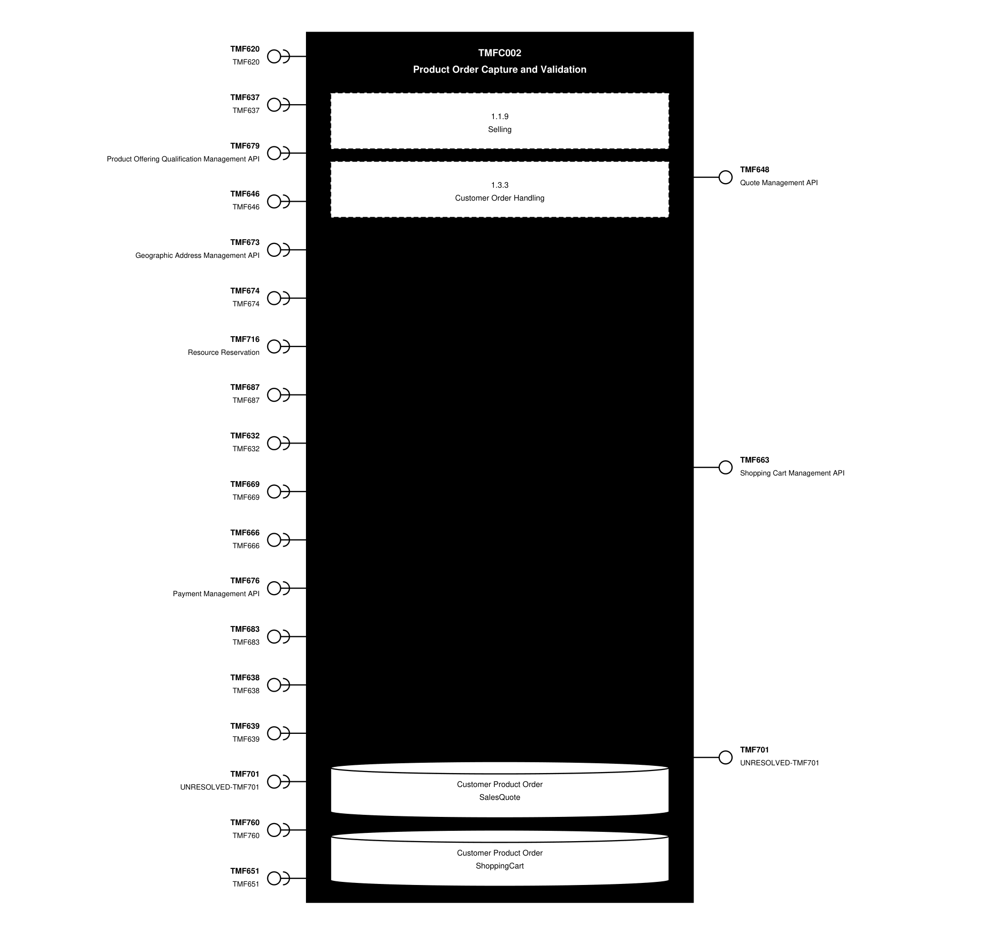
API Context diagram

Exposed APIs
API ID | API Name | Mandatory / Optional | API Version | Resource | Operations
TMF648 | Quote Management API | Optional | 4 | quote | POST  GET  GET /id  PATCH  DELETE
TMF663 | Shopping Cart Management API | Mandatory | 5 | shoppingCart | GET  GET /id  POST  PATCH  DELETE
TMF663 | Shopping Cart Management API | Mandatory | 4 | shoppingCart | POST  GET  GET /id  PATCH  DELETE
TMF701 | UNRESOLVED-TMF701 | Optional | 4 | processFlow  taskFlow | POST  GET  GET /id  DELETE  PATCH

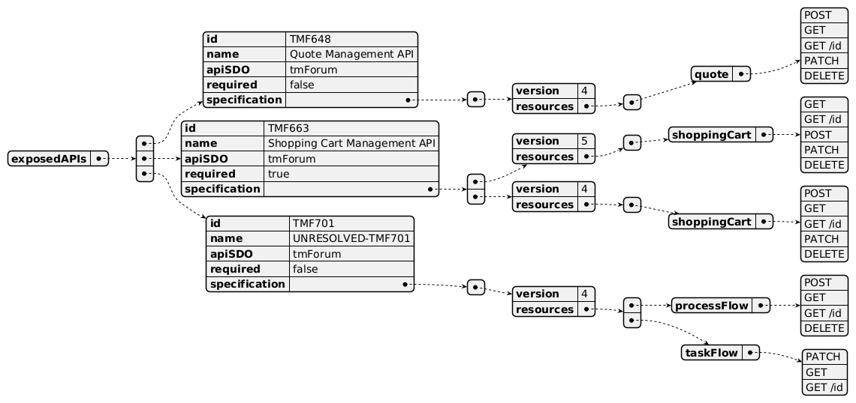
Exposed API diagram

Dependent APIs
API ID | API Name | API Version | Mandatory / Optional | Resource | Operations
TMF620 | TMF620 | 5 | Mandatory | productOffering  productOfferingPrice  productSpecification | GET  GET /id
TMF620 | TMF620 | 4 | Mandatory | productCategory  productOffering  productOfferingPrice  productSpecification | GET  GET /id
TMF637 | TMF637 | 5 | Mandatory | product | GET  GET /id  POST  PATCH
TMF637 | TMF637 | 4 | Mandatory | product | GET  GET /id  POST  PATCH
TMF679 | Product Offering Qualification Management API | 4 | Optional | productOfferingQualification | GET  GET /id  POST  PATCH
TMF646 | TMF646 | 4 | Optional | appointment  searchTimeSlot | GET  GET /id  POST  PATCH  DELETE
TMF673 | Geographic Address Management API | 4 | Optional | geographicAddress  geographicSubAddress  geographicAddressValidation | GET  GET /id  POST  PATCH
TMF674 | TMF674 | 4 | Optional | geographicSite | GET  GET /id
TMF716 | Resource Reservation | 4 | Optional | resourceReservation  cancelResourceReservation | GET  GET /id  POST  PATCH  DELETE
TMF687 | TMF687 | 4 | Optional | checkProductStock  queryProductStock  reserveProductStock  productStock | GET  GET /id  POST  DELETE
TMF632 | TMF632 | 5 | Optional | individual  organization | GET  GET /id
TMF632 | TMF632 | 4 | Optional | individual  organization | GET  GET /id
TMF669 | TMF669 | 5 | Optional | partyRole | GET  GET /id
TMF669 | TMF669 | 4 | Optional | partyRole | GET  GET /id
TMF666 | TMF666 | 5 | Optional | billingAccount | GET  GET /id
TMF666 | TMF666 | 4 | Optional | billingAccount | GET /id  GET
TMF676 | Payment Management API | 4 | Optional | payment | GET /id  GET
TMF683 | TMF683 | 5 | Optional | partyInteraction | GET  GET /id
TMF683 | TMF683 | 4 | Optional | partyInteraction | GET /id  GET
TMF638 | TMF638 | 5 | Optional | service | GET  GET /id
TMF638 | TMF638 | 4 | Optional | service | GET /id  GET
TMF639 | TMF639 | 4 | Optional | resource | GET /id  GET
TMF701 | UNRESOLVED-TMF701 | 4 | Optional | processFlow  taskFlow | POST  PATCH  GET  GET /id
TMF760 | TMF760 | 5 | Optional | checkProductConfiguration  queryProductConfiguration | GET  GET /id  POST
TMF651 | TMF651 | 4 | Optional | agreement | GET  GET /id

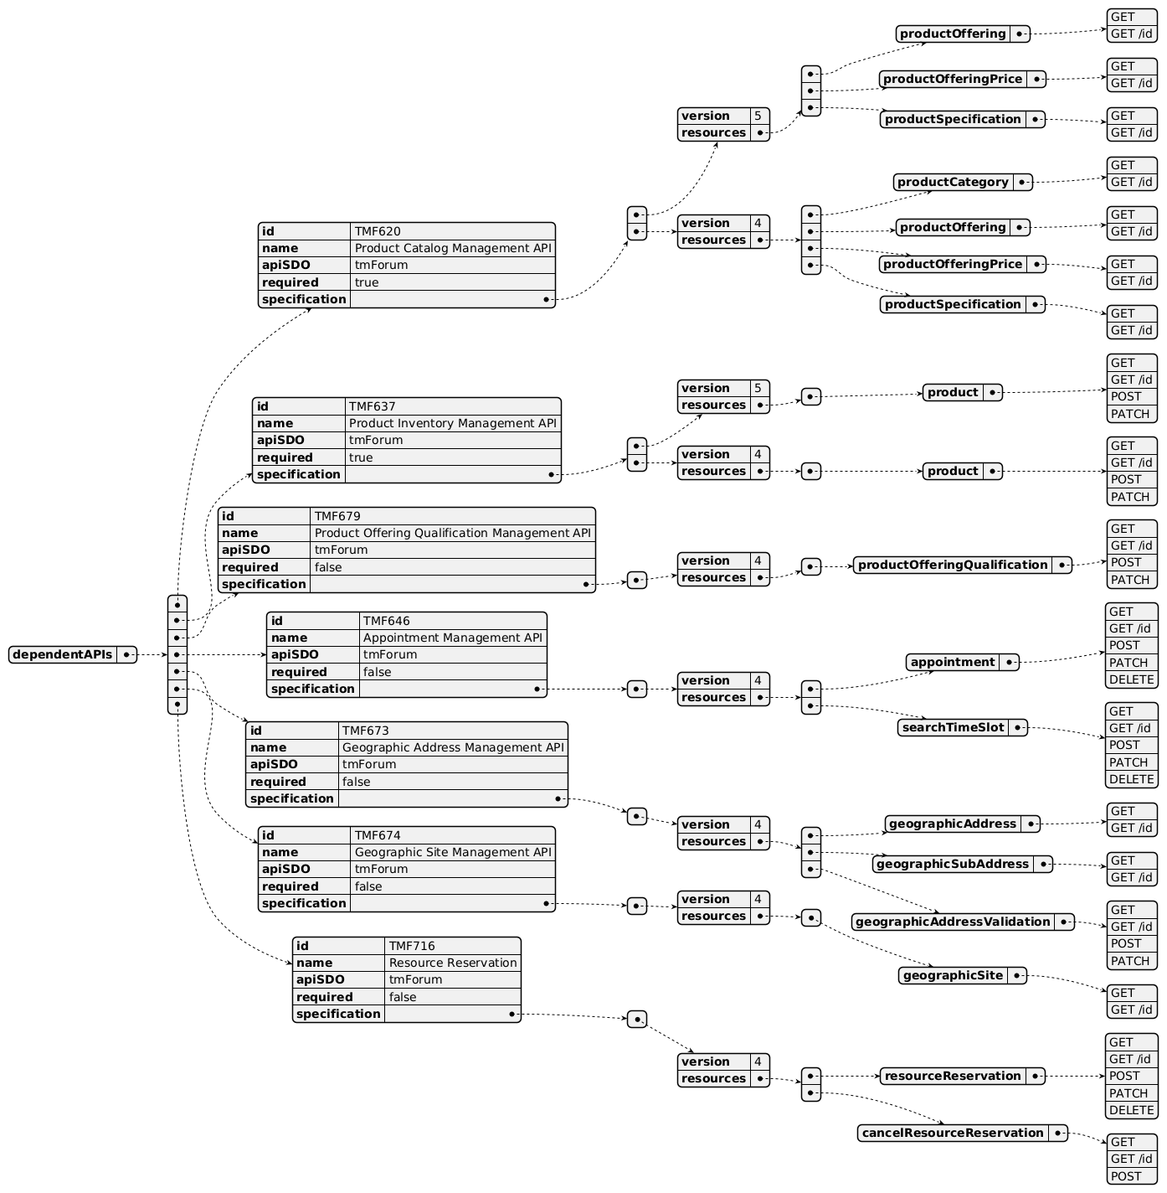
Dependent API diagram (1 of 2)
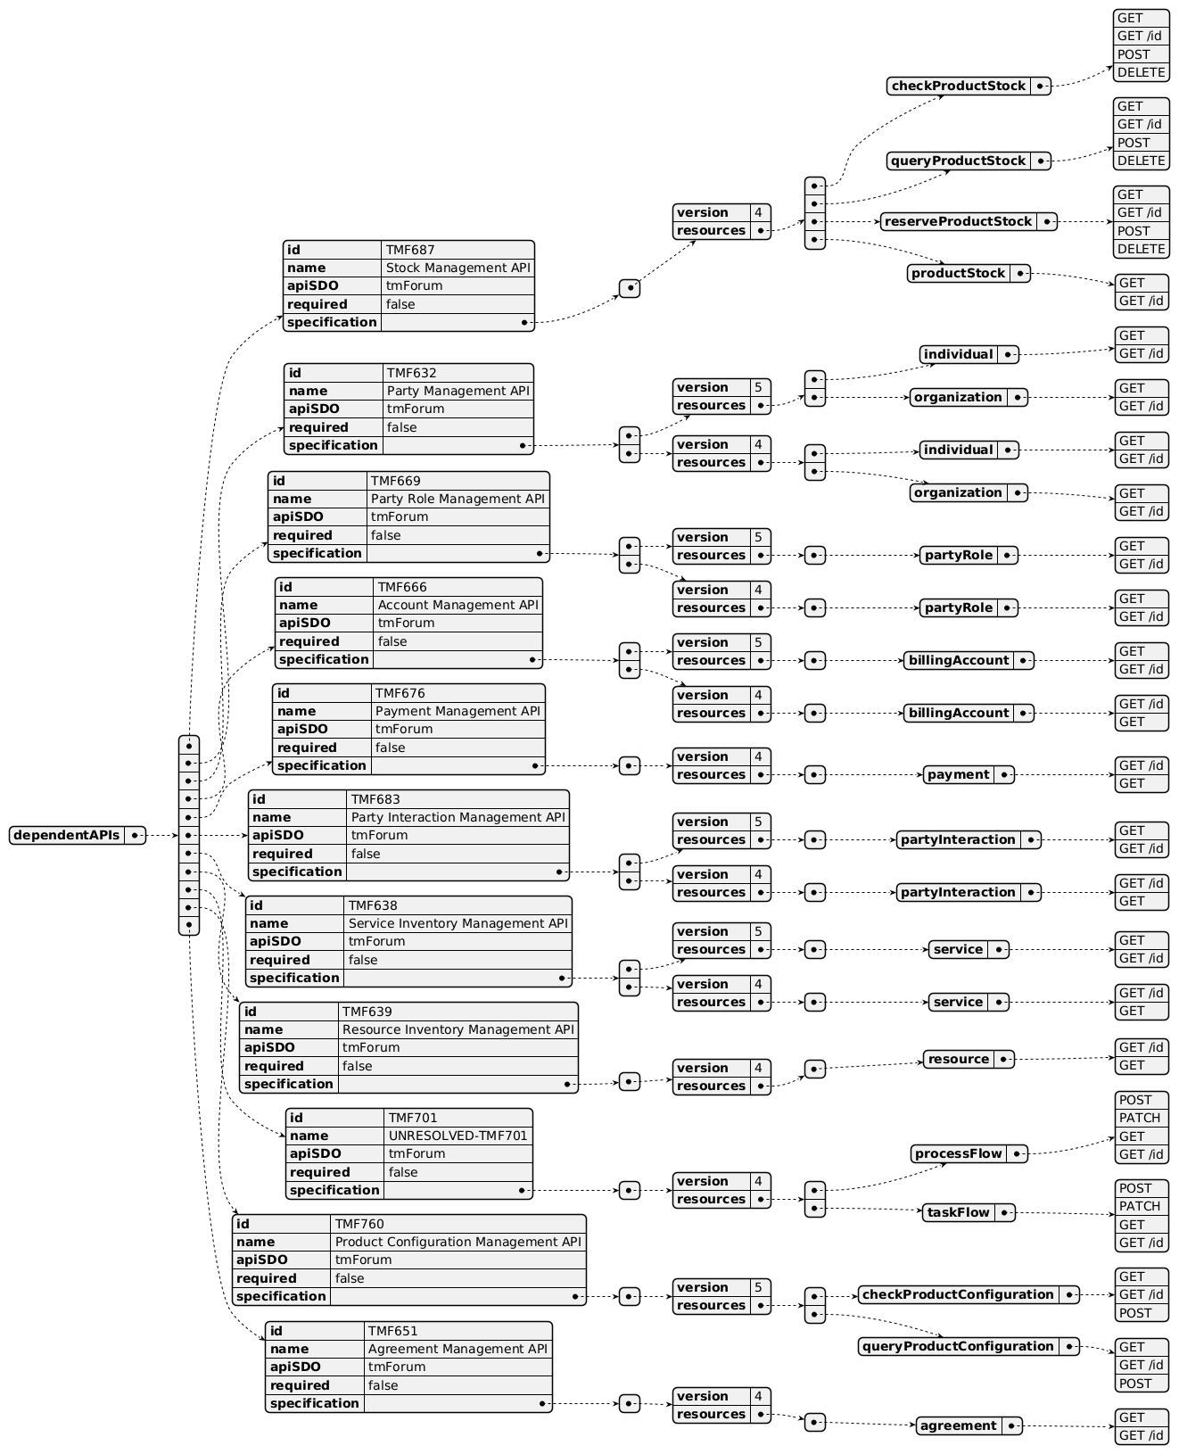
Dependent API diagram (2 of 2)

Events
The diagram illustrates the Events which the component may publish and the Events that the component may subscribe to and then may receive. Both lists are derived from the APIs listed in the preceding sections.

Published Events
API ID | API Name | Event Resources
TMF648 | Quote Management API | quoteStateChangeEvent  quoteCreateEvent  quoteAttributeValueChangeEvent  quoteDeleteEvent  quoteInformationRequiredEvent
TMF663 | Shopping Cart Management API | shoppingCartCreateEvent  shoppingCartAttributeValueChangeEvent  shoppingCartDeleteEvent
TMF701 | UNRESOLVED-TMF701 | processFlowCreateEvent  processFlowStateChangeEvent  processFlowStateDeleteEvent  processFlowStateAttributeValueChangeEvent  taskFlowCreateEvent  taskFlowStateChangeEvent  taskFlowDeleteEvent  taskFlowAttributeValueChangeEvent  taskFlowInformationRequiredEvent

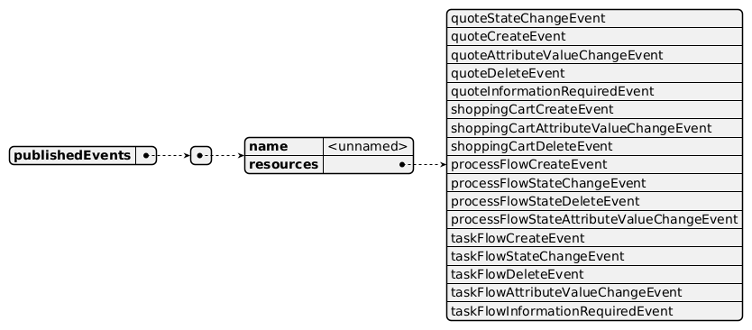
Published Events diagram

Subscribed Events
API ID | API Name | Event Resources
TMF679 | Product Offering Qualification Management API | productOfferingQualificationStateChangeEvent
TMF673 | Geographic Address Management API | geographicAddressValidationStateChangeEvent
TMF676 | Payment Management API | paymentCreateEvent  paymentStateChangeEvent
TMF716 | Resource Reservation | resourceReservationCreateEvent  resourceReservationAttributeValueChangeEvent  resourceReservationDeleteEvent  resourceReservationStateChangeEvent  resourceReservationInformationRequiredEvent  cancelResourceReservationCreateEvent  cancelResourceReservationStateChangeEvent  cancelResourceReservationInformationRequiredEvent

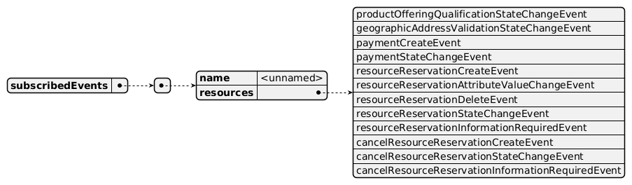
Subscribed Events diagram

Machine Readable Component Specification
Refer to the ODA Component Directory on the TM Forum website for the machine-readable component specification files for this component.

References

TMF Standards related versions
Standard | Version(s)
eTOM | v23.0
SID | v25.0
Functional Framework | v23.0

Jira References
eTOM

Review L2 1.2.9 - Product Offering Purchasing and clarify L3 definitions and inbound / outbound terminology; delete L3 1.2.9.8 - Report Product Offering Purchase as redundant with 1.3.3.6 - Report Customer Order Handling and 1.6.8.6 - Report Business Partner Orders

Review L3 1.3.3.4 - Complete Customer Order definition as it mixed customer information, customer contracts and service orders. Also review L3 1.3.3.7 - Close Customer Order definition and clarify close/complete terminology and link with 1.3.3.4 - Complete Customer Order (do we need 2 L3?)

1.3.3.8 - Manage Order Fallout: as this L3 is shared by POCV and POOM components (to be consistent with Functional Framework mapping), clarify which type of fallout needs to be managed during the order delivery orchestration (at POOM level) and which needs to be managed at Product Order Capture and Follow-Up level (by POCV)
SID *(none currently listed)*
Functional Framework These updates need to be studied for R22.0 or R22.5:

Function 204 - Customer Order Completion: rename the function "Customer Order Entry Finalization" as "completion" is confusing here

Function 269 - Installation Preference Configuration: review the definition of this function or delete it (why limited to installation? Why a dedicated function to provide an interface for the customer to capture a set of information?)

Add function(s) to describe the closure step of the customer order

Function 934 - Sales Negotiation Support: review definition and delete part related to service order generation
API

How can we trigger the Product Configurator for configuration? Refer to Jira detailed in Product Configurator specifications

How can we evaluate Customer Credit (refer to Function 205 for definition): can this check be added in TMF696 - Risk Management API?

AP-6002 - TMF696 - create real Task resource(s) (BACKLOG)

How can we manage/represent mass operations in general, and mass transaction ordering in particular?

[AP-6617] TMF622 - specialize ProductOrderItem for ProductSpecification and ProductOffering - TM Forum Jira

Further resources
This component is involved in use cases described in IG1228 How to use ODA - Using Open APIs to realize Use Cases.

Administrative Appendix

Document History

Version History
Version Number | Date | Modified by | Description of changes
1.0.0 | 29-Mar-2022 | Gaetano Biancardi, Anastasios Sarantis, Sylvie Demarest, Emmanuel A. Otchere | First version of document
1.0.1 | 25-Jul-2023 | Ian Turkington | No content changed, simply a layout change to match template 3. Separated the YAML files to a managed repository.
2.0.1 | 19-Aug-2024 | Sylvie Demarest | Updated Component Template; Jira reference AP-6617 added to section 5.2.4 as requested by Olivier Arnaud; final edits prior to publication
2.0.1 | 06-Sep-2024 | Amaia White | Final edits prior to publication
2.1.0 | 12-Nov-2024 | Gaetano Biancardi | API version, only major version to be specified
2.1.0 | 26-Nov-2024 | Amaia White | Final edits prior to publication
2.1.1 | 08-Jul-2025 | Rosie Wilson | Updates to description per agreed YAML updated on 03-Jun-2025; Jira reference AP-6617 added to section 5.2.4 as requested by Olivier Arnaud; final edits prior to publication

Release History
Release Status | Date Modified | Modified by | Description of changes
Pre-production | 29-Mar-2022 | Goutham Babu | Initial release
Production | 20-May-2022 | Adrienne Walcott | Updated to reflect TM Forum Approved status
Pre-production | 14-Aug-2023 | Amaia White | New release 1.0.1
Production | 06-Oct-2023 | Adrienne Walcott | Updated to reflect TM Forum Approved status
Pre-production | 06-Sep-2024 | Amaia White | New release 2.0.1
Production | 01-Nov-2024 | Adrienne Walcott | Updated to reflect TM Forum Approved status
Pre-production | 26-Nov-2024 | Amaia White | New release 2.1.0
Production | 07-Mar-2025 | Adrienne Walcott | Updated to reflect TM Forum Approved status
Pre-production | 08-Jul-2025 | Rosie Wilson | New release 2.1.1

Acknowledgements
Team Member | Company | Role
Gaetano Biancardi | Accenture | Reviewer
Anastasios Sarantis | Vodafone | Reviewer
Sylvie Demarest | Orange | Editor
Elisabeth Andersson | MATRIXX | Reviewer
Emmanuel A. Otchere | Huawei | Additional Input
Ian Turkington | TM Forum | Additional Input
Hugo Vaughan (TM Forum) | TM Forum | Additional Input
Abinash Vishwakarma | Netcracker | Reviewer
Jose Macaluso | Xacria | Reviewer
Kamal Maghsoudlou | Ericsson | Reviewer
Milind Bhagwat | BT | Reviewer
Ritu Arora | BT | Reviewer
Matteo Destino | Accenture | Reviewer
Rosie Wilson | TM Forum | Additional Input

