TMFC005 Product Inventory v1.1.4
Components and Canvas
In this deliverable:

Overview
Component Name | ID | Description | ODA Function Block
Product Inventory | TMFC005 | The Product Inventory component is responsible for storage and exposure of products that are assigned to and used by Parties. This component has functionality that enables creation of inventory items, inventory organization, inventory search or filter, inventory monitoring and tracking, inventory control and inventory auditing. The minimum check to be performed upon inventory item creation or update is for global consistency with related Product Catalog information. | Core Commerce

eTOM Processes, SID Data Entities and Functional Framework Functions

eTOM business activities
eTOM business activities this ODA Component is responsible for:
Identifier | Level | Business Activity Name | Description
1.2.11 | L2 | Product Inventory Management | Product Inventory Management is responsible to establish, manage and administer the enterprise's product inventory, as embodied in the Product Inventory repository, and monitor and report on the usage and access to the product inventory.
1.1.19 | L2 | Loyalty Program Management | Define all aspects of a loyalty program, such as requirements and objectives of a loyalty program, determine the benefits to participants. Develop a program, prototype it, test it, rollout/launch it, amend and evaluate it, and terminate it when it is no longer viable for an enterprise.
1.1.19.2 | L3 | Loyalty Program Operation | Manage all operational aspects of running a loyalty program. Enable parties to become a members of a program, earn currency and rewards, and redeem currency. Manage a loyalty program account, leave a program, and provide operational reports.
1.1.19.2.5 | L4 | Manage Loyalty Program Account | Update a loyalty program account and make changes to loyalty program participant information. Expire, reinstate, transfer in/out, adjust, a loyalty participant's account currency. Prepare and send a loyalty program communication to a participant or for internal use by an enterprise.
1.1.19.2.7 | L4 | Provide Loyalty Program Operation Report | Generate a loyalty program operation report, such as various loyalty program status reports, trend analysis, and reports that identify suspected abuse of a loyalty program.

SID ABEs
SID ABEs this ODA Component is responsible for:
SID ABE Level 1 | SID ABE Level 2 (or set of BEs) | SID ABE L1 Definition | SID ABE L2 Definition
Product and Offering Instance | Product | Product and ProductOfferingInstance represent, in the product inventory, respectively an instance of a ProductSpecification and ProductOfferindSpecification subscribed or not yet subscribed to by a Customer from the CSP or by the CSP from a BusinessPartner. The Product carries the place where the product is in use, as well as configuration characteristics, such as assigned telephone numbers and internet addresses. The Product and Offering Instance ABE also tracks the links to services and/or resources through which the Product is realized as well as the applied tariff and commitment duration related to the ProductOfferingInstance. | Represents an instance in the product inventory of a ProductSpecification subscribed or not yet subscribed by a Customer to the CSP or by the CSP to a BusinessParnter, the place where the product is in use, as well as configuration characteristics, such as assigned telephone numbers and internet addresses. It may come from a CustomerProductOrderItem or a BusinessPartnerOrderItem. At one time, it might be contained in a unique ProductOfferingInstance. The Product ABE also tracks the links to services and/or resources through which the product is realized. The Product ABE also contains detailed concerning Network Products and Usage Volume Products as well as other examples of Products.
Product and Offering Instance |  | Product and ProductOfferingInstance represent, in the product inventory, respectively an instance of a ProductSpecification and ProductOfferindSpecification subscribed or not yet subscribed to by a Customer from the CSP or by the CSP from a BusinessPartner. The Product carries the place where the product is in use, as well as configuration characteristics, such as assigned telephone numbers and internet addresses. The Product and Offering Instance ABE also tracks the links to services and/or resources through which the Product is realized as well as the applied tariff and commitment duration related to the ProductOfferingInstance. | *(no description available)*
Loyalty | Loyalty Program | A loyalty program is one of the tools used by the loyalty process to retain customers. The Loyalty ABE contains all entities useful to specify and instantiate loyalty programs. A LoyaltyProgramProdSpec defines the LoyaltyRules that have to be checked in order to identify the actions to apply. Depending on the type of LoyaltyRules a LoyaltyAccount might be needed to collect gains or not. A LoyaltyProgramProduct is a type of ProductComponent and described by a LoyaltyProgramProdSpec. | The Loyalty Program ABE contains all entities needed to instantiate a loyalty program for a specific customer such as LoyaltyProgram and LoyaltyAccount.

eTOM L2 - SID ABEs links
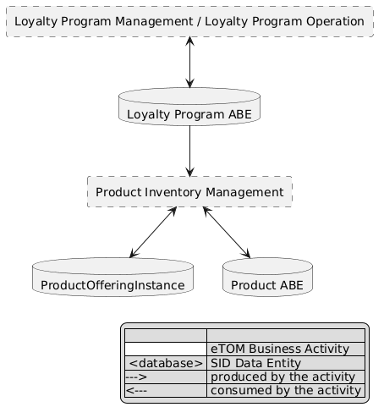
eTOM L2 - SID ABEs links diagram

Functional Framework Functions
Function ID | Function Name | Function Description | Aggregate Function Level 1 | Aggregate Function Level 2
180 | Assigned Products Maintenance | Assigned Products Maintenance permits defining and update: / - product characteristics / - links with the related service or resource (handsets, SIM cards, ...) needed to deliver the product, ... | Product Management | Product Repository Management
197 | Customer Product Storage | Product Storage provides the functionality necessary to store and make available the Products. / This function allows: / • to instantiate or update offers and products ordered by the customer, whatever their type (network product, bundle, device, …) or their marketing mode (rented, sold, …), with their configuration, their tariffs and discounts, and their status (initialized with a creation order) / • to update Products status / • to search and read Offer and Product installed base (subscribed offers, configuration of installed products, installed tariffs and discount, statuses, …). | Product Management | Product Repository Management
198 | Customer Loyalty Score Balance Management | Customer Loyalty Score Balance Management function calculates the score according to accumulation/decrease rules. When a customer subscribes to the loyalty program with more than one SIM or other ‘traffic objects’, the Score Management accumulates the points into a single balance. The loyalty score could decrease for one of the following events: prize purchase, points expiry or points deletion by Call Centre. The functionality may also include the visualization of Score details (date, description event type, points, final score) via different contact Channels (e.g. via Web, IVR, Call Centre). | Product Management | Loyalty Account Management
237 | Customer Loyalty Communication | Customer Loyalty Communication function sends information related to Loyalty Programs (Point Balance, Prize Request status, renewed Loyalty Code) to external components in push and pull modes. | Product Management | Loyalty Account Management
361 | Contract Implementation | Product Agreement Implementation function provides functionality pertaining to the implementation of the Product Agreement (a.k.a. contract) across fulfillment, assurance, and billing according to Product Agreement Specification. / A Product Agreement represents the approval by the Customer and the Vendor of all term or conditions of a ProductOffering. | Product Management | Product Agreement Management
362 | Contract Searching | *(no description available in the source document or the Functional Framework spreadsheets)* | *(no description available)* | *(no description available)*
363 | Contract Storage | Contract Storage provides the central repository for contract storage as well as the associated contract meta-data. This data can be mined for Campaigns and Lead Generation. / Product Agreement Storage provides functionality necessary to store and make available the Product Agreements. / This function allows: / • to instantiate or update Product Agreement approved by the customer with their party involved, their configuration, their approvals and their status, / • to update Product Agreements status, / • to search and read Product Agreements. | Product Management | Product Agreement Management
1201 | Product Configuration Check | Product Configuration Check Function Checks for each Product submitted if all Product configuration rules have been respected such as prerequisite, incompatibility rules between ProductSpecifications or mandatory characteristics. | Product Management | Product Repository Management

TM Forum Open APIs & Events
The following part covers the APIs and Events; this part is split in 3:

List of Exposed APIs - This is the list of APIs available from this component.

List of Dependent APIs - In order to satisfy the provided API, the component could require the usage of this set of required APIs.

List of Events (generated & consumed) - The events which the component may generate are listed in this section along with a list of the events which it may consume. Since there is a possibility of multiple sources and receivers for each defined event.

API Context Diagram
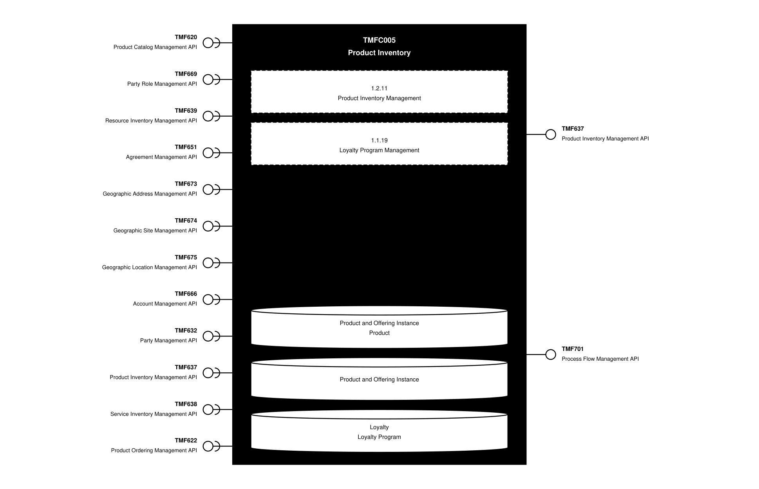
API Context diagram

Exposed APIs
API ID | API Name | Mandatory / Optional | API Version | Resource | Operations
TMF637 | Product Inventory Management API | Mandatory | 5 | product | GET  GET /id  POST  PATCH  DELETE
TMF637 | Product Inventory Management API | Mandatory | 4 | product | GET  GET /id  POST  PATCH  DELETE
TMF701 | Process Flow Management API | Optional | 4 | processFlow  taskFlow | POST  GET  GET /id  DELETE  PATCH

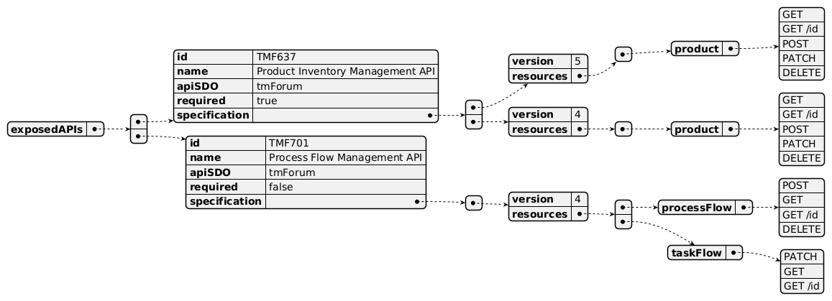
Exposed API diagram

Dependent APIs
API ID | API Name | API Version | Mandatory / Optional | Resource | Operations
TMF620 | Product Catalog Management API | 5 | Mandatory | productOffering  productOfferingPrice  productSpecification | GET  GET /id
TMF620 | Product Catalog Management API | 4 | Mandatory | productSpecification  productOffering  productOfferingPrice | GET  GET /id
TMF669 | Party Role Management API | 5 | Optional | partyRoleManagement | GET  GET /id
TMF669 | Party Role Management API | 4 | Optional | PartyRoleManagement | GET  GET /id
TMF639 | Resource Inventory Management API | 4 | Optional | resource | GET  GET /id
TMF651 | Agreement Management API | 4 | Optional | agreement | GET  GET /id
TMF673 | Geographic Address Management API | 4 | Optional | geographicAddress  geographicSubAddress | GET  GET /id
TMF674 | Geographic Site Management API | 4 | Optional | geographicSite | GET  GET /id
TMF675 | Geographic Location Management API | 4 | Optional | geographicLocation | GET  GET /id
TMF666 | Account Management API | 5 | Optional | billingAccount | GET  GET /id
TMF666 | Account Management API | 4 | Optional | billingAccount | GET  GET /id
TMF632 | Party Management API | 5 | Optional | individual  organization | GET  GET /id
TMF632 | Party Management API | 4 | Optional | individual  organization | GET  GET /id
TMF637 | Product Inventory Management API | 5 | Optional | product | GET  GET /id  POST  PATCH  DELETE
TMF637 | Product Inventory Management API | 4 | Optional | product | GET  GET /id  POST  PATCH  DELETE
TMF638 | Service Inventory Management API | 5 | Optional | service | GET  GET /id
TMF638 | Service Inventory Management API | 4 | Optional | service | GET  GET /id
TMF622 | Product Ordering Management API | 5 | Optional | productOrder | GET  GET /id
TMF622 | Product Ordering Management API | 4 | Optional | productOrder | GET  GET /id

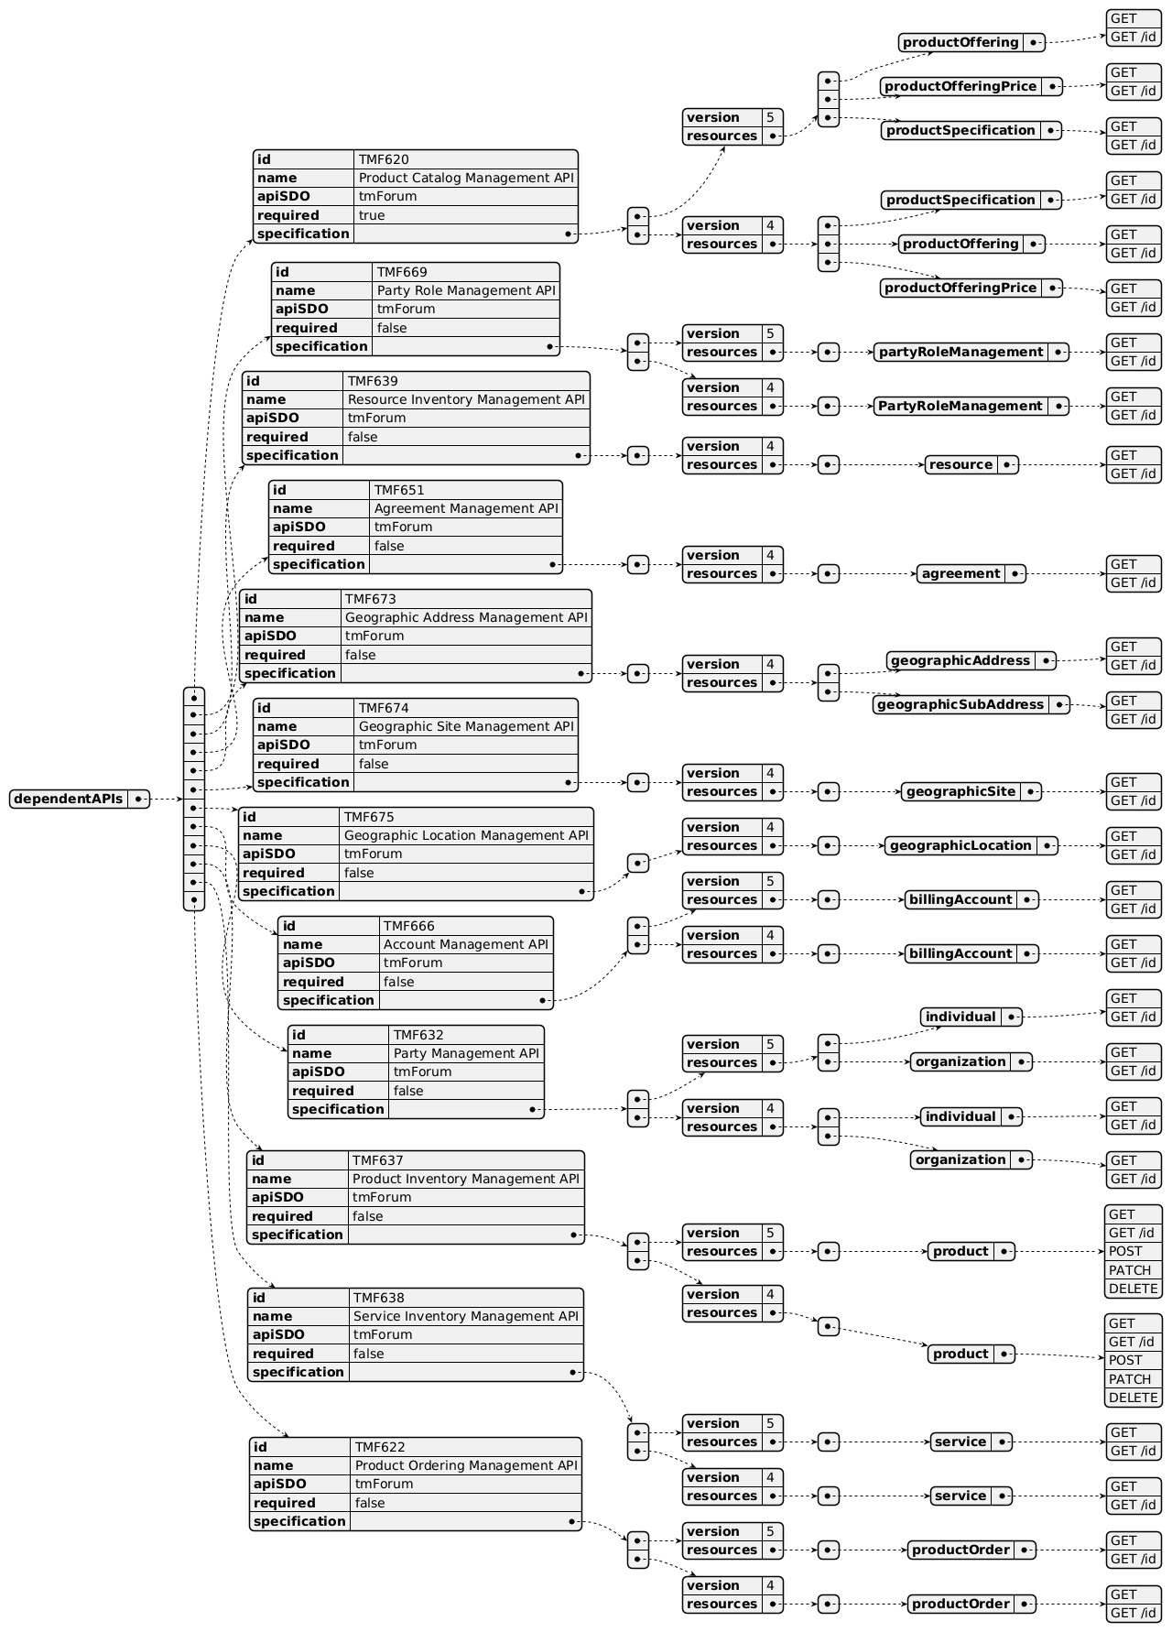
Dependent API diagram

Events
The diagram illustrates the Events which the component may publish and the Events that the component may subscribe to and then may receive. Both lists are derived from the APIs listed in the preceding sections.

Published Events
API ID | API Name | Event Resources
TMF637 | Product Inventory Management API | productCreateEvent  productAttributeValueChangeEvent  productStateChangeEvent  productDeleteEvent  productBatchEvent
TMF701 | Process Flow Management API | processFlowCreateEvent  processFlowStateChangeEvent  processFlowStateDeleteEvent  processFlowStateAttributeValueChangeEvent  taskFlowCreateEvent  taskFlowStateChangeEvent  taskFlowDeleteEvent  taskFlowAttributeValueChangeEvent  taskFlowInformationRequiredEvent

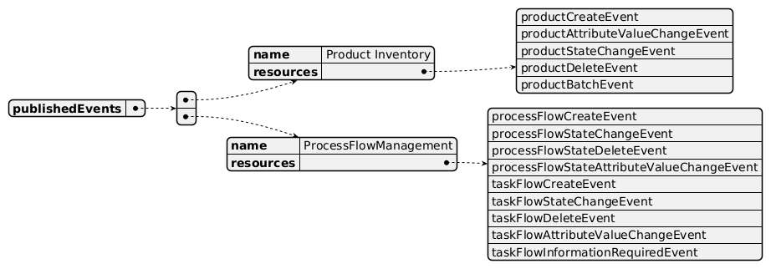
Published Events diagram

Subscribed Events
API ID | API Name | Event Resources
TMF639 | Resource Inventory Management API | resourceDeleteEvent
TMF638 | Service Inventory Management API | serviceDeleteEvent
TMF620 | Product Catalog Management API | productSpecificationDeleteEvent  productOfferingDeleteEvent  productOfferingPriceDeleteEvent
TMF669 | Party Role Management API | partyRoleDeleteEvent
TMF651 | Agreement Management API | agreementDeleteEvent
TMF666 | Account Management API | billingAccountDeleteEvent
TMF672 | User Role Permission Management API | permissionDeleteEvent
TMF674 | Geographic Site Management API | geographicSiteDeleteEvent
TMF675 | Geographic Location Management API | geographicLocationDeleteEvent
TMF632 | Party Management API | individualDeleteEvent  organizationDeleteEvent
TMF622 | Product Ordering Management API | productOrderDeleteEvent
TMF637 | Product Inventory Management API | productCreateEvent  productDeleteEvent  productAttributeValueChangeEvent  productStateChangeEvent

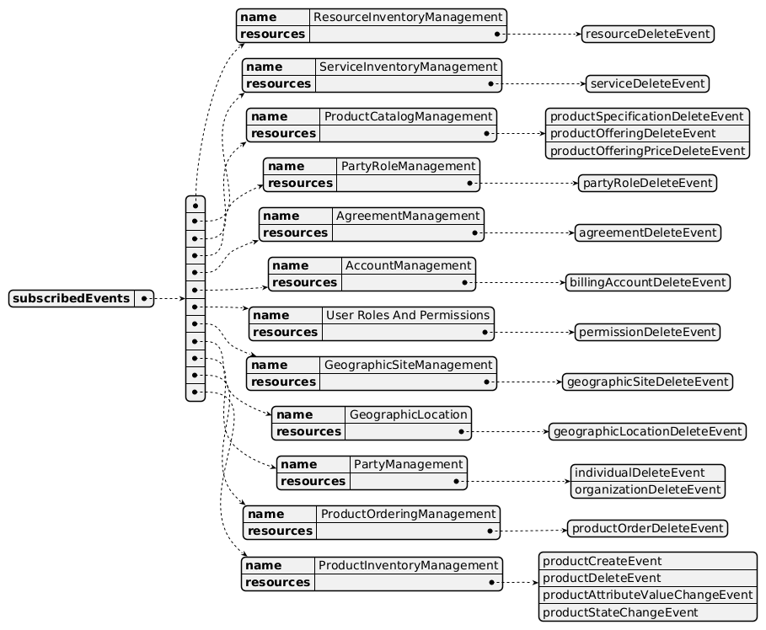
Subscribed Events diagram

Machine Readable Component Specification
Refer to the ODA Component Directory on the TM Forum website for the machine-readable component specification files for this component.

References

TMF Standards related versions
Standard | Version(s)
eTOM | v24.0
SID | v25.0
Functional Framework | v24.0

Jira References
eTOM

https://projects.tmforum.org/jira/browse/ISA-413 L2 - Loyalty Program Management (1.1.19): review positioning of L2 (why in Market & Sales and not in Product) and detailed L3 and L4
SID *(none currently listed)*
Functional Framework

https://projects.tmforum.org/jira/browse/ISA-415 Add a function to check data integrity at Product level, including mandatory relationships.

https://projects.tmforum.org/jira/browse/ISA-414 Clarify functions using "contract" in their name and/or definition as globally at product level (instantiation of Product Offering or Product Specification).

https://projects.tmforum.org/jira/browse/ISA-416 Harmonize as much as possible functions related to Product, Service and Resource Inventory
API

TMF637 - Product Inventory Management: list missing information and relationship as Loyalty Account

https://projects.tmforum.org/jira/browse/AP-3844

https://projects.tmforum.org/jira/browse/AP-3139

TMF637 Product Inventory Management: list missing information related to SID ABE productOfferingInstance

https://projects.tmforum.org/jira/browse/AP-7096

ProductPriceCharge should be managed by this component, including all specialization of ProductPriceCharge (oneTime, recurring, usage...)

See https://projects.tmforum.org/jira/browse/ISA-1369

Further resources
This component is involved in the following use cases described in IG1228 How to use ODA - Using Open APIs to realize Use Cases.

Administrative Appendix

Document History

Version History
Version Number | Date | Modified by | Description of changes
1.0.0 | 31-May-2022 | Kamal Maghsoudlou, Sylvie Demarest | Final edits prior to publication
1.0.1 | 25-Jul-2023 | Ian Turkington | No content changed, simply a layout change to match template 3. Separated the YAML files to a managed repository.
1.0.1 | 14-Aug-2023 | Amaia White | Final edits prior to publication
1.0.2 | 11-Jun-2024 | Sylvie Demarest | Updated Component Template. Aligned to Frameworks 23.5
1.0.3 | 28-Mar-2025 | Gaetano Biancardi | Correct typo in Exposed API diagram
1.0.3 | 08-Jul-2025 | Rosie Wilson | Updates to description per agreed YAML updated on 03 Jun 2025. Final edits prior to publication
1.0.4 | 30-Sep-2025 | julien rouland | Update to reflect productOfferingInstance ABE as mentioned in ISA-414 - Clarify Product Inventory Mgt sub-domain vocabulary SME REVIEW
1.0.4 | 19-Nov-2025 | Rosie Wilson | Final edits prior to publication
1.0.4 | 16-Jan-2026 | Adrienne Walcott | Updated to reflect TM Forum Approved status
1.1.0 | 28-April-2026 | Hugo Vaughan (TM Forum) | Gen 5 API incorporation
1.1.0 | 25-Jun-2025 | Sannah Sibaya | Final edits prior to publication

Release History
Release Status | Date Modified | Modified by | Description of changes
Pre-production | 31-May-2022 | Goutham Babu | Initial release
Production | 22-Jul-2022 | Adrienne Walcott | Updated to reflect TM Forum Approved Status
Pre-production | 14-Aug-2023 | Amaia White | New release 1.0.1
Production | 06-Oct-2023 | Adrienne Walcott | Updated to reflect TM Forum Approved status
Pre-production | 12-Jul-2024 | Amaia White | New release 1.0.2
Production | 30-Aug-2024 | Adrienne Walcott | Updated to reflect TM Forum Approved status
Pre-production | 08-Jul-2025 | Rosie Wilson | New release 1.0.3
Production | 05-Sep-2025 | Adrienne Walcott | Updated to reflect TM Forum Approved status
Pre-production | 19-Nov-2025 | Rosie Wilson | New release 1.0.4
Production | 16-Jan-2026 | Adrienne Walcott | Updated to reflect TM Forum Approved status
Pre-production | 01-Jun-2026 | Sannah Sibaya | New release 1.1.0; final edits prior to publishing

Acknowledgements
This document was prepared by the members of the TM Forum ODA Components & Canvas team.
Team Member | Company | Role
Kamal Maghsoudlou | Ericsson | Editor
Sylvie Demarest | Orange | Editor
Ian Turkington | TM Forum | Additional Input
Hugo Vaughan (TM Forum) | TM Forum | Additional Input
Gaetano Biancardi | Accenture | Additional Input / Reviewer
Abinash Vishwakarma | Netcracker | Reviewer
Jose Macaluso | Xacria | Reviewer
Kamal Maghsoudlou | Ericsson | Reviewer
Milind Bhagwat | BT | Reviewer
Ritu Arora | BT | Reviewer
Matteo Destino | Accenture | Reviewer
julien rouland | Orange | Additional Input / Reviewer

