TMFC006 Service Catalog Management v1.3.0
Components and Canvas
In this deliverable:

Overview
Component Name | ID | Description | ODA Function Block
Service Catalog Management | TMFC006 | This Component has conformance testing for v4 APIs only at this point. The Service Catalog Management component is responsible for organizing the collection of service specifications that identify and define all requirements of a service that can be performed. This component has the functionality that enables presentation of a customer-facing view so users are able to search and select services they need, as well as a technical view to enable definition and setup of what is needed to deliver service specifications (Customer Facing Service Specifications (CFSSs) and Resource Facing Service Specifications (RFSSs)) contained in the service catalog. The Service Catalog Management component has functionalities that include creation of new service specifications, managing service specifications, administering the lifecycle of services, describing relationships between service specification attributes, reporting on service specifications and their changes, and facilitating easy and systematic indexing and access to services, as well as facilitating automation of the service delivery process. | Production

eTOM Processes, SID Data Entities and Functional Framework Functions

eTOM business activities
eTOM business activities this ODA Component is responsible for:
Identifier | Level | Business Activity Name | Description
1.4.13 | L2 | Service Catalog Lifecycle Management | Catalog Lifecycle Management business process covers a set of business activities that enable manage the lifecycle of an organizations catalog from design to build according to defined requirements.
1.4.14 | L2 | Service Catalog Operational Readiness Management | Service Catalog Operational Readiness Management business process establishes and administers the support needed to operationalize Service catalogs for ongoing day-to-day business needs.
1.4.15 | L2 | Service Catalog Content Management | Service Catalog Content Management business process define and provide the business activities that support the day-to-day operations of Service Catalogs in order to realize the business operations goals.
1.4.16 | L2 | Service Catalog Planning Management | Service Catalog Planning Management business process covers a set of business activities that understand and enable establish the plan to define, design and operationalize a catalog in order to meet the needs and objectives of Service cataloging. / The Service Catalog Planning Management business process ensure that the organization is able to identify the most appropriate scheme and goal for it catalog. It includes designing the Catalog plan and developing the specification according to Service management requirement.
1.4.19 | L2 | Service Specification Management | Service Specification Management business process leverages captured service requirements to develop, master, analyze, and update documented standard conditions that must be satisfied by service design and/or delivery. / Service Specifications Management can result in establishing, in a centralized way, technical (know-how) standards. / Such standards provide the organization with a means to control and approve the values and inputs of service specification through structure, review, approval and distribution processes to stakeholders and suppliers.
1.4.3 | L2 | Service Specification Development & Retirement | Service Specification Development & Retirement processes are project oriented in that they develop and deliver new or enhanced service types. These processes include process and procedure implementation, systems changes and customer documentation. They also undertake rollout and testing of the service type, capacity management and costing of the service type. It ensures the ability of the enterprise to deliver service types according to requirements.
1.4.3.4 | L3 | Develop Detailed Service Specifications | The Develop Detailed Service Specifications processes develop and document the detailed service-related technical and operational specifications, and customer manuals. These processes develop and document the required service features, the specific underpinning resource requirements and selections, the specific operational, and quality requirements and support activities, any service specific data required for the systems and network infrastructure as agreed through the Develop New Service Business Proposal processes. The Develop Detailed Product Specifications processes provide input to these specifications. The processes ensure that all detailed specifications are produced and appropriately documented. Additionally, the processes ensure that the documentation is captured in an appropriate enterprise repository.

SID ABEs
SID ABEs this ODA Component is responsible for:
SID ABE Level 1 | SID ABE Level 2 (or set of BEs) | SID ABE L1 Definition | SID ABE L2 Definition
Service Specification |  | The Service Specification ABE contains entities that define the shared characteristics of both types of Service entities. This enables multiple instances to be derived from a single specification entity. In this derivation, each instance will use the characteristics defined in its associated specification. The Service Specification ABE is composed of two main concepts: The CSP Know-Hows specification a.k.a. Customer Facing Services Specification or CFSSpec that describe only functional characteristics and capabilities that the CSP can provide to a customer however the CSP builds on its own all or part of the technical solution. Note that it corresponds only to non-tangible goods. The Technical solution specification a.k.a. Resource Facing Services Specification or RFSpec that describes only technical characteristics and capabilities. Entities in this ABE focus on adherence to standards, distinguishing features of a Service, dependencies (both physical and logical, as well as on other services), quality, and cost. In general, entities in this ABE enable Services to be bound to Products and run using Resources. | *(no description available)*
Service Performance | Service Level Spec | The Service Performance ABE collects information used to correlate, consolidate, and validate various performance statistics and other operational characteristics of Know-Hows (a.k.a. CFS) and Technical Solutions (a.k.a. RFS). It provides a set of entities that enables performance monitoring and reporting. Each of these entities also enables network performance assessment against planned goals, performs various aspects of trend analysis, including error rate and cause analysis and Service degradation. Entities in this ABE also enable the traffic trend analysis. | The Service Specification ABE contains entities that define the invariant characteristics and behavior of both types of Service entities. This enables multiple instances to be derived from a single specification entity. In this derivation, each instance will use the invariant characteristics and behavior defined in its associated template. This ABE includes a third type of Service Specification entity: that of a ServiceLevelSpecification. This type of specification templatizes Services that are bound to a Service Level Agreement.
Service Performance | Service Performance Specification | The Service Performance ABE collects information used to correlate, consolidate, and validate various performance statistics and other operational characteristics of Know-Hows (a.k.a. CFS) and Technical Solutions (a.k.a. RFS). It provides a set of entities that enables performance monitoring and reporting. Each of these entities also enables network performance assessment against planned goals, performs various aspects of trend analysis, including error rate and cause analysis and Service degradation. Entities in this ABE also enable the traffic trend analysis. | The Service Performance Specification ABE defines measure of the manner in which a Service is functioning.
Service Usage | ServiceUsageSpec | The Service Usage ABE represents the specification of Service Usage types and collects Service Usage records with their characteristics (a.k.a. consumption data). | This is the base entity for defining the Service hierarchy. All Services are characterized as either being related to Products or Resources. This gives rise to the two subclasses of Service: CustomerFacingService (used to realize a Product) and ResourceFacingService (which support the network/infrastructure facing part of the service). Services are defined as being tightly bound to Products. A Product defines the context of the Service, Service and its related entities (e.g., ServiceSpecification, ServiceRole, and so forth) are related to entities in the Resource, Product, and other domains through a set of relationships. A Service represents the object that will be instantiated. Each Service instance can be different; therefore, Service is limited to owning just the attributes, relationships, and constraints that are specific to an instance of a Service. The shared attributes, relationships, and constraints that can be instantiated are defined by a ServiceSpecification. The purpose of this entity is twofold. First, it is used to define attributes, and relationships that are common to all Services. Second, it provides a convenient point to define how Services interact with other parts business entities.
Service Configuration | ServiceConfigSpec | The Service Configuration ABE represents the specification of the different possible Service configurations as well as the Service Configurations instantiated for a Service. | The definition of how a Service operates or functions in terms of CharacteristicSpecification(s) and related ResourceSpec(s) and ServiceSpec(s).

eTOM L2 - SID ABEs links
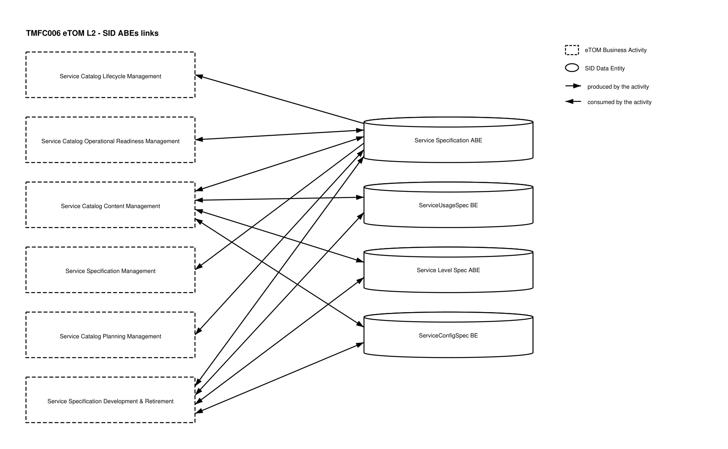
eTOM L2 - SID ABEs links diagram

Functional Framework Functions
Function ID | Function Name | Function Description | Aggregate Function Level 1 | Aggregate Function Level 2
1135 | Technical Solution Policy Design | The Technical Solution Policy Management Function enables to define, and to check consistency of, potentially complex rules to automate the choice of the technical solution (CFS Spec) for a know-how (RFS Spec) or parts of the technical solution. / Criteria can be of various nature and combined: / geographical / depending on the chosen characteristics values of the know-how / depending on other products / know-hows of the customer installed or ordered / depending on the current state of Service Platforms, Network equipment (occupation rate, load balancing, etc. ) / depending on Supplier/Partner contracts (volume discounts, etc) / Etc. | Service Specification Development | Technical Solution Policy Management
995 | Service Task Item Policy Control Configuration | Define and configure the policies which will be implemented during the Service task item lifecycle. | Service Specification Development | Service Specification Design
1080 | Service Specification Change Auditing | Service Specification Change Auditing manages the implications of Service Specifications changes to determine the consequences of any given change. Customer Facing Service Specifications (CFSSpec) changes may impact other CFSSpec according to relationships and also Product Specification that restrict it. Resources Facing Service Specification (RFSSpec) may impact other RFSSpecs according to relationships and / or CFSSpecs it realizes. / The function logs Service Specifications changes and supports the analysis of relationships between Service Specifications. / In addition, it tracks the history of changes in an easy and accessible manner. | Service Specification Development | Service Specification Design
1081 | Service Specification Repository Management | Service Specification Repository Management is able to create, modify and delete Service Specification and related entities such as Service Usage Specification. / This includes the ability to manage the state of an entity during its lifecycle (e.g. planned, deployed, in operation, replaced by, locked). / It includes Service Specifications retrieval, integrity rules check and versioning management. / | Service Specification Development | Service Specification Design
1084 | Know-How Specification Design | Know-How Specification Design provides the means to describe the Customer Facing Service Specifications including constraints, characteristics and types of usages. / It also identifies Technical Solutions usable for the Know-How and rules to find the Technical Solution. | Service Specification Development | Service Specification Design
1085 | Technical Solution Design | Technical Solution Design provides the means to describe Resource Facing Service Specifications (a.k.a. RFSSpec) including constraints, characteristics and types of usages. / It also identifies Resource Specifications used for each Technical Solution Specification (a.k.a. RFSSpec). | Service Specification Development | Service Specification Design
1086 | Service Specification to Supplier Product Specification Relationship Design | Service Specification to Supplier Product Specification Relationship Design identifies, when know-how, technical solutions or part of it are not realized by the CSP, the Supplier Product Specification used to implement and corresponding rules. | Service Specification Development | Service Specification Design
897 | Building Access Control | Building Access Control checks, stops or allow physical access to facilities according to access roles and rules. | Identification and Permission Management | Permission Control
900 | Authorization Control Management | Authorization Control Function controls permissions according to roles and related rules. / It consists in evaluating if a requester is granted the permission to act by providing the required evidence. The evidence corresponds to the condition specified for each right (for instance keying the correct password to use a specific mailbox). If the action is protected via a right which is assigned (possibly via a role) to a person then the person has to be identified to retrieve their rights and verify if the request to act can be granted. | Identification and Permission Management | Permission Control

TM Forum Open APIs & Events
The following part covers the APIs and Events; this part is split in 3:

List of Exposed APIs - This is the list of APIs available from this component.

List of Dependent APIs - In order to satisfy the provided API, the component could require the usage of this set of required APIs.

List of Events (generated & consumed) - The events which the component may generate are listed in this section along with a list of the events which it may consume. Since there is a possibility of multiple sources and receivers for each defined event.

API Context Diagram
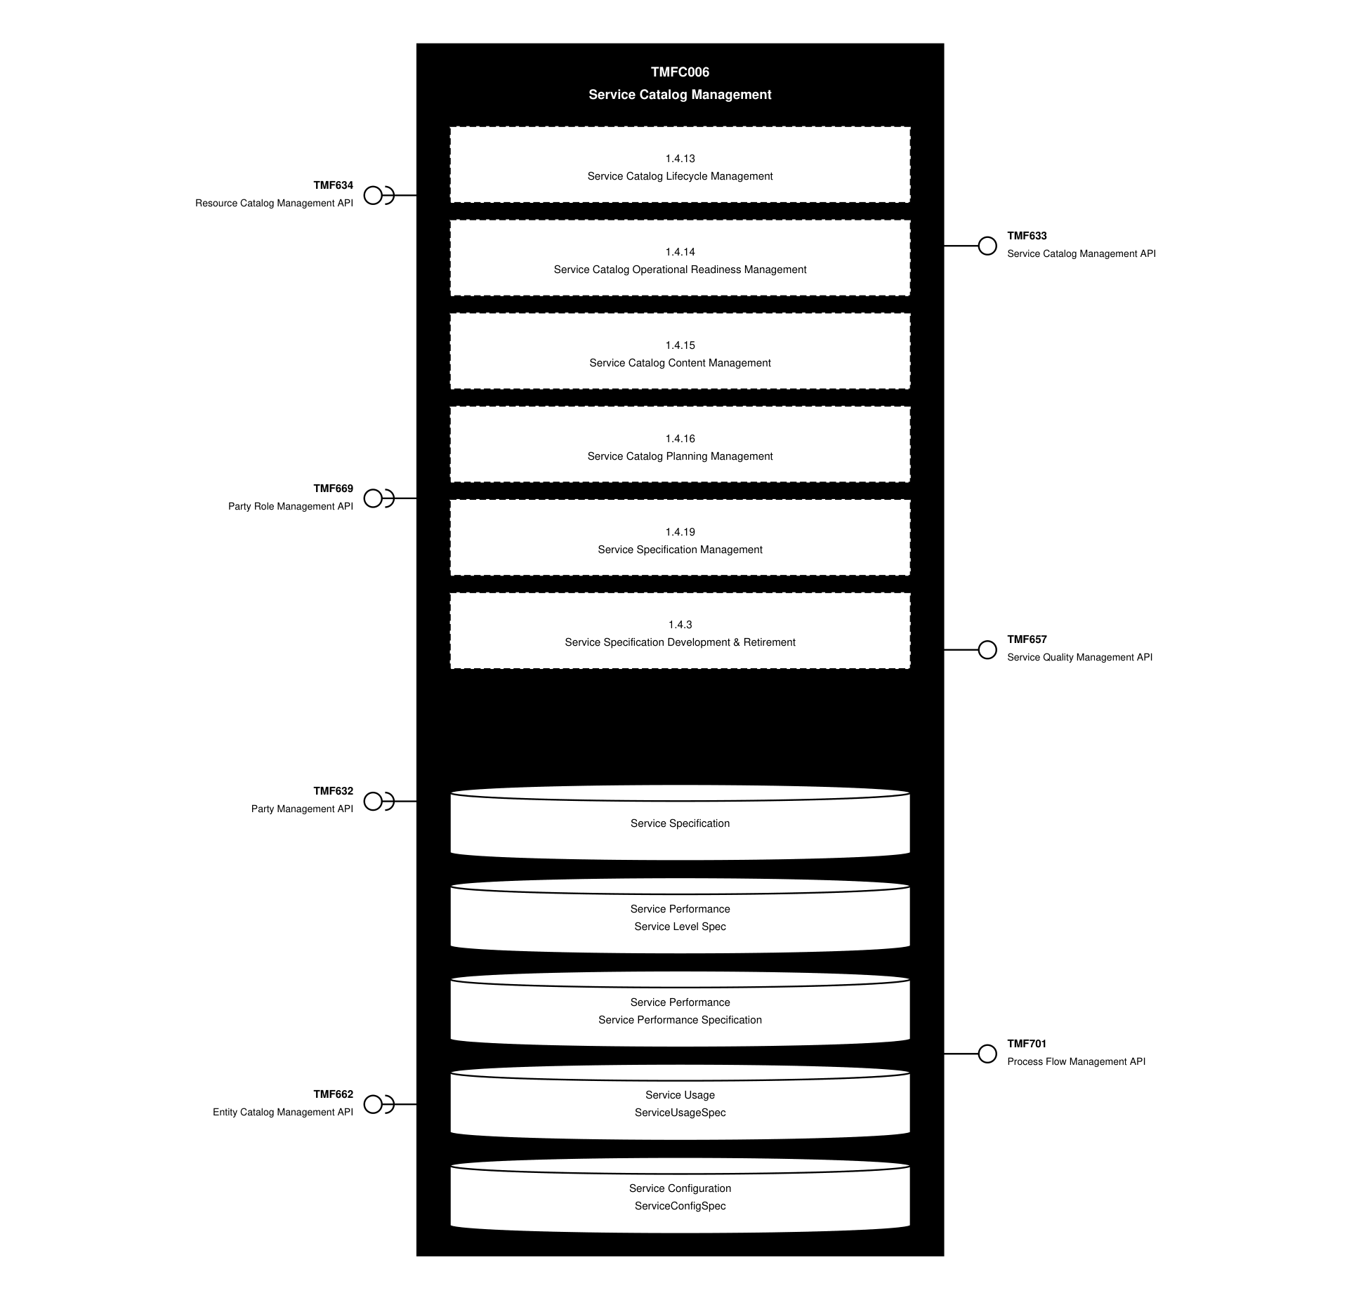
API Context diagram

Exposed APIs
API ID | API Name | Mandatory / Optional | API Version | Resource | Operations
TMF633 | Service Catalog Management API | Mandatory | 4 | catalog  category  serviceSpecification  serviceCandidate  exportJob  importJob | GET  GET /id  POST  PATCH  DELETE
TMF657 | Service Quality Management API | Mandatory | 4 | serviceLevelSpecification  serviceLevelObjective  serviceLevelSpecParameter | GET  GET /id  POST  PATCH  DELETE
TMF701 | Process Flow Management API | Optional | 4 | processFlow  taskFlow | POST  GET  GET /id  DELETE  PATCH

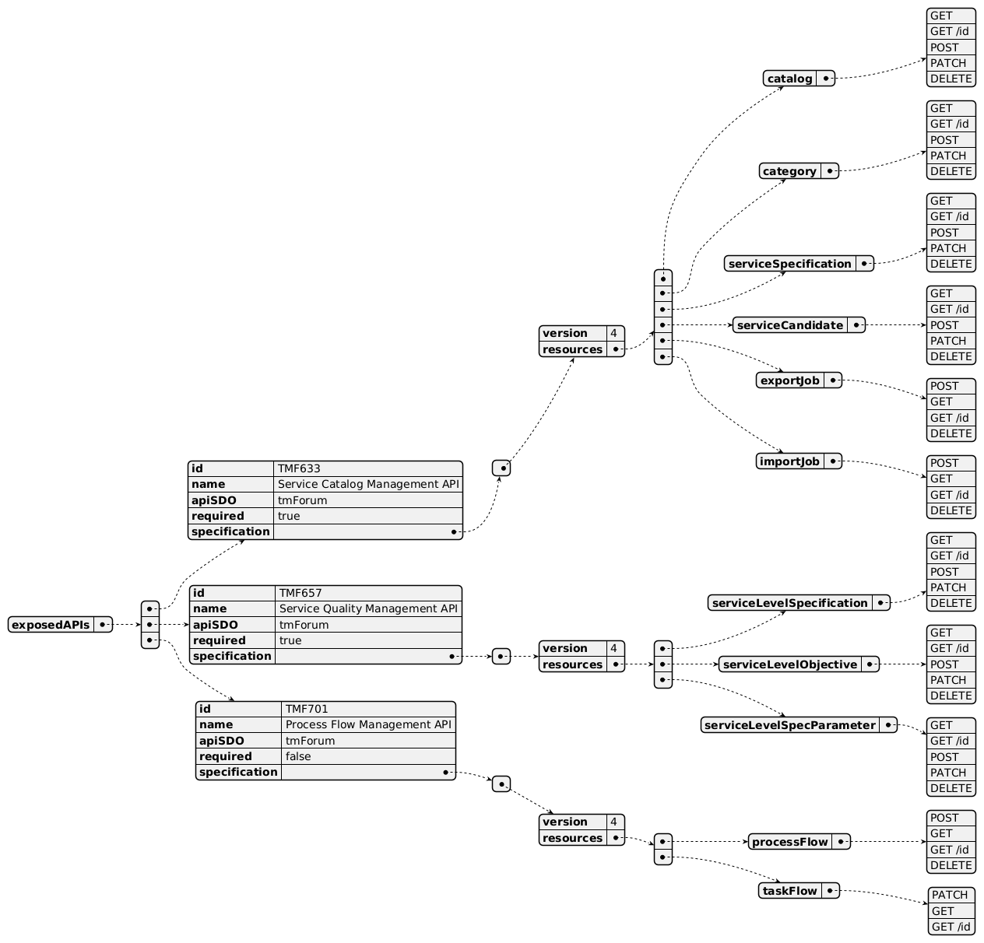
Exposed API diagram

Dependent APIs
API ID | API Name | API Version | Mandatory / Optional | Resource | Operations
TMF634 | Resource Catalog Management API | 5 | Optional | resourceSpecification | GET  GET /id
TMF634 | Resource Catalog Management API | 4 | Optional | resourceSpecification | GET  GET /id
TMF669 | Party Role Management API | 5 | Optional | partyRole | GET  GET /id
TMF669 | Party Role Management API | 4 | Optional | partyRole | GET  GET /id
TMF632 | Party Management API | 5 | Optional | individual  organization | GET  GET /id
TMF632 | Party Management API | 4 | Optional | individual  organization | GET  GET /id
TMF662 | Entity Catalog Management API | 4 | Optional | entitySpecification  associationSpecification | GET  GET /id

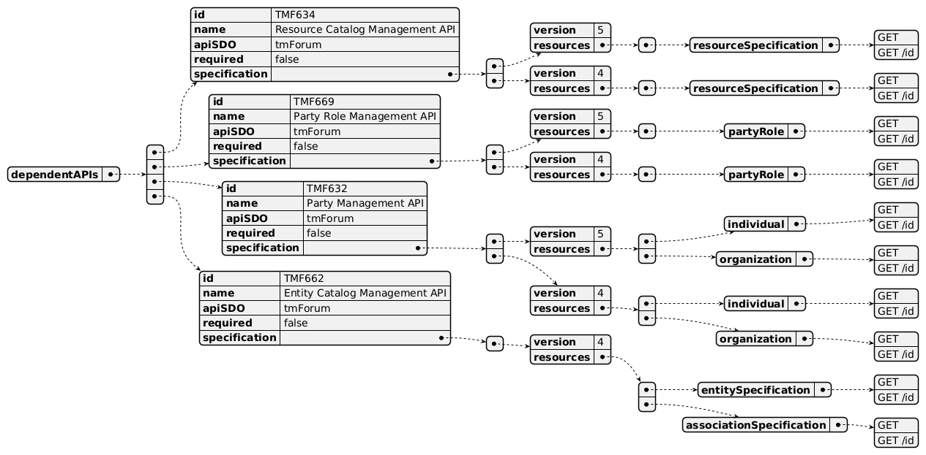
Dependent API diagram

Events
The diagram illustrates the Events which the component may publish and the Events that the component may subscribe to and then may receive. Both lists are derived from the APIs listed in the preceding sections.

Published Events
API ID | API Name | Event Resources
TMF633 | Service Catalog Management API | serviceSpecificationCreateEvent  serviceSpecificationChangeEvent  serviceSpecificationDeleteEvent  serviceCategoryCreateEvent  serviceCategoryChangeEvent  serviceCategoryDeleteEvent  serviceCandidateCreateEvent  serviceCandidateChangeEvent  serviceCandidateDeleteEvent  serviceCatalogCreateEvent  serviceCatalogChangeEvent  serviceCatalogDeleteEvent  serviceCatalogBatchEvent
TMF657 | Service Quality Management API | serviceLevelObjectiveCreateEvent  serviceLevelObjectiveChangeEvent  serviceLevelObjectiveAttributeValueChangeEvent  serviceLevelSpecificationCreateEvent  serviceLevelSpecificationDeleteEvent  serviceLevelSpecificationAttributeValueChangeEvent
TMF701 | Process Flow Management API | processFlowCreateEvent  processFlowStateChangeEvent  processFlowStateDeleteEvent  processFlowStateAttributeValueChangeEvent  taskFlowCreateEvent  taskFlowStateChangeEvent  taskFlowDeleteEvent  taskFlowAttributeValueChangeEvent  taskFlowInformationRequiredEvent

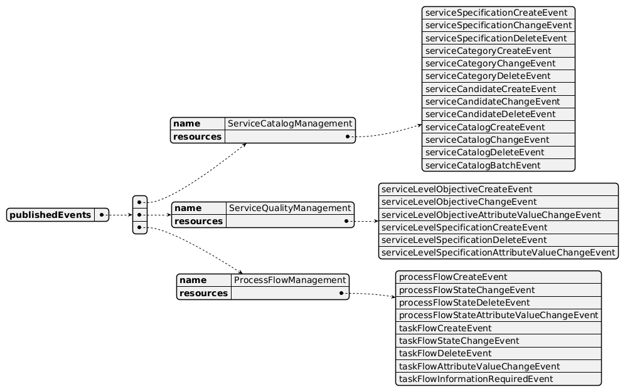
Published Events diagram

Subscribed Events
API ID | API Name | Event Resources
TMF634 | Resource Catalog Management API | resourceSpecificationCreateEvent  resourceSpecificationChangeEvent  resourceSpecificationDeleteEvent
TMF662 | Entity Catalog Management API | entitySpecificationCreateEvent  entitySpecificationAttributeValueChangeEvent  entitySpecificationChangeEvent  entitySpecificationDeleteEvent

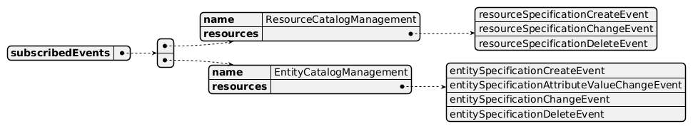
Subscribed Events diagram

Machine Readable Component Specification
Refer to the ODA Component Directory on the TM Forum website for the machine-readable component specification files for this component.

References

TMF Standards related versions
Standard | Version(s)
eTOM | v23.0
SID | v25.0
Functional Framework | v23.0

Jira References
No open Jira issues currently listed for this component.

Further resources
1. IG1228: please refer to IG1228 for defined use cases with ODA components interactions. 2. TMF633 Service Catalog Management API User Guide v4.0.0

Administrative Appendix

Document History

Version History
Version Number | Date | Modified by | Description of changes
1.0.0 | 29-Mar-2022 | Kamal Maghsoudlou, Gaetano Biancardi, Sylvie Demarest | Final edits prior to publication
1.0.1 | 25-Jul-2023 | Ian Turkington | No content changed, simply a layout change to match template 3. Separated the YAML files to a managed repository.
1.0.1 | 14-Aug-2023 | Amaia White | Final edits prior to publication
1.1.0 | 03-May-2024 | Amaia White | Final edits prior to publication
1.2.0 | 12-Nov-2024 | Gaetano Biancardi | TMF688 removed from the core specification, moved to supporting functions; TMF672 removed from the core specification, moved to supporting functions; API version, only major version to be specified
1.2.0 | 26-Nov-2024 | Amaia White | Final edits prior to publication
1.2.1 | 08-Jul-2025 | Rosie Wilson | Updates to description per agreed YAML updated on 03-Jun-2025; updated exposed API TMF657 to mandatory in the table to align with the diagram and YAML
1.2.1 | 15-Jul-2025 | Rosie Wilson | Final edits prior to publication

Release History
Release Status | Date Modified | Modified by | Description of changes
Pre-production | 29-Mar-2022 | Goutham Babu | Initial release
Production | 20-May-2022 | Adrienne Walcott | Updated to reflect TM Forum Approved status
Pre-production | 14-Aug-2023 | Amaia White | New release 1.0.1
Production | 06-Oct-2023 | Adrienne Walcott | Updated to reflect TM Forum Approved status
Pre-production | 02-May-2024 | Hugo Vaughan | Version 1.1.0 alignment to Frameworks 23.5; Service Test descoped to enable the definition of an additional Component
Pre-production | 02-May-2024 | Amaia White | New release 1.1.0
Production | 28-Jun-2024 | Adrienne Walcott | Updated to reflect TM Forum Approved status
Pre-production | 26-Nov-2024 | Amaia White | New release 1.2.0
Production | 07-Mar-2025 | Adrienne Walcott | Updated to reflect TM Forum Approved status
Pre-production | 15-Jul-2025 | Rosie Wilson | New release 1.2.1

Acknowledgements
Team Member | Company | Role
Elisabeth Andersson | MATRIXX | Editor
Hugo Vaughan (TM Forum) | TM Forum | Additional Input
Gaetano Biancardi | Accenture | Additional Input
Sylvie Demarest | Orange | Additional Input
Ian Turkington | TM Forum | Additional Input
Abinash Vishwakarma | Netcracker | Reviewer
Jose Macaluso | Xacria | Reviewer
Kamal Maghsoudlou | Ericsson | Reviewer
Milind Bhagwat | BT | Reviewer
Ritu Arora | BT | Reviewer
Matteo Destino | Accenture | Reviewer

